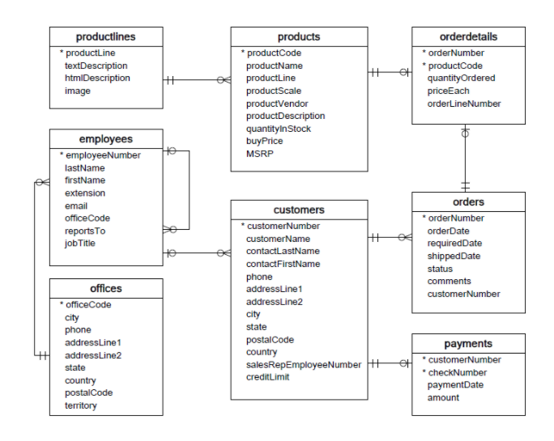

Part-1

-----------

1.) Display the product information of productcode , productname and price of product, which include of GST of 18% of its price. Display only the product price(inclusive of GST) which is greater than the half of the price of maximum price 214.

2) Display the productcode, productname, productline, where productscale ratio is end with value of 12

3) Display the product code and its name which quantity in stock is less then and equal to of 100

4) Display the productcode and product name who’s product's stock is greater the 5000 and less than 10000

5) Display the productcode and product name where product name is having the 'Ford'

6) Display the product name , vendor name and product category, where not to display product category of "Planes" and display only the vendor name which contains the "Classics" in its name.

7) Display the product code, productname, productline and quantity in stock. Display only product code where it has quantity is stock in greater than 5000 and in product category of Planes,Ships and Motorcycles

8) Display the productcode , product name and msrp, Display only the product's profit is more than half of the buy price of product

9) Display the ordernumber, productcode and qty order is greater than 50 and less than 100 and its price is greater than or equal to 100.(orderdetails tables)

10) Display the ordernumber,orderdate.Where ordernumber is not shipped.(orders table)

11) Display the ordernumber and orderdate,Where order are take place between the 2022-01-01 to 2022-07-01 (orders table)

12) Display all employee's number and firstname, except of who works in office code of 1.

13.Display customer's firstname and lastname as Name and there Address as show below

Name Address

--------------------------------------------------------------------------------

Schmitt Carine 54, rue Royale Nantes -44000.France

King Jean 8489 Strong St. Las Vegas NV-83030.USA

Ferguson Peter 636 St Kilda Road Level 3 Melbourne Victoria-3004.Australia

-------------------------------------------------------------------------------

Part -2

-------------

1. Display productcode and number of order , only for the product code with S700_* (orderdetails)

2. Display the employee number, firstname and their extension without any Alphabet (employees)

3. Display the product code and sum of the quantity sold where greater than 1000 (orderdetails)

4. Display productcode, productname and Stock_info. Stock_info is information that help them to place order

when stock is less than 1000 display "Immediate Order Place"

when stock is less than 3000 display "1 Week stock left"

when stock is less than 6000 display "2 Week Stock left"

when stock is less than 10000 display "1 Month stock left"

when stock more than 10000 display " Over Stocked" (product)

5. Display the years and number of orders made by customers in a year. Only the number of orders is greater than five (orders)

6. Display the ordernumber,orderdate,shipped date if not shipped than display the status. Order which is placed in between 01-05-2022 and 31-05-2022 (orders)

7. Display the employee number , name of employee by joining name titled,first name and last name (Mr/Mrs. Sam Peter),only the employees working in office code of 5,6,7 (employees)

8. Display the employee number and first name of employees which start with P,B,H from the sale Represenatative job title.(employees)

9. Display Vendor name who supplies more than 9 products

10. Display year and customer number list.where orderdate is taken place in year of 2003 and 2004(orders)

11. Display the max price of each category (products)

12. Display Ordernumber. Number of orders is more than one (ordersdetails)

13. List all product category and number of product is supplied by each vendor. Display number of product supplied as "Total_supply".

Display product vendor in ascending and Total_Supply in descending (products)

14. Display the productcode and productname.Only those product description contains any of the words "Working Steering", "Detailed Engine", "Turnable front Wheels","Exact replica".

15. Display sum of quantityordered of productcode start with S10,S18,S24.Display sum of quantityordered as "PType_Sum".Display only record is which greater than or equal to 1000

Pcode PType_Sum

-----------------------------

S10 12343

S18 35233

S24 26508

16. Display the unique sale manager's Area Zone as "Area_Zone"

---------------------------------------------------------------------------------

Part -3

--------------------

1.1 Display the managerId(ie employeenumber of manager) and there firstname as

"Manager's_Name"

1. List of employees who working in USA. Display first name and city

2. List of employee's firstname, city and there customer name

3. List the order dates in descending. Only orders for the 1940 Ford Pickup Truck.

4. List the names of customers and their corresponding order number where a particular order from that customer has a value greater than $25,000?

5. List of customer name, addressline1,city , state and order status.Where whose orders are not shipped

6. List the product name which is order in year of 2021

7. Display sales rep name, city and number of their customers.

8. Display the officecode, city and number of employeees in a office is greater than 5.

9. Display the productcode, productname and sum of quantities ordered in product category of 'Ships'

10.Display the customername and sum of amount.Whose payment is more than 100 thousand dollor.

11. List the customername and their country. Who were only made orders in year 2022.

12. List productcode, and number of orders made in year 2023.

---------------------------------------------------------------------------------------