IICS – informatica intelligent cloud service

Integrated platform as a service . It is data integration and ETL tool. Cloud solution offered by informatica. It also contains some features of informatica powercenter. We can use on-premise, on cloud and hybrid. It support batch processing and in real time processing.

**Informatica cloud architecture:**

It had 2 components:

* + Informatica cloud
  + Secure agent

Informatica cloud is bundle of hardware and software that informatica provides to us. we no need to install any where we can access through our web browser

Secure agent will replace the service of the integration service in the powercenter. It is light weight software which installed on the server behind the organization firewall in the on premise. It act as the bridge between the cloud and on premise. it will process the data locally and securely. Informatica cloud will automatically update the secure agent and restart it. It retrieve meta data from the informatica cloud.

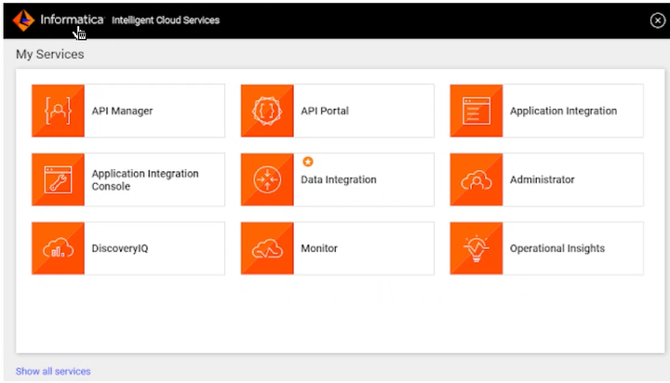

* Data integration its like a mapping designer
* Application uses to like integrating api’s
* CDI: cloud data integration
* CAI: cloud application integration
* Administrator will create connection and we can clone the connections or edit or copy. We can download the secure agents and install it in the server.

Difference between informatica powercenter and IICS

|  |  |
| --- | --- |
| Mapping | Mapping |
| Session task | Mapping task |
| Workflow | Task flow |
| GUI interface (Designer) | Web based interface |
| On premises solution | Cloud based solution |
| Traditional ETL services | Cloud native integration service – Data quality, Data governance, Application integration |
| Integration service | Secure agent |

Services provided by IICS are:

**Data integration service:**

This runs the batch jobs. It executes the data integration jobs.

Mapping task: it is similar to mapping designer in informatica powercenter. this is used to define the dataflow logic to process the data. Which is session task.

Task flow: combine different types of task and you run them together in a flow that is called as task flow. task flow controls the execution sequence of a mapping, configuration, task, or synchronization task based on the output of previous task. Because it is latest.

Replication task: it will replicate more than one object from source to a target. Can use full load or incremental load to replicate the data.

Synchronisation task: it is used to synchronise the data between source and target. Using this task you can sync only one object data at a time.

Masking task: making the source data and creating the subset of the source data in the target

PC task: import a powercenter workflow so that you can run it as a cloud data integration task.

**Monitor:**  will do the function of workflow monitor in the Powercenter. monitor is where you can monitor your jobs developed by data integration. You can check the running jobs failed jobs, success jobs. It also provides the option to restart your job, stop your job and download your session logs and task flow logs. OK, so this is your monitor functionality again.

**Data quality**

**Application integration**

**Profiling the data**

**Mass ingestion**

all the metadata gets stored in the Informatica cloud repository. Informatica cloud. You'll have repository unlike Power Center, all the information in Informatica Cloud is stored on the server maintained by the Informatica. As a user, we don't have access to the repository database.

How does an update strategy transformation work in Informatica Cloud?

There is no update strategy transformation in Informatica Cloud. In the target transformation, in the mapping in the target side, in a mapping your Informatica Cloud provides an option for action to be performed on the target. Either you want to insert, update, delete or you know insert, update, upsert, delete and data-driven, insert, update, delete, update and data-driven option is provided in the target site of your Informatica cloud mapping.

what is the different status available in IICS monitor?

Start, Queued, Running, Success, Warning, Failed, Stopped, Aborted

Three major Services on the server which secure agent will runs.

Data integration service

Common integration service

Process integration service

What is IDMC intelligent data management cloud IDMC your IICS next advanced IDMC intelligent data management cloud. It's a robust cloud data integration architecture designed for scalability and flexibility. So this IDMC has everything, your data quality, everything is combined and you know it gives one platform. OK, your idmc. So very new and trending in the market.

<https://www.youtube.com/watch?v=VUbwUve4llY> referral for IICS architecture.

Architecture of IICS

Difference between power centre and IICS

Secure agent

Replication task

Syncronisation task

Monitor components

Different states in IICS monitor

Administrator component