**Power BI Desktop**

**Workspace on power BI Desktop:** In Power BI desktop you can switch between **Report**, **Data**, and **Relationship** views by selecting the icons in the left-hand navigation panel.

**Report View:** Power BI Desktop includes a Report view, where you can create any number of report pages with visualizations. Once you've added some data, you can add fields to a new visualization in the canvas.  You can add all sorts of visualizations to a page. You can move visualizations around, copy and paste, merge, and so on.

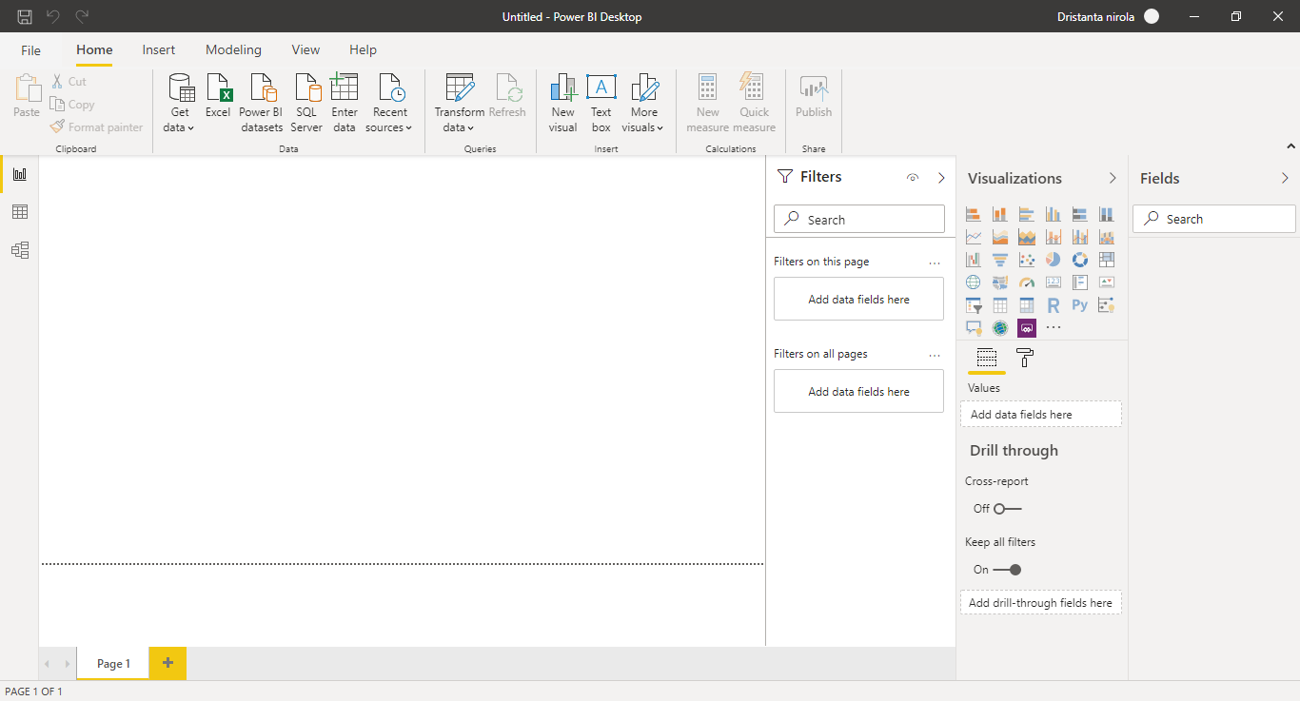

Figure : Report View page:

**Data view:** Defined datasets based on data retrieved from one or more data sources. Data view offers limited transformation features, with many more capabilities available through Query Editor, which opens in a separate window.

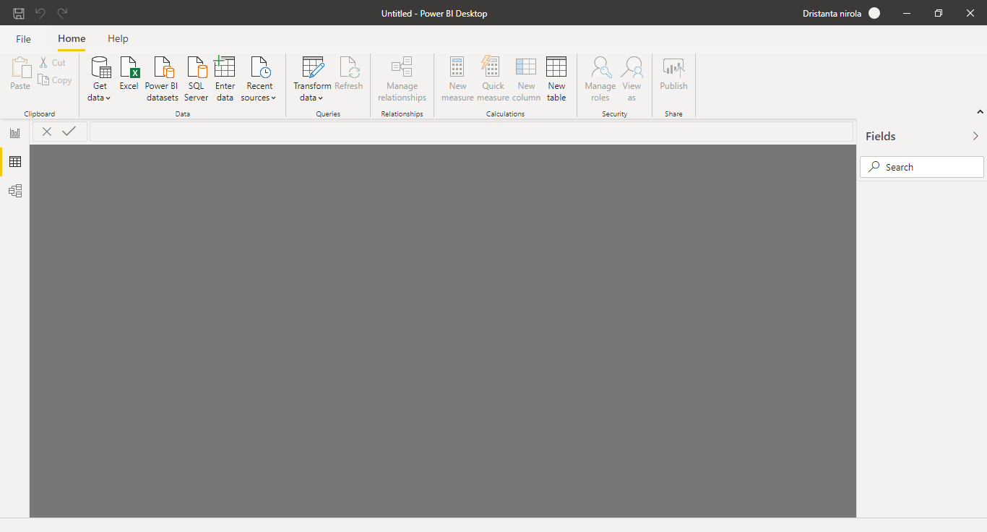

Figure : Data View page

**Model View:** Identified relationships between the datasets defined in Data view. When possible, Power BI Desktop identifies the relationships automatically, but we can also define them manually.

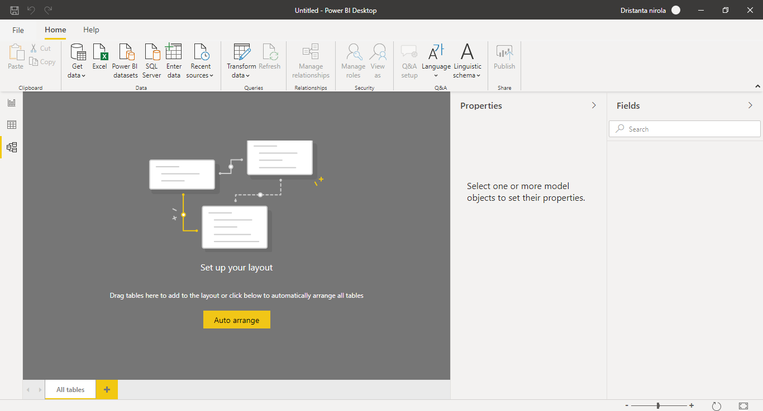

Figure : Model View page

**Power query editor: Power query:** Power query editor provides you with tools to transform and enhance the data. When you’re preparing a dataset for reporting, you should evaluate the data types that have been assigned to each column to ensure they’re what you need. Also, you’ll want to added, removed, or split columns so you’re not including unnecessary anomalies in the data.

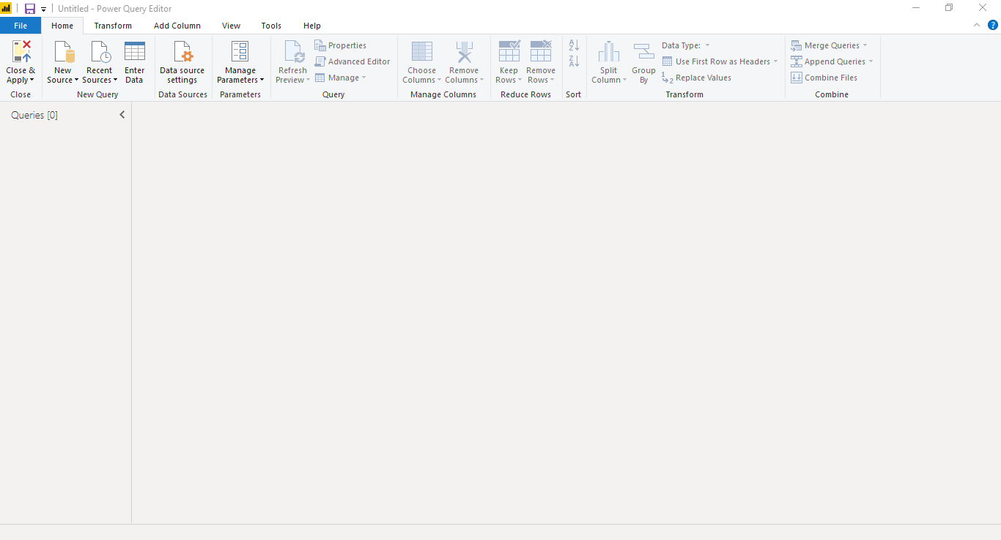

Figure : Power query page

**Advance Editor:** The **Advanced Editor** lets you see the code that Power Query Editor is creating with each step. It also lets you create your own shaping code.

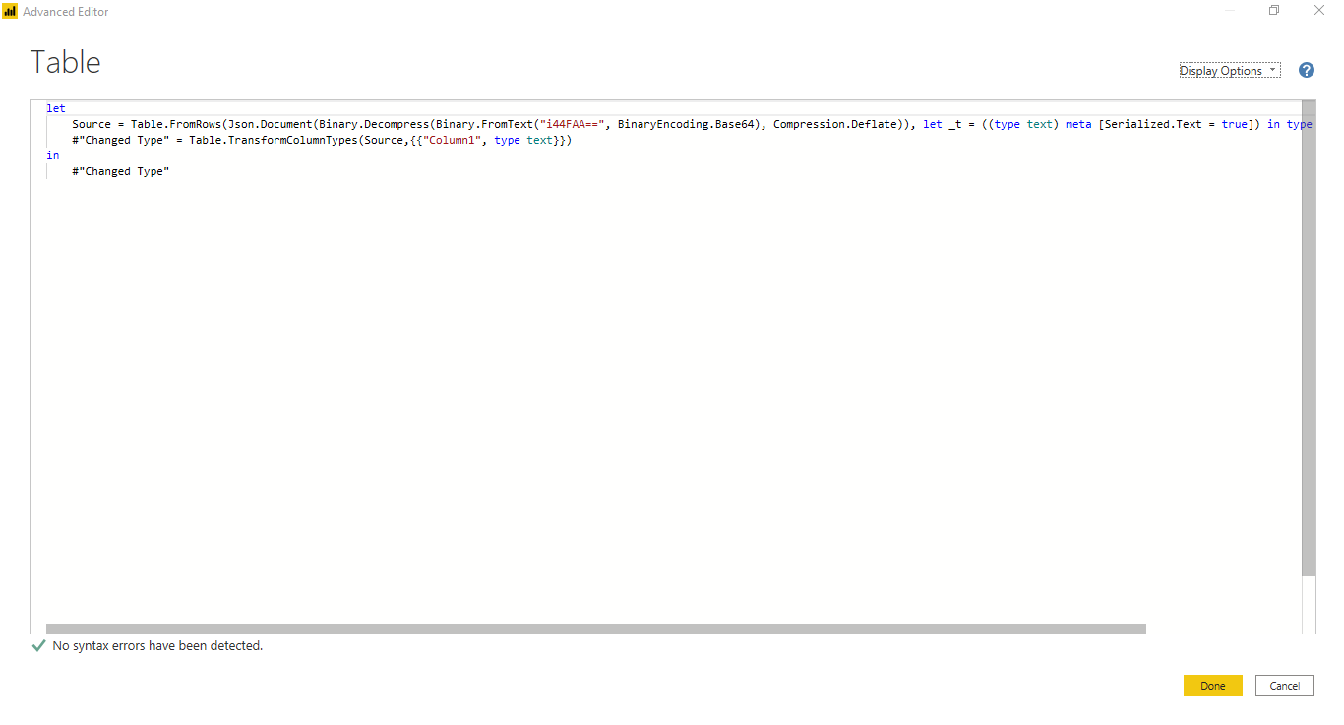

Figure : Advance Editor