Lab 1.1
Code:
<!DOCTYPE html>
<html lang="en">
<head>
<meta charset="UTF-8">
<meta name="viewport" content="width=device-width, initial-scale=1.0">
<title>Homepage</title>
</head>
<body>

<h1>Welcome to Web Technology</h1>

<nav>
<a href="about.html">About Us</a>
<a href="services.html">Services</a>
<a href="contact.html">Contact Us</a>
</nav>

</body>
</html>

Output:

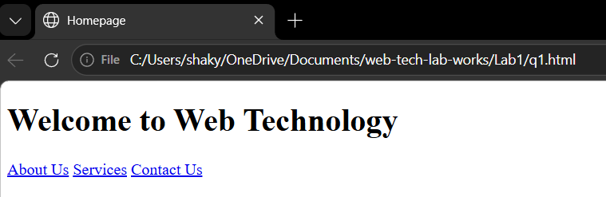

Lab 1.2
Code:
<!DOCTYPE html>
<html lang="en">
<head>
<meta charset="UTF-8">
<title>Department Page</title>
</head>
<body>

<h1>Department of CSIT</h1>
<p>Our department focuses on computing, technology and practical skills to prepare students for the tech industry.</p>
<h2>Programs Offered</h2>
<ul>
<li>BSc.CSIT</li>
<li>BIT</li>
</ul>

<h2>Why Choose Us?</h2>
<ol>
<li>Experienced faculty</li>
<li>Modern labs</li>
<li>High placement rate</li>
</ol>
</body>
</html>

Output:


Lab 1.3

Code:
<!DOCTYPE html>
<html lang="en">
<head>
<meta charset="UTF-8">
<title>Class Timetable</title>
</head>
<body>

<h1>Class Timetable</h1>

<table border="1">
<tr>
<th>Day</th>
<th>10:30 - 11:25</th>
<th>11:25 - 12:20</th>
<th>12:20 - 1:10</th>
<th>1:10 - 2:00</th>
<th>2:00 - 2:30</th>
<th>2:30 - 3:20</th>
<th>3:20 - 4:10</th>
</tr>
<tr>
<td>Sunday</td>
<td>DAA</td>
<td>Web Technology</td>
<td>Cryptography</td>
<td>SAM</td>
<td>Break</td>
<td>Multimedia</td>
<td>SAD</td>
</tr>
<tr>
<td>Monday</td>
<td>DAA</td>
<td>Web Technology</td>
<td>Cryptography</td>
<td>SAM</td>
<td>Break</td>
<td>Multimedia</td>
<td>SAD</td>
</tr>
<tr>
<td>Tuesday</td>
<td>DAA</td>
<td>Web Technology</td>
<td>Cryptography</td>
<td>SAM</td>
<td>Break</td>
<td>Multimedia</td>
<td>SAD</td>
</tr>
<tr>
<td>Wednesday</td>
<td>DAA</td>
<td>Web Technology</td>
<td>Cryptography</td>
<td>SAM</td>
<td>Break</td>
<td>Multimedia</td>
<td>SAD</td>
</tr>
<tr>
<td>Thursday</td>
<td>DAA</td>
<td>Web Technology</td>
<td>Cryptography</td>
<td>SAM</td>
<td>Break</td>
<td>Multimedia</td>
<td>SAD</td>
</tr>
<tr>
<td>Friday</td>
<td>DAA</td>
<td>Web Technology</td>
<td>Cryptography</td>
<td>SAM</td>
<td>Break</td>
<td>Multimedia</td>
<td>SAD</td>
</tr>
<tr>
<td>Saturday</td>
<td colspan="7" style="text-align:center;">Off</td>
</tr>
</table>

</body>
</html>

Output:
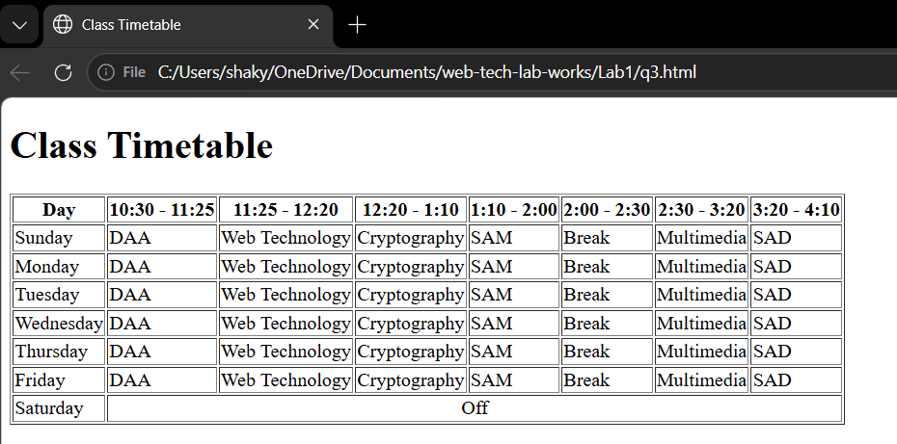

Lab 1.4

Code:
Html:
<!DOCTYPE html>
<html lang="en">
<head>
<meta charset="UTF-8">
<meta name="viewport" content="width=device-width, initial-scale=1.0">
<title>Types of CSS</title>
<style>
#p1{
color: green;
}
</style>
<link rel="stylesheet" href="q4style.css" >
</head>
<body>
<h1>Demonstrating different types of CSS</h1>
<p style="color: blue;">This paragraph use inline css</p>
<P id="p1">This paragraph use internal css</P>
<P id="p2">This paragraph use external css</P>
</body>
</html>
CSS:
#p2{
color: red;
}

Output:
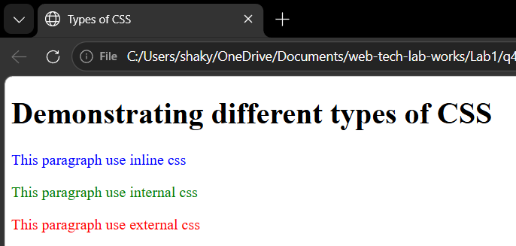

Lab 1.5
Code:
<!DOCTYPE html>
<html>
<head>
<title>Lists</title>
<style>
ul{list-style:disc;}
ul.circle{list-style:circle;}
ul.square{list-style:square;}
ol.roman{list-style:upper-roman;}
ol.alpha{list-style:upper-alpha;}
</style>
</head>
<body>
<h3>Unordered</h3>
<ul><li>HTML</li><li>CSS</li></ul>
<ul class="circle"><li>HTML</li><li>CSS</li></ul>
<ul class="square"><li>HTML</li><li>CSS</li></ul>
<h3>Ordered</h3>
<ol><li>HTML</li><li>CSS</li></ol>
<ol class="roman"><li>HTML</li><li>CSS</li></ol>
<ol class="alpha"><li>HTML</li><li>CSS</li></ol>
<h3>Description</h3>
<dl>
<dt>HTML</dt><dd>Structure</dd>
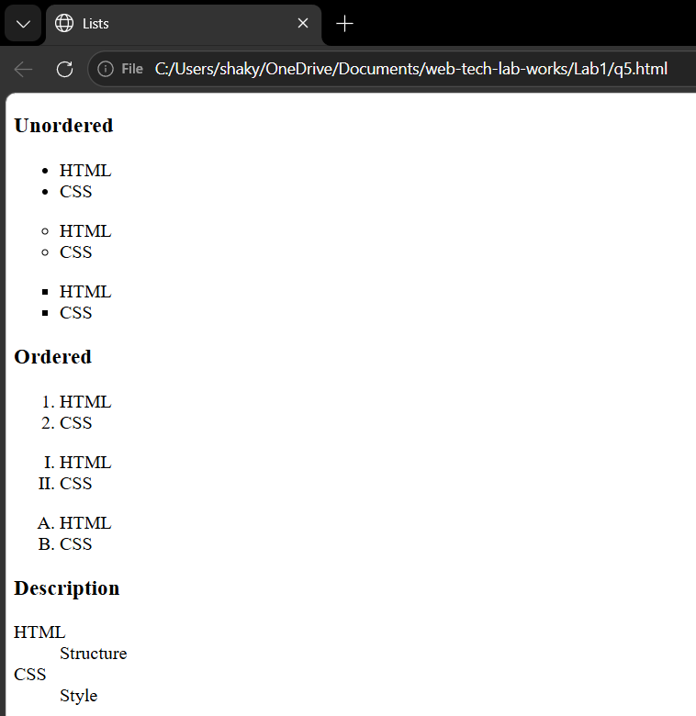
<dt>CSS</dt><dd>Style</dd> Output:
</dl>
</body>
</html>

Lab 1.6
Code:
<!DOCTYPE html>
<html lang="en">
<head>
<title>Basic Web Layout</title>
<style>
* {
margin: 0;
padding: 0;
box-sizing: border-box;
}
body {
font-family: Arial, sans-serif;
}
#header {
background-color: red;
color: white;
text-align: center;
padding: 20px;
}
#navbar {
background-color: salmon;
padding: 15px;
text-align: center;
}
#wrapper {
display: flex;
}
#sidebar {
background-color: gray;
width: 20%;
min-height: 200px;
padding: 15px;
}
#content {
background-color: lightgreen;
width: 40%;
min-height: 200px;
padding: 15px;
}
#highlight {
background-color: rgba(100, 167, 189, 0.856);
width: 40%;
min-height: 200px;
padding: 15px;
}
#footer {
background-color: #555;
color: white;
text-align: center;
padding: 15px;
}
</style>
</head>
<body>
<div id="header">Header</div>
<div id="navbar">Navbar</div>
<div id="wrapper">
<div id="sidebar">Sidebar</div>
<div id="content">Content</div>
<div id="highlight">Highlight</div>
</div>
<div id="footer">Footer</div>
</body>
</html>
Output:
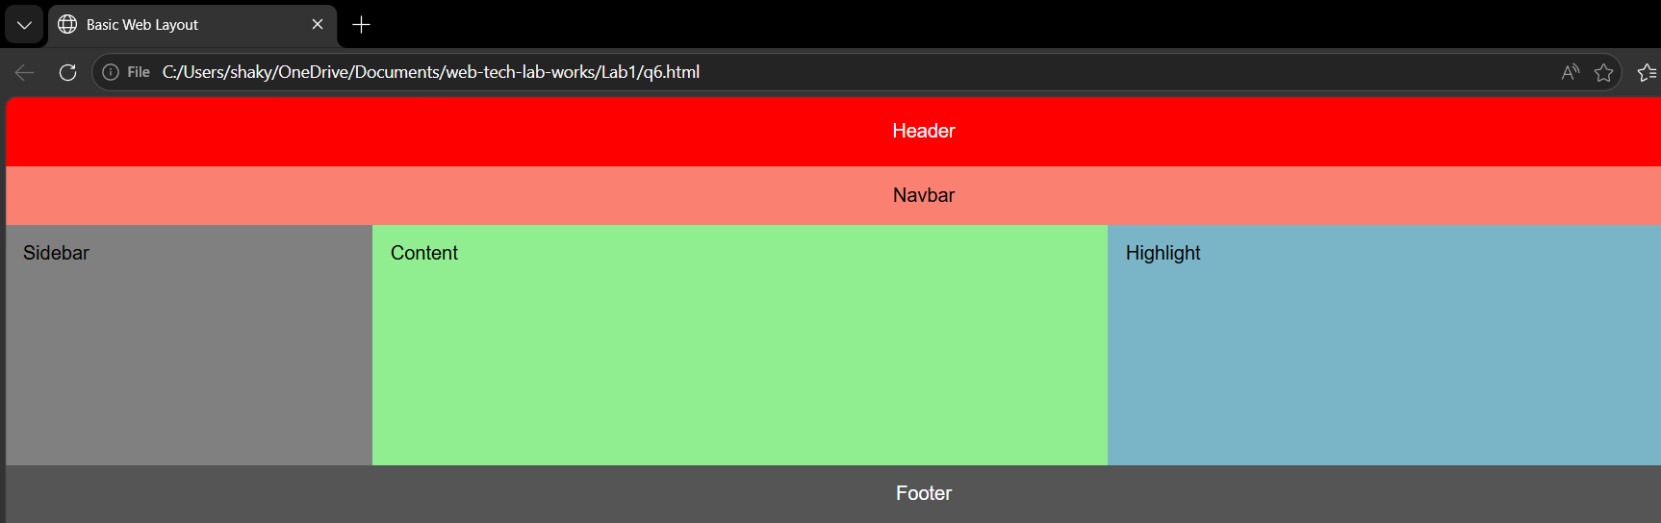

Lab 1.7.
Code:
<!DOCTYPE html>
<html lang="en">
<head>
<meta charset="UTF-8">
<title>Frames Layout</title>
</head>
<frameset cols="20%, 60%, 20%">
<frame src="left.html" name="leftFrame" title="Contents">
<frame src="center.html" name="centerFrame" title="Body">
<frame src="right.html" name="rightFrame" title="Highlights">
</frameset>
</html>
left.html
<h3>Contents</h3>
<ul>
<li>Home</li>
<li>About</li>
<li>Services</li>
</ul>
center.html
<h3>Body</h3>
<p>This is the main body of the web page.</p>
right.html
<h3>Highlights</h3>
<ul>
<li>News 1</li>
<li>News 2</li>
<li>News 3</li>
</ul>
Output:
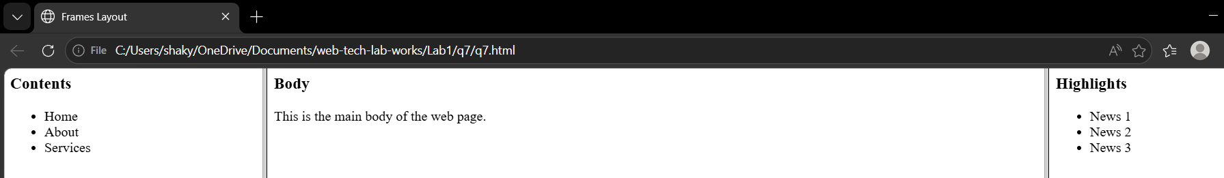

Lab 1.8
Code:
<!DOCTYPE html>
<html>
<head>
<title>List Box</title>
<style>
body { font-family: Arial; }
select { width: 200px; margin: 10px 0; }
</style>
</head>

<body>
<h3>Single Select</h3>
<select size="5">
<option>HTML</option>
<option>CSS</option>
<option>JS</option>
<option>Python</option>
<option>Java</option>
</select> Output:
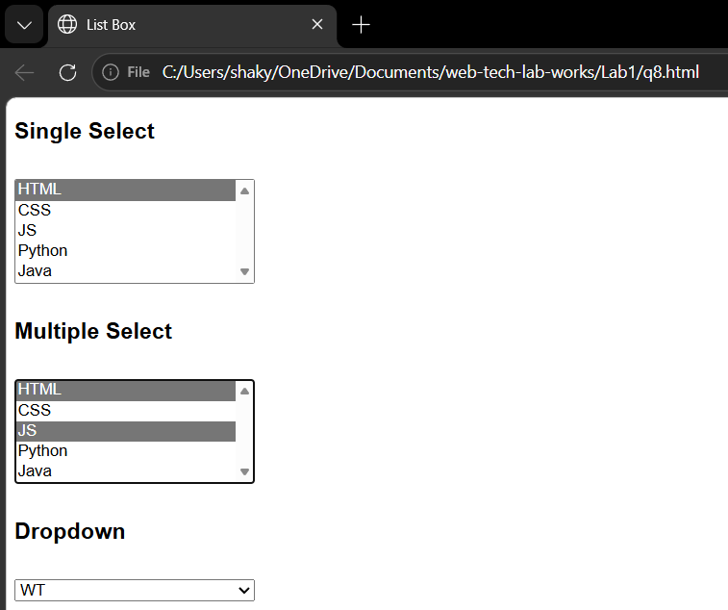
<h3>Multiple Select</h3>
<select size="5" multiple>
<option>HTML</option>
<option>CSS</option>
<option>JS</option>
<option>Python</option>
<option>Java</option>
</select>
<h3>Dropdown</h3>
<select>
<option>Select</option>
<option>WT</option>
<option>DAA</option>
</select>
</body>
</html>

Lab 1.9
Code:
<!DOCTYPE html>
<html>
<head>
<title>Mark Sheet</title>
<style>
body { font-family: Arial; }

table {
width: 60%;
margin: auto;
border-collapse: collapse;
}

th, td {
border: 1px solid #ccc;
padding: 8px;
text-align: center;
}

th { background: darkblue; color: #fff; }

.pass { color: green; }
.total { background: lightgreen; font-weight: bold; }
</style>
</head>

<body>

<h2 align="center">Mark Sheet</h2>
<h4 align="center">Name | Roll | Year</h4>

<table>
<tr>
<th>S.No</th><th>Sub</th><th>FM</th><th>PM</th><th>Marks</th><th>Status</th>
</tr>

<tr><td>1</td><td>DAA</td><td>100</td><td>40</td><td>75</td><td class="pass">Pass</td></tr>
<tr><td>2</td><td>WT</td><td>100</td><td>40</td><td>80</td><td class="pass">Pass</td></tr>
<tr><td>3</td><td>Crypto</td><td>100</td><td>40</td><td>70</td><td class="pass">Pass</td></tr>

<tr class="total">
<td colspan="4">Total</td>
<td>225</td>
<td>Pass</td>
</tr>
</table>

</body>
</html>

Output:
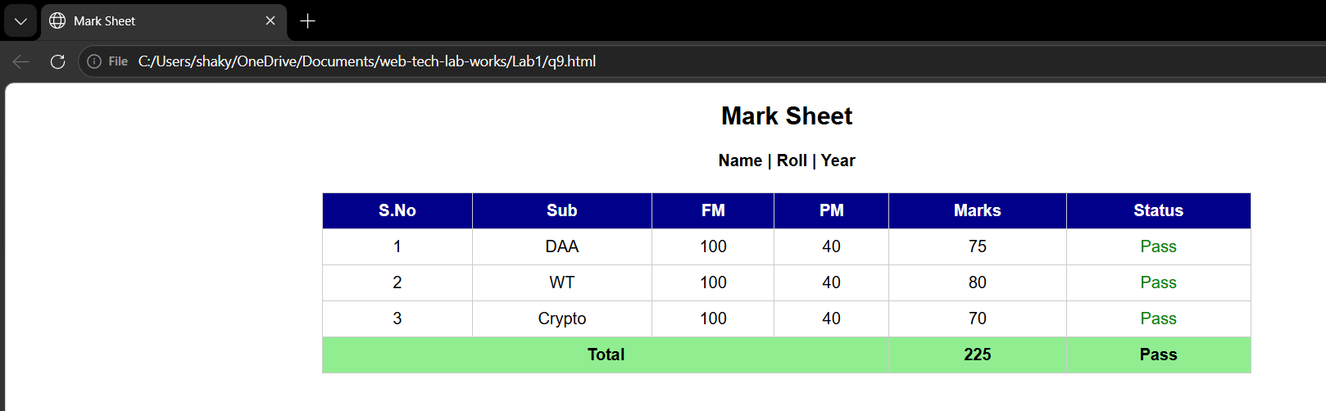

Lab 1.10
Code:
<!DOCTYPE html>
<html lang="en">
<head>
<meta charset="UTF-8">
<title>Registration Form</title>
<style>
h1 {
text-align: center; color: darkblue;
}
.form-container {
width: 450px;
margin: 20px auto;
padding: 30px;
border-radius: 10px;
box-shadow: 0 0 10px rgba(0,0,0,0.1);
}
label {
display: block;
margin-top: 15px;
font-weight: bold;
}
input, select, textarea {
width: 100%;
padding: 8px;
margin-top: 5px;
border: 1px solid #ccc;
border-radius: 5px;
box-sizing: border-box;
}
.radio-group {
margin-top: 5px;
}
button {
width: 100%; padding: 10px;
margin-top: 20px;
background-color: darkblue; color: white;
border: none; border-radius: 5px;
font-size: 16px;
cursor: pointer;
}
button:hover {
background-color: blue;
}
</style>
</head>
<body>
<h1>Registration Form</h1>
<div class="form-container">
<form>
<label>Full Name</label>
<input type="text" placeholder="Enter your full name">

<label>Email</label>
<input type="email" placeholder="Enter your email">

<label>Password</label>
<input type="password" placeholder="Enter your password">

<label>Phone Number</label>
<input type="tel" placeholder="Enter your phone number">

<label>Gender</label>
<div class="radio-group">
<input type="radio" name="gender" id="male">
<label for="male" style="display:inline; font-weight:normal;">Male</label>
<input type="radio" name="gender" id="female">
<label for="female" style="display:inline; font-weight:normal;">Female</label>
<input type="radio" name="gender" id="other">
<label for="other" style="display:inline; font-weight:normal;">Other</label>
</div>

<label>Address</label>
<textarea rows="3" placeholder="Enter your address"></textarea>

<label>
<input type="checkbox" style="width:auto;"> I agree to the Terms & Conditions
</label>

<button type="submit">Register</button>
</form>
</div>

</body>
</html>

Output:
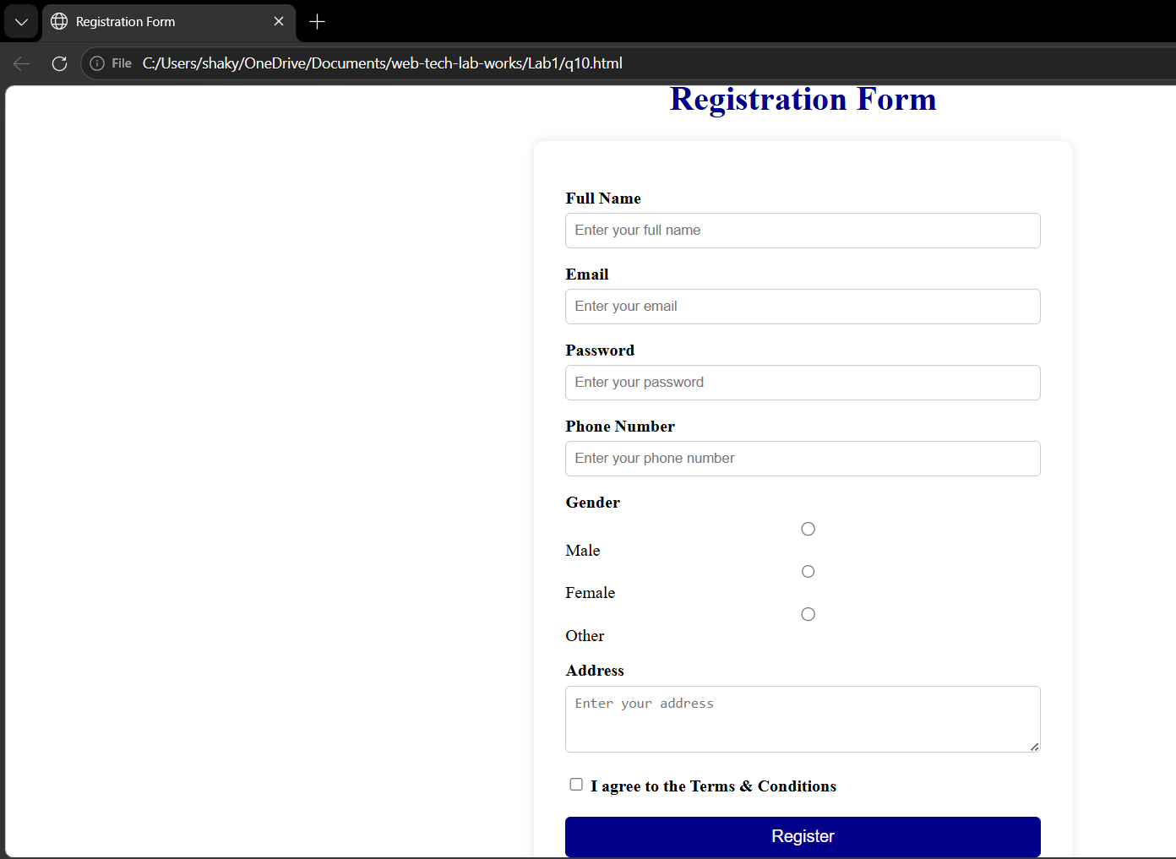

Lab 1.11
Code:
<!DOCTYPE html>
<html>
<head>
<title>Image</title>
<style>
body { font-family: Arial; text-align: center; }
img { width: 200px; }
</style>
</head>

<body>

<h2>My Photo</h2>

<img src="my-image.jpg" alt="Photo">
<p>Dristi Shakya</p>

</body>
</html>

Output:
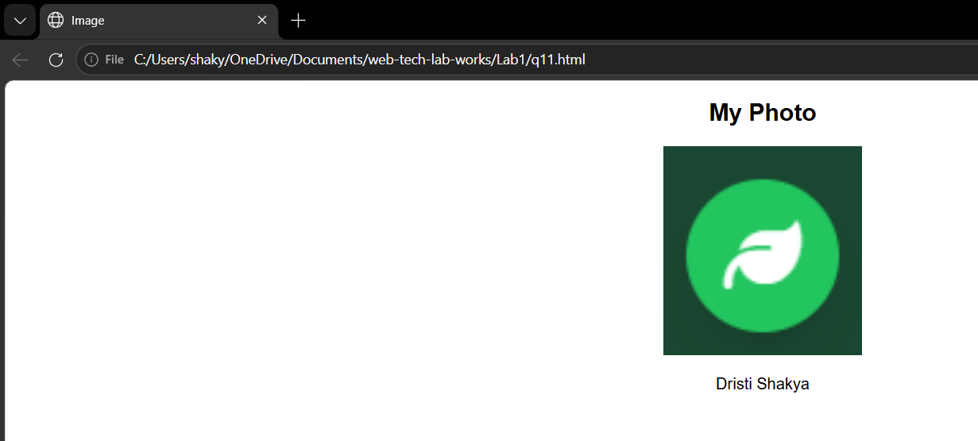

Lab 1.12
Code:
<!DOCTYPE html>
<html>
<head>
<title>CV</title>
<style>
body {
font-family: Arial; font-size: 14px;
margin: 10px;
}
.cv {
width: 400px; margin: auto;
border: 2px solid black;
padding: 10px;
}
h1, h2 {
color: darkblue; margin: 5px 0;
}
table {
width: 100%;
border-collapse: collapse;
font-size: 13px;
}
th, td {
border: 1px solid #ccc;
padding: 4px;
text-align: center;
}
ul {
margin: 5px 0 10px 18px;
}
</style>
</head>

<body>

<div class="cv">

<h1 style="text-align:center;">Dristi Shakya</h1>
<p style="text-align:center;">Email | Phone | Kathmandu</p>
<h2>Objective</h2>
<p>CS student interested in web development.</p>
<h2>Education</h2>
<table>
<tr><th>Degree</th><th>Year</th><th>Grade</th></tr>
<tr><td>CSIT</td><td>Running</td><td>-</td></tr>
<tr><td>+2</td><td>2023</td><td>3.42</td></tr>
</table>
<h2>Skills</h2>
<ul>
<li>HTML, CSS</li>
<li>Python</li>
<li>Git</li>
</ul>
<h2>Subjects</h2>
<ul>
<li>DAA</li>
<li>Web Tech</li>
<li>Crypto</li>
</ul>
<h2>Projects</h2>
<p>Portfolio website, Student system</p>
</div>

</body>
</html> Output:
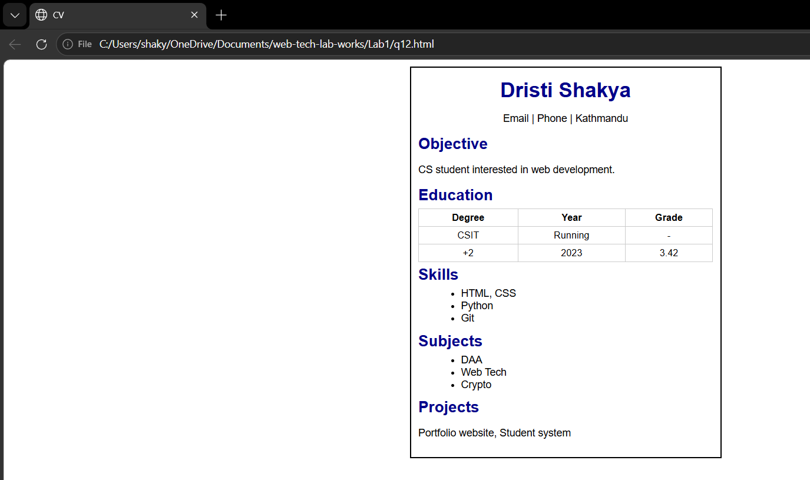

Lab 2.1
Code:
<!DOCTYPE html>
<html lang="en">
<head>
<meta charset="UTF-8">
<title>Alert on Button Click</title>
</head>
<body>

<h1>Alert Message Demo</h1>
<button onclick="showAlert()">Click Me</button>

<script>
function showAlert() {
alert("Hello! Welcome to Web Technology!");
}
</script>

</body>
</html>

Output:
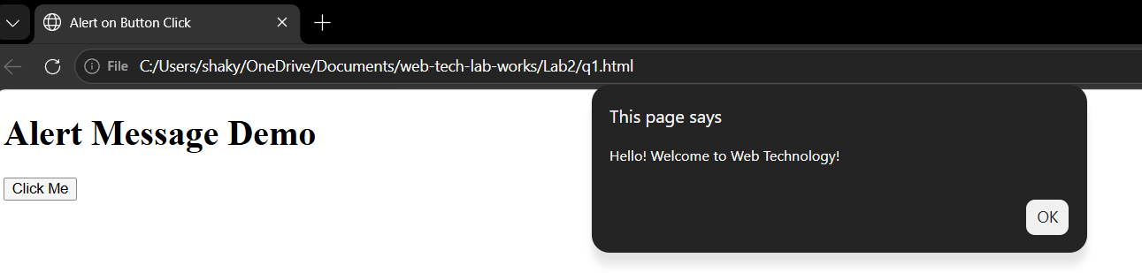

Lab 2.2
Code:
<!DOCTYPE html>
<html lang="en">
<head>
<meta charset="UTF-8">
<title>Sum of Two Numbers</title>
</head>
<body>
<h1>Sum of Two Numbers</h1>
<button onclick="calcSum()">Click to Enter Numbers</button>
<p id="result"></p>

<script>
function calcSum() {
let num1 = Number(prompt("Enter first number:"));
let num2 = Number(prompt("Enter second number:"));
let sum = num1 + num2;
document.getElementById("result").innerHTML = "Sum of " + num1 + " and " + num2 + " = " + sum;
}
</script>

</body>
</html>

Output:
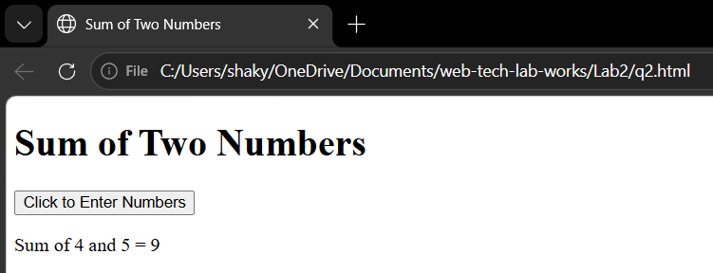

Lab 2.3
Code:
<!DOCTYPE html>
<html lang="en">
<head>
<meta charset="UTF-8">
<title>Current Date and Time</title>
</head>
<body>
<h1>Current Date and Time</h1>
<button onclick="showDateTime()">Get Date & Time</button>
<p id="result"></p>

<script>
function showDateTime() {
let now = new Date();
document.getElementById("result").innerHTML = now.toLocaleString();
}
</script>

</body>
</html>

Output:
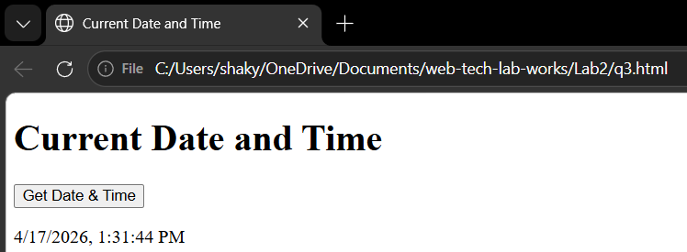

Lab 2.4
Code:
<!DOCTYPE html>
<html lang="en">
<head>
<meta charset="UTF-8">
<title>Sum of Even Numbers</title>
</head>
<body>
<h1>Sum of Even Numbers from 1 to 25</h1>
<button onclick="sumEven()">Calculate</button>
<p id="result"></p>
<script>
function sumEven() {
let sum = 0;
for (let i = 1; i <= 25; i++) {
if (i % 2 == 0) {
sum += i;
}
}
document.getElementById("result").innerHTML = "Sum of even numbers from 1 to 25 = " + sum;
}
</script>
</body>
</html>

Output:
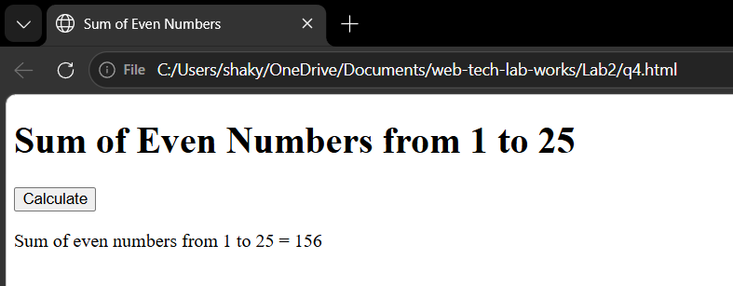

Lab 2.5
Code:
<!DOCTYPE html>
<html lang="en">
<head>
<meta charset="UTF-8">
<title>Form Validation</title>
</head>
<body>

<h1>Registration Form</h1>

<form onsubmit="return validate()">
<label>Full Name:</label><br>
<input type="text" id="name"><br>
<span id="nameErr" style="color:red;"></span><br>

<label>Email:</label><br>
<input type="text" id="email"><br>
<span id="emailErr" style="color:red;"></span><br>

<label>Phone Number:</label><br>
<input type="text" id="phone"><br>
<span id="phoneErr" style="color:red;"></span><br>

<label>Age:</label><br>
<input type="text" id="age"><br>
<span id="ageErr" style="color:red;"></span><br>

<label>Password:</label><br>
<input type="password" id="password"><br>
<span id="passwordErr" style="color:red;"></span><br>

<label>Confirm Password:</label><br>
<input type="password" id="confirmPassword"><br>
<span id="confirmErr" style="color:red;"></span><br>

<button type="submit">Register</button>
<span id="successMsg" style="color:green;"></span>

</form>

<script>
function validate() {
let valid = true;

// Clear all errors first
let errors = ["nameErr","emailErr","phoneErr","ageErr","passwordErr","confirmErr"];
errors.forEach(id => document.getElementById(id).innerHTML = "");

let name = document.getElementById("name").value;
let email = document.getElementById("email").value;
let phone = document.getElementById("phone").value;
let age = document.getElementById("age").value;
let password = document.getElementById("password").value;
let confirmPassword = document.getElementById("confirmPassword").value;

if (name == "") {
document.getElementById("nameErr").innerHTML = "Name is required!";
valid = false;
}
if (email == "") {
document.getElementById("emailErr").innerHTML = "Email is required!";
valid = false;
} else if (!email.includes("@")) {
document.getElementById("emailErr").innerHTML = "Enter a valid email!";
valid = false;
}
if (phone == "" || phone.length != 10) {
document.getElementById("phoneErr").innerHTML = "Enter a valid 10 digit phone number!";
valid = false;
}
if (age == "" || age < 18) {
document.getElementById("ageErr").innerHTML = "You must be at least 18 years old!";
valid = false;
}
if (password == "" || password.length < 6) {
document.getElementById("passwordErr").innerHTML = "Password must be at least 6 characters!";
valid = false;
}
if (password != confirmPassword) {
document.getElementById("confirmErr").innerHTML = "Passwords do not match!";
valid = false;
}

if (valid) {
document.getElementById("successMsg").innerHTML = "Registration Successful!";
}
return false;
}
</script>

</body>
</html>

Output:
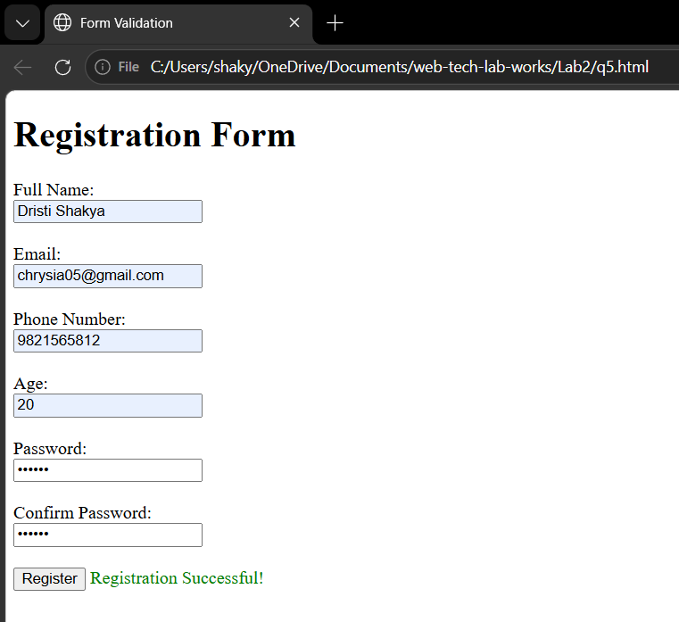

Lab 2.6
Code:
<!DOCTYPE html>
<html lang="en">
<head>
<meta charset="UTF-8">
<title>Array and ForEach Loop</title>
</head>
<body>
<h1>Array and ForEach Loop</h1>
<button onclick="showArray()">Show Array</button>
<p id="result"></p>

<script>
function showArray() {
let subjects = ["DAA", "Web Technology", "Cryptography", "SAM", "Multimedia", "SAD"];
let output = "<b>Subjects:</b><br>";

subjects.forEach(function(subject, index) {
output += (index + 1) + ". " + subject + "<br>";
});

document.getElementById("result").innerHTML = output;
}
</script>

</body>
</html>

Output:
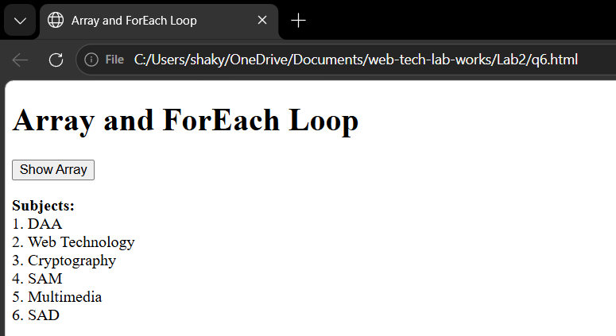
Lab 2.7
Code: Output:
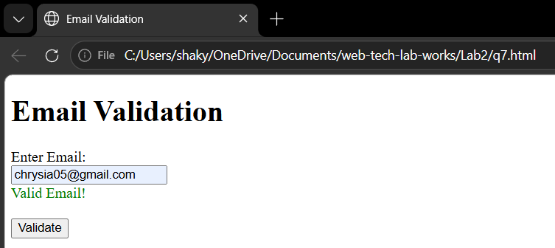
<!DOCTYPE html>
<html lang="en">
<head>
<meta charset="UTF-8">
<title>Email Validation</title>
</head>
<body>

<h1>Email Validation</h1>

<label>Enter Email:</label><br>
<input type="text" id="email" placeholder="example@email.com"><br>
<span id="result" style="color:red;"></span><br><br>
<button onclick="validateEmail()">Validate</button>

<script>
function validateEmail() {
let email = document.getElementById("email").value;
let result = document.getElementById("result");

// Regular expression for email validation
let regex = /^[a-zA-Z0-9._%-]+@[a-zA-Z0-9.-]+\.[a-zA-Z]{2,}$/;

if (email == "") {
result.style.color = "red";
result.innerHTML = "❌ Email is required!";
} else if (regex.test(email)) {
result.style.color = "green";
result.innerHTML = "Valid Email!";
} else {
result.style.color = "red";
result.innerHTML = "Invalid Email!";
}
}
</script>

</body>
</html>
Lab 2.8
Code:
<!DOCTYPE html>
<html>
<head>
<title>Cookies</title>
</head>

<body>

<h2>Cookie Demo</h2>

<h3>Set</h3>
Name: <input id="n"><br>
Value: <input id="v"><br>
Days: <input id="d" type="number"><br>
<button onclick="setC()">Set</button>
<p id="s"></p>

<h3>Get</h3>
<input id="gn">
<button onclick="getC()">Get</button>
<p id="g"></p>

<h3>Delete</h3>
<input id="dn">
<button onclick="delC()">Delete</button>
<p id="x"></p>

<script>
function setC(){
let n=document.getElementById("n").value;
let v=document.getElementById("v").value;
let d=document.getElementById("d").value;

let date=new Date();
date.setTime(date.getTime()+d*86400000);

document.cookie=n+"="+v+";expires="+date.toUTCString()+";path=/";
document.getElementById("s").innerText="Cookie Set";
}

function getC(){
let n=document.getElementById("gn").value;
let cookies=document.cookie.split(";");

for(let c of cookies){
c=c.trim();
if(c.startsWith(n+"=")){
document.getElementById("g").innerText=c;
return;
}
}

document.getElementById("g").innerText="Not found";
}

function delC(){
let n=document.getElementById("dn").value;
document.cookie=n+"=;expires=Thu, 01 Jan 1970 00:00:00 UTC;path=/";
document.getElementById("x").innerText="Deleted";
}
</script>

</body>
</html>

Output:
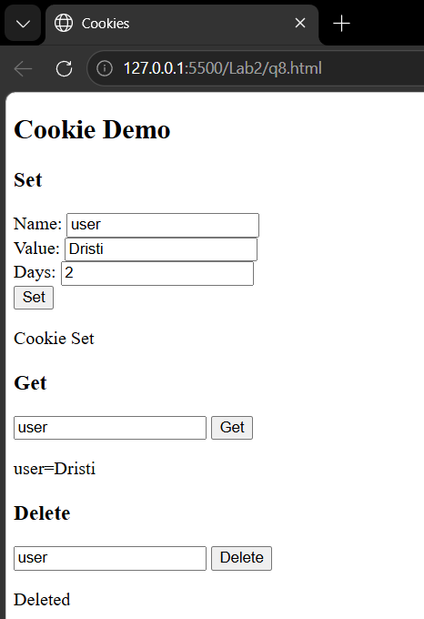
Lab 2.9
Code:
<!DOCTYPE html>
<html lang="en">
<head>
<title>Dropdown with jQuery</title>
<script src="https://cdnjs.cloudflare.com/ajax/libs/jquery/3.7.1/jquery.min.js"></script>
</head>
<body>
<h1>Dropdown Box using jQuery</h1>

<label>Select a Subject:</label><br><br>
<select id="myDropdown">
<option value="1">DAA</option><option value="2">Web Technology</option>
<option value="3">Cryptography</option><option value="4">SAM</option>
<option value="5">Multimedia</option><option value="6">SAD</option>
</select><br><br>
<button id="getBtn">Get Selected</button><br><br>
<span id="result"></span>
<script>
$(document).ready(function() {
$("#getBtn").click(function() {
let value = $("#myDropdown").val();
let text = $("#myDropdown option:selected").text();
$("#result").html("Selected Value: <b>" + value + "</b><br>Selected Text: <b>" + text + "</b>");
});
});
</script>

</body>
</html> Output:
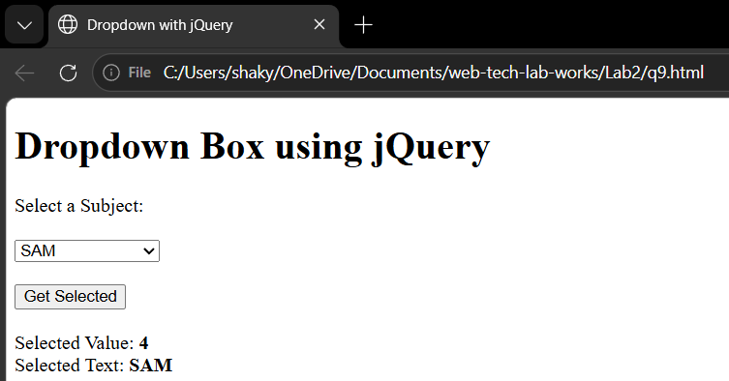

Lab 2.10
Code:
<!DOCTYPE html>
<html>
<head>
<title>AJAX</title>
<script src="https://cdnjs.cloudflare.com/ajax/libs/jquery/3.7.1/jquery.min.js"></script>
</head>

<body> Output:

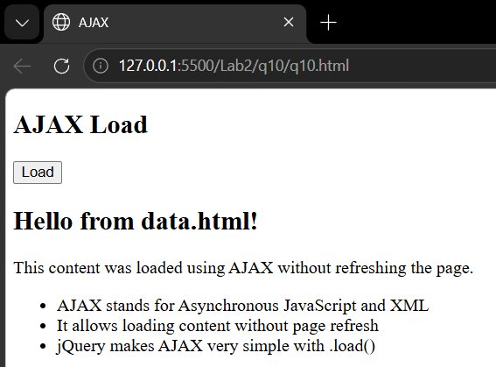
<h2>AJAX Load</h2>

<button id="btn">Load</button>
<div id="out">Content here</div>

<script>
$("#btn").click(function () {
$("#out").load("data.html", function (res, status) {
if (status == "error") $("#out").text("Error");
});
});
</script>

</body>
</html>
data.html
<h2>Hello from data.html!</h2>
<p>This content was loaded using AJAX without refreshing the page.</p>
<ul>
<li>AJAX stands for Asynchronous JavaScript and XML</li>
<li>It allows loading content without page refresh</li>
<li>jQuery makes AJAX very simple with .load()</li> </ul>

Lab 2.11
Code:
<!DOCTYPE html>
<html lang="en">
<head>
<title>jQuery Chaining</title>
<script src="https://cdnjs.cloudflare.com/ajax/libs/jquery/3.7.1/jquery.min.js"></script>
<style>
body { margin: 30px; }
#box { width: 300px; padding: 20px; background-color: lightblue; border-radius: 5px; margin-top: 20px; text-align: center; }
button { padding: 8px 16px; background-color: darkblue; color: white; border: none; border-radius: 5px; cursor: pointer; margin: 5px; }
</style>
</head>
<body>
<h1>jQuery Chaining</h1>
<button id="chainBtn">SlideUp then SlideDown</button>
<div id="box">
<h3>I am a box!</h3>
<p>Watch me slide up and down using chaining!</p>
</div>
<script>
$(document).ready(function() {
$("#chainBtn").click(function() {
$("#box").slideUp(1000).slideDown(1000);
});
});
</script> Output:
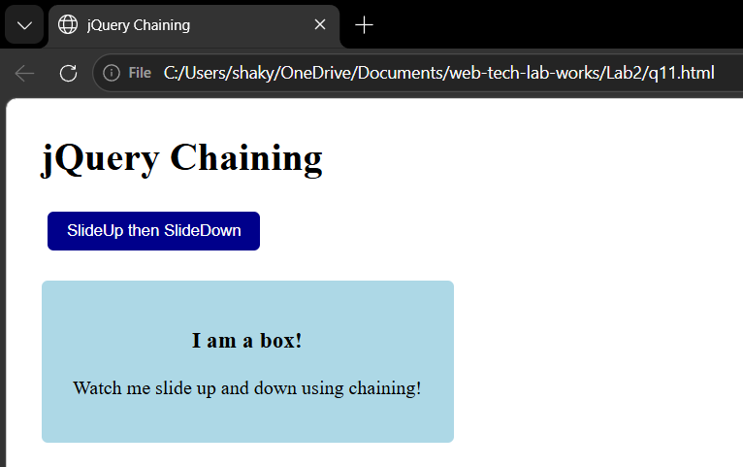
</body>
</html>

Lab 2.12
Code:
<!DOCTYPE html>
<html lang="en">
<head>
<meta charset="UTF-8">
<title>Image Slider</title>
<script src="https://cdnjs.cloudflare.com/ajax/libs/jquery/3.7.1/jquery.min.js"></script>
</head>
<body>

<h1>Image Slider</h1>

<button id="prevBtn">&#8592; Previous</button>
<button id="nextBtn">Next &#8594;</button>

<br><br>

<img id="slider" src="img1.jpg" width="400px">

<p id="counter"></p>

<script>
$(document).ready(function() {
let images = ["img1.jpg", "img2.jpg", "img3.jpg", "img4.jpg"];
let current = 0;

// Show initial counter
$("#counter").html("Image " + (current + 1) + " of " + images.length);

$("#nextBtn").click(function() {
current = (current + 1) % images.length;
$("#slider").attr("src", images[current]);
$("#counter").html("Image " + (current + 1) + " of " + images.length);
});

$("#prevBtn").click(function() {
current = (current - 1 + images.length) % images.length;
$("#slider").attr("src", images[current]);
$("#counter").html("Image " + (current + 1) + " of " + images.length);
});
});
</script>

</body>
</html>

Output:
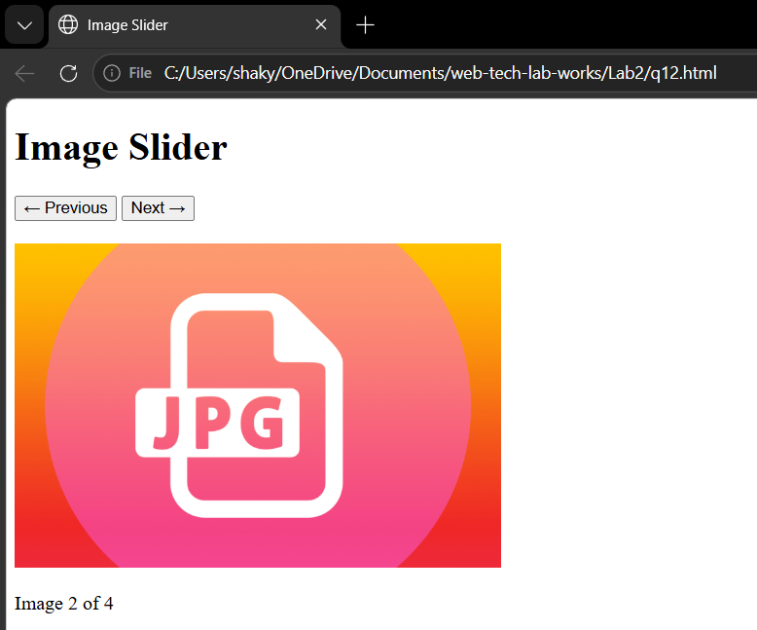

Lab 2.13
Code:
<!DOCTYPE html>
<html lang="en">
<head>
<meta charset="UTF-8">
<title>Sequential Animation</title>
<script src="https://cdnjs.cloudflare.com/ajax/libs/jquery/3.7.1/jquery.min.js"></script>
</head>
<body>

<h1>Sequential Animation</h1>
<button id="animateBtn">Animate!</button>
<button id="resetBtn">Reset</button>

<br><br>

<div id="box" style="width:100px; height:100px; background-color:black;"></div>

<script>
$(document).ready(function() {
$("#animateBtn").click(function() {
$("#box")
.animate({ width: "300px" }, 800)
.animate({ height: "300px" }, 800)
.animate({ opacity: 0.2 }, 800);
});

$("#resetBtn").click(function() {
$("#box").animate({ width: "100px", height: "100px", opacity: 1 }, 800);
});
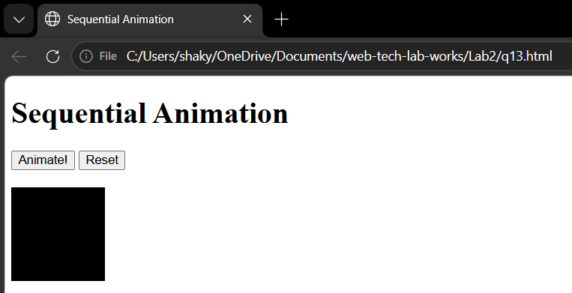
});
</script>

</body>
</html>

Lab 3.1
Code:
<?php

function divide($a, $b) {
if ($b == 0) {
throw new Exception("Division by zero is not allowed!");
}
return $a / $b;
}

try {
echo "10 / 2 = " . divide(10, 2) . "<br>";
echo "5 / 0 = " . divide(5, 0) . "<br>";
} catch (Exception $e) {
echo "Exception caught: " . $e->getMessage();
}
?>

Output:
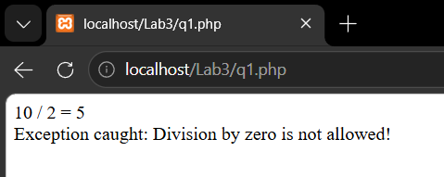

Lab 3.2
Code:
<?php
$a = 10;
$b = 3;

echo "<h2>Arithmetic Operators</h2>";
echo "a = $a, b = $b <br><br>";
echo "Addition: $a + $b = " . ($a + $b) . "<br>";
echo "Subtraction: $a - $b = " . ($a - $b) . "<br>";
echo "Multiplication: $a * $b = " . ($a * $b) . "<br>";
echo "Division: $a / $b = " . ($a / $b) . "<br>";
echo "Modulus: $a % $b = " . ($a % $b) . "<br>";
echo "Exponentiation: $a ** $b = " . ($a ** $b) . "<br>";

echo "<h2>Comparison Operators</h2>";
echo "a = $a, b = $b <br><br>";
echo "a == b : " . var_export($a == $b, true) . "<br>";
echo "a != b : " . var_export($a != $b, true) . "<br>";
echo "a > b : " . var_export($a > $b, true) . "<br>";
echo "a < b : " . var_export($a < $b, true) . "<br>";
echo "a >= b : " . var_export($a >= $b, true) . "<br>";
echo "a <= b : " . var_export($a <= $b, true) . "<br>";

echo "<h2>Logical Operators</h2>";
$x = true;
$y = false;
echo "x = true, y = false <br><br>";
echo "x AND y : " . var_export($x && $y, true) . "<br>";
echo "x OR y : " . var_export($x || $y, true) . "<br>";
echo "NOT x : " . var_export(!$x, true) . "<br>";
echo "NOT y : " . var_export(!$y, true) . "<br>";
?>

Output:
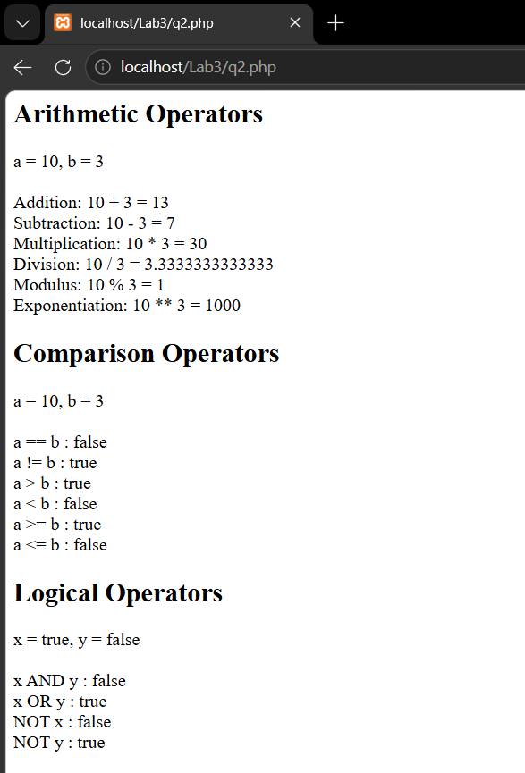

Lab 3.3
Code:
<?php
$name = $_POST['name'];
$email = $_POST['email'];
$gender = isset($_POST['gender']) ? $_POST['gender'] : "Not selected";
$course = $_POST['course'];
$hobbies = isset($_POST['hobbies']) ? implode(", ", $_POST['hobbies']) : "None selected";
?>
<!DOCTYPE html>
<html lang="en">
<head>
<meta charset="UTF-8">
<title>Form Data</title>
</head>
<body>
<h1>Submitted Details</h1>
<p><b>Full Name:</b> <?php echo $name; ?></p>
<p><b>Email:</b> <?php echo $email; ?></p>
<p><b>Gender:</b> <?php echo $gender; ?></p>
<p><b>Course:</b> <?php echo $course; ?></p>
<p><b>Hobbies:</b> <?php echo $hobbies; ?></p>

<br>
<a href="q3.html">Go Back</a>

</body>
</html>
Html
<!DOCTYPE html>
<html lang="en">
<head>
<meta charset="UTF-8">
<title>Form</title>
</head>
<body>
<h1>Student Form</h1>
<form action="q3.php" method="POST">
<label>Full Name:</label><br>
<input type="text" name="name" placeholder="Enter your name"><br><br>

<label>Email:</label><br>
<input type="text" name="email" placeholder="Enter your email"><br><br>

<label>Gender:</label><br>
<input type="radio" name="gender" value="Male"> Male
<input type="radio" name="gender" value="Female"> Female
<input type="radio" name="gender" value="Other"> Other<br><br>

<label>Select Course:</label><br>
<select name="course">
<option value="">-- Select --</option>
<option value="BCA">BCA</option>
<option value="BSc CSIT">BSc CSIT</option>
<option value="BIT">BIT</option>
<option value="MCA">MCA</option>
</select><br><br>

<label>Hobbies:</label><br>
<input type="checkbox" name="hobbies[]" value="Coding"> Coding
<input type="checkbox" name="hobbies[]" value="Gaming"> Gaming
<input type="checkbox" name="hobbies[]" value="Reading"> Reading
<input type="checkbox" name="hobbies[]" value="Travelling"> Travelling<br><br>

<input type="submit" value="Submit">
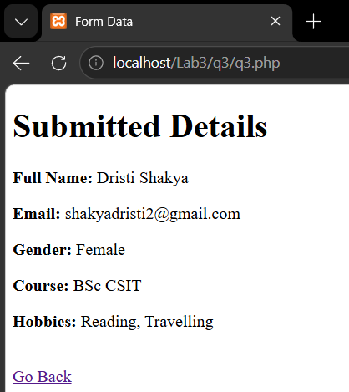
</form>
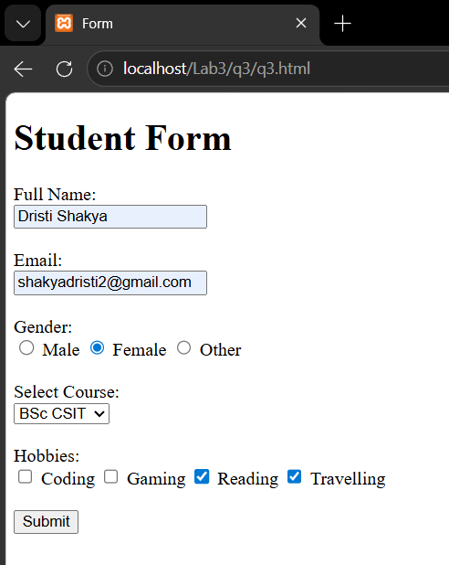
</body>
</html>
Output:

Lab 3.4
Code:
<?php
$filename = "data.txt";
if (!file_exists($filename)) {
echo "File not found!";
exit;
}
$file = fopen($filename, "r");
?>
<!DOCTYPE html>
<html lang="en">
<head>
<meta charset="UTF-8">
<title>Read File</title>
</head>
<body>
<h1>File Contents</h1>
<table border="1" cellpadding="8">
<tr>
<th>Name</th><th>Age</th><th>Course</th>
</tr>
<?php
while (!feof($file)) {
$line = fgets($file); Output:
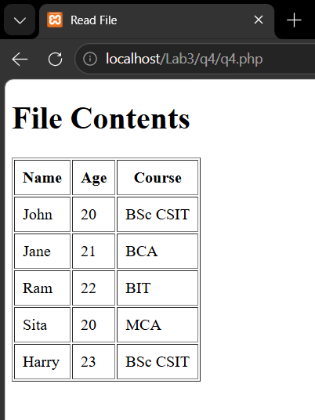
if ($line) {
$data = explode(",", trim($line));
echo "<tr>";
echo "<td>" . $data[0] . "</td>";
echo "<td>" . $data[1] . "</td>";
echo "<td>" . $data[2] . "</td>";
echo "</tr>";
}
}
fclose($file);
?>
</table>
</body>
</html>

Lab 3.5
Code:
Html:
<!DOCTYPE html>
<html lang="en">
<head>
<meta charset="UTF-8">
<title>Login</title>
</head>
<body>
<h1>Login</h1>
<form action="q5.php" method="POST">
<label>Username:</label><br>
<input type="text" name="username" placeholder="Enter username"><br><br>
<label>Password:</label><br>
<input type="password" name="password" placeholder="Enter password"><br><br>
<input type="submit" value="Login">
</form>
</body>
</html>
Php:
<?php
$validUsername = "admin";
$validPassword = "123456";
$username = $_POST['username'];
$password = $_POST['password'];
if ($username == $validUsername && $password == $validPassword) {
header("Location: welcome.php?username=$username");
exit;
} else {
echo "<h2 style='color:red;'>❌ Invalid username or password!</h2>";
echo "<a href='q5.html'>Go Back</a>";
}
?>
welcome.php
<?php
// Welcome page after successful login

$username = $_GET['username'];
?>

<!DOCTYPE html>
<html lang="en">
<head>
<meta charset="UTF-8">
<title>Welcome</title>
</head>
<body>

<h1>Welcome, <?php echo $username; ?>! 🎉</h1>
<p>You have successfully logged in.</p>
<br>
<a href="q5.html">Logout</a>

</body>
</html>

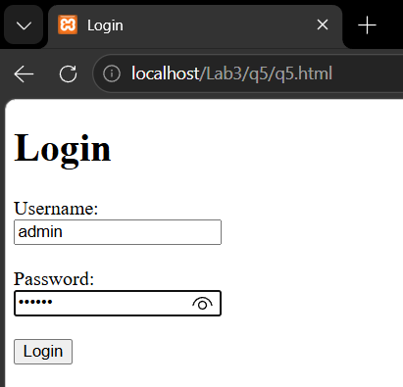
Output:

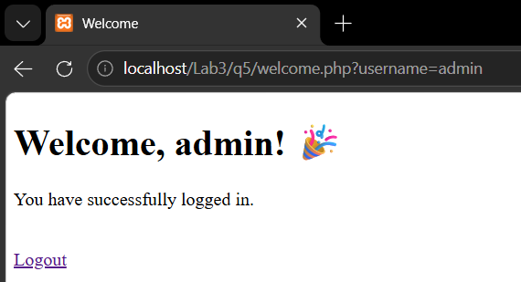

Lab 3.6
Code:
<?php
$conn = mysqli_connect("localhost", "root", "", "studentdb");

if (!$conn) {
die("Connection failed: " . mysqli_connect_error());
}
$name = $_POST['name'];
$address = $_POST['address'];
$phone = $_POST['phone'];
$age = $_POST['age'];
$gender = isset($_POST['gender']) ? $_POST['gender'] : "Not selected";
$sql = "INSERT INTO students (name, address, phone, age, gender)
VALUES ('$name', '$address', '$phone', '$age', '$gender')";
if (mysqli_query($conn, $sql)) {
echo "<h2 style='color:green;'> Student details saved successfully!</h2>";
echo "<a href='q6.html'>Go Back</a>";
} else {
echo "<h2 style='color:red;'> Error: " . mysqli_error($conn) . "</h2>";
}
mysqli_close($conn);
?>
Html:
<!DOCTYPE html>
<html lang="en">
<head>
<meta charset="UTF-8">
<title>Student Form</title>
</head>
<body>
<h1>Student Registration</h1>
<form action="q6.php" method="POST">
<label>Full Name:</label><br>
<input type="text" name="name" placeholder="Enter your name"><br><br>

<label>Address:</label><br>
<input type="text" name="address" placeholder="Enter your address"><br><br>

<label>Phone:</label><br>
<input type="text" name="phone" placeholder="Enter your phone"><br><br>

<label>Age:</label><br>
<input type="text" name="age" placeholder="Enter your age"><br><br>

<label>Gender:</label><br>
<input type="radio" name="gender" value="Male"> Male
<input type="radio" name="gender" value="Female"> Female
<input type="radio" name="gender" value="Other"> Other<br><br>

<input type="submit" value="Submit">
</form>
</body>
</html>

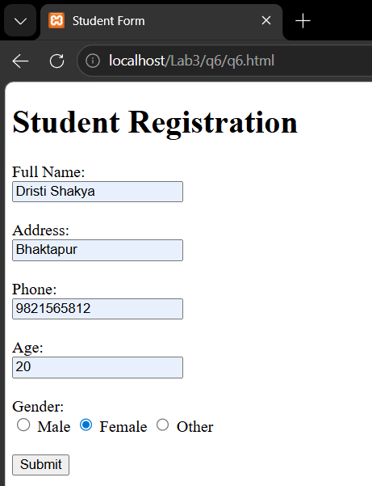
Output:

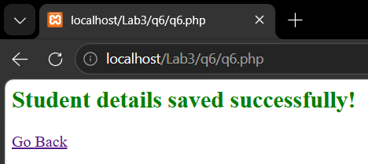

Lab 3.7
Code:
<?php
// Q7: Store page views count in SESSION, increment on each refresh and show on webpage

session_start();

if (!isset($_SESSION['count'])) {
$_SESSION['count'] = 0;
}

$_SESSION['count']++;
?>

<!DOCTYPE html>
<html lang="en">
<head>
<meta charset="UTF-8">
<title>Page View Counter</title>
</head>
<body>

<h1>Page View Counter</h1>
<p>You have visited this page <b><?php echo $_SESSION['count']; ?></b> times!</p>

<a href="q7.php">Refresh</a> |
<a href="reset.php">Reset Counter</a>

</body>
</html>

Output:
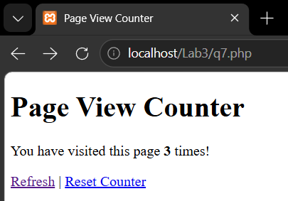

Lab 3.8
Code:
<?php
error_reporting(E_ALL);
ini_set('display_errors', 1);
$conn = new mysqli("localhost", "root", "");
if ($conn->connect_error) {
die("Connection failed: " . $conn->connect_error);
}
echo "Connected successfully<br>";
if ($conn->query("CREATE DATABASE IF NOT EXISTS collegedb")) {
echo "Database created successfully<br>";
} else {
die("Error creating database: " . $conn->error);
}
$conn->select_db("collegedb");
$sql = "CREATE TABLE IF NOT EXISTS teachers (
id INT AUTO_INCREMENT PRIMARY KEY,
name VARCHAR(100),
age INT,
subject VARCHAR(100)
)";
if ($conn->query($sql)) {
echo "Table created successfully<br>";
} else {
die("Error creating table: " . $conn->error);
}
$check = $conn->query("SHOW COLUMNS FROM teachers LIKE 'phone'");
if ($check->num_rows == 0) {
if ($conn->query("ALTER TABLE teachers ADD phone VARCHAR(15)")) {
echo "Phone column added successfully<br>";
} else {
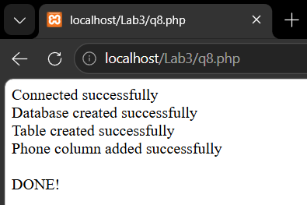
echo "Error adding column: " . $conn->error;
}
} else {
echo "Phone column already exists<br>";
}
echo "<br>DONE!";
$conn->close();
?>
Lab 3.9
Code:
<?php
setcookie("username", "John", time() + (86400), "/");
setcookie("course", "BSc CSIT", time() + (86400), "/");
setcookie("college", "TU", time() + (86400), "/");
?>
<!DOCTYPE html>
<html lang="en">
<head>
<meta charset="UTF-8">
<title>Cookies Demo</title>
</head>
<body>
<h1>Passing Variables with Cookies</h1>
<?php
if (isset($_COOKIE['username'])) {
echo "<p><b>Username:</b> " . $_COOKIE['username'] . "</p>";
echo "<p><b>Course:</b> " . $_COOKIE['course'] . "</p>";
echo "<p><b>College:</b> " . $_COOKIE['college'] . "</p>";
} else {
echo "<p>Cookies not set yet! Please refresh the page.</p>";
}
?>
<br>
<a href="q9.php">Refresh to see cookies</a>
</body>
</html>

Output:
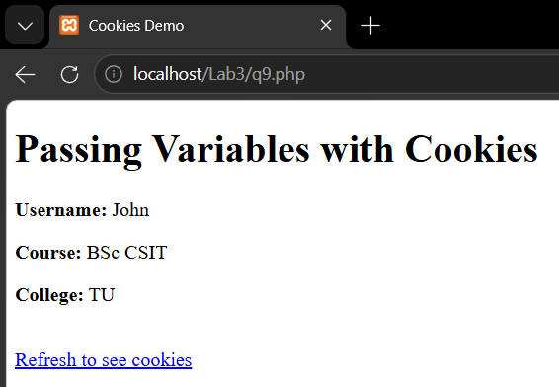

Lab 3.10
Code:
<?php
class Student {
public $name;
public $age;
// Constructor
function __construct($n, $a) {
$this->name = $n;
$this->age = $a;
}
// Method
function display() {
echo "Name: " . $this->name . "<br>";
echo "Age: " . $this->age;
}
}
// Creating object
$s = new Student("Dristi", 20);

// Calling method
$s->display();

?>

Output:
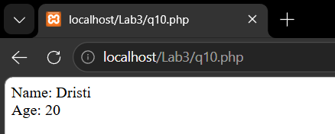

Lab 3.11
Code:
<?php
?>
<!DOCTYPE html>
<html lang="en">
<head>
<meta charset="UTF-8">
<title>Passing Variables through URL</title>
</head>
<body>
<h1>Passing Variables through URL</h1>
<p>Click a student to see their details:</p>
<a href="q11receive.php?name=Ram&age=20&course=BSc CSIT">Ram</a><br><br>
<a href="q11receive.php?name=Sita&age=21&course=BCA">Sita</a><br><br>
<a href="q11receive.php?name=Harry&age=22&course=BIT">Harry</a>
</body>
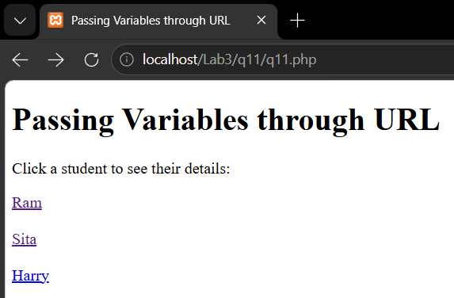
</html>
receive.php
<?php
$name = $_GET['name'];
$age = $_GET['age'];
$course = $_GET['course'];
?>
<!DOCTYPE html>
<html lang="en">
<head>
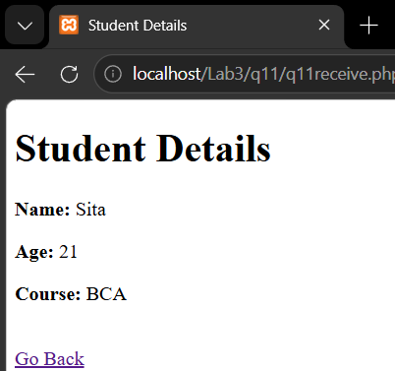
<meta charset="UTF-8">
<title>Student Details</title>
</head>
<body>
<h1>Student Details</h1>
<p><b>Name:</b> <?php echo $name; ?></p>
<p><b>Age:</b> <?php echo $age; ?></p>
<p><b>Course:</b> <?php echo $course; ?></p>
<br>
<a href="q11.php">Go Back</a>

</body>
</html>
Lab 4.1
Code:
<?xml version="1.0" encoding="UTF-8"?>
<books>
<book>
<title>Introduction to Algorithms</title>
<author>Thomas H. Cormen</author>
<isbn>978-0262033848</isbn>
<publisher>MIT Press</publisher>
<edition>3rd</edition>
<price>$85.00</price>
</book>
<book>
<title>Web Technology</title>
<author>Chris Bates</author>
<isbn>978-0470017616</isbn>
<publisher>Wiley</publisher>
<edition>3rd</edition>
<price>$45.00</price>
</book>
</books>

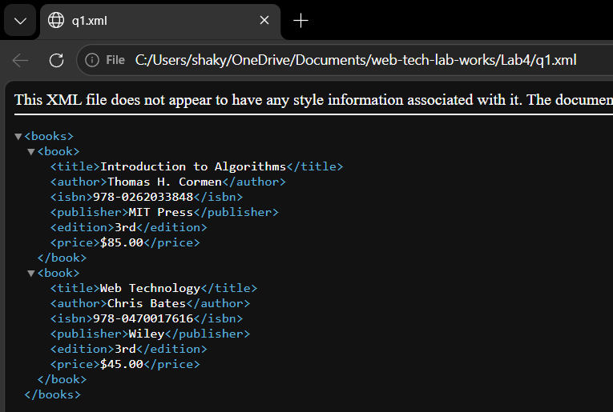
Output:

Lab 4.2
Code:
<?xml version="1.0" encoding="UTF-8"?>
<!-- Q2: XML file to display Employee information -->
<employees>
<employee><name>Ram Sharma</name><address>Kathmandu</address><phone>9841234567</phone><designation>Software Engineer</designation><salary>50000</salary></employee>
<employee><name>Sita Thapa</name><address>Pokhara</address><phone>9857654321</phone><designation>Web Developer</designation><salary>45000</salary></employee>
</employees>
Xsd:
<?xml version="1.0" encoding="UTF-8"?>
<xs:schema xmlns:xs="http://www.w3.org/2001/XMLSchema">
<xs:element name="employees">
<xs:complexType><xs:sequence>
<xs:element name="employee" maxOccurs="unbounded">
<xs:complexType><xs:sequence>
<xs:element name="name" type="xs:string"/>
<xs:element name="address" type="xs:string"/>
<xs:element name="phone" type="xs:string"/>
<xs:element name="designation" type="xs:string"/>
<xs:element name="salary" type="xs:integer"/>
</xs:sequence></xs:complexType>
</xs:element>
</xs:sequence></xs:complexType>
</xs:element>
</xs:schema>
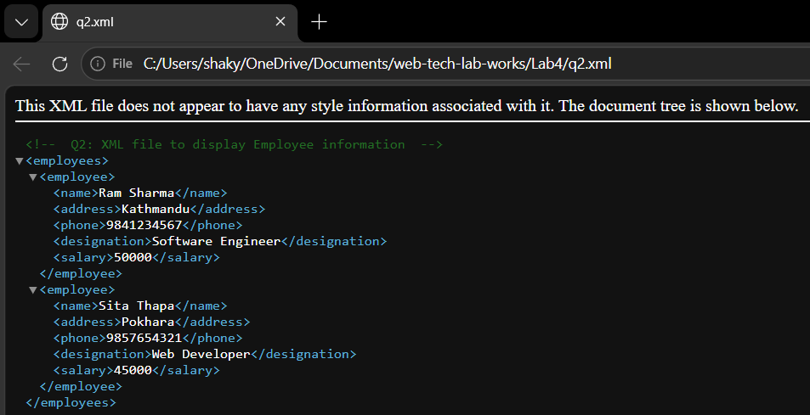
Output:

Lab 4.3
Code:
<?xml version="1.0" encoding="UTF-8"?>
<!-- Q3: Valid XML to validate book details -->
<books xmlns:xsi="http://www.w3.org/2001/XMLSchema-instance" xsi:noNamespaceSchemaLocation="q3.xsd">
<book isbn="978-0262033848">
<name><firstname>Introduction</firstname><middlename>to</middlename><lastname>Algorithms</lastname></name>
<author>Thomas Cormen</author><author>Charles Leiserson</author>
<pageno>1292</pageno><price>850</price>
</book>
</books>
Xsd:
<?xml version="1.0" encoding="UTF-8"?>
<xs:schema xmlns:xs="http://www.w3.org/2001/XMLSchema">
<xs:element name="books">
<xs:complexType><xs:sequence>
<xs:element name="book" maxOccurs="unbounded">
<xs:complexType>
<xs:sequence>
<xs:element name="name">
<xs:complexType><xs:sequence>
<xs:element name="firstname" type="xs:string"/>
<xs:element name="middlename" type="xs:string"/>
<xs:element name="lastname" type="xs:string"/>
</xs:sequence></xs:complexType>
</xs:element>
<xs:element name="author" type="xs:string" maxOccurs="unbounded"/>
<xs:element name="pageno" type="xs:integer"/>
<xs:element name="price">
<xs:simpleType><xs:restriction base="xs:integer">
<xs:maxInclusive value="1000"/>
</xs:restriction></xs:simpleType>
</xs:element>
</xs:sequence>
<xs:attribute name="isbn" type="xs:string" use="required"/>
</xs:complexType>
</xs:element>
</xs:sequence></xs:complexType>
</xs:element>
</xs:schema>

Output:
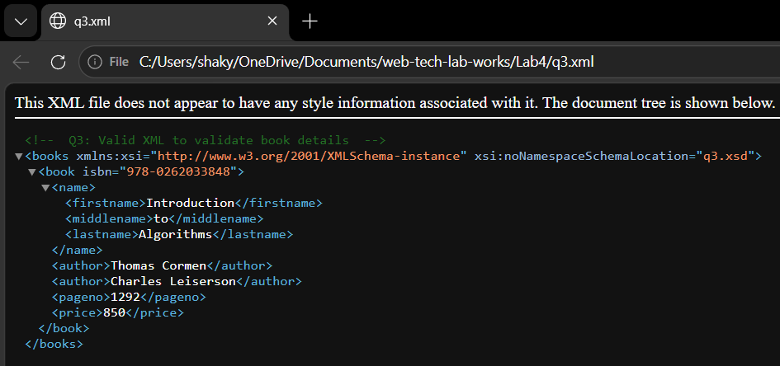

Lab 4.4
Code:
<?xml version="1.0" encoding="UTF-8"?>
<?xml-stylesheet type="text/xsl" href="q4.xsl"?>
<students>
<student><name>Ram</name><address>Kathmandu</address><rollno>3001</rollno></student>
<student><name>Sham</name><address>Pokhara</address><rollno>3002</rollno></student>
</students>
Xsl:
<?xml version="1.0" encoding="UTF-8"?>
<xsl:stylesheet version="1.0" xmlns:xsl="http://www.w3.org/1999/XSL/Transform">
<xsl:template match="/">
<html><body>
<h2>List of students</h2>
<xsl:for-each select="students/student">
<p>Name: <xsl:value-of select="name"/>, Address: <xsl:value-of select="address"/>, Roll no: <xsl:value-of select="rollno"/></p>
</xsl:for-each>
</body></html>
</xsl:template>
</xsl:stylesheet>

Output:
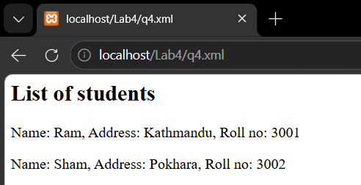

Lab 4.5
Code:
<?xml version="1.0" encoding="UTF-8"?>
<songs>
<song>
<name>Bohemian Rhapsody</name>
<singer>Freddie Mercury</singer>
<composedby>Freddie Mercury</composedby>
<length>5:55</length>
</song>
<song>
<name>Shape of You</name>
<singer>Ed Sheeran</singer>
<composedby>Ed Sheeran</composedby>
<length>3:53</length>
</song>
<song>
<name>Blinding Lights</name>
<singer>The Weeknd</singer>
<composedby>Abel Tesfaye</composedby> Output:
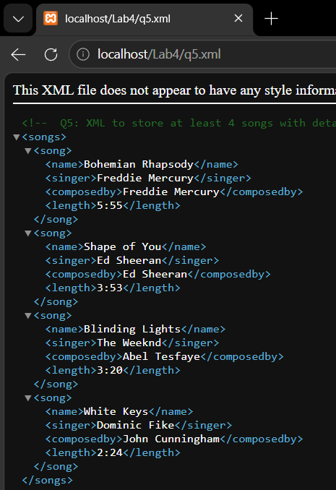
<length>3:20</length>
</song>
<song>
<name>White Keys</name>
<singer>Dominic Fike</singer>
<composedby>John Cunningham</composedby>
<length>2:24</length>
</song>
</songs>

Lab 4.6
Code:
?xml version="1.0" encoding="UTF-8"?>
<books>
<book>
<title>OpenGL Programming Guide Fourth Edition</title>
<location>107</location>
<publisher>Addison Wesley</publisher>
<year>2004</year>
</book>
<book>
<title>Curves and Surfaces for CAGD: A Practical Guide</title>
<location>116</location>
<publisher>Academic Press</publisher>
<year>2002</year>
</book>
<book>
<title>An Introduction to NURBS: With Historical Perspective</title>
<location>120</location>
<publisher>Academic Press</publisher>
<year>2001</year>
</book>

<book>
<title>NURBS: From Projectory Geomertry to Practical Use</title>
<location>125</location>
<publisher>AK Peters</publisher>
<year>1999</year>
</book>
</books>
Xsl:
<?xml version="1.0" encoding="UTF-8"?>
<xsl:stylesheet version="1.0" xmlns:xsl="http://www.w3.org/1999/XSL/Transform">
<xsl:template match="/">
<html><body>
<h2>Book List</h2>
<table border="1" cellpadding="8">
<tr><th>Title</th><th>Location</th><th>Publisher</th><th>Year</th></tr>
<xsl:for-each select="books/book">
<tr>
<td><xsl:value-of select="title"/></td><td><xsl:value-of select="location"/></td>
<td><xsl:value-of select="publisher"/></td><td><xsl:value-of select="year"/></td>
</tr>
</xsl:for-each>
</table>
</body></html>
</xsl:template>
</xsl:stylesheet>

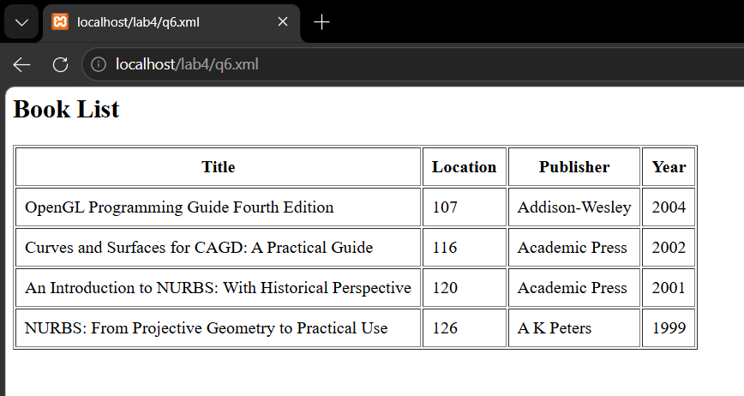
Output:

Lab 4.7
Code:
<?xml version="1.0" encoding="UTF-8"?>
<!-- Q7: XML with CSS to display contact details -->
<?xml-stylesheet type="text/css" href="q7.css"?>
<contacts>
<contact><name>James Smith</name><street>101 South Street</street>
<city>Halifax</city><email>james@dal.ca</email><phone>4940001</phone></contact>
<contact><name>Tom White</name><street>202 Victoria Road</street>
<city>Dartmouth</city><email>tom@dal.ca</email><phone>4940002</phone></contact>
</contacts>
CSS:
contact { display: block; margin: 20px; }
name { display: block;
font-size: 24px; font-weight: bold;
color: red; font-family: Georgia, serif; }
street, city, email, phone {
display: block;
color: green;
font-family: Georgia, serif;
}

Output:
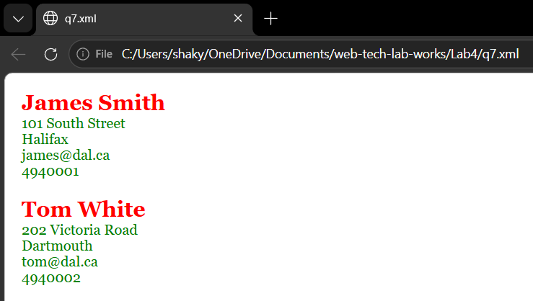

Lab 4.8
Code:
<?xml version="1.0" encoding="UTF-8"?>
<!-- Q8: XML document validated using DTD -->

<!DOCTYPE students [
<!ELEMENT students (student+)>
<!ELEMENT student (name, address, rollno)>
<!ELEMENT name (#PCDATA)>
<!ELEMENT address (#PCDATA)>
<!ELEMENT rollno (#PCDATA)>
]>
<students>
<student>
<name>Ram Sharma</name>
<address>Kathmandu, Nepal</address>
<rollno>3001</rollno>
</student>
<student>
<name>Sita Thapa</name>
<address>Pokhara, Nepal</address>
<rollno>3002</rollno>
</student>
</students>

Output:
