Software Requirements Specification Document

Bearcat Marketplace

Software Requirements Specification

1.0

06/11/209

**Team Members**

Aawaj Joshi

Dristi Marasini

Srujana Gattu

Chinmai Sai Sure

Jeevan Sai Subhash Veeramachaneni

Venkat Raghava Sampath Vagicharla

Submitted in partial fulfilment

Of the requirements of

CSIS 44-691 Graduate Directed Project 1

**Revision History**

|  |  |  |  |
| --- | --- | --- | --- |
| **Date** | **Description** | **Author** | **Comments** |
| 06/13/2019 | 1.0 | Srujana Gattu | First Revision |
| 06/20/2019 |  | Aawaj Joshi | Second Revision |
| 06/27/2019 |  | Chinmai Sai Sure | Third Revision |
| 06/03/2019 |  | Dristi Marasini | Fourth Revision |

# **Document Approval**

The following Software Requirements Specification has been accepted and approved by the following:

|  |  |  |  |
| --- | --- | --- | --- |
| **Signature** | **Printed Name** | **Title** | **Date** |
|  | Dr. Zhengrui Qin  Lohitha Bethalem | Project Requirements | 06/12/2019 |
|  | Dr. Zhengrui Qin  Lohitha Bethalem | ER Diagram |  |
|  | Dr. Zhengrui Qin  Lohitha Bethalem | Project Schedule(Gantt Chart) |  |
|  | Dr. Zhengrui Qin  Lohitha Bethalem | UI designs |  |

**Table of contents Page no**

**1. Introduction** **4**

1.1 Purpose 4

1.2 Scope 4

1.3 Definitions, Acronyms, and Abbreviations 5

1.4 References 5

1.5 Overview 5

**2.General Description** **7**

2.1.Product Perspective 7

2.2.Product Functions 7

2.3.User Characteristics 7

2.4.General Constraints 7

2.5.Assumptions and Dependencies 7

**3. Specific Requirements** **8**

3.1. External Interface Requirements 8

3.1.1. User Interfaces 8

3.1.2. Hardware Interfaces 8

3.1.3. Software Interfaces 8

3.1.4. Communications Interface 8

3.2. Functional Requirements 8

3.2.1. Admin Requirements 8

3.2.2 User Requirements 9

3.3.Use Cases 10

3.4. Class/Objects 10

3.5 Non-Functional Requirements 10

3.5.1. Performance 10

3.5.2. Reliability 11

3.5.3. Availability 11

3.5.4 Security 11

3.5.6 Portability 11

3.6. Inverse Requirements 11

3.7. Design Constraints 11

3.8. Logical Database Requirements 11

3.9. Other Requirements 11

3.10. Prototypes (for complete project) 11

3.11 Use Case diagrams 12

**4.Design** **13**

4.1 ER Diagram 13

4.2 Prototypes 15

# 

# 

# 

# 

# 

# 

# 

# 

# 

# 

# 

# 

# **1. Introduction**

## **1.1 Purpose**

This is a project requirements document for Bearcat Marketplace, a web-based e-commerce platform designed for the use of students and faculty of Northwest Missouri State University (NWMSU) located in the city of Maryville, Missouri. The application will be designed to enable users to post items for sale, do a customized browsing of the items posted for sale, and send an email to the seller. This project requirements document describes the various aspects of the project, such as scope, requirements, objectives, and the end goal. The document describes both functional as well as non-functional requirements, which were identified and defined by both the project team and the primary client. The functional requirements highlighted in the document are elucidated with use cases and class/object models. This document was created with the objective of directing the design and implementation of the target web application, and will be subjected to modification should new requirements need to be added to the ones already established in the document.

## **1.2 Scope**

The scope of the project is an e-commerce platform that allows the students and faculty of Northwest Missouri State University (NWMSU) to post or browse items for sale. The use of the application will be restricted to only the students and faculty of NWMSU who have a verifiable Northwest email account. Online payment for products through credit cards or any online payment system is not part of this project. The restriction is established to encourage a local and off-line transaction and promote website security. Contact between two prospective parties will be limited to Northwest email. Online live chat and in-app messaging are not part of this project.

## **1.3 Definitions, Acronyms, and Abbreviations**

|  |  |
| --- | --- |
| Acronyms and Abbreviations | Definition |
| NWMSU | Northwest Missouri State University |
| UI | User Interface |
| URD | User Requirement Document |
| SRD | Software Requirement Document |
| ERD | Entity Relationship Diagram |
| SDLC | Software Development Life Cycle |
| DNS | Domain Name System |

## **1.4 References**

*will be updated as more work is done on the project.

## **1.5 Overview**

This document provides detailed specifications of the web application and is organized into five different chapters:

1. Introduction of our project

2. General Description - This chapter describes in detail the perspective of the product, its many functionalities, the characteristics of the end users, pre-recognized constraints, and the many assumptions and dependencies established during the course of the development.

3. Specific Requirements - This chapter specifies the external Interface Requirements and Functional Requirements, which are further organized into several categories. The Interface Requirements section specifies measurable objectives and constraints on the overall application. The Functional Requirements section describes the use cases, classmodels, and non-functional requirements which are further categorized to describe the performance and reliability of the application .

4. Design - This chapter showcases the interaction diagrams - Entity Relationship Diagram and the Graphical User Interface.

5. Analysis Model - The final chapter presents as well as textually describes the Data Flow Diagram and the Sequence Diagram of the project.

# **2.General Description**

## **2.1.Product Perspective**

The client is looking for an e- commerece website based on the mutual buying and selling of mainly used products . They are looking for the products for buying and selling the products on the main basis of the communication between the buyer and seller.

## **2.2.Product Functions**

As it was an ecommerce website the main function is to buy and sell products for that we need a basic function of buying is the searching and sorting of the product. The other important function is donating of the products.

## **2.3.User Characteristics**

The basic characteristics of the project is to have both buyer and seller options to a user by this they can easily get access to sell or buy a product.

## **2.4.General Constraints**

The biggest constraint is to have good communication between the buyer and seller.And the payment options.

## **2.5.Assumptions and Dependencies**

The biggest assumption is the concept of the donation thing which is a toff task and also the other main dependencies is on the buyer how he wants to sell the product.

# **3. Specific Requirements**

## **3.1. External Interface Requirements**

### **3.1.1. User Interfaces**

### 

### **3.1.2. Hardware Interfaces**

### 

### **3.1.3. Software Interfaces**

### 

### **3.1.4. Communications Interface**

## **3.2. Functional Requirements**

## **3.2.1. Admin Requirements**

1. Admin login

Seller should be able to log in to the system with admin privileges using his admin username and password

|  |  |
| --- | --- |
| Admin username | Any username |
| Password | Minimum of 8 characters  At least one uppercase letter  At least one lowercase letter  At least one number or symbol (!, #, %, &. *) |

2. Add new items to the inventory

Seller should be able to add new items to the list.. New item should have the following fields. Items should be able to publish to the user’s list or hide it from the user’s list.

|  |  |  |  |  |  |  |  |  |
| --- | --- | --- | --- | --- | --- | --- | --- | --- |
| ID | Picture of the item | Item | Descri-ption | Buying price | #of units needed | Added date | Expiring Date | Comments |

3. Edit/Remove items on the inventory

Seller should be able to edit or remove any existing items on the list. When editing, he can edit all the fields except ID.

4. Accept or deny items supply requests from users

Once a user submit an item supply request, vendor should be able to accept or deny the request and inform the user the decision through an email.

5. Conform the received items from the users

Once vendor received the items from a user, vendor should be able to conform the received items and send a request for invoice from the user. These information will be sent to the user’s email.

## **3.2.2 User Requirements**

1. Make request for sign up

When a potential user wanted to be a member of the smart inventory system, he should fill the sign up form and send it to the vendor for approval. When a user sign up for the system, he should provide the following details.

|  |  |  |  |  |  |  |  |  |
| --- | --- | --- | --- | --- | --- | --- | --- | --- |
| First Name | Last Name | Email Address | Password | Contact number | Date of birth | Gender | Selected security question | Security answer |

In addition he needs to agree to the user agreement and user privacy notice

2. Log in to the Smart Inventory - Web

Once vendor approves the signup request, user can log in to the Smart Inventory – Browser using his email address and password.

4. View the items and details vender looking for

Once the user logs in to the Smart Inventory – Web, he can view the list of items currently vender is looking for. In the initial list it will display the following fields

|  |  |  |  |  |  |
| --- | --- | --- | --- | --- | --- |
| ID | Picture of the item | Item | Buying Price | # of units needed | Expiring date |

If user wants to see more details about a specific item, he can tap on the item and view the other information and methods of supplying the items.

5. Send requests for canceling/editing supplying list

If user wants to cancel or change a supply request that sent to the vendor, he should be able to send a cancel/change supply request to the vendor.

6. View the user’s transaction history

User should be able to view his transaction history with vendor

7. Logout

## **3.3.Use Cases**

## 

## **3.4. Class/Objects**

## **3.5 Non-Functional Requirements**

### **3.5.1. Performance**

In includes the no of resources required, response time the system takes and any benchmark specifications

### **3.5.2. Reliability**

It's about how often our system fails.

### **3.5.3. Availability**

The process that prioritize on increasing testability, diagnostics and maintenance of the project.

### **3.5.4 Security**

Protecting the project from the vulnerable attacks.No exposure of private details.

### **3.5.6 Portability**

Our system is flexible to any operating system.

### **3.6. Inverse Requirements**

Requirement that specified by the client that is mandatory to do.

## **3.7. Design Constraints**

Only Northwest Missouri students and faculty with SID can use it.

## **3.8. Logical Database Requirements**

We will work on MongoDB

## **3.9. Other Requirements**

At present no other requirements but may change in later levels.

## **3.10. Prototypes (for complete project)**

We will update prototypes once our design in finalized.

## **3.11 Use Case diagrams**

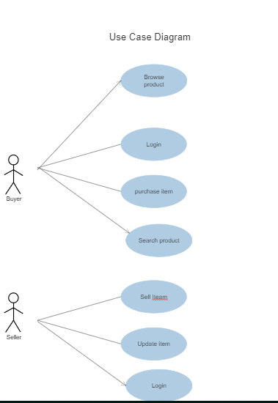

# **4.Design**

## **4.1 Initial ER Diagram**

## 

## 

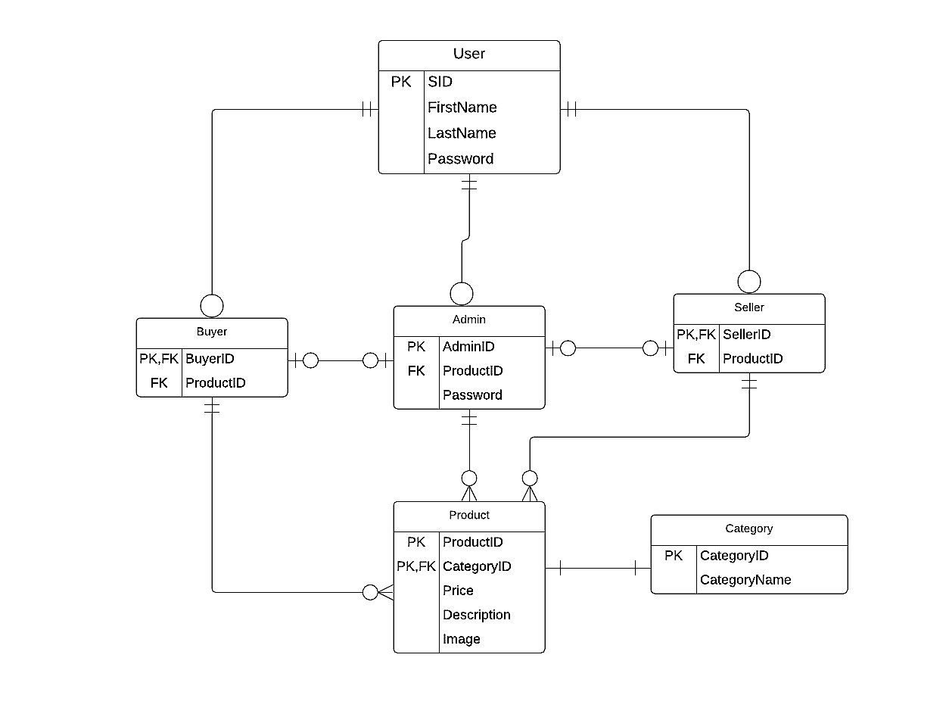

Updated ER diagram

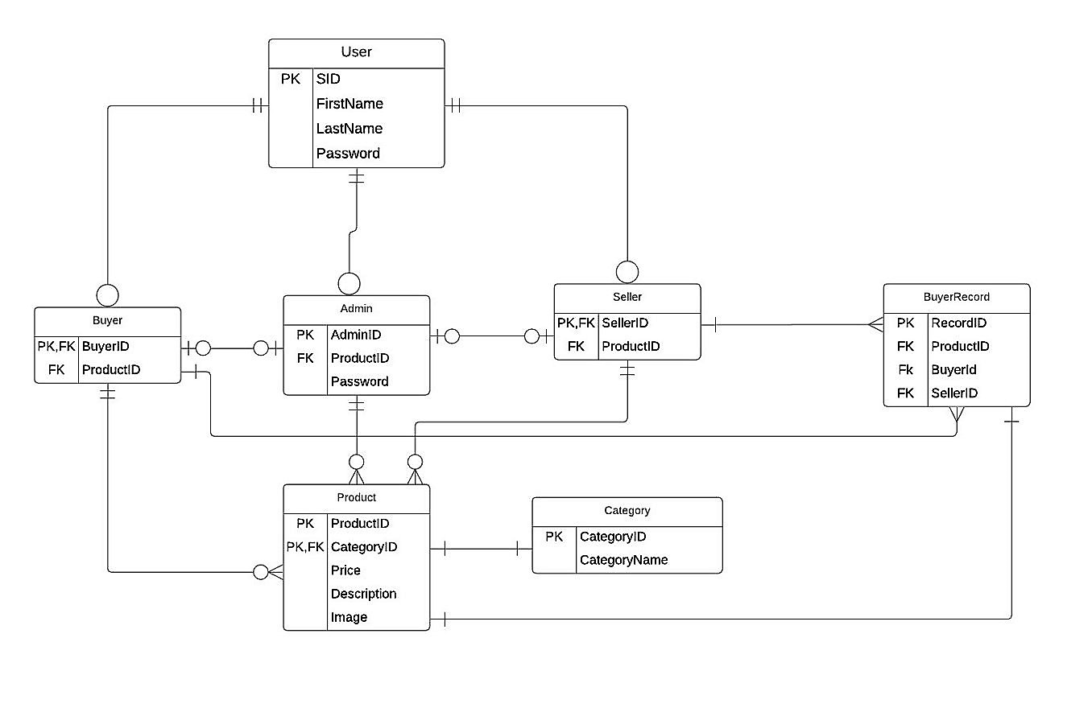

In our project, we have a real world user entity who has student ID in Northwest Missouri State University. Attributes include SID as primary key and First Name Last Name and Password. We have Seller entity who can sell items,Buyer entity who can sell items and Admin can monitor all the items and these processes are done are using SID. Every Seller, Buyer, Admin must be a user but not vice versa.Seller sells the items and saves the buyer info in buyer record.Seller can sell multiple items and save multiple buyer records.

Admin manages the product. He/she can add , delete and update the product. Buyer purchases the product with their Buyer Id. Every product belongs to some category which has category Id as primary key. Product entity has price, description , image, category Id as attributes. Category Id is foreign key in Product entity .

## 

## 

## **4.2 Prototypes**

Home page:

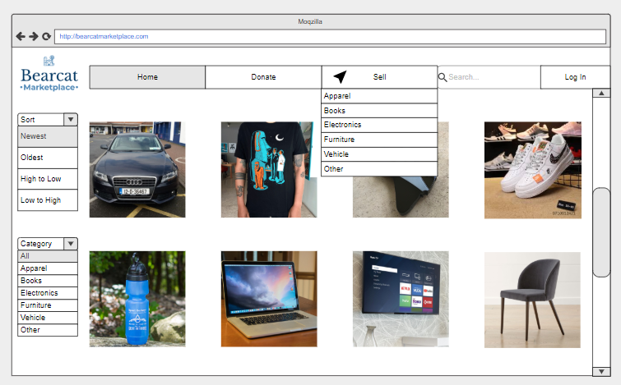

Login page:

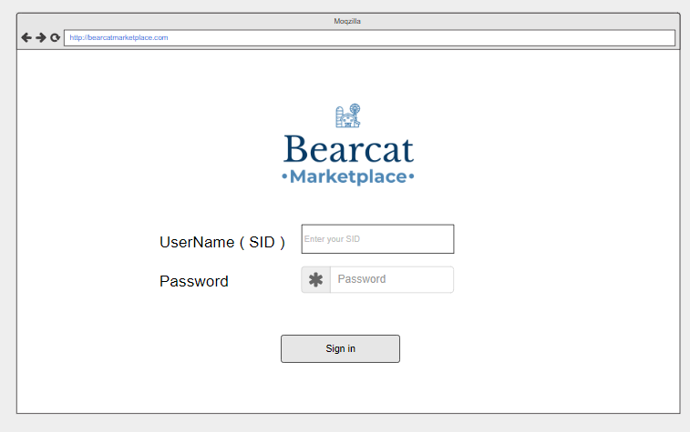

Seller page:

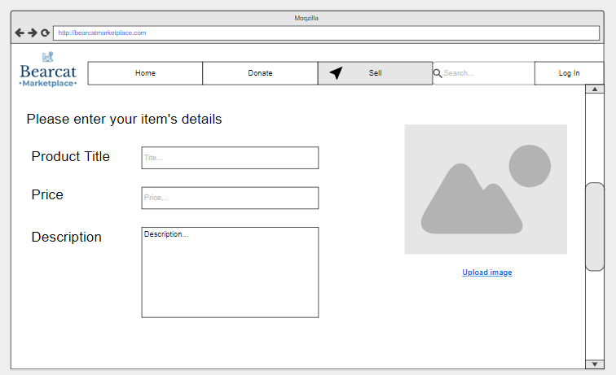

Product details page:

