CS 242: Lab 1 Problems

Note: Use only command-line interface, not GUI. If there are any queries, ask any TA present during the lab.

1. Open terminal. (There are multiple ways to open terminal, for reference read: <https://www.wikihow.com/Open-a-Terminal-Window-in-Ubuntu>)
2. Check the current working directory in the opened terminal. It should be /home/your_username. This directory is usually called as user home directory. (Hint: You can use the pwd command to check the current working directory.)
3. Make directory cs242 inside your home directory. (Hint: The command is mkdir. For reference read: <https://www.techwalla.com/articles/how-to-make-a-new-directory-in-linux>)

1. Make directory lab_1 inside cs242 directory. (Your current working directory should be the user home directory)
2. Delete cs242 directory. Does this also delete lab_1 directory? (Hint: Use rm command. For reference read: <https://www.linuxtechi.com/rm-command-examples-for-beginners/>)

1. Now recreate the directory structure as mentioned in problem3 and 4 (lab_1 inside cs242 inside your user home directory) using a single command. Your current working directory should be /home/your_username, before executing the command.
2. Change current directory to lab_1. (Hint: Use cd command. For reference read: <https://www.computerhope.com/issues/ch000795.htm#linux>)
3. Download the file available at (link1: <https://a.uguu.se/SLOyYlwQjPsi_practice_material.tar.gz>, link2: <http://172.16.117.60:5002/practice_material.tar.gz>) inside lab_1 directory using wget command. (For reference read: <https://www.howtogeek.com/281663/how-to-use-wget-the-ultimate-command-line-downloading-tool/>). Use link 2 for faster access.
4. Extract the downloaded file using tar command. The downloaded file is compressed using the [gzip](https://en.wikipedia.org/wiki/Gzip) compression. (For reference read: <https://www.interserver.net/tips/kb/extract-tar-gz-files-using-linux-command-line/>)
5. Suppose the compressed file is very large in size and there is not enough disk space available on your device. How can you list the content of archived file without extracting it? How to extract a specific file without extracting the complete archived file? Let say, you need to extract test_file_2.md file from the downloaded file. (Reference same as the reference for problem 9)
6. The folder structure should look like as shown below. Verify. You can generate this using tree command. Change directory to cs242 and type tree.

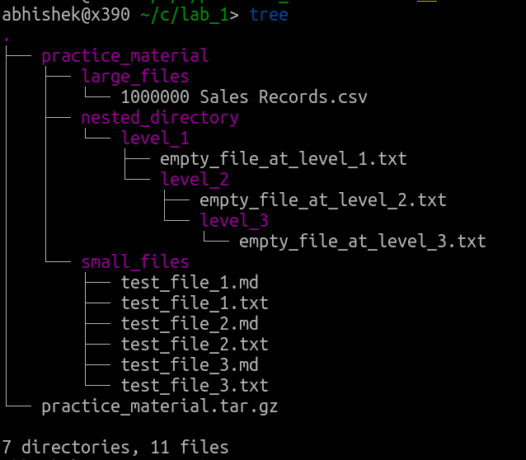

1. With lab_1 as your present working directory, list all the files and directories present in the practice_material directory. (For reference read: <https://www.tecmint.com/15-basic-ls-command-examples-in-linux/>)
2. Recursively list and files and directories in practice_material directory using ls and find commands. (For reference read: <https://www.cyberciti.biz/faq/how-to-show-recursive-directory-listing-on-linux-or-unix/>)
3. Repeat task 12 with the modification that the content will be listed in alphabetical order.
4. Repeat 12 with the modification that the content will be listed with increasing order of file size.
5. Repeat 12 with the modification that the content will be listed with the last modified content first.
6. Clear the content of current terminal session. (refer: <https://linoxide.com/linux-how-to/commands-clear-linux-terminal/>)
7. Change directory to /tmp/
8. Create an empty file with name test_file.txt using the touch command. For reference read: <http://www.linfo.org/touch.html>
9. Print your name on the terminal using the echo command. (For reference read: <https://www.geeksforgeeks.org/echo-command-in-linux-with-examples/>)
10. The output of echo is printed on the terminal as a standard output stream. This output can be redirected to other linux utilities or to files. Now use the redirection operator, to write your name into the test_file.txt. The command should be echo “Your_name” > test_file.txt
11. Display the content of the test_file.txt using cat command. (For reference read: <https://en.wikipedia.org/wiki/Cat_(Unix>))
12. Read more about redirection operators and append your roll number to the test_file.txt. (For reference read till pipes section: <https://www.digitalocean.com/community/tutorials/an-introduction-to-linux-i-o-redirection>)

1. Display the content of test_file.txt on the terminal. Does this display your name and roll number?
2. What are the file permissions of this test_file.txt? (For reference read: <https://www.pluralsight.com/blog/it-ops/linux-file-permissions>)
3. Change the file permission of test_file.txt to read only file.
4. Now try appending your branch name to the test_file.txt using the echo command and output redirections.
5. Are you able to write to the file?
6. Change the file permission of test_file.txt such that only you (your user not the group) can write. More on user management will be covered in next labs.
7. Repeat problem 27.
8. Display the content of test_file.txt on the terminal. Does it contain your name, roll number and branch name?
9. Reboot the OS. (Use reboot or systemctl reboot command.)
10. When rebooting is finished, open terminal and change directory to /tmp/
11. Check the content of the /tmp/ using ls command.
12. Does it contain test_file.txt file? Now change the directory to /home/your_username/cs242/lab_1/practice_material.
13. There are multiple files and directories present in the practice_material directory. How can we list all files present in practice_material and all its subdirectories which have an extension of “.txt”? (Hint: You can use the command ls -R **/*.txt) The wildcard pattern and regular expression will be covered in next labs.
14. For the file practice_material/large_files/1000000 Sales Records.csv, how can we get some basic information about this file such as number of lines, words and characters? (Hint use wc command, for reference read: <https://www.tecmint.com/wc-command-examples/>)
15. Display the content of practice_material/nested_directory/level_1/empty_file_at_level_1.txt on the standard output. (Hint: Problem 22)
16. Display the content of all .txt files present in the practice_material directory and all its subdirectories. (Hint: use combination of cat command and the wildcard pattern used in problem 36)
17. In problem 37, we found out that there are one million lines in 1000000 Sales Records.csv file. How can we display the first 20 and last 20 lines of this file? (Hint: use head and tail commands, for reference read: <https://www.linux.com/blog/14-tail-and-head-commands-linuxunix>)
18. How can we display the content of 1000000 Sales Records.csv from line 355 to line 375? (Hint: You must use a combination of head and tail commands with the pipe operator) Check reference of problem 40 and <http://www.linfo.org/pipes.html>
19. The data present is 1000000 Sales Records.csv file is obtained from <http://eforexcel.com/wp/downloads-18-sample-csv-files-data-sets-for-testing-sales/>. It is a [comma separated file](https://en.wikipedia.org/wiki/Comma-separated_values), where the second column has country names. How can we get only the country names mentioned in first 40 lines of this file? (Hint: use head command to get first 40 lines, pipe its output to cut command to filter column 2. For reference read: <https://www.thegeekstuff.com/2013/06/cut-command-examples/> point 4)
20. The output of problem 42 will be 40 countries, one country name per line, in the order as present in the original file. How can we sort these country names alphabetically? (Hint: Pipe the output of problem 42 to sort command, example: previous_commands | sort)
21. The output of 43 problem is sorted list of country names. Some country names are mentioned multiple times as the data have multiple entries for that country. How can we display only unique country names? (Hint: Pipe the output of command used in problem 43 to uniq command, reference for sort and uniq commands: <https://www.linode.com/docs/tools-reference/tools/manipulate-lists-with-sort-and-uniq/>)
22. How to find the current running process? (Hint: Use top command, for reference read: <https://www.geeksforgeeks.org/top-command-in-linux-with-examples/>)
23. We can also use the ps command to find current running processes. (For reference read: <http://www.linfo.org/ps.html>)
24. Get process id of your browser. Hint use ps –aux | grep name_of_browser. Will cover more on grep command in next labs.
25. Suppose your browser becomes very slow. Terminate the browser using the kill command. (Hint: Find its process id, then use kill command with the process id. For reference read: <http://www.linfo.org/kill.html>)