**ST10254488**

Akadinso Osuagwu

WED5020

POE

Part 1

**Table of Contents**

Introduction - Website Choice 2

Website Assets 4

Website Pages and Content 8

List of References 16

# **Introduction - Website Choice**

**Lander: Cultivating Sustainable Green Spaces**

**My idea:** Imagine an economy in which all communities have access to colorful green areas that promote health and ecological harmony. By uniting people, groups, and organizations committed to sustainable landscaping, my website aims to make this vision a reality.

**What This Website Is Going to Focus on:** Lander specializes in reviving rural and urban environments using cutting-edge, environmentally responsible methods. The webpage provides:

1. **Community Projects:** Learn about and lend your support to regional landscaping efforts. Look for opportunities to get involved or launch your own project, such as restoring parks or developing community gardens.
2. **Resource Hub:** Get an abundance of knowledge about water-saving strategies, native species, and sustainable landscaping practices. You can incorporate green practices into your own environment with the aid of our toolkits and tutorials.
3. **Workshops for Education:** Attend our webinars and online workshops to hear from specialists in environmental science and horticulture. Our intention is to arm you with the information you need to change the world.
4. **Opportunities for Collaboration:** Establish connections with corporations, NGOs, and local governments to work together on green projects. Our platform makes it easier to establish alliances that lead to significant change.
5. **Volunteer and Donate:** Contribute your time or resources to support our initiatives. Explore volunteer opportunities or donate to help fund vital green space projects.

In summary, Lander is more than just a website; it's a movement towards greener, healthier environments. Where growing community can come together and create beautiful, sustainable spaces that help improve lives and ecosystems.

# **Website Assets**

**Logo:** For my logo, I decided to use the name of my NGO – it's more concise and strikes its purpose. The title ‘Lander.’ is put inside of an <a> tag within a <h1> tag, so it is clickable and makes the whole navbar interactable.

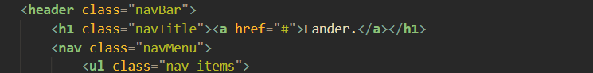

**Organization Icons:**

* (SVGrepo, n.d.)
* (SVGrepo, n.d.)

**Slogan & Hero Paragraph:** When picking a slogan, I had to make it something that gave my target audience hope on observation of it. **“Building green by green”**, since my NGO targets low-income communities – like townships, slow-growing demographics or un-sanitized environments. This seemed like a fitting slogan

Then for the summary of what we do, it had to get straight to the point, giving the user a sense of motivation when reading and accessing. 

**Images:**

* **Project Images**

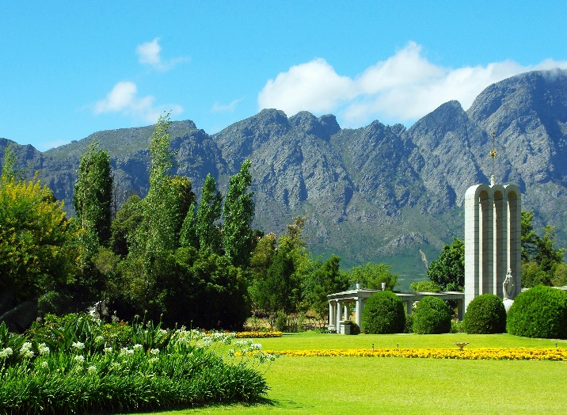

`(Pexels, 2017)

`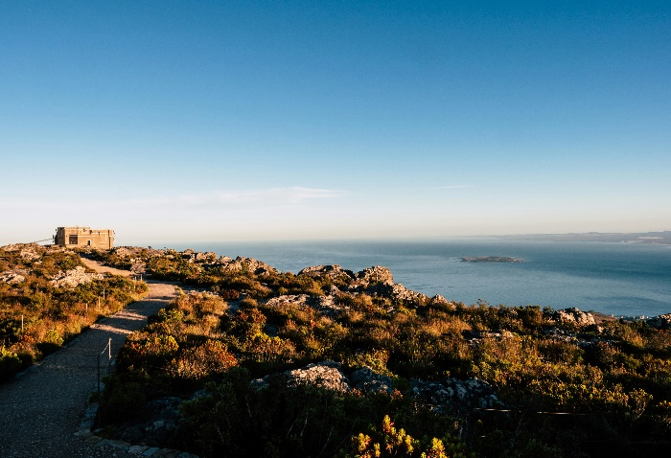

`(Pexels, 2018)

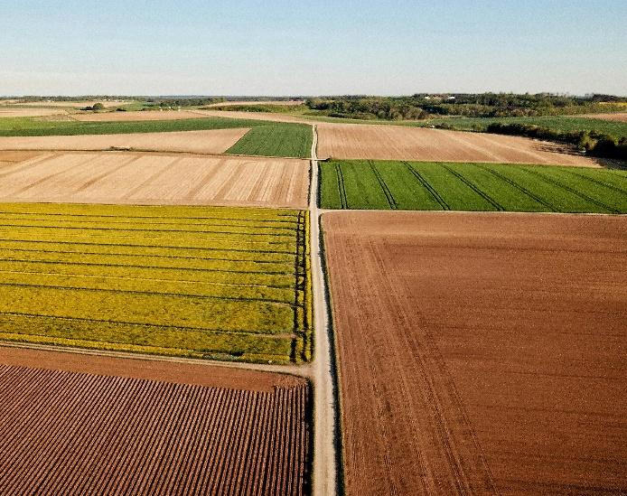

(Pexels, 2020)

**-About Us Images**



(Pexels, 2017)



(Pexels, 2021)

# **Website Pages and Content**

* **Homepage:**
  + **Meta Section (Head):**
    - **Title**: Defines the title of the webpage shown in the browser tab. Crucial for user recognition and SEO.
    - **Meta Tags**: Includes character set, description, and viewport settings. Essential for SEO and responsive design.
  + **Header:**
    - **Navigation Bar**: Contains the company logo, navigation links (Home, Projects, About Us, Contact Us), and social media icons. This is the main access point for navigating the website.
    - **Navigation Toggle Button**: Important for mobile users to expand or collapse the menu.
  + **Hero Section:**
    - **Hero Text and Buttons**: Highlights the company's mission and provides direct links to key actions (Enquire Here, View Projects). This section grabs the visitor's attention and directs them to the most important parts of the site.
  + **Services Section:**
    - **Service List**: Displays the guarantees of the company's services. This section explains what the company offers and builds trust with potential clients.
  + **Projects Section:**
    - **Recent Project Locations**: Showcases recent work to demonstrate the company's experience and quality.
    - **Testimonials Section:**
    - **Client Testimonials**: Provides social proof of the company’s quality and service from previous clients.
  + **Footer:**
    - **Legal Information and Social Links**: Contains copyright information, links to the privacy policy, terms of service, and social media icons. It serves as the concluding part of the homepage, offering essential information and social connections.
* **Projects Page:**
  + **Header**
  + **Navigation Bar**: Provides access to other pages and sections, ensuring that users can easily navigate your site.
    - Logo/Brand Name
    - Menu Items (Home, Projects, About Us, Contact Us)
    - Toggle Button (for mobile view)
  + **Main Content**
  + **Hero Section (if applicable)**: An introduction to the projects page. This could include a brief overview or a compelling image that represents the page’s purpose.
  + **Projects Overview**: A clear heading or title indicating the section's purpose (e.g., "Our Projects").
  + **Project Listings**: Organized in a grid or list format with the following elements:
    - **Project Image**: A relevant and high-quality image representing the project.
    - **Project Title**: The name or title of the project.
    - **Project Description**: A concise description of the project highlighting its key features and impacts.
  + **Footer**
  + **Footer Links**: Additional navigation options or important links.
    - Privacy Policy
    - Terms of Service
  + **Social Media Icons**: Links to your social media profiles.
  + **Copyright Information**: Legal information and copyright notice.
* **About Us Page:**
  + **Header**
  + **Navigation Bar**: Ensures users can easily navigate to other pages and sections.
    - Logo/Brand Name
    - Menu Items (Home, Projects, About Us, Contact Us)
    - Toggle Button (for mobile view)
  + **Social Media Icons**: Links to social media profiles.
  + **Hero Section**
  + **Hero Text**: A captivating introduction to the page with a brief description of Lander’s mission.
  + **Main Content**
  + **About Lander Section**:
    - Overview of the organization, including its mission and values.
    - **Text and Image Containers**: For detailing mission and vision, paired with relevant images.
  + **Accordion Section**:
    - **Sustainability**: Information about environmental practices.
    - **Community**: Details on community engagement.
    - **Innovation**: Insights into innovative practices.
    - **Inclusivity**: Information on how Lander ensures inclusivity.
  + **Team Section**:
    - Profiles of key team members with images and roles.
  + **Video Section**:
    - A video showcasing the organization’s journey or projects.
  + **Call-to-Action (CTA) Section**:
    - Encourages visitors to get involved or contact the organization.
  + **Footer**
  + **Footer Links**: Additional navigation options or important links.
    - Privacy Policy
    - Terms of Service
  + **Social Media Icons**: Links to social media profiles.
  + **Copyright Information**: Legal information and copyright notice.
* **Contact Page:**
  + **Header**
    - **Navigation Bar**:
      * Logo/Brand Name
      * Menu Items (Home, Projects, About Us, Contact Us)
      * Toggle Button (for mobile view)
    - **Social Media Icons**: Links to social media profiles.
  + **Hero Section**
    - **Hero Title and Description**: Introduces the purpose of the page and invites users to get in touch.
  + **Contact Information Section**
    - **Contact Details**:
      * **Email**: Contact email address.
      * **Phone**: Phone number.
      * **Address**: Physical address.
    - **Google Map Embed**: Shows the location on a map.
    - **Contact Form (Optional)**
    - **Form Elements**:
      * **Name Field**: User’s name.
      * **Email Field**: User’s email address.
      * **Message Field**: <Textarea> tag for the message.
      * **Submit Button**: To submit the form.
  + **Footer**
    - **Footer Links**:
      * Privacy Policy
      * Terms of Service
    - **Social Media Icons**: Links to social media profiles.
    - **Copyright Information**: Legal information and copyright notice.
* **Services Page:**
* **Header**
  + **Navigation Bar**:
    - Logo/Brand Name
    - Menu Items (Home, Projects, About Us, Services, Contact Us)
    - Toggle Button (for mobile view)
* **Social Media Icons**: Links to social media profiles.
* **Hero Section**
  + **Hero Title and Description**: Briefly introduce the services offered by Lander.
* **Services Overview Section**
  + **Introduction to Services**: Explain the value and purpose of the services offered.
  + **List of Services**: Detailed descriptions of each service provided by Lander.
* **Service Details Section**
  + **Individual Service Sections**: Detailed information about each service, possibly including images, benefits, and how it addresses client needs.
  + **Case Studies or Examples (Optional)**
  + **Project Highlights**: Showcase successful projects related to the services offered, with images and brief descriptions.
* **Call to Action Section**
  + **Encouragement to Contact or Request a Quote**: Invite users to get in touch or request more information.
* **Footer**
  + **Footer Links**:
    - Privacy Policy
    - Terms of Service
  + **Social Media Icons**: Links to social media profiles.
  + **Copyright Information**: Legal information and copyright notice.

# **List of References**

• Pixabay. (2017) *Green trees near building*. Available at: <https://www.pexels.com/photo/green-trees-near-building-259463/> (Accessed: 11 August 2024).

• Tembela Bohle. (2018) *Brown grass field near body of water*. Available at: <https://www.pexels.com/photo/brown-grass-field-near-body-of-water-920040/> (Accessed: 11 August 2024).

• Johannes Strötker. (2020) *Different colorful agricultural fields under sky in countryside*. Available at: <https://www.pexels.com/photo/different-colorful-agricultural-fields-under-sky-in-countryside-4303919/> (Accessed: 11 August 2024).

• Sarah Trummer. (2017) *Brown maple leaf with person’s eye*. Available at: <https://www.pexels.com/photo/brown-maple-leaf-with-person-s-eye-955787/> (Accessed: 11 August 2024).

• Tara Winstead. (2021) *Mission wooden blocks on white surface*. Available at: <https://www.pexels.com/photo/mission-wooden-blocks-on-white-surface-7666429/> (Accessed: 11 August 2024).

• SVGrepo. (n.d.) *Instagram icon*. Available at: <https://www.svgrepo.com/svg/512399/instagram-167> (Accessed: 11 August 2024).