MARVEL Driver Drowsiness Monitoring

A beginner guide from camera input to EAR and CNN
This handbook explains how our four-person team will build the first phase of the project from scratch. We begin by preparing the development environment, opening a webcam, displaying its images and understanding their shape. We then locate the eyes, implement the EAR method, train a CNN, compare them separately and evaluate their combination.
The first program opens a camera. It does not train a model. Training begins only after we understand the image inputs, can extract eye regions, and have suitable labelled data.
Our goal is a working and explainable prototype. We will measure what it can do, record where it fails, and test the required modes on the Jetson Nano. We do not have measured model accuracy or confirmed Jetson runtime compatibility yet.

How to use this handbook
Read the beginner walkthrough first. It explains the words and sequence needed to understand the engineering reference that follows. The complete previous design is retained in the reference, including requirements, formulas, repository structure, interfaces, risks, evaluation rules and later phases.
Use Word's Navigation Pane to jump between headings. During implementation, finish one checkpoint, demonstrate its result to another teammate and explain the relevant functions before adding the next component.
The diagrams use a consistent direction: arrows show what information moves next. A model file is loaded during setup; camera frames pass through the running system repeatedly. Training data and final test answers are separate from the live camera path.

A1 The project in six understandable steps
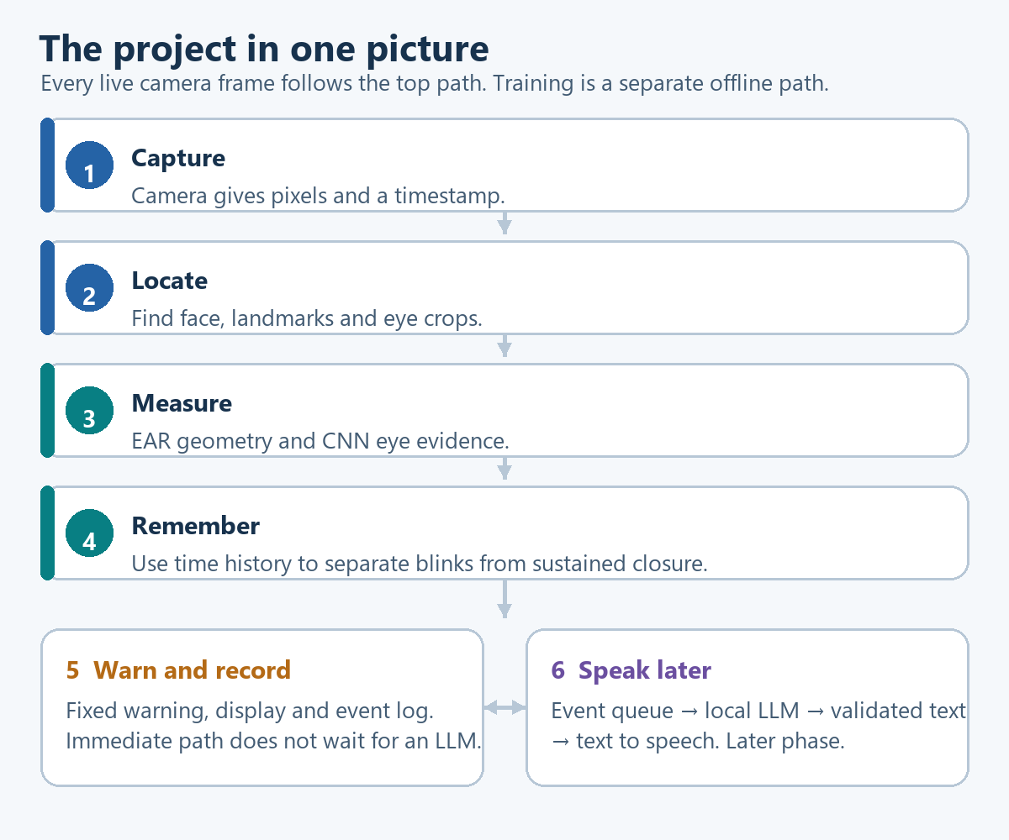
The complete project explained in six steps
Step 1 Capture: the camera supplies an image. It supplies pixels, not a drowsiness label.
Step 2 Locate: a pretrained detector finds the face and points around the eyes and mouth. A pretrained model has already learned from another dataset. We use it rather than training a face detector at the beginning.
Step 3 Measure: EAR describes eye opening using distances. The CNN estimates eye state from eye images. These are two ways of interpreting the same observation.
Step 4 Remember: the program keeps a short history. A brief closed-eye observation may be a blink. A sustained sequence can justify a prolonged-closure event under our configured rules.
Step 5 Warn and record: the alert controller requests a fixed sound and records the event. The display shows what the system observed and why it acted.
Step 6 Speak later: a separate language-model worker can generate a short sentence from the measured event. Text to speech converts that sentence into sound. It does not delay the immediate warning.
For example, the vision system may observe prolonged eye closure and trigger a warning. The later LLM receives that event summary. It does not inspect the driver's identity, invent a diagnosis, or decide whether the initial alert was necessary.

A2 What we build first and what comes later
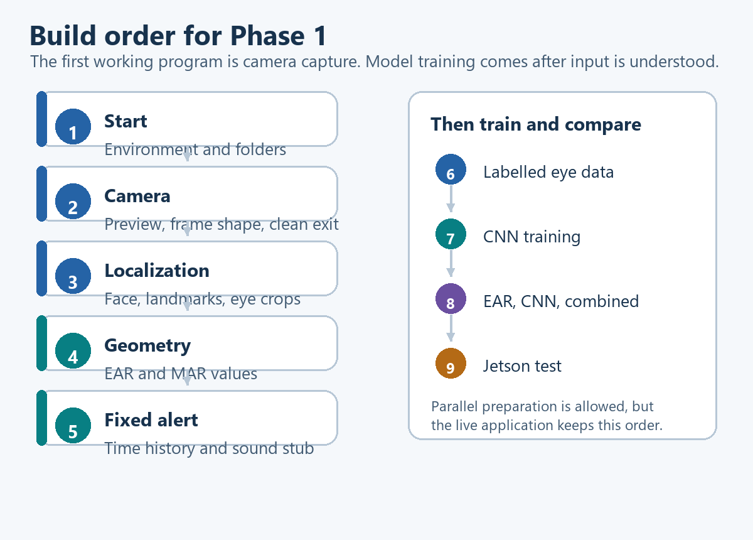
The camera comes before model training
Checkpoint | What we build | What we should see
Start | A suitable Python environment and a clear project folder | Everyone can run a small Python program
Camera | Webcam preview and clean shutdown | A live image changes when a person moves
Frame handling | Image dimensions, timestamps and saved-video input | We can explain what one frame contains
Localization | Face box, eye points and eye crops | Points and crops follow the correct features
Geometry | EAR and MAR calculations | Values change as the eyes and mouth move
First alert | Closure duration, unknown state and a fixed sound | Blinks and sustained closure behave differently
Learning | Labelled data, CNN training and saved model | The model classifies held-out eye images
Comparison | EAR mode, CNN mode and combined mode | Three separate result sets on the same recordings
Target device | Jetson capture, inference and profiling | The complete required modes run with measured limits

While one teammate builds camera capture, another may investigate datasets. That parallel work does not change the learning order for the runtime application. Nobody needs to wait for a trained CNN to demonstrate a working webcam preview.

A3 The minimum vocabulary
Term | Plain meaning | Example in our project
Script | A file containing instructions executed by Python | Open the camera and display frames
Function | A named operation with inputs and an output | Compute EAR from six points
Module | A Python file grouping related functions | capture.py contains camera operations
Library | Reusable code written by others | OpenCV provides video input functions
Environment | The interpreter and installed dependency versions used together | A project-specific Python environment
Frame | One image in a video stream | One webcam image at a particular time
Pixel | A small image location represented by numerical values | A colour pixel has three channel values
Landmark | A predicted point at a specific facial location | The inner corner of the left eye
Crop or ROI | A selected region of an image | The rectangle containing one eye
Feature | A measurement used to make a prediction | EAR is an engineered feature
Label | The independently established correct training answer | This eye is closed
Inference | Using fixed model weights to make a prediction | Classify a new eye image
Training | Updating model weights using labelled examples | Learn eye-state patterns from a dataset
Temporal | Relating to time and observation history | Track how long closure persists
Fusion | Combining evidence from multiple methods | Combine compatible EAR and CNN scores
Adapter | A component that hides platform-specific details | Windows and CSI capture return the same frame record
Manifest | A table describing samples and their metadata | Image path, subject, label and split
Checkpoint | Saved model parameters during training | A CNN file selected using validation
Latency | Delay between an input and a usable result | Age of a frame when a decision is made
Ground truth | The reference answers used to evaluate predictions | Human-reviewed eye labels and closure intervals

Face detection asks where a face is. Landmark detection asks where particular facial points are. Face recognition asks whose face it is. Our pipeline needs the first two operations; it does not need identity recognition.

A4 Start from the camera

First prepare the environment
1. Confirm which Python executable runs on each laptop and record its version.
2. Create an isolated project environment using agreed compatible dependencies.
3. Verify that the Windows Camera application can use the webcam, then close it before testing the Python preview if the device cannot be shared.
4. Check camera permissions if capture fails.
5. Install and verify the selected OpenCV build inside the project environment.
6. Run the preview. Do not add MediaPipe, CNN inference or audio until capture and cleanup work.
Exact package versions are selected after the environment check. A laptop training environment and the original Nano runtime may require different versions. Installing the newest package everywhere is not a compatibility strategy.

What the camera program repeatedly does
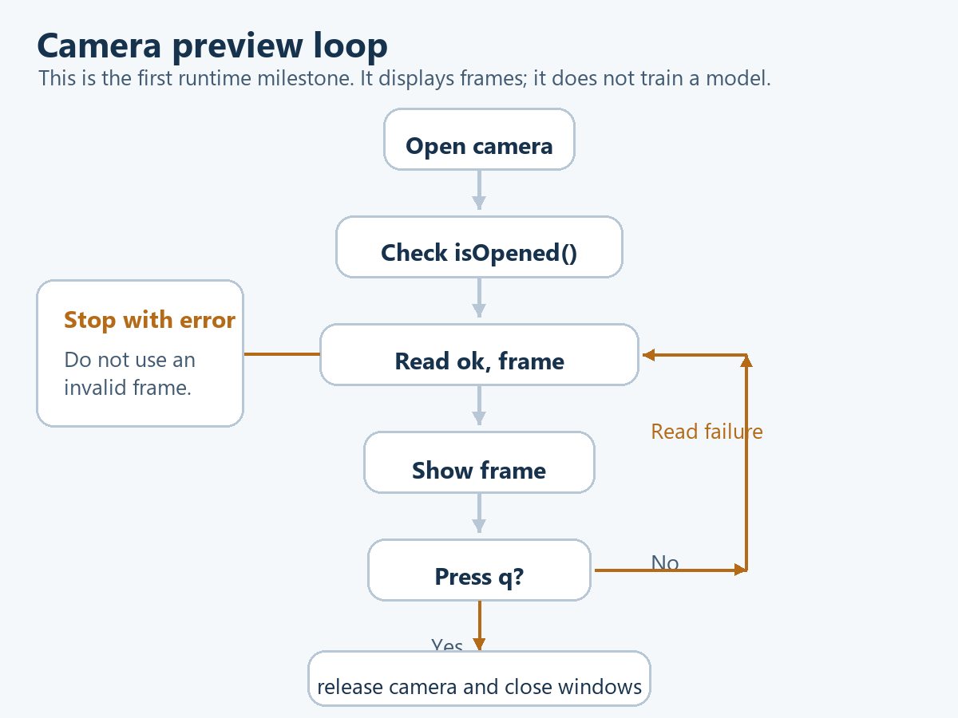
Camera preview loop and cleanup
Algorithm: open the camera once; check that it opened; repeatedly read and display frames; stop on a requested key or a read failure; release the device and close the display windows even if an error occurs.
This is an illustrative OpenCV 4 style preview, not a tested installation recipe or the final capture module. Camera index 0 requests the first camera exposed by the selected backend; the correct index or backend can differ by laptop. The example does not access a camera when reading this document.
import cv2

camera = cv2.VideoCapture(0)
try:
if not camera.isOpened():
raise RuntimeError("Camera could not be opened")

while True:
ok, frame = camera.read()
if not ok:
raise RuntimeError("Camera frame could not be read")

cv2.imshow("Camera preview", frame)
key = cv2.waitKey(1) & 0xFF
if key == ord("q"):
break
finally:
camera.release()
cv2.destroyAllWindows()

Understand every meaningful line
Code | What it does and why it exists
import cv2 | Loads the OpenCV Python interface. Installing a package and importing it are different steps.
cv2.VideoCapture(0) | Creates a capture object for a camera source. This occurs once, outside the loop.
try | Starts work whose resources must be cleaned up even if an error interrupts it.
camera.isOpened() | Checks whether the capture source opened. A variable existing does not prove the device opened.
raise RuntimeError(...) | Stops with an explicit error rather than pretending an image is available.
while True | Repeats until the program reaches a break or an exception. Video requires repeated reads.
ok, frame = camera.read() | Receives a success flag and an image. Check the flag before using the image.
cv2.imshow(...) | Displays the current frame in a named window. It does not train or classify anything.
cv2.waitKey(1) | Gives OpenCV's GUI a chance to process events and checks for a key. It does not guarantee a 1 ms frame period.
& 0xFF | Keeps the low eight bits for this simple key comparison. It is a bitwise operation.
ord("q") | Gets the numerical code for the character q. The preview window normally needs keyboard focus.
break | Leaves the loop after q is detected.
finally | Runs cleanup after normal exit or an exception.
camera.release() | Releases the capture resource so another program can use it.
cv2.destroyAllWindows() | Closes OpenCV's display windows.

The preview follows OpenCV's documented capture, read and release workflow. OpenCV video capture reference

What we add immediately after the preview
Inspect frame.shape to learn the actual image dimensions. A colour frame with shape (480, 640, 3) contains 480 rows, 640 columns and three colour channels. The real webcam may return a different shape. OpenCV commonly supplies BGR; the model's stored input transform must convert to its required channel order. OpenCV colour spaces
Add frame IDs and a monotonic receipt timestamp, then clearly distinguish receipt time from the actual camera exposure timestamp if the backend does not expose the latter. Buffering can make an apparently new read contain an older image. Later latency reports must state which time source was available.
Add a saved-video adapter. It should return the same kind of frame record but use media timestamps for temporal evaluation. Do not time a saved-video closure by how fast your computer happens to replay it.
Camera checkpoint: the preview runs, motion is visible, the frame dimensions are understood, q exits cleanly, and camera/read failures produce explicit errors. No ML model is required for this checkpoint.

Common camera problems
Symptom | First thing to inspect | What not to conclude
Camera does not open | Permissions, source index, another app holding the device, backend | The CNN is broken
Preview is black or freezes | Camera app test, successful reads, exposure and buffered frames | The face detector needs retraining
Preview is slow | Capture rate, display work and frame age separately | Every problem needs GPU acceleration
Colours look wrong | BGR/RGB conversion and display path | The model is necessarily inaccurate
Program will not exit cleanly | GUI focus, key processing and cleanup | Force-closing is an acceptable permanent design

The Jetson CSI camera requires a different capture adapter. We test it separately using the board's compatible camera stack. The geometry, temporal controller and logging should not need to know which adapter supplied the frame.

A5 From a face image to numbers
After capture works, add the pretrained landmark detector. Draw a face box and selected eyelid points before trusting any measurements. A point is usually a coordinate pair; it is not an eye-state label.
An eye crop gives the CNN image pixels. Eyelid points give EAR geometry. Both refer to the same eye and frame. If a crop belongs to one frame and EAR belongs to another, the fusion experiment is invalid even if both numbers look plausible.
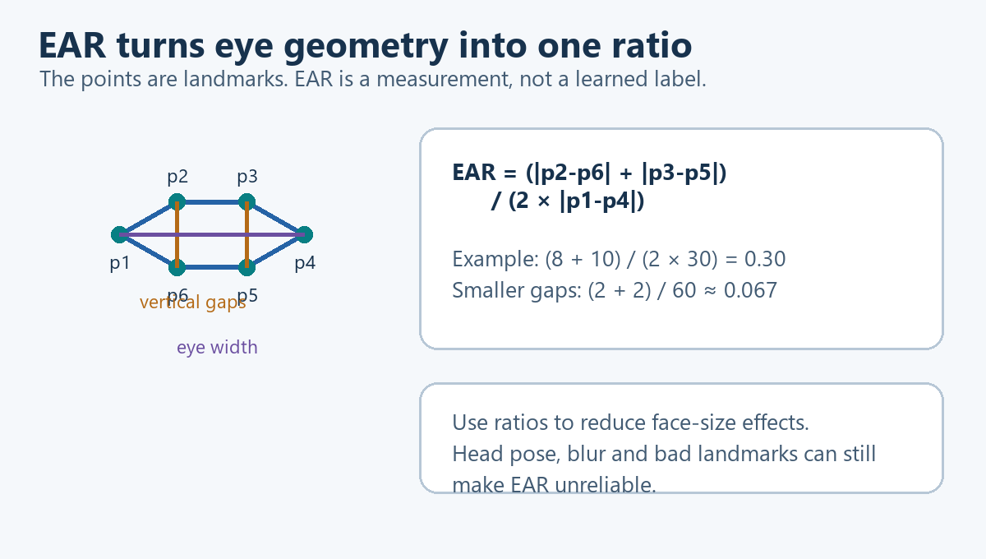
How eye geometry becomes EAR
The original EAR formula is preserved in the reference. Its meaning is average vertical eyelid gap divided by eye width. Suppose the two vertical gaps are 8 and 10 pixels and the width is 30 pixels. EAR is (8 + 10) / (2 × 30) = 0.30. If the gaps become 2 and 2 pixels with the same width, EAR is about 0.067. These are illustrative measurements, not universal thresholds.
Why use a ratio? If every distance doubles because the face appears larger, numerator and denominator both double and the ratio remains unchanged. Head rotation, bad points or nonuniform resizing can still distort it. Scale resistance is not immunity to every camera change.
MAR applies a documented vertical-opening-to-width relationship to the mouth. It is a measurement of mouth opening. Talking can increase it, so we initially display and log it rather than treating every large value as a yawn.

A6 What the CNN adds
EAR uses a formula we specify. A CNN learns image patterns from examples whose eye states are labelled. Its filters are small learned numerical operations over image regions; later layers combine responses into a classification score.
Training term | Meaning in this task
Input X | A batch of eye-image arrays
Target y | Matching verified open/closed labels
Weights | Numbers the CNN changes while learning
Loss | A penalty comparing predicted scores with the labels
Backpropagation | Calculation of how parameters contributed to the loss
Optimizer | The rule used to update weights from those calculations
Epoch | One pass through the training examples
Validation | Evaluation used to choose settings without learning from final-test answers
Saved model | Architecture information and selected learned parameters

We can start from a compact pretrained CNN, replace its classification head, and adapt it to our labels. This is transfer learning. It reduces the amount we must learn from our own dataset but does not eliminate the need for representative labels and evaluation.
Training happens offline on a laptop. Live inference loads the model once and uses it repeatedly. An eye classified closed does not establish how long it was closed. The temporal controller supplies that missing history.

A7 Combining the methods without mixing incompatible values
Raw EAR describes geometry. A CNN score describes learned evidence for a class. Before a weighted combination, the EAR value is mapped to a compatible closure score using separate calibration data. Optional CNN calibration checks whether its scores reflect observed frequencies.
The original combination formula is preserved in the reference. Alpha controls how much weight comes from the CNN. A hypothetical CNN score of 0.90 and mapped EAR score of 0.70 give 0.80 when alpha is 0.50. We choose alpha using validation data, not by forcing an improvement on the final test.
If both methods share the same poor eye crop or inaccurate localization, they can both be wrong. Agreement does not prove correctness. That is why we record quality, invalid observations and disagreements as well as classification scores.
The first comparison has three modes: EAR only, CNN only and combined. Each mode gets its own copy of the same temporal controller. Their histories are separate, so one method's result cannot alter another method's experiment.

A8 Why the program must remember time
A photo of closed eyes cannot tell us whether it was captured during a normal blink or a prolonged closure. We therefore maintain state across observations.
Concept | Plain explanation
Closure duration | How long valid sampled evidence has supported closure
Hysteresis | Different boundaries for entering and leaving a state, reducing rapid switching
Recovery | Sustained valid reopening that clears a prior event
Unknown | We cannot assess the current eye state reliably
Event | A recorded transition that justifies an action
Cooldown or repeat policy | Limits repeated outputs while preserving necessary escalation

For example, if 15 frames are processed at 30 frames per second, they span about half a second. At 5 frames per second, 15 frames span about three seconds. Count elapsed observation time, not a fixed number of frames.
If the camera loses the eyes during an event, we cannot assume the eyes remained closed or reopened. The current observation becomes unknown. A long gap breaks continuity, and valid reopening is needed to establish recovery from an earlier alarm.
PERCLOS and richer fatigue states come later. Their purpose is to describe a pattern over a longer window, alongside the immediate prolonged-closure path.

A9 What proper testing means
We need labels to score a prediction, but the runtime must never receive those labels as input. Training teaches the CNN; calibration maps scores; validation chooses settings; the final test measures frozen choices. All four roles are detailed in the original reference.
Metric | Beginner interpretation
Closed-eye recall | Of the truly closed-eye examples, how many did we detect?
Closed-eye precision | Of the examples predicted closed, how many were truly closed?
F1 score | A combined measure balancing precision and recall; unrelated to Formula 1 racing
Coverage | How often could we make a valid observation?
False alerts per hour | How often did the complete system warn unnecessarily during evaluated time?
Alert delay | How long after a defined event onset did the warning occur?
p95 latency | A delay value at or below which 95 percent of measured delays fall

A good score on easy frames can hide failure under glasses or infrared lighting. Evaluate those conditions separately and report the number of examples. Do not let images of the same person leak across training and test groups through different crops or adjacent video frames.

A10 Four people building one understandable system
All teammates first run the camera preview and explain the six-step project diagram. Then divide ownership: capture/runtime, perception/CNN, geometry/fusion, and data/evaluation. Review each other's interfaces rather than building four disconnected scripts.
At every checkpoint record three things: what changed, what evidence shows it works, and what still fails. The first complete demo should be a camera with landmarks, EAR/MAR and a timed fixed alert. CNN and combined modes remain mandatory subsequent Phase 1 checkpoints; they are not removed merely to meet the original two-week estimate.

Questions to check understanding
1. Does a working camera preview prove a CNN is installed? No. It only proves that basic capture and display work in that environment.
2. Does a CNN train while the live application runs? Not in this design. Training is an offline workflow; live inference uses fixed weights.
3. Why retain timestamps? The device may process frames at different rates, while closure duration is a time measurement.
4. Can a large MAR prove yawning? No. Mouth movement needs context and suitable labels.
5. Should unknown count as open? No. Missing evidence must remain explicit.
6. Is the combined mode required to beat both individual modes? No. It must be implemented and evaluated honestly; deployment quality still has to meet the agreed requirements.
The complete engineering reference follows. Use its detailed tables and file map while implementing the checkpoints explained above.

Complete engineering reference
The following section preserves the previous Phase 1 design in full. It is the detailed implementation reference behind the beginner walkthrough. The equations are rendered as Word equations, and the figures are embedded so the handbook can be shared as one file.

MARVEL: EAR, CNN and Combined Drowsiness Monitoring

System design and Phase 1 implementation guide
Prepared: 11 September 2026
Status: Proposed implementation specification. No detector, CNN, dataset, or Jetson runtime has been implemented or validated in this workspace.
Audience: Four beginners learning computer vision, ML integration and embedded deployment.

1. The decision we are making
We will implement and evaluate three modes:
1. EAR only: facial landmarks → Eye Aspect Ratio → eye-state decision.
2. CNN only: eye crops → trained convolutional neural network → eye-state decision.
3. Combined: valid EAR evidence and CNN evidence → a calibrated combination → eye-state decision.
Each mode feeds the same closure-duration and alert logic. We will build the two individual approaches first, then implement and test the combined approach. The combination is a required experiment; improved performance is a hypothesis, not a guaranteed outcome. All three modes remain available for demonstration and comparison even if fusion does not win.
This is a project-specific design. We borrow the baseline comparison principle from the F1 project, but the input representation, labels, temporal logic, metrics and deployment constraints are different.
The CNN in the first experiment classifies each eye as open or closed. It does not directly diagnose drowsiness. MAR remains in Phase 1 as a mouth-opening measurement and logged supporting signal. A separate mouth CNN and temporal yawn classification are later extensions unless the team explicitly expands Phase 1 again. A high MAR alone is not a yawn label.

Confirmed constraints
Item | Confirmed information | Design consequence
Team | Four people, little practical CV experience | Small modules, early integration, paired reviews
Development machines | Windows laptops with integrated webcams | Develop capture, inference, training and tests on Windows
Target | Original Jetson Nano, 4 GB RAM, Maxwell GPU | Check runtime compatibility and measure memory and latency early
Board access | About 3 to 4 hours per week | Prepare repeatable tests before every board session
Camera ordered | Raspberry Pi NoIR Camera Module V2 | Verify carrier-board cable and capture; evaluate actual NoIR images
Schedule | Initial target about two weeks; extension accepted for CNN and quality | Use evidence-based completion gates rather than declaring success on a date
Final speech | Local LLM and voice output planned | Keep speech outside the immediate alert path

Still unverified
Installed JetPack, Python and Ubuntu versions; available laptop GPU and memory; exact carrier-board revision; camera arrival and capture; dataset licences and labels; first required lighting conditions; numerical acceptance thresholds. These do not prevent architecture work, but they prevent claiming deployment compatibility or selecting exact installation versions.

2. Visual overview of the entire project
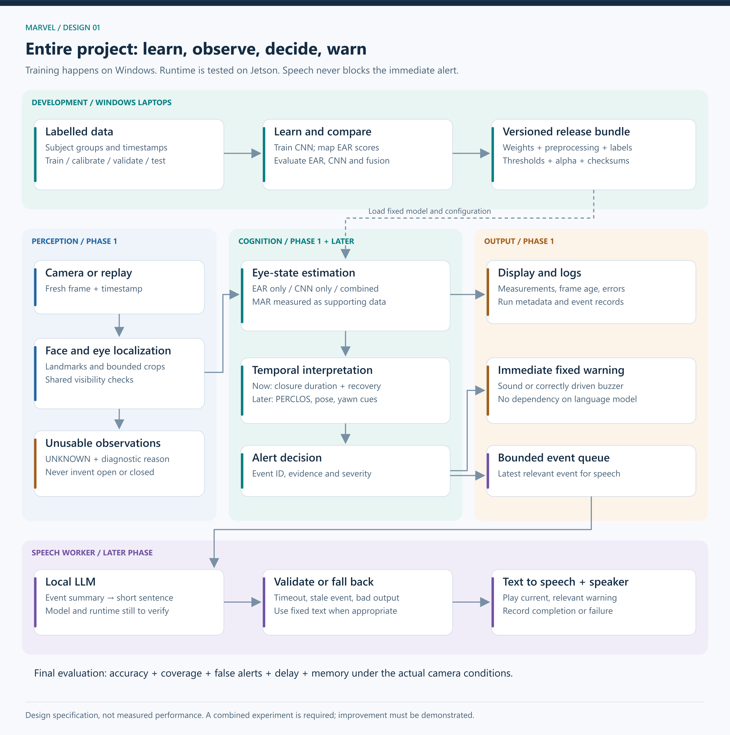
Complete project system design
Scalable SVG version

How to read the architecture
Development lane: labelled examples are prepared on Windows. We train the CNN, fit score mappings, choose operating settings, and save a versioned release bundle.
Runtime lane: the camera produces observations. Perception locates the face and eyes. EAR and CNN estimate eye state. Temporal logic interprets the observation history. The alert controller produces an immediate warning and records the event.
Speech lane, later: a bounded queue delivers event summaries to a separate LLM worker. Generated text is checked and sent to text-to-speech. Invalid output, an expired event, or a timeout uses a fixed fallback or is discarded according to the event policy. Speech never determines whether the initial alarm is necessary.
Evaluation lane: labelled recordings are replayed into the same runtime components. Predictions are joined to ground truth by sample ID and timestamp. A separate evaluator computes results. Ground-truth labels never enter runtime prediction.

Logical layers and their responsibilities
Layer | Responsibility | Outputs
Perception | Capture, locate driver face, find landmarks, crop eyes, assess visibility | Images, named points, quality information
Cognition | EAR/MAR, eye-state estimates, fusion, history and alert decisions | State, evidence and events
Reasoning, later | Turn measured event context into a short sentence | Validated text
Actuation | Execute sound and later speech requests | Audible output and execution status
Observability | Record timing, errors, measurements and model identity | Logs and reproducible results
Training and evaluation | Learn parameters and measure generalization | Models, configuration, reports

These are local Python modules and workers, not a requirement for microservices, a web backend or a cloud platform.

3. Phase 1 system design
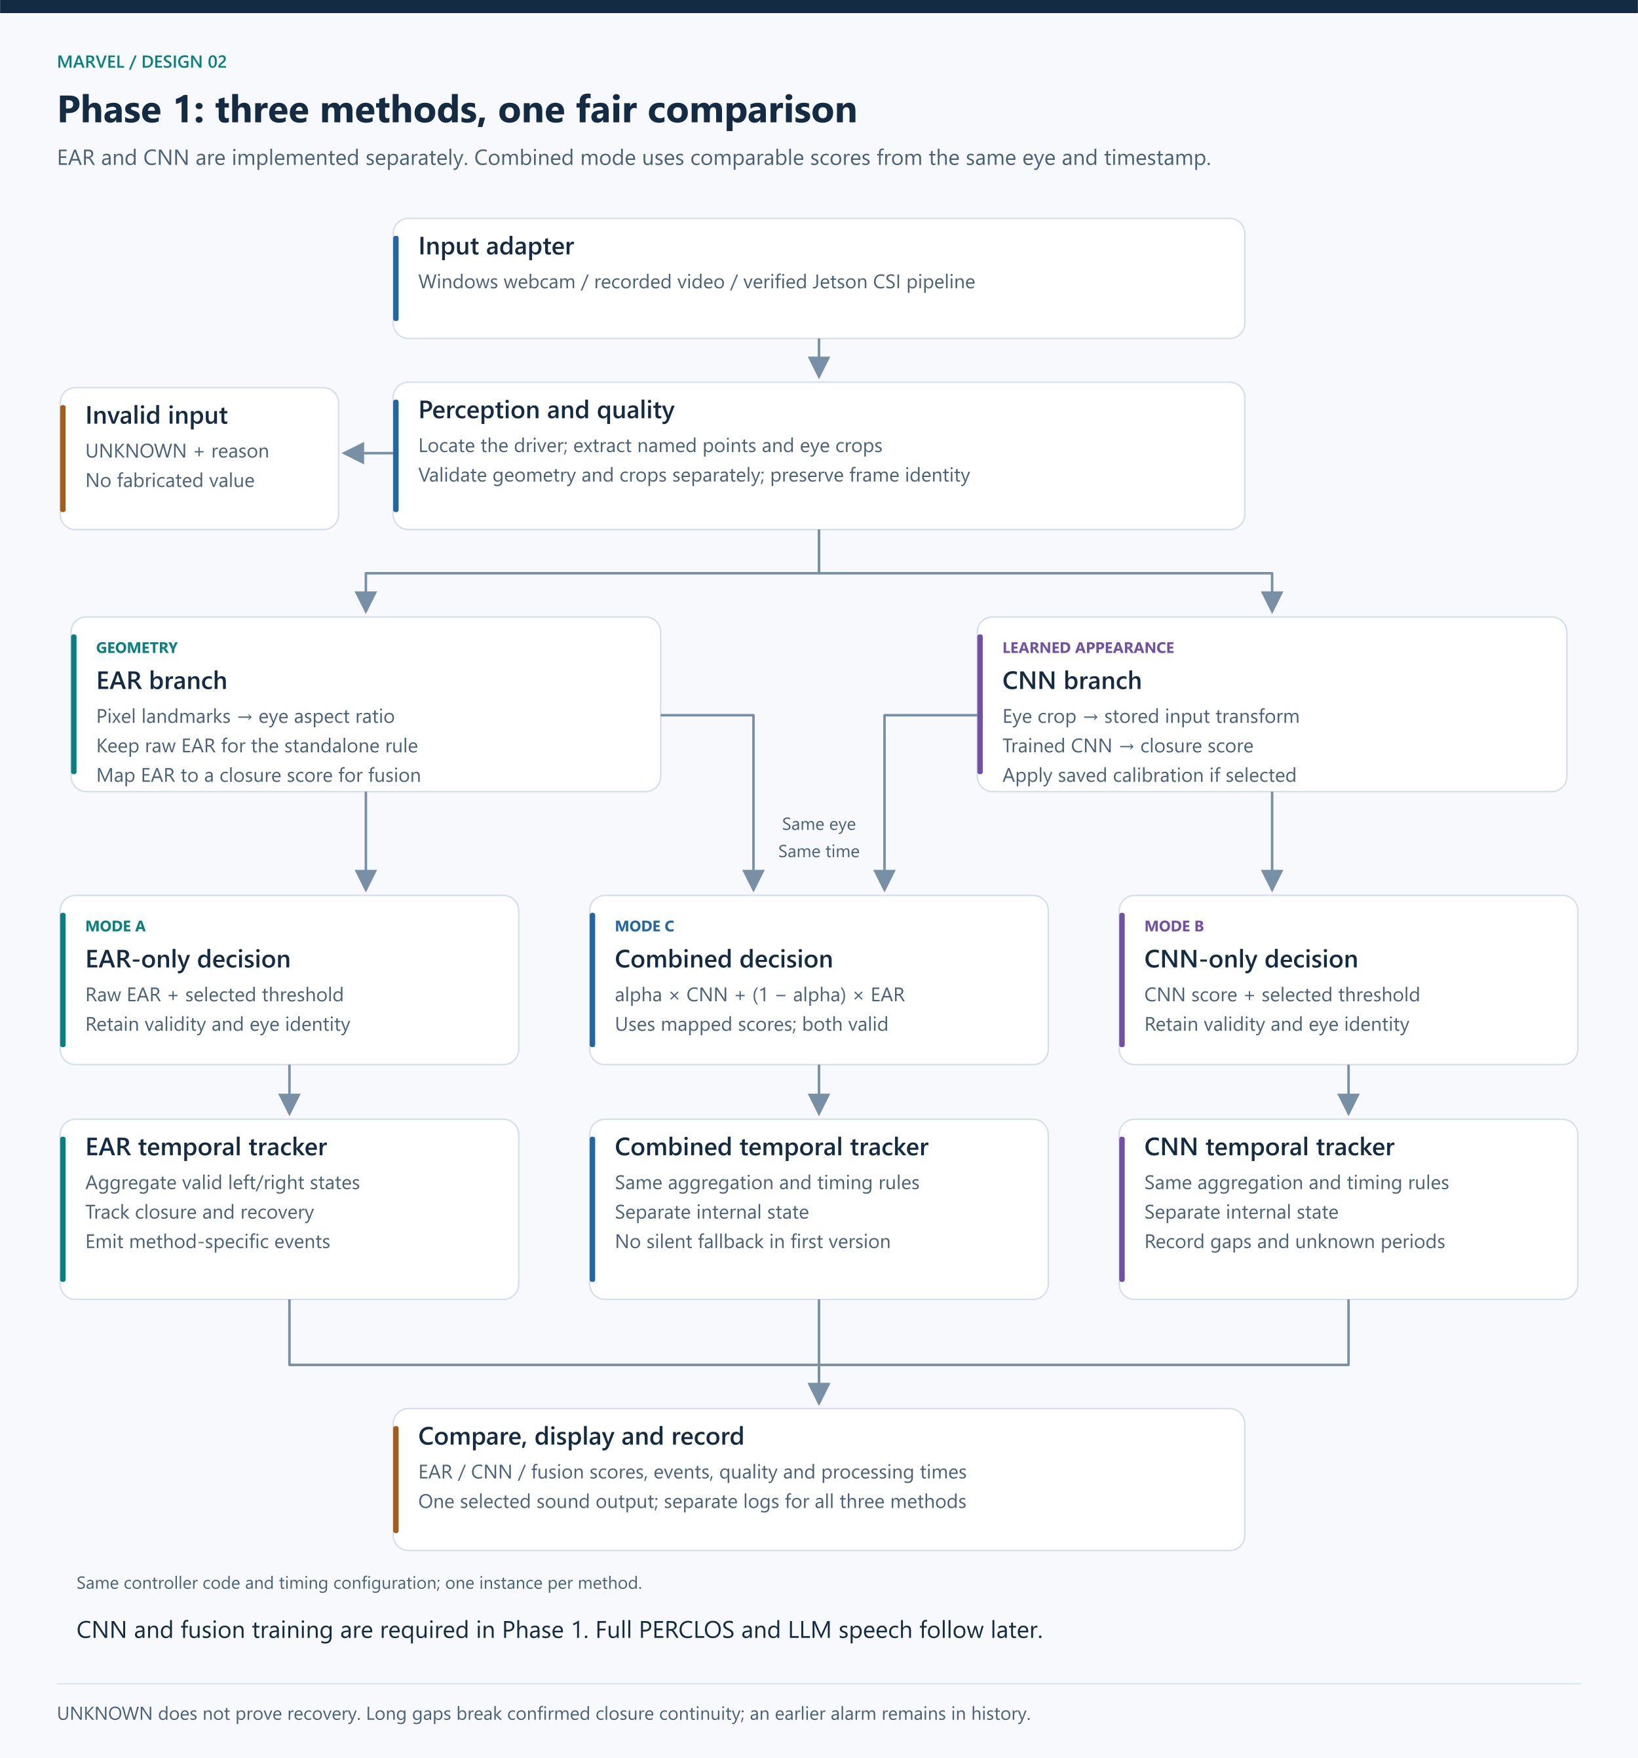
Phase 1 runtime and experiment design
Scalable SVG version

Phase 1 must contain
1. Windows webcam and recorded-video input with timestamps.
2. Early Jetson environment and candidate inference checks.
3. Driver-face localization, facial landmarks and eye crops.
4. Shared image checks plus separate geometry and crop validity checks.
5. EAR and a documented MAR definition.
6. An EAR-only eye-state mode.
7. A trained eye CNN and a CNN-only mode.
8. Score mapping, fusion and a combined mode.
9. The same basic temporal trigger for all three modes.
10. An actual fixed sound on Windows; a separately testable Jetson output adapter.
11. Live overlays and structured measurement/event logs.
12. Reproducible image-level and video-level evaluation.
13. Model/configuration bundles and setup documentation.

Explicitly later
Full PERCLOS processing, richer fatigue states, head-pose interpretation, mouth CNN and yawn-event classification, TensorRT optimization experiments, LLM generation, neural TTS and a polished dashboard. Basic duration tracking, recovery and invalid-data handling belong in Phase 1 even though the richer state machine comes later.

The runtime sequence
Step | Operation | Why it exists | Failure handling
1 | Read frame and timestamp | Establish what was observed and when | Camera error; no old frame reused as new
2 | Locate intended driver face | Avoid analyzing a passenger | Mark unknown if target is lost; reset identity-dependent history on target change
3 | Find points and eye regions | Supply geometry and image inputs | Validate each eye and branch independently
4 | Compute EAR/MAR and CNN scores | Produce the two kinds of evidence | Missing values remain missing, never zero
5 | Select EAR, CNN or fusion mode | Make the experiment explicit | Fused mode requires both branches initially
6 | Aggregate usable eyes | Convert per-eye observations into one driver observation | Initial policy requires both eyes; otherwise unknown
7 | Update duration/recovery logic | Distinguish a brief blink from sustained closure | Long gaps break confirmed closure continuity
8 | Emit transition event | Prevent a new alarm request on every frame | Event IDs, recovery and bounded repeat policy
9 | Display and log | Make the result explainable and measurable | Preserve error reasons and run metadata

Comparison mode: replay the same video through three separate tracker instances, one per method. The tracker code and timing settings are identical, but their internal state is not shared. Log all three; enable sound for only one selected mode so the comparison does not create overlapping alarms.
Live mode: select one method in configuration. Report its method name and bundle version on the display. Do not silently switch methods during an experiment.

4. What each algorithm does

4.1 EAR baseline
For six ordered eyelid points:
$EAR = \frac{‖p₂ − p₆‖ + ‖p₃ − p₅‖}{2‖p₁ − p₄‖}$
The numerator adds two vertical eyelid gaps. Dividing by two averages them. Dividing by eye width makes the measurement less sensitive to uniform scaling.
Implementation: map the detector's indices to six named points for each eye; convert coordinates to pixels in the same frame; reject near-zero widths and invalid geometry; calculate left and right EAR separately; threshold each valid eye. Choose thresholds using development data, not final-test labels.
Normalizing x by image width and y by image height produces different axis scales. Convert both into pixel coordinates before Euclidean-distance calculations. If crops are resized anisotropically, do not calculate geometry from the distorted crop.
EAR is a geometric feature, not a probability. A low EAR suggests closure but can also result from pose or incorrect points. Guided person-specific normalization is an optional improvement after the global baseline. It must use a declared calibration protocol and may not adapt silently during suspected fatigue.

4.2 MAR measurement
Choose named inner-lip points and record the exact formula. One simple definition is average inner-lip vertical gap divided by inner-mouth width. Other MAR definitions use different sums or factors; thresholds cannot be copied between them.
Initially display and log MAR. Mouth opening alone must not trigger a drowsiness alarm. The same eye pipeline comparison should not be confounded by changing mouth rules between methods.

4.3 CNN classifier
Training input: an eye crop produced with a documented crop, resize, channel and normalization policy. Target: independently annotated open or closed state for that eye. Ambiguous, partly closed or unobservable examples need a declared labelling policy rather than forced binary labels.
Candidate choices:
Candidate | Benefit | Drawback | Recommendation
Small custom CNN with convolution, pooling and a classification head | Easy to inspect; can be compact | Must learn visual features from the available eye data | Useful if pretrained model deployment is blocked or as a later comparison
Compact pretrained CNN, such as MobileNetV3-Small | Reuses learned visual features | Input requirements and exported operations must match runtime support | First candidate to investigate, not a confirmed deployment choice
Larger pretrained CNN | Potentially richer features | More memory, latency and integration cost | Not the first choice for Nano

Train a replacement classification head first. Fine-tune selected backbone layers only if validation supports it. For a single-output binary model, use a logit and binary cross-entropy with logits. Apply sigmoid during inference to obtain a probability-shaped score. A two-output model can instead use cross-entropy; pick one convention and document it.
The training loop is: read labelled batches → forward prediction → loss → backpropagation → optimizer update → validation → save selected checkpoint. Training changes parameters; inference reads fixed parameters. Save the class mapping so open and closed cannot be swapped accidentally. See PyTorch transfer learning and Torchvision MobileNetV3.
Train and debug on Windows. Verify the selected architecture can run through a compatible Jetson runtime before investing in extensive tuning. PyTorch checkpoint creation does not itself establish Jetson deployment compatibility.

4.4 Combining EAR and CNN correctly
We will compare three possible fusion approaches before committing to the final one:
Method | Mechanism | Advantage | Cost or failure mode
Agreement rule | Require both classifiers, or accept either classifier | Easy to explain | AND can miss closures; OR can increase false alerts
Calibrated weighted combination | Map both signals to compatible closed-eye scores; combine them | Small and interpretable | Needs separate calibration and tuning data; may not improve correlated errors
Learned fusion classifier | Learn a small classifier on branch outputs and quality features | Can learn conditional interactions | Adds parameters and needs held-out or out-of-fold branch predictions

Recommended first combined experiment: calibrated weighted combination, after the standalone implementations work.
1. Fit a simple logistic mapping from valid EAR to closed-eye likelihood using the calibration partition. With one EAR input, constrain or check that increasing EAR does not increase predicted closure likelihood. Preserve the raw-threshold baseline separately.
2. Check CNN calibration; use a held-out temperature fit if justified. Do not treat every sigmoid score as a reliable probability.
3. For the same eye and observation timestamp, compute:
$p_combined = α p_CNN + (1 − α) p_EAR, 0 ≤ α ≤ 1$
4. Select alpha and decision thresholds using validation data. Include alpha endpoints 0 and 1 so the search can conclude that an individual method is better.
5. Freeze the selected configuration before the final test. A weighted score is not automatically calibrated even if the inputs were calibrated; check reliability if it will be described as a probability.
6. Initially require both valid branches for combined mode. If either is unavailable, emit unknown. Any later fallback to a single branch must be explicit, logged and evaluated as a separate policy.
Illustration only: if EAR maps to 0.70, CNN gives 0.90, and alpha is 0.50, the combined score is 0.80. Neither these scores nor that alpha are measured project settings.
Per-eye first: calculate left and right outputs separately. An initial driver policy can classify bilateral closure when both valid eyes are classified closed, classify open only when both are open, and treat disagreement as ambiguous/unknown. This is conservative about mixed evidence and can reduce coverage. Tune and compare any alternative eye aggregation policy on development videos; keep it identical across methods for the initial experiment.
See probability calibration. A learned combiner must never be trained using base-model predictions produced on the same examples the base model memorized.

4.5 The minimal temporal controller
Runtime states: OPEN, CLOSURE_PENDING, ALARM, UNKNOWN. These are observable operational states, not clinical diagnoses.
Input or condition | Controller behaviour
Valid closed observation following open | Start closure candidate using observation time
Continued valid closure with acceptable observation gaps | Accumulate confirmed sampled closure duration
Duration reaches configured threshold | Emit one prolonged-closure event
Valid reopening before threshold | Cancel the candidate
Invalid or stale data | Mark current observation unknown; do not count the gap as closed or open
Gap beyond configured tolerance or driver target changes | Break continuity and require fresh evidence
Valid reopening after an alarm | Require configured recovery duration before clearing the event
Unknown after an alarm | Preserve the outstanding event record; do not claim recovery
Persistent unknown | Emit a distinct monitoring-unavailable notification under a bounded policy

Alarm history and present observation validity should be separate fields: the latest observation can be unknown while an earlier alarm is still outstanding. Audio duration and repetitions are controlled by an explicit bounded policy, not an endless frame-by-frame sound call.
Use a monotonic clock for live elapsed time. For recorded video, use media timestamps so playback speed does not change the result. Record wall-clock time separately for human-readable logs. Estimating continuity between samples requires a maximum accepted gap; do not imply continuous visual proof between arbitrarily spaced frames.
Two eye-state thresholds can add hysteresis. Keep closure/recovery timings common across EAR, CNN and fusion during the first comparison. Their numerical decision thresholds may be tuned separately on validation data.

5. Dataset and evaluation design
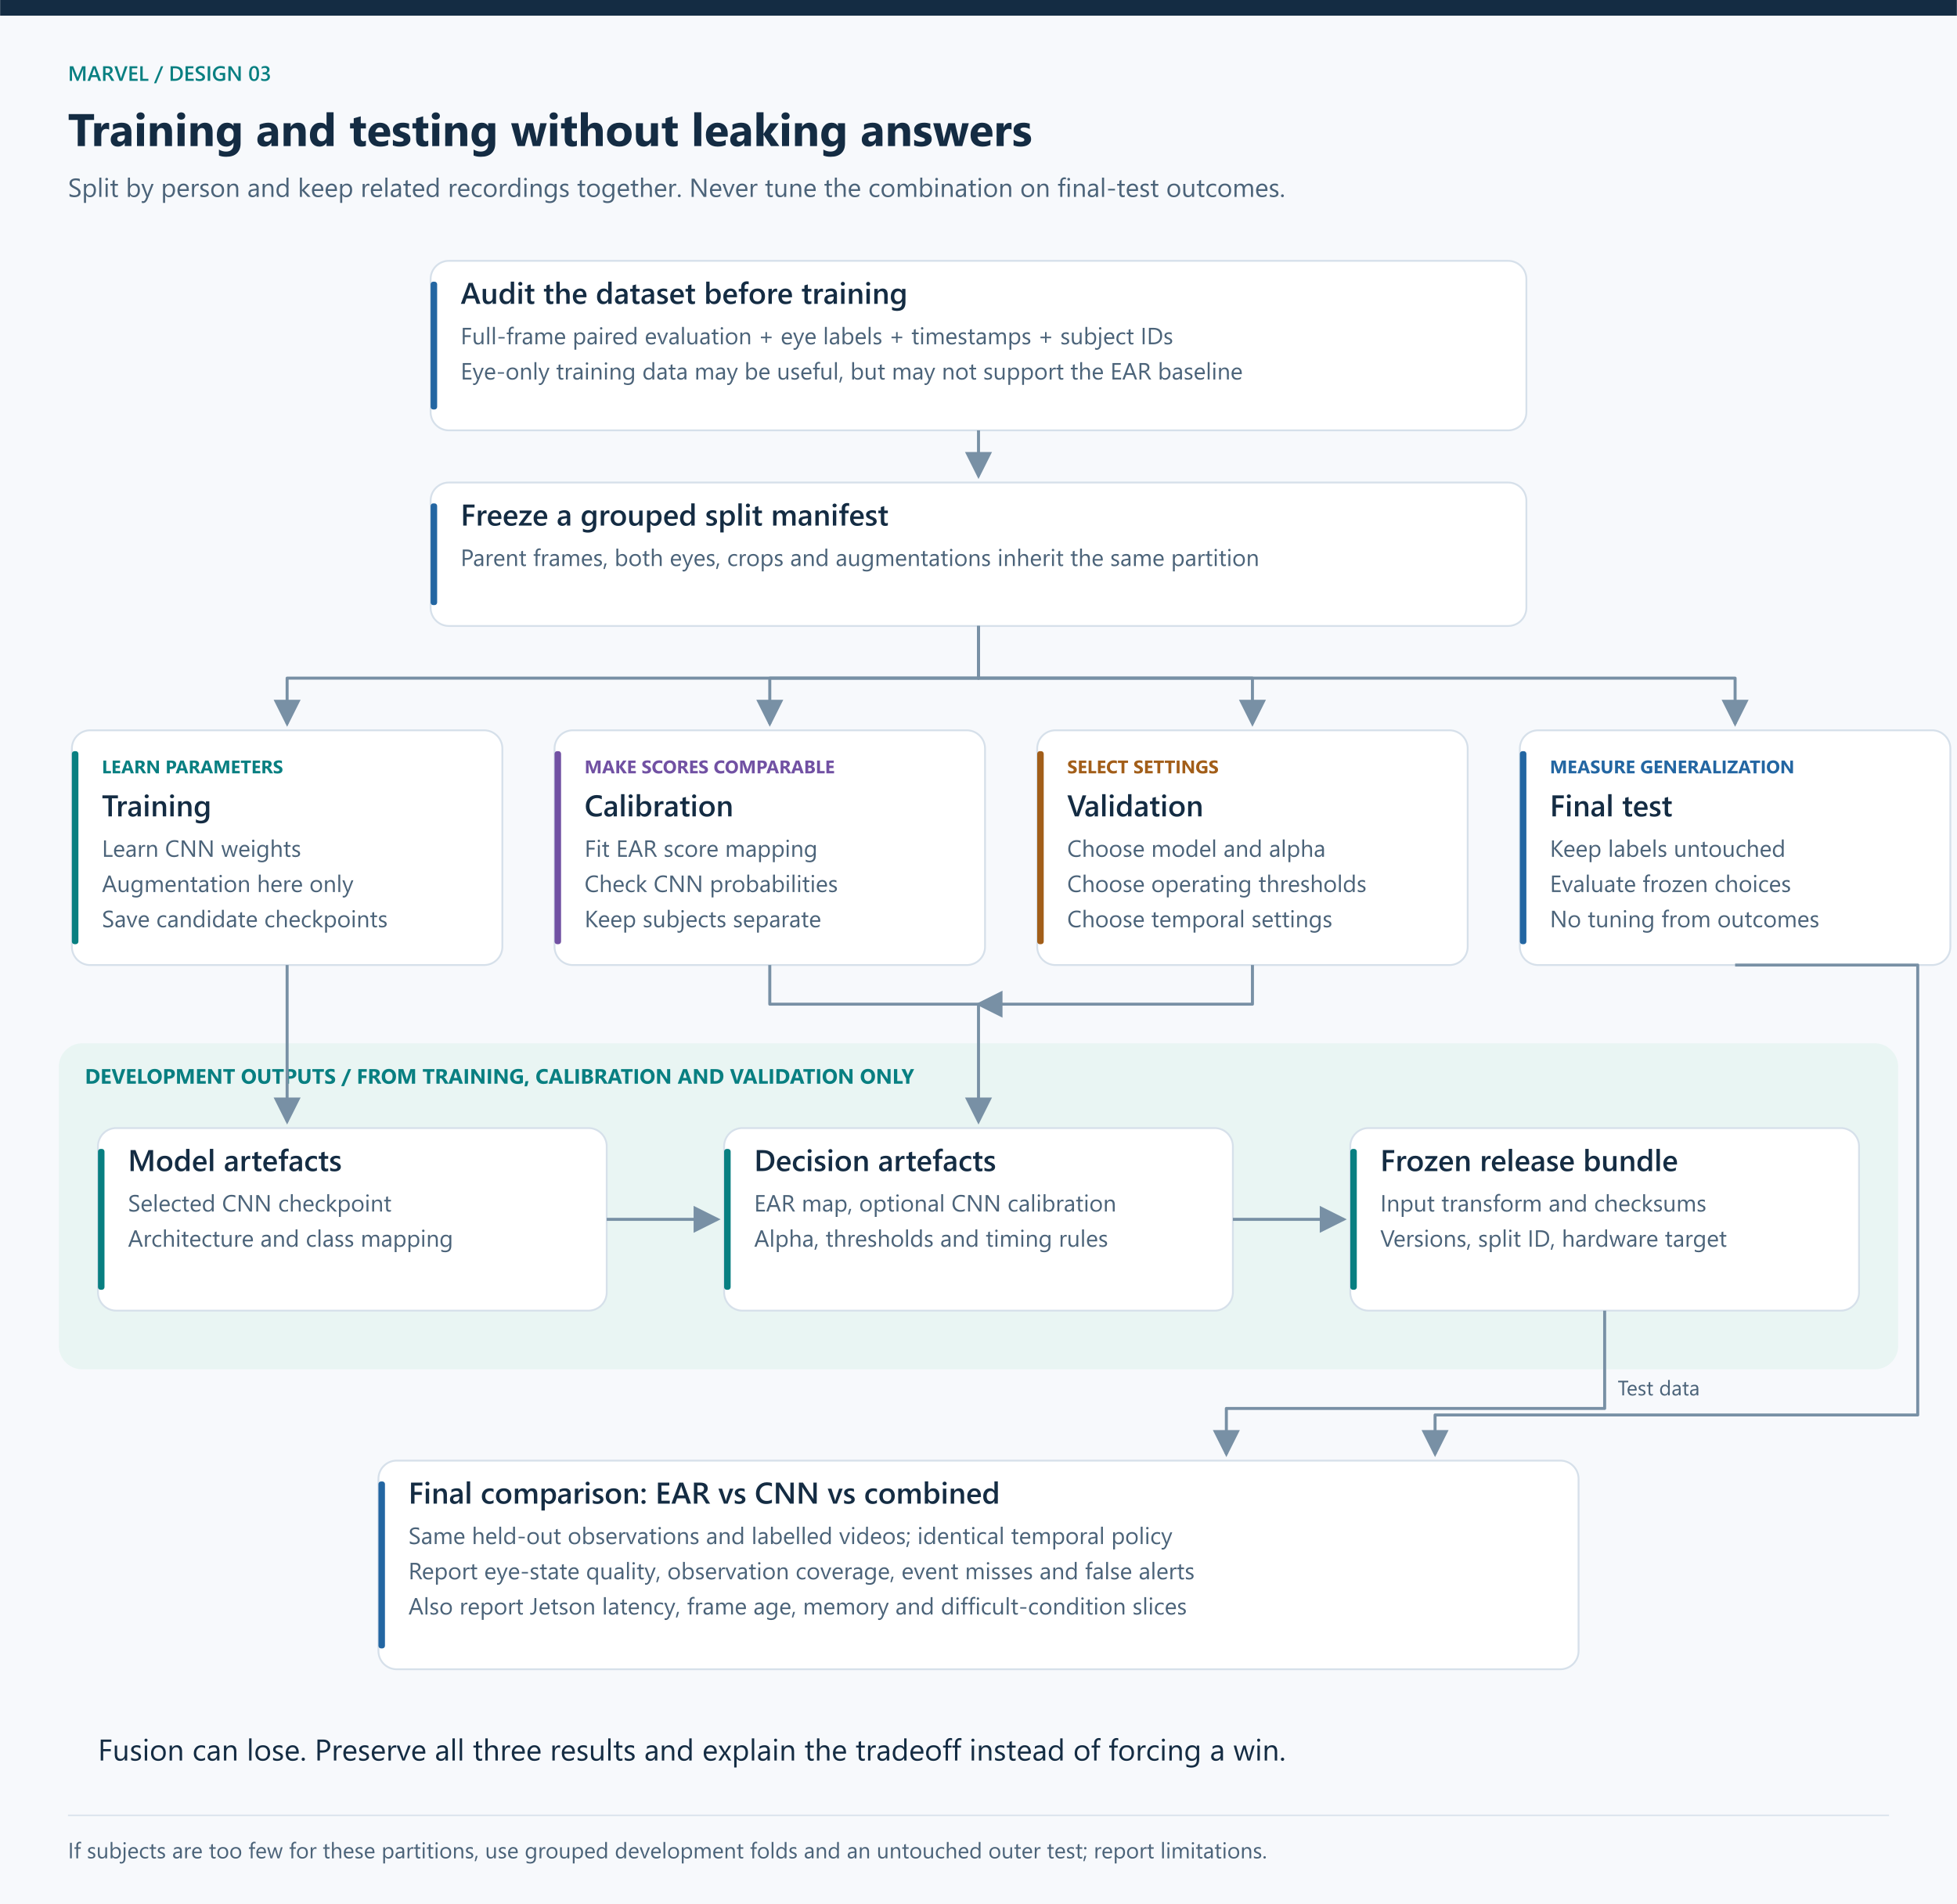
Training, calibration, validation and test flow
Scalable SVG version

Data required now
Data cannot wait until Phase 5. CNN training, calibration and honest fusion evaluation require it in Phase 1.
1. Training examples: labelled open/closed eyes with enough variation to train the classifier.
2. Paired evaluation examples: the same eye observations must support both geometry and CNN crops. Full-face frames or videos with eye labels are preferable. Tiny eye-only datasets may help CNN training but may not support the face-landmark baseline.
3. Temporal recordings: timestamps and independently annotated blink/prolonged-closure intervals. Static image labels alone cannot evaluate alert duration and delay.
4. Target-camera samples: actual webcam and later NoIR frames. Daylight grayscale conversions do not reproduce infrared imaging.
5. Metadata: subject, session, source, lighting, glasses, pose, label provenance, licence and acquisition conditions where available.
A four-person collection can support debugging and a limited demonstration; it is not enough by itself to claim broad generalization. Dataset selection is still open. Do not assume every dataset mentioned in the proposal has eye-level labels, subject identifiers or permission for the intended use.

Suggested manifest fields
sample_id, subject_id, session_id, video_id, timestamp_ms, frame_path, eye_side, eye_label, observable, lighting, glasses, source, split, label_version.
Eye crops inherit the parent frame's subject and split. Both eyes from one person must remain in that person's partition. Keep the same frame ID when generating geometry and image inputs so predictions can be joined correctly.

Split before crop generation or augmentation
Partition | What it may influence | What it must not influence
Training | CNN weights | Final reported test performance through label access
Calibration | EAR score mapping and optional CNN score calibration | CNN weight fitting on the same samples
Validation | Architecture, threshold, alpha, recovery and runtime policy choices | Final test labels
Final test | Frozen comparison results | Any subsequent tuning presented as the same untouched test

Group by subject first and keep sessions/clips together. Choose partition sizes based on the available number of subjects and class coverage, not a blind frame-percentage split. If separate partitions are too small, use grouped development folds and held-out predictions, with a genuinely untouched outer test. Explain the increased implementation complexity before using that route. See grouped cross-validation.
Use the same final-test examples for all predeclared methods. Select the deployment candidate using validation and resource checks before test evaluation. Reporting all three final-test scores is valid; changing the method using those scores requires a new holdout for a new unbiased claim.
Never label training data using the EAR rule and then claim the CNN beats EAR against those same labels. Review label ambiguity separately. Augment training data only; do not leak altered copies into other partitions.

Evaluation at two levels
Eye observation: closed-eye recall, precision, F1, confusion matrix and invalid-observation rate. Compute conditional classifier metrics on jointly valid samples for an apples-to-apples classifier comparison; also report end-to-end coverage and all failures. Never hide failed crops by dropping them without accounting.
Video event: missed prolonged closures, detected events, false alerts per observed hour, onset-to-alert delay, valid observation coverage and behaviour during missing data. Predefine event matching: what overlap or onset tolerance counts, how duplicate alerts are counted, and whether alerts inside annotation uncertainty regions are excluded or reviewed. Do not treat repeated alerts for one event as multiple true positives.
Performance: capture rate, inference latency, full frame processing latency, frame age, p50/p95 latency, peak memory, device configuration and sustained-run stability. Combined mode must be timed with both branches active. EAR computation is cheap, but its landmark detector may not be.
Slices: each subject, glasses, lighting, pose and camera source. Report denominators. If sample size permits, estimate uncertainty by resampling subjects or sessions rather than treating adjacent frames as independent.

Proposed completion criteria
These are proposed engineering gates, not existing results or a road-safety certification:
- [ ] Each mode loads its declared bundle and runs the same labelled replay.
- [ ] Correctly ordered landmarks and stable crops have been visually checked.
- [ ] EAR, CNN and combined results are recorded separately.
- [ ] Changing playback speed does not change event decisions.
- [ ] Missing frames do not count as confirmed closure or recovery.
- [ ] Normal blinks, sustained closure, winks, talking, head turns and absent faces have explicit expected outcomes.
- [ ] A sustained replay of at least 10 minutes completes without a crash, growing frame backlog or uncontrolled alert repetition.
- [ ] An initial latency budget is written before tuning. A possible lab target is p95 frame age below 500 ms; confirm or revise it explicitly for the demonstrated operating conditions.
- [ ] Event delay is measured against the configured closure duration plus processing delay, not quoted only as model FPS.
- [ ] Target recall and acceptable false alerts per hour are chosen after inspecting dataset annotation quality and before final testing. No arbitrary accuracy percentage is promised here.
- [ ] At least one Jetson capture/inference integration check is documented; full embedded Phase 1 completion requires all required modes to be tested on the target, with results or explicit unresolved blockers.
- [ ] Another teammate can reproduce the demonstration from the guide and versioned configuration.
If the CNN or fusion underperforms, the experiment is still informative. If it fails the agreed operational requirements, the build is not declared successful merely because training completed.

6. Drawbacks and how we will address them
Drawback | Mechanism | Phase 1 mitigation | Later improvement or remaining limit
Person-dependent EAR | Normal eye geometry differs | Validate a global threshold across people; log per-person errors | Guided calibration with a frozen reference; avoid learning fatigue as normal
Landmark or crop failure | Pose, blur or obstruction corrupts input | Visual overlays, geometry checks, crop bounds and minimum resolution | Better localization or pose gating; invisible eyes stay unknown
Correlated errors | Both branches share sensor and localization | Record disagreements and shared failures; do not assume redundancy | Fusion only helps where errors are complementary
Training/deployment mismatch | Different camera, illumination or people | Source-separated evaluation and representative augmentation | Collect actual NoIR data; assess performance under that modality
Overfitting | CNN learns people, backgrounds or camera artefacts | Grouped splits, modest model, validation checkpoint selection | More representative data, not simply more epochs
Unreliable confidence | CNN scores are overconfident | Calibration diagnostics and explicit uncertainty policy | Recheck after deployment-domain changes
Fusion adds complexity without gain | Scores are redundant or tuning overfits | Predeclared standalone comparisons and alpha endpoints | Prefer a standalone deployed method if requirements allow; retain combined experiment
Blink false alarms | Single-frame decisions ignore duration | Timestamp-based candidate, recovery and repeat policy | Rolling closure statistics and richer temporal logic
Camera loss appears as recovery | Missing data is filled with zeros/open labels | Unknown state and gap reset; preserve event history | Monitoring-unavailable indication and independent system-health mechanisms
Two eyes disagree | Wink, occlusion or asymmetric prediction | Explicit per-eye outputs and ambiguous state | Validate a quality-aware aggregation policy separately
Mouth opening is mistaken for a yawn | Talking/laughing share static appearance | MAR is logged, not treated as sufficient alarm evidence | Labelled mouth sequences and yawn-event classification
Slow alerts despite good FPS | Queues accumulate old frames | Latest-frame buffer for live capture; frame-age logging | Optimize measured bottleneck; verify numerical parity after conversion
LLM blocks detection | Sequential inference or shared-resource overload | LLM absent from Phase 1 | Separate worker, bounded event queue, timeouts and fixed warning
Buzzer assumed independent | Same board/process controls output | Sound adapter reports failures; no guarantee claimed | Independent watchdog/hardware requires separate design

NoIR needs illumination in darkness. Hardware placement, focus, exposure and reflections can dominate model choice. CLAHE is an experiment, not an automatic repair: it can amplify noise and alter the CNN input distribution. Apply identical preprocessing at training and inference, and measure any benefit.

7. Review of the proposed repository structure
Verdict: the subsystem grouping is useful, but the supplied tree does not implement the revised EAR + CNN + fusion Phase 1 scope.
Supplied choice | Required revision | Reason
Capture and detection under perception | Keep, add crop and quality modules | Both branches depend on observable eye inputs
EAR/MAR under cognition | Keep | Clear mathematical responsibility
Only a naive threshold trigger | Add duration, unknown, recovery and bounded repeats now | A blink-only alarm is not an adequate usable baseline
No CNN module | Add architecture and inference components | CNN is mandatory in Phase 1
No training or data preparation | Add offline scripts and dataset utilities | Training must be reproducible
No fusion | Add score mapping, calibration metadata and fusion | Combined experiment is mandatory
Models empty until Phase 3 | Store landmark assets and trained checkpoints in Phase 1 | Models already exist before optimization
Data empty until Phase 5 | Prepare manifests and split information immediately | Labels and holdouts precede training
Benchmarks only in Phase 3/5 | Add evaluation and profiling now | Comparison cannot be deferred until after selecting a winner
Logger in Phase 4/5 actuation | Move logging to observability in Phase 1 | Every experiment needs evidence
Main integration in Week 4 | Start main with the first webcam demo | Catch interface mismatches throughout development
Buzzer stub only | Windows sound plus a mock for tests; Jetson adapter separately | A stub proves wiring of software calls, not audible output
Single requirements.txt | Separate training and runtime environment specifications | Windows and Jetson have different binary dependencies
Empty future modules | Document future modules without implementing empty placeholders | Reduce beginner confusion about what works

Revised target tree
This is the planned tree. This documentation task creates the guide and diagrams only. Python modules are created incrementally as their checkpoint is implemented.
marvel-drowsiness-detection/
├── pyproject.toml Package metadata; consistent src imports
├── README.md Setup and demo instructions
├── .gitignore Exclude environments, recordings and large outputs
├── configs/
│ ├── runtime.yaml Source, mode, thresholds, timing, quality policy
│ ├── training.yaml Architecture, crop policy, loss, seed, optimizer
│ └── experiments.yaml Splits, calibration, fusion search, metrics
├── environments/
│ ├── windows-training.txt Tested and pinned laptop dependencies
│ ├── windows-runtime.txt Tested laptop demo dependencies
│ └── jetson-runtime.md Verified board versions and install procedure
├── src/
│ └── marvel/
│ ├── __init__.py
│ ├── main.py Integrate from checkpoint 1
│ ├── contracts.py Frame, eye observation, estimate, event records
│ ├── perception/
│ │ ├── __init__.py
│ │ ├── capture.py Webcam, video and Jetson capture adapters
│ │ ├── detection.py Swappable face/landmark detector adapter
│ │ ├── crops.py Eye extraction, alignment and bounds checks
│ │ └── quality.py Shared and branch-specific validity checks
│ ├── cognition/
│ │ ├── __init__.py
│ │ ├── features.py EAR and documented MAR
│ │ ├── ear_classifier.py Raw EAR decision and optional score mapping
│ │ ├── cnn_architecture.py Model definition shared by train and inference
│ │ ├── cnn_inference.py Load once; predict valid eye batches
│ │ ├── fusion.py Combine compatible scores with validity rules
│ │ └── trigger.py Closure duration, gaps, recovery, events
│ ├── actuation/
│ │ ├── __init__.py
│ │ └── audio.py Windows sound, mock, later Jetson adapter
│ ├── observability/
│ │ ├── __init__.py
│ │ ├── overlay.py Face, crops, measurements, state, frame age
│ │ └── logger.py Run metadata, observations and event records
│ └── training/
│ ├── __init__.py
│ ├── dataset.py Manifest-backed labelled samples
│ └── transforms.py Shared deterministic input transform; train augmentation
├── scripts/
│ ├── inspect_environment.py Read-only environment report
│ ├── prepare_dataset.py Validate manifest, groups, labels and crops
│ ├── train_cnn.py Offline training and checkpoint selection
│ ├── calibrate_scores.py Fit mappings using calibration partition
│ ├── tune_fusion.py Select alpha and settings using validation
│ ├── evaluate.py Image and event comparison with frozen settings
│ └── profile_runtime.py Latency, frame age, memory and sustained run
├── data/
│ ├── README.md Sources, licences and acquisition instructions
│ ├── manifests/ Versioned sample metadata and split definitions
│ ├── raw/ Original authorised data, ignored by Git
│ ├── processed/ Derived crops/features, ignored by Git
│ └── demo/ Consent-based lab recordings, ignored by Git
├── models/
│ ├── README.md Asset sources and checksums
│ ├── landmarks/ Pretrained localization assets
│ ├── checkpoints/ CNN weights and training metadata
│ ├── calibration/ EAR map, CNN calibration, selected alpha
│ └── exports/ Later compatible runtime exports
├── reports/
│ └── runs/ Run ID, config snapshot, logs, metrics and plots
├── tests/
│ ├── test_features.py Known geometry, scaling, invalid inputs
│ ├── test_trigger.py Timestamped scenarios, gaps and recovery
│ ├── test_fusion.py Score direction, alpha endpoints, missing branches
│ ├── test_dataset.py Subject split and sample-ID integrity
│ └── test_inference_contract.py Saved preprocessing/class mapping and output shape
└── docs/
├── PHASE_1_SYSTEM_DESIGN.md This guide
├── diagrams/ PNG and editable SVG diagrams
└── decisions.md One decision, evidence and consequence per entry
The src/marvel package with __init__.py avoids depending on the terminal's accidental working directory. pyproject.toml defines the package; install it into the chosen environment as part of setup. Exact setup commands follow the environment audit. Configuration and manifests contain metadata, not private recordings. Keep model weights outside ordinary Git history or use an agreed large-file mechanism.
Later add cognition/perclos.py, cognition/pose.py, richer temporal state logic, reasoning/prompt_builder.py, reasoning/llm_inference.py and actuation/tts.py when their phase begins.

8. Interfaces: how four people's code connects
Record | Required fields | Producer → consumer
FramePacket | frame ID, source ID, image, observation time, receive time | capture → perception
EyeObservation | frame ID, eye side, pixel points, crop, geometry validity, crop validity, reasons | perception → EAR/CNN
EyeEstimate | frame ID, eye side, method, raw score, score meaning, valid flag, model version | EAR/CNN → fusion/controller
DriverObservation | observation time, selected method, bilateral state, validity, reasons | aggregation → controller
AlertEvent | unique ID, onset, detection time, reason, method, evidence, severity | controller → sound/log/later speech
RunMetadata | code revision, dataset split version, model checksum, config, hardware/software | launcher → evaluator/report

Arrays and dictionaries are enough to prototype these contracts. Introduce dataclasses when the selected Python versions support the chosen implementation. Do not add a database or API just to pass values between local functions.
Initialize camera and models once. The per-frame loop calls them repeatedly. Do not reload a model or create a sound process for every observation. For live capture, keep a bounded latest-frame handoff if needed; for offline evaluation, process every requested sample deterministically and record any dropped samples.

Planned function responsibilities
Function | Plain-language job | Key check
read_frame() | Return a fresh image and its time | Failed capture never returns stale data as current
detect_face() | Locate intended face and landmarks | Identity/location policy is stable
extract_eyes() | Return bounded crops and named points | Crops match the correct frame and eye
compute_ear() | Translate the EAR formula into distances | Known geometry and invalid width
predict_eye() | Apply stored preprocessing and CNN | Correct class mapping and evaluation mode
combine_scores() | Apply saved mapping, alpha and validity | No mixing raw EAR with a probability
update_trigger() | Interpret valid observations over time | Frame-rate variation and gaps
handle_alert() | Execute one declared sound request | Deduplication and bounded repeat policy
write_observation() | Save measurements and reasons | Traceability to run and frame

9. Tools and installation requirements
Tool | Purpose | Where used | Installation decision
Python + virtual environment | Application and isolated dependencies | All laptops; compatible runtime on Jetson | Confirm versions first; do not replace Jetson system Python
OpenCV | Capture, image conversion, cropping and overlay | Windows and Jetson | Verify build capabilities; CSI requires suitable GStreamer support
NumPy | Arrays and geometry | Runtime and training | Pin tested compatible versions
MediaPipe Face Landmarker | Laptop landmark candidate | Windows first | Model asset plus library; Jetson compatibility unproven
dlib or another compatible detector | Alternative landmark backend | Conditional Jetson fallback | Compile/runtime and model licence checks before adoption
PyTorch + torchvision | CNN training and initial inference | Windows | Match installed Python and GPU driver; CPU possible but speed unknown
scikit-learn | Calibration, grouped splitting and metrics | Development | Not necessarily required in deployed runtime if mappings are exported
pandas | Manifests and results tables | Development | Keep outside the hot loop
Matplotlib | Curves, confusion matrices and comparisons | Development | Save plots with run IDs
pytest | Meaningful geometry/timing/data tests | Development | Test behaviour, not copies of implementation
YAML loader | Configuration | Development/runtime | Safe parsing and schema checks
Git | Collaboration and version history | All laptops | Small changes with reviewed interfaces
GStreamer/Argus | CSI capture | Jetson | Use packages compatible with installed JetPack
Jetson profiling tools | Memory, temperature and load | Jetson | Use tools available in the board image
ONNX/TensorRT | Conditional deployment and later optimization | Jetson | Early compatibility may require export; full optimization is later

Hardware: Windows laptop webcam; available storage for datasets; optional compatible training GPU; powered and cooled Nano; microSD image; correct CSI cable; keyboard/display or a working remote terminal; speaker or correctly driven buzzer. Inspect the exact buzzer electrical requirements before GPIO wiring. A GPIO pin is a control signal, not a universal power supply for an arbitrary buzzer.
NVIDIA's JetPack 4.6.6 documentation describes the original Nano generation and an older Ubuntu/CUDA stack. A current Windows training environment does not imply the same packages run on it. Inspect the existing board installation and choose compatible system packages, wheels, source builds or containers. A virtual environment cannot replace incompatible drivers; a container still depends on host compatibility. NVIDIA JetPack 4.6.6.
MediaPipe's Python Face Landmarker uses a package plus a separate model asset. Keep that asset's origin and checksum. Do not assume examples for a different MediaPipe API version match your installation. MediaPipe Python guide.

Read-only environment inventory
On each Windows laptop, record Python version, interpreter location, RAM, webcam availability and GPU model/driver if present. On the Jetson, record board model, Jetson Linux release, OS, architecture, Python, memory, camera elements and OpenCV build information. Preserve exact errors. Do not fix installation problems by repeatedly installing unpinned packages into the system interpreter.

10. Implementation order and ownership
There is no Week 4 integration milestone. Integration begins with the first frame and continues after every step.
Gate | Work | Owner / reviewer | Evidence before moving on
G0 | Environment inventory, dataset audit, contracts | P1 + P4; everyone reviews scope | Known constraints, viable data plan, initial Jetson compatibility test booked
G1 | Main entry, webcam/video capture, overlays, logs | P1 / P2 | Reproducible preview with timestamps and clean shutdown
G2 | Landmark mapping, crops, EAR/MAR and validity | P2 + P3 / P4 | Visual checks and geometry tests
G3 | EAR mode and minimal temporal trigger | P3 / P4 | Blink, closure, gap and recovery replay tests
G4 | Grouped dataset manifest and CNN training | P2 / P4 | Split audit, training/validation curves, loadable checkpoint
G5 | CNN mode using shared temporal logic | P2 + P1 / P3 | Same recordings evaluated; class/preprocessing parity checked
G6 | Score calibration and combined mode | P3 / P4 | Held-out calibration, validation-selected fusion settings
G7 | Frozen three-method evaluation | P4 / all | Observation/event metrics, coverage, failures and resource costs
G8 | Target deployment and demonstration | P1 + all | All required modes tested on Jetson; reproducible handoff

Owners are suggested roles, not assignments based on department. P1 leads hardware/runtime, P2 leads perception/CNN, P3 leads geometry/fusion, and P4 leads data/evaluation. Balance workload by having P4 build data tooling while P2 builds the detector, and P3 work on timing tests while the CNN trains. Everyone must be able to explain the entire pipeline.

Initial two-week working target
Week 1: G0 to G3, with dataset work for G4 in parallel. First Jetson slot checks software, camera if available, and one landmark/CNN candidate on a saved input. Even an untrained architecture can test runtime operator compatibility; it does not prove accuracy.
Week 2: G4 to G6 and an initial G7 report if data and runtime gates are clear. The second Jetson slot tests the integrated candidate pipeline and logs actual timings. Do not claim all work fits this schedule before dataset and dependency checks.
Extension if needed: complete fusion validation, difficult-condition tests and G8. CNN and fusion are not dropped to preserve the two-week date. Extend based on named blockers and evidence, rather than adding unmeasured features.

Prepare each 3 to 4 hour Jetson slot
- Bring a fixed sample image, short labelled video, selected model bundle and the expected laptop outputs.
- Inspect the environment before changing it.
- Check camera capture separately from model inference.
- Check one model prediction separately from the full application.
- Compare laptop and Jetson outputs on the same saved inputs within declared tolerances.
- Run the full pipeline and measure latency, frame age, memory and failures.
- Save commands, versions, logs and next blockers before leaving.

11. Learning checkpoints
For every module: define the behaviour → predict an example → implement one increment → explain its custom lines and library calls → test normal and failure cases → record one decision.
Topic | What each teammate should be able to explain
Image arrays | Height, width, channels, BGR/RGB and crop coordinates
Detection vs recognition | Locating facial features versus identifying a person
EAR | Why vertical gaps are divided by eye width and why invalid points matter
CNN | Input pixels, labels, weights, loss, training, validation and inference
Calibration vs personalization | Score reliability mapping versus a person's normal opening reference
Fusion | Why raw EAR cannot be averaged with a probability
Temporal logic | Why 15 frames do not represent a fixed time at variable FPS
Evaluation | Why frames from one person must not leak across splits
Deployment | Why a model file and compatible runtime are both necessary

Interview description of the planned work: We compare geometric EAR, a trained eye-image CNN, and calibrated fusion within the same temporal alert pipeline. We evaluate unseen subjects, observation coverage, false alerts and latency, then measure the selected configuration on a Jetson Nano. LLM speech is a later independent output stage.
Decision record: Use EAR, CNN and fusion as explicit experiment modes because the team requires both geometric and learned perception and needs evidence of their individual and combined value.

12. What this guide does and does not establish
This guide defines the architecture, build sequence, interfaces and validation plan. It does not establish dataset suitability, model accuracy, camera support, night operation, Jetson FPS or LLM feasibility. Those become measured results at their respective gates.
The immediate next implementation is G0 and G1: inspect environments, audit candidate datasets, agree on observation contracts, then create a small webcam/video preview with timestamps and logging. Do not generate the full application in one unexplained step.

References
The original proposal and guide supplied by the team informed the goals. This document supersedes their Phase 1 scheduling where CNN training, fusion, logs and evaluation must now begin earlier.
1. MediaPipe Face Landmarker for Python
2. PyTorch transfer learning tutorial
3. Torchvision MobileNetV3 models
4. Scikit-learn probability calibration
5. Scikit-learn grouped cross-validation
6. NVIDIA JetPack 4.6.6

Visual files
The PNG images render directly in this guide. SVG copies are scalable and editable. Keep this Markdown file and the diagrams folder together when sharing, or use the bundled ZIP.

Document contents and boundaries
This handbook describes a proposed design. It does not claim that the Jetson Nano runtime, the ordered NoIR camera, a detector, a CNN, or any accuracy result has already been validated. Phase 1 begins with camera input and environment checks. Training is an offline step after the input and eye crops are understood.
The Word version includes the complete previous Markdown reference, the four new beginner diagrams, and the three original system diagrams. The SVG files remain in the project repository as scalable source artwork; the PNG versions are embedded here for portability.

