EE/CprE/SE 491 Technical Analysis Document
Group number: sdmay26-45
Project title: 600-12 Volt Converter
Client &/Advisor: Formula SAE

EE/CprE/SE 491 Technical Analysis DocumentGroup number: sdmay26-45Project title: 600-12 Volt ConverterClient &/Advisor: Formula SAE 1
Precharge/Discharge Circuit (Hunter): 1
Primary Stage (Chandler): 4
Secondary Side (Caleb): 6
Rectifier: 6
Output Filter: 9
Transformer (Hunter): 10
Oscillator and Control Loop (Bixler): 10
Power Supply (Diego): 10
Overtemperature Protection (Wesley): 11
Appendix: 12

Precharge/Discharge Circuit (Hunter):
The primary function of the Precharge & Discharge circuit is to charge the capacitor prior to supplying 600VDC current to the DC link capacitor and discharging the 600VDC of the DC link capacitor once the circuit is turned off, respectively. The Precharge circuit uses a constant current to reduce the amount of power going through the resistor and therefore making the resistor much smaller physically.
Going through the entire process of the circuit, we first need a 12VDC supply denoted by V3 to supply the comparators and NMOS’. From there we must look at the “Constant Current Precharge”, V3 is used as a reference in the U10A while the current going through Q4 & R6 determines the comparing voltage. As the comparing voltage drops or rises, U10A increases or decreases its voltage output respectively, by throttling the voltage output from U10A, the gate of Q4 allows more or less current to R6 and thus creates a constant current to the DC link capacitor. It’s worth mentioning the purpose of R51, R49, & D13 is to make the circuit act ideally; R51 is there to increase the stability of the U10A, R49 is to allow current drive to the gate of Q4, and lastly D13 is to prevent a false positive of Q4 during startup that could cause the circuit to turn on without input.
The “Precharge Close” has the function of shorting the DC-link capacitor to the 600VDC source when the capacitor is close enough to 600VDC so as to not cause a large inrush of current. Once more, starting from the V3 source, the 12VDC is used as a reference in conjunction with R47 & R50. However, the 12VDC also flows through R53 to control the input of the U10B. As the DC-link capacitor charges the voltage above D12 & R52 goes towards 0VDC, - once the voltage above D12 & R52 gets below 11.3VDC the V3 source connects to ground through Q4 and activates R52 & R53 as a voltage divider and causes the output of U10B to go high. Once U10B goes high, it activates Q3 and shorts the DC-link capacitor and permanently keeps U10B high. Once again, R7 & R8 are used for stability and serve the same purpose of R51 & R49, but C38 is used to prevent false positives in the event of keeping Q3 closed.
Lastly, the passive discharge is comprised of R47 & R2 by shorting the DC-link capacitor and slowly discharging it in the event neither Q3 nor Q4 are conducting. Due to the size of R47 & R2 the DC-link capacitor discharges slowly, but this is done to reduce the amount of current going through the resistors therefore making them smaller.
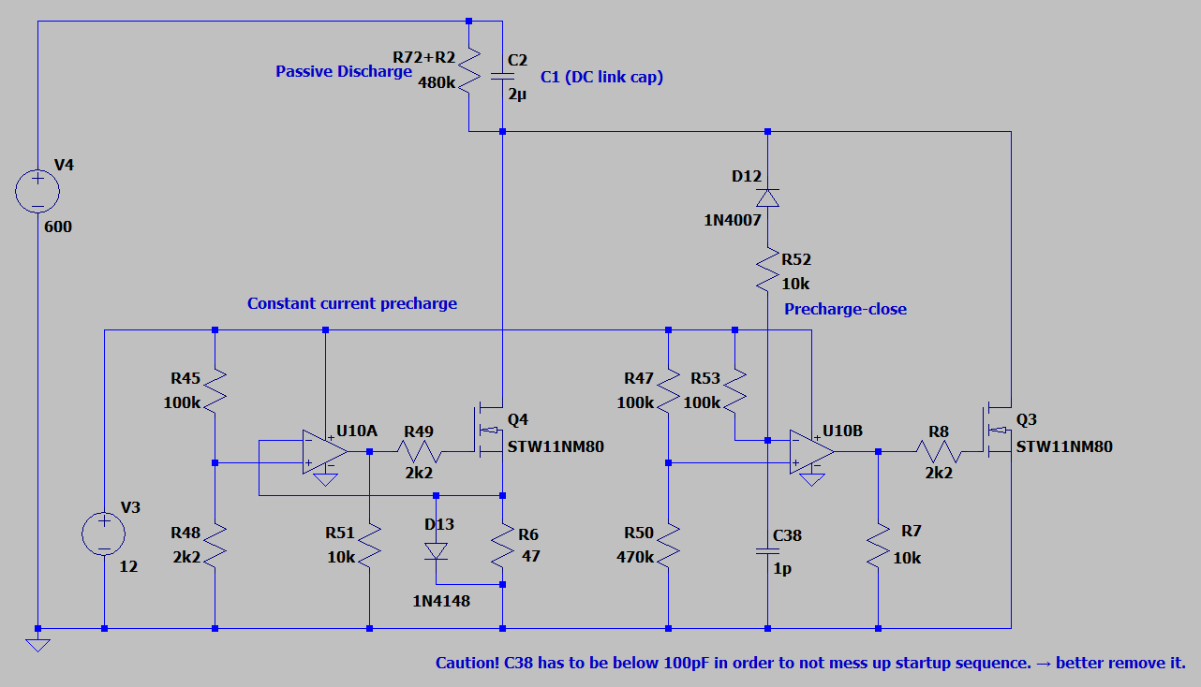
Parts:
- U10A & U10B: TLV2372DR
  - 2mV input offset voltage
  - 100mA output
  - +- 16V supply
- R45, R47, & R53: RC0402FR-07100KL
- R48: RMCF0402FT2k20
- R7, R51 & R52: RC0402FR-0710KL
- R50: RMCF0402FT470K
- R6: RC2010JK-0747RL
- D12: 1N4007FL
- D13: MMBD4148
- Q3 & Q4: IPD80R2k7C3AATMA1
  - 90mJ pulse dissipation
  - 800VDC blocking
  - 42W continuous power
- C38: 04023J1R0BBSTR
- R72 + R2: RCL0612475KFKEA

Primary Stage (Chandler):
The primary stage uses two MOSFETs (IMBG65R050M2HXTMA1) to turn the DC 600V input into an AC signal that can then be used to be stepped down and rectified to 12VDC. The MOSFETs are driven by the UCC25600DR to open and close the MOSFETs and are boosted by the UCC21520DWR gate driver which supports the higher current which is needed to drive the MOSFETs.
Programable dead time is needed to optimize the efficiency of the converter. Using a higher resistance value connected to the DT pin on the UCC25600DR to shorten the dead time. The UCC25600DR also has a programable frequency which is needed to match the frequency of the resonate tank and transformer.
Going through the Circuit, U3 creates the clock signal using a 12v dc input; the dead time is set with the 10k resistor to minimize switching loss. The RT pin is connected to the two series connected resistors and the output of the optocoupler that is on the secondary side of the converted which sets the minimum and maximum switching frequencies. The SS pin is tied to ground with a resistor to set the soft start timing.
GD1 and GD2 are connected to INA high side and INB low side of the U1 gate driver and grounding GND, disable and other unused pins on U1. VCCI, VDDA, and VDDB are connected to the same 12V input as U3 to supply power to both the primary and secondary side of the gate driver. OUTA and OUTB connect to the gates of M1 and M2. The MOSFETS M1 and M2 are connected in series and will alternate when they switch on and off based on the input clock signal. The node that connects M1 and M2 is defined as HB_out which is sent to the primary side of the transformer.
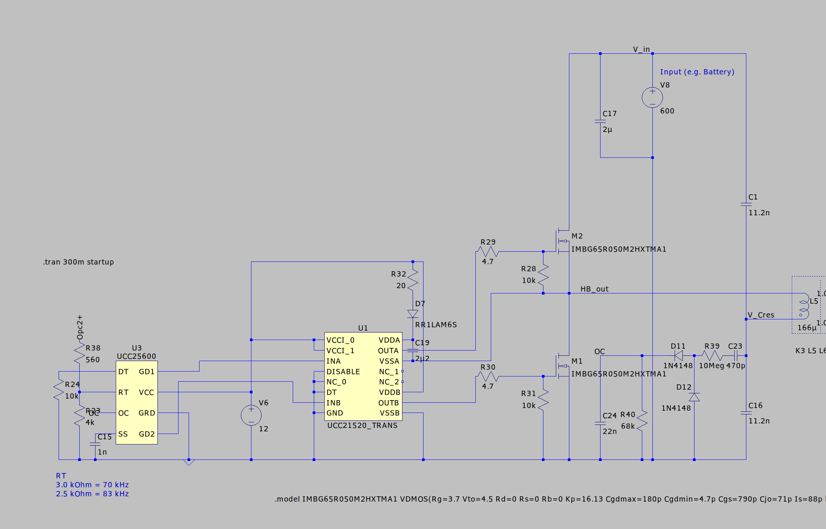
Components used:
- UCC21520DWR – Gate Driver
  - 33ns propagation delay
  - 8kVpk isolation
- IMBG65R050M2HXTMA1 – MOSFET
  - Very low switching losses
  - Vgs of 4.5V
- UCC25600DR
  - Programable dead time
  - Programable minimum switching frequency
  - 50/50 duty cycle
  - Over current protection

Secondary Side (Caleb):
The secondary side is defined as the circuit that connects the transformer output, the secondary winding, to the load. The secondary side’s primary function is to rectify the output, 12-volt AC signal, into a stable, smooth 12-volt DC signal. Additionally, the secondary side contains a voltage-controlled feedback circuit to provide galvanically isolated, proportional feedback to the control circuit. To debrief further we will cover each circuit below in more detail:

Rectifier:
The first circuit on the secondary side is the center-tapped full wave synchronous rectifier. The purpose of this circuit is once again to convert 12-volt AC to a rough 12 volt DC signal. A standard center tapped full wave rectifier is shown below, where the center-tap serves as the output to the load (high-side) and the ends of the transformer are tied to ground via diodes (termed low side). These diodes serve to rectify the AC signal. However, the main issue with using diodes or passive rectification in our application is that we have a relatively low-voltage, large current output, so the voltage drops, and power dissipation of the diodes becomes a significant problem and the bottleneck of the DC-DC converter.
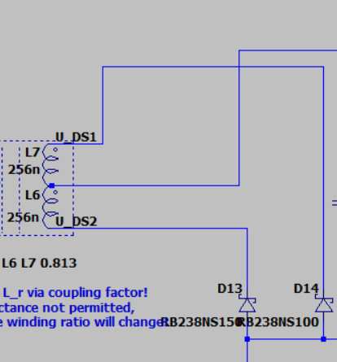
Figure: Center-Tapped Full Wave Passive Rectifier
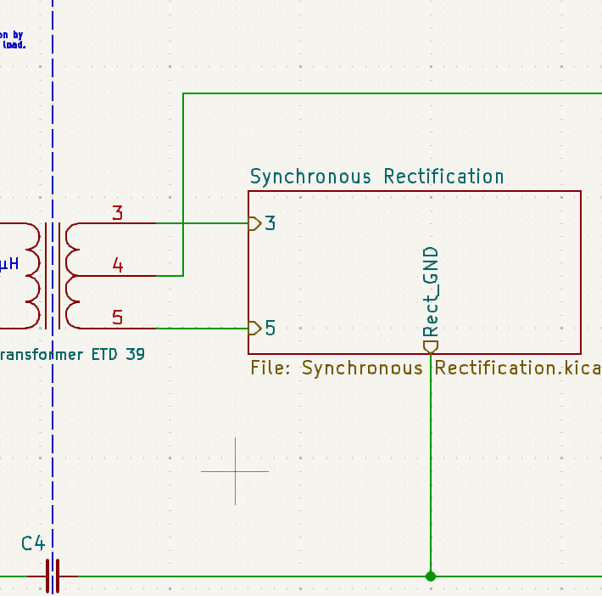
Figure: Center-tapped Active Rectifier Implementation
The synchronous rectifier solves the conduction loss issue by using MOSFETs to conduct current, which will present a lower voltage drop due to their low RDS-on characteristic. A controller then drives the MOSFETs to synchronize its switching cycle with the AC signal. It does this through a voltage sense pin CS which measures the drain voltage of the MOSFET in reference to ground (the source). When a voltage of less than -.75 mv is sensed at the drain, this means that the body diode of the MOSFET is conducting (forward bias mode) and therefore, the MOSFET is switched on to provide a less resistive path and reduce conduction losses. When a voltage of nearly 0 v is sensed at the drain, this means that the diode is now reverse biased because the current is travelling in the opposite direction through the MOSFETs channel; therefore, the MOSFET is switched off to mock the reverse-bias behavior of a rectifier diode. Essentially, the MOSFET mocks the function of diode with the added benefit of lower conduction loss -an ingenious design.
Components:
- SR Controller: NCP4305DMTTWG (NCP4305 Datasheet)
- MOSFET: BSC027N06LS5ATMA1 (Datasheet BSC027N06LS5)
  - RDS-on: 2.7 ohms
  - Power Limit
  - ID: 134 Amps
  - VDS: 60 volts
  - Qc: 24 nc
134 Amps! Note that numbers can be deceiving. Looking closer:
Without proper cooling (copper pour and heatsink), max ID is only 23 Amps. However, with a heatsink, its max is closer to 134 amps at 25 C or 84 amps at 100 C.
- C31 decoupling capacitor specified from datasheet
- R13 and C6 serve to properly trigger the CS pin (validated through testing)
- R42 sets minimum of-time period
- R38 sets the minimum on-time period

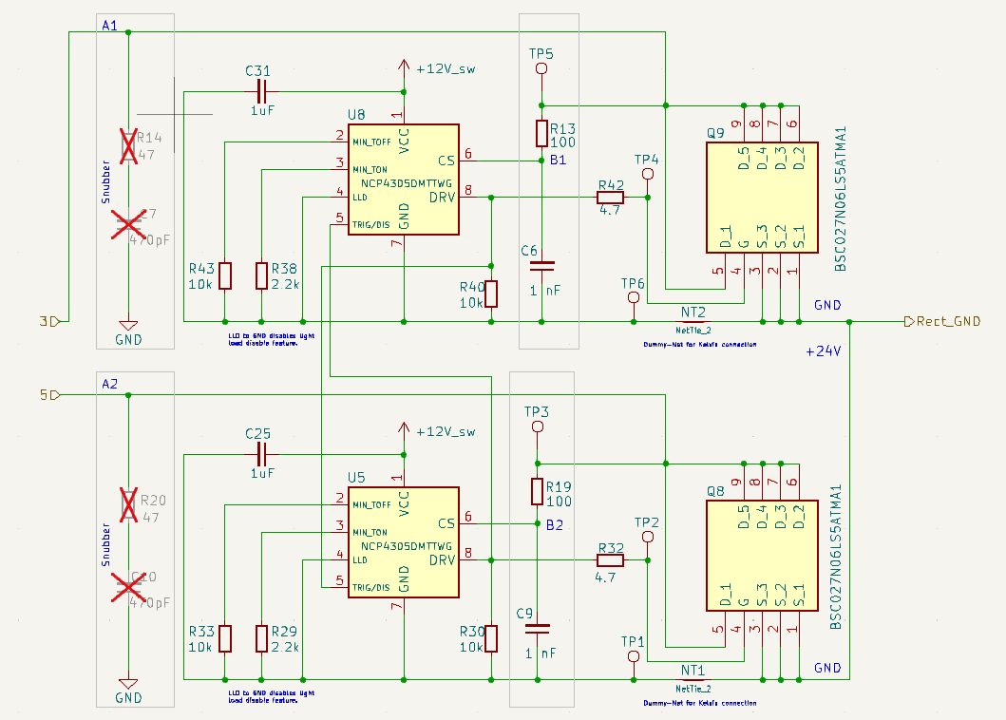
Figure: Synchronous Rectifier
Calculated MOSFET losses:
- Conduction Losses:
$$P_{Cond}={I_{D}}^{2}×R_{ds-on}=4.32 W$$

Output Filter:
Sequentially, the next circuit on the secondary side is the Pi filter which serves to smooth out the rectified DC output. The Pi filter is essentially two low pass filters in series.
Inductor:
Current Inductor: 7443091100 Würth Elektronik | Inductors, Coils, Chokes | DigiKey
New Inductor:
7443091080 Wurth Elektronik | Mouser

Capacitors:
Stage 1:
GRM32ER71J106MA12L Murata Electronics | Capacitors | DigiKey
New Cap: (5x)
MSAST32MAB5476MPNDT1 TAIYO YUDEN | Mouser
Stage 2:
UHW1V222MHD Nichicon | Capacitors | DigiKey

Transformer (Hunter):

Oscillator and Control Loop (Bixler):

Power Supply (Diego):
The power supply starts with taking in the stepped down rectified voltage from the transformer. This voltage then gets stepped down via U3, a high efficiency step down converter to 3.7 Volts to charge the super capacitor C_start1. This is achieved by adjusting the voltage from the feedback pin via a voltage divider. U3 is an MP4541_SOP8-EP, and we are using its common configuration provided by the datasheet.

FB Voltage: 1.0 V
$$V_{out}= 1.0 ⋅\left(1+\frac{27000}{10000}\right)=3.7 V$$

The capacitors C15 and C53 that are in parallel stabilize the input and provide instantaneous current during switching. C17 achieves this as well, however it is connected to the VCC pin on the converter. R25 sets the switching frequency U3 uses via the FREQ pin.
The pulses that U3 produces are then smoothed out by the L3 inductor to make it a continuous DC current. The way this is achieved is when the switch turns off the inductor keeps the current flowing through the diode D7 and resistor R22 into the capacitors C12 and C16 where C16 is connected to the feedback pin on the converter and C12 is connected parallel to the diode D7 and resistor R22. The configuration of the MOSFET Q7 as well as a reversed biased diode D8 is used for reverse current protection and enable gating. When Q7 is off, the inductor releases a kicked-up voltage then is rectified by D9. When the DC is low, current can’t flow back into the converter or input line.
U4 is a TLV61048DBVR which is a boost converter. U4 takes the voltage from the super capacitor C_start1 and boosts it to 12 Volts.
C64 C8 Stabilize voltage and provide instant current during switching.
U2 is a low dropout voltage regulator, and it takes the boosted 12V and converts it to a fixed 9V. C17 C18 provides smoother 12V. The 9V is used to power the fans.
- Can we get rid of the whole step-down converter process since we are not inputting 24 volts and just taking 12 volts directly?
- No, we can’t get rid of the stepping down of the initial voltage since we need it to charge the super capacitor
- All we would need is smoothing from the transformer current
- We still need U2 since the fan circuit uses 9Volts
- Yes, if the fans used 12 Volts instead of 9 Volts we wouldn’t need U2 at all

Overtemperature Protection (Wesley):

The Overtemperature Protection system shuts down the device when the temperature surpasses the safe operating limit to prevent overheating. The Overtemperature Protection and Fan control are comprised of 2 op-amps. The Overtemperature control op-amp Vin+ is connected to a D10 diode that is connected to the op-amp output for latching. The Vin- is connected to a TH2, which uses the diode to measure the maximum temperature based on the parallel combination of the R36 = 4.7K resistor and parallel resistor. The TH2 impedance changes based on the combined parallel resistance and is converted to a temperature value measured in Celsius. TH2 is connected to the 2 parallel resistors. Right now, for R35 (330K) in parallel to the R36, the TH2 has a resistance of 1404 ohms, which is a temperature of 113.5 Celsius, which is measured as 106.9 Celsius due to noise on the op-amp signals.
The fan control circuit regulates the fan speed by adjusting the current or voltage following into it. When the fan op-amp is on, the fan receives 5.9466 V which converts to 4784 Ohms which converts to 77 degrees Celsius. When the fan op-amp is off, the fan receives 6.0533 V which converts to 4617 Ohms which converts to 68 degrees Celsius.

Components used:
- R36, R35, R34
- TH2, C28, R11, C48
- LM2904BIDDFR (U6A)
- D10
- LM2904BIDDFR (U6B)
- C19, R16
- R75, R31, R15
- R18

Appendix:
SPICE Simulation Settings:

