Project Test Plan
Group number: sdmay26-45
Project title: 600-12 Volt Converter
Client &/Advisor: Formula SAE, Professor Cheng Huang

Resources:
- Build Guide
- DC-DC Table

Contents
Project Test Plan Group number: sdmay26-45 Project title: 600-12 Volt Converter Client &/Advisor: Formula SAE, Professor Cheng Huang 1
Transformer: 2
Printed Circuit Board: 2

Transformer

Isolation Test:
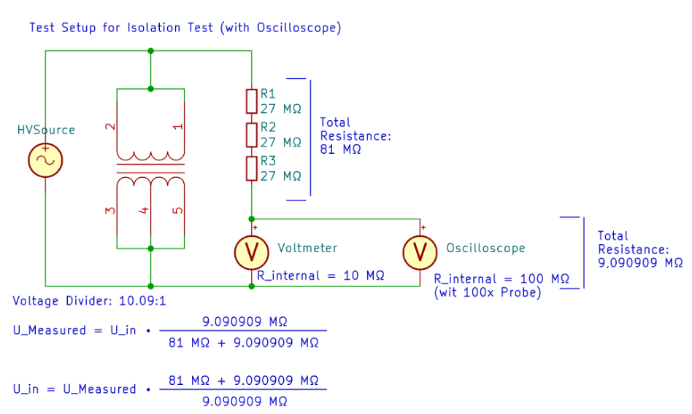
Figure 1: Isolation test setup (pg. 51)
Steps
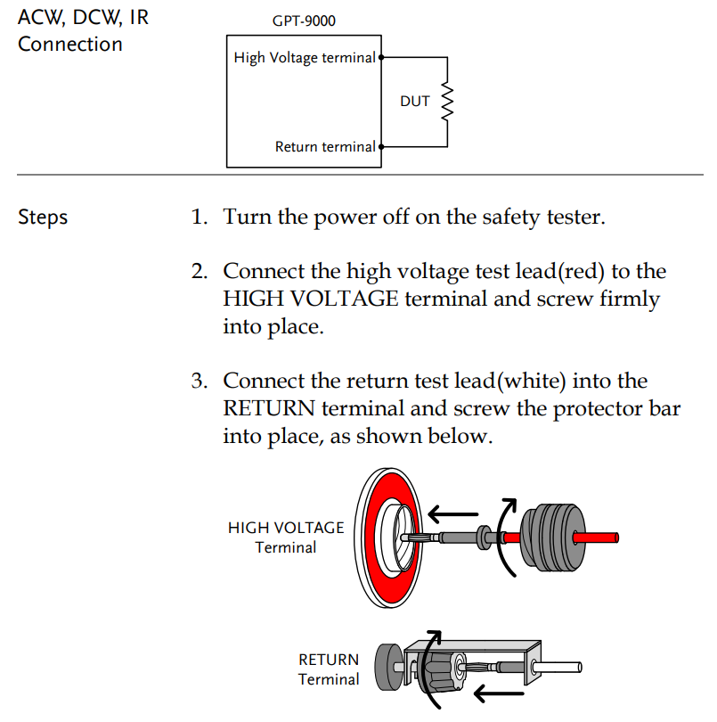
Figure 2: Connection to GPT-9803
- The Isolation tester (Instek GPT-9803 Hi-Pot Tester) positive must connect to the primary side of the transformer (figure 2)
- The secondary side of the transformer must connect to the ground of the GPT-9803 (figure 2)
- Set voltage to 1800VAC & frequency to 60Hz
- Run the test

Assembly
- Verify transformer is fully de-energized and isolated from all external circuits.
- Connect transformer terminals according to the pair being tested:
  - High-Voltage Lead (HOT): primary winding terminals tied together (H1/H2).
  - Return/LOW Lead: secondary winding terminals tied together (X1/X2), or transformer core/tank depending on test.
- Ensure unused terminals are left floating unless the tester manual requires grounding.
- Attach tester’s safety ground to test bench earth.
- Confirm all personnel are clear of the test area before energizing.

Expected Values
- Applied Voltage: 1800 VAC @ 50 Hz.
- Duration: 60 seconds.
- Leakage Current Limit: 0.5mA
- Expected Behavior:
  - No breakdown, arcing, or audible corona during test.
  - Tester completes the test without triggering “FAIL,” “ARC,” or “HV OFF” fault modes.

Test Procedure
- Setup and Safety
  - Verify terminals are clean and dry
  - Turn on & confirm GPT-9803 output is off
- Tester Configuration
  - Select AC Withstand Mode.
  - Set Output Voltage to 1800 VAC.
  - Set Frequency to 50 Hz.
  - Set Ramp Time to default
  - Set Test Time to 60 seconds.
  - Set Leakage Current Trip Level: 0.5mA
  - Enable Arc Detection
- Isolation Test
  - Test A: Primary to Secondary
    - Hot lead to primary terminal.
    - Return lead to secondary terminal.
    - Start the test.
  - Test B: Primary to Core
    - Hot lead to primary terminal.
    - Return lead to core.
    - Start the test.
  - Test C: Secondary to Core
    - Hot lead to secondary terminal.
    - Return lead to core.
    - Start the test.
- Interpreting Results
  - Test Pass:
    - Tester completes the full duration.
    - No visible discharge, change in smell, audible crackle, or insulation failure.
  - Test Failure:
    - GPT-9803 triggers leakage overcurrent, arc detection, breakdown, or shutdown.
    - Any visible arc, smoke, or audible corona.
- Post-Test
  - Turn HV output of GPT-9803 off.
  - Wait for GPT-9803 & Transformer windings to discharge

Load test:
Materials required
- High Voltage DC Source
- High Voltage Inverter
- Immersion heater
- 120VAC wall socket
- 5gal bucket of cold water
- Current clamp
- Multimeter
- Transformer
- 4/0AWG wires
- Alligator clips or lugs
Steps
- Connect Transformer to wall socket through use of alligator clamps
- Plug in immersion heater to wall socket (set heater to off)
- Set up multi-meter to measure AC from the low-side of transformer
- Connect Transformer to single pole of Inverter through use of alligator clamps and 4/0awg wire, cap or electrically isolate remaining poles
- Connect inverter to High Voltage DC source
- Turn on High Voltage DC source after making sure the inverter is pre-charged
- Measure AC voltage from low-side of transformer, if below 20VAC proceed to next step
- Using a current clamp connected to the multi-meter, clamp around the immersion heater wires
- Measure current & Voltage at the same time, assume power loss is negligible
- Control power going into transformer through use of the inverter.

Printed Circuit Board:

Test: Initial Test Without HV Input

Required Materials:
- Testing Tools
  - DC Power Supply (Coover)
  - Voltmeter (Coover)
- DC/DC Parts
  - Lithium Capacitor
Process:
- Keep DC power supply output OFF for this step. Set DC power supply to a current of 100 mA and 0V. Connect it to the output of the DC/DC with the same polarity.
- Slowly turn the DC power supply output to ON. Turn the voltage of DC power supply to 12 V.
  - Check for voltage of 3.6 to 3.8 V between pads of $C_{start1}$
  - Check that the 5 V LED lights up
- Enable switch on DCDC
  - Check for a voltage of 12 to 12.5 V between pads 1 and 2 of U1
  - Check that 12 V and power LEDs light up
  - Check that input current at 23V is 20 - 30 mA.
- Insert the super cap ($C_{start1}$).
  - Be careful in this step! The capacitor is charged between 3.6 to 3.8 V.
  - Be careful not to short the circuit in this step
- Remove R61 to deactivate UVP/OVP

Test:
- Check for square waves, measured against ground: U12 pins 5 and 8, Q10 and Q11 pin 1 (gate).
- Apply low voltage, like 10V or 100mA to HV input.

Required Materials:
Process:

Initial test without HV input:
-Set constant current of 100mA and 0V on the Lab power supply with output Off connected to the output of the DCDC with the same polarity.
-Slowly increase the voltage on the laboratory power supply to max. 23V. A voltage of between 3.6 and 3.8 V should be at the pads of $C_{start}$ 1 and the 5V LED should light up. -Switch on the DCDC with an enable switch. Approx. 12 to 12.5 Volt should be present between pads 1 and 2 of U1 and the 12V and Pwr LEDs should light up. The input current at 23V should be between 20 and 30 mA.
-Insert the lithium capacitor. Do not short circuit both contacts when trimming the connections.
-Remove R61 to deactivate UVP/OVP.
-Check whether square wave signals are present, measured against ground: U12 pins 5 and 8, Q10 and Q11 pin 1 (gate).
-Do not set output above 23V for testing.
-Apply a low voltage (e.g. 10V / 100mA ) to the HV input.

Test Set up:
At the HV input:
- Voltage source 0 – 600 V / 0-2 A
- Multimeters for voltage and current measurement
  - The multimeters are connected voltage-based, i.e. voltage measurement behind the current meter, followed by the DCDC
On the LV output:
- Power sink 24V / max. 0 –31.25 A
- Multimeter for voltage measurement (connected via measuring points J4)
- Multimeter for current measurement (or measurement of the current via a suitable shunt)
- Laboratory power supply unit for charging the start capacitor (suitable for 5-24 V)

On the DCDC with oscilloscope:
- A) Voltage measurement via Cres (HV! Only suitable if differential HV probes up to 600V are available or oscilloscope has isolated measurement inputs)
- B) Current measurement (insulated current measuring coil) via a transformer cable. The measured values of both measurement methods (A/B) can be approximately converted into each other, so it is not necessary to measure both. However, the current measurement may be more suitable for understanding the actual load on the transformer.
- Voltage measurement via drain source and gate source on one of the SR MOSFETS (Q8 or Q9)
- Measurements via C1 (HV!) to check the precharge
- HV input and LV output for ripple voltage measurements
Other measurements:
- Room temperature (for isolation measurement also humidity)
- Thermal imaging camera (highly recommended!), alternatively, IR thermometer (way less accurate, does not measure to a precise point, reflections not recognizable.

