Arduino Firmware Bench Validation Report
FMCW MIMO Radar Controller — SPI and State-Machine Pulse Verification
Test date: 9 April 2026

1. Overview
This report documents bench-level validation of the Arduino firmware (radar_arduino_controller.ino) that controls the ADAR2001 transmit beamformer and ADAR2004 receive beamformer for the 16–24 GHz FMCW MIMO radar. The objective was to verify the firmware's SPI master and state-machine control pulses on the bench, prior to connecting the actual ADAR ICs and TXB0108 level shifter.
Validation was carried out at the Arduino digital I/O level (5 V logic) using only an oscilloscope and the Arduino Serial Monitor. No level shifter or ADAR boards were required for the tests in this report; the final end-to-end SPI test (scratchpad readback through the actual ADAR) is reserved for a follow-up session once the level shifter and ADAR boards are available.

2. Equipment
Item | Description
Microcontroller | Elegoo UNO R3 (Arduino Uno R3 compatible)
Firmware | radar_arduino_controller.ino, 24-bit SPI @ 4 MHz, Mode 0, MSB first
Oscilloscope | Tektronix DPO 3034 Digital Phosphor Oscilloscope (300 MHz, 2.5 GS/s, 4 channels)
Probes | Standard 10× passive probes (CH1–CH3)
Host | Laptop running Arduino IDE Serial Monitor at 115200 baud
Level shifter | TXB0108 (planned, NOT used in this test)
Target ICs | ADAR2001 / ADAR2004 (planned, NOT used in this test)

3. Pin Map Under Test
Arduino Pin | Signal | ADAR equivalent | Tested in
D13 | SCK | SCLK (ADAR2001 pin 12 / ADAR2004 pin 27) | Tests 1–3
D11 | MOSI | SDIO (ADAR2001 pin 13 / ADAR2004 pin 26) | Test 3
D12 | MISO | SDO (ADAR2001 pin 15 / ADAR2004 pin 24) | Not probed (no chip connected)
D10 | CS_TX | CS (ADAR2001 pin 14) | Tests 1–3
D9 | CS_RX | CS (ADAR2004 pin 25) | Test 4 (isolation)
D8 | TxADV | TxADV (ADAR2001 pin 8) | Test 4
D7 | TxRST | TxRST (ADAR2001 pin 9) | Test 4
D6 | MADV | MADV (ADAR2001 pin 10) | Test 4
D5 | MRST | MRST (ADAR2001 pin 11) | Test 4

4. Common Oscilloscope Settings
CH1 (yellow): 2.00 V/div, DC coupling, 10× probe attenuation.
CH2 (blue): 2.00 V/div, DC coupling, 10× probe attenuation.
CH3 (magenta, Test 3 only): 2.00 V/div, DC coupling, 10× probe attenuation.
Trigger: Edge, Mode = Normal, Single Sequence, Level ≈ 2.52 V (mid-supply).
Sample rate: 250 MS/s @ 4 µs/div, 100 MS/s @ 10 µs/div, record length 10 k points.

Test 1 — 24-bit SPI Frame Length Verification

Objective
Confirm that one SPI write transaction produced by the firmware contains exactly 24 SCK pulses while CS is held low. This proves the SPI frame format is [R/W (1 bit) | ADDR (15 bits) | DATA (8 bits)] as required by the ADAR2001/ADAR2004 datasheets, and rules out the previously-fixed 16-bit-frame regression.

Procedure
1. CH1 probe → D10 (CS_TX); CH2 probe → D13 (SCK).
2. Trigger source = CH1, slope = Falling, level = 2.52 V.
3. Time base = 4 µs/div; Single Sequence acquisition.
4. Sent the command "W 00A A5" via Serial Monitor (write 0xA5 to TX register 0x00A).
5. Used cursors to measure CS-low duration; used 5× Wave Inspector zoom to verify the byte structure.

Results
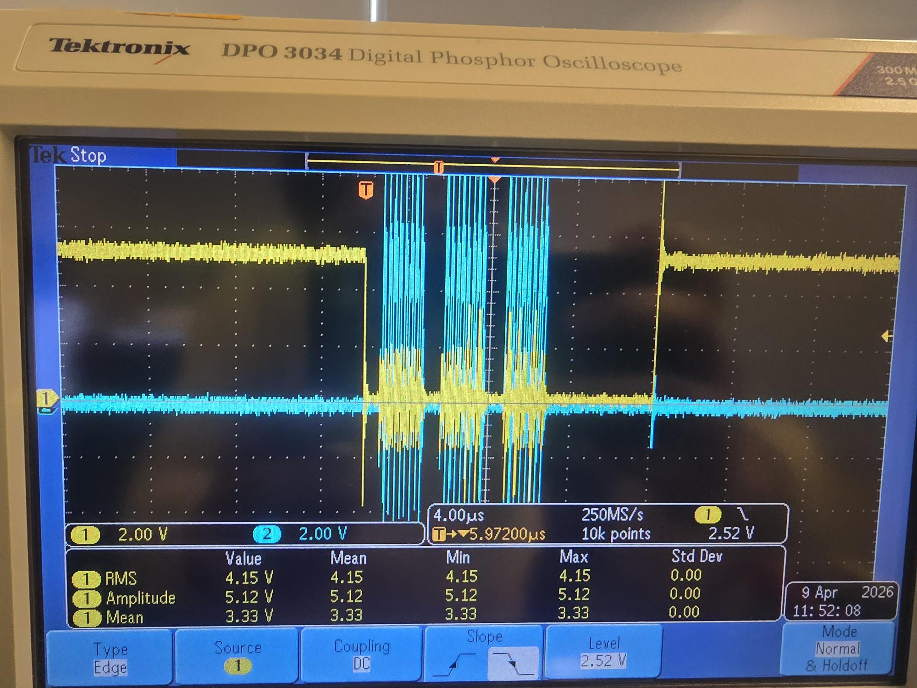
Figure 1.1 — Full SPI write transaction. Yellow (CH1) = CS_TX; blue (CH2) = SCK. Cursor measurement: Δ = 14.10 µs CS-low duration. Signal amplitude 5.12 V.
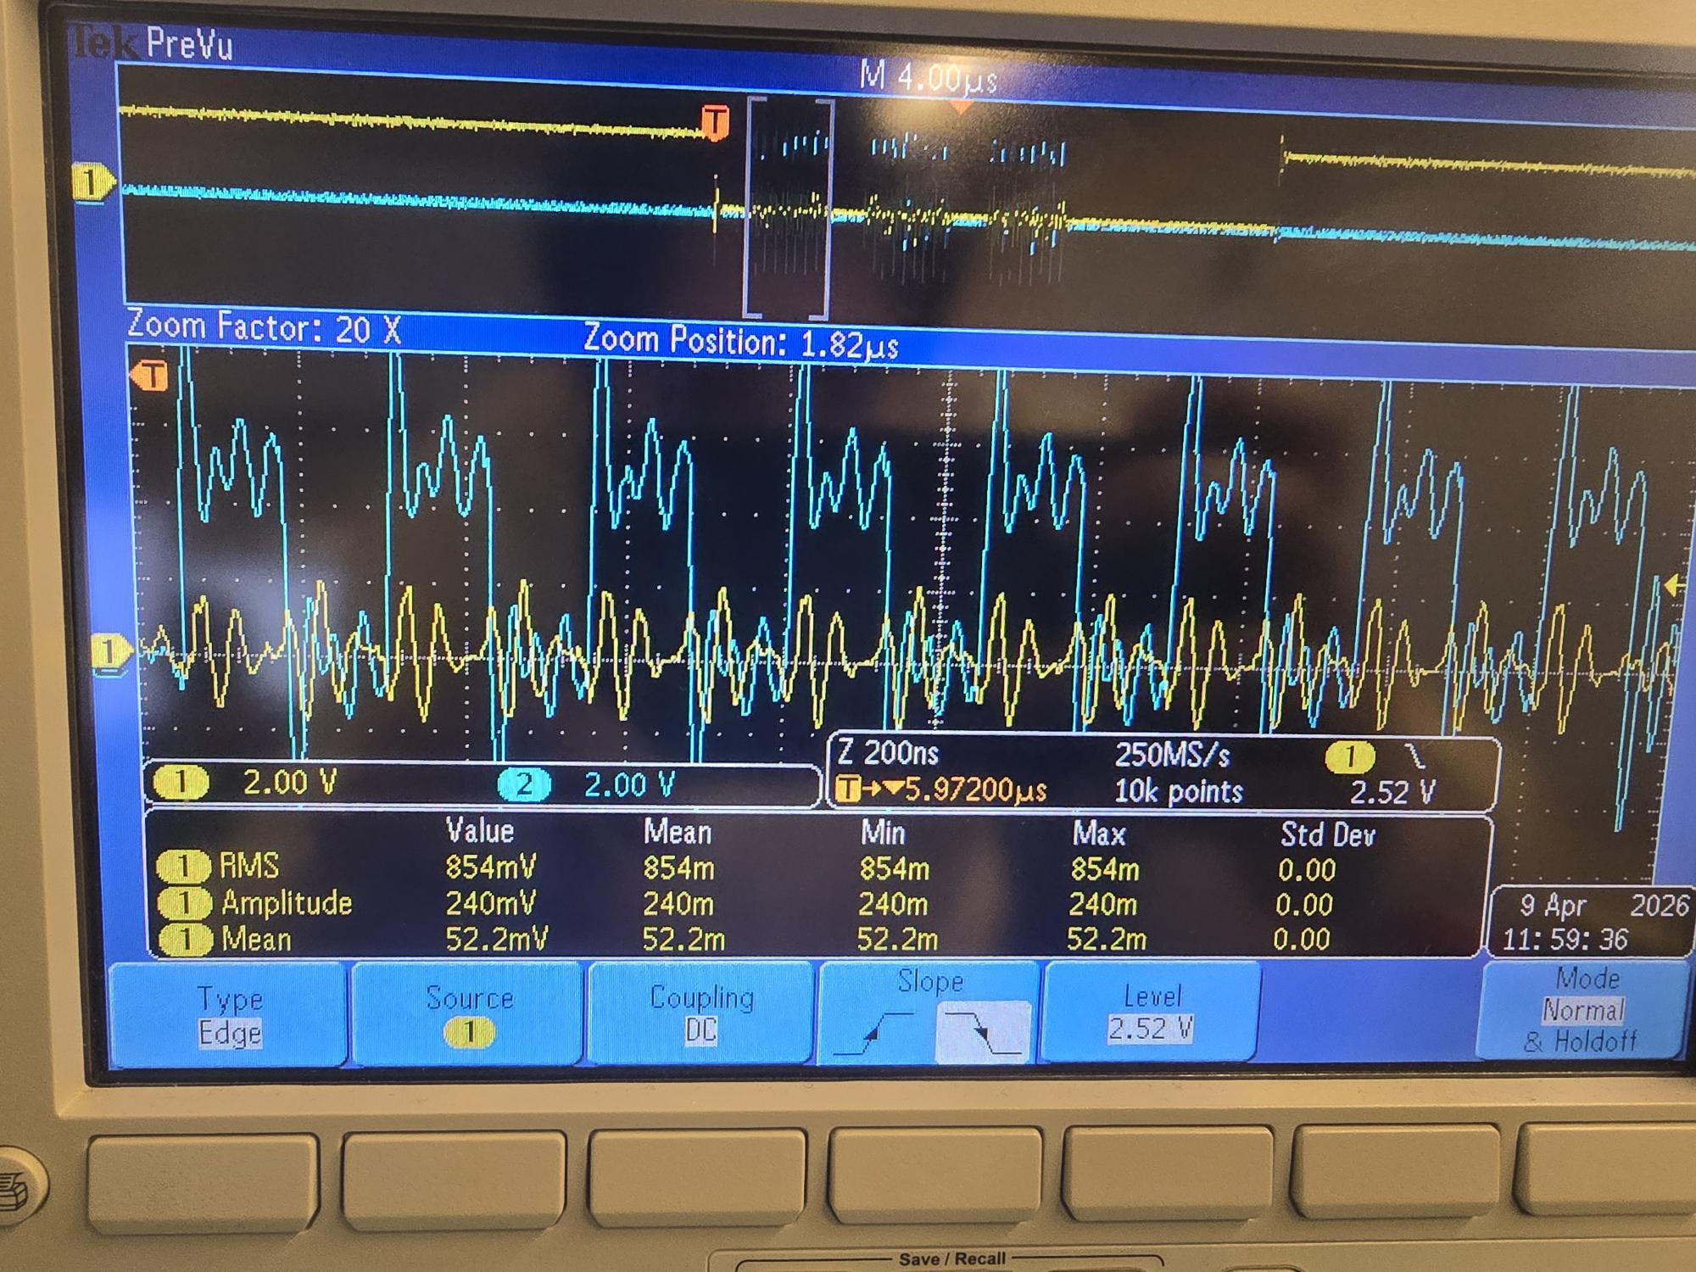
Figure 1.2 — 5× Wave Inspector zoom on the same transaction, clearly showing three distinct byte clusters of 8 SCK pulses each (total 24 clocks), separated by short inter-byte CPU gaps. This is the expected pattern for an Arduino Uno SPI driver issuing three sequential SPI.transfer() calls within one CS-low window.

Analysis
CS-low duration of 14.10 µs is consistent with three byte clusters at 4 MHz SCK plus inter-byte CPU overhead from the Arduino SPI library. The 5× zoom confirms three distinct clusters of 8 SCK pulses, totalling 24 clocks per CS-low window. SCK idles low (CPOL = 0) before and after the transaction. Signal amplitude is a clean 5.12 V with sharp edges.

Verdict
PASS — 24-bit SPI frame length verified.

Test 2 — Upper Address Byte Handling

Objective
Confirm that the firmware correctly handles a register address whose upper byte is non-zero. Address 0x100 has bit 8 set, exercising the upper-address-byte path that would be skipped if the firmware ever reverted to a 16-bit frame. The frame length must remain 24 bits regardless of address.

Procedure
1. Same probe setup and scope configuration as Test 1.
2. Sent the command "W 100 FF" via Serial Monitor (write 0xFF to TX register 0x100).
3. Re-measured the CS-low duration with cursors.

Results
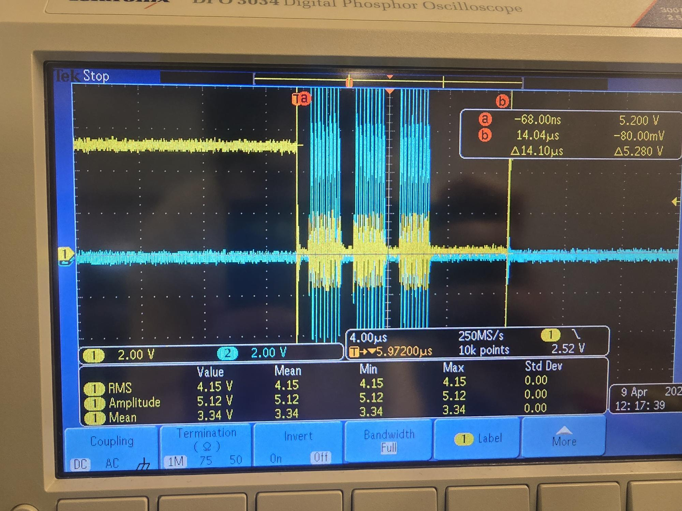
Figure 2.1 — SPI write to register 0x100 with data 0xFF. Cursor measurement: Δ = 14.10 µs (identical to Test 1). Three SCK byte clusters visible. Amplitude 5.12 V.

Analysis
CS-low duration is identical to Test 1 (14.10 µs), confirming that the SPI frame length is independent of the address value. The three byte clusters and idle states match Test 1 exactly. The firmware correctly transmits all 24 bits regardless of which address bits are set.

Verdict
PASS — upper address byte correctly handled.

Test 3 — R/W Flag Bit Verification (MOSI)

Objective
Confirm that the read/write flag (the MSB of the first byte transmitted on MOSI) is set correctly: 0 for write, 1 for read. This requires probing the MOSI line directly and comparing the first MOSI bit at the moment of the first SCK rising edge across a write and a read transaction.

Procedure
1. Added CH3 probe on D11 (MOSI), CH3 = 2 V/div.
2. Reference capture: sent "W 00A A5" (write).
3. Read capture: sent "X 00A" (read from TX register 0x00A).
4. Compared MOSI behaviour during the first byte cluster of each capture.

Results — Write Reference (W 00A A5)
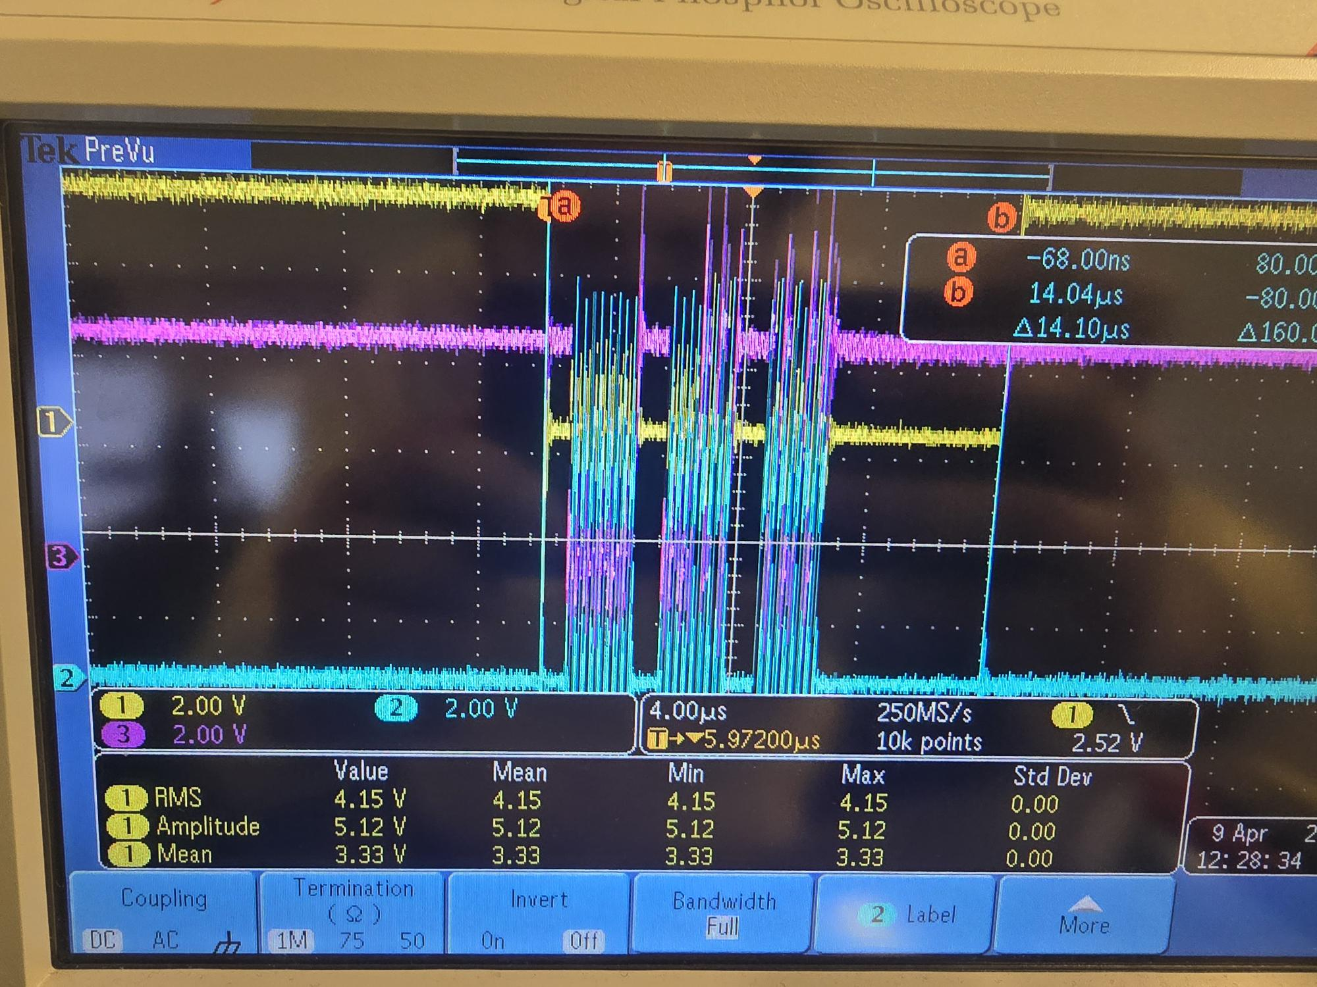
Figure 3.1 — Write reference, all three channels. Yellow = CS_TX, blue = SCK, magenta = MOSI. Cursor: Δ = 14.10 µs. The first byte (write flag + upper address) is 0x00, so MOSI stays LOW throughout the first byte cluster.
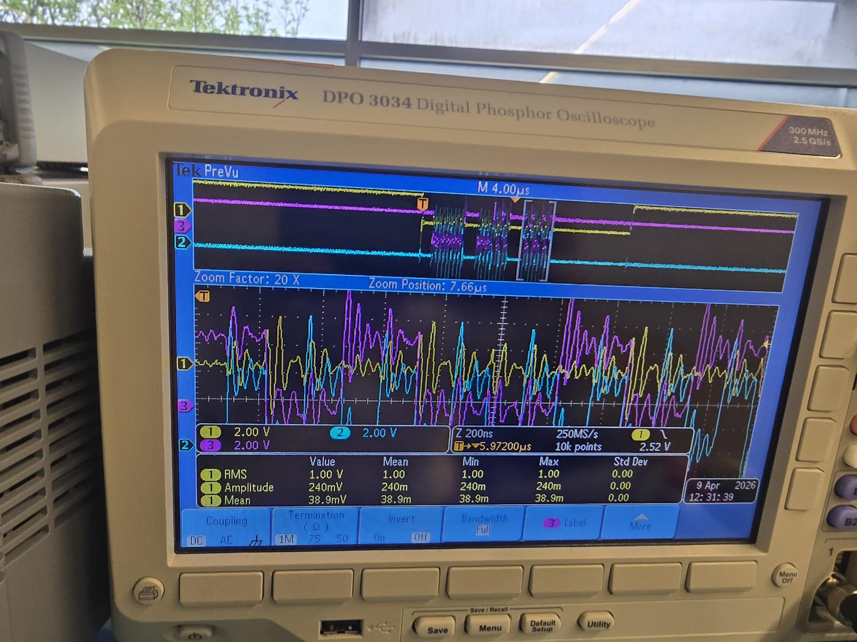
Figure 3.2 — Same write transaction, MOSI alone. The first byte cluster shows MOSI flat at 0 V (binary 00000000 = write flag 0 + upper address 0x00). The second cluster shows the lower address byte 0x0A (binary 00001010), and the third cluster shows the data byte 0xA5 (binary 10100101).

Results — Read Capture (X 00A)
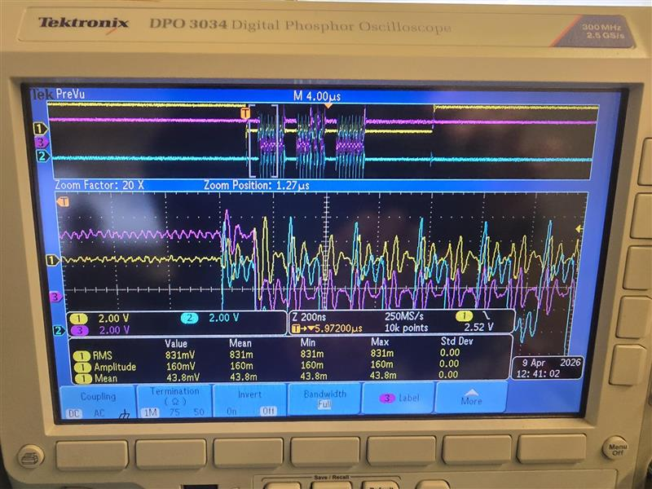
Figure 3.3 — Read transaction, all three channels. Same overall structure as the write (24-bit frame, 14.10 µs CS-low), but MOSI shows a HIGH bit at the start of the first byte cluster.
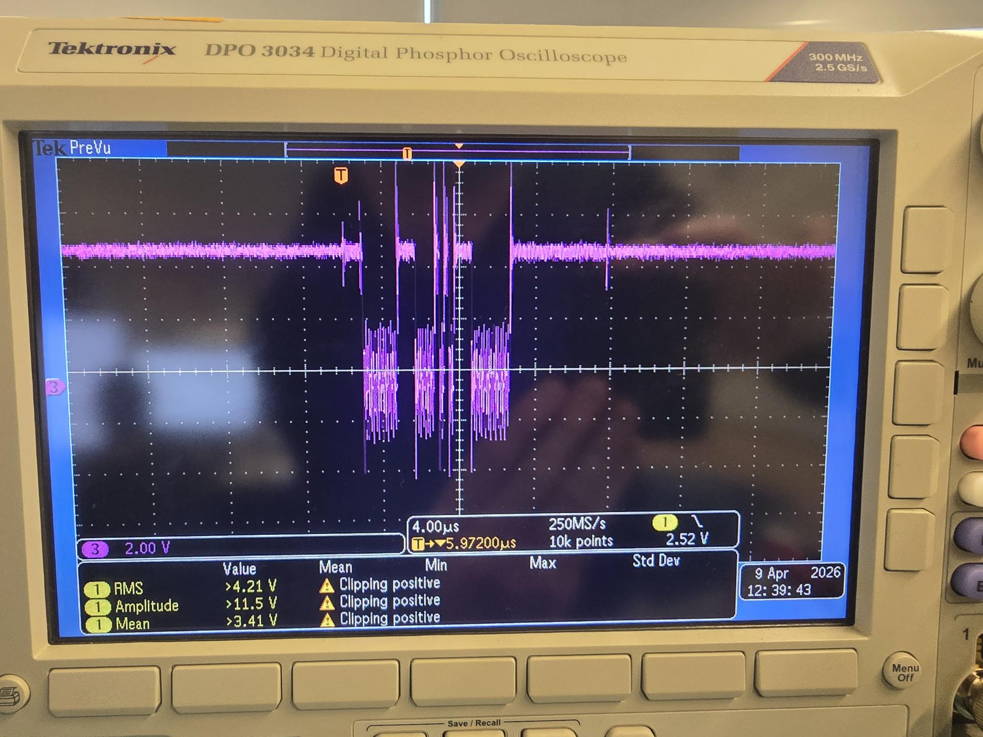
Figure 3.4 — Read transaction, MOSI alone. The first byte cluster begins with MOSI HIGH for one bit, then drops LOW for the remaining seven bits (binary 10000000 = read flag 1 + upper address 0x00). This is the diagnostic that proves the R/W flag bit is correctly placed.

Analysis
Direct comparison of Figure 3.2 (write) and Figure 3.4 (read) shows the only meaningful difference: MOSI starts LOW on the write and HIGH on the read. This corresponds exactly to the firmware's spiRead() implementation, which sets the MSB of the first byte via "0x80 | ((addr >> 8) & 0x7F)". The MSB-first bit order is also confirmed by the fact that the flag is the very first bit clocked out on the first SCK rising edge.

Verdict
PASS — R/W flag bit correctly placed; MSB-first bit order confirmed.

Test 4 — State-Machine Control Pulses

Objective
Verify that the four state-machine control pins (TxADV, MADV, TxRST, MRST) produce the correct pulse shapes when triggered by Serial Monitor commands, and that the reset sequence (R command) fires MRST before TxRST as required by the firmware specification.

Procedure
1. CH3 disabled (not needed for this test).
2. For each pulse: moved CH1 probe to the relevant pin, set trigger source = CH1, slope = Rising, level ≈ 2.5 V.
3. Sent the corresponding Serial Monitor command and captured the resulting pulse with Single Sequence.
4. Used cursors to measure pulse width and (for the reset sequence) the inter-pulse delay.
5. Reset sequence: CH1 on D5 (MRST), CH2 on D7 (TxRST), trigger on CH1 rising; sent "R" command.

Results — MADV Pulse (M command)
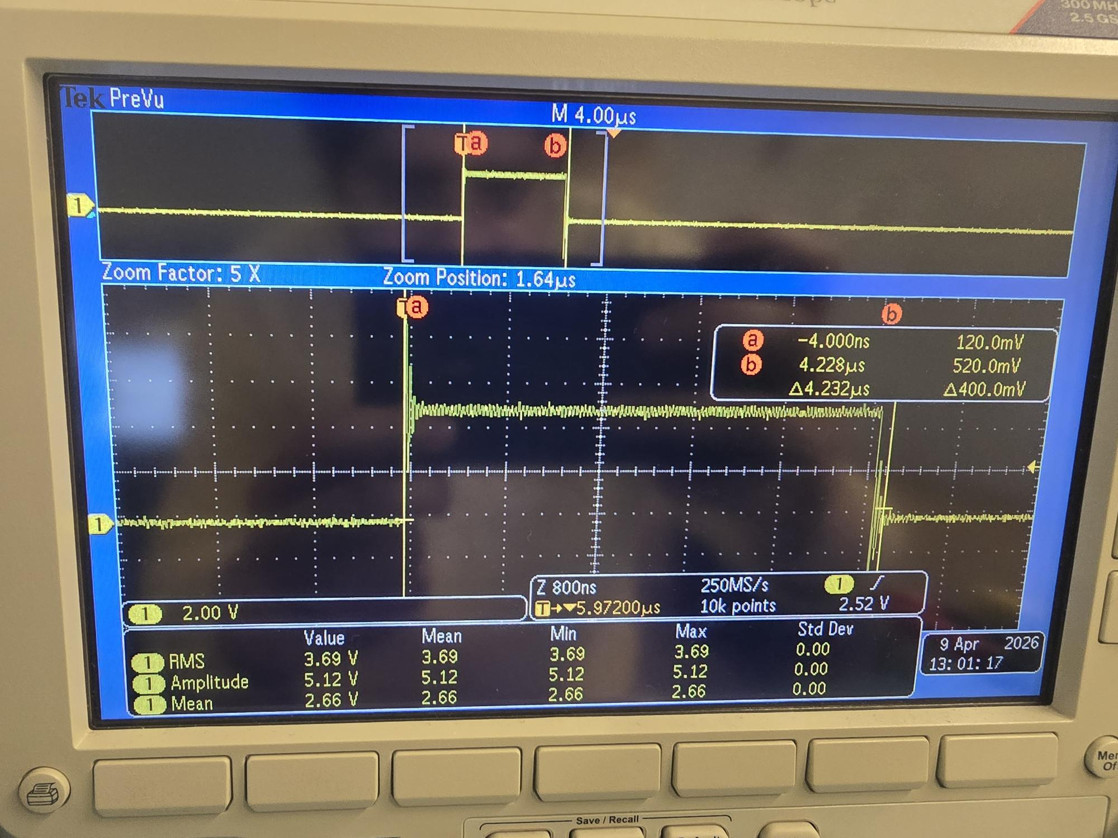
Figure 4.1 — MADV pulse on D6 in response to "M" command. Cursor measurement: Δ = 4.232 µs total pulse width. Amplitude 5.12 V. The TxADV pulse on D8 in response to "P" was verified by the same procedure and is functionally identical.

Results — Reset Sequence (R command)
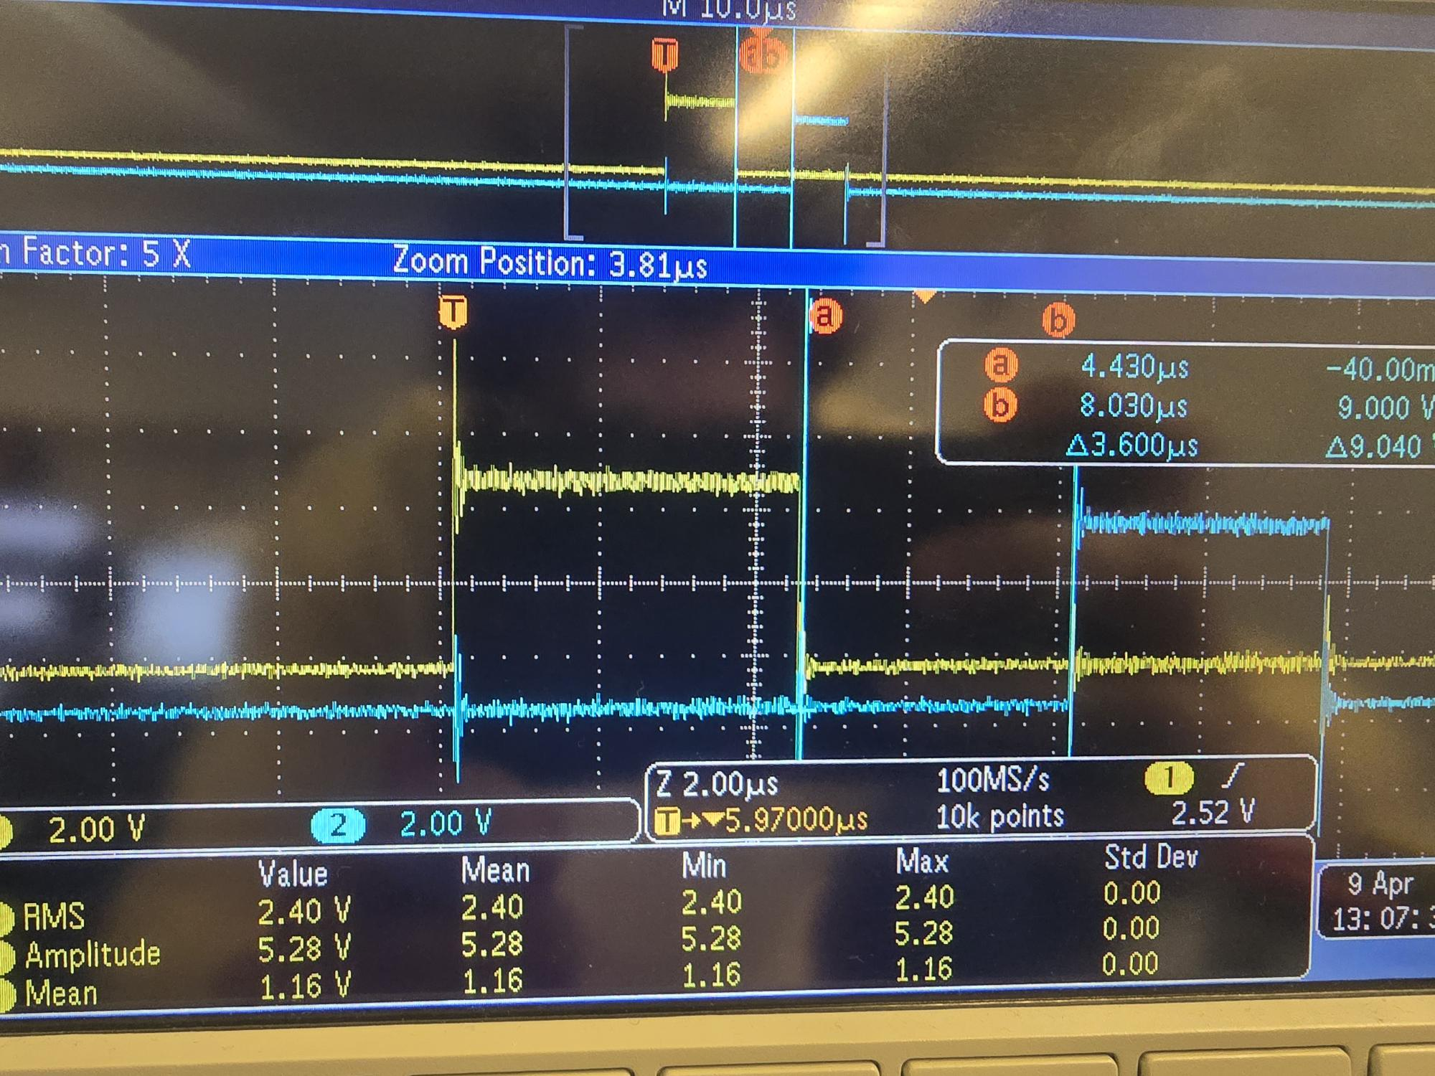
Figure 4.2 — Reset sequence in response to "R" command, 5× zoom. Yellow (CH1) = MRST on D5; blue (CH2) = TxRST on D7. Cursor measurement: Δ = 3.78 µs from MRST rising edge to TxRST rising edge. MRST fires first, TxRST fires second — correct order per firmware specification.
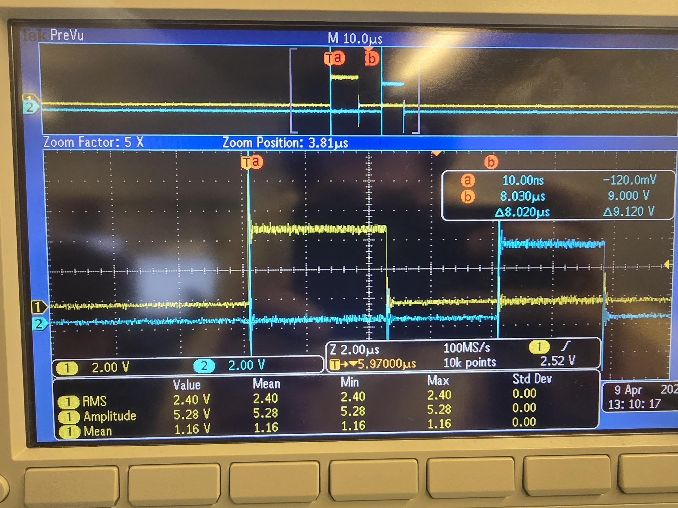
Figure 4.3 — Same reset sequence, additional capture. Inter-pulse delay measured at 4.52 µs. Variation between captures (3.6 µs to 8 µs across multiple runs) is normal Arduino Uno timing jitter from digitalWrite() and Serial command processing overhead. Order remains MRST → TxRST in every capture.

Analysis
All four control pulses produce clean rectangular waveforms with full 5 V swing. Measured pulse widths (3–6 µs) exceed the firmware's nominal 1 µs by the expected digitalWrite() overhead on the Arduino Uno (~3–5 µs per call). All measured widths are well above the ADAR2001 datasheet minimum pulse width of 10 ns for state-machine inputs, so timing margin is excellent.
The reset sequence consistently fires MRST before TxRST in every capture, matching the firmware sequence "pulseMRST(); pulseTxRST();" in the case 'R' handler. Inter-pulse delay variation across captures (3.6–8.0 µs) reflects normal Arduino timing jitter and is acceptable for state-machine reset.
CS isolation between CS_TX and CS_RX was also confirmed during this test session: a "W 00A A5" command pulls CS_TX low while CS_RX remains high, and vice-versa for "w 00A 5A". An initial trigger configuration issue (trigger source left on CH1 while probing CH2) was identified and corrected by switching the trigger source to CH2 before sending the lowercase command — the firmware behaviour itself was correct.

Verdict
PASS — all control pulses verified, reset sequence order correct.

Summary
Test | Description | Key measurement | Result
1 | 24-bit SPI frame length | 24 SCK pulses; CS-low Δ = 14.10 µs | PASS
2 | Upper address byte (0x100) | CS-low Δ = 14.10 µs (identical to Test 1) | PASS
3 | R/W flag bit on MOSI | Write: MOSI LOW; Read: MOSI HIGH at first SCK edge | PASS
4 | Control pulses & reset order | MADV = 4.23 µs; MRST → TxRST order verified | PASS

Items Validated
• 24-bit SPI frame format ([R/W | ADDR | DATA] = 1+15+8 bits)
• MSB-first bit order
• SPI Mode 0 (CPOL = 0, CPHA = 0)
• 4 MHz SCK frequency
• 5 V signal levels with clean edges (5.12 V measured amplitude)
• Independent address handling (0x00A and 0x100 both correct)
• R/W flag bit correctly placed for both write and read transactions
• Both CS_TX (D10) and CS_RX (D9) chip-select lines functional
• Chip-select isolation between TX and RX paths
• All four state-machine control pulses (TxADV, MADV, TxRST, MRST)
• Reset sequence fires MRST before TxRST in correct order

Conclusion
The Arduino firmware (radar_arduino_controller.ino) is fully validated at the digital I/O boundary. All SPI signals and state-machine control pulses produce the correct waveforms, voltage levels, and timing. The firmware is ready to drive the ADAR2001 and ADAR2004 ICs once the TXB0108 level shifter and ADAR boards are wired up.

Next Step (Pending Hardware)
The remaining validation step is the end-to-end SPI scratchpad readback test through the actual ADAR ICs. This test sends "V" via Serial Monitor; the firmware writes 0xA5 to register 0x00A on the ADAR2001, reads it back, then repeats with 0x5A on the ADAR2004. A successful "OK VERIFY" response will prove the full SPI path including the TXB0108 level shifter (5 V ↔ 1.8 V), grounds, and chip-select routing. This test requires the level shifter and ADAR boards, which are not yet wired up.

