Preliminary Design and Build of Automatic Mass Balancing Cubesat ADCS Testbed
Dmitriy Rivkin
September 15, 2015
GNAT Lab, NASA Ames
Abstract
A preliminary mass balancing system for a spherical air bearing was built to evaluate the feasibility of such a system on a cubesat-sized testbed. A novel balancing approach based on direct force measurements was implemented. Results are promising but indicate that hardware refinements are critical before the system is put to practical use. Recommendations for future improvements are made based on experience gained from building this system.

Background
Cubesats are a promising technology, whose capabilities are significantly enhanced when outfitted with a high performance attitude determination and control system (ADCS). Testing such a system on the ground requires a simulation of the orbital environment. This necessitates a nearly frictionless testbed whose attitude dynamics are unaffected by gravitation, which can be achieved with a finely balanced, spherical air bearing. Performing the balancing (co-location of the center of mass (COM) of the testbed with the center of rotation of the air bearing) is a non-trivial task. Manual balancing cannot achieve the required balance accuracy. Therefore, this report is concerned with the development of an automatic balancing system.

Objectives
This report is concerned with the design and build of a preliminary system, which will be used for evaluation purposes but not for practical applications. The the final design subsection describes objectives that need to be met in order for the final product to be useful in practice, and the preliminary design subsection describes the goals for this project.

Final Design
Ultimately, a balancing system should be able to achieve a fine balance with minimum human intervention. A balance can be deemed satisfactory when the torque due to gravity is 1/100th of the maximum actuation torque of the ADCS being tested. In addition, moment of inertia (MOI) of the testbed should be minimized, however, it is generally unavoidable that the MOI of the balancing testbed is significantly larger than that of the Cubesat. Finally, the system should be very rigid, so that no deflection occurs when it is tilted. A deflection of any part of the testbed will change the mass distribution and the system will no longer be balanced.

Preliminary Design
The preliminary testbed should be relatively inexpensive and quick to build. It must strive to achieve the same design goals as the final design, so as to act as a proof of concept of solutions that may be used to achieve the final design goals. It must demonstrate an enhanced balance capability with reduced human input as compared to a manual balancing setup. Finally, it must serve as a platform for the evaluation of the feasibility of the novel force sensor based balancing method described in the Method section.

Method
The key components of the balancing system are three sliding masses, mounted orthogonally. These allow for full xyz control of the location of the COM. Each mass is actuated by a stepper motor which turns a lead screw. The mass is then mounted on a lead nut and restrained from rotating. Thus, the rotary motion of the stepper motor is converted into linear motion. By using a high resolution motor and screw with with a small lead, fine (about 1 micron) positional precision can achieved.

The necessary sensing capabilities depend on the balancing method being implemented. Most known methods rely on inertial measurement units (IMU) and sometimes inclinometers, which can easily be added to the system at hand. However, in this paper a novel balancing method, based on directly measuring the gravitational torque using force sensors, is used. In the first step, the testbed is restrained to a horizontal orientation by an external support. Force sensors on the testbed measure the force exerted by the testbed on the restraint, and the X and Y masses are moved so that the force is reduced to zero. At this point, the center of mass lies somewhere along the Z axis. The testbed is then tilted by several degrees and restrained. Again, the force is measured, and driven to zero my moving the Z mass. At this point the testbed is balanced. This method requires two force sensors on board the testbed and no other sensors.

An embedded Linux system is used to make sensor readings and control the actuators. It uses a radio to communicate with a PC, where the balancing algorithm is implemented. This allows for greater computational resources and faster software development as compared with implementation aboard the embedded system.

In order to allow for a rapid, inexpensive first iteration, laser cut acrylic was used as the primary building material whenever possible.

Results
The system was successfully built, and all hardware functions properly. Refer to the appendix for details on hardware implementation. It was balanced using force sensor measurements as the feedback mechanism. The velocities of the masses were controlled manually by an operator reading the force sensor measurements.

A quantitative evaluation of the quality of the balance could theoretically be made from the force sensor measurements. However, this would require a careful calibration of the force sensor circuits which is reserved for future work. It can also be evaluated by looking at the frequency of oscillation of the test bed: the slower the oscillation, the better the balance. A perfectly balanced testbed does not oscillate at all. The observed oscillation period was about seven seconds.

Discussion

The preliminary testbed has served its purpose, in that it has verified the feasibility of a balancing system of such a scale, as well as the force sensor based balancing method. It can also be used as a platform for evaluating or developing other balancing techniques. However, a number of refinements are necessary before the system can be put to practical use. The following is a discussion of the things that worked well and should be carried over to the next iteration and things that should be changed. The term “we” is used because the following text is largely composed of opinions or impressions of the author.

Structure
The testbed structure was comprised of three layers of laser cut acrylic mounted on four threaded rods. The middle layer was mounted on the air bearing hemisphere. The X and Y actuators were mounted between the middle and bottom layers, and the Z actuator was mounted vertically between the bottom and top layers, with a part of the middle layer cut out to allow the weigh to pass through it. The net result was a bottom-heavy testbed. The addition of a payload should raise the COM somewhat, but it will still probably be necessary to add some weights to the top to raise the COM further. This adds a significant amount of inertia to the system. Future designs should try to raise the COM by raising the X and Y stages, if possible, or reducing the the mass of the X and Y stages.

The laser cut acrylic/threaded rod combination is not recommended for the future. The acrylic bends under the weights of the linear stages, and might therefore be a limiting factor in the quality of the balance. This bending, coupled with the freedom of motion afforded by the threaded rod coupling mechanism, makes it difficult to ensure that all of the levels of the testbed are parallel, and, critically, that the Z axis actuator is perpendicular to the X and Y actuators and the acrylic layers. We recommend that machined aluminum be used in future designs, and that the couplings between different layers be made of fixed length pieces. We also recommend getting a mechanical engineer to design a structure which maximizes rigidity while minimizing MOI. We feel that if it were more carefully designed and made out of aluminum, the MOI of the testbed could be significantly reduced.

Balancing Approach
The force sensor based balancing approach worked fairly well, but proved to be sensitive to build qualities of both the testbed and the restraint. In the first stage of the balancing, the testbed must be restrained in a horizontal orientation. It is very important the gravity vector in this orientation lies parallel to the Z axis actuator. If the Z axis actuator is not perpendicular to the horizontal plates of the testbed, this is difficult to achieve. Hence the requirement on precise build quality of the testbed. To achieve this horizontal restraint, the rig which must restrains the testbed must be placed level to the ground, and at precisely the right height, hence the sensitivity to the build quality of the restraint rig. Furthermore, the restraint rig must restrain the testbed both from tilting up and down and side to side, but without exerting a force on the sensors apart from the normal force opposing the gravitational torque. This means that that the restraint rig must have jaws that fit perfectly around the testbed. A small amount of extra restraint force may be acceptable, if it can be compensated for by adjusting the potentiometers on the force sensor amplifiers (see sensors section below).

Despite the tight requirements on build quality, this balancing method compares favorably with other known methods. The main advantage of this method is that it does not require any knowledge of the MOI of the system or accurate location of the masses, which many other balancing methods rely on. This makes it easy to swap out payloads without having go through a complex estimation procedure for each one. Another advantage of this method is that it does not have to deal with any dynamics, which makes it both very simple to implement and computationally undemanding. Also, the sensors used are simpler and less expensive than an IMU, which is necessary for all other balancing approaches. Finally, most, if not all, known balancing approaches require high precision on some aspect of the system, such as knowledge of the MOI or exact location of the masses. Thus, building a system that works well with an IMU-based approach may not be any easier.

Actuators
The lead screw method of linear actuation worked well. Before the system was built, a much more expensive piezoelectric actuation system was evaluated, but we feel that the lead screws provided plenty of precision, and will not be the limiting factor in the precision of the balance. The stepper motors also worked well. They are small, light, and precise, and provided sufficient torque.

The weights were supported and restrained from rotation using four steel rods, with sleeve bearings glued into the weight (refer to appendix for an illustration). This setup was prone to binding, which we managed to get rid of by loosening the constraints on the bars, i.e. increasing the diameter of the sleeve bearings and loosening the screws on the ends. This is not a desirable solution, as it can create a misalignment between the desired and true axes of motion. To remedy these faults, a linear bearing based solution should be considered for the next iteration.

Sensors
In order achieve the greatest balance accuracy, the signals from the force sensors were amplified by a factor of several thousand using a modified instrumentation amplifier circuit. This allowed for rather sensitive measurements. Preliminary tests showed that a force of about 1/100th of a gram could be resolved. Such a large amplification produced a large amount of noise, however, because the desired signal has very low frequency, a passive capacitive filter at the output of the amplifier was sufficient.

The force sensor produces a differential output. Theoretically, when no force is applied, the difference should be zero. However, this is never the case in practice, and because of the great gain of the amplifier, even a small difference would cause the output to rail (go to either Vss or Vdd). To compensate for this difference, a potentiometer was installed, and manually adjusted prior to balancing. Because of the high gain, the circuit was very sensitive to the position of the potentiometer, which made it difficult to adjust. In addition, the potentiometer had a tendency to move slightly when the system was bumped, which was enough to throw off force measurements significantly, and the location of the potentiometer on the testbed made it difficult to adjust when the testbed was assembled. Several steps should be taken to remedy these issues. First, larger fixed resistors should be used in the voltage divider along with the potentiometer to make the circuit less sensitive to the position of the potentiometer. Second, a larger potentiometer should be used, as it would be less prone to movement when bumped and easier to adjust. Finally, the potentiometer should be placed near the outer edge of the testbed to allow for easy adjustments. Alternately, a computer controlled trimming solution could be implemented, where a pulse width modulated (PWM) output is generated by the embedded processor, and then filtered to create a steady DC offset value. This approach would certainly be more convenient, but is more complex and requires extra connections to the processor.

Combined with the high gain amplifier, the force sensors we used were quite sensitive, and we suggest that the next iteration use them as well at first, although it is possible that they will become the limiting factor, and will need to be replaced with a more sensitive model.

Embedded System
The BeagleBone Black (BBB) was certainly capable of the basic IO tasks that were asked of it. Upon the conception of the system architecture, it was decided that the BBB would be the central processor for both the balancing system and the payload. We suggest giving the balancing system its own processor; a simple microcontroller. As long as any complex algorithms are deferred to the PC, there is no need for such a capable processor for the balancing system. Having its own processor would make the balancing system more modular, and make it easier to swap out a larger variety of payloads.

Electrical
Currently, there are a large number of wires running all over the testbed, and many breadboards. The number of wires should be minimized and the remaining wires need to be attached securely to the body of the testbed to avoid any deformation and change of mass distribution. We suggest that a PCB containing the force sensors and amplifiers, central processor, power converters, and stepper motor drivers. This will make the system much more user friendly. It may be prudent to put the force sensors on a daughter board which would allow for an easier upgrade to higher performance hardware if necessary.

Limit switches should be added to the linear stages, which will allow for a greater variety of balancing algorithms, and less wear and tear on the actuators.

Conclusion
The current system has demonstrated the feasibility of a payload-flexible mass balancing system for cubesat-scale applications, as well as the force-sensor based balancing method. For use in practical balancing applications, a refinement of the current system is necessary, and the nature of this refinement is described.

We feel that it would also be interesting and useful to investigate other balancing methods and attempt to find or invent one which is less sensitive to build quality. The current system would be an excellent platform for testing these methods.

Appendix A: Illustrative Images
A detailed description of the testbed and linear actuator structure is not provided in this report. Instead, we offer photographs of the system.

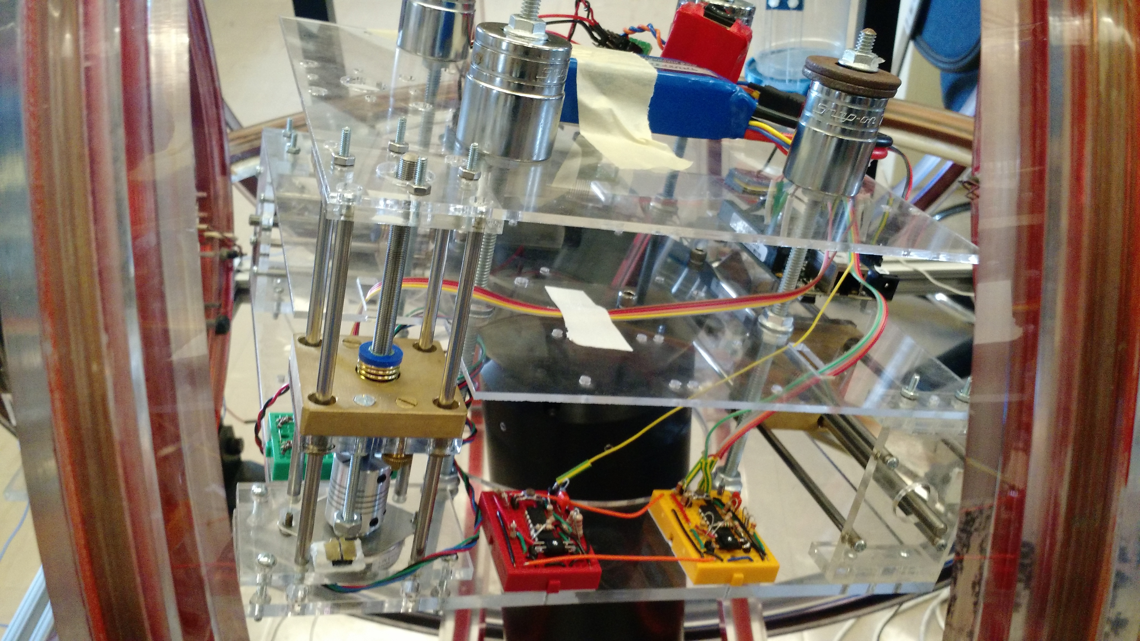
counter-weight
battery
force sensor
amplifier

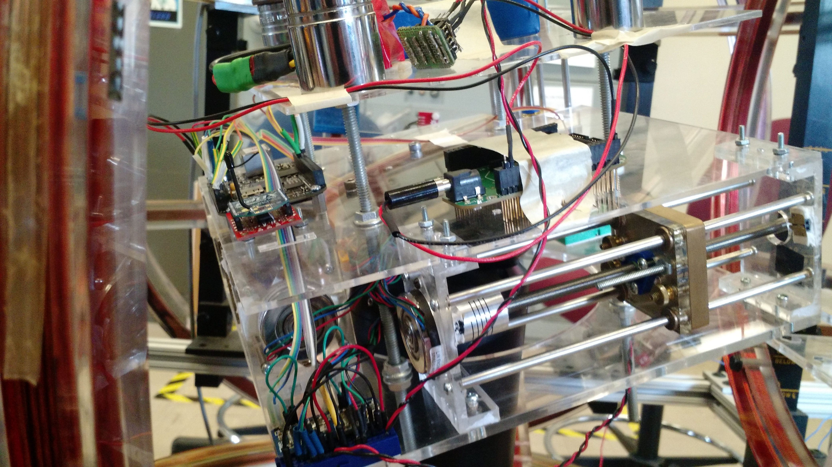
5V regulator
Balance mass
lead screw
stepper motor
stepper motor driver
BeagleBone Black
Xbee radio
lead nut
Appendix B: Wiring Diagrams
System schematic, with pins on BBB labeled in parentheses

Beagle Bone Black
Force Sensor 0
Stepper Driver 1
Force Sensor 1
Stepper Driver 2
Stepper Driver 3
Radio
USB
5V(P9_5)
GND(P9_34)
Analog(P9_40)

5V
GND
Analog(P9_39)
Step(P8_13)
Direction(P8_14)
Enable(P8_15)
GND(P8_2)
Step(P9_14)
Direction(P9_15)
Enable(P9_16)
GND(P9_1)
Step(P9_21)
Direction(P9_22)
Enable(P9_23)

GND
Vbat
GNDbat
Battery
Vbat
GNDbat
Vbat
GNDbat
5V Regulator
Vbat
GND

5V
GND

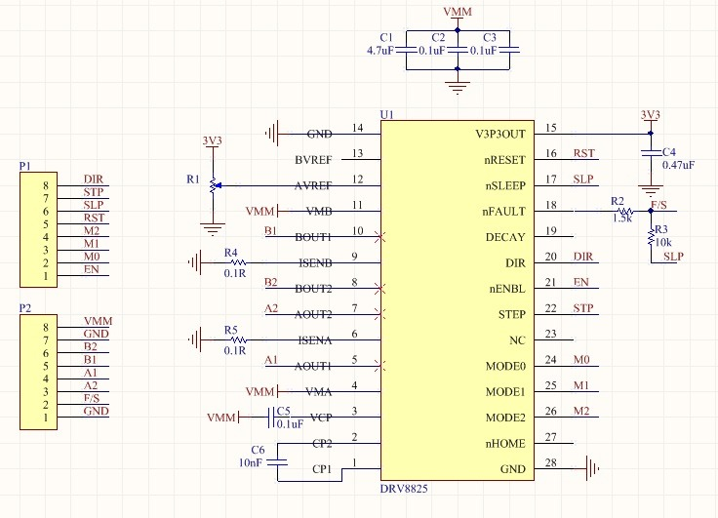
Stepper Driver Board Schematic With Connections to BBB
Direction
Step
Enable

Force Sensor Amplifier Schematic

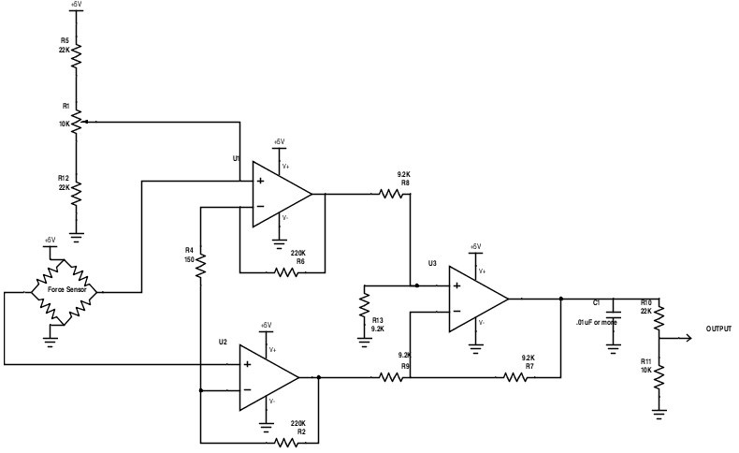

Appendix C: Serial Interface
The BeagleBone Black responds to several commands. It communicates through its on-board full size USB port. A wireless radio is plugged into this port through a serial-USB adapter dongle. The paired radio is plugged into a PC. The serial configuration settings should be configured on the PC as follows:

Baud Rate: 38400
Data Bits: 8
Stop Bits: 1
Parity Bits: None
Flow Control: None

Each command is sent to the BBB as a set of 8 bytes, which are read as two signed integers. The first integer is the command, and the second integer is a data value. Some commands cause the BBB to send back information. The command list is as follows

Command Name | Command Integer | Data Integer | Return Data
Echo | 0 | Any Integer | 1 int, Sent Data Integer
Set Motor 1 Step Period | 1 | Step period in milliseconds (negative for CCW rotation) | none
Set Motor 2 Step Period | 2 | Same as motor 1 | None
Set Motor 3 Step Period | 3 | Same as motor 1 | None
Sleep Motors (De-energize coils in all motors) | 4 | Ignored | None
Wake motors (Energize all motor coils) | 5 | Ignored | None
Tell motor periods | 6 | Ignored | 3 ints, corresponding to periods of M1, M2, and M3 in that order. Negative for CCW rotation.
Tell Sensor Readings | 7 | Ignored | 3 ints, first two are 8-point MAV filtered ADC values from force sensors, third is limit switch values (ignore)

Appendix D: List of Parts

Description | Quantity | Manufacturer | Part Number
Stepper Motor | 3 | Lin Engineering | 3907Z-12
Stepper Motor Driver | 3 | Texas Instruments | DRV8825
Lead Screw, 1/4” diam, 0.024” lead | 3 | Helix Linear | 025024RS/00/00/36.00/S
Lead Nut, flanged, plastic, anti-backlash, matching screw | 3 | Helix Linear | AFA025024R
Force Sensor | 2 | Honeywell | FSS1500NSR
4 Op Amp IC | 2 | Microchip | MCP6004
Embedded Linux System | 1 | BeagleBone Black

