SIGA: Subgroup Identification Based on a Genetic Algorithm
  - User manual for the R package SIGA, version 0.1.0
Liang Zhao
31 October 2026
Table of Contents

1 Introduction
SIGA (subgroup identification based on a genetic algorithm) is a method for finding, in the data of a two-arm randomised clinical trial, a subgroup of patients defined by a combination of biomarker conditions in which the treatment effect is much larger than in the remaining patients. It was proposed for censored survival data by Zhao et al. (2024, Journal of Biopharmaceutical Statistics 34(1), 55–77, doi:10.1080/10543406.2023.2170397) and is extended in this package to binary and continuous endpoints.
Compared with tree-based methods, which split the population one biomarker at a time, the genetic algorithm evaluates complete subgroup definitions, so that several biomarkers that are only predictive in combination can be found together. Because any search will find a “best” subgroup even in the absence of a real effect, SIGA embeds the search in a resampling scheme that controls
- multiplicity: a subgroup is reported only if the subgroups found in random training subsamples also improve the treatment effect in the held-out patients by at least $100η\%$; and
- complexity: only biomarkers that are selected in at least a proportion $θ$ of the resamples can define the subgroup.
The package provides:
- siga(), the complete procedure, with print, summary, plot and prediction methods, and update() to change $η$ and $θ$ without recomputation;
- siga_search(), the genetic algorithm search on given biomarkers;
- siga_screen(), the prescreening of candidate biomarkers;
- siga_cv(), cross-validation of the complete procedure;
- subgroup_effect(), the treatment effects in a subgroup, its complement and the interaction, e.g. in validation data;
- siga_simulate(), data from the simulation models of the SIGA paper.
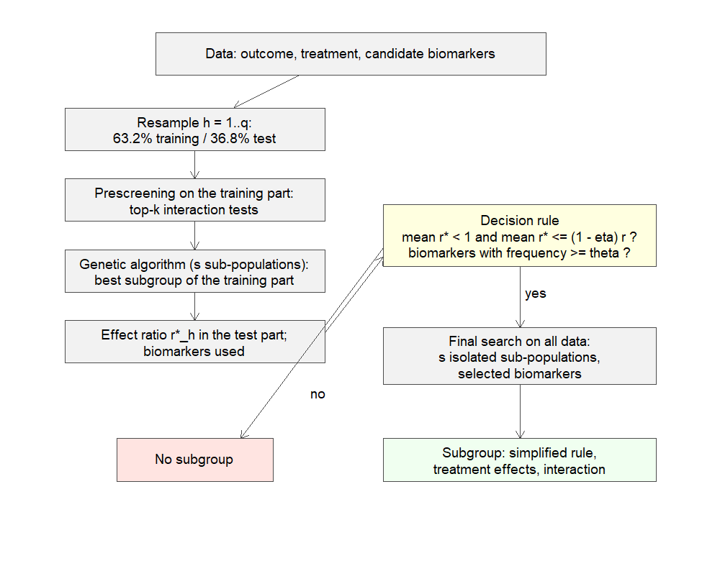
The SIGA procedure.

2 Installation
SIGA depends on the genetic algorithm toolbox gatbxr (version 0.2.0 or later), and on survival and mvtnorm from CRAN. Until both packages are on CRAN they are installed from GitHub:
install.packages("remotes")
remotes::install_github("drizztxx/gatbxr")
remotes::install_github("drizztxx/SIGA", build_vignettes = TRUE)
The optional package randomForestSRC enables the random forest prescreening (screen = "rf"). Parallel computing (n_cores > 1) uses the parallel package that comes with R; it works on all operating systems, including Windows. The vignettes reproduce the chapters of this manual:
browseVignettes("SIGA")

3 Getting started
SIGA (subgroup identification based on a genetic algorithm) looks for a subgroup of patients with an enhanced treatment effect in a two-arm randomised trial. This vignette walks through a complete analysis of simulated time-to-event data. The method itself is described in vignette("siga-method").

3.1 Data
The data must contain the outcome, a treatment variable with two values and the candidate predictors (numeric, ordered factors, factors, logical or character). We use model B3 of the SIGA paper: 300 patients, 20 covariates, 30% censoring, and a predictive subgroup $x_{4}>1$ and $x_{5}=1$ in which the experimental treatment reduces the hazard substantially, plus the prognostic covariates $x_{2}$ and $x_{9}$.
dat <- siga_simulate(300, model = "B3", seed = 2024)
dim(dat)
#> [1] 300 23
head(dat[, 1:8])
#> time status trt x1 x2 x3 x4 x5
#> 1 1.5543905 1 1 0.9819694 0.52329815 -0.4267558 0.3631370 0
#> 2 0.8586736 1 0 0.4687150 -0.03078797 0.9488462 0.1918505 0
#> 3 0.2690376 0 0 -0.1079713 1.65430308 0.8461535 2.9689668 1
#> 4 1.0012930 1 1 -0.2128782 0.08070920 0.6631026 3.3668901 0
#> 5 0.4315110 0 0 1.1580985 0.51498152 1.3201987 0.6780575 0
#> 6 0.7502730 1 1 1.2923548 0.03080127 -1.1888248 0.2926320 0
mean(attr(dat, "true_subgroup")) # proportion of patients in the true subgroup
#> [1] 0.2
The model is written as outcome ~ treatment | predictors. The predictors can be listed (x1 + x2), or . uses every other column (. - id excludes id). Here trt is coded 0/1, so 0 is the control arm; for other codings set control_arm, e.g. control_arm = "placebo".

3.2 Prescreening
siga_screen() shows which predictors interact with the treatment. SIGA repeats this step inside every resample and keeps the top $k=⌈20/2⌉=10$ candidates.
siga_screen(Surv(time, status) ~ trt | ., data = dat)
#> Candidate prescreening (lrt), tte endpoint: 10 of 20 predictors selected
#> variable type statistic df p_value rank selected
#> x5 binary 19.9 1 8.21e-06 1 TRUE
#> x4 numeric 10.4 1 0.0012 2 TRUE
#> x16 numeric 0.897 1 0.3436 3 TRUE
#> x9 numeric 0.856 1 0.3548 4 TRUE
#> x10 numeric 0.757 1 0.3843 5 TRUE
#> x1 numeric 0.757 1 0.3844 6 TRUE
#> x12 numeric 0.625 1 0.4293 7 TRUE
#> x15 numeric 0.596 1 0.4402 8 TRUE
#> x11 numeric 0.554 1 0.4566 9 TRUE
#> x3 numeric 0.534 1 0.4648 10 TRUE
#> x2 numeric 0.374 1 0.5409 11 FALSE
#> x17 numeric 0.327 1 0.5675 12 FALSE
#> x19 numeric 0.304 1 0.5812 13 FALSE
#> x13 numeric 0.283 1 0.5950 14 FALSE
#> x8 numeric 0.036 1 0.8495 15 FALSE
#> x18 numeric 0.0225 1 0.8807 16 FALSE
#> x7 numeric 0.00543 1 0.9413 17 FALSE
#> x14 numeric 0.00282 1 0.9577 18 FALSE
#> x6 binary 0.00183 1 0.9659 19 FALSE
#> x20 numeric 0.000332 1 0.9855 20 FALSE

3.3 Running SIGA
siga() runs the complete procedure. The defaults are the recommended settings: eta = 0.2 (0.25 for binary endpoints), theta = 0.5, 10 resamples, and a genetic algorithm with 50 individuals, 50 generations and 5 sub-populations (siga_control()) in every resample and in the final search. The analysis of 300 patients takes about 20 seconds on one core; n_cores distributes the resamples over several cores.
fit <- siga(Surv(time, status) ~ trt | ., data = dat, eta = 0.2, theta = 0.5, seed = 1)
#> SIGA: tte endpoint, 300 patients, 20 predictors; 10 resamples on 1 core(s)
#> SIGA: final search with 5 sub-population(s) on x4, x5
#> SIGA finished in 9.9 s: x4 >= 0.9481 & x5 = 1
fit
#> SIGA: subgroup identification based on a genetic algorithm
#> Endpoint: time-to-event, Surv(time, status); 300 patients (155 trt = 1, 145 control = 0)
#> Overall hazard ratio: 0.51
#> Resampling: 10 subsamples (10 evaluable); mean test-set ratio 0.233 vs threshold (1 - 0.20) x 0.51 = 0.408
#> Selection frequency: x4 (0.90), x5 (0.80), x2 (0.40), x1 (0.30), x9 (0.30), x10 (0.20) ...
#> Predictors selected (theta = 0.50): x4, x5
#> Subgroup: x4 >= 0.9481 & x5 = 1 [64 patients, 21.3%]
#> hazard ratio in subgroup 0.0668 (95% CI 0.0234, 0.19), in complement 0.872; interaction one-sided p = 8.85e-11
The printout gives the overall hazard ratio, the mean hazard ratio of the subgroups found in the resamples when applied to the held-out patients, the threshold $\left(1−η\right)×$ overall hazard ratio, the selection frequency of the predictors, and — if a subgroup is identified — its definition and the treatment effects in the subgroup and its complement. summary() adds the prescreening of the complete data, the distribution of the held-out effects and the best subgroup of each sub-population of the final search.
summary(fit)
#> SIGA: subgroup identification based on a genetic algorithm
#> Endpoint: time-to-event, Surv(time, status); 300 patients (155 trt = 1, 145 control = 0)
#> Overall hazard ratio: 0.51
#> Resampling: 10 subsamples (10 evaluable); mean test-set ratio 0.233 vs threshold (1 - 0.20) x 0.51 = 0.408
#> Selection frequency: x4 (0.90), x5 (0.80), x2 (0.40), x1 (0.30), x9 (0.30), x10 (0.20) ...
#> Predictors selected (theta = 0.50): x4, x5
#> Subgroup: x4 >= 0.9481 & x5 = 1 [64 patients, 21.3%]
#> hazard ratio in subgroup 0.0668 (95% CI 0.0234, 0.19), in complement 0.872; interaction one-sided p = 8.85e-11
#>
#> Test-set effect ratios of the resampled subgroups:
#> n evaluable 0% 25% 50% 75% 100% mean
#> 10.000 10.000 0.080 0.100 0.163 0.280 0.763 0.233
#>
#> Predictor selection frequencies:
#> variable frequency selected
#> x4 0.9 TRUE
#> x5 0.8 TRUE
#> x2 0.4 FALSE
#> x1 0.3 FALSE
#> x9 0.3 FALSE
#> x10 0.2 FALSE
#> x13 0.2 FALSE
#> x11 0.1 FALSE
#> x12 0.1 FALSE
#> x14 0.1 FALSE
#> x19 0.1 FALSE
#> x7 0.1 FALSE
#> x8 0.1 FALSE
#>
#> Prescreening of the complete data (lrt):
#> variable type statistic df p_value rank selected
#> x5 binary 1.99e+01 1 8.21e-06 1 TRUE
#> x4 numeric 1.04e+01 1 0.0012 2 TRUE
#> x16 numeric 8.97e-01 1 0.3436 3 TRUE
#> x9 numeric 8.56e-01 1 0.3548 4 TRUE
#> x10 numeric 7.57e-01 1 0.3843 5 TRUE
#> x1 numeric 7.57e-01 1 0.3844 6 TRUE
#> x12 numeric 6.25e-01 1 0.4293 7 TRUE
#> x15 numeric 5.96e-01 1 0.4402 8 TRUE
#> x11 numeric 5.54e-01 1 0.4566 9 TRUE
#> x3 numeric 5.34e-01 1 0.4648 10 TRUE
#> x2 numeric 3.74e-01 1 0.5409 11 FALSE
#> x17 numeric 3.27e-01 1 0.5675 12 FALSE
#> x19 numeric 3.04e-01 1 0.5812 13 FALSE
#> x13 numeric 2.83e-01 1 0.5950 14 FALSE
#> x8 numeric 3.60e-02 1 0.8495 15 FALSE
#> x18 numeric 2.25e-02 1 0.8807 16 FALSE
#> x7 numeric 5.43e-03 1 0.9413 17 FALSE
#> x14 numeric 2.82e-03 1 0.9577 18 FALSE
#> x6 binary 1.83e-03 1 0.9659 19 FALSE
#> x20 numeric 3.32e-04 1 0.9855 20 FALSE
#>
#> Best subgroup of every sub-population of the final search:
#> subpop objective size proportion n_conditions rule
#> 1 8.85e-11 64 0.213 2 x4 >= 0.9481 & x5 = 1
#> 2 8.85e-11 64 0.213 2 x4 >= 0.9481 & x5 = 1
#> 3 8.85e-11 64 0.213 2 x4 >= 0.9481 & x5 = 1
#> 4 8.85e-11 64 0.213 2 x4 >= 0.9481 & x5 = 1
#> 5 8.85e-11 64 0.213 2 x4 >= 0.9481 & x5 = 1
#>
#> Treatment effect (hazard ratio, treated vs control; benefit = lower):
#> group n n trt/ctrl events trt/ctrl median trt/ctrl estimate
#> overall 300 155/145 113/107 1.26/1.05 0.51
#> subgroup 64 32/32 18/26 2.07/0.923 0.0668
#> complement 236 123/113 95/81 1.17/1.09 0.872
#> 95% CI p
#> (0.386, 0.673) 1.90e-06
#> (0.0234, 0.19) 4.05e-07
#> (0.645, 1.18) 0.3723
#> Interaction (ratio of hazard ratios): 0.051 (95% CI 0.0205, 0.127), one-sided p = 8.85e-11

3.4 Plots
plot(fit, "frequency") # selection frequency of the predictors, with theta
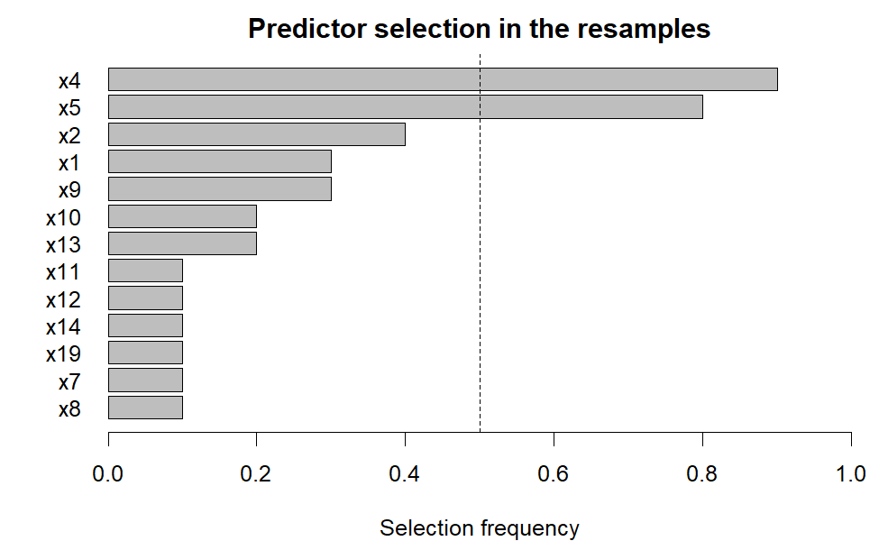
plot(fit, "resamples") # held-out hazard ratios of the resampled subgroups
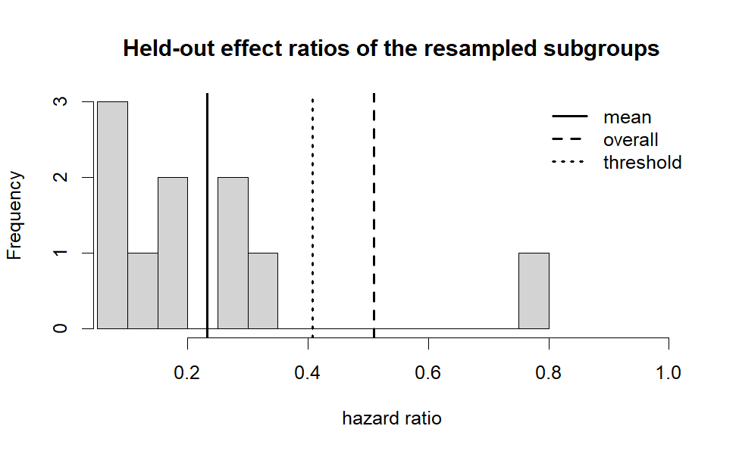
plot(fit, "effect") # Kaplan-Meier curves by arm in the subgroup and complement
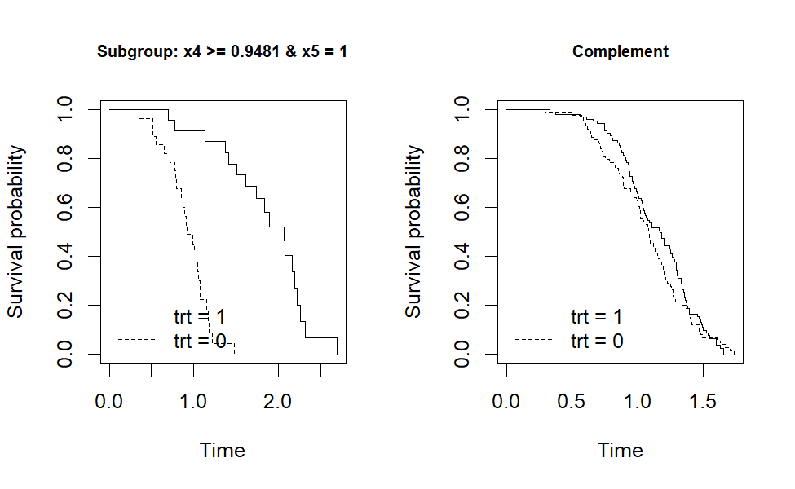
plot(fit, "convergence") # best objective value per generation and sub-population
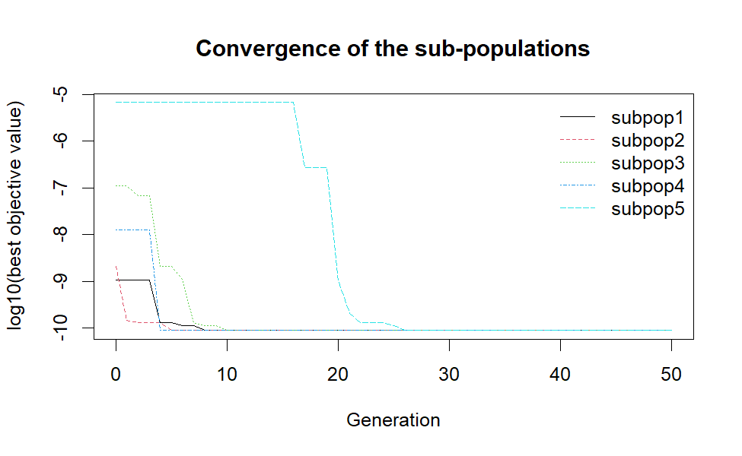

3.5 Other tuning parameters without recomputation
The decision rule only depends on the stored resampling results, so update() changes eta (multiplicity control) and theta (complexity control) without repeating the resampling. The result is the same as running siga() again with the same seed. With 10 resamples a borderline decision can depend on the seed, so it is worth repeating an analysis with a few seeds (see vignette("siga-method")).
update(fit, eta = 0.25, theta = 0.7)
#> SIGA: subgroup identification based on a genetic algorithm
#> Endpoint: time-to-event, Surv(time, status); 300 patients (155 trt = 1, 145 control = 0)
#> Overall hazard ratio: 0.51
#> Resampling: 10 subsamples (10 evaluable); mean test-set ratio 0.233 vs threshold (1 - 0.25) x 0.51 = 0.382
#> Selection frequency: x4 (0.90), x5 (0.80), x2 (0.40), x1 (0.30), x9 (0.30), x10 (0.20) ...
#> Predictors selected (theta = 0.70): x4, x5
#> Subgroup: x4 >= 0.9481 & x5 = 1 [64 patients, 21.3%]
#> hazard ratio in subgroup 0.0668 (95% CI 0.0234, 0.19), in complement 0.872; interaction one-sided p = 8.85e-11

3.6 Applying the subgroup to new patients
predict() returns the subgroup membership and subgroup_effect() estimates the treatment effects, for instance in an independent validation set:
new <- siga_simulate(2000, model = "B3", seed = 99)
table(predicted = predict(fit, new), true = attr(new, "true_subgroup"))
#> true
#> predicted FALSE TRUE
#> FALSE 1602 0
#> TRUE 20 378
subgroup_effect(fit, data = new)
#> Subgroup: x4 >= 0.9481 & x5 = 1
#> Treatment effect (hazard ratio, treated vs control; benefit = lower):
#> group n n trt/ctrl events trt/ctrl median trt/ctrl estimate
#> overall 2000 970/1030 638/718 1.18/1.12 0.704
#> subgroup 398 192/206 105/145 1.75/1.16 0.215
#> complement 1602 778/824 533/573 1.11/1.12 0.986
#> 95% CI p
#> (0.63, 0.786) 3.84e-10
#> (0.16, 0.29) 2.91e-24
#> (0.876, 1.11) 0.8091
#> Interaction (ratio of hazard ratios): 0.225 (95% CI 0.167, 0.304), one-sided p = 1.54e-22
The rule can also be used as R code, e.g. with subset():
fit$rule
#> x4 >= 0.9481 & x5 = 1
format(fit$rule, style = "R")
#> [1] "x4 >= 0.9481 & x5 == \"1\""

3.7 Cross-validation
siga_cv() estimates how well the procedure generalises by running it on the training part of every fold and evaluating the subgroup on the held-out fold (the paper used 100 repetitions of 5-fold cross-validation). It can also be used to compare tuning parameters. Each fold runs a complete siga(), so this is the most expensive function; use n_cores.
cv <- siga_cv(Surv(time, status) ~ trt | ., data = dat, k = 5, repeats = 20,
eta = 0.2, theta = 0.5, n_cores = 8, seed = 1)
summary(cv)

3.8 Genetic algorithm search only
siga_search() runs only the genetic algorithm on given predictors, without prescreening and resampling. Its result is always the best subgroup of the search and is therefore optimistic; use it for exploration.
s <- siga_search(Surv(time, status) ~ trt | x2 + x4 + x5 + x9, data = dat, seed = 1)
s
#> SIGA genetic algorithm search (time-to-event endpoint, 300 patients, 4 predictors, 5 sub-population(s))
#> Best subgroup: x2 <= 1.654 & x4 >= 0.9547 & x5 = 1 & x9 >= -0.8299 [46 patients, 15.3%]
#> objective (interaction) = 4.57e-12
#> hazard ratio in subgroup 0.0178 (95% CI 0.00225, 0.14), in complement 0.812; interaction one-sided p = 4.57e-12
#> Best subgroup of every sub-population:
#> subpop objective size proportion n_conditions
#> 1 5.01e-07 126 0.420 1
#> 2 5.74e-11 62 0.207 3
#> 3 2.02e-11 59 0.197 3
#> 4 4.57e-12 46 0.153 4
#> 5 5.35e-11 67 0.223 3
#> rule
#> x4 >= 0.8886
#> x4 >= 0.9481 & x5 = 1 & x9 <= 1.123
#> x2 <= 1.44 & x4 >= 0.9481 & x5 = 1
#> x2 <= 1.654 & x4 >= 0.9547 & x5 = 1 & x9 >= -0.8299
#> x2 <= 1.636 & x4 >= 0.8561 & x5 = 1

3.9 Reproducibility and parallel computing
Every resample, sub-population and cross-validation fold has its own random number stream derived from seed. Results are identical for any number of cores, and set.seed() before the call has the same effect as seed. Parallel computing (n_cores > 1) starts background R processes, which requires the package to be installed (not only loaded with devtools).
fit4 <- siga(Surv(time, status) ~ trt | ., data = dat, seed = 1, n_cores = 4)
identical(fit4$resamples, fit$resamples) # TRUE

4 The SIGA method
This vignette describes the SIGA procedure as implemented in the package, how its parameters map to the notation of the SIGA paper (Zhao et al.), and where the package differs from the original code.

4.1 Setting
Consider a two-arm randomised trial with treatment indicator $Z$ (1 = experimental, 0 = control), an outcome $Y$ and $p$ baseline predictors $X_{1},…,X_{p}$. A subgroup $G$ is defined by conditions on some predictors, for example $\{X_{4}>1\}∩\{X_{5}=1\}$. $G$ is predictive if the treatment effect in $G$ is larger than in its complement $\overset{‾}{G}$, and the predictors in its definition are predictive biomarkers. SIGA searches for the predictive subgroup with the strongest evidence of an enhanced treatment effect, while controlling
- multiplicity: the risk of reporting a subgroup when no predictive subgroup exists, and
- complexity: the risk of including noise variables in the subgroup definition.
Endpoint | Outcome in the formula | Model | Treatment effect
time-to-event | Surv(time, status) | Cox proportional hazards | hazard ratio (HR)
binary | logical, 2-level factor or 0/1 | logistic regression | odds ratio (OR)
continuous | numeric | linear regression | mean difference
The argument direction states which direction is beneficial: a lower hazard (default for time-to-event), a higher probability of the event level (default for binary; the event level is TRUE, 1 or the second factor level) or a higher mean (default for continuous).

4.2 Candidate prescreening
To focus the search on predictors that may interact with the treatment, every predictor $X_{j}$ is tested in the model with $Z$, $X_{j}$ and $ZX_{j}$, e.g. for time-to-event data
$$h\left(t\right)=h_{0}\left(t\right)exp\left(α_{j}X_{j}+β_{j}Z+γ_{j}ZX_{j}\right).$$
The predictors are ranked by the likelihood-ratio test of $γ_{j}=0$ (F test for continuous endpoints) and the top $k$ are kept (n_candidates). The paper recommends $k=⌈p/2⌉$ for $p≤20$ and $k=10$ otherwise, the package default. Categorical predictors enter as dummy variables and ordinal predictors with their level codes. screen = "rf" ranks predictors by the difference of random forest variable importance between the arms instead, and screen = "none" keeps all predictors. Prescreening is repeated in every resample (section 5).

4.3 Genetic representation of subgroups
A candidate subgroup (an individual) is a vector of $k$ real-valued genes $B_{j}∈\left[0,4\right]$, one per candidate predictor. The initial population draws the genes uniformly. A gene is decoded as follows.
Gene value | Numeric or ordinal $X_{j}$ | Binary $X_{j}$ | Categorical $X_{j}$ with $c$ levels
$B_{j}≤2$ | not used | not used | not used
$2<B_{j}≤3$ | $X_{j}≤P_{B_{j}−2}\left(X_{j}\right)$ | $X_{j}$ = first level | $X_{j}∈C_{s}$, $s=⌈\left(B_{j}−2\right)\left(2^{c}−2\right)/2⌉$
$3<B_{j}≤4$ | $X_{j}≥P_{B_{j}−3}\left(X_{j}\right)$ | $X_{j}$ = second level | (same)
$P_{u}\left(X_{j}\right)$ is the type-7 sample quantile of $X_{j}$ at probability $u$, and $C_{1},…,C_{2^{c}−2}$ are the non-empty proper subsets of the levels, ordered by size and then lexicographically. Every predictor is therefore used with probability 1/2. The conditions of the used genes are combined with AND. Patients with a missing value of a used predictor do not belong to the subgroup. Categorical predictors may have at most 10 levels.
Predictor types are taken from the data: numeric columns are numeric, ordered factors ordinal, and factors, logical or character columns binary or categorical. Use predictor_types to override, e.g. predictor_types = c(stage = "ordinal"). A 0/1-coded numeric column is treated as numeric, which is equivalent to a binary split but is less efficient; code categorical variables as factors.

4.4 Objective function and genetic operators
Objective. With $I$ the indicator of membership of the candidate subgroup, SIGA fits
$$h\left(t\right)=h_{0}\left(t\right)exp\left(αI+βZ+γZI\right)$$
(logistic or linear regression with the same terms for the other endpoints) and uses the one-sided p-value of the interaction $γ$ in the direction of a larger benefit in the subgroup as the objective to be minimised (objective = "interaction"). A subgroup smaller than $MinS$ (min_size, default 10%) gets the worst value 1. As in the original code, the size of a subgroup is measured by $2min\left(n_{1},n_{0}\right)$, the numbers of treated and control patients in the subgroup. Alternatives are "subgroup" (p-value of the treatment effect in the subgroup, set to 1 when the complement has a smaller p-value), "differential" (difference of the Wald statistics in subgroup and complement) and user-defined functions (see ?siga_control).
Operators. Every generation applies the operators of the Sheffield Genetic Algorithm Toolbox (package gatbxr):
- fitness assignment by linear ranking with selective pressure 2 (ranking): the best individual has twice the average selection probability;
- selection of $GGAP×m$ parents by stochastic universal sampling (sus; generation gap ggap, default 0.9);
- line recombination of consecutive pairs of selected parents (reclin): offspring gene $=P_{1}+α\left(P_{2}−P_{1}\right)$ with one $α∼U\left(−0.25,1.25\right)$ per pair;
- mutation with the breeder genetic algorithm operator (mutbga), mutation rate $1/k$;
- reinsertion: the offspring replace the worst parents (reins), so the best individuals always survive (elitism).
The search stops after $MaxG$ generations (max_gen, default 50) with populations of $m$ individuals (pop_size, default 50). To avoid premature convergence, $s$ isolated sub-populations (n_subpop, default 5) evolve independently. The fittest individual over all generations and sub-populations defines the subgroup; ties are broken by the larger subgroup and then by the simpler rule.
Reported rule. Thresholds are replaced by the boundary values observed in the subgroup (for example $X≤60$ instead of the interpolated percentile 62.5), and conditions that do not change the membership are removed. The membership in the data is unchanged.

4.5 Resampling: multiplicity and complexity control
A genetic algorithm always returns a “fittest” subgroup, even without a true predictive subgroup. SIGA therefore embeds the search in a resampling scheme:
- Draw $q$ (n_resample, default 10) training subsamples $D_{h}$ of 63.2% of the patients without replacement (resample_prop; resample_method = "bernoulli" draws every patient independently with probability 0.632 as in the original code). The remaining 36.8% form the test sets $D_{−h}$.
- In every $D_{h}$, prescreen the predictors and run the genetic algorithm with resample_subpop sub-populations (by default as many as in the final search, 5). Evaluate the best subgroup by its treatment effect ratio $r_{h}^{*}$ in $D_{−h}$, and record the predictors it uses.
- Let $r$ be the effect ratio of the complete data and r*=1qh​rh*. SIGA reports no subgroup unless
$${\overset{‾}{r}}^{*}<1 \text{and} {\overset{‾}{r}}^{*}≤\left(1−η\right) r,$$
- i.e. unless the subgroups found in the training subsamples improve the treatment effect in new patients by at least $100η\%$ (eta). Only predictors used by the best subgroups of at least a proportion $θ$ of the resamples are kept (theta); without such a predictor, SIGA also reports no subgroup.
- Otherwise the multi-population search is run on the complete data with the kept predictors.
Effect ratios. $r$ is a ratio for which lower values indicate more benefit:
Endpoint | Effect ratio $r$
time-to-event | hazard ratio (as in the paper)
binary | $1/OR$, the odds ratio of the non-event
continuous | $exp\left(−πd/\sqrt{3}\right)$, $d$ = mean difference / pooled SD
For continuous endpoints $d$ is the standardised mean difference (with the pooled standard deviation of the complete data) and $πd/\sqrt{3}$ the corresponding log odds ratio under the logistic approximation, so that $η$ has the same interpretation for all endpoints. With $η=0.2$ the standardised effect must improve by about 0.12 standard deviations. In a test set $r_{h}^{*}$ is set to 1 when the subgroup or its complement is empty, and to missing when it is not estimable or extreme ($r_{h}^{*}>100$ or $<0.001$).
Number of resamples. The paper recommends $q=100$; the default $q=10$ is that of the original code. With it the package reproduces the false discovery rates of the simulation study of the paper, on which the recommended $η$ and $θ$ are based (see the validation report in the validation/ directory of the source repository). Without a predictive subgroup the held-out ratios $r_{h}^{*}$ are on average 10% to 20% larger than $r$ (a subgroup that looks better than average in the training part tends to look worse in the complementary test part), so false discoveries occur when ${\overset{‾}{r}}^{*}$ is low by chance. Its variance, and with it the false discovery rate, decreases with $q$: with $η=0.2$ and $θ=0.5$ the rate in the null models of the paper is about 6% for $q=10$ (higher with 300 than with 600 patients) and close to 0 for $q=100$, which needs $η≈0.05$ for a comparable rate. With $q=10$ the decision for a given data set can depend on the seed; repeat the analysis with a few seeds, or use more resamples with a smaller $η$, before relying on a borderline result.
Search effort per resample. The paper describes a single sub-population per resample, whereas the original code ran as many sub-populations as the final search, which is the default (resample_subpop = control$n_subpop). More search effort per resample finds the predictive biomarkers more consistently, which increases their selection frequencies and improves the held-out effects. In model B1 of the paper with 300 patients, for example, the biomarker $X_{4}$ was used by 67% of the resampled subgroups with one and by 91% with five sub-populations, and the mean held-out hazard ratio relative to the overall one fell from 0.68 to 0.55. resample_subpop = 1 makes the resampling about five times faster.
Re-using the resampling. The decision depends on $η$ and $θ$ only through ${\overset{‾}{r}}^{*}$ and the selection frequencies, so update(fit, eta, theta) re-applies the rule without repeating the resampling. Because the random number streams of the final search are fixed by the seed, the result equals a new call of siga() with the same seed.

4.6 Recommended settings
Parameter | Argument | Default | Recommendation (paper)
candidates $k$ | n_candidates | $⌈p/2⌉$ / 10 | $⌈p/2⌉$ if $p≤20$, else 10
population size $m$ | siga_control(pop_size) | 50 | 50
generations $MaxG$ | siga_control(max_gen) | 50 | 50
sub-populations $s$ | siga_control(n_subpop) | 5 | 5
generation gap | siga_control(ggap) | 0.9 | 0.8 to 1
minimum size $MinS$ | siga_control(min_size) | 0.1 | 0.1
resamples $q$ | n_resample | 10 | 100 (10 in the simulations)
sub-populations per resample | resample_subpop | n_subpop | 1 (5 in the simulations)
multiplicity $η$ | eta | 0.2 (binary: 0.25) | 0.15 weak, 0.2 moderate, 0.25 strict
complexity $θ$ | theta | 0.5 | 0.5 weak, 0.7 moderate, 0.9 strict
In the simulations of the paper (and with the package defaults) $η=0.2$ kept the false subgroup discovery rate around 5% (for binary endpoints it was 8.5% in the validation simulations, also with $θ=0.7$, and 5% to 6% with $η=0.25$, the default for binary endpoints), and $θ=0.5$ gave the best balance between detecting all predictive biomarkers and excluding noise variables. Large $θ$ (e.g. 0.9) tends to keep only one biomarker. The settings can be compared with siga_cv().
SIGA is an exploratory method: the multiplicity control is not a strong (family-wise) control, and subgroups should be confirmed in independent data or a subsequent trial.

4.7 Differences from the original code
The genetic algorithm reproduces the original implementation operator by operator: with the same objective values and random seed, the best objective value of every generation is identical (see the validation report). The following points differ.
- Bug fixes. (i) A single continuous predictor used in one direction took its threshold from the pooled quantiles of all numeric candidates. (ii) A single binary factor produced an empty subgroup (x == ''). (iii) A single categorical factor stopped the search when several were candidates, and factors with exactly three levels could only define single-level subsets.
  - The binary prescreening used the deviance instead of the p-value and kept the least predictive predictors. (v) The best-subgroup summary could produce vacuous conditions x >= a | x <= b. (vi) The last generation was ignored when choosing the best individual.
- Objective scale. The original code used the two-sided interaction p-value, replaced by $1−p$ for harmful interactions with $p<0.5$. The package uses the one-sided p-value. For beneficial interactions the ranking of the subgroups, and hence the search, is the same.
- Resampling. As in the original code, every resample runs n_subpop sub-populations (the paper describes one), but exactly 63.2% of the patients are drawn, as described in the paper; the original code drew every patient independently with probability 0.632 (resample_method = "bernoulli").
- Thresholds. The upper condition is $X≥P$ (the paper writes $X>P$), which matters for ordinal predictors.
- Simulation program. The original program used the event time as the observed time of censored patients (the event indicator is correct). siga_simulate() uses $min\left(T,C\right)$ by default; legacy = TRUE reproduces the original data exactly. The noise covariates $X_{11}$ to $X_{20}$ were generated with pairwise correlation 0.5 (noise_rho).

4.8 References
Zhao L, Zhang W, Wu Y, Cao L, Wang L, Li K (2024). A promising subgroup identification method based on a genetic algorithm for censored survival data. Journal of Biopharmaceutical Statistics 34(1), 55–77. https://doi.org/10.1080/10543406.2023.2170397
Chipperfield A, Fleming P, Pohlheim H, Fonseca C (1994). Genetic Algorithm Toolbox for use with MATLAB. University of Sheffield.
Mühlenbein H, Schlierkamp-Voosen D (1993). The science of breeding and its application to the breeder genetic algorithm (BGA). Evolutionary Computation 1(4), 335–360.
Chinn S (2000). A simple method for converting an odds ratio to effect size for use in meta-analysis. Statistics in Medicine 19(22), 3127–3131.

5 Binary and continuous endpoints
SIGA was developed for censored survival data, but only the model behind the objective function, the prescreening test and the treatment effect measure depend on the endpoint. The package supports three endpoints with the same interface; the endpoint is detected from the outcome in the formula.
Endpoint | Outcome | Objective and prescreening | Effect | Effect ratio $r$ for $η$
time-to-event | Surv(time, status) | Cox model | hazard ratio | HR
binary | logical, 2-level factor, 0/1 | logistic model | odds ratio | 1 / OR
continuous | numeric | linear model ($t$ / F test) | mean difference | $exp\left(−πd/\sqrt{3}\right)$

5.1 Binary endpoints
For a binary outcome the event level is TRUE, 1, or the second level of a factor. By default a higher probability of the event is beneficial (for example a response); for an adverse event use direction = "lower". siga_simulate(endpoint = "binary") uses the linear predictors of the paper on the logit scale. In model B1 the subgroup $x_{4}>1$ has an odds ratio of $e^{2}≈7.4$, and the treatment has no effect elsewhere. A binary outcome carries less information than a survival time, so larger samples are needed for the same effect size; here we use 600 patients.
db <- siga_simulate(600, model = "B1", endpoint = "binary", seed = 9)
table(response = db$y, arm = db$trt)
#> arm
#> response 0 1
#> 0 197 165
#> 1 88 150
fb <- siga(y ~ trt | ., data = db, seed = 1)
#> SIGA: binary endpoint, 600 patients, 20 predictors; 10 resamples on 1 core(s)
#> SIGA: final search with 5 sub-population(s) on x4
#> SIGA finished in 37.9 s: x4 >= 1.037
fb
#> SIGA: subgroup identification based on a genetic algorithm
#> Endpoint: binary, y; 600 patients (315 trt = 1, 285 control = 0)
#> Overall inverse odds ratio: 0.491
#> Resampling: 10 subsamples (10 evaluable); mean test-set ratio 0.175 vs threshold (1 - 0.25) x 0.491 = 0.369
#> Selection frequency: x4 (0.90), x13 (0.30), x15 (0.30), x16 (0.30), x7 (0.30), x8 (0.20) ...
#> Predictors selected (theta = 0.50): x4
#> Subgroup: x4 >= 1.037 [215 patients, 35.8%]
#> odds ratio in subgroup 9.25 (95% CI 4.96, 17.3), in complement 0.846; interaction one-sided p = 3.04e-10
The effect ratio used by the multiplicity rule is the odds ratio of the non-event, $1/OR$, so that, as for hazard ratios, lower values mean more benefit and $η$ is the required relative improvement. For binary endpoints the default is $η=0.25$ instead of 0.2. In the validation simulations (validation report in the validation/ directory of the source repository) the false discovery rate with $η=0.2$ was 8.5% for binary endpoints, against 5% to 6% for time-to-event and continuous endpoints, and $θ=0.7$ hardly reduced it. With $η=0.25$ it was 5% to 6%.

5.2 Continuous endpoints
For continuous outcomes the objective is the one-sided $t$-test p-value of the treatment-by-subgroup interaction in the linear model $E\left(Y\right)=μ+αI+βZ+γZI$, and the prescreening uses the F test of the interaction. By default a higher mean is beneficial; for outcomes such as pain scores use direction = "lower".
In the continuous version of model B3 the outcome is $y=L+ε$ with $ε∼N\left(0,{1.5}^{2}\right)$, so the treatment increases the mean by 2 in the subgroup $x_{4}>1,x_{5}=1$.
dc <- siga_simulate(600, model = "B3", endpoint = "continuous", sigma = 1.5, seed = 8)
fc <- siga(y ~ trt | ., data = dc, seed = 1)
#> SIGA: continuous endpoint, 600 patients, 20 predictors; 10 resamples on 1 core(s)
#> SIGA: final search with 5 sub-population(s) on x4, x5, x2
#> SIGA finished in 14.4 s: x2 >= -0.3725 & x4 >= 1.04 & x5 = 1
fc
#> SIGA: subgroup identification based on a genetic algorithm
#> Endpoint: continuous, y; 600 patients (302 trt = 1, 298 control = 0)
#> Overall effect ratio exp(-pi d / sqrt(3)): 0.883
#> Resampling: 10 subsamples (10 evaluable); mean test-set ratio 0.166 vs threshold (1 - 0.20) x 0.883 = 0.706
#> Selection frequency: x4 (1.00), x5 (1.00), x2 (0.90), x17 (0.40), x10 (0.20), x1 (0.10) ...
#> Predictors selected (theta = 0.50): x4, x5, x2
#> Subgroup: x2 >= -0.3725 & x4 >= 1.04 & x5 = 1 [76 patients, 12.7%]
#> mean difference in subgroup 2.77 (95% CI 1.99, 3.56), in complement -0.261; interaction one-sided p = 1.63e-15
The multiplicity rule needs a ratio. SIGA converts the standardised mean difference $d=Δ/s$ ($s$ = pooled within-arm standard deviation of the complete data) into the log odds ratio $πd/\sqrt{3}$ of the logistic approximation and uses $r=exp\left(−πd/\sqrt{3}\right)$. With $η=0.2$, the held-out subgroups must improve the standardised effect by $−log\left(0.8\right)\sqrt{3}/π≈0.12$ standard deviations over the overall effect. The treatment effects themselves are reported as mean differences:
if (fc$subgroup) subgroup_effect(fc)
#> Subgroup: x2 >= -0.3725 & x4 >= 1.04 & x5 = 1
#> Treatment effect (mean difference, treated vs control; benefit = higher):
#> group n n trt/ctrl mean trt/ctrl estimate 95% CI p
#> overall 600 302/298 0.256/0.143 0.114 (-0.152, 0.379) 0.4013
#> subgroup 76 37/39 2.68/-0.0972 2.77 (1.99, 3.56) 8.30e-10
#> complement 524 265/259 -0.0816/0.179 -0.261 (-0.518, -0.00345) 0.0470
#> Interaction (difference of mean differences): 3.03 (95% CI 2.3, 3.77), one-sided p = 1.63e-15

5.3 Reversing the direction
direction reverses the benefit direction for any endpoint. With direction = "lower" the continuous outcome above is treated as one where lower values are better, so SIGA looks for patients in whom the treatment lowers the outcome:
fl <- siga_search(y ~ trt | x1 + x4 + x5, data = dc, direction = "lower", seed = 1,
control = siga_control(n_subpop = 2))
fl$effects$interaction$estimate # difference of mean differences (subgroup - complement)
#> [1] -1.14855

5.4 Custom objective functions
Any objective can be plugged into the genetic algorithm with siga_control(objective = f), where f(y, trt, subgroup, endpoint) returns a number (smaller is better). The minimum subgroup size rule is applied before f is called. For example, the negative mean difference in the subgroup:
neg_diff <- function(y, trt, subgroup, endpoint)
-(mean(y[subgroup & trt == 1]) - mean(y[subgroup & trt == 0]))
fs <- siga_search(y ~ trt | x1 + x4 + x5, data = dc, seed = 1,
control = siga_control(objective = neg_diff, n_subpop = 2))
fs$rule
#> x1 <= 0.1405 & x4 >= 1.104 & x5 = 1

6 Function reference
Function | Purpose | Main arguments
siga() | complete SIGA procedure | formula, data, control_arm, direction, eta, theta, n_resample, resample_subpop, screen, n_candidates, control, n_cores, seed
update() | new eta / theta for a siga fit | object, eta, theta
siga_search() | genetic algorithm search only | formula, data, control, n_cores, seed
siga_screen() | prescreening of candidate biomarkers | formula, data, method, n_candidates
siga_control() | genetic algorithm settings | pop_size, max_gen, n_subpop, ggap, min_size, objective
siga_cv() | k-fold cross-validation | formula, data, k, repeats, ... (passed to siga())
subgroup_effect() | effects in subgroup and complement | object, data
predict() | subgroup membership | object, newdata
plot() | "frequency", "resamples", "convergence", "effect" | x, type
summary(), print() | reports
format(), rule_members(), rule_variables() | subgroup rules | x, style, digits, data
siga_simulate() | data from the simulation models of the paper | n, model, endpoint, n_noise, legacy, seed
siga_true_subgroup() | true subgroup of the simulation models | data, model
The formula has the form outcome ~ treatment | predictors: the outcome is Surv(time, status), a binary variable or a numeric variable; the treatment variable has two values (control_arm sets the control); the predictors are column names separated by +, or . for all remaining columns. The help pages (e.g. ?siga) document every argument and returned component.
Output of siga(). The fit contains, among others, subgroup (was a subgroup identified?), rule (the subgroup), decision (mean held-out effect ratio, threshold, selected biomarkers and the reason for “no subgroup”), resamples (one row per resample), frequency (selection frequency of every biomarker), screening (prescreening of the complete data), final (the final search, including the best subgroup of each sub-population) and effects (treatment effects in the subgroup and its complement).

7 Reproducing the simulation study

7.1 Simulation models
The simulation study of the SIGA paper (section 3) uses six models with 20 covariates and a binary treatment $Z$: two null models without a predictive subgroup and four models with one.
Model | Linear predictor $L$ | Prognostic | Predictive | True subgroup
A1 | $0$ | none | none | none
A2 | $2\left(x_{1}+x_{2}\right)$ | $x_{1},x_{2}$ | none | none
B1 | $0.1\left(x_{1}+x_{2}\right)+2ZI\left(x_{4}>1\right)$ | $x_{1},x_{2}$ | $x_{4}$ | $x_{4}>1$
B2 | $0.2\left(x_{1}+x_{2}\right)+1.2ZI\left(x_{1}>0\right)$ | $x_{1},x_{2}$ | $x_{1}$ | $x_{1}>0$
B3 | $0.3\left(x_{2}+x_{9}\right)+2ZI\left(x_{4}>1,x_{5}=1\right)$ | $x_{2},x_{9}$ | $x_{4},x_{5}$ | $x_{4}>1,x_{5}=1$
B4 | $2ZI\left(x_{1}<0.5,x_{5}=1,x_{6}=1\right)$ | none | $x_{1},x_{5},x_{6}$ | $x_{1}<0.5,x_{5}=1,x_{6}=1$
Survival times follow $T=1.2 {\left(−logU e^{L}\right)}^{1/4.34}$, so that the hazard is proportional to $e^{−L}$ (a hazard ratio of $e^{−2}≈0.14$ in the B1 subgroup), and censoring times are uniform on $\left(0,π\right)$ with the values of $π$ of the paper that give 30% censoring. siga_simulate() generates these data; siga_true_subgroup() gives the true subgroup membership.
d <- siga_simulate(600, model = "B4", seed = 1)
c(censoring = mean(d$status == 0), true_subgroup = mean(attr(d, "true_subgroup")))
#> censoring true_subgroup
#> 0.3166667 0.1866667
The observed time is $min\left(T,C\right)$, as described in the paper. legacy = TRUE reproduces the original simulation program exactly for a given seed, including two details that differ from the paper: the noise covariates $x_{11},…,x_{20}$ have pairwise correlation 0.5 within the block (noise_rho), and the event time is stored as the observed time of censored patients (the event indicator is correct). Censored patients then stay in the risk sets until their event time. The Cox model remains valid, because censoring does not depend on the covariates, but the risk sets are larger, which can change the operating characteristics of SIGA. The validation of the package (report in the validation/ directory of the source repository) therefore uses proper censoring and compares the results with those on data from the original program.

7.2 Performance criteria
For every trial a training set $L_{1}$ ($n=300$ or 600) and a test set $L_{2}$ ($n=5000$) are generated. SIGA is applied to $L_{1}$, and the subgroup found is evaluated as follows:
- false discovery rate (A1, A2): proportion of trials with a subgroup;
- $p_{one}$, $p_{all}$, $p_{exact}$: probability that the subgroup uses at least one, all, or exactly the predictive biomarkers, given that a subgroup is found;
- sensitivity, specificity, AUC: classification of the $L_{2}$ patients into the true subgroup (AUC = (sensitivity + specificity) / 2 for a rule);
- subgroup proportion in $L_{2}$, hazard ratio of the subgroup in $L_{1}$ and in $L_{2}$, and the relative bias $\left({\hat{τ}}_{L_{1}}−{\hat{τ}}_{L_{2}}\right)/{\hat{τ}}_{L_{2}}$.

7.3 Running a trial
One trial with the settings of the simulation study of the paper, which are the package defaults (20 covariates, $k=10$ candidates, $q=10$ resamples, $m=50$, $MaxG=50$ and $s=5$ sub-populations in every resample and in the final search):
one_trial <- function(model, n, seed) {
L1 <- siga_simulate(n, model, seed = seed)
L2 <- siga_simulate(5000, model, seed = seed + 5)
fit <- siga(Surv(time, status) ~ trt | ., data = L1, eta = 0.2, theta = 0.5,
seed = seed, verbose = FALSE)
if (!fit$subgroup) return(c(found = 0))
pred <- predict(fit, L2)
truth <- attr(L2, "true_subgroup")
vars <- rule_variables(fit$rule)
c(found = 1, all = all(attr(L1, "predictive") %in% vars),
se = mean(pred[truth]), sp = mean(!pred[!truth]),
hr_L2 = subgroup_effect(fit, data = L2)$table$estimate[2])
}
one_trial("B3", 300, seed = 1)
The validation scripts in the validation/ directory of the source repository run all scenarios in parallel (one resampling per trial, re-used for the nine combinations of $η∈\{0.15,0.2,0.25\}$ and $θ∈\{0.5,0.7,0.9\}$ with update()) and compare the results with Tables 3 to 6 of the paper. A trial takes about half a minute on one core.

