1) Sample requests and test suite from WSDL

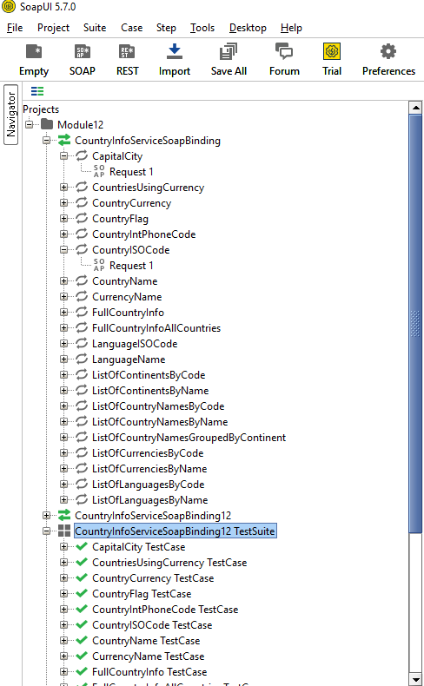

2) Test suite execution

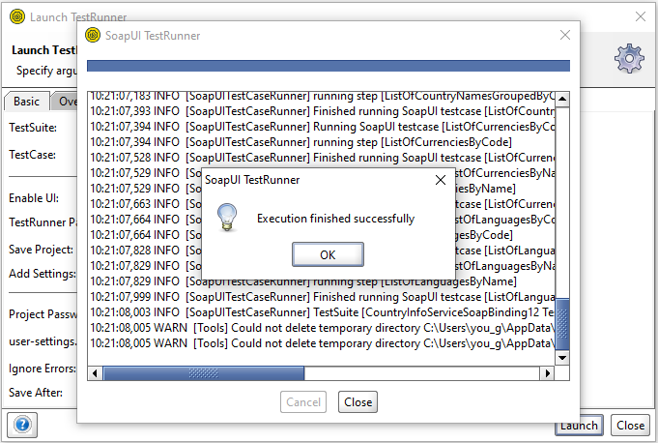

3) Add test step

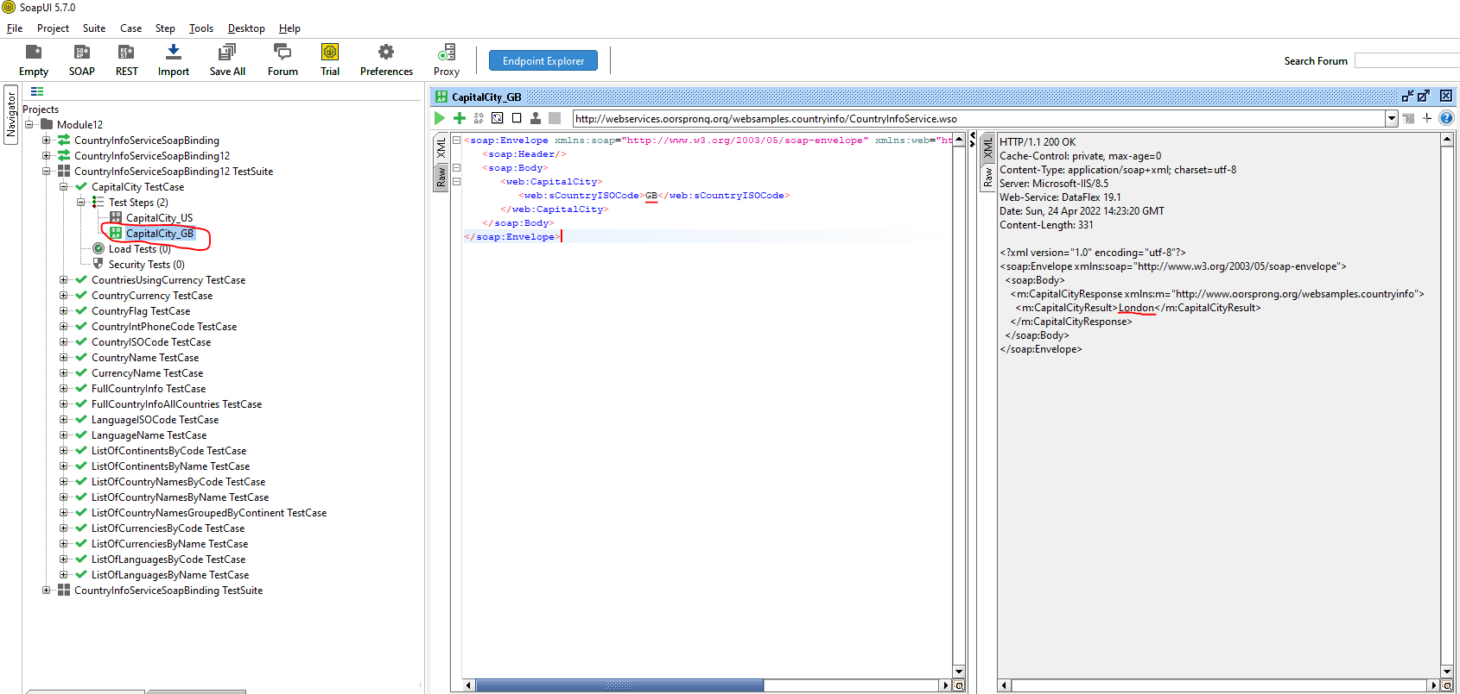

4) Perform test step for SOAP 1.1

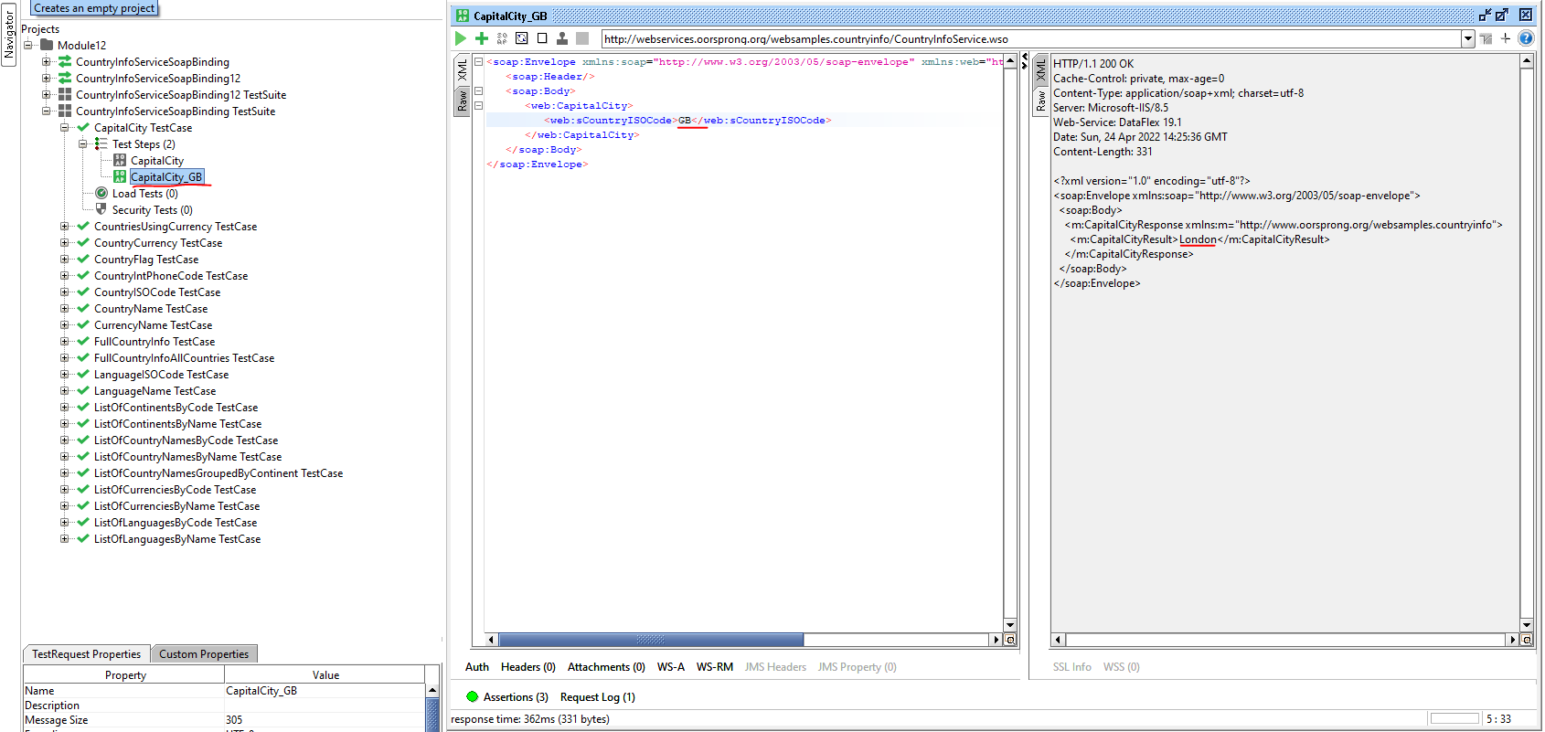

5) Perform test step for SOAP 1.2



6) Perform Send Request Manually and Reading Response step

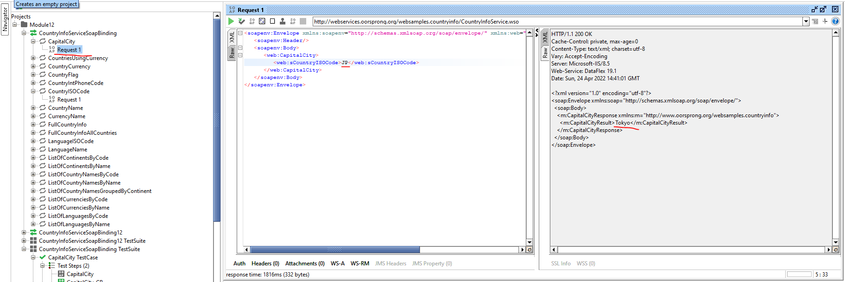

7) SOAP response messages in Log Panels

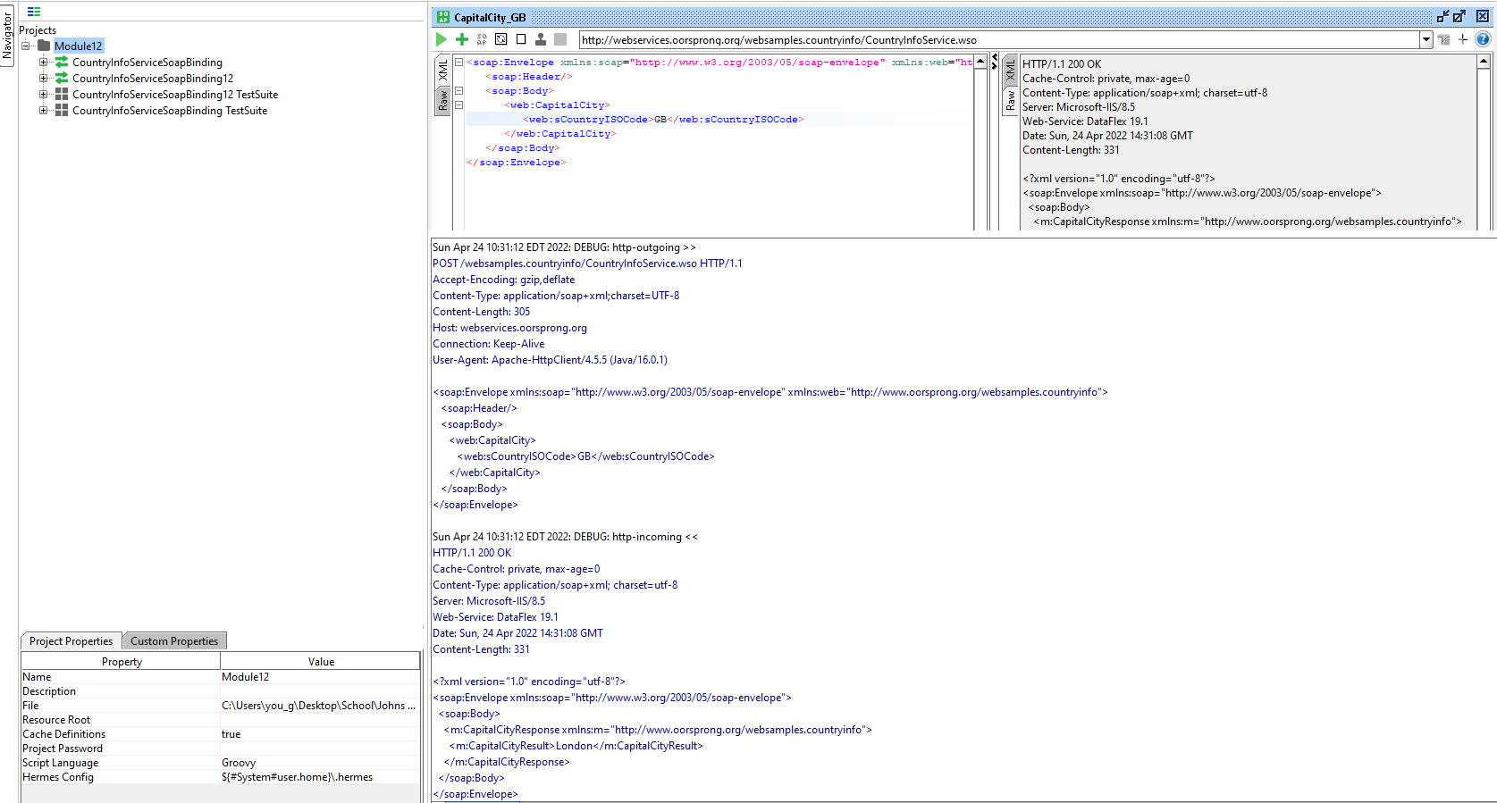

8) Validation test for WS-I compliance

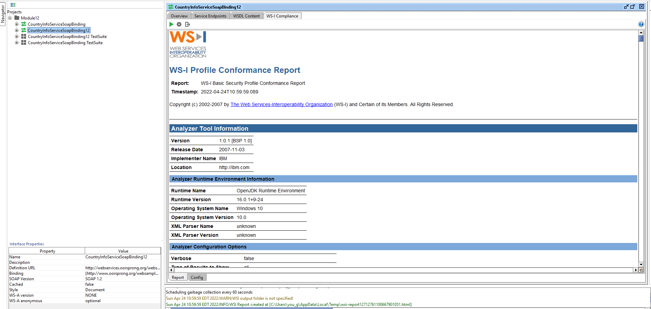

9) Provide written analysis of result report

The test itself ensures the definitions in the WSDL are in compliance with WS-I by running assertions on the generated endpoints and bindings. More specifically, most of these tests seem to focus on message integrity and security (e.g., encryption, signing, transformations) rather than the business logic that would be tested on a per request basis.