DJ - Collection 1

1) Initialize environment – Pre-request script employed at the collection level in order to set environment variables for each request

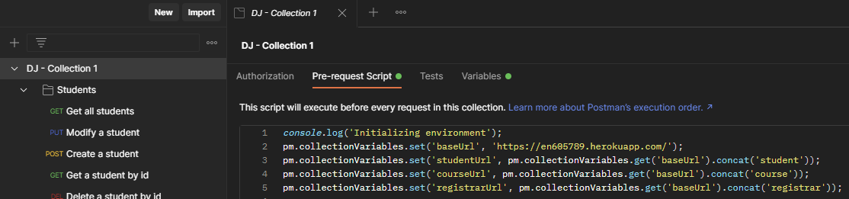

2) Students API:

a) Create valid student – 201 CREATED

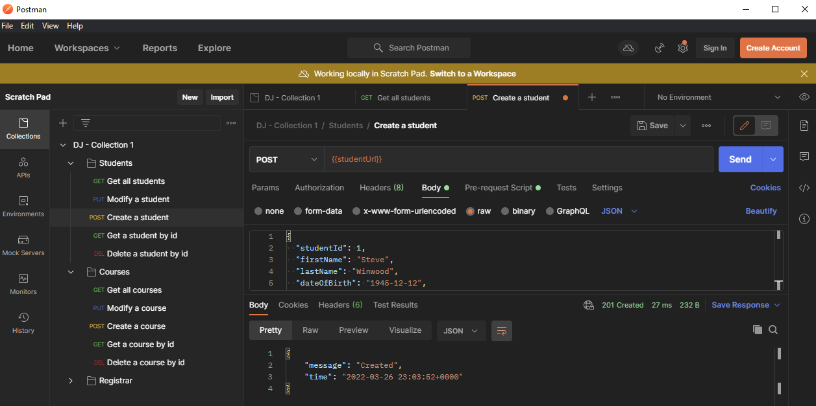

b) Create duplicate student – 304 NOT MODIFIED

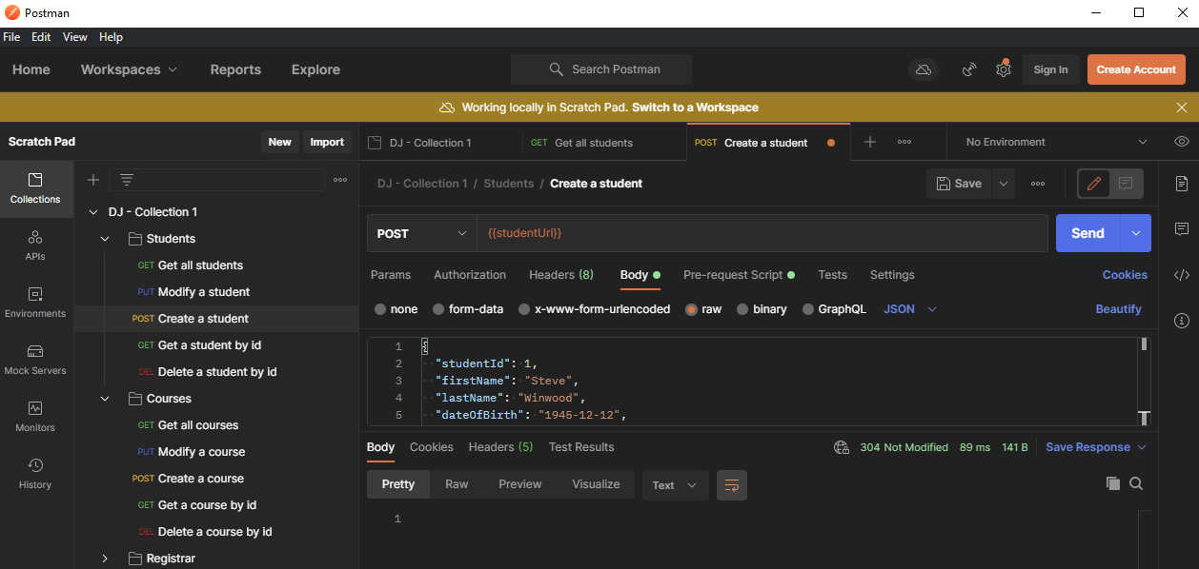

c) Create invalid student – 400 BAD REQUEST

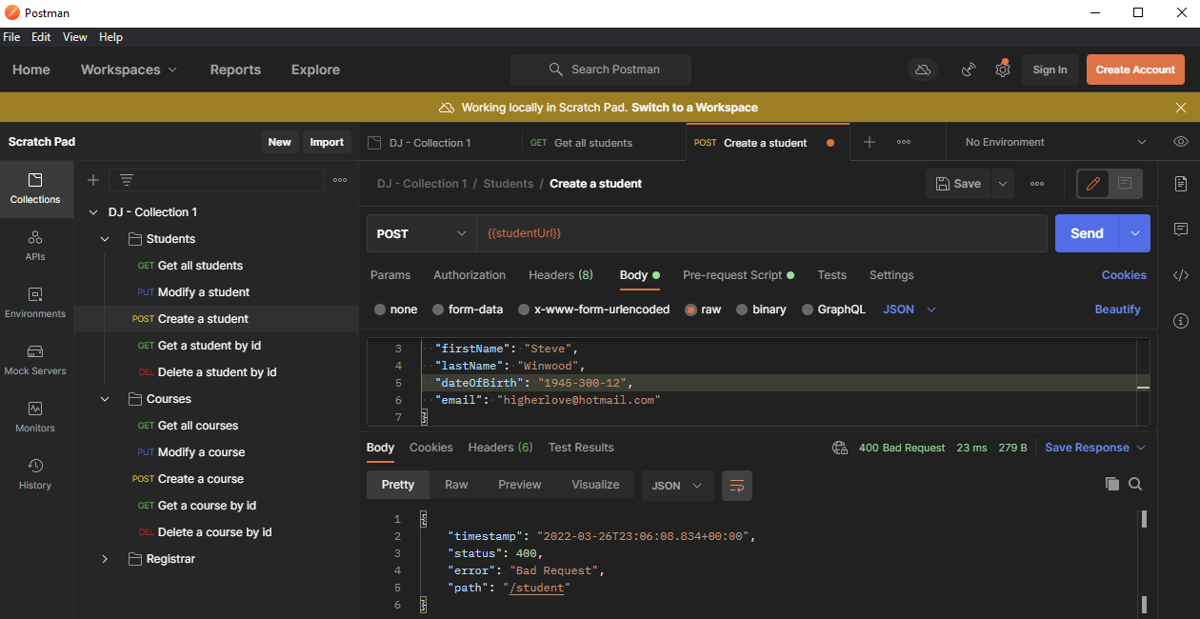

d) Get a student by valid id – 200 OK

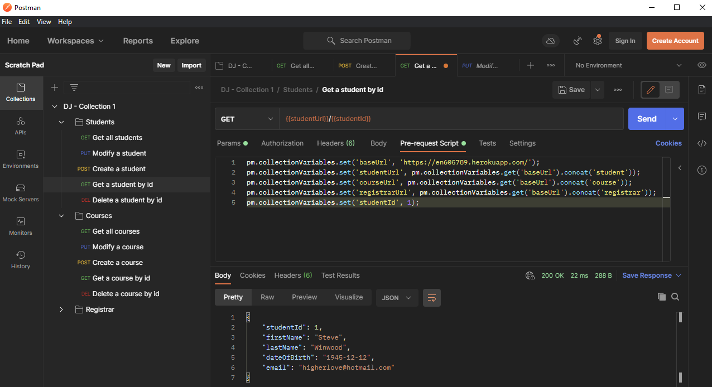

e) Get a student by invalid id – 200 OK (probably should be 204 NO CONTENT, but was configured as 200 OK during Module 7. Regardless, still sends empty response body)

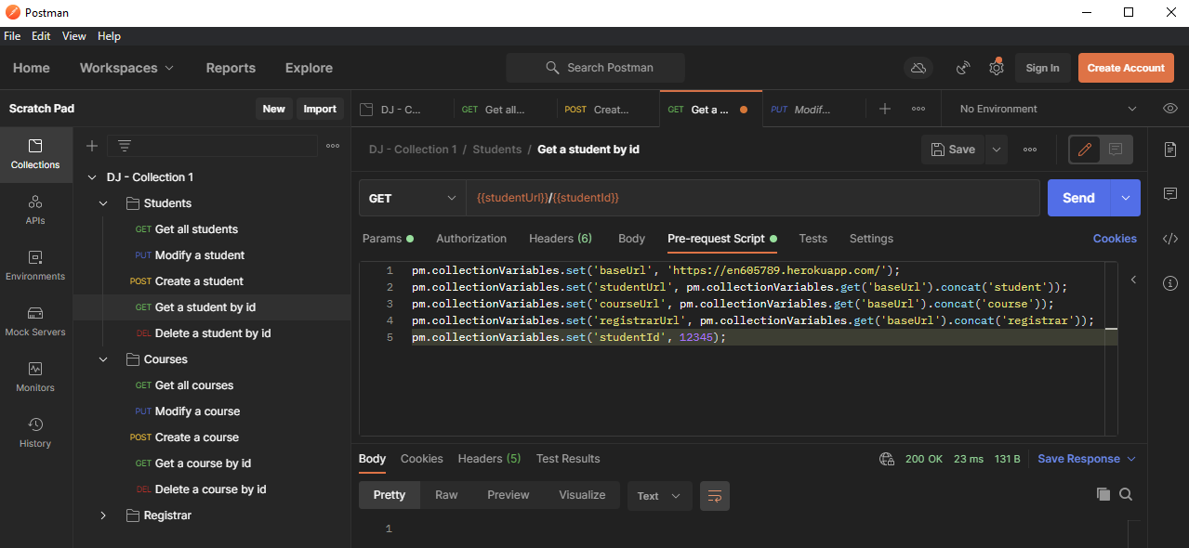

f) Modify a valid student – 200 OK

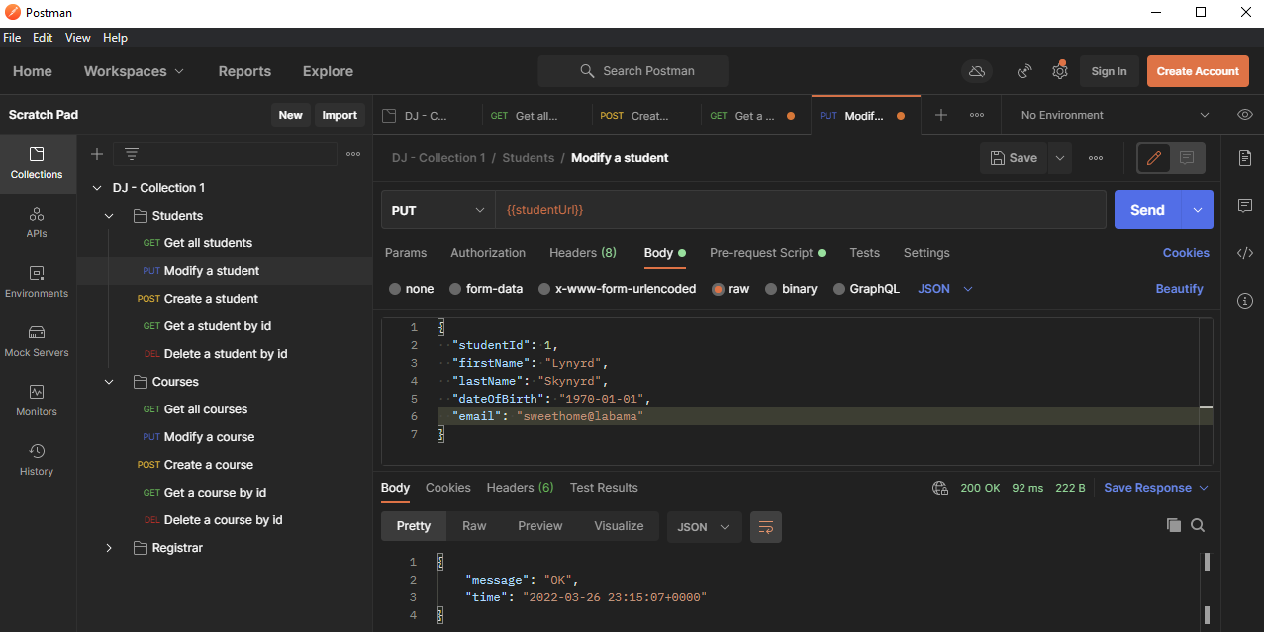

g) Modify invalid student – 400 BAD REQUEST

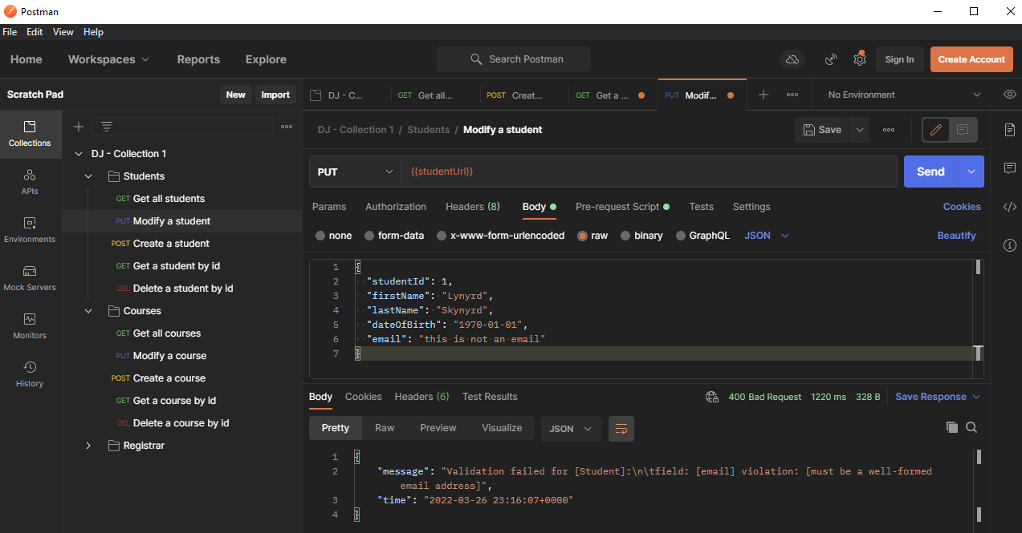

h) Get all students – 200 OK

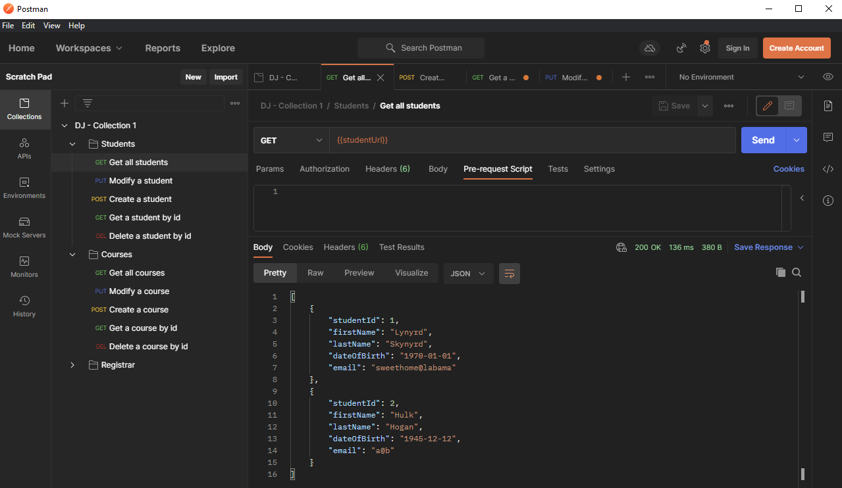

i) Delete a valid student – 200 OK

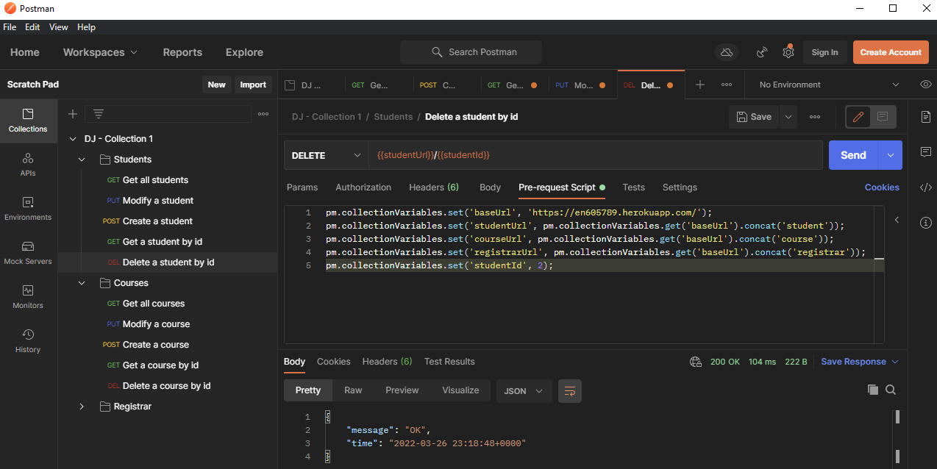

j) Delete an invalid student – 404 NOT FOUND (probably should be 204 NO CONTENT, but this is how it was configured for Module7).

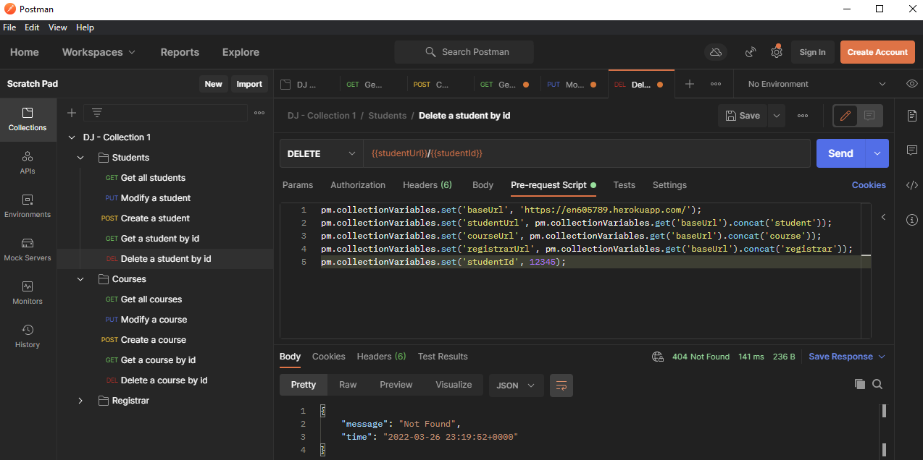

3) Course API

a) Create valid course – 201 CREATED

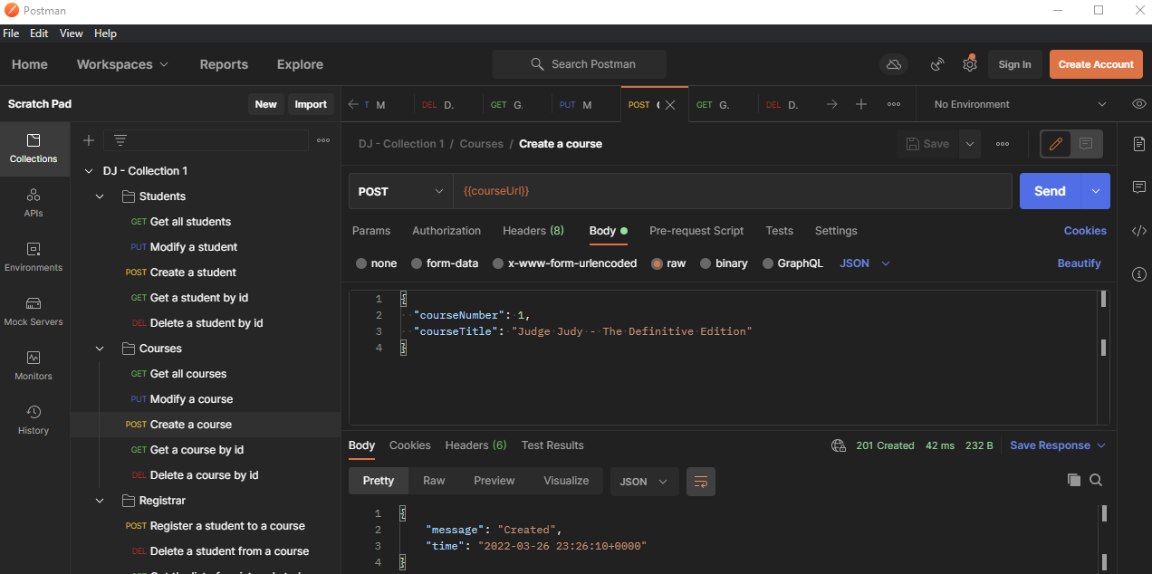

b) Create duplicate course – 304 NOT MODIFIED

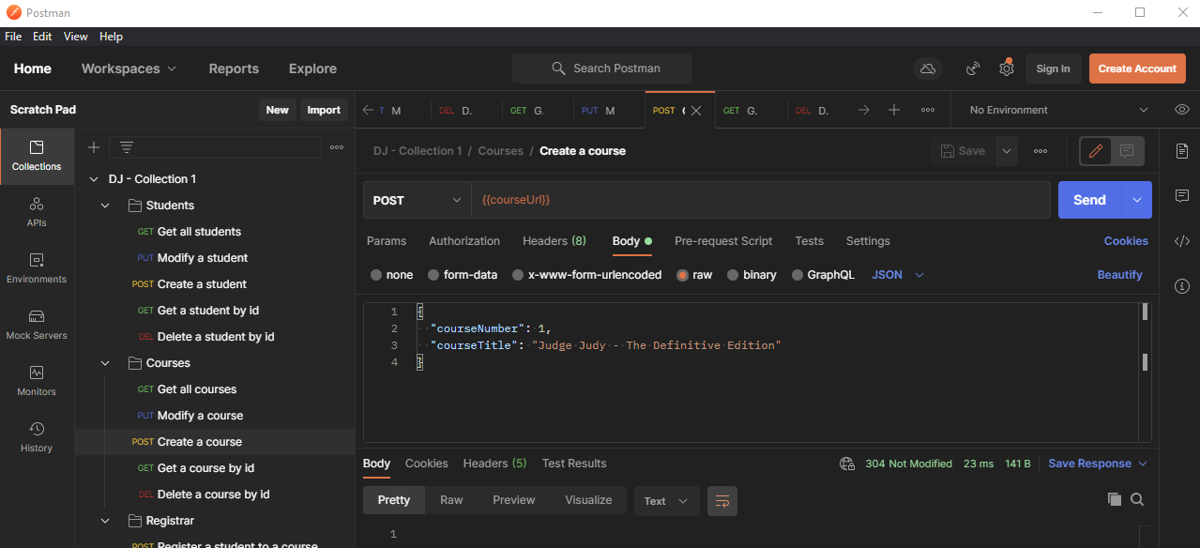

c) Create invalid course – 400 BAD REQUEST

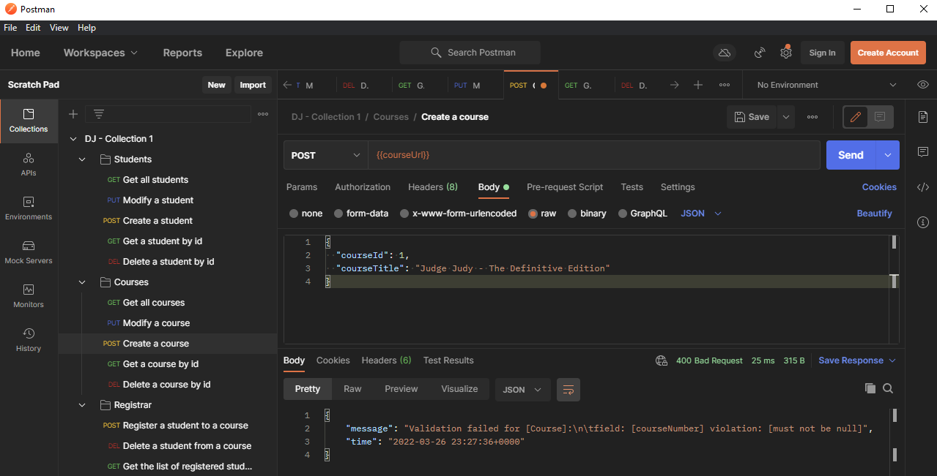

d) Get a course by valid id – 200 OK

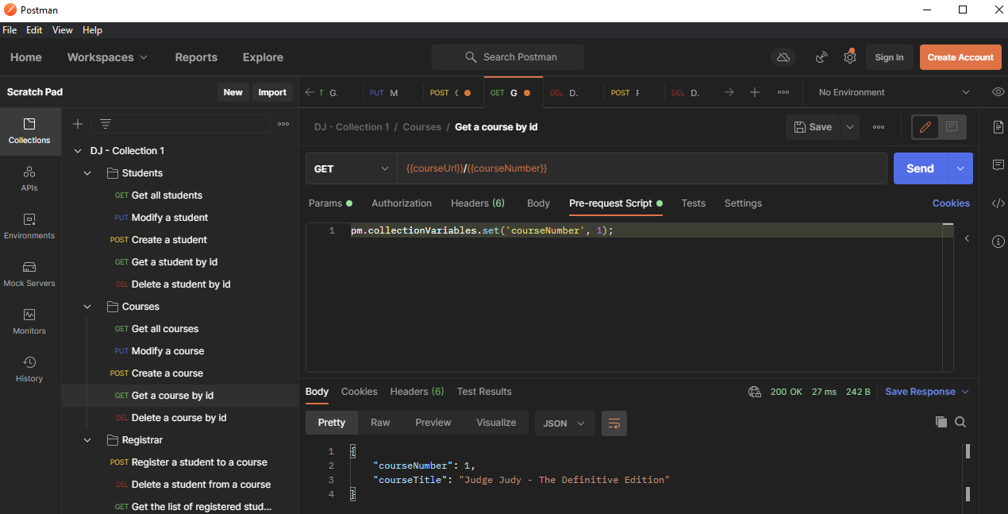

e) Get a course by invalid id – 200 OK ( probably should be 204 NO CONTENT, but was configured as 200 OK during Module 7. Regardless, still sends empty response body)

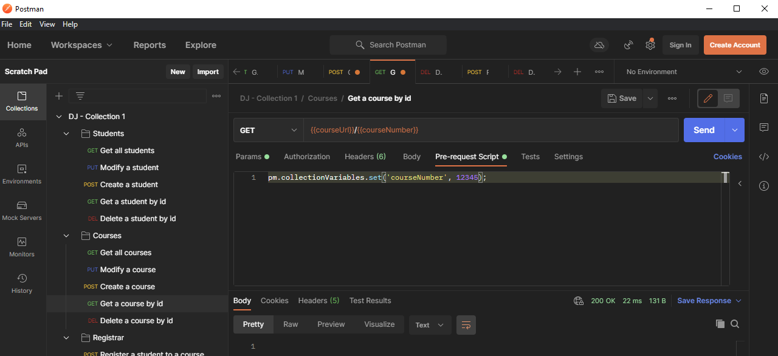

f) Modify a valid course – 200 OK

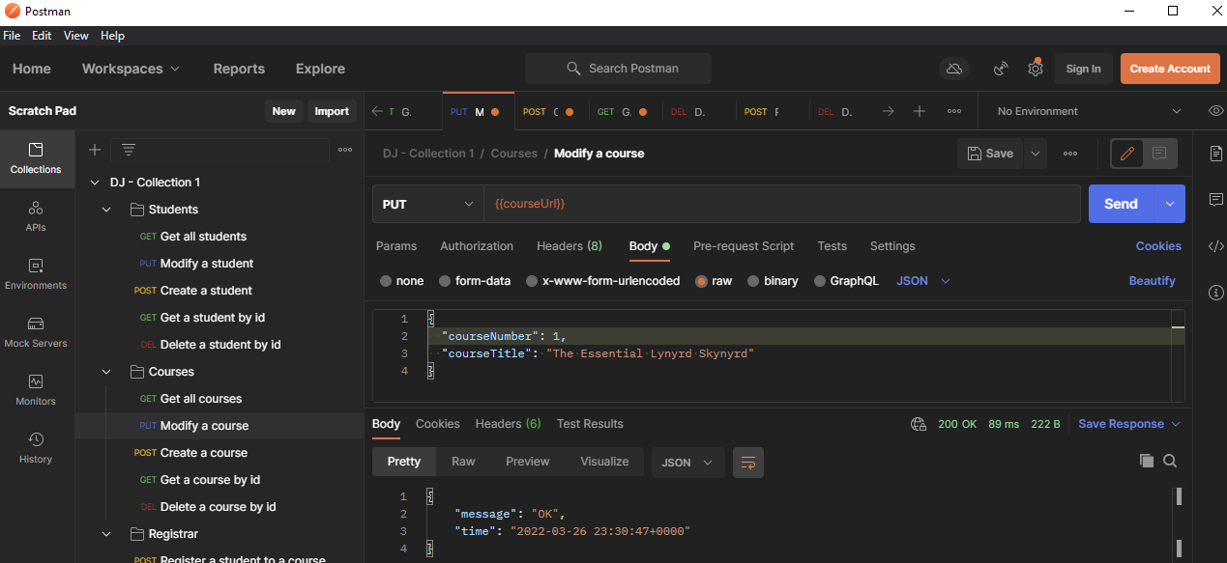

g) Modify invalid course – 204 NO CONTENT

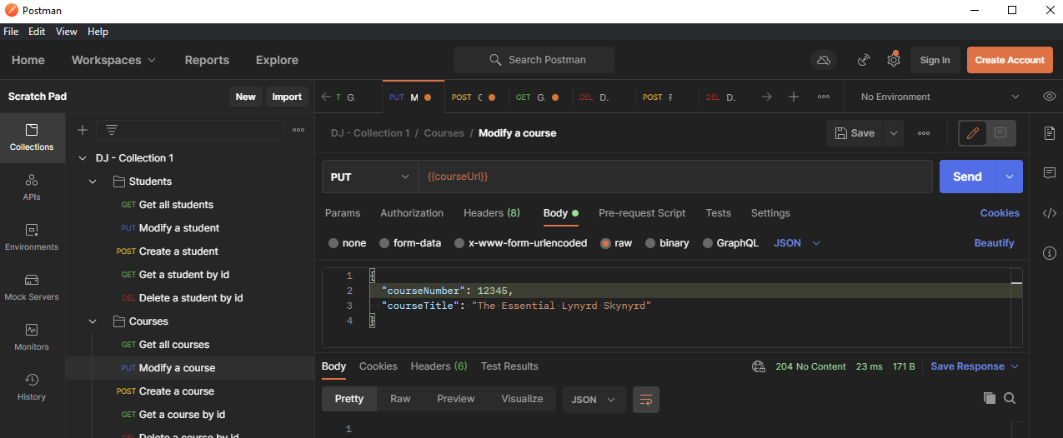

h) Get all courses – 200 OK

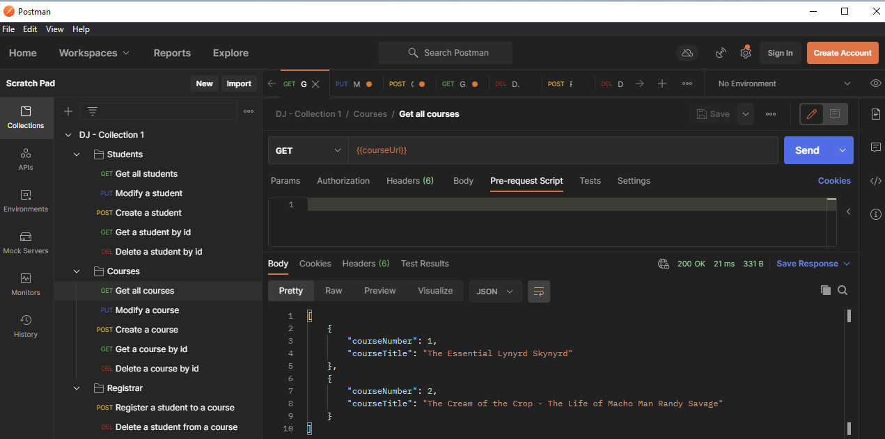

i) Delete a valid course – 200 OK

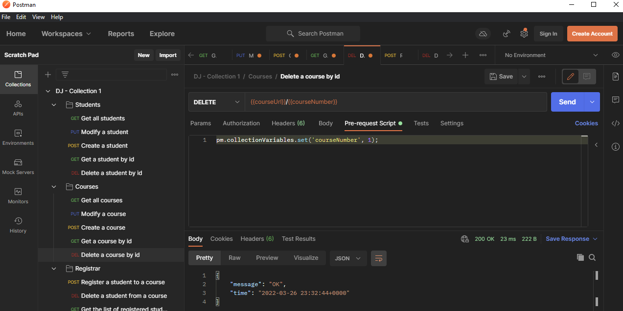

j) Delete an invalid course – 204 NO CONTENT

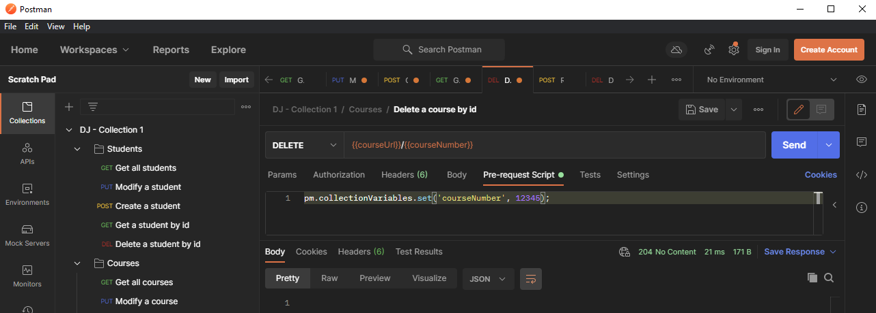

4) Registrar API

a) Register a valid student to a valid course – 200 OK

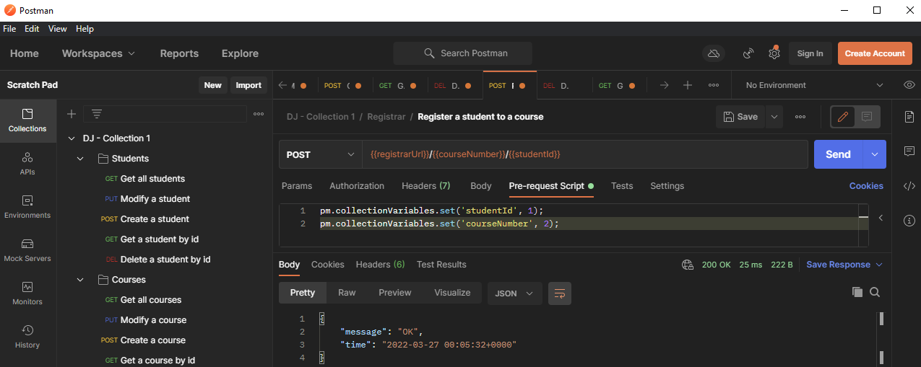

b) Register an invalid student to a valid course – 400 BAD REQUEST

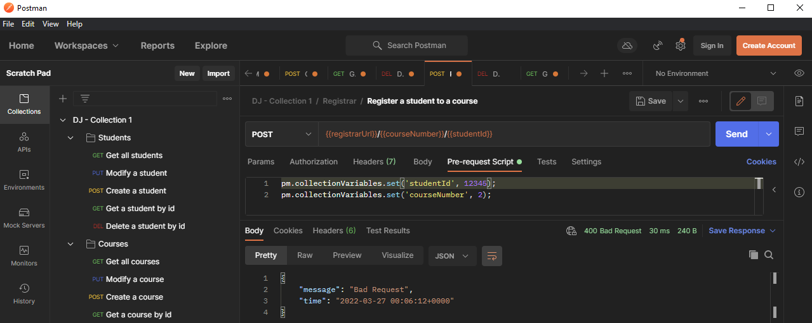

c) Register a valid student to an invalid course – 400 BAD REQUEST

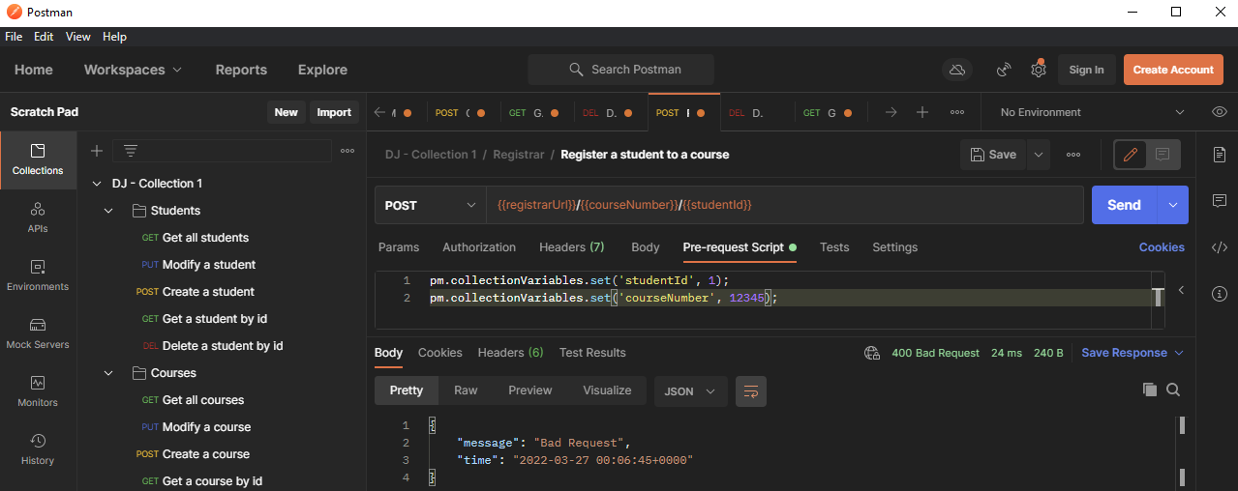

d) Register an invalid student to an invalid course – 400 BAD REQUEST

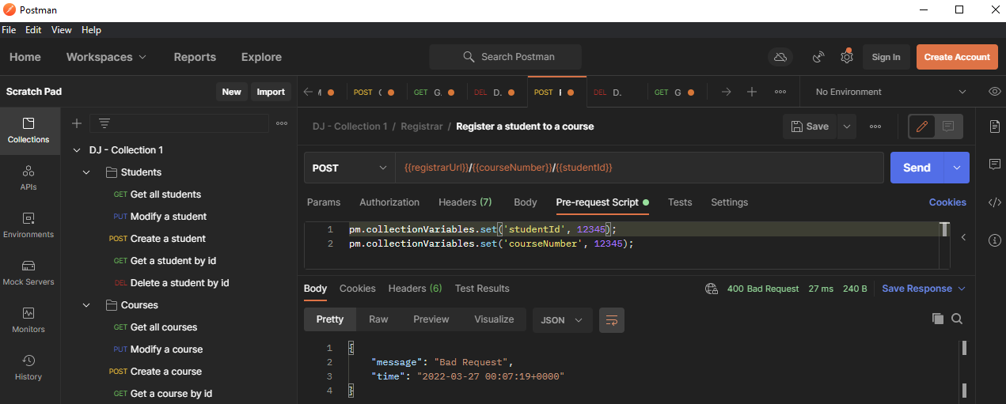

e) Duplicate registration – 304 NOT MODIFIED

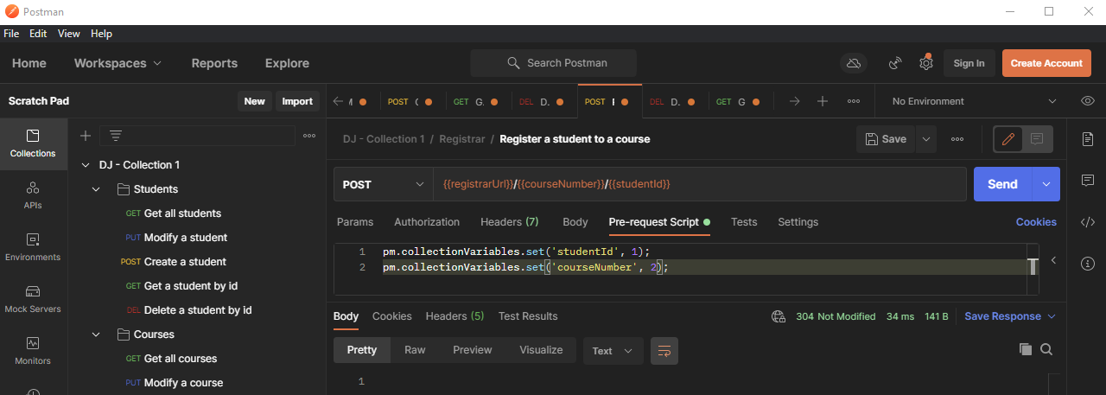

f) Delete a valid student from a valid course – 200 OK

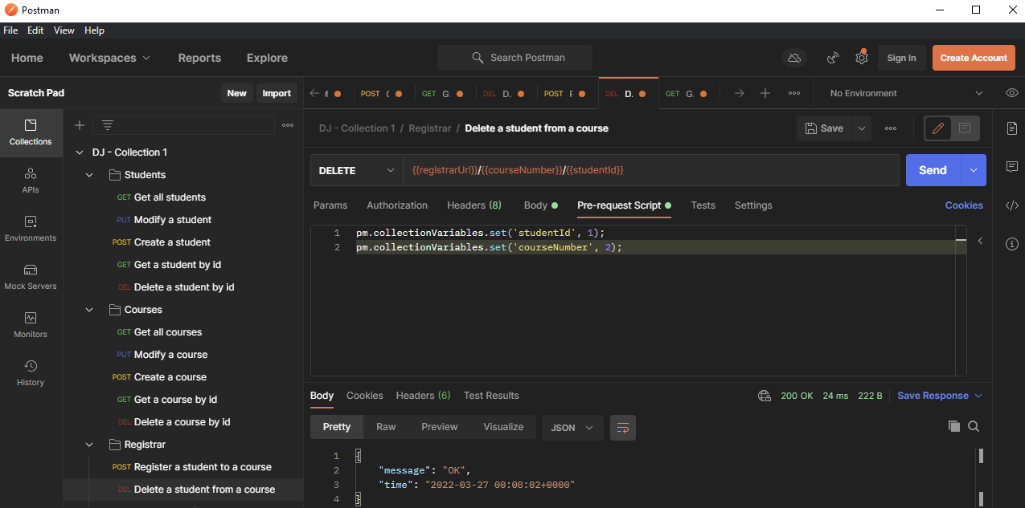

g) Delete an invalid student from a valid course – 400 BAD REQUEST

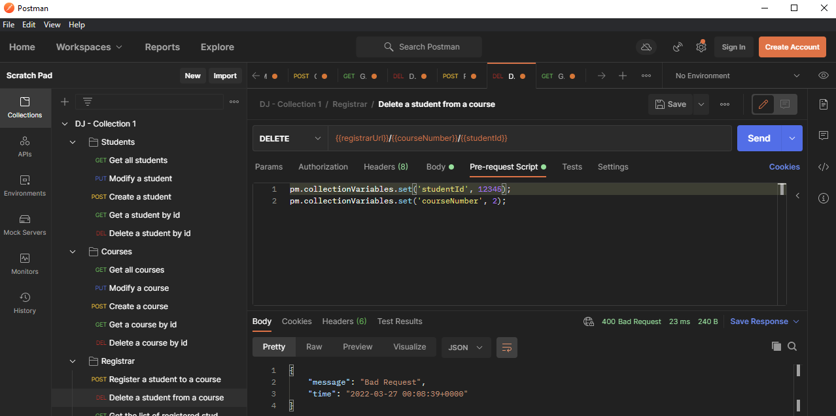

h) Delete a valid student from an invalid course – 400 BAD REQUEST

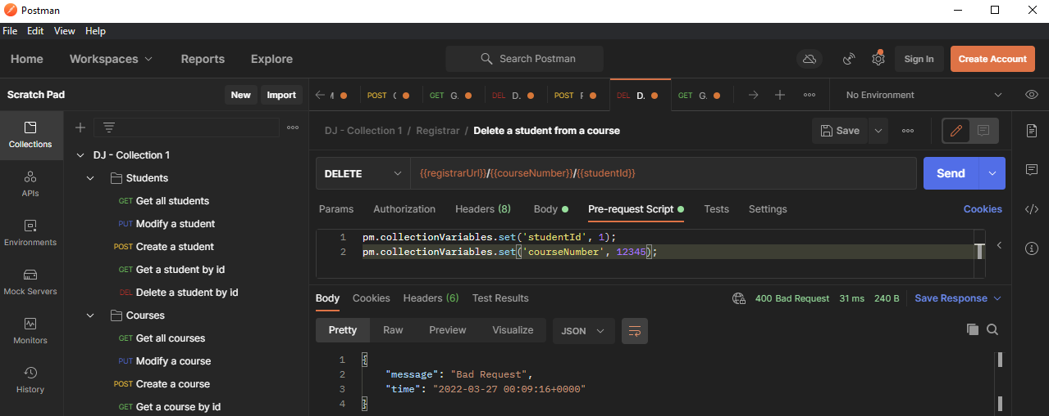

i) Delete an invalid student from an invalid course – 400 BAD REQUEST

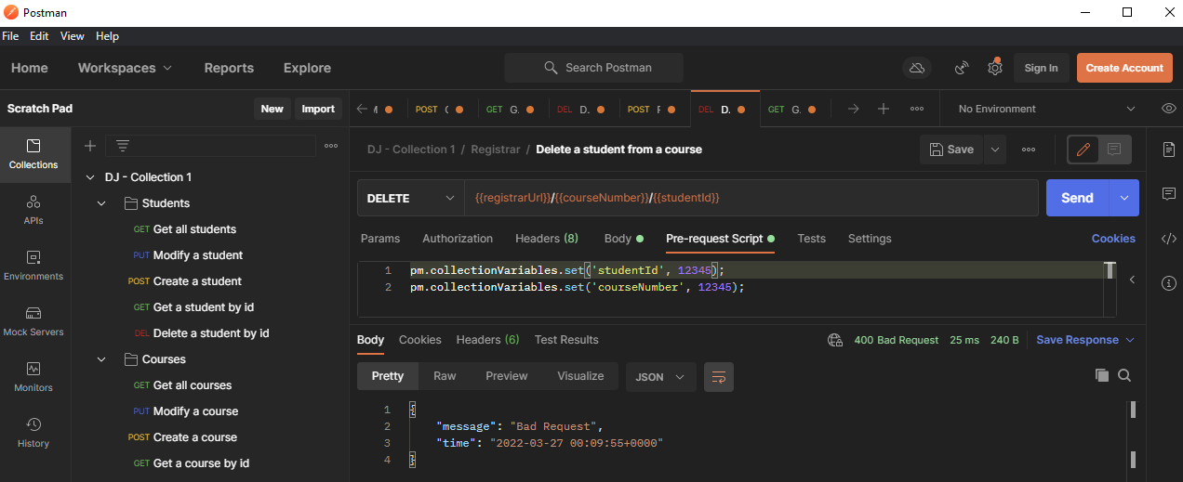

j) Delete a valid student from a valid course in which it is not registered – 304 NOT MODIFIED

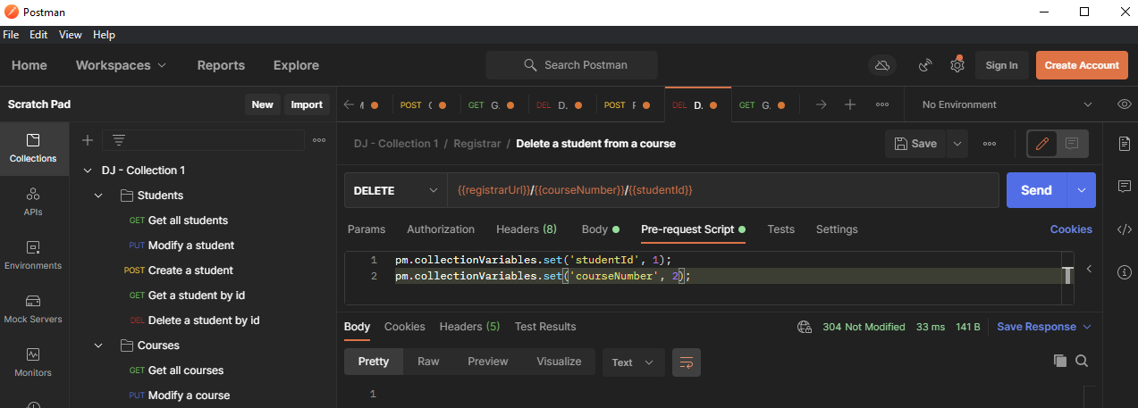

k) Get list of registered students by valid course id – 200 OK

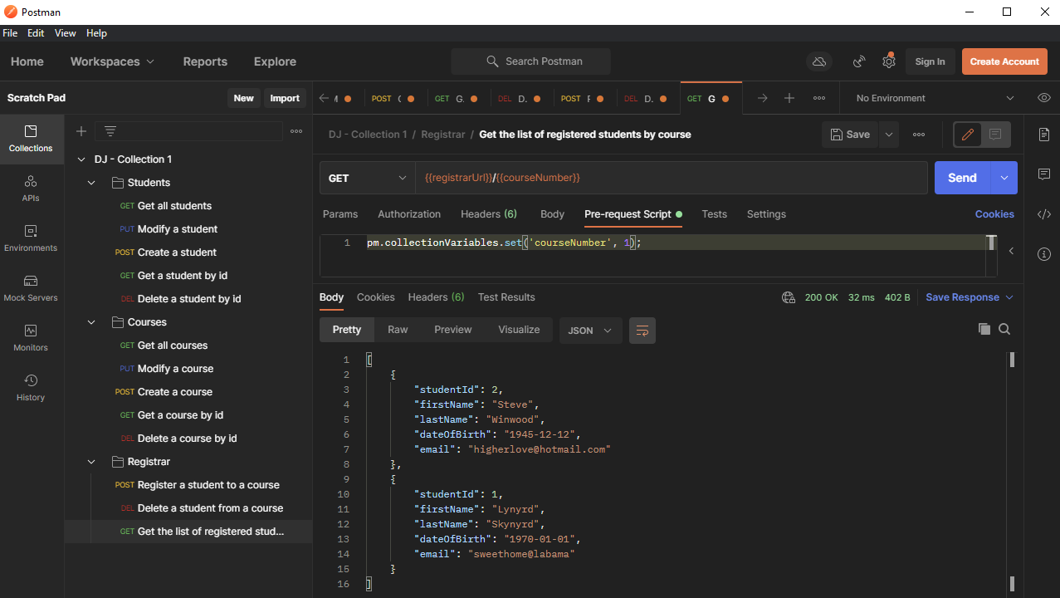

l) Get list of registered students by invalid course id – 400 BAD REQUEST

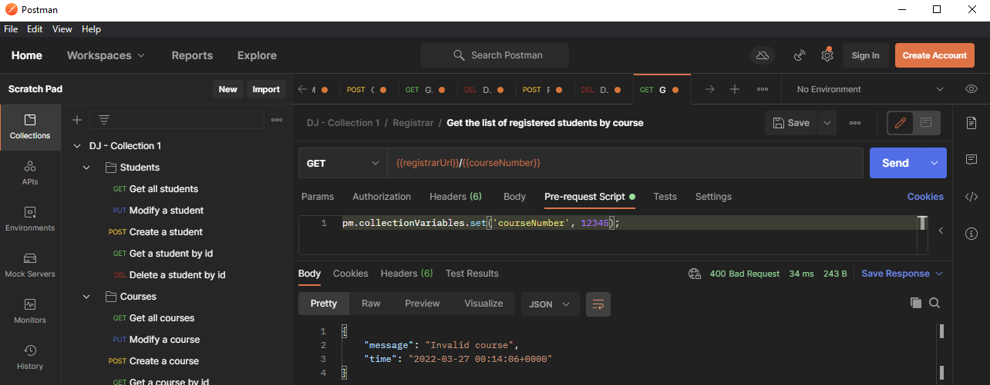

5) DJ – Collection 2 → the tests are the same as above, though the tests are automated

