When I was a toddler I caught a wave, stood up, and surfed it all the way to the beach. This experience was an *anti*traumatic event, forever predisposing me to the wonders of the ocean. *maybe not, but I would like to think such a romantic thing could be true. I also love to understand how things work, make things, tinker.

It is, in hindsight, obvious why I ended up at university doing something of a union of my two loves: Ocean Engineering. It wasn’t so obvious amidst deciding what to do at university, of course. And doing Ocean Engineering required moving to the deep south to Tasmania, where the Australian Maritime College is, and where I knew zero people. But my head, heart, and gut all implied ‘go for it, man’, so off I went (after deferring for a year to travel – a story for another time).

**My introduction to wave energy**

During the course, some assignments involved carrying out hydrodynamic experiments in wave basins on offshore structures, vessels, and machines. In these experiments, we built scaled down models of offshore structures, vessels, and machines, moored them in a wave basin (a fancy pool that generates waves at one end), equipped the models and basin with sensors, then sent wave after wave down the basin and watch the things bob and toss about. That is, investigate their hydrodynamic behaviour. We then analysed the gathered data by generating graphs of quantities that describe how the things interact with simulated ocean waves. With a bit more number crunching and head scratching we designed full-scale things that should, in theory, behave similarly to the scaled down model. This is the purpose of doing such experiments: to understand how things work cheaply, quickly, scaled down, low risk, in the proverbial sandbox, then apply this new understanding to design big, real-world, expensive, risky, complex things.

I was most fascinated by the experiments on machines called wave energy converters (WECs). These machines, amazingly, convert the raw energy in ocean waves into usable electricity. I think why I was so fascinated by these machines is because at an experiential level, I knew something of the power of ocean waves, having surfed all my life and flip-flopped, tumbled, elongated, and held under some terrifying waves. ‘Can we really *use* this raw power? It’s crazy, but it might work!’ said my mind to itself.

Luckily, a wave energy tech start-up were set to carry out proof-of-concept tests of their novel WEC machine at my university's hydrodynamic test laboratory (Fig. 1**c**). The scaled-down WEC was a strange looking [thing](https://www.youtube.com/watch?v=jkXpv2rJo8k). It had a series of pipes poking out of the water (Fig. 1**a**). Underwater, these pipes were connected to a long submerged membrane filled with air. When waves pass over, the changing pressure field created by the wave crests and troughs drives entrapped air in the membrane back and forth through the pipes, like a foot pump. Thus, wave energy is converted to pneumatic energy (airflow) which can do *work*, where power equals work divided by time. In the real machine, this airflow pneumatic energy would be converted into mechanical energy by an air turbine (like a mini wind turbine), with this spinning turbine coupled to a generator to create electricity. Easy!

My research project, in brief, consisted of developing an underwater camera-based measurement system that captured the dynamic motion of the working membrane (Fig. 1**b**). From this dynamic motion, we could infer the power absorbed by the WEC from the waves – key information that helped *prove* the concept, i.e., that the WEC could indeed capture and convert a reasonable amount of wave energy.

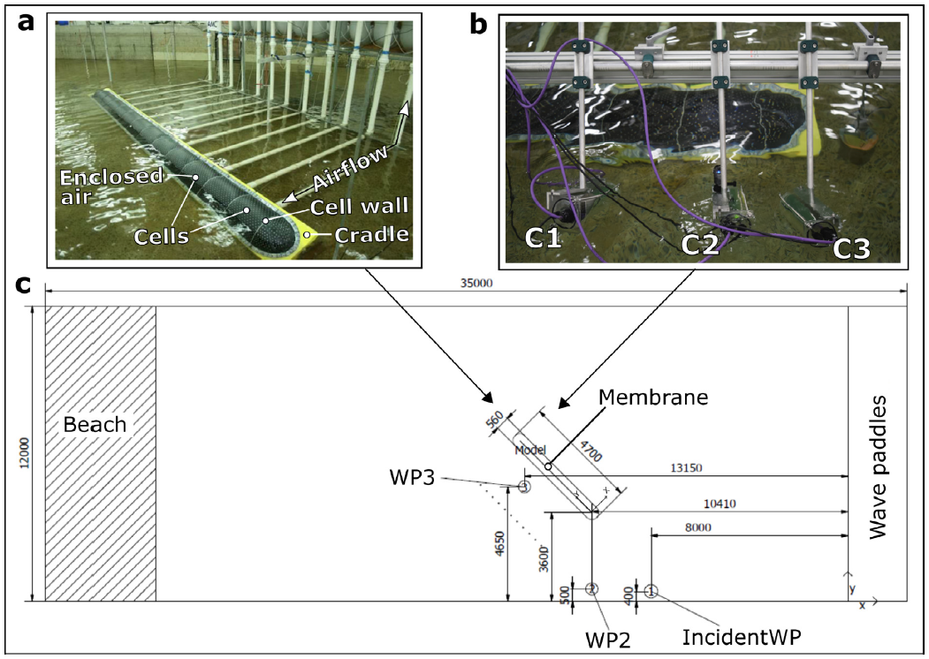

After university I moved home and considered, no less, what to do with my life. After some deliberation, I began to seriously consider the opportunity to undertake a PhD in wave energy. Clearly the afterglow of a year amidst the messy/beautiful process of research encouraged me pursue it. So after ~6 months o*n the road* again, I began what would be the most challenging and fruitful four years of my life. I would begin again the messy/beautiful process of research.

**PhD**

The vague idea of was to investigate better ways in which to test and develop wave energy converter technologies, from proof-of-concept to prototype and beyond.

To refresh, a WEC is a machine that converts the energy in ocean waves into a useable form, most commonly, electricity. Wave energy is actually not a new idea; the first patent was in 1799[1]and it gained interest in the 1973 oil crises. As climate change arose as a serious problem, wave energy attracted significant interest among engineers and scientists and, later, business folk. Theoretically, wave energy could supply the world's energy demands. Practically, however, it is probably ~10% – still a stupendous number of joules.

Despite decades of research and development, the beautiful idea of utilising ocean waves to help power the world is largely still an idea. Without satisfactory solutions, many different concepts are still being actively developed, at various stages of development. With this diversity of designs and no clear technology convergence (wind turbines essentially all look the same now, [but this wasn't always so](https://en.wikipedia.org/wiki/History_of_wind_power)), it has been difficult for the wave energy community to establish accurate and robust standards and guidelines that can be used to cost-effectively progress technologies through various stages of 'readiness', from proof-of-concept to prototype and beyond.

The specific aim of my research, then, was to review and provide technical enhancement of parts of these guidelines. The focus was on, as you might guess from my diversion above, hydrodynamic modelling; more precisely, hydrodynamic model test experiments.

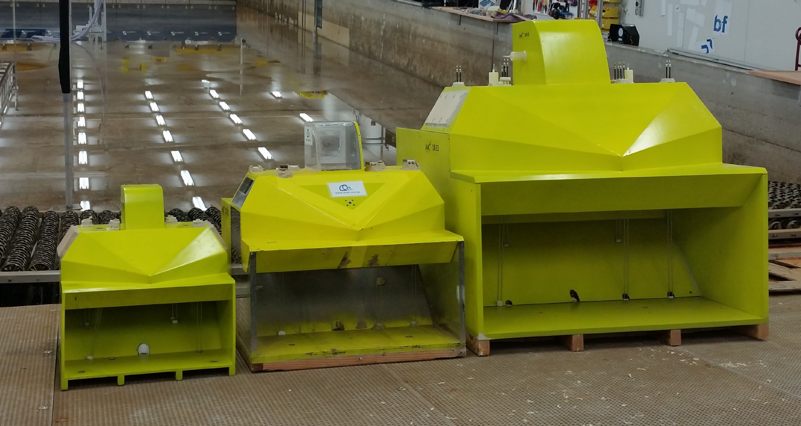

Hydrodynamics is the study of how fluids and structures interact; hydrodynamic modelling is the practice of developing simplified models of real-world fluid-structure interactions; and hydrodynamic model test experiments are the practice of building scaled-down models of yet-to-be-built, full-scale ocean structures, vessels, or machines and testing them in wave basins that simulate ocean conditions.

Why models? Models help us understand, assess, predict; but they are limited, uncertain. In the context of sophisticated machines operating in the challenging and at times tempestuous ocean environment, building models enables a fast and frugal means to develop prototypes at acceptable cost, risk, and time. And here comes the but: all models are wrong, but some are useful. Therefore, to seek to know how models are wrong is to – strangely – maximise their usefulness. This seeking manifests as understanding the limitations and uncertainties of models, thereby gauging the degree of (un)certainty of the model outputs. Doing so converts at least some of the unknown unknowns into known unknowns – there will always be unknown unknowns, no matter how much we cajole nature into revealing her secrets. This process, though it requires more effort and head scratching, can significantly improve the outcomes of experiments and save time and money in the long run by avoiding costly mistakes in the prototypes.

So within this context, my research sought to better understand the causes and effects of uncertainty in hydrodynamic model test experiments of WECs. To this effect, we reviewed technical guidelines and literature to identify major uncertainties needing investigation, then conducted a series of model test experiments designed to investigate these uncertainties.

The main conclusion was that experimental uncertainty is an inseparable part of and can significantly influence the results of hydrodynamic model test experiments of WECs. Therefore, the wave energy community stands to benefit from (1) acknowledging this uncertainty; (2) investing time, money, and resources into accounting for newly revealed major uncertainties; and (3) implementing the research outcomes into future guidelines so they contain updated knowledge and methods used to test and develop WEC technologies more cost-effectively.

For those strange and curious people (you know who you are) you can read my thesis **here**.

**Final thought**

If I had to condense everything I learned throughout my research, it would be this: let curiosity lead, even if it chases rabbits down holes, especially if it chases rabbits down holes, because down there, deep down in some holes, exist things no other human as ever seen nor will ever see again.

DUMP

This story almost seems like a real story, with a beginning, an arc, and a somewhat satisfying end. But almost certainly this is a product of hindsight and omission of the countless slipups, surprises, and setbacks. With each new scene came new problems, new decisions to be made under uncertainty. And of course, many instances of luck.

Throughout my childhood I surfed, bodyboarded, bodysurfed, cliff jumped, got tossed about on barnacle-covered rocks, swam, snorkelled, skin dived, floated, kayaked, fished, played clay wars. The ocean caressed my curiosity; never quite still, never the same; sometimes graceful, bluegreen, other times a raging mess of froth and wind. Reflecting on my ocean playground stirs up rich images and feelings, ranging from general memories of sprinting barefoot to the surf in extreme anticipation, to singular memories of barrels where there is ‘that sound’ and time almost halts. *This is what happens inside of a barrel – try it.



Okay, time for some science. You can skip this section if it looks scary, but with a flicker of curiosity and effort I’m sure you can get the gist.

My research project for these proof-of-concept tests was to develop an underwater non-contact optical measurement technique called videogrammetry. What does this *videogrammetry* have to do with wave energy? Often in science and engineering research we must go around a long and winding roundabout, sometimes smashing into a dead end and having to find another route, to eventually arrive at the destination of understanding. In this case, the understanding to be arrived at was the hydrodynamic behaviour of the membrane which, as we now know from above, is key to understanding how the machine interacts with waves and, eventually, enabling the effective design and optimisation of the prototype.

Back to videogrammetry. This measurement system consisted of array of three submerged video cameras pointing at a section of the membrane.

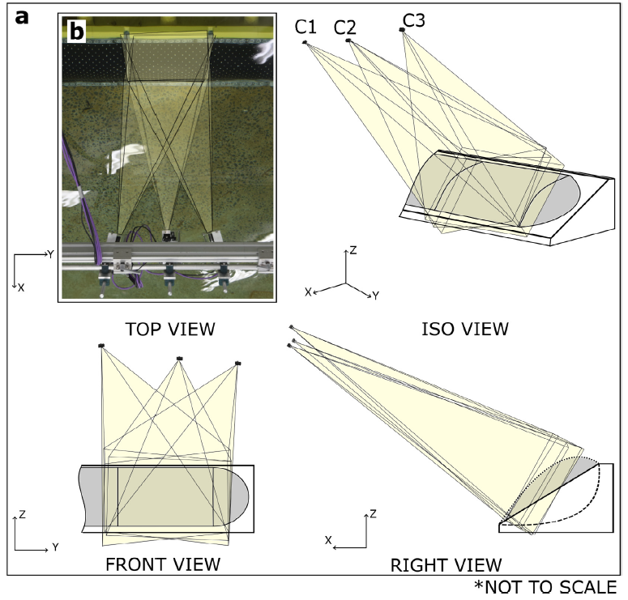

The membrane itself was painted with a tight grid of high-contrast dots.

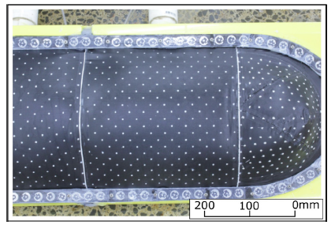

Starting with a simple static case – photogrammetry, ‘measurement from photos’ – photos from these three points of view could be used to obtain the 3D positions of each of the dots on the membrane surface. Kind of like how GPS works, with triangulation. This 3D grid of dots are like a CAD model [refer to mars rover]. Fitting a surface to the dots, we could then calculate the volume of air contained within that section of the membrane, called ‘cell volume’ (a cell is an enclosed section of the membrane, whose air is flown up and back the connected pipe).

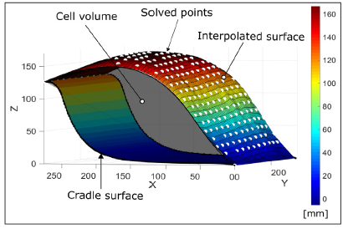

Now, extending to the dynamic case – videogrammetry, ‘measurement from video’ – we can simply apply the same method as above but for each frame of the video, which is essentially a series of photos. Thus we could calculate cell volume across four-dimensions (three space + time).

Why is cell volume over time important to know? First, a bit more math and head scratching. As the membrane inflates and deflates under passing waves, we can calculate the rate of change of cell volume, or how much the cell volume changes in a small slice of time. This time slice is the time between frames of the camera (at 12 frames per second, the time slice = 1/12 = 0.083 secs). Making this calculation we get volumetric flow rate, or how much air flows through the pipes per second. With this volumetric flow rate in hand, we multiply it with the pressure of the air flying up and back the pipe (before and after an orifice that simulates damping of an air turbine) to obtain the power of the working fluid (air).

Now we have what we always wanted to know: the power output of the model WEC machine. Put another way, how much power the machine stole from the waves and gave to us. [* reference paper]

1. Babarit, A., 2017. *Ocean wave energy conversion: resource, technologies and performance*.