Interior Design Platform
User manual and screen guide
Every use case, for customers, designers and administrators.
CSIT314 Software Engineering Project · 12 November 2026
All screens in this manual were captured from the running application against the seeded demonstration data.

Contents
1 About this manual 3
1.1 The three roles 3
1.2 Demonstration accounts 3
2 Getting the platform running 3
3 Customer 4
3.1 Create an account and sign in 5
3.2 Check your account on the dashboard 6
3.3 Find a project with filters 7
3.4 Search by photo 8
3.5 Open a project and read the details 9
3.6 Save a project to the shortlist 10
3.7 Request a quote 11
3.8 Compare, counter and accept a quote 12
3.9 Book a consultation 13
3.10 Cancel a consultation 14
3.11 Report a project 15
4 Designer (IDM) 16
4.1 Check the designer account 17
4.2 Complete the company profile 18
4.3 Publish a project with photos and tags 19
4.4 Manage the portfolio 20
4.5 Answer a quote request 21
4.6 Read the public designer page 22
4.7 Accept or cancel a consultation 23
5 Administrator 24
5.1 Approve and suspend accounts 25
5.2 Manage categories 26
5.3 Read the activity report 27
5.4 Review reported projects 28
6 Reference 29
6.1 Ports and addresses 29
6.2 Where the data lives 29
6.3 When something looks wrong 29

Page numbers refer to the printed layout of this manual.

1 About this manual
This manual explains what a person can do in the platform and where to do it. It is written for the three roles the platform supports. Each use case gives the screen, the steps, and the result to expect.
The application is a teaching build. Records live in the memory of the backend process, so a restart empties the catalogue. Section 2 explains how to restore it.

1.1 The three roles
Role | Can do | Cannot do
Customer | Browse and search the catalogue, search by photo, save projects, request quotes, accept or decline a quote, name a target price, book and cancel a consultation, report a project | Publish projects, answer quotes, manage accounts
Designer (IDM) | Publish and edit projects, upload photos, read tags, set the company profile with a meeting address and a call link, answer and revise quotes, accept or cancel a consultation | Approve accounts, manage categories, read platform reports
Platform manager | Approve or suspend accounts, review reported projects, take a project down, suspend a designer, add, archive and restore categories, read activity reports | Publish projects, send or answer quotes

1.2 Demonstration accounts
Every demonstration account uses the password passw0rd123. The administrator account is created from APP_ADMIN_EMAIL and APP_ADMIN_PASSWORD at startup.
Role | Email | What it shows
Platform manager | admin@example.com | Approval queue, categories, reports
Designer | verde@example.com | Studio Verde: company profile and portfolio
Designer | designer000@example.com | A bulk designer with a large portfolio
Customer | casey@example.com | A customer with a saved shortlist and one answered request

2 Getting the platform running
One clone, one install, two commands. The repository contains the seed scripts, so the catalogue can be rebuilt on any machine in about a minute.
1. Double-click 1-check-my-pc.bat to confirm the tools are present.
2. Double-click 2-install.bat to create the Python environment and install the front end.
3. Double-click 3-start-app.bat. Two windows open: the API on port 8000 and the site on port 5173.
4. Double-click 4-load-demo-data.bat to rebuild the recorded dataset.
5. Open http://localhost:5173 and sign in with a demonstration account.
6. Double-click 5-stop-app.bat when finished.
If another program already holds port 8000, start the API on another port and point the front end at it: set VITE_API_TARGET=http://127.0.0.1:8010 before npm run dev.

3 Customer
A customer looks for a designer whose work fits a room, keeps the ones worth a second look, and asks for a price.
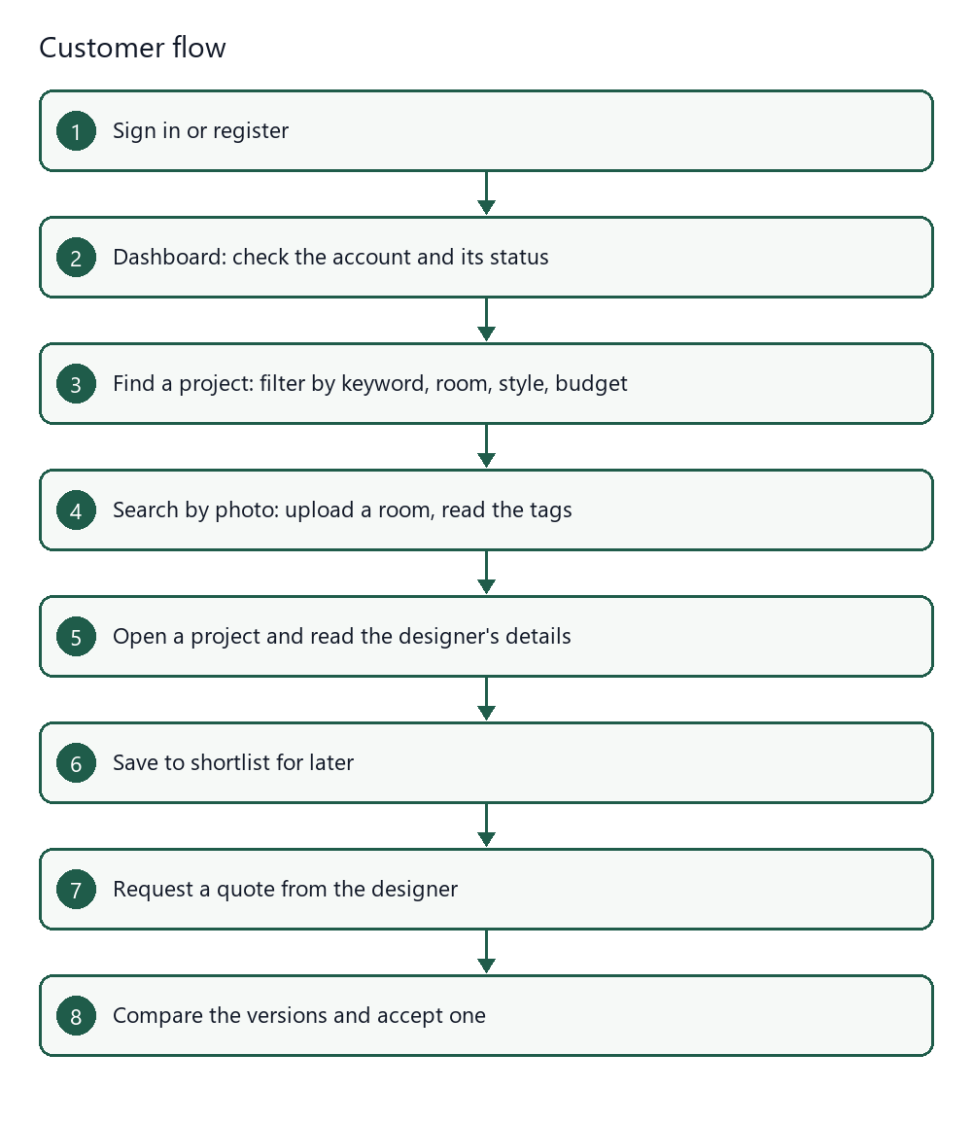
Figure 1 The customer journey from sign in to an accepted quote.

3.1 Create an account and sign in
Where: Create account, then Sign in
You need an account to save projects or send a request. Browsing the catalogue does not need one.
1. Open the site and press Create account in the top navigation.
2. Enter your name, your email address and a password.
3. Press Create account. New accounts start as Pending for a designer, active for a customer.
4. Sign in with the same email address and password.
Result: The dashboard opens with your name in the navigation bar.
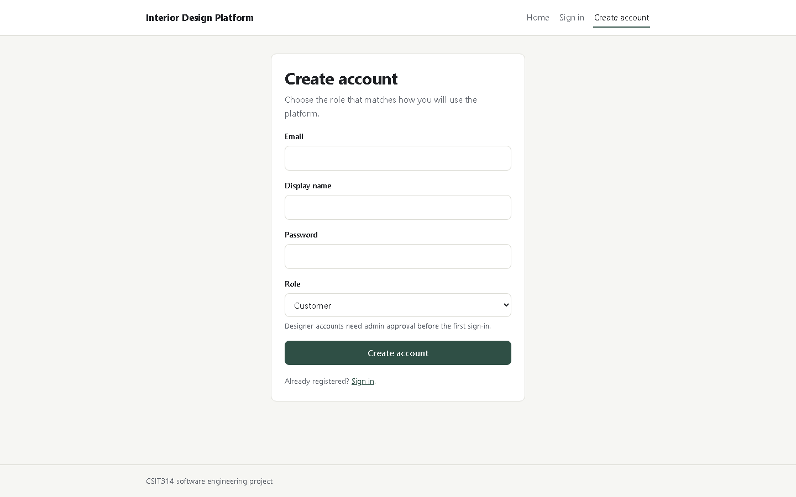
Figure 2 The registration form. The role field decides which screens appear after sign in.

3.2 Check your account on the dashboard
Where: Dashboard
The dashboard confirms which account is signed in and whether it can act.
1. Press Dashboard in the top navigation.
2. Read Display name, Email, Role and Status.
3. Read Account ID and Member since when support asks for them.
4. If a notice appears above the card, read it: a pending designer cannot publish yet.
Result: You can see the account state at a glance. Saved work and requests have their own links in the top navigation.
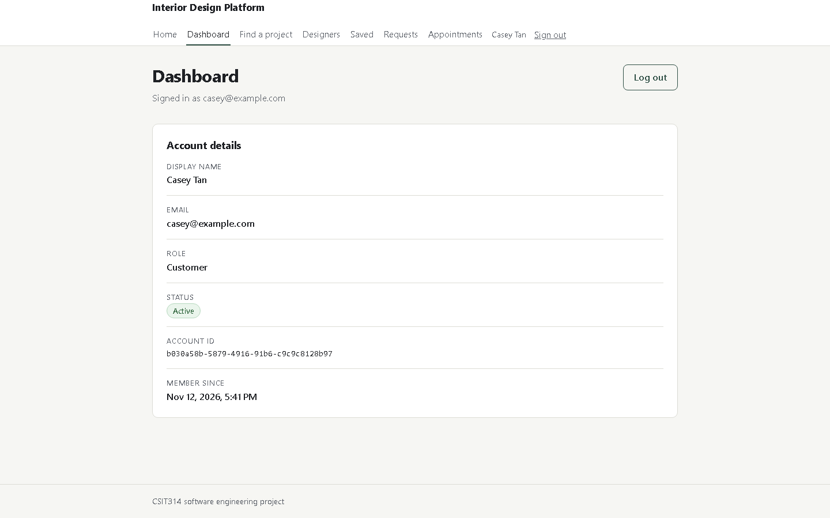
Figure 3 The dashboard: one card with the account details and its status.

3.3 Find a project with filters
Where: Find a project
The catalogue holds every published project. Filters narrow it to the rooms and styles that matter.
1. Press Find a project in the top navigation.
2. Type a word in Keyword to match the title, the description or a tag.
3. Choose a Room and a Style, or leave them on All rooms and All styles.
4. Drag the Budget sliders to the range you can spend.
5. Press Search. The count above the results shows how many projects matched.
Result: Each card shows the room, the style, the price range, the tags and the designer.
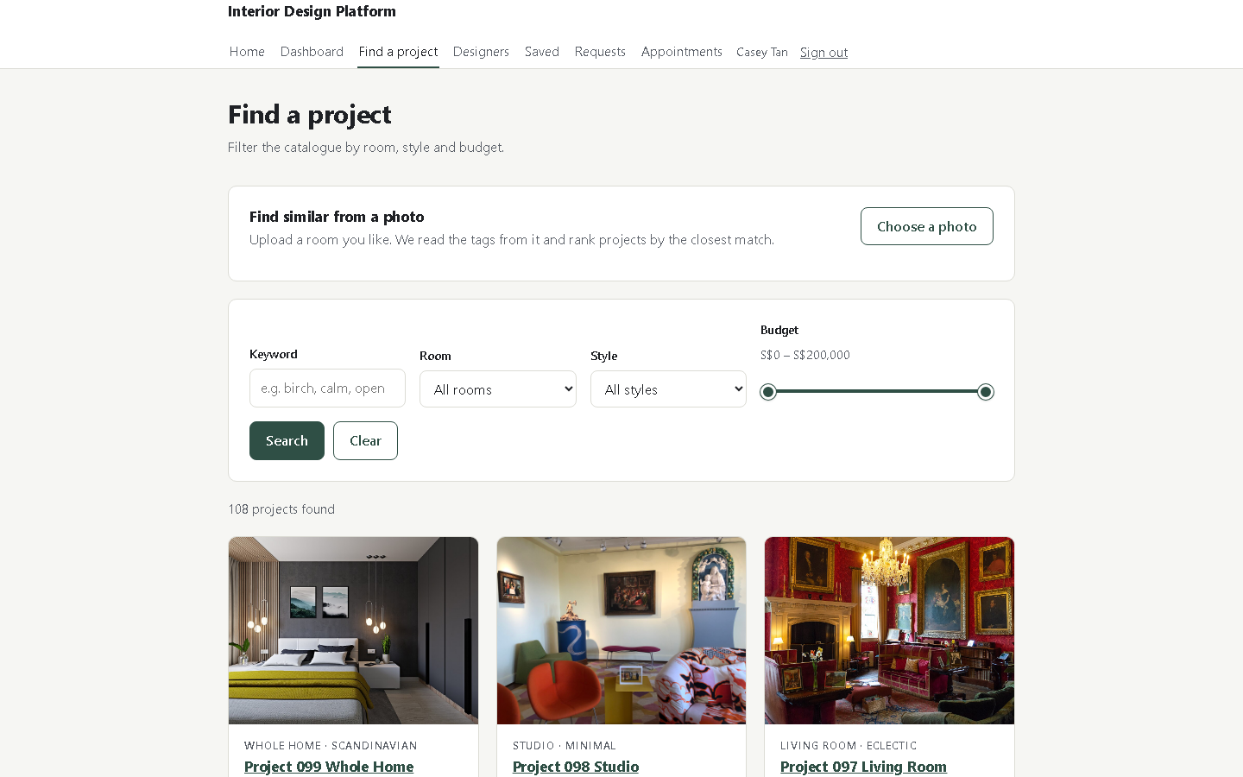
Figure 4 The catalogue with the filter panel and the ranked result count.

3.4 Search by photo
Where: Find a project, then Find similar from a photo
Sometimes a picture says what words cannot. Upload a room you like and the platform reads the objects in it.
1. Press Choose a photo and pick a JPEG, PNG or WebP image up to 5 MB.
2. The photo appears under Your reference photo. No button is needed: the reading starts at once.
3. Read the tags under the photo. A tag you do not want can be removed with its x.
4. The results below are ranked by how many tags they share with the photo.
Result: A bedroom photo returns sofa, sliding door, bed, moody, neutral palette and busy detail, and the catalogue drops to the projects that share those tags.
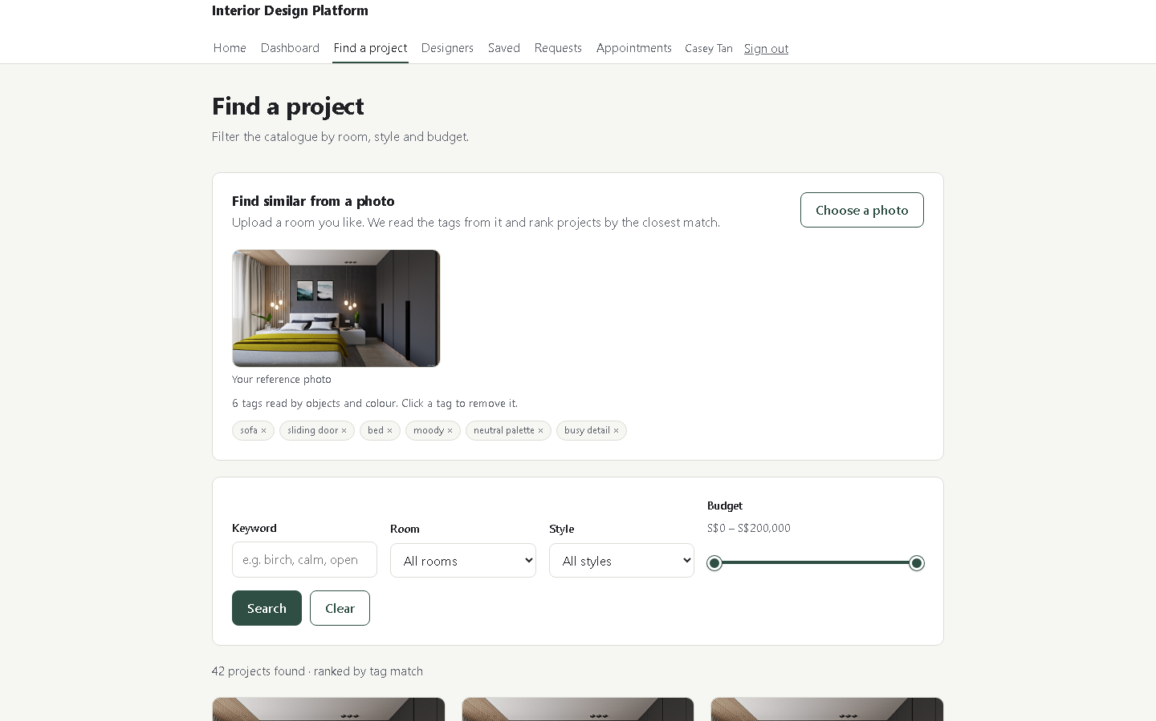
Figure 5 A photo search. Six tags were read; the list is ranked by tag match.

3.5 Open a project and read the details
Where: Any project card
Before saving or asking for a price, check the budget, the scope and the designer.
1. Press the project title on a card.
2. Read the description, the budget range and the tags.
3. Press View designer to read the company profile and the rest of that portfolio.
Result: The project page shows who made it, what it costs and how it looks.
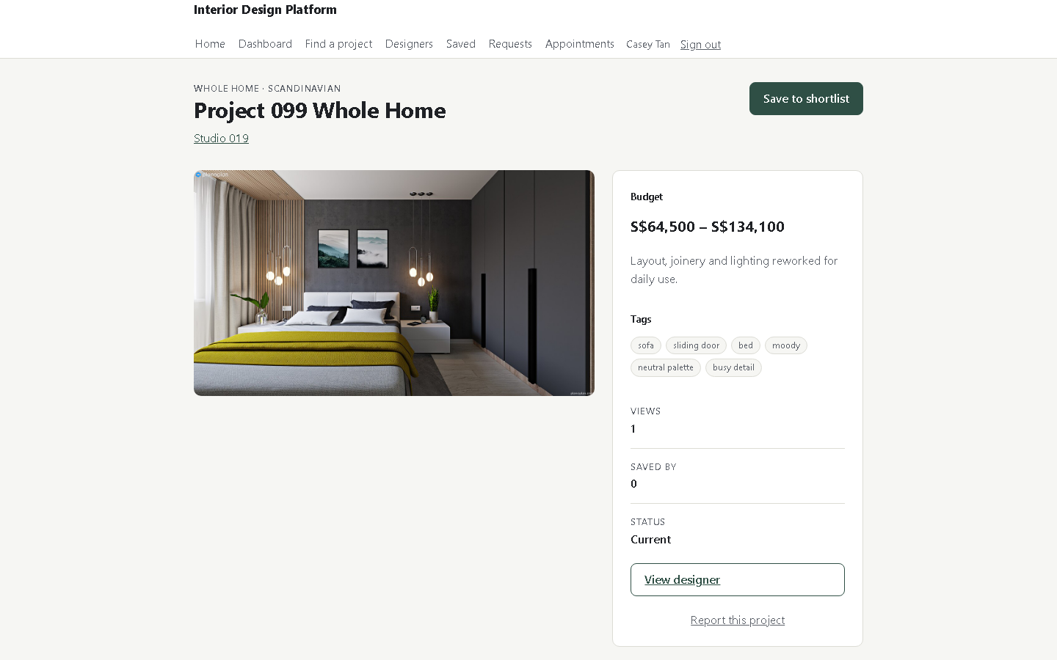
Figure 6 A project page with its photographs, budget and designer.

3.6 Save a project to the shortlist
Where: A project page
A shortlist keeps the candidates together while you compare them.
1. Press Save to shortlist on the project page.
2. The button changes to Saved — remove, so the same press undoes it.
3. Press Saved in the top navigation to see the whole list.
Result: The project stays in Saved until you remove it. The designer sees the count.
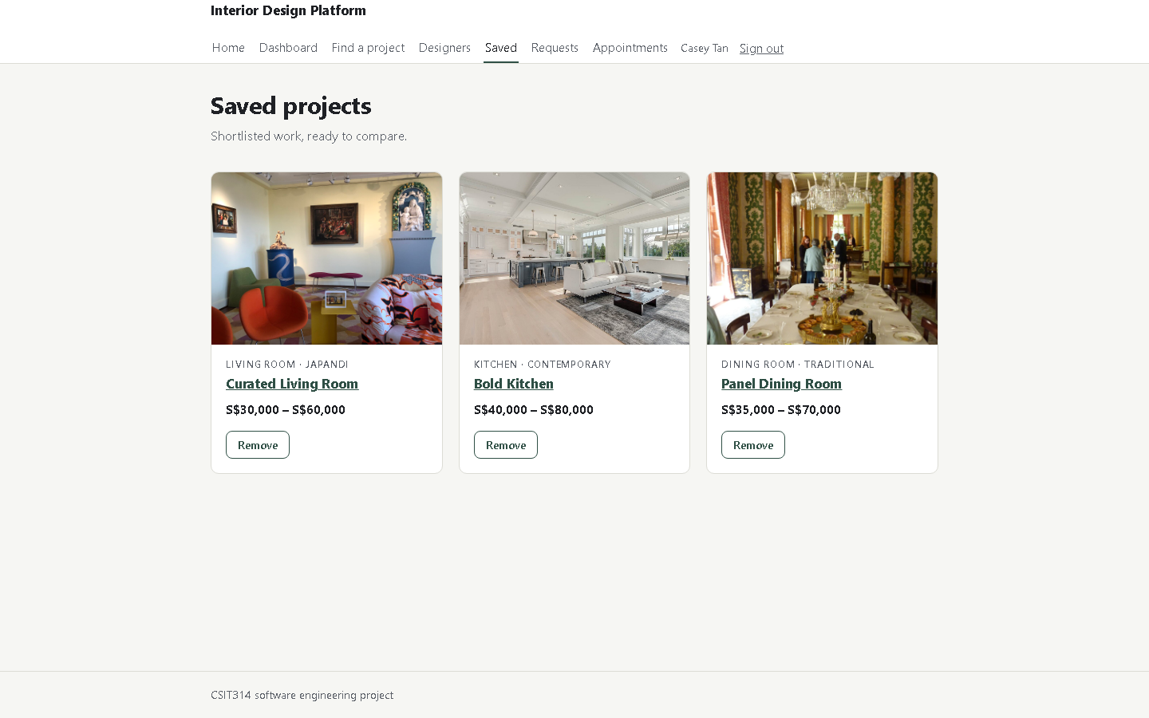
Figure 7 The shortlist. Each card links back to the project.

3.7 Request a quote
Where: A designer page, then Request a quote
A request states the work and the budget. The designer answers with a total.
1. Open the designer page from a project or from Designers.
2. Press Request a quote.
3. Give the request a title and describe the scope in your own words.
4. Enter the budget floor and ceiling, and an optional target price.
5. Press Send request.
Result: The request appears under Requests as Pending until the designer answers.
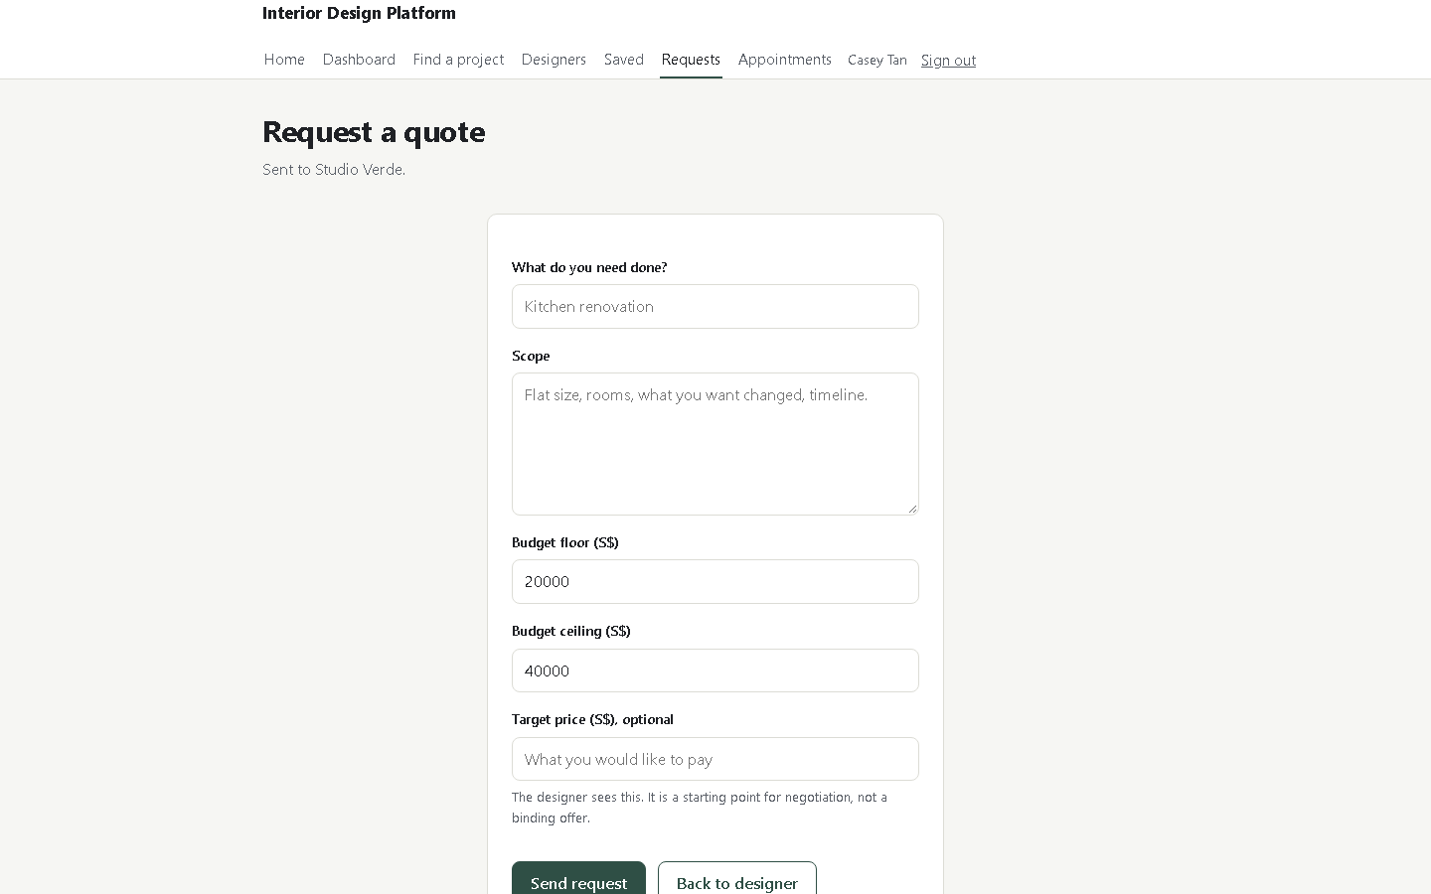
Figure 8 The request form. The scope is what the designer prices.

3.8 Compare, counter and accept a quote
Where: Requests, then one request
Every answer is kept as a version, so you can see what changed and why.
1. Open Requests and choose the request.
2. Read the Scopes card, then the Versions table: total, GST, valid until, state and note.
3. To negotiate, type a target price and press Send target. The designer may answer with a new version.
4. Press Accept quote to accept the current version, or Decline quote with a reason.
Result: An accepted quote is marked Accepted and the rest of the versions stay visible for the record.
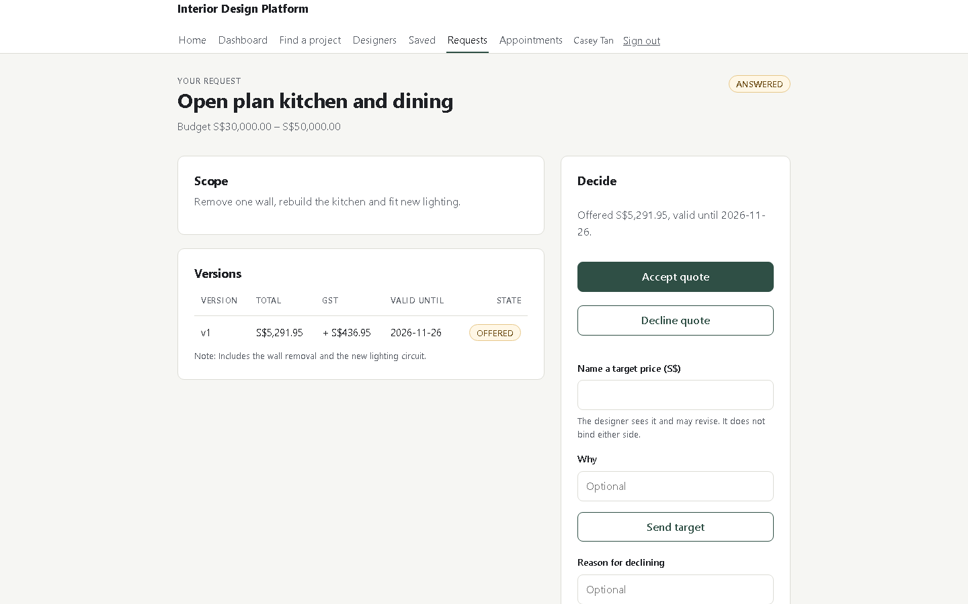
Figure 9 A quote with one version, the GST line, the validity date and the decision panel.

3.9 Book a consultation
Where: Designers, then a studio, Book a consultation
A consultation is one hour with the designer, before any work is agreed.
1. Open Designers and choose a studio.
2. Press Book a consultation under the company details.
3. Choose Where: In person or Video call. The line under it names the meeting address, or says that the call link arrives after the designer accepts.
4. Choose a Day. The list covers the next 14 days.
5. Press one free Time. One hour is one slot, and a taken hour is not offered.
6. Write what you need in the box, then press Book this time.
7. Read the confirmation, then press View my appointments.
Result: The hour is held as Pending with its meeting place. An online link stays hidden until the designer accepts. The designer sees the booking in Consultations and confirms it.
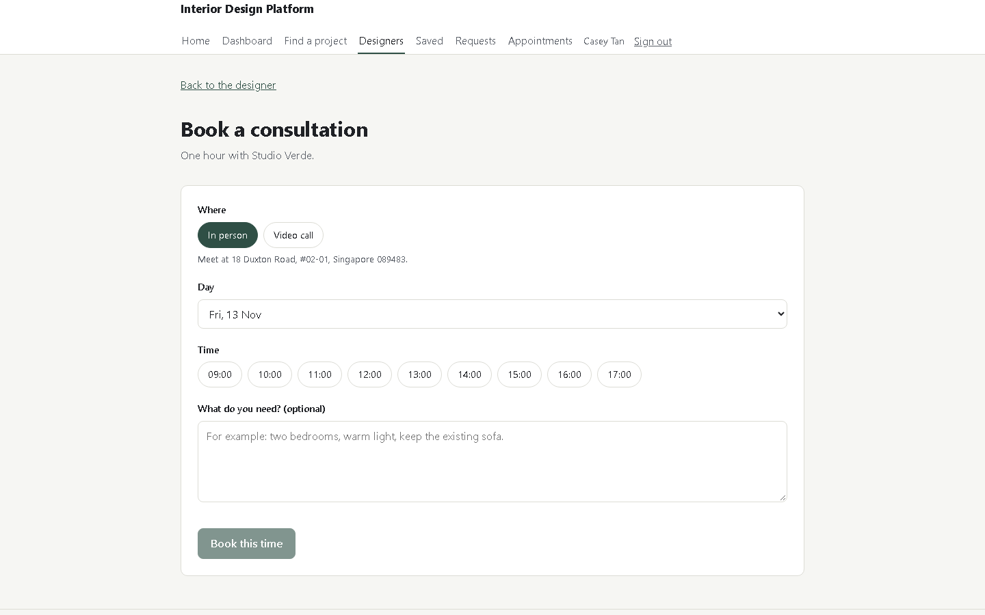
Figure 10 The booking page: the meeting type, the day list, the free hours and the requirements box.

3.10 Cancel a consultation
Where: Appointments
A booked hour can be given back. The record stays, so both parties keep the history.
1. Press Appointments in the top navigation.
2. Find the row by Designer, Day and Time.
3. Read the Where column: it shows the meeting address or the call link.
4. Press Cancel on that row.
5. Read the State column: the row now says Cancelled and the hour returns to the designer.
Result: The cancelled hour is offered again to other customers on the booking page.
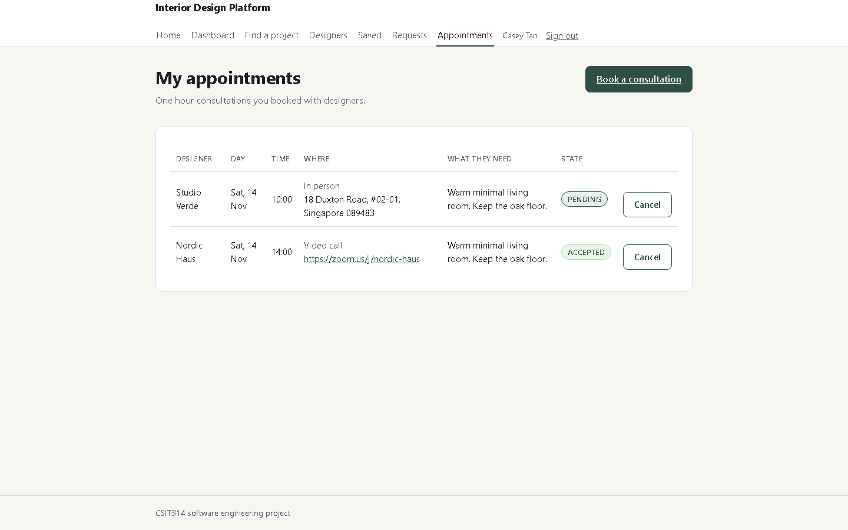
Figure 11 The customer's appointment list with the state of each booking.

3.11 Report a project
Where: A project page, Report this project
A project that breaks the rules can be flagged for the administrator.
1. Open the project page and press Report this project under View designer.
2. Choose a Reason from the list.
3. Write what is wrong in the Comments box, then press Send report.
4. Read the confirmation on the page.
Result: The report reaches the administrator's queue. One customer holds one open report per project, and the reported project stays visible until staff act.
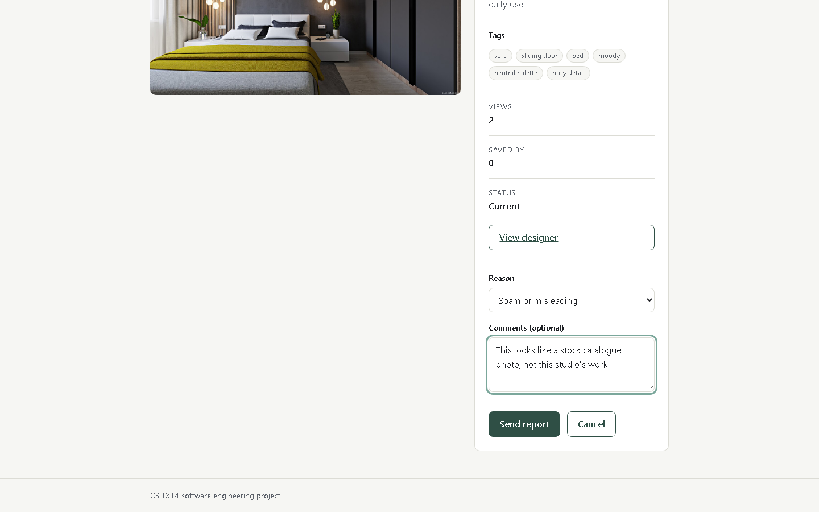
Figure 12 The report form in the project sidebar: the reason list, the comments box and Send report.

4 Designer (IDM)
A designer publishes work, keeps the portfolio current, and answers the requests that customers send.
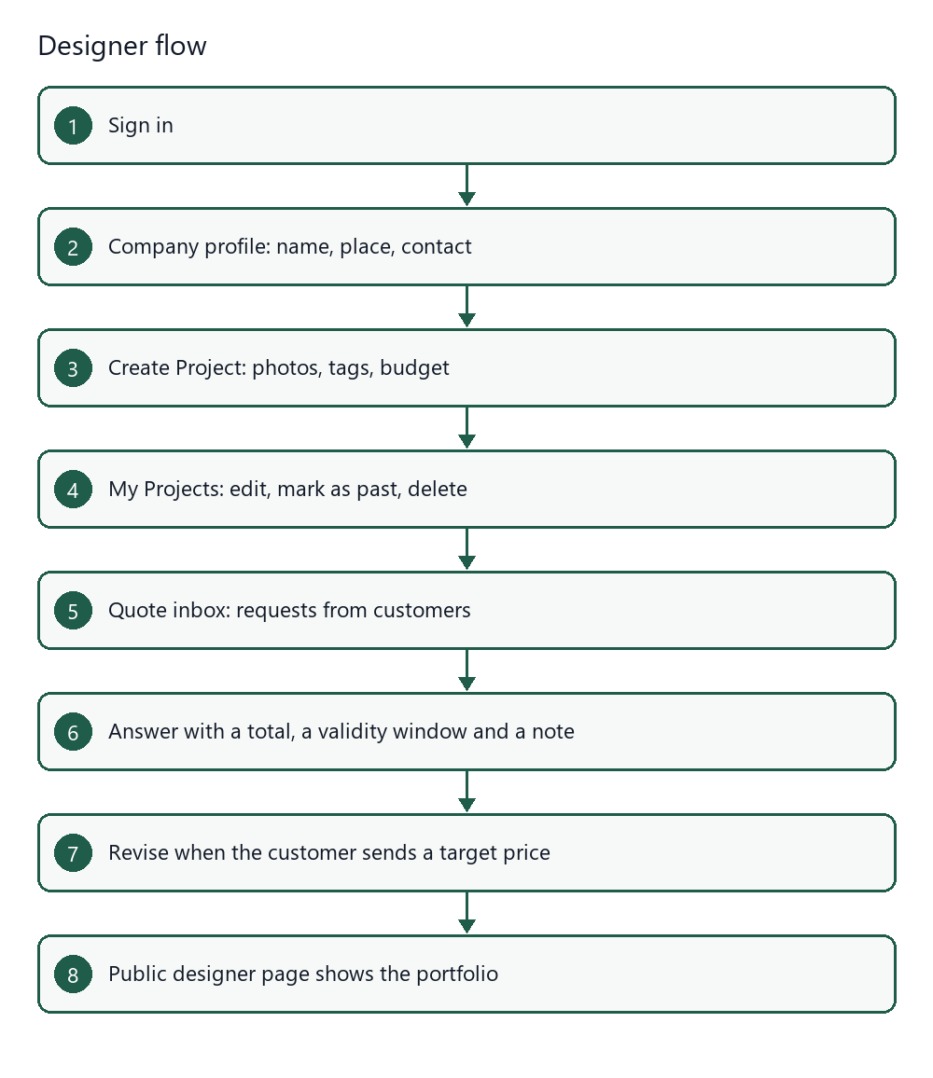
Figure 13 The designer journey from profile to an answered request.

4.1 Check the designer account
Where: Dashboard
The dashboard shows the account state. A designer must be active before a project can be published.
1. Sign in with a designer account.
2. Read Display name, Email, Role, Status, Account ID and Member since.
3. A Pending notice means an administrator has not approved the account yet.
4. A Suspended notice means the account cannot publish until an administrator restores it.
Result: The account card states exactly what the platform will let this account do.
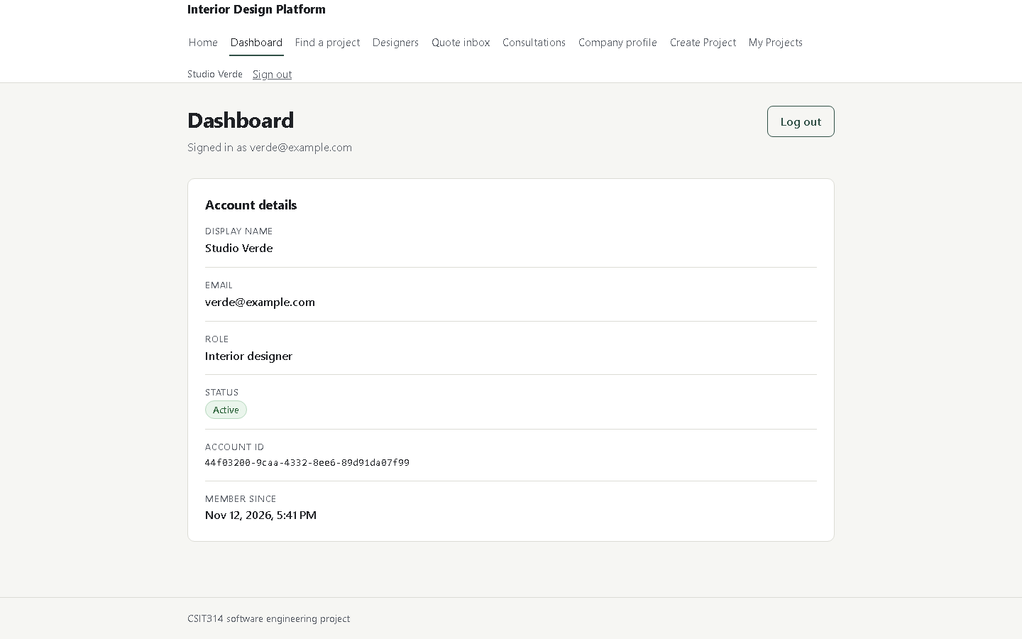
Figure 14 The designer dashboard.

4.2 Complete the company profile
Where: Company profile
The profile is what a customer reads before sending a request.
1. Press Company profile in the top navigation.
2. Enter the studio name, the city, a short description, a contact email and a phone number.
3. Enter the Meeting address for in person consultations, and the Video call link for online ones.
4. Press Save profile.
Result: The profile appears on the public designer page and beside every project. A customer reads the meeting address there. The video call link stays hidden until the customer holds an accepted booking.
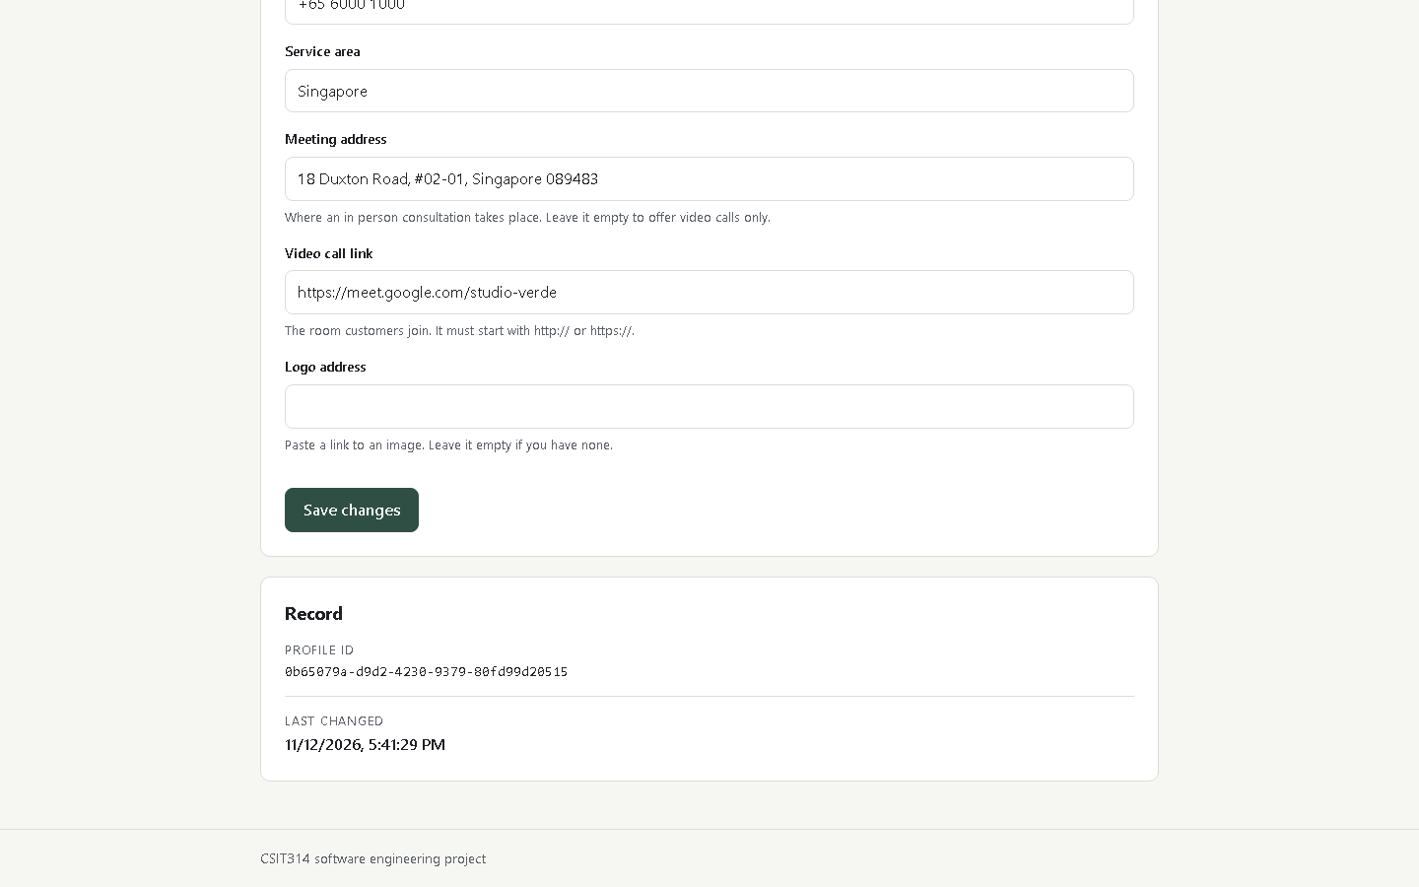
Figure 15 The company profile form.

4.3 Publish a project with photos and tags
Where: Create Project
Photographs carry the work; the tags make it findable.
1. Press Create Project in the top navigation.
2. Give the project a title and a description, then choose a category and a style.
3. Enter the budget floor and ceiling.
4. Press + Add photo and pick up to eight images. Each upload adds to the queue; it does not replace the last one.
5. Read Suggested from your photos. Press a chip to add that tag to Description tags, and press the x on a photo to remove it.
6. Press Create Project.
Result: The project appears in My Projects and in the catalogue, with the tags you kept.
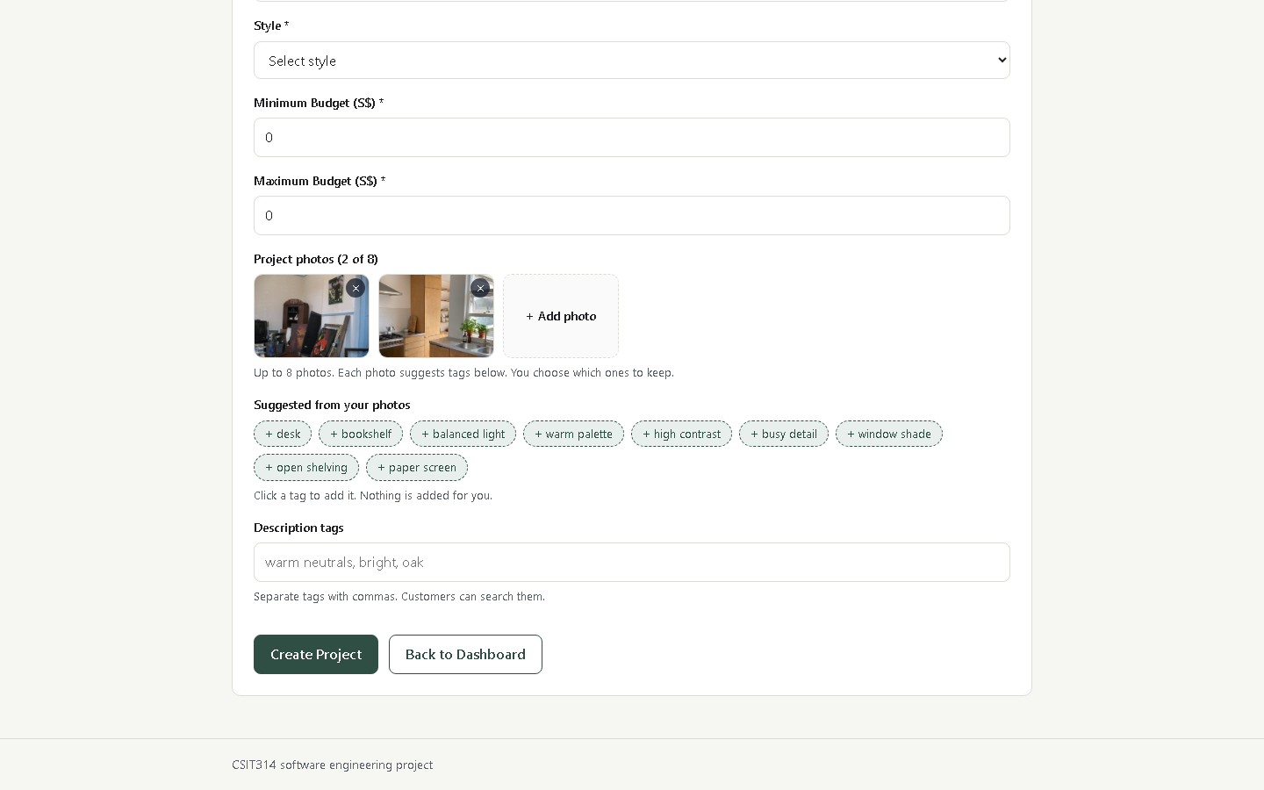
Figure 16 Two photos in the queue, the tags they suggested, and the empty tag field waiting for a choice.

4.4 Manage the portfolio
Where: My Projects
Projects change: prices move, work finishes, a mistake must go.
1. Press My Projects in the top navigation.
2. Use the search box and the status filter to find a project.
3. Press Edit to change the details, the photos or the tags.
4. Press Mark as Past when the work is finished, or Delete to remove it.
Result: Counts on the card update as customers view and save the work.
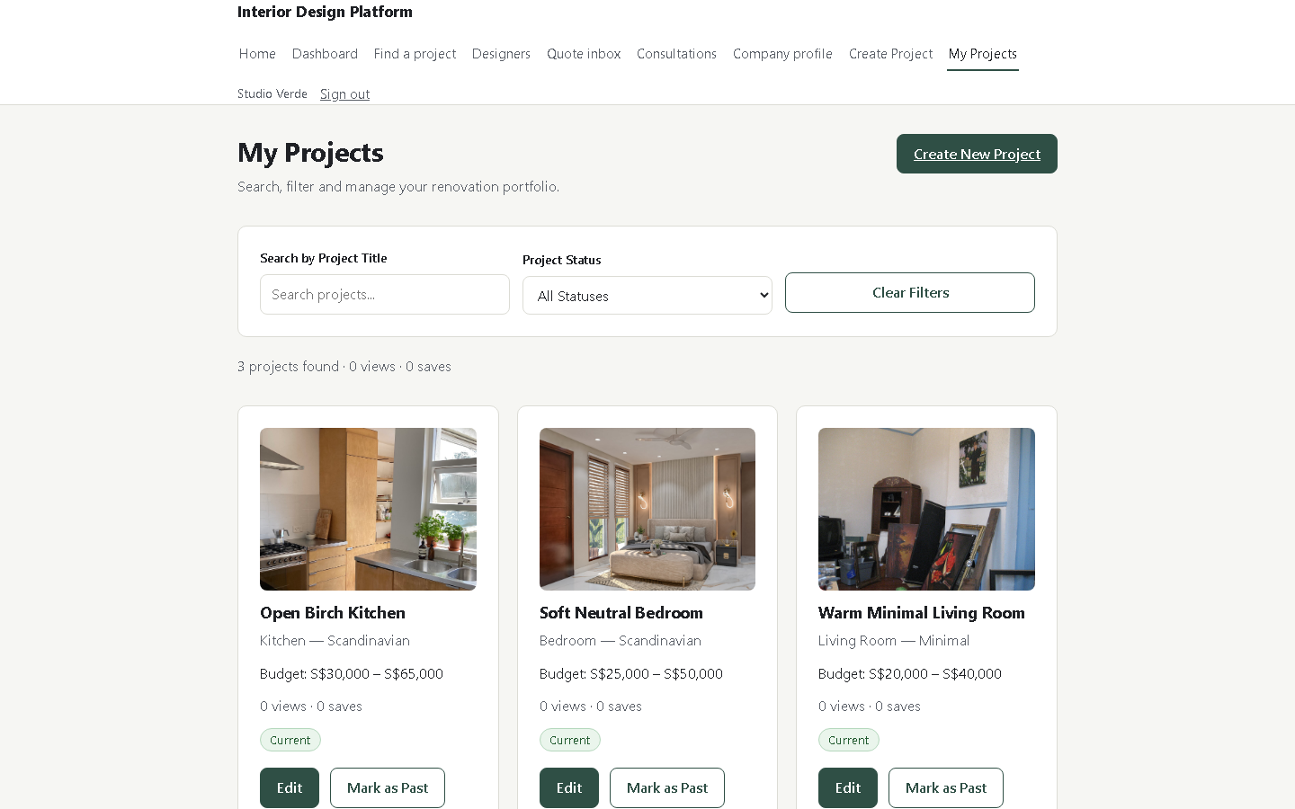
Figure 17 My Projects with views, saves and the actions for each row.

4.5 Answer a quote request
Where: Quote inbox, then one request
An answer is one total, one validity window and an optional note.
1. Press Quote inbox in the top navigation.
2. Open the request you want to answer.
3. Read the scope and the budget the customer gave.
4. Enter the total, choose how many days the quote stays valid, and say whether GST is included.
5. Add a note, then press Send quote.
Result: The request moves to Answered and the customer sees version one. A later answer becomes version two.
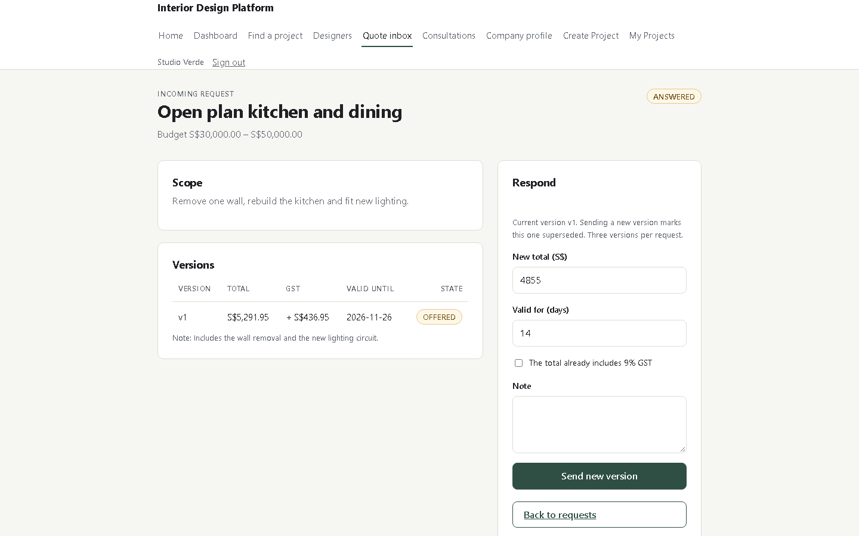
Figure 18 One request with its versions and the answer form.

4.6 Read the public designer page
Where: Designers, then a studio
This is the page a customer reaches from Designers.
1. Open Designers from the top navigation.
2. Press a studio name.
3. Read the description, the contact details and the projects underneath.
Result: The portfolio shows every published project with its tags and price range.
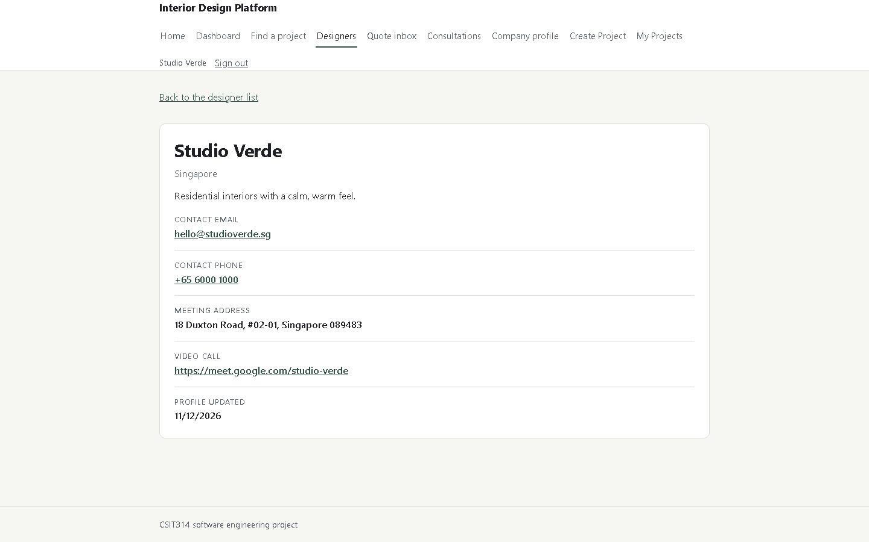
Figure 19 The public page for Studio Verde.

4.7 Accept or cancel a consultation
Where: Consultations
The consultation inbox is the designer's diary for the next two weeks.
1. Press Consultations in the top navigation.
2. Read Customer, Day, Time, Where, What they need and State.
3. Press Accept to confirm a Pending booking. The customer sees Accepted on Appointments, and an online booking then shows the room link.
4. Press Cancel to give the hour back. The row stays as Cancelled.
Result: A Pending booking becomes Accepted, and the customer reads that state on their own list.
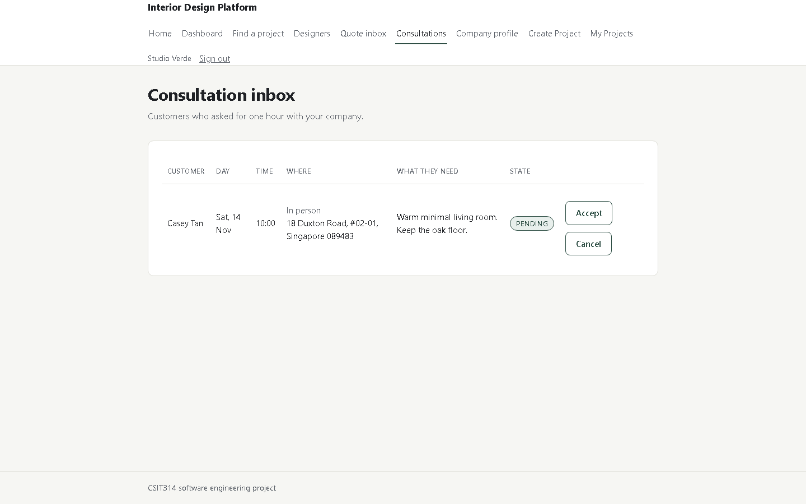
Figure 20 The designer's consultation inbox with a pending booking and its two actions.

5 Administrator
The administrator keeps the platform tidy: accounts are approved, categories stay current and activity is measured.
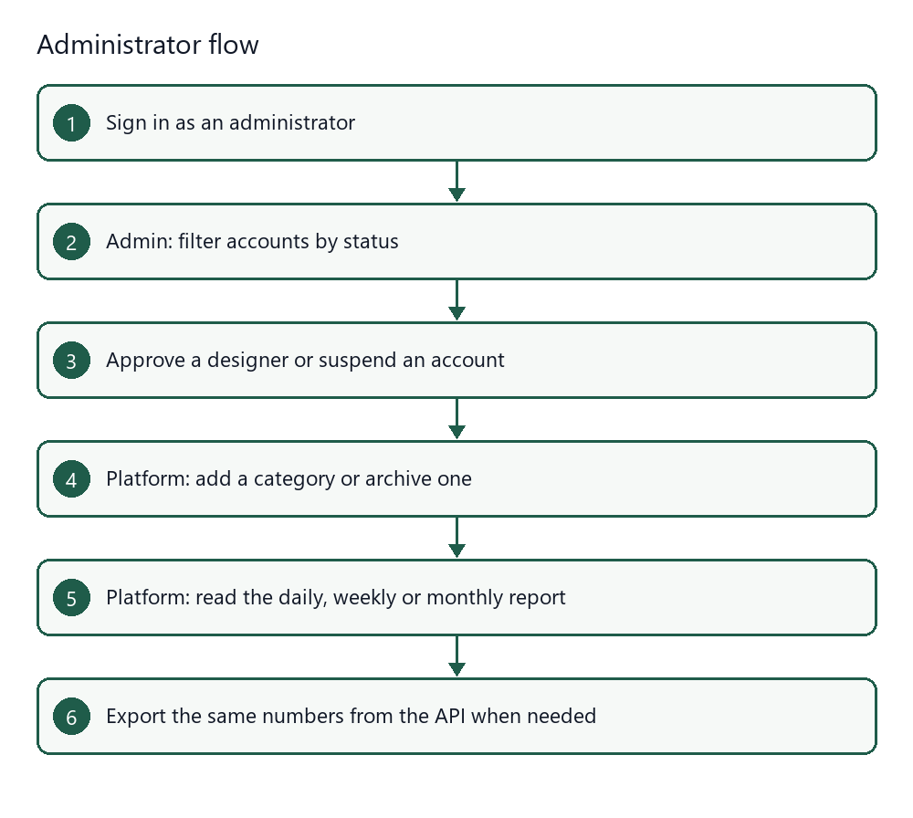
Figure 21 The administrator journey.

5.1 Approve and suspend accounts
Where: Admin
A designer cannot publish until an administrator approves the account.
1. Press Admin in the top navigation.
2. Choose a status in Show: Pending, Active, Suspended or all.
3. Find the account and press Approve to let it in, or Suspend to stop it.
4. Press Show again to confirm the new status.
Result: An approved designer can sign in and publish. A suspended account cannot.
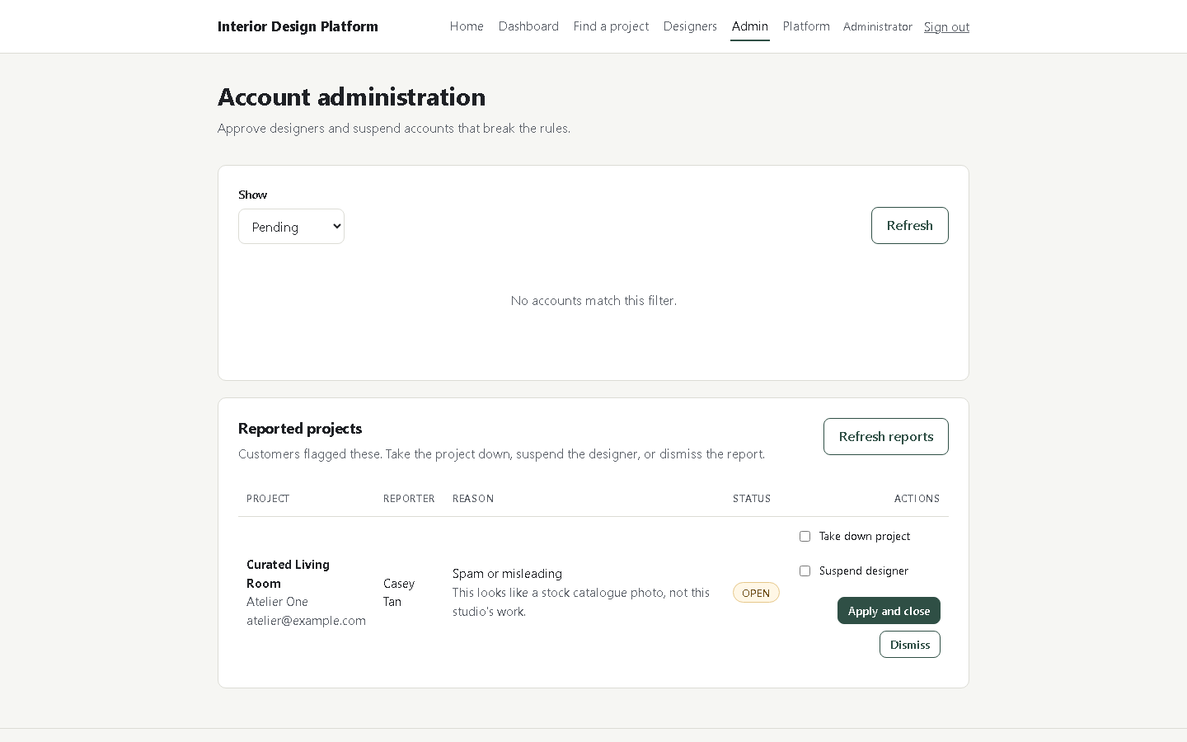
Figure 22 The account list with its status filter and the approve and suspend actions.

5.2 Manage categories
Where: Platform, Categories
Categories are how customers filter the catalogue. They are archived, never deleted, so old projects keep a valid label.
1. Press Platform in the top navigation.
2. Type a name under New category and press Add.
3. Press Archive beside a category to retire it, or Restore to bring it back.
Result: The category list on the project form follows these states.
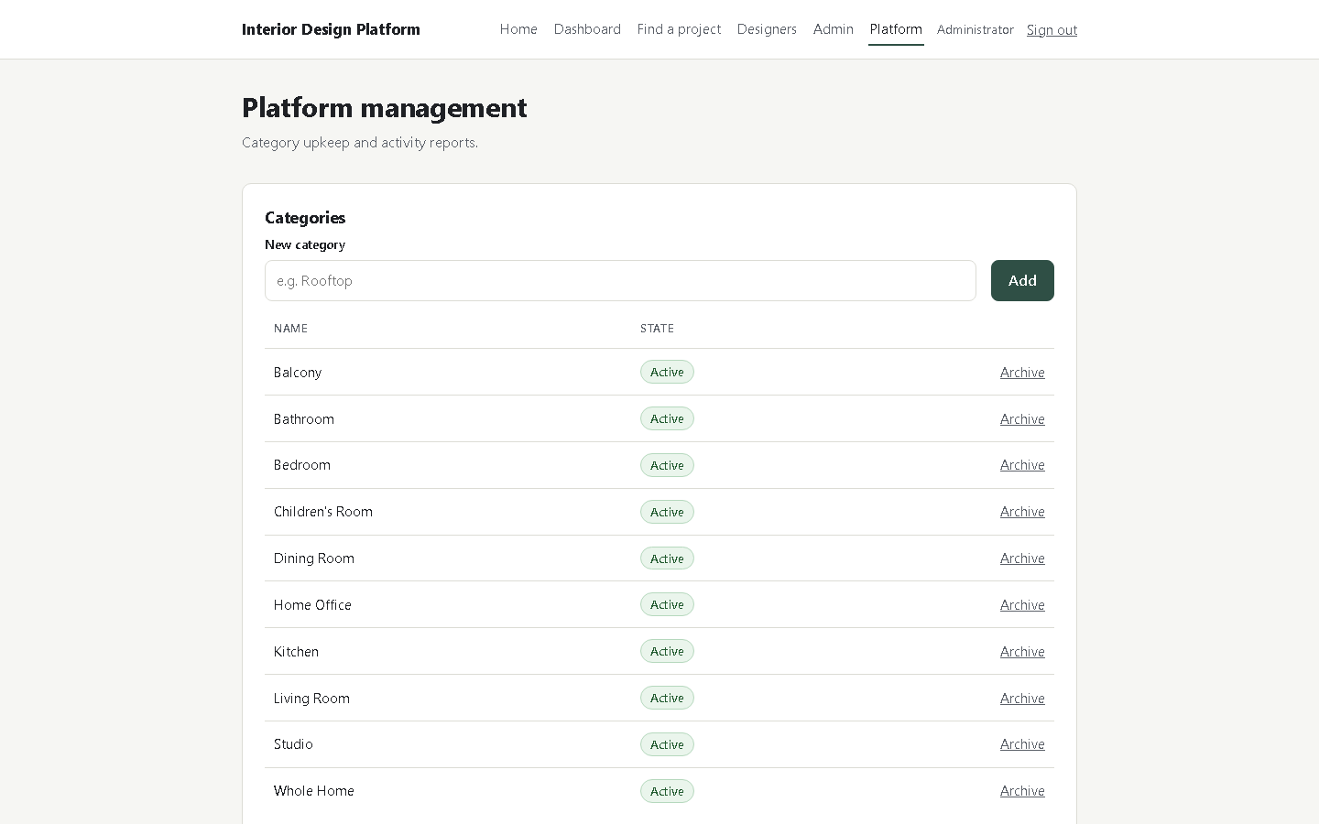
Figure 23 Platform management: the category list with Add, Archive and the state of each row.

5.3 Read the activity report
Where: Platform, Activity reports
The report answers a simple question: is the platform being used, and how much?
1. Scroll to Activity reports on the Platform page.
2. Choose a Period: daily, weekly or monthly.
3. Choose how many Buckets to show, for example 14 days or 30 days.
4. Read the columns: accounts, projects, requests and quotes per bucket.
Result: The newest bucket shows the current totals. The same numbers are served by GET /api/reports?period=weekly&buckets=6 for a script.
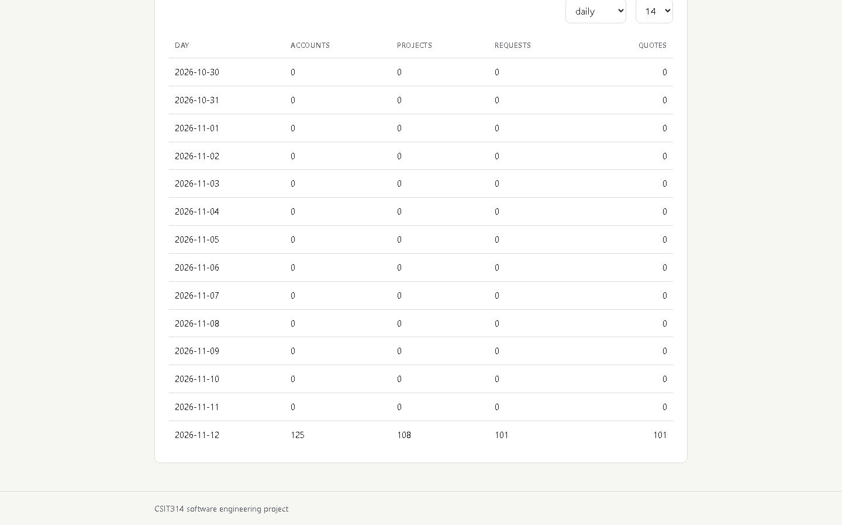
Figure 24 A daily report. The last row carries the current totals.

5.4 Review reported projects
Where: Admin, Reported projects
The report queue is where a complaint becomes a decision.
1. Sign in as an administrator and press Admin in the top navigation.
2. Scroll to Reported projects and read the Project, Reporter, Reason and Status.
3. Tick Take down project, Suspend designer, or both.
4. Press Apply and close. Press Dismiss when the report needs no action.
Result: A taken down project leaves the catalogue and the search, and stays on the designer's My Projects page marked Taken down. A suspended designer cannot sign in.
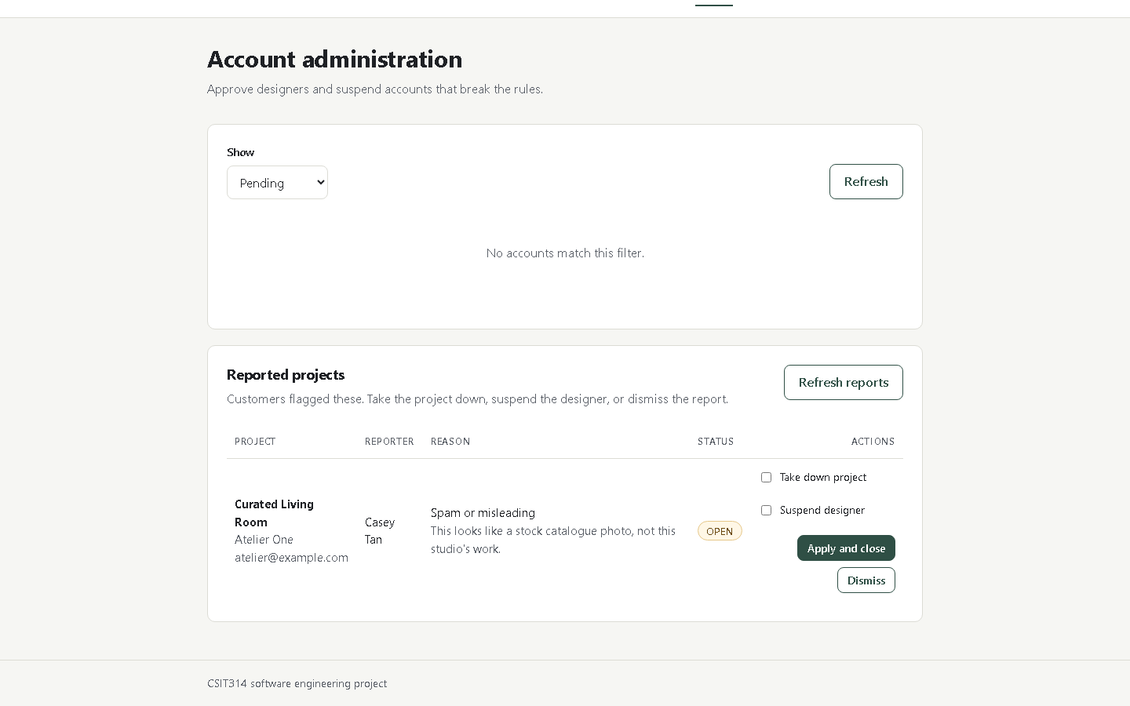
Figure 25 The report queue with two open reports and their actions.

6 Reference

6.1 Ports and addresses
Service | Address | Note
Front end | http://localhost:5173 | Vite dev server
API | http://127.0.0.1:8000 | FastAPI; set another port with the uvicorn flag
API documentation | http://127.0.0.1:8000/docs | Every endpoint with a Try it out button
Uploaded photos | http://127.0.0.1:8000/uploads/... | Served from backend/uploads

6.2 Where the data lives
Accounts, companies, projects, requests, quotes, appointments and categories live in the memory of the backend process. A restart empties them. The repository carries the rebuild:
1. backend/scripts/seed_all.py runs the demo seed and then the bulk seed.
2. The result is 125 accounts, 23 companies, 108 projects, 100 requests and 100 quotes.
3. testing/fixtures/video-environment.json records that dataset for comparison.
Uploaded photos are the exception: they are files under backend/uploads, which is ignored by git. They stay after a restart even when the rows that pointed at them do not.

6.3 When something looks wrong
Symptom | Cause | Fix
The catalogue is empty | The backend restarted | Run 4-load-demo-data.bat, or seed_all.py
Cannot reach the server | The API is not running, or on another port | Start it, and set VITE_API_TARGET to match
A photo does not appear after upload | The file is larger than 5 MB or not an image | Use a JPEG, PNG or WebP under 5 MB
Login says the password is wrong | The account was seeded with another password | Use passw0rd123, or register again

End of manual.

