* 29/09/2015
* Management of ICT projects
* Introduction to strand B

A project plan is now needed in order for the project to progress. Important dates and deadlines will be addressed in a Gantt chart, and the phases of the project will be discussed the final phases will be decided on.

***Project Phases***

After looking at many examples of project phases I have decided on what I feel are the best examples for my project.

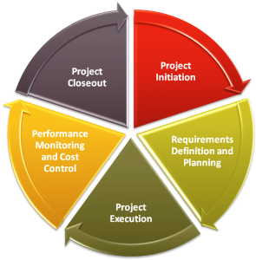Here is an example of a project phase. As you can see the project phase is showing how to project at hand will be developed, managed and finally closed out. The key points here are The project initiation and project closeout. Everything within these two parameters is the project as they mark the beginning and end of the project.

The requirements and definitions are in place to define the current project at hand. This is helpful for referring back to the original idea of the project and furthermore what the intent of the project is.

Project execution is where the main body of the project takes place. Here the initial steps leading to the project closeout will commence and therefore it shows the main workload clearly so that there is no confusion on where the project should really be developed.

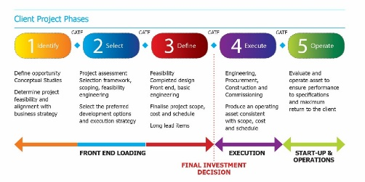  
This next phase has more detail and is more straight forward. There isn’t a loop as it explains a process but there are many similarities in the field definitions. Things such as execution are the same and there are again 5 fields in which the project takes place. Identify, select, define, execute and operate are the 5 fields and these identities could be mapped to different names. I feel that his phase is a better example of how my project will function than the first phase. The sub categories are in a better order as execution is towards the end instead of the middle and operate can act as testing and evaluation. Overall it is more geared to the project at hand.

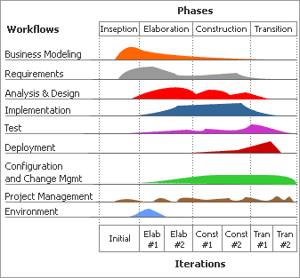This project phase is highly advanced. It has graphs to show the activity of each section of which there are 9 phases. Although this model provides lots of information which can come in handy, it is more detailed than what I need, and some phases such as environment I don’t need for the planning of the project. It does however have a really good visual representation of a project overview and so might be something to consider in the future.

To decide on the start and end dates I needed to look at the project as a whole. With the start date already established as the 9th of September (as this is when contact was made with Google in order to proceed), the end date must also now be finalised. It was discussed early that with the 5 planned meetings, the final meeting will be the handover of the project, this is said to take place on the 25th of January 2016 therefore providing an end date as was discussed with Mrs Ewing and the rest of the team. The end date may change and meeting may have to be put back as there are activities taking place in January that affect all of the team, but until they are finalised we cannot make any movements to the dates and they will be added to the project plan.

In conclusion I feel that the second project phase is most suited towards the project at hand, it is the right balance of functionality and form and I will use this as my structure.

However Edexcel have provided the project phases I will be using for me which are:

* Analysis
* Initial design
* Prototyping and formative testing
* Summative testing
* Documentation
* hand over to the customer

I believe that these phases closely match those of the second project phase which I picked out as being the best for my project needs. The phases that have been provided by Edexcel use 6 sections, they are similar to that of the project phases I looked at but are more specific with areas such as Summative testing and Documentation as this project will contain a product as well as all the content to go along with it. So basing my project off the second phase’s model these will be my phase headings. I think that they will go well in tandem with each other and should provide a good back bone for the project. The project plan will contain the phases that have been given to me by Edexcel, along with the resources that I will need for each section. I will also be adding my personal comments to the sections as the project develops, this will also mean there will be an intended start and end date and as the project progresses there will then be the actual start and end date of when the section was completed.

I will also be creating Gantt charts with the phase headings in order to further develop the planning of the project. I have done some Gantt experiments and have finalised on the Gantt software provided at <http://www.smartsheet.com>. The date and time of the meetings may also change activities will arise in January with will mean large gaps of the project will be taken up. Using the Gantt software will mean that these dates can simply be dragged along. I also feel that this online software is more intuitive and offers a wider range of functions than the Gantt software which is provided by the school. I can also easily back track my Gantt chart with this software with its backup feature meaning that I can roll back any bad additions to the Gantt chart before it becomes imbedded.