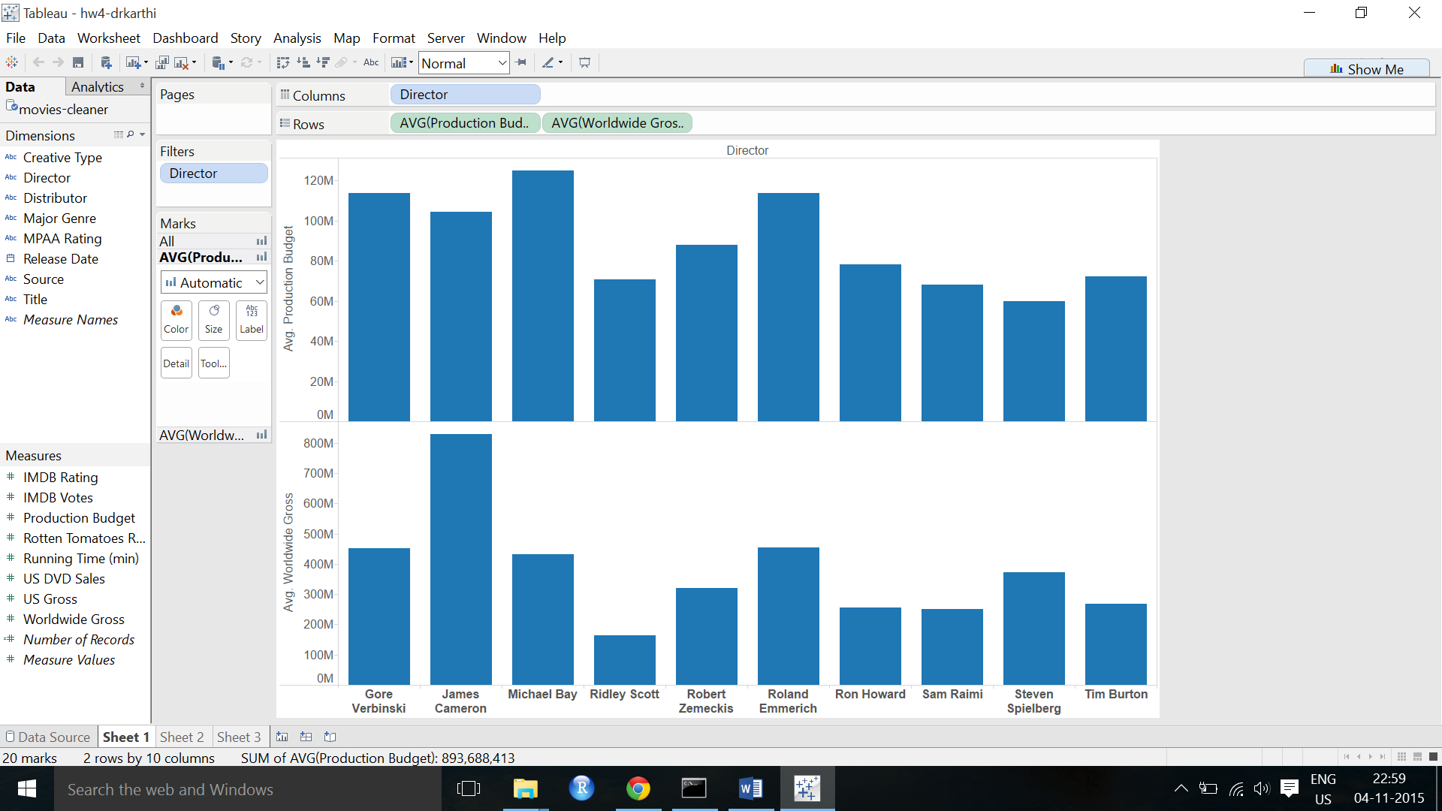**Comparison of production budget and worldwide gross of top directors**

**Movies in a certain range of production budget**



**Top distributors for a certain type of movie**

