Module 6.2 Assignment

Djon Harrison, Marcos Hernandez, Nazir Knuckles, Zachary Donohue
CIS325-T301 Advanced Python
Bellevue University
April 24, 2026
Professor John Woods

Task 5
Screenshot of program running
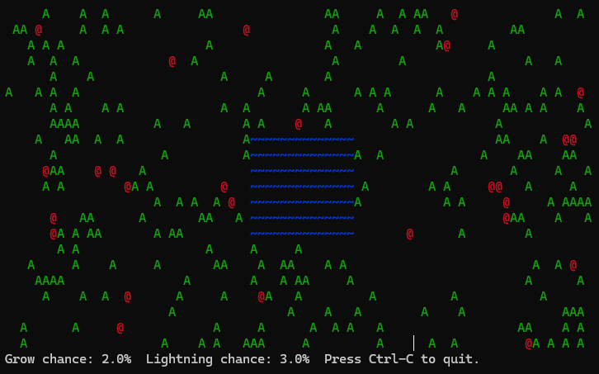

Flowchart for “forestfiresim_325.py” (main)
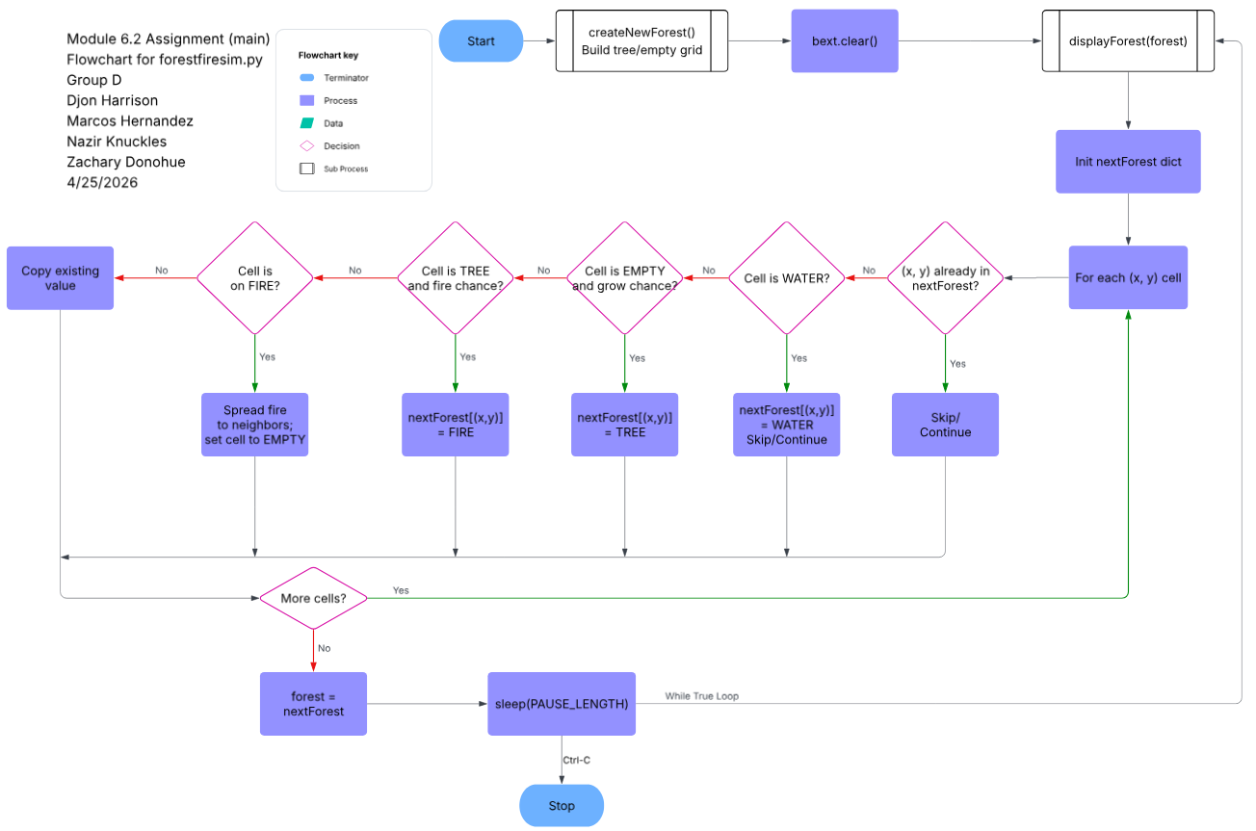

Flowchart for “forestfiresim.py” (createNewForest())
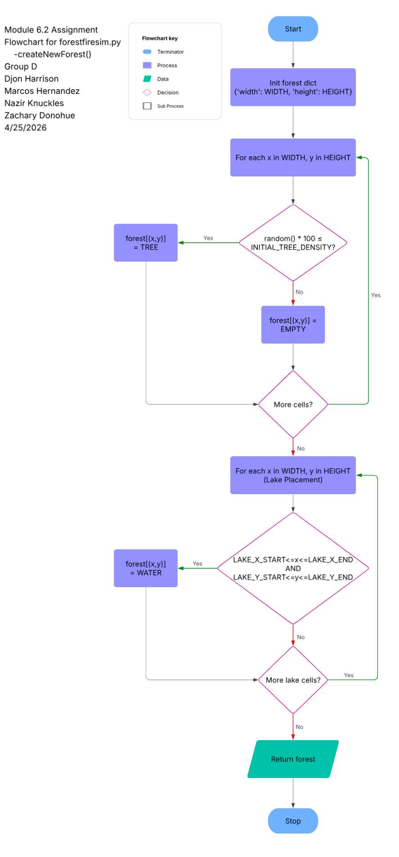
Flowchart for “forestfiresim.py” (displayForest(forest))
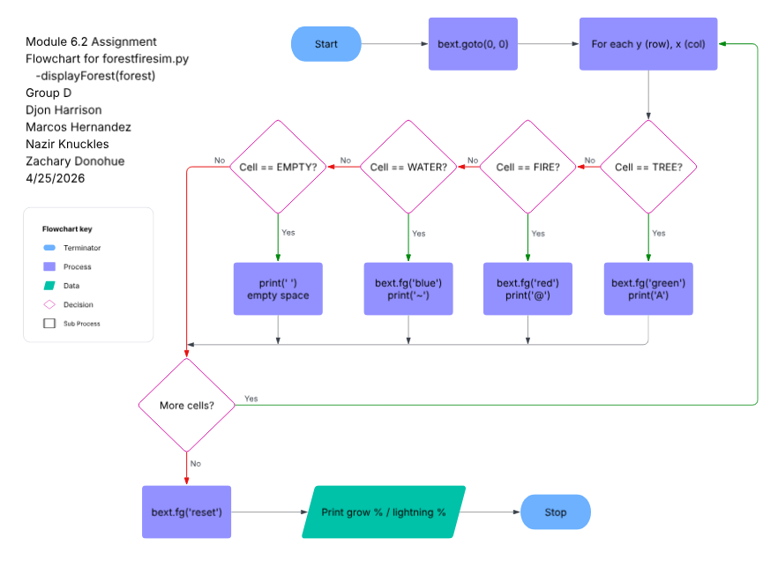

Github Upload

References
Lucid Software. (2025). Lucidchart [Web-based diagramming tool]. https://www.lucidchart.com

