Module 3.2 Assignment

Zachary Donohue
CIS325-T301 Advanced Python
Bellevue University
April 2, 2026
Professor John Woods

Task 4
Flowchart for “chohan.pay”
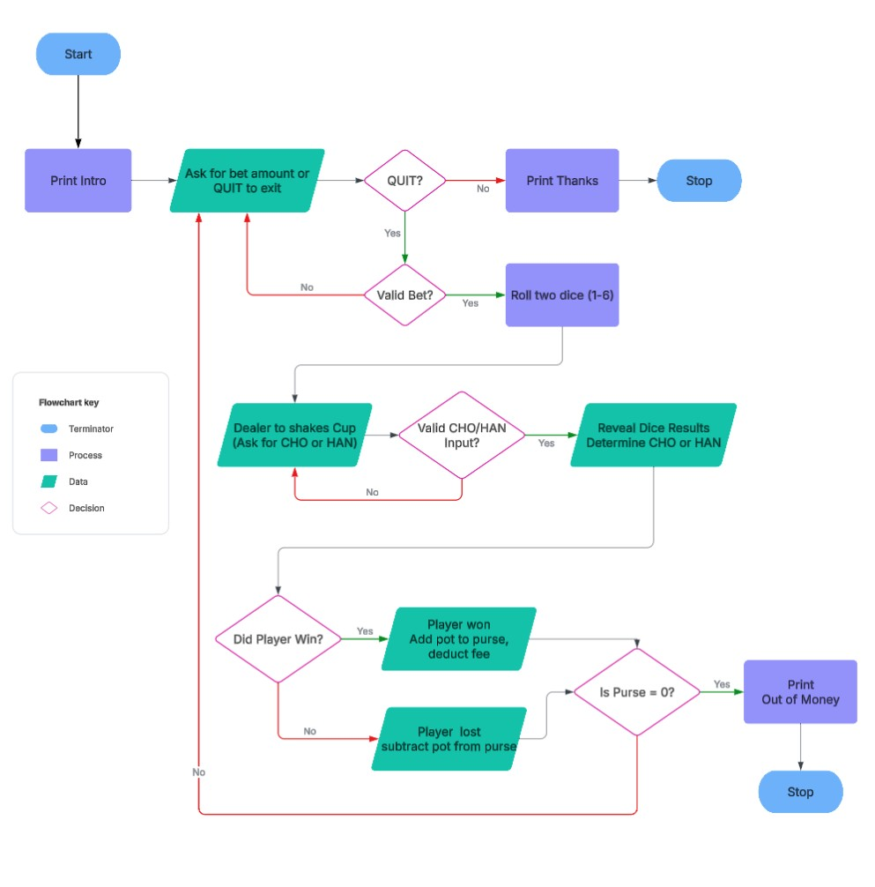

Github Upload

References
Lucid Software. (2025). Lucidchart [Web-based diagramming tool]. https://www.lucidchart.com

