Module 1.3 Assignment

Zachary Donohue
CIS325-T301 Advanced Python
Bellevue University
March 21, 2026
Professor

Task 1
Flowchart for “bottle of beers on the wall”
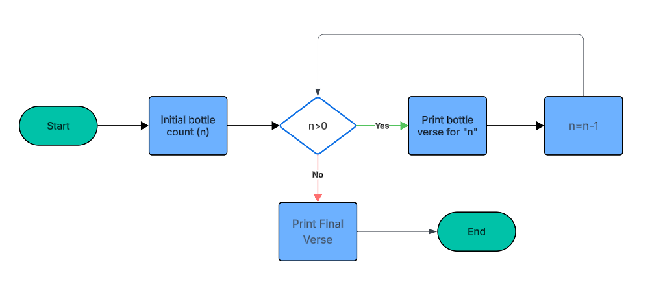

References
Lucid Software. (2025). Lucidchart [Web-based diagramming tool]. https://www.lucidchart.com

