Module 7.2 Assignment

Zachary Donohue
CIS325-T301 Advanced Python
Bellevue University
April 30, 2026
Professor John Woods

Task 4a
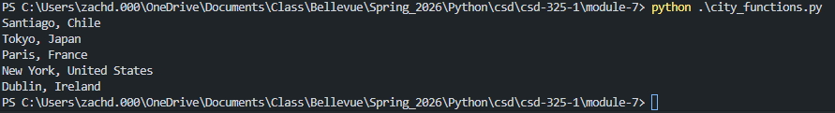

Task 4b
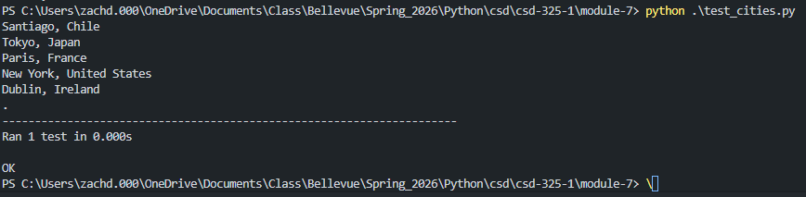

Task 4d
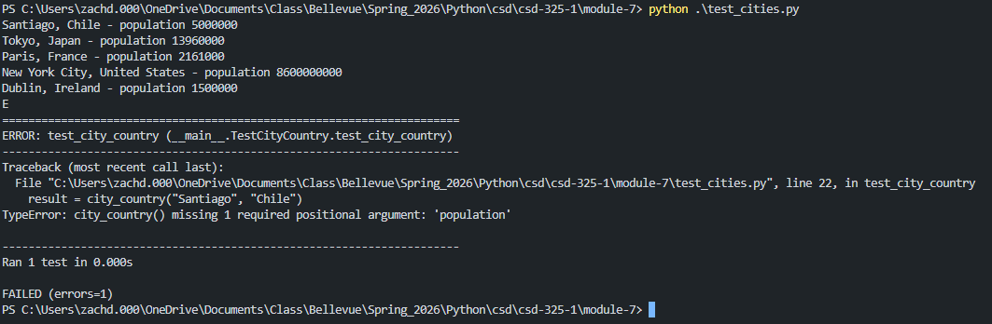

Task 4f
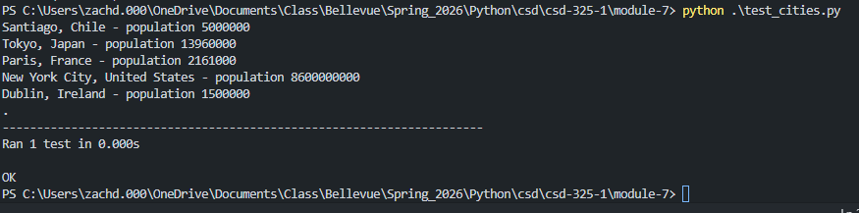

Task 4h
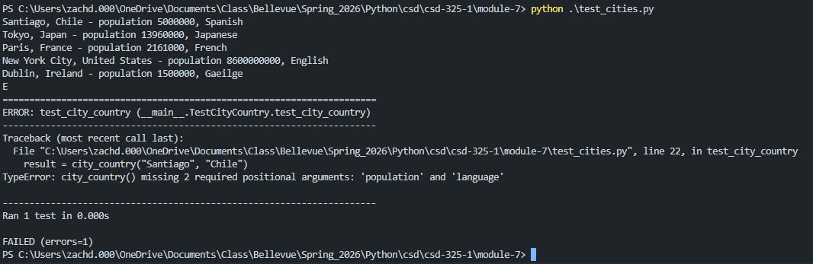

Task 4j
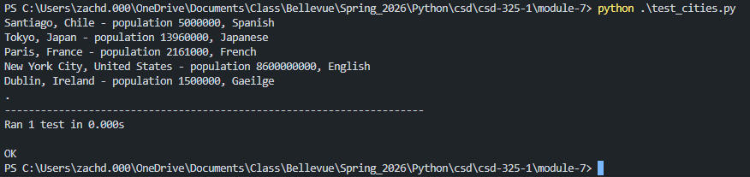

Task 4k

Github Upload
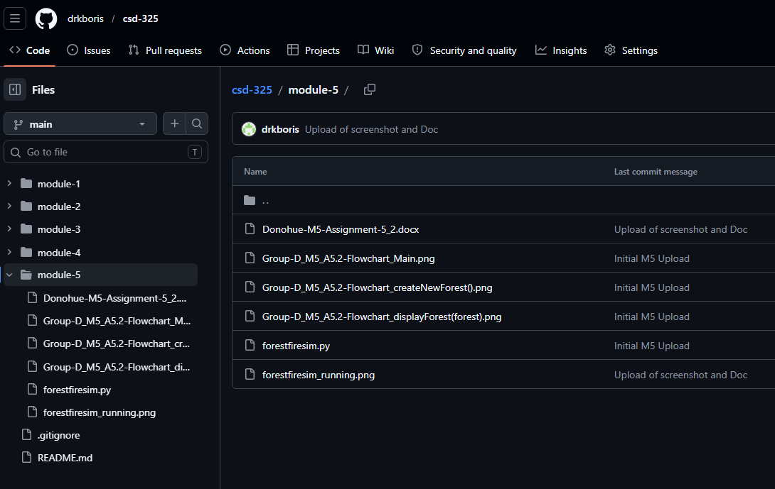

References
Matthes, E. (2023). Python crash course: A hands-on, project-based introduction to programming (3rd ed.). No Starch Press.

