Module 8.2 Assignment

Zachary Donohue
CIS325-T301 Advanced Python
Bellevue University
May 8, 2026
Professor John Woods

Task 2.
Flowchart for assignment_8-2.py program
Assignment_8-2.py(main)
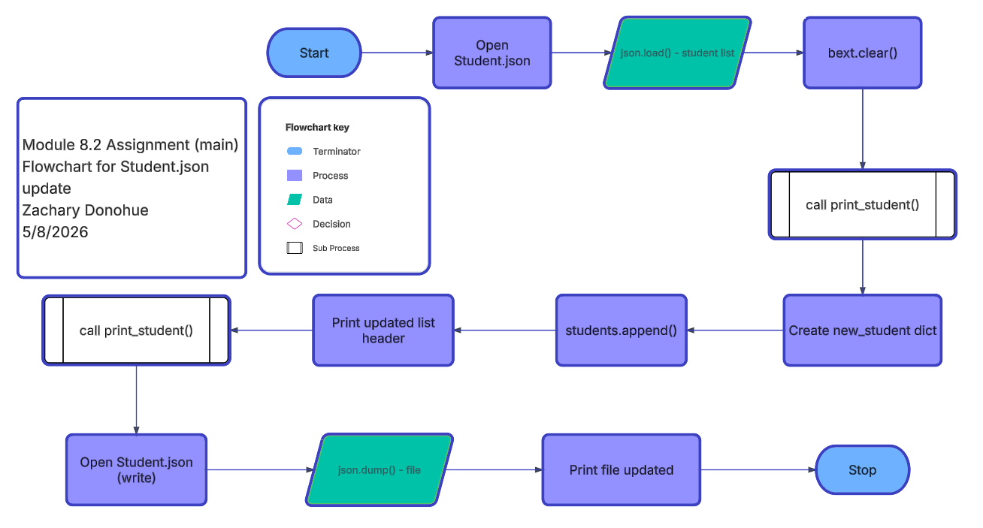

Assignment_8-2.py(print_studetns())
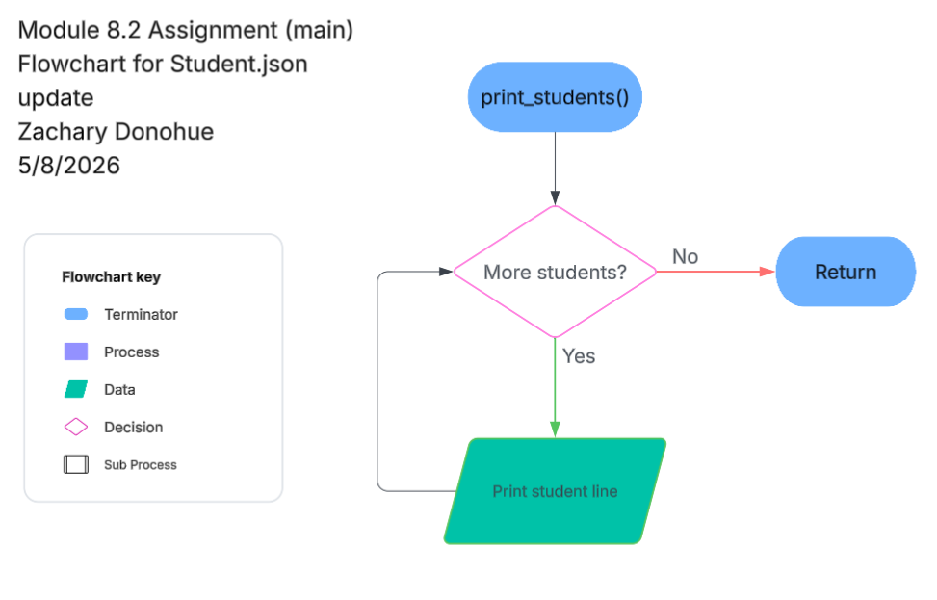
Task c.
Output notification to user that this is the original student list.
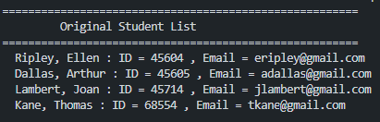

Task f.
Output notification to the user that this is the updated student list
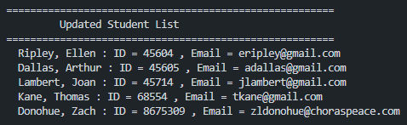

Task f.
Output notification to the user that the .json file was updated.
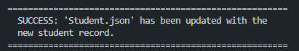

Task k.
Notification to save .json file or not
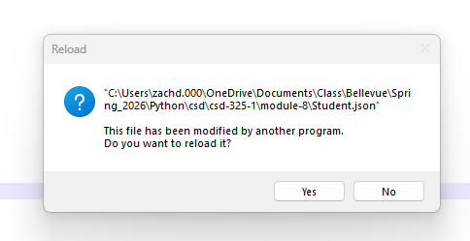

Task l.
Contents of Student.json
[
{
"F_Name": "Ellen",
"L_Name": "Ripley",
"Student_ID": 45604,
"Email": "eripley@gmail.com"
},
{
"F_Name": "Arthur",
"L_Name": "Dallas",
"Student_ID": 45605,
"Email": "adallas@gmail.com"
},
{
"F_Name": "Joan",
"L_Name": "Lambert",
"Student_ID": 45714,
"Email": "jlambert@gmail.com"
},
{
"F_Name": "Thomas",
"L_Name": "Kane",
"Student_ID": 68554,
"Email": "tkane@gmail.com"
},
{
"F_Name": "Zach",
"L_Name": "Donohue",
"Student_ID": 8675309,
"Email": "zldonohue@choraspeace.com"
}
]

Github Upload

References
Lucid Software. (2025). Lucidchart [Web-based diagramming tool]. https://www.lucidchart.com

