Module 9.2 Assignment

Zachary Donohue
CIS325-T301 Advanced Python
Bellevue University
May 14, 2026
Professor John Woods

Task 6(c).
Print out the response from the request, with no formatting.
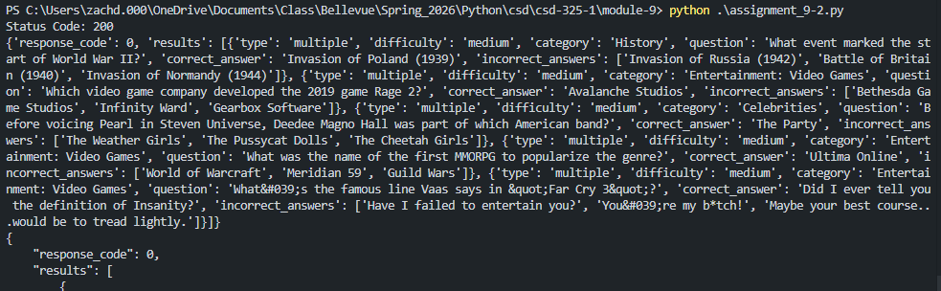
Task 6(d).
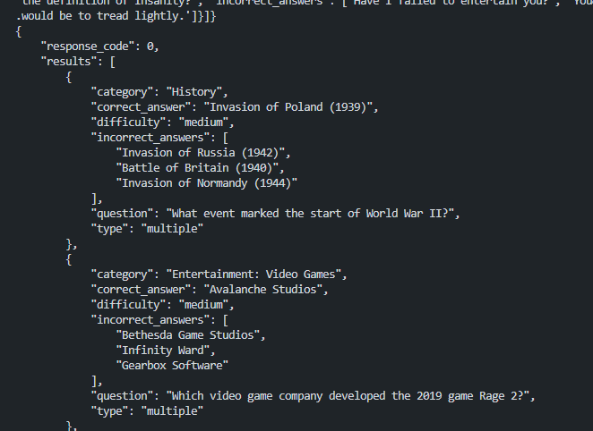

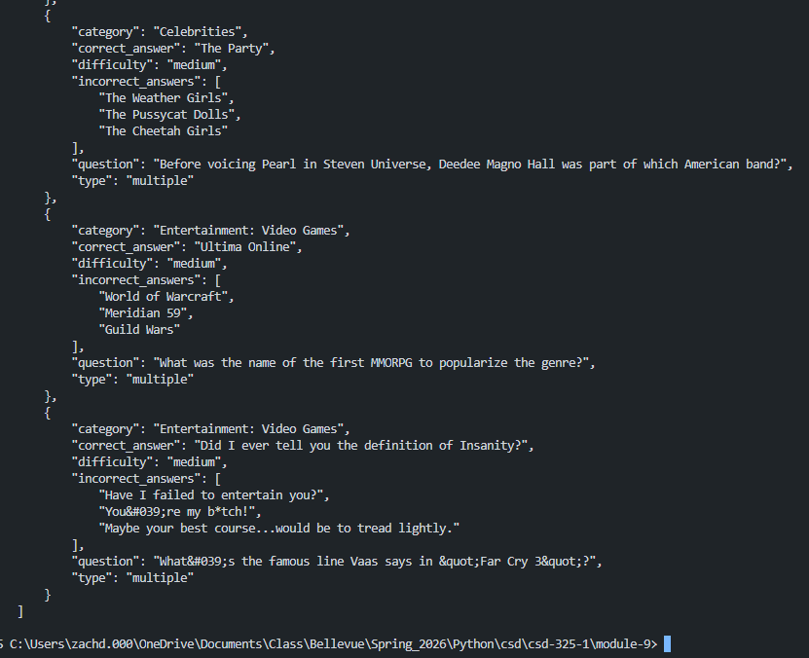
Github Upload

References

