Module 2.2 Assignment

Zachary Donohue
CIS325-T301 Advanced Python
Bellevue University
March 26, 2026
Professor John Woods

Task 3
Flowchart for “update logging host”
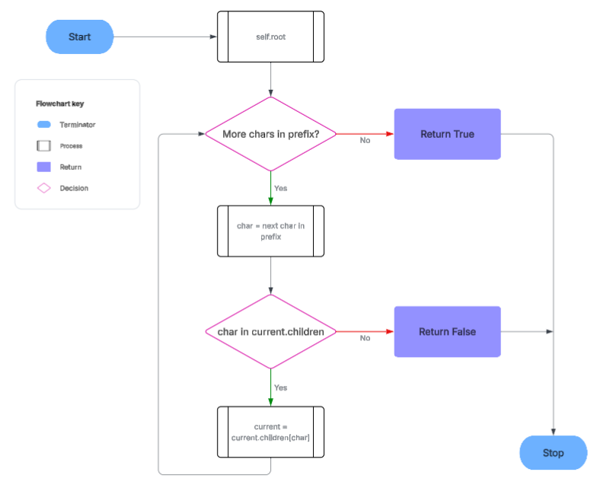

Task 7
Breakpoint selected and ran with Debugging
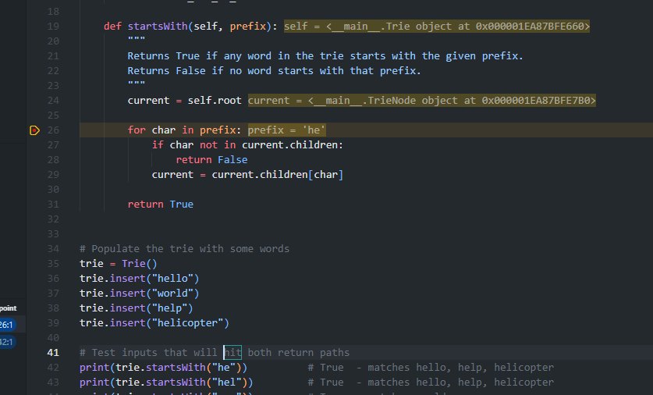

Task 8
One step in using debugging
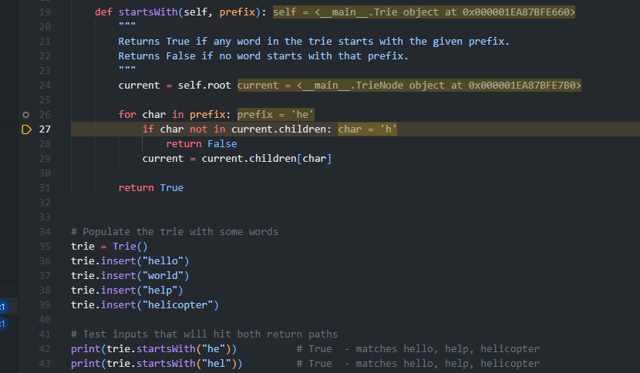

Task 9
Continued step in till false test return hit.
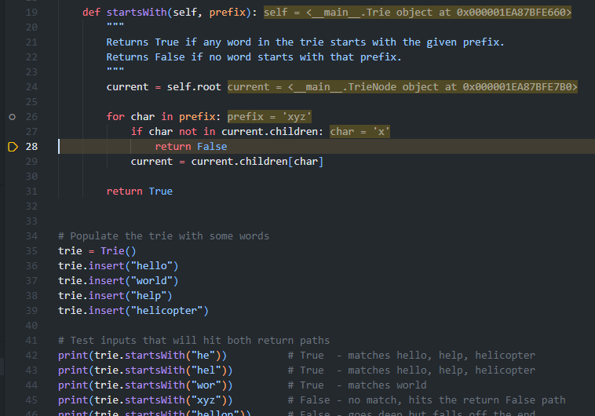

References
Lucid Software. (2025). Lucidchart [Web-based diagramming tool]. https://www.lucidchart.com

