Module 4.2 Assignment

Zachary Donohue
CIS325-T301 Advanced Python
Bellevue University
April 9, 2026
Professor John Woods

Task 4
Flowchart for “sitka_highs.py”
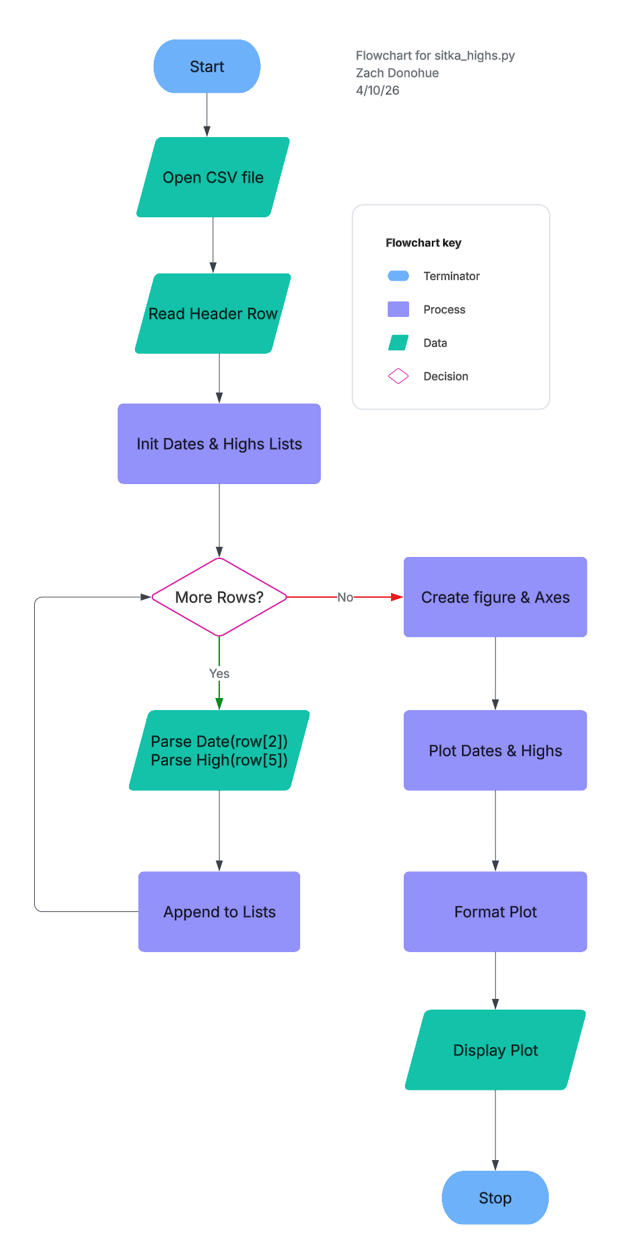

Task 7
Flowchart for “sitka_high_low_zld.py”
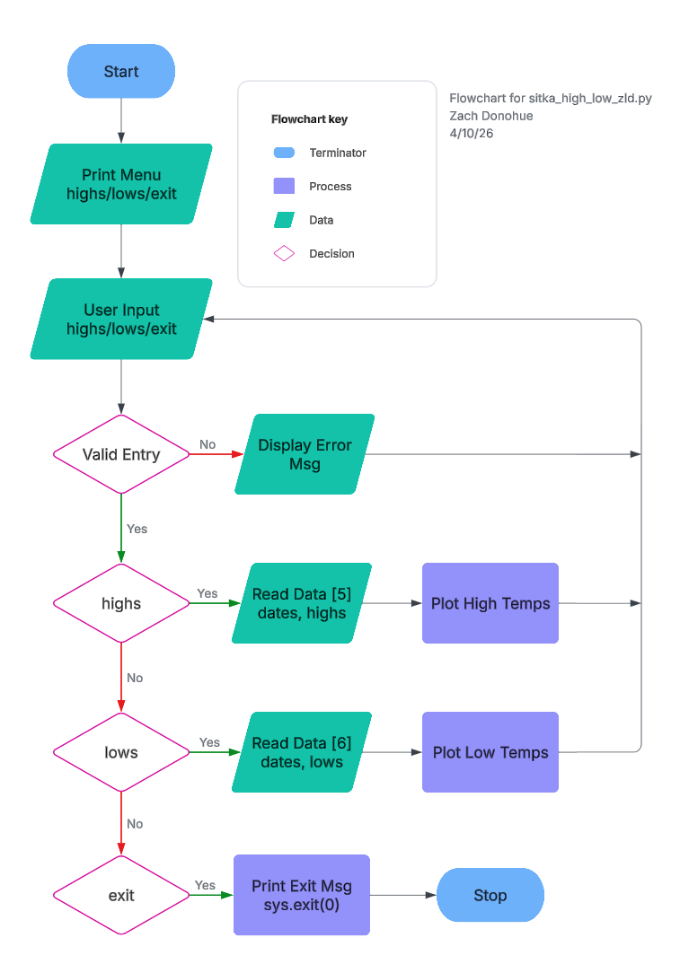
Github Upload

References
Lucid Software. (2025). Lucidchart [Web-based diagramming tool]. https://www.lucidchart.com

