Cycle | reset | pc | instr | branch | srca | srcb | aluout | zero | pcsrc | writedata | memwrite | read data
1 | 1 | 00 | addi $2,$0,5  20020005 | 0 | 0 | 5 | 5 | 0 | 0 | 0 | 0 | x
2 | 0 | 04 | addi $3,$0,12  2003000c | 0 | 0 | c | c | 0 | 0 | 0 | 0 | x
3 | 0 | 08 | addi $7,$3,-9  20067fff7 | 0 | c | -9 | 3 | 0 | 0 | 0 | 0 | x
4 | 0 | 0C
Table 1. First sixteen cycles of executing mipstest.asm
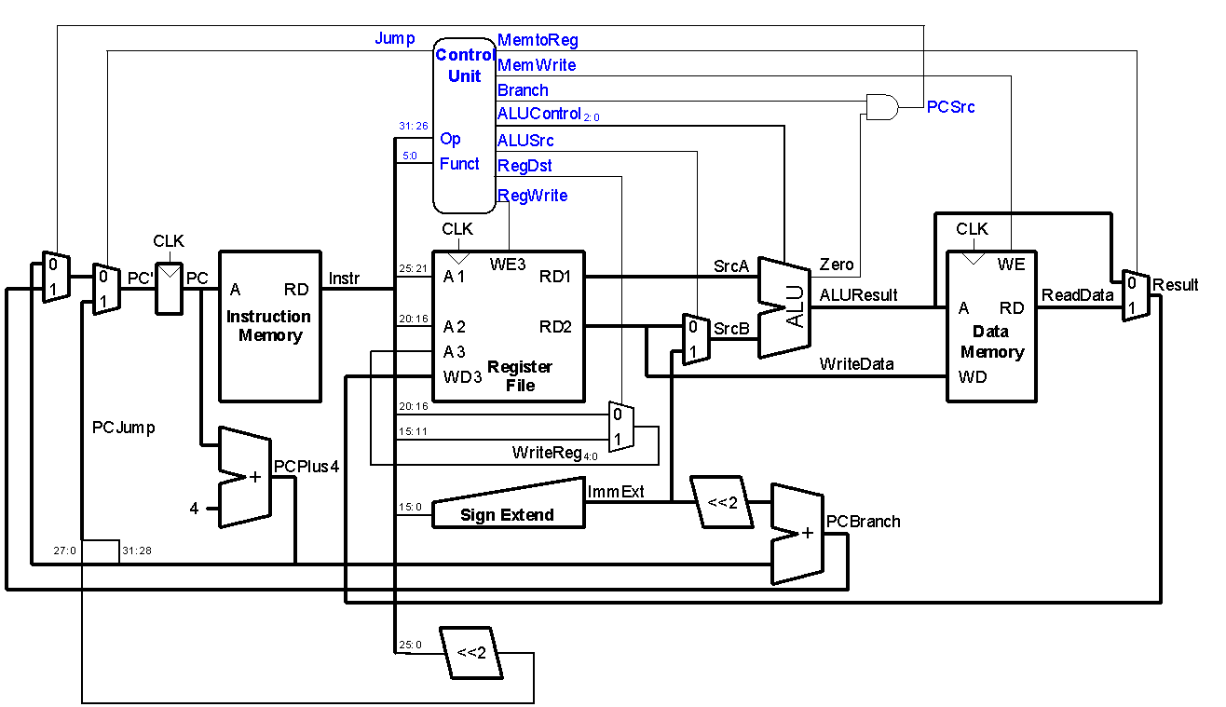
Single-cycle MIPS processor

Extended functionality. Main Decoder:
Instruction | Op_{5:0} | RegWrite | RegDst | AluSrc_{1:0} | Branch | MemWrite | MemtoReg | ALUOp_{1:0} | Jump
R-type | 000000 | 1 | 1 | 00 | 0 | 0 | 0 | 10 | 0
lw | 100011 | 1 | 0 | 01 | 0 | 0 | 1 | 00 | 0
sw | 101011 | 0 | X | 01 | 0 | 1 | X | 00 | 0
beq | 000100 | 0 | X | 00 | 1 | 0 | X | 01 | 0
addi | 001000 | 1 | 0 | 01 | 0 | 0 | 0 | 00 | 0
j | 000010 | 0 | X | XX | X | 0 | X | XX | 1
ori | 001101
bne | 000101
Table 2. Extended functionality. Main Decoder
Extended functionality. ALU Decoder:
ALUOp_{1:0} | Meaning
00 | Add
01 | Subtract
10 | Look at funct field
11

