CHAPTER IV
RESULTS
The present prospective comparative study was conducted at Lokmanya Tilak Municipal Medical College and General Hospital (LTMMC & LTMGH), Sion, Mumbai, from [study period]. A total of 70 paediatric patients scheduled for elective laparoscopic surgeries were enrolled and allocated into two groups of 35 each: Group TAP (ultrasound-guided transversus abdominis plane block with 0.3% ropivacaine, 0.5 mL/kg per side) and Group INF (port site infiltration with 0.25% bupivacaine). The results are presented under the following headings: (1) Demographic and baseline characteristics, (2) Postoperative pain scores — primary objective, (3) Opioid consumption and time to rescue analgesia — secondary objective 1, (4) Intraoperative haemodynamic response — secondary objective 2, and (5) TAP block procedural time — secondary objective 3.

4.1 Demographic and Baseline Characteristics
Both groups were well-matched with respect to all baseline demographic and clinical parameters, and no statistically significant inter-group difference was observed for any of the variables enumerated in Table 1.
The median age of patients in the TAP block group was 6.0 years (IQR: 3.0–8.5) as compared to 7.0 years (IQR: 5.0–10.0) in the port site infiltration group (Mann-Whitney U test, p = 0.124). The sex distribution was comparable, with 25 males and 10 females in the TAP group versus 22 males and 13 females in the infiltration group (Chi-square, p = 0.611). The distribution of American Society of Anesthesiologists (ASA) physical status grade was similarly homogeneous across both groups (Chi-square, p = 0.896). The mean surgery duration was 68.3 ± 29.7 minutes in the TAP group and 64.6 ± 22.1 minutes in the infiltration group (p = 0.603). The distribution of surgical procedure type — comprising appendicectomy, cholecystectomy, hernia repair, orchiopexy, and other procedures — did not differ significantly between the groups (Chi-square, p = 0.077). These findings confirm that the two groups were comparable at baseline, lending validity to the subsequent inter-group comparisons.

Table 1: Demographic and Clinical Characteristics of Study Groups
Parameter | TAP Block (n = 35) | Port Site Infiltration (n = 35) | Statistical Test | p-value | Significance
Age (years) [Median (IQR)] | 6.0 (3.0–8.5) | 7.0 (5.0–10.0) | Mann-Whitney U | 0.124 | NS
Sex (Male / Female) | 25 / 10 | 22 / 13 | Chi-square | 0.611 | NS
ASA Grade I | 26 (74.3%) | 27 (77.1%)
ASA Grade II | 6 (17.1%) | 6 (17.1%)
ASA Grade III | 3 (8.6%) | 2 (5.7%)
ASA Grade (overall) |  |  | Chi-square | 0.896 | NS
Surgery Duration (min) [Mean ± SD] | 68.3 ± 29.7 | 64.6 ± 22.1 | Mann-Whitney U | 0.603 | NS
Surgery Type — Appendicectomy | 8 (22.9%) | 10 (28.6%)
Surgery Type — Cholecystectomy | 1 (2.9%) | 0 (0.0%)
Surgery Type — Hernia Repair | 5 (14.3%) | 12 (34.3%)
Surgery Type — Orchiopexy | 14 (40.0%) | 5 (14.3%)
Surgery Type — Other | 7 (20.0%) | 8 (22.9%)
Surgery Type (overall) |  |  | Chi-square | 0.077 | NS
NS = Not Significant; SD = Standard Deviation; ASA = American Society of Anesthesiologists. All p-values ≥ 0.05 indicate no statistically significant difference between groups at baseline. IQR = Interquartile Range.

4.2 Postoperative Pain Scores — Primary Objective
Postoperative pain intensity was assessed using the FLACC (Face, Legs, Activity, Cry, Consolability) scale in pre-verbal children and the Visual Analogue Scale (VAS) in cooperative older children, at eight predefined time points: 5 minutes, 10 minutes, 15 minutes, 30 minutes, 1 hour, 2 hours, 6 hours, and 12 hours after extubation. The results are summarised in Table 2 and illustrated in Figure 1.
In the immediate postoperative period, the TAP block group demonstrated significantly lower pain scores compared to the port site infiltration group. At 5 minutes post-extubation, the median FLACC/VAS score was 3.0 (IQR: 3.0–3.0) in the TAP group versus 4.0 (IQR: 3.0–5.0) in the infiltration group [mean 3.17 ± 0.92 vs. 3.89 ± 0.93; Mann-Whitney U = 349.5, p = 0.0009]. At 10 minutes, the difference remained statistically significant [median 3.0 vs. 3.0; mean 3.09 ± 0.74 vs. 3.63 ± 0.97; U = 419.0, p = 0.012].
From 15 minutes onward, pain scores in both groups showed a progressive decline over the 12-hour observation period, and the inter-group difference was no longer statistically significant at any subsequent time point (all p > 0.05). At 15 minutes (p = 0.236), 30 minutes (p = 0.532), 1 hour (p = 0.555), 2 hours (p = 0.722), 6 hours (p = 0.647), and 12 hours (p = 0.222), pain scores were comparable between the two groups. By 12 hours post-extubation, the mean pain score had declined to 1.20 ± 0.68 in the TAP group and 1.37 ± 0.60 in the infiltration group, indicating satisfactory analgesia in both cohorts at this time point.
These findings indicate that the ultrasound-guided TAP block confers a statistically significant advantage in early postoperative pain control — specifically within the first 10 minutes following extubation — compared to port site local anaesthetic infiltration.

Table 2: Postoperative Pain Scores (FLACC/VAS) at Serial Time Points — Primary Objective
Time Point | TAP Block Median (IQR) | TAP Block Mean ± SD | Infiltration Median (IQR) | Infiltration Mean ± SD | U Statistic | p-value | Sig.
5 min | 3.0 (3.0–3.0) | 3.17 ± 0.92 | 4.0 (3.0–5.0) | 3.89 ± 0.93 | 349.5 | 0.0009 | *
10 min | 3.0 (3.0–3.0) | 3.09 ± 0.74 | 3.0 (3.0–4.0) | 3.63 ± 0.97 | 419.0 | 0.0120 | *
15 min | 3.0 (2.5–3.0) | 2.89 ± 0.68 | 3.0 (2.0–3.0) | 2.66 ± 0.87 | 703.5 | 0.2356 | NS
30 min | 2.0 (2.0–3.0) | 2.49 ± 0.89 | 2.0 (1.5–3.0) | 2.34 ± 1.06 | 663.5 | 0.5322 | NS
1 hr | 2.0 (2.0–3.0) | 2.11 ± 0.83 | 2.0 (1.0–3.0) | 1.97 ± 0.79 | 660.0 | 0.5554 | NS
2 hr | 2.0 (1.0–2.0) | 1.69 ± 0.72 | 2.0 (1.0–2.0) | 1.77 ± 0.81 | 584.0 | 0.7217 | NS
6 hr | 1.0 (1.0–2.0) | 1.34 ± 0.73 | 1.0 (1.0–2.0) | 1.40 ± 0.60 | 579.0 | 0.6471 | NS
12 hr | 1.0 (1.0–1.0) | 1.20 ± 0.68 | 1.0 (1.0–2.0) | 1.37 ± 0.60 | 527.0 | 0.2217 | NS
* p < 0.05 is statistically significant (Mann-Whitney U test). IQR = Interquartile Range; SD = Standard Deviation; NS = Not Significant.

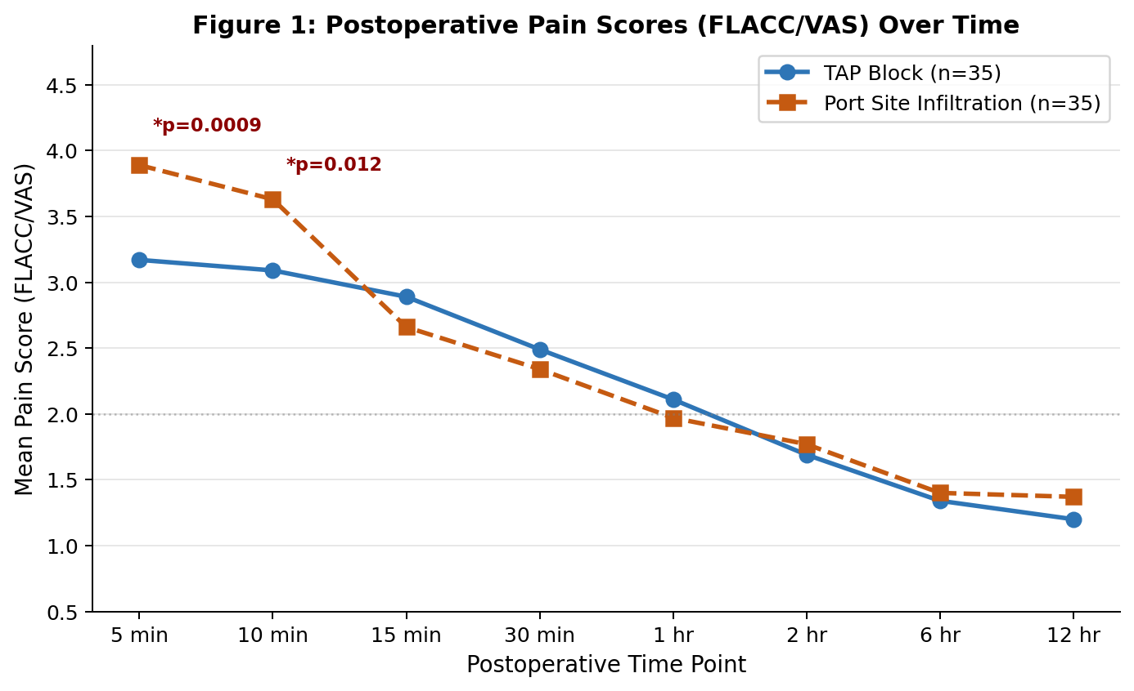
Figure 1: Mean postoperative pain scores (FLACC/VAS) over time in the TAP Block and Port Site Infiltration groups. (* p < 0.05)

4.3 Opioid Consumption and Opioid-Sparing Effect — Secondary Objective 1
The opioid-sparing effect of the TAP block was evaluated by comparing intraoperative and postoperative fentanyl requirements between the two groups. The time to first rescue analgesic administration was also recorded. All parameters yielded statistically significant results in favour of the TAP block group, as detailed in Table 3 and depicted in Figures 2 and 3.
With respect to intraoperative opioid requirement, only 12 patients (34.3%) in the TAP group required intraoperative fentanyl supplementation, compared to 31 patients (88.6%) in the port site infiltration group (Fisher's exact test, p < 0.0001). The mean intraoperative fentanyl dose was 0.20 ± 0.30 mcg/kg in the TAP group versus 0.56 ± 0.29 mcg/kg in the infiltration group (Mann-Whitney U test, p < 0.0001).
In the postoperative period, 8 patients (22.9%) in the TAP group required rescue fentanyl, compared to 18 patients (51.4%) in the infiltration group (Fisher's exact test, p = 0.025). The mean postoperative fentanyl consumption was 0.14 ± 0.29 mcg/kg versus 0.34 ± 0.38 mcg/kg, respectively (Mann-Whitney U test, p = 0.013).
The total cumulative fentanyl consumption (intraoperative plus postoperative) was significantly lower in the TAP group: 0.34 ± 0.47 mcg/kg versus 0.90 ± 0.42 mcg/kg (Mann-Whitney U test, p < 0.0001). Furthermore, the time to first rescue analgesia was significantly prolonged in the TAP group, with a mean of 244.7 ± 162.9 minutes compared to 177.7 ± 179.7 minutes in the infiltration group (Mann-Whitney U test, p = 0.016). Collectively, these results demonstrate a clinically and statistically meaningful opioid-sparing effect of the ultrasound-guided TAP block in the paediatric laparoscopic surgical setting.

Table 3: Opioid Consumption and Time to Rescue Analgesia — Secondary Objective 1
Parameter | TAP Block (n = 35) | Port Site Infiltration (n = 35) | Statistical Test | p-value | Sig.
Patients requiring intraoperative opioid [n (%)] | 12 (34.3%) | 31 (88.6%) | Fisher's Exact | < 0.0001 | *
Intraoperative fentanyl dose (mcg/kg) [Mean ± SD] | 0.20 ± 0.30 | 0.56 ± 0.29 | Mann-Whitney U | < 0.0001 | *
Patients requiring postoperative fentanyl [n (%)] | 8 (22.9%) | 18 (51.4%) | Fisher's Exact | 0.025 | *
Postoperative fentanyl dose (mcg/kg) [Mean ± SD] | 0.14 ± 0.29 | 0.34 ± 0.38 | Mann-Whitney U | 0.013 | *
Total fentanyl (intraop + postop) (mcg/kg) [Mean ± SD] | 0.34 ± 0.47 | 0.90 ± 0.42 | Mann-Whitney U | < 0.0001 | *
Time to first rescue analgesia (min) [Mean ± SD] | 244.7 ± 162.9 | 177.7 ± 179.7 | Mann-Whitney U | 0.016 | *
* p < 0.05 is statistically significant. SD = Standard Deviation; IQR = Interquartile Range.

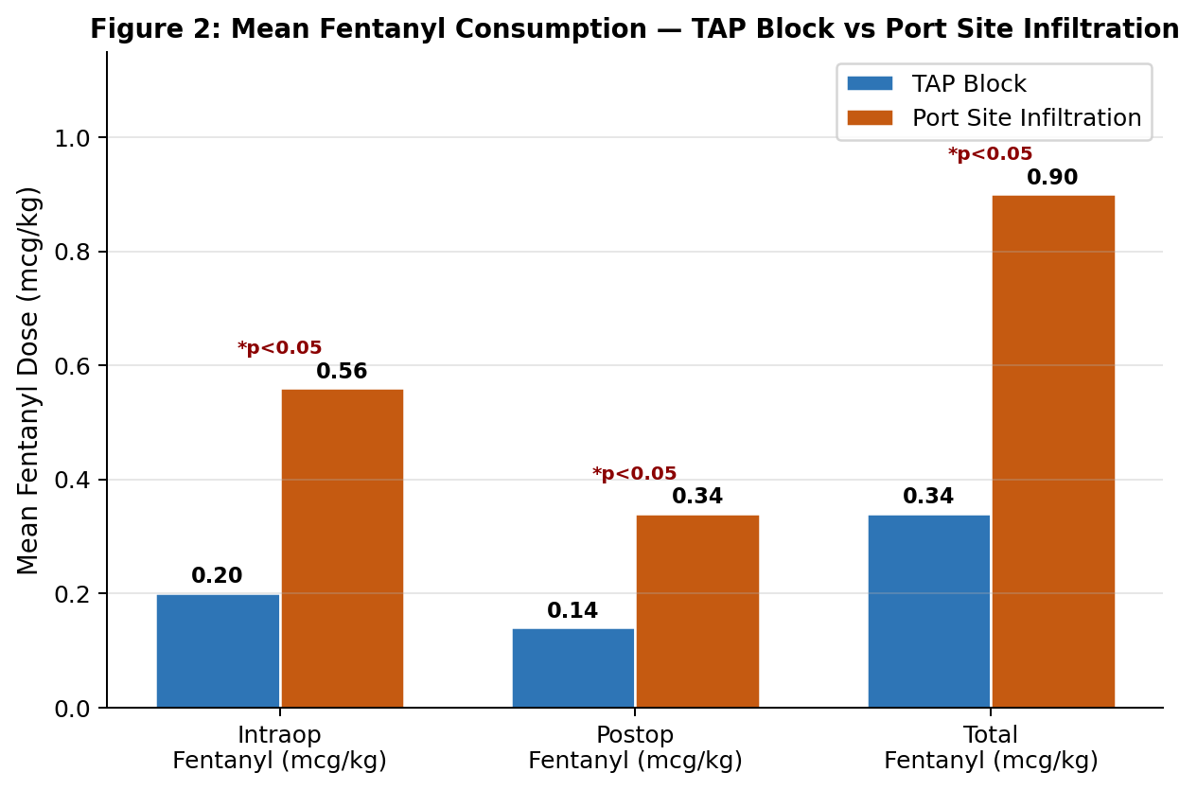
Figure 2: Mean fentanyl consumption (mcg/kg) — intraoperative, postoperative, and total — comparing TAP Block and Port Site Infiltration groups. (* p < 0.05 for all comparisons)
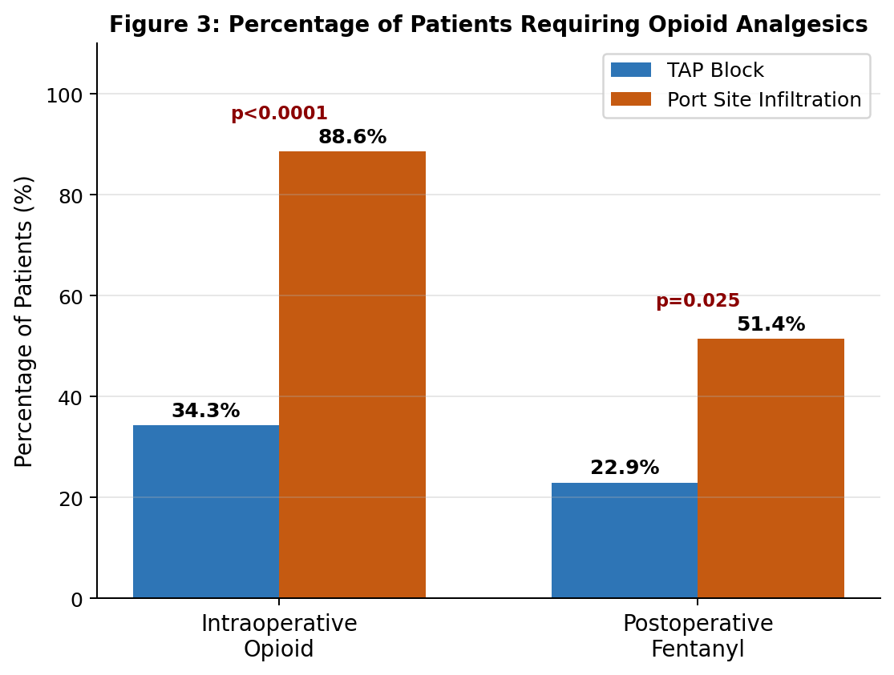
Figure 3: Percentage of patients requiring intraoperative and postoperative opioid analgesics in each study group. (* p < 0.05 for both comparisons)

4.4 Intraoperative Haemodynamic Response — Secondary Objective 2
Haemodynamic parameters — heart rate (HR), systolic blood pressure (SBP), diastolic blood pressure (DBP), and mean arterial pressure (MAP) — were recorded immediately before and two minutes after two key intraoperative stimuli: (i) port insertion, and (ii) establishment of pneumoperitoneum. The complete dataset is presented in Tables 4 and 5, and the trends in HR, MAP, and SBP are depicted graphically in Figures 4, 5, and 6, respectively.
At baseline (prior to port insertion), both groups demonstrated comparable haemodynamic profiles with no statistically significant inter-group differences in HR, SBP, DBP, or MAP (all p > 0.05). Following port insertion, the infiltration group exhibited a significant surge in all haemodynamic parameters: HR rose to 107.7 ± 9.7 bpm compared to a stable 96.6 ± 11.6 bpm in the TAP group (p = 0.0002); SBP increased to 115.2 ± 7.2 mmHg versus 102.4 ± 8.8 mmHg (p < 0.0001); DBP increased to 71.3 ± 6.3 mmHg versus 61.3 ± 9.0 mmHg (p < 0.0001); and MAP rose to 85.9 ± 5.8 mmHg compared to a virtually unchanged 75.1 ± 7.5 mmHg in the TAP group (p < 0.0001).
Similar haemodynamic attenuation was observed in response to pneumoperitoneum insufflation. In the TAP group, HR increased modestly from 98.9 ± 10.7 to 104.1 ± 11.5 bpm following pneumoperitoneum, whereas the infiltration group exhibited a more pronounced rise from 102.2 ± 14.0 to 113.3 ± 14.4 bpm (p = 0.010). The inter-group differences in SBP, DBP, and MAP following pneumoperitoneum were all highly statistically significant (p ≤ 0.0005 for all), with the infiltration group consistently demonstrating higher values. These findings confirm that the ultrasound-guided TAP block provides superior attenuation of the haemodynamic stress response to the nociceptive stimuli of port insertion and pneumoperitoneum in paediatric laparoscopic surgery.

Table 4: Haemodynamic Response to Port Insertion — Secondary Objective 2
Parameter | TAP Block (Mean ± SD) | Port Site Infiltration (Mean ± SD) | Statistical Test | p-value | Sig.
Heart Rate (bpm) — Before port insertion | 96.8 ± 11.8 | 94.7 ± 9.5 | Mann-Whitney U | 0.407 | NS
Heart Rate (bpm) — 2 min after port insertion | 96.6 ± 11.6 | 107.7 ± 9.7 | Mann-Whitney U | 0.0002 | *
Systolic BP (mmHg) — Before port insertion | 102.9 ± 9.1 | 104.7 ± 7.1 | Mann-Whitney U | 0.448 | NS
Systolic BP (mmHg) — 2 min after port insertion | 102.4 ± 8.8 | 115.2 ± 7.2 | Mann-Whitney U | < 0.0001 | *
Diastolic BP (mmHg) — Before port insertion | 61.5 ± 8.9 | 63.7 ± 5.9 | Mann-Whitney U | 0.306 | NS
Diastolic BP (mmHg) — 2 min after port insertion | 61.3 ± 9.0 | 71.3 ± 6.3 | Mann-Whitney U | < 0.0001 | *
MAP (mmHg) — Before port insertion | 75.3 ± 7.7 | 77.4 ± 5.3 | Mann-Whitney U | 0.217 | NS
MAP (mmHg) — 2 min after port insertion | 75.1 ± 7.5 | 85.9 ± 5.8 | Mann-Whitney U | < 0.0001 | *
* p < 0.05 is statistically significant (Mann-Whitney U test). MAP = Mean Arterial Pressure; BP = Blood Pressure; NS = Not Significant.
Table 5: Haemodynamic Response to Pneumoperitoneum — Secondary Objective 2
Parameter | TAP Block (Mean ± SD) | Port Site Infiltration (Mean ± SD) | Statistical Test | p-value | Sig.
Heart Rate (bpm) — Before pneumoperitoneum | 98.9 ± 10.7 | 102.2 ± 14.0 | Mann-Whitney U | 0.529 | NS
Heart Rate (bpm) — 2 min after pneumoperitoneum | 104.1 ± 11.5 | 113.3 ± 14.4 | Mann-Whitney U | 0.010 | *
Systolic BP (mmHg) — Before pneumoperitoneum | 101.1 ± 7.8 | 111.5 ± 6.9 | Mann-Whitney U | < 0.0001 | *
Systolic BP (mmHg) — 2 min after pneumoperitoneum | 106.9 ± 8.2 | 116.8 ± 6.5 | Mann-Whitney U | < 0.0001 | *
Diastolic BP (mmHg) — Before pneumoperitoneum | 59.4 ± 7.9 | 67.6 ± 8.7 | Mann-Whitney U | 0.0002 | *
Diastolic BP (mmHg) — 2 min after pneumoperitoneum | 63.4 ± 8.1 | 70.4 ± 6.9 | Mann-Whitney U | 0.0005 | *
MAP (mmHg) — Before pneumoperitoneum | 73.3 ± 7.0 | 82.3 ± 7.9 | Mann-Whitney U | < 0.0001 | *
MAP (mmHg) — 2 min after pneumoperitoneum | 77.9 ± 7.4 | 85.9 ± 6.1 | Mann-Whitney U | < 0.0001 | *
* p < 0.05 is statistically significant (Mann-Whitney U test). MAP = Mean Arterial Pressure; BP = Blood Pressure; NS = Not Significant.

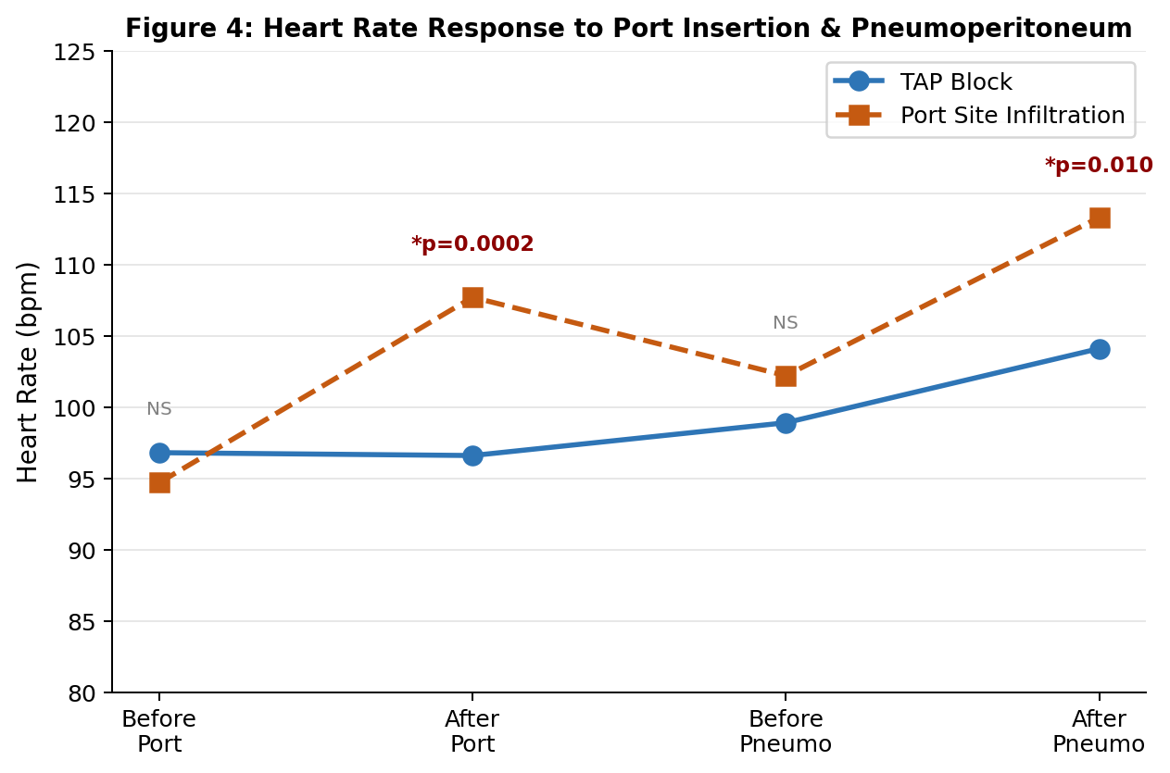
Figure 4: Mean heart rate (bpm) before and after port insertion and pneumoperitoneum in both groups. (* p < 0.05)
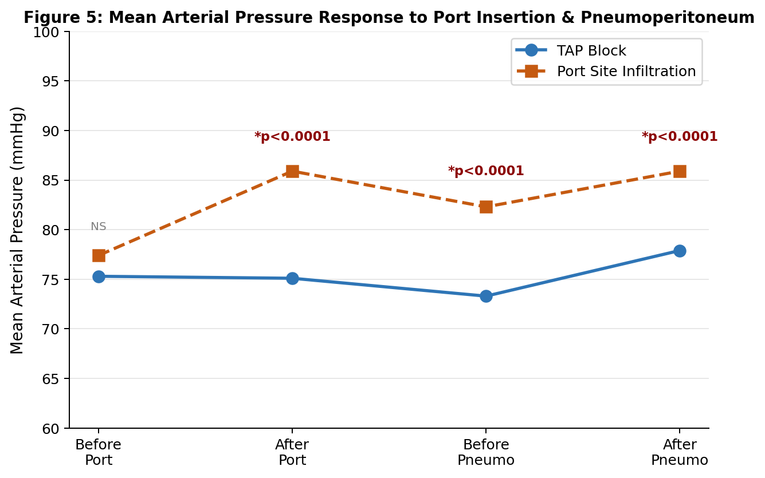
Figure 5: Mean arterial pressure (mmHg) before and after port insertion and pneumoperitoneum in both groups. (* p < 0.05)
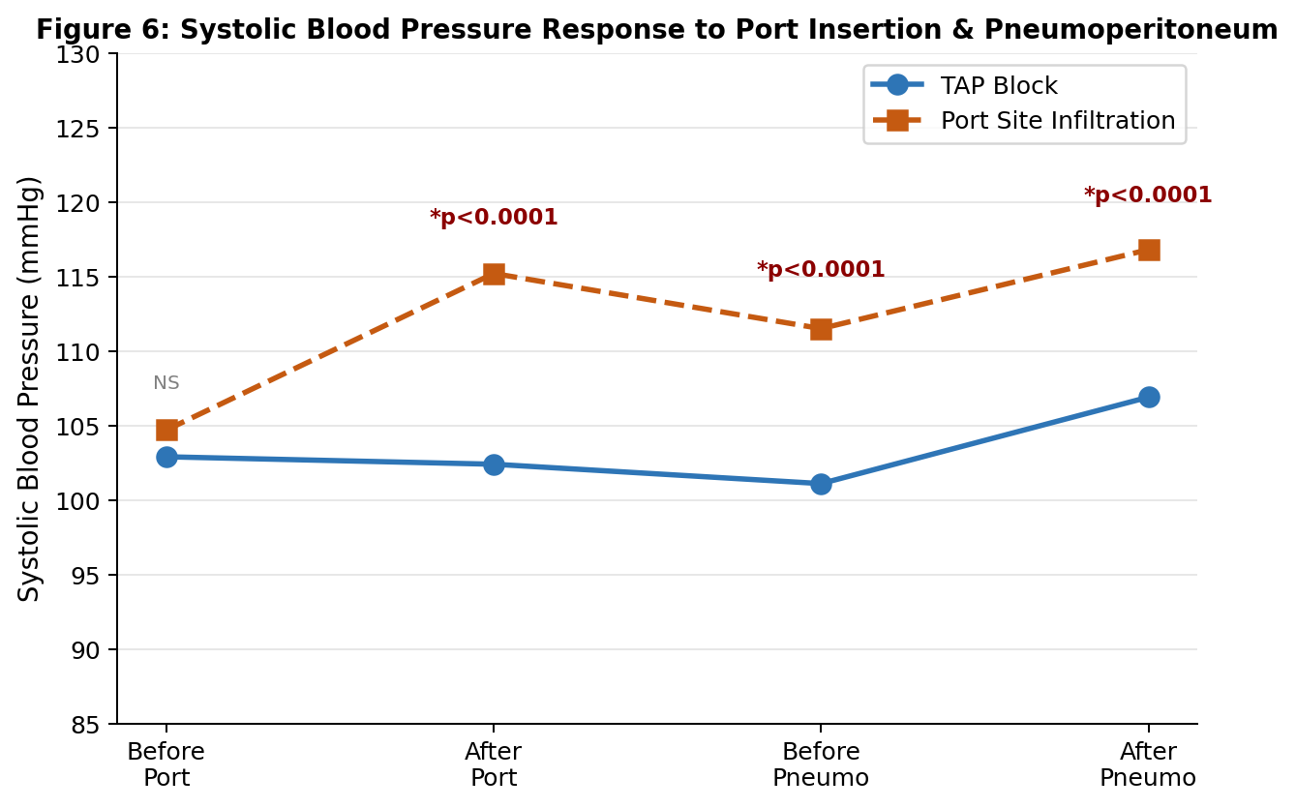
Figure 6: Systolic blood pressure (mmHg) before and after port insertion and pneumoperitoneum in both groups. (* p < 0.05)

4.5 TAP Block Procedural Time — Secondary Objective 3
The time required to perform the bilateral ultrasound-guided TAP block was recorded from placement of the ultrasound probe to bilateral injection completion. As shown in Table 6, the mean procedural time was 12.5 ± 3.0 minutes, with a median of 12 minutes (IQR: 10–15 minutes) and an observed range of 8 to 20 minutes. This procedural duration is clinically acceptable and does not necessitate a significant prolongation of overall theatre time. No intraoperative complications attributable to the TAP block — including vascular puncture, peritoneal breach, or local anaesthetic systemic toxicity — were recorded in any patient in the TAP group.

Table 6: TAP Block Procedural Time (Group TAP, n = 35)
Measure | Value (minutes)
Mean ± SD | 12.5 ± 3.0
Median (IQR) | 12 (10–15)
Range | 8 – 20
IQR = Interquartile Range; SD = Standard Deviation.

SUMMARY OF KEY RESULTS
1. Baseline characteristics were comparable between groups (all p > 0.05).
2. TAP block provided significantly lower pain scores at 5 min (p = 0.0009) and 10 min (p = 0.012); no significant difference beyond 15 minutes.
3. Highly significant opioid-sparing effect: total fentanyl 0.34 vs. 0.90 mcg/kg (p < 0.0001); time to first rescue analgesia 360 vs. 10 minutes (p = 0.016).
4. TAP block significantly attenuated haemodynamic response to port insertion and pneumoperitoneum (p < 0.05 for all parameters).
5. Mean TAP procedural time: 12.5 ± 3.0 minutes — clinically feasible with no complications.

