Development Specifications Document (DSD)

*Process Name: < WhiteHatAutomation >*

Table of Contents

**Document Overview**1

Automated Master Project Details 1

Runtime Guide 2

Runtime Diagram 2

List of Packages 2

Master Project Runtime Details 2

**Project Details**4

Project Name: <project name> 4

Workflow(s) specific to the Project 5

Project Name: <project name> 5

Workflow(s) specific to the Project 7

**Compliance Considerations and Reporting Requirements**7

**Other Details**8

Future Improvements 8

Debugging Tips 8

Other Remarks 8

**Post UAT Specifications**8

**Glossary**8

Version Control

|  |  |  |  |  |  |  |
| --- | --- | --- | --- | --- | --- | --- |
| Date | Version | Role | Name | Organization Department | Function | Comments |
| 05-11-2020 | 1.0 | Author | Ankit Yadav | Developer | RPA | N/A |



# Document Overview

The Development Specifications Document (DSD) is created for every business process automated using RPA. The DSD needs to be reviewed and updated for every change requested and applied to the automated process. This document provides a technical snapshot and must always reflect the latest design and key features of the automated workflow.

The document naming convention will follow the naming convention and the version of the automated process. This can be “business process name version” or it can be defined, case by case, as part of the larger RPA project design.

This document is completed by the RPA Solution architect and RPA developer who automates the business process. It is reviewed by the business process owner, application owner, and CoE design authority.

This document is meant to assist the RPA COE, IT operations and process owners by providing a snapshot of the automated process details and components. It can also serve developers to have a quick glance at the setup, before diving into the code, to troubleshoot or update changes. The purpose of the document is to record the outcome specific to the automated master project and its subcomponents: projects, workflows, sequences etc.

# Automated Master Project Details

Details filled in by the developer reflect the actual information for the master project released for production.

|  |  |  |
| --- | --- | --- |
| # | Item | Details  Fill in with free text. If not applicable, mark the filed as "N/A". No empty fields. |
| 1 | Master Project Name and Version | WhiteHatAutomation v1.0 |
| 2 | Robot Type (attended/unattended/mix) | Attended |
| 3 | Is Orchestrator used? (Yes/No) | Yes |
| 4 | Scalable? (Yes/No)  Can the process be run by multiple robots in parallel? | Yes |

# Runtime Guide

## Runtime Diagram

**Architectural Structure of the Master Project** Display the interaction between components (package / robots, Orchestrator queues, and running order).

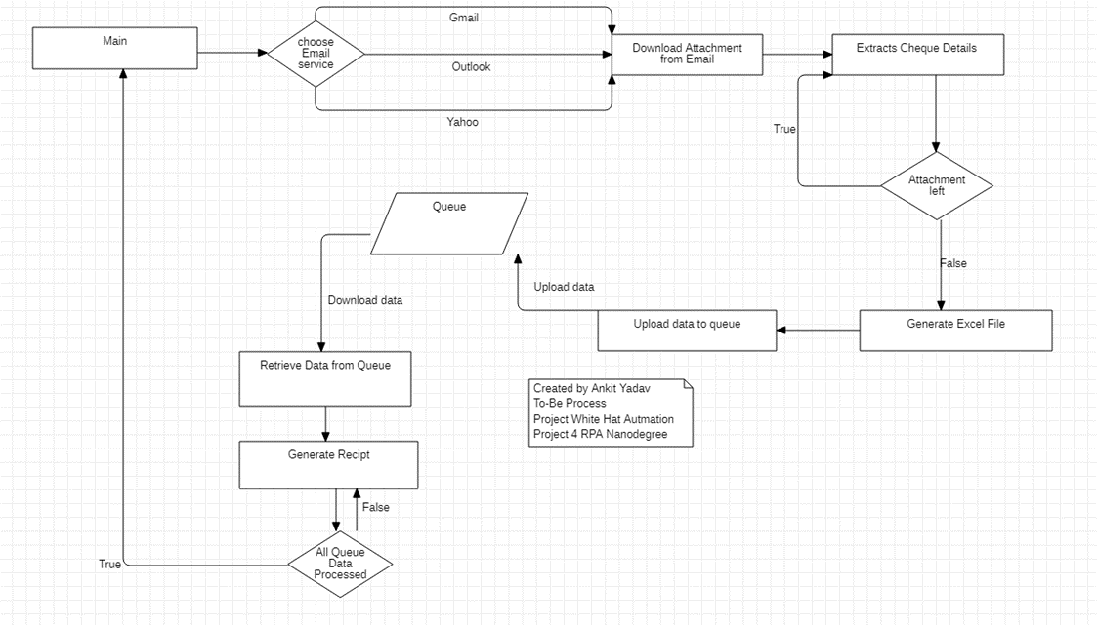

## List of Packages

Include **the list of packages and the high level description** for each of them, to explain each one's purpose:

|  |  |  |
| --- | --- | --- |
| # | Package Name | High-Level Description |
| 1 | UiPath.Mail.Activities [1.7.2] | For Email Automation |
| 2 | UiPath.UIAutomation.Activities [19.11.3] | For General automation Task |
| 3 | UiPath.System.Activities [19.10.1] | For Automating System Task |
| 4 | UiPath.Excel.Activities [2.7.2] | For Excel Automation |

*Add more rows to the table to include all the project names and versions. No fields should be left empty. Use “N/A” for the items that don't apply to your project.

## Master Project Runtime Details

Details of the automated process:

|  |  |  |
| --- | --- | --- |
| # | Item | Details  (Fill in with free text. If the section does not apply to your automation, mark the field as “N/A”. No empty fields. ) |
| 1 | Production Environment Details | Windows 10 OS, Access to Internet and Email and Service |
| 2 | Prerequisites to run | Email Credentials on Assets in Orchestrator if using Gmail and Yahoo. Email Containing attachment with specified custom subject |
| 3 | Input Data | Email Attachment and Email Service Choice |
| 4 | Expected Output (output data) | Receipts corresponding to Cheque attached in Email |
| 5 | How to start the automated process? | Simply run the Main.XAML File |
| 6 | Resuming the process from a particular step | N/A |
| 7 | Reporting  queues reporting, Kibana or another platform | N/A |
| 8 | Manual Error Handling  roll back or manually complete failed transactions. Procedures to reset the item. Ex “set status as investigating” |  |
| 1. How to resume the process in case of error | Restart the process |
| 1. How to manually fix transactions with error | Check Logs for error |
| 9 | Use of Orchestrator |  |
| 1. Password Policies   specific compliance requests? | N/A |
| 1. Stored Credentials   Never hard code credentials in the workflow | Email Credentials in Assets |
| 1. List of Asset Names | Gmail_Id , Gmail_Password , Yahoo_Mail , Yahoo_Password |
| 1. List of Queues Name | Cheque_Details |
| 1. Schedule Details | N/A |
| 10 | Recommended Resolution | N/A |

# Project Details

In this section describe all the projects that compose the automated process.

For each project, describe the workflow(s) in the logical order that they are called in.

If the workflow is a flowchart, also include the exported image from Studio.

If the automated process is composed of multiple projects, copy paste and fill in the table below for each project with its specific details (there are 2 here already, assuming a dispatcher and performer project)

## Project Name: <*WhiteHatAutomation(Main_Extract_And_Upload_Cheque_Details)* >

General information about the process selected for RPA prior to automation.

|  |  |  |
| --- | --- | --- |
| # | Item Name | Details  Fill in with free text. If not applicable, mark the field as “N/A". No empty fields. |
| 1 | Environment used for development  name, location, configuration details etc | Windows 10, Outlook Email client and web Client for Gmail and Yahoo, Ui-Path Studio |
| 2 | Environment prerequisites  OS details, libraries, required apps | Windows 10, Standard pr-loaded libraries check Project. Json for more details |
| 3 | Logging level | Info,Error,Warn |
| 4 | Details about automation  if the apps were automated using UI Automation, Image & Text | N/A |
| 5 | In case of attended bot, can the user operate the computer while the robot is running? | Not Recommended but to most part of automation system can be used |
| 6 | Repository for project  where the developed project is stored | N/A |
| 7 | List of reused components | Email Attachment download |
| 8 | Custom logs defined in the workflows  where Throw Activity was used or custom log message was defined | No Email Attachment Found exception |
| 9 | Frequent errors found in the development phase | Selector Errors but resolved now |
| 10 | Workarounds used in the automation phase | N/A |
| 11 | Configuration method  assets, excel file, Json file | Project.json |
| 12 | Configuration details  path for input files, configuration Orchestrator assets used | Orchestrator Asset Used for Credentials. Queue used for storing extracted cheque Information |
| 13 | Workflow File Export List  Use the project mapping tool | N/A |

### Workflow(s) specific to the Project

Define below all the workflow files (.xaml files) used in the project, with the Input and Output data.

|  |  |  |  |  |
| --- | --- | --- | --- | --- |
| # | Workflow File Name | Description | Arguments | Comments |
| 1 | Download_Data_From_Queue | This XAML file is responsible for downloading data from the Queue and generate receipts. | out_Amount out_Cheque_Date out_Payee out_Cheque_No | N/A |
| 2 | Main_Recipt_Generation_Automation | his XAML file is responsible for executing all sub workflows in sequence to achieve this automation workflow fully. | N/A | N/A |
| 3 | Recipt_Generation | This XAML file is responsible for generating receipts for the retrieved values from the Queue. | in_Amount in_Cheque_Date in_Payee in_Cheque_No | N/A |

## Project Name: <*WhiteHatAutomation(Main_Recipt_Generation_Automation)*>

General information about the process selected for RPA prior to automation.

|  |  |  |
| --- | --- | --- |
| # | Item Name | Details  Fill in with free text. If not applicable, mark the field as “N/A". No empty fields. |
| 1 | Environment used for development  name, location, configuration details etc | Windows 10, Outlook Email client and web Client for Gmail and Yahoo, Ui-Path Studio |
| 2 | Environment prerequisites  OS details, libraries, required apps | Windows 10, Standard pr-loaded libraries check Project. Json for more details |
| 3 | Logging level | Info,Error,Warn |
| 4 | Details about automation  if the apps were automated using UI Automation, Image & Text | N/A |
| 5 | In case of attended bot, can the user operate the computer while the robot is running? | Not Recommended but to most part of automation system can be used |
| 6 | Repository for project  where the developed project is stored | N/A |
| 7 | List of reused components | Email Attachment download |
| 8 | Custom logs defined in the workflows  where Throw Activity was used or custom log message was defined | No Email Attachment Found exception |
| 9 | Frequent errors found in the development phase | Selector Errors but resolved now |
| 10 | Workarounds used in the automation phase | N/A |
| 11 | Configuration method  assets, excel file, Json file | Project.json |
| 12 | Configuration details  path for input files, configuration Orchestrator assets used | Orchestrator Asset Used for Credentials. Queue used for storing extracted cheque Information |
| 13 | Workflow File Export List  Use the project mapping tool | N/A |

### Workflow(s) specific to the Project

Define below all the workflow files (.xaml files) used in the project, with the Input and Output data.

|  |  |  |  |  |
| --- | --- | --- | --- | --- |
| # | Workflow File Name | Description | Arguments | Comments |
| 1 | Main | This XAML file is responsible for combining the two workflows to achieve automation as a whole | N/A | N/A |
| 2 | Main_Extract_And_Upload_Cheque_Details | This XAML file is responsible for executing all the workflows in a sequence to achieve the complete automation of the workflow | N/A | Need to upload credentials to assets on orchestrator before hand if using Gmail or Yahoo options |
| 3 | Download_Attachments_From_Mails | This XAML file is responsible for Downloading the attachments from the E-mail with the specified subjects. | out_No_Of_Attachments out_mail_choice | N/A |
| 4 | Extract_Cheque_Details | This XAML file is responsible for extracting Cheque Details via OCR and loading it into the xlsx file . | in_No_Of_Attachments out_DT_Cheque_Details out_Generated_XLSX_File_Path | N/A |
| 5 | Generate_Excel_And_Upload_To_Queue | This XAML file is responsible for generating the xlsx file as well as dispatching the Cheque details to Queue | in_DT_Cheque_Details in_Generated_XLSX_File_Path | N/A |

# Compliance Considerations and Reporting Requirements

* N/A

# Other Details

## Future Improvements

* More Organized Template Based Receipts can be generated
* Improved data manipulation to provide more accuracy with OCR based Data extraction

## Debugging Tips

* Check the Logs for exception occurred

## Other Remarks

* N/A

# Post UAT Specifications

* Average duration per transaction (varies depending on the Test environment):
* Recommended number of robots for the specified volumes:
* Specified schedule:

# Glossary

* **Master project** - the overall output of the development, containing one or multiple projects that together cover the scope of the robotic process automation.
* **Project** - a UiPath Studio project containing one or multiple workflow files. A project can be converted to a package and run independently, covering a particular scope within the master project. The project is used when defining the development and support phase of the automation.
* **Package** - the output of compiling a project. A package can be deployed on the robot machine and be executed by the robot service. Only one package can be executed at a given time by a robot. The package is used when defining the running phase of the automation
* **Workflow** - a component of the package, the workflow encapsulates a part of the project logic. The workflow can be of type: sequence, flowchart or state machine. a workflow is saved as an .xaml file inside the project folder. A workflow file can be invoked from another workflow and by default there is an initial workflow file that will run when executing the package.
* **Activity** - an action that the robot executes.
* **Sequence** - a workflow where activities are executed one after another, in a sequential order
* **Flowchart** - a workflow where activities are connected by arrows and the logic of the workflow can be easily followed in a visual manner. The flowchart can also be exported as an image from UiPath studio
* **State machine** - a more advanced way of organizing a workflow, similar to a flowchart.
* **BOR** - Back office robot
* **FOR** – Front office robot
* **Orchestrator** – Enterprise architecture server platform supporting: release management, centralized logging, reporting, auditing and monitoring tools, remote control, centralized scheduling, queue/robot workload management, assets management.