Process Definition Document (PDD)

*Process Name: <**WhiteHatAutomation>*

Table of Contents

**Introduction** **1**

Purpose of the Document 1

Objectives 1

Process Key Contact 1

Minimum Prerequisites for Automation 1

**As-Is Process Description** **2**

Process Overview 2

Applications used in the Process 3

As-Is Process Map 3

**To-Be Process Description** **3**

Detailed Process Map 3

Robot Type 4

Business Exceptions Handling 4

Known Exceptions 4

Unknown Exceptions 4

System Exceptions Handling 4

**Other Observations** **5**

**Additional sources of process documentation** **5**



# Introduction

## Purpose of the Document

The Process Definition Document outlines the business process chosen for automation using UiPath Robotic Process Automation (RPA) technology.

The document describes the sequence of steps performed as part of the business process, the conditions and rules of the process prior to automation and how they are envisioned to work after automating it, partly or entirely. This specifications document serves as a base for developers, providing them with the details required for applying robotic process automation to the selected business process.

## Objectives

The business objectives and benefits expected by the Business Process Owner after automation of the selected business process are:

* Automate the Process of Extracting data from Cheque
* Generate Receipts automatically after processing all Cheques
* Extracting and Generating Receipts can be performed on separate machine asynchronously

## Process Key Contact

The specifications document includes concise and complete requirements of the business process and it is built based on the inputs provided by the process Subject Matter Expert (SME)/ Process Owner.

The Process Owner is expected to review it and provide signoff for accuracy and completion of the steps, context, impact and a set of process exceptions. The details are to be included in the table below.

|  |  |  |  |
| --- | --- | --- | --- |
| Role | Name | Contact Details  (email & phone number) | Notes |
| Process Owner | Ankit Yadav | drkkgy@gmail.com | N/A |
| Business Analyst | Ankit Yadav | drkkgy@gmail.com | N/A |

## Minimum Prerequisites for Automation

|  |  |
| --- | --- |
| Met (Y/N) | Prerequisites |
| Y | A filled in and completed Process Definition Document |
| Y | Closure of any open process questions |
| Y | Environment set up |
| Y | Test Data to support development and testing |
| N/A | User access and creation of user accounts (licences, permissions, restriction to create accounts for robots) |

# As-Is Process Description

## Process Overview

General information about the process selected for RPA prior to automation.

|  |  |  |
| --- | --- | --- |
| # | Item | Description |
| 1 | Process Full Name | WhiteHatAutomation |
| 2 | Process Area | Processing Cheques and generating Receipts |
| 3 | Department | Finance |
| 4 | Process Short Description  (operation, activity, outcome) | Extract Cheques details and generate corresponding receipts  And also store data to queue for multi Machine operation |
| 5 | Role(s) required for performing the process | N/A |
| 6 | Process schedule and frequency | Weekly or Daily |
| 7 | # of items processed /reference period | For 6 Cheques as a reference it takes approx. 5 minutes to complete |
| 8 | Process execution time | Approx. 3-5 minutes (Depends on no of Cheques processed) |
| 9 | Peak period(s) | Depends on the load |
| 10 | Transaction Volume During Peak period | One Cheque at a time |
| 11 | Total # of FTEs supporting this activity | N/A |
| 12 | Expected increase of volume in the next reference period | N/A |
| 13 | Level of exception rate | Minimal |
| 14 | Input data | Cheque files downloaded from provided email |
| 15 | Output data | Receipts for corresponding Cheques downloaded form email |

*Add more rows to the table to include relevant data for the automation process. No fields should be left empty. Use “n/a” for the items that don't apply to the selected business process.

## Applications used in the Process

The table includes a comprehensive list of all the applications that are used as part of the process to be automated to perform the given steps in the flow.

|  |  |  |  |  |  |
| --- | --- | --- | --- | --- | --- |
| # | Application Name & Version | System Language | Thin/Thick Client | Environment/ Access Method | Comments |
| 1 | Outlook | Windows 10 | Thin Client | Email Client | Pre-Configure outlook client |
| 2 | Windows explorer | Windows 10 | Thin Client | UI Interaction | N/A |
| 3 | Photos | Windows 10 | Thin Client | UI Interaction | Windows 10 default image software |

*Add more rows to the table to include the complete list of applications.

## As-Is Process Map

**High Level As-Is Process Map:** This chapter depicts the As-Is business process at a High Level to enable developers to have a high-level understanding of the current process.

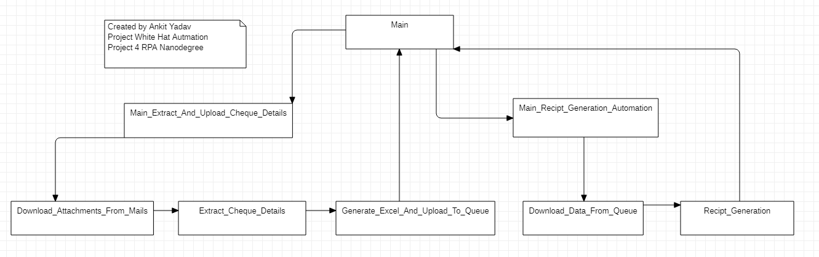

**Detailed Process Map:** This chapter depicts the As-Is business process at a detailed view to enable process owners to document their process

|  |  |  |  |
| --- | --- | --- | --- |
| # | Step Action/Description | Screenshot | Remarks |
| 1 | Choose Email service |  | Select the Email service for Gmail and Yahoo ensure your credentials are stored in assets on orchestrator |
| 2 | Process iterated over attachments one by one |  | Process automatically scans all the cheque images to extract image data |
| 3 | Cheque Images being scanned with OCR |  | Each cheque is scanned one at a time |
| 4 | Automation Successful completion message |  | Automation completed |

# To-Be Process Description

## Detailed Process Map

**High Level To-Be Process Map:** This chapter depicts the To-Be automation process at a High Level to enable developers/COE to have a high-level understanding of the to be developed process.

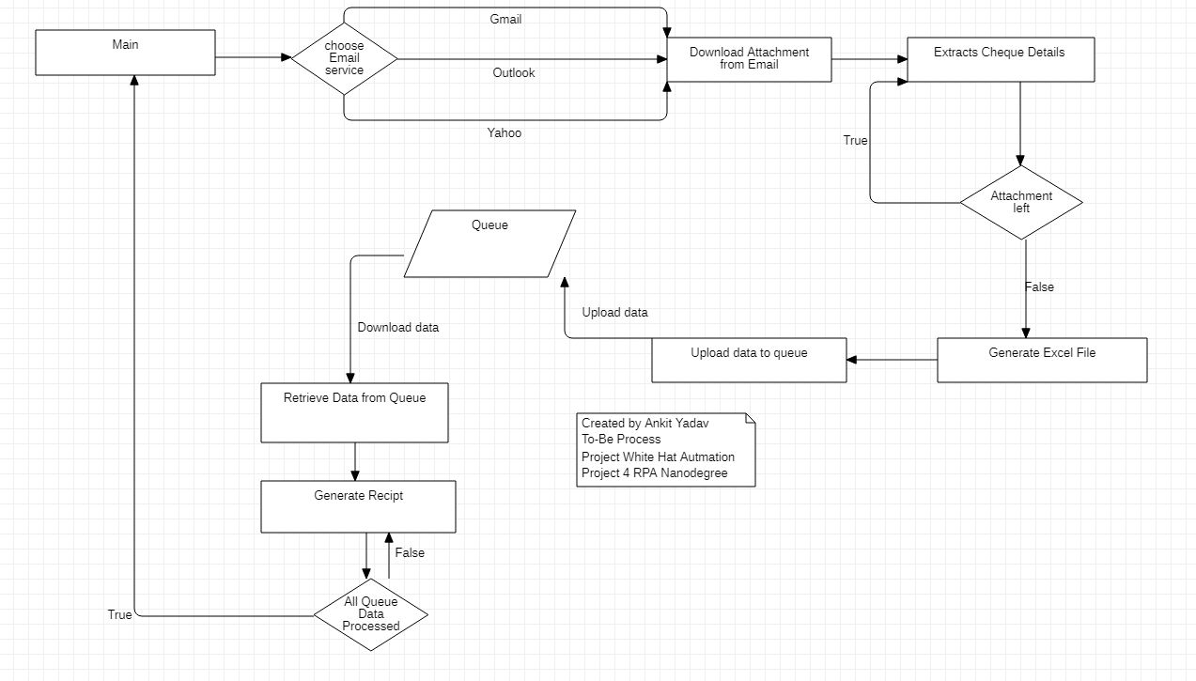**Detailed Process Map:** This chapter depicts the To-Be automation process at a detailed view to enable developers/COE to see the workflows involved in the RPA solution

|  |  |  |  |  |  |
| --- | --- | --- | --- | --- | --- |
| **Workflow Name** | **Description** | **Pre-conditions** | **Post-actions** | **Arguments** | **Notes** |
| Main | This XAML file is responsible for combining the two workflows to achieve automation as a whole | N/A | N/A | N/A | N/A |
| Main_Extract_And_Upload_Cheque_Details | This XAML file is responsible for executing all the workflows in a sequence to achieve the complete automation of the workflow | N/A | Cheque Attachment downloaded and Excel File generated and data uploaded | N/A | N/A |
| Download_Attachments_From_Mails | This XAML file is responsible for Downloading the attachments from the E-mail with the specified subjects. | N/A | Attachments are downloaded into a folder "Cheque_Attachment | out_No_Of_Attachments out_mail_choice | Need to upload credentials to assets on orchestrator before hand if using Gmail or Yahoo options |
| Extract_Cheque_Details | This XAML file is responsible for extracting Cheque Details via OCR and loading it into the xlsx file . | Attachments Downloaded and placed in Cheque_Attachment Folder | All Cheque Details are extracted and stored in an XLSX File. | in_No_Of_Attachments out_DT_Cheque_Details out_Generated_XLSX_File_Path | N/A |
| Generate_Excel_And_Upload_To_Queue | This XAML file is responsible for generating the xlsx file as well as dispatching the Cheque details to Queue | Attachment Downloaded and details extracted | XLSX file generated and Cheque details uploaded to Queue | in_DT_Cheque_Details in_Generated_XLSX_File_Path | N/A |
| Download_Data_From_Queue | This XAML file is responsible for downloading data from the Queue and generate receipts. | Details Uploaded on Queue | Recipts are Generated and stored in folder Recipts | out_Amount out_Cheque_Date out_Payee out_Cheque_No | N/A |
| Main_Recipt_Generation_Automation | his XAML file is responsible for executing all sub workflows in sequence to achieve this automation workflow fully. | Details Uploaded on Queue | Receipts are generated for all the processed Cheques. | N/A | N/A |
|  |  |  |  |  |  |

## Robot Type

|  |  |  |  |  |
| --- | --- | --- | --- | --- |
| # | Attended | Unattended | Trigger | Comments |
| 1 | Attended | N/A | N/A |  |

## Business Exceptions Handling

The Business Process Owner and Business Analysts are expected to document below all the business exceptions identified in the automation process. These can be classified as:

### Known Exceptions

The table below reflects all the business process exceptions encountered during the process evaluation and documentation. These are known exceptions that occurred before. For each of these exceptions, define a corresponding expected action that the robot should complete if it encounters the exception.

|  |  |  |  |  |
| --- | --- | --- | --- | --- |
| BE # | Exception Name | Step | Parameters | Action to be Taken |
| 1 | No Attachment | Log a message | N/A | Log a Message “No Attachment found Please Check your mail box and try again !!” |
| 2. | Close Open Excel file | Log a message and close open XLSX File | N/A | Close Open XLSX File |
|  |  |  |  |  |

### Unknown Exceptions

For all other unanticipated or unknown business (process) exceptions, the robot should:

* The Robot will add a log message with a specified Log Level for every unanticipated exception occurs. In most cases it will continue until a fatal exception occurs.

## System Exceptions Handling

A comprehensive list of all errors, warnings or notifications should be consolidated here with the description and action to be taken, for each, by the robot.

Errors identified in the automation process can be classified as:

|  |  |  |  |  |
| --- | --- | --- | --- | --- |
| SE # | Exception Name | Step | Parameters | Action to be Taken |
| 1 | Attachment Download Error | Log a message | N/A | Log a message “Unable to download attachments” |
| 2 | Asset access error | Log a Message | N/A | Log a message “Unable to access * Mail Credentials Assets” |
| 3. | Email Access Error | Log a Message | N/A | Log a message” Error in connecting to Email” |

For all the other unanticipated or unknown system exceptions, send an email to **<drkkgy@gmail.com >** and attach a screenshot of the error message.

# Other Observations

Include below any other relevant observations you consider needed to be documented here.

* If using Email Service other than Outlook ensure your credentials are present in Asset on Orchestrator

# Additional sources of process documentation

* WhiteHatAutomaton-whiteboard-v1.xlsx
* WhiteHatAutomaton-development-specifications-document-dsd-v1.pdf