Sheikh Ibrar i170-192

Ali Hamza i170-254

Amna Zahid i170-286

Database Project

PAkistan POst

4/29/2019 Database

**National University of Computer & Emerging Sciences, FAST, Islamabad**

**Computer Science Department**

# HOME WORK - ASSIGNMENT COVER SHEET

COURSE TITLE DATABASE SYSTEMS COURSE CODE CS203

INSTRUCTOR Dr. EJAZ AHMED TYPE √ (Please tick)

Indiv. Group

ASSIGNMENT NO 1

ASSIGNMENT Lab Project –PAK Post Services

HAND OUT DATE 08-APR-2019 DUE DATE 25-APR-2019

ESTIMATE TIME 28 Hours

|  |  |
| --- | --- |
| ASSESSMENT CRITERIA (or attached) | % Mark |
| Instructions to Candidates:  Grade Distribution is Attached  Submission: Print & online slate followed by Demo/ presentation  Tools: **Oracle Database & PHP**  Group of max 4 students is allowed, individual work is discouraged with 10% deduction |  |

|  |
| --- |
| TO BE COMPLETED BY STUDENT GROUP MEMBERS ID  ID i170254 Sec# E  ID i170286 Sec# E  ID i170192 Sec# E  ID Sec#  ID Sec#  +  NAME Ali Hamza  ID NO i170254  Time Taken 14 Days  DECLARATION: I/We declare that this Coursework is my/our group’s own work  SIGNATURES (All members) |

|  |
| --- |
| GRADE/ MARK AWARDED COMMENTS  INSTRUCTOR’S SIGNATURE DATE |

Contents

ER DIAGRAM 3

ER QUESTIONS 4

LOGICAL SCHEMA 5

DDL AND RECORDS 10

DATASET 25

FORMS & REPORTS 30

**ER Diagram:**

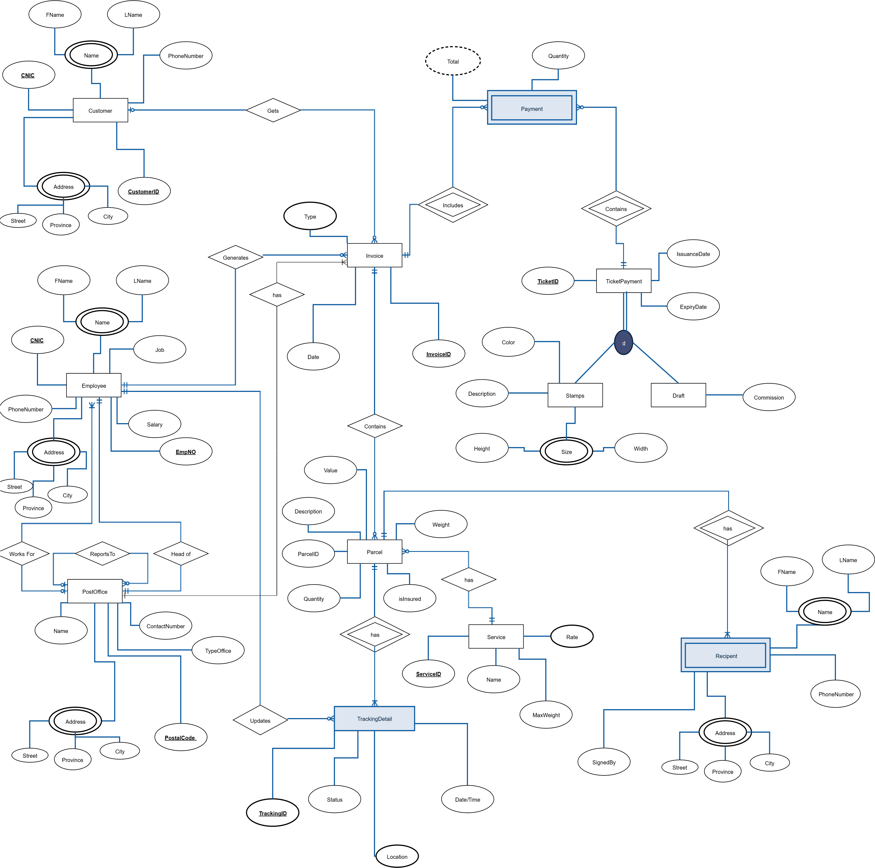

**ER Questions:**

Q1: How a Customer Will send a Parcel?

Q2: What Services a Customer can Avail when sending a parcel?

Q3: Who will Update the Parcel Tracking Information?

Q4: How Tickets purchase Information Will be stored?

Q5: How Recipient Information Will be managed?

Q6: How Invoice Will Be Issued?

Q7: Who Will be the Participants in the Invoice process?

Q8: Which type of Information an employee can update in tracking details of a parcel?

Q9: How Tracking Details of a parcel are stored?

Q10: How many Parcels an Invoice Can Have? How will bounced parcels be managed?

**Logical Schema:**

|  |  |  |  |  |  |  |  |  |  |  |  |  |
| --- | --- | --- | --- | --- | --- | --- | --- | --- | --- | --- | --- | --- |
| Customer | **CustomerID** | CNIC | FName | LName | PhoneNumber | Street |  |  |  |  |  |  |
|  | City | Province |  |  |  |  |  |  |  |  |  |  |
|  | | | | | | | | | |  |  |  |
| Employee | **Empno** | FName | LName | CNIC | PhoneNumber | Job |  |  |  |  |  |  |
|  | Salary | Street | City | BranchID=Post_Office (PostalCode) | | |  |  |  |  |  |  |
|  | | | | | | | | | |  |  |  |
| Invoice | **InvoiceID** | Type | InDate | CustomerID | Empno | PostalCode |  |  |  |  |  |  |
| InvoiceID=Invoice(InvoiceID) | | BranchID=Post_Office (PostalCode) | | CustomerID=Customer (CustomerID) | | Empno=Employee (Empno) | |  |  |  |  |  |
|  | | | | | | | | |  |  |  |  |
| Post_Office | **PostalCode** | Name | OfficeType | Street | City | Province | Head |  |  |  |  |  |
|  | ContactNumber | Head=Employee (Empno) | |  |  |  |  |  |  |  |  |  |
|  | | | | | | | | | | | | |
| Service | **ServiceID** | Name | MaxWeight | Rate |  |  |  |  |  |  |  |  |
|  | | | | | | | | | |  |  |  |
| Parcel | **ParcelID** | InvoiceID | Description | Quantity | ServiceID | Weight | IsInsurred |  |  |  |  |  |
|  | Value | InvoiceID=Invoice (InvoiceID) | | ServiceID=Service (ServiceID) | |  |  |  |  |  |  |  |
|  | | | | | | | | | | | | |
| Recipient | **ParcelID** | FName | LName | Street | City | Province |  |  |  |  |  |  |
|  | PhoneNumber | ParcelId=Parcel (ParcelID) | |  |  |  |  |  |  |  |  |  |
|  |  |  |  |  |  |  |  |  |  |  |  |  |
| Tracking_Detail | **ParcelID** | **TrackingID** | Empno | Status | Location | Date |  |  |  |  |  |  |
| ParcelId=Parcel (ParcelID) | | Empno=Employee (Empno) | |  |  |  |  |  |  |  |  |  |
|  | | | | | | | | | | |  |  |
| Payment | **InvoiceID** | **TricketID** | Quantity | Total |  |  |  |  |  |  |  |  |
|  | InvoiceID=Invoice (InvoiceID) | | TicketID=Ticket Payment (TicketID) | |  |  |  |  |  |  |  |  |
|  |  |  |  |  |  |  |  |  |  |  |  |  |
| TicketPayment | **TicketID** | IsuanceDate | ExpiryDate | Price |  |  |  |  |  |  |  |  |
|  | | | | | | | |  |  |  |  |  |
| Draft | **TicketID** | Commission | TicketID=TicketPayment (TicketID) | |  |  |  |  |  |  |  |  |
|  | | | | | | | |  |  |  |  |  |
| Stamp | **TicketID** | Description | Color | Height | Width | TicketID=TicketPayment (TicketID) | |  |  |  |  |  |

**DDL:**

**CUSTOMER**

CREATE TABLE CUSTOMER (

CustomerID NUMBER NOT NULL,

CNIC NUMBER(14) NOT NULL,

FName VARCHAR2(25) NOT NULL,

LName VARCHAR2(25) NOT NULL,

Province VARCHAR(25) NOT NULL,

City VARCHAR2(25) NOT NULL,

Street VARCHAR2(50) NOT NULL,

PhoneNumber NUMBER(11) NOT NULL,

PRIMARY KEY(CustomerID)

);

**POST_OFFICE**

CREATE TABLE POST_OFFICE (

POSTALCODE NUMBER NOT NULL,

Name VARCHAR2(40) NOT NULL,

Province VARCHAR(25) NOT NULL,

City VARCHAR2(25) NOT NULL,

Street VARCHAR2(50) NOT NULL,

ContactNumber NUMBER(11) NOT NULL,

OfficeType VARCHAR2(15) NOT NULL,

Head NUMBER ,

GPO NUMBER ,

PRIMARY KEY(POSTALCODE),

FOREIGN KEY(GPO) REFERENCES POST_OFFICE(POSTALCODE) );

**EMPLOYEE**

CREATE TABLE EMPLOYEE (

Empno NUMBER NOT NULL,

CNIC NUMBER(14) NOT NULL,

FName VARCHAR2(25) NOT NULL,

LName VARCHAR2(25) NOT NULL,

Province VARCHAR(25) NOT NULL,

City VARCHAR2(25) NOT NULL,

Street VARCHAR2(50) NOT NULL,

PhoneNumber NUMBER(11) NOT NULL,

Salary NUMBER NOT NULL,

Job VARCHAR2(20) NOT NULL,

BranchID NUMBER ,

FOREIGN KEY(BranchID) REFERENCES POST_OFFICE(POSTALCODE),

PRIMARY KEY(Empno) );

**Head Constraint POST_OFFICE**

ALTER TABLE POST_OFFICE ADD CONSTRAINT fk_Head FOREIGN KEY (Head) REFERENCES EMPLOYEE(Empno);

**TICKET_PAYMENT**

CREATE TABLE TICKET_PAYMENT (

TICKETID NUMBER NOT NULL,

IssuanceDate Date NOT NULL,

ExpiryDate Date NOT NULL,

Price NUMBER NOT NULL,

PRIMARY KEY(TICKETID));

**STAMP**

CREATE TABLE STAMP (

TICKETID NUMBER NOT NULL,

Description VARCHAR2(40) NOT NULL,

COLOR VARCHAR2(10) ,

HEIGHT NUMBER(2) ,

WIDTH NUMBER(2) ,

PRIMARY KEY(TICKETID),

FOREIGN KEY(TICKETID) REFERENCES TICKET_PAYMENT(TICKETID) );

**DRAFT**

CREATE TABLE DRAFT (

TICKETID NUMBER NOT NULL,

Commission NUMBER NOT NULL,

PRIMARY KEY(TICKETID),

FOREIGN KEY(TICKETID) REFERENCES TICKET_PAYMENT(TICKETID) );

**SERVICE**

CREATE TABLE SERVICE (

ServiceID NUMBER NOT NULL,

Name VARCHAR2(20) NOT NULL,

Rate NUMBER NOT NULL,

MaxWeight NUMBER NOT NULL,

PRIMARY KEY(ServiceID) );

**INVOICE**

CREATE TABLE INVOICE (

InvoiceID NUMBER NOT NULL,

CustomerID NUMBER ,

Empno NUMBER NOT NULL,

Type NUMBER NOT NULL,

InDate Date NOT NULL,

POSTALCODE NUMBER NOT NULL,

PRIMARY KEY(InvoiceID),

FOREIGN KEY(Empno) REFERENCES EMPLOYEE(Empno),

FOREIGN KEY(CustomerID) REFERENCES CUSTOMER(CustomerID),

FOREIGN KEY(POSTALCODE) REFERENCES POST_OFFICE(POSTALCODE) );

**PARCEL**

CREATE TABLE PARCEL (

ParcelID NUMBER NOT NULL,

Quantity NUMBER NOT NULL,

Weight NUMBER NOT NULL,

Description VARCHAR2(50) ,

isInsured NUMBER ,

Value NUMBER ,

ServiceID NUMBER ,

InvoiceID NUMBER NOT NULL,

FOREIGN KEY(ServiceID) REFERENCES SERVICE(ServiceID),

FOREIGN KEY(InvoiceID) REFERENCES INVOICE(InvoiceID),

PRIMARY KEY(ParcelID) );

**RECIPIENT**

CREATE TABLE RECIPIENT (

ParcelID NUMBER NOT NULL,

FName VARCHAR2(25) NOT NULL,

LName VARCHAR2(25) NOT NULL,

Province VARCHAR2(25) NOT NULL,

City VARCHAR2(25) NOT NULL,

Street VARCHAR2(50) NOT NULL,

PhoneNumber NUMBER(11) ,

SignedBy VARCHAR2(30) NOT NULL,

FOREIGN KEY(ParcelID) REFERENCES PARCEL(ParcelID) );

**TRACKING_DETAILS**

CREATE TABLE TRACKING_DETAILS (

ParcelID NUMBER NOT NULL,

TrackingID NUMBER NOT NULL,

Empno NUMBER NOT NULL,

Location VARCHAR2(40) NOT NULL,

Status VARCHAR2(100) NOT NULL,

DateANDTime Date ,

PRIMARY KEY(ParcelID,TrackingID),

FOREIGN KEY(ParcelID) REFERENCES PARCEL(ParcelID),

FOREIGN KEY(Empno) REFERENCES EMPLOYEE(Empno) );

**PAYMENT**

CREATE TABLE PAYMENT (

InvoiceID NUMBER NOT NULL,

TICKETID NUMBER NOT NULL,

Quantity NUMBER NOT NULL,

Total NUMBER NOT NULL,

FOREIGN KEY(InvoiceID) REFERENCES INVOICE(InvoiceID),

FOREIGN KEY(TICKETID) REFERENCES TICKET_PAYMENT(TICKETID)

);

**DROPING RELATIONS**

DROP TABLE PAYMENT;

DROP TABLE RECIPIENT;

DROP TABLE TRACKING_DETAILS;

DROP TABLE PARCEL;

DROP TABLE SERVICE;

DROP TABLE INVOICE;

DROP TABLE CUSTOMER;

ALTER TABLE POST_OFFICE DROP CONSTRAINT fk_Head;

DROP TABLE EMPLOYEE;

DROP TABLE POST_OFFICE;

DROP TABLE STAMP;

DROP TABLE DRAFT;

DROP TABLE TICKET_PAYMENT;

**RECORDS**

# Customer Records

INSERT INTO CUSTOMER(CustomerID,FName,LName,CNIC,PhoneNumber,Street,City,Province)  
Values(17000,'Omer','Baig',1740948824551,3099856748,'8221 West Lane ','Attock','Punjab');  
  
INSERT INTO CUSTOMER(CustomerID,FName,LName,CNIC,PhoneNumber,Street,City,Province)  
Values(17001,'Muhammad','Arif',7115276142322,3328388999,'Centereach, NY 11720','Badin','Sindh');  
  
INSERT INTO CUSTOMER(CustomerID,FName,LName,CNIC,PhoneNumber,Street,City,Province)  
Values(17002,'Ishma','Ahmad',1685761892795,3128473311,'17 Snake Hill Dr. ','Bahawal Nagar','Punjab');  
  
INSERT INTO CUSTOMER(CustomerID,FName,LName,CNIC,PhoneNumber,Street,City,Province)  
Values(17003,'Sana','Ali',4312334113874,3348092120,'Conway, SC 29526','Bahawalpur','Punjab');  
  
INSERT INTO CUSTOMER(CustomerID,FName,LName,CNIC,PhoneNumber,Street,City,Province)  
Values(17004,'Shabbir','Hussain',2779319865028,3333456128,'908 N. Orange Road ','Chitral','khyber Pakhtun Khwa');  
  
INSERT INTO CUSTOMER(CustomerID,FName,LName,CNIC,PhoneNumber,Street,City,Province)  
Values(17005,'Ali','Hajan',6024865090061,3214879320,'Middletown, CT 06457','Faisalabad','Punjab');  
  
INSERT INTO CUSTOMER(CustomerID,FName,LName,CNIC,PhoneNumber,Street,City,Province)  
Values(17006,'Abdul','Jabbar',3893446066184,3022931003,'7337 S. Bear Hill Street ','Gilgit','Gilgit Baltistan');  
  
INSERT INTO CUSTOMER(CustomerID,FName,LName,CNIC,PhoneNumber,Street,City,Province)  
Values(17007,'Zahid','Akram',9637882913598,3453784394,'Decatur, GA 30030','Hyderabad','Sindh');  
  
INSERT INTO CUSTOMER(CustomerID,FName,LName,CNIC,PhoneNumber,Street,City,Province)  
Values(17008,'Ghulam','Ansari',4076361542097,3313849393,'130 Cemetery Ave. ','Islamabad','Punjab');  
  
INSERT INTO CUSTOMER(CustomerID,FName,LName,CNIC,PhoneNumber,Street,City,Province)  
Values(17009,'Haider','Naseer',3726016575412,3018498398,'Saint Paul, MN 55104','Karachi','Sindh');  
  
INSERT INTO CUSTOMER(CustomerID,FName,LName,CNIC,PhoneNumber,Street,City,Province)  
Values(17010,'Muhammad','Kashifullah',1460717777335,3328374999,'8237 Purple Finch St. ','Kotli','Azad Kashmir');  
  
INSERT INTO CUSTOMER(CustomerID,FName,LName,CNIC,PhoneNumber,Street,City,Province)  
Values(17011,'Muhammad','Ahmed',9981826603801,3009832841,'Atlantic City, NJ 08401','Mirpur','Azad Kashmir');  
  
INSERT INTO CUSTOMER(CustomerID,FName,LName,CNIC,PhoneNumber,Street,City,Province)  
Values(17012,'Fareed',' Ghulam',2509478351201,3451873899,'50 Locust Street ','Multan','Punjab');  
  
INSERT INTO CUSTOMER(CustomerID,FName,LName,CNIC,PhoneNumber,Street,City,Province)  
Values(17013,'Salman','Haider',6406189841439,3019849390,'Dearborn Heights, MI 48127','Sheikhupura','Punjab');  
  
INSERT INTO CUSTOMER(CustomerID,FName,LName,CNIC,PhoneNumber,Street,City,Province)  
Values(17014,'Ayesha','Altaf',8808778383710,3229489200,'73 North 53rd Lane ','Rawalakot','Azad Kashmir');  
  
INSERT INTO CUSTOMER(CustomerID,FName,LName,CNIC,PhoneNumber,Street,City,Province)  
Values(17015,'Sidra','Khalid',7349651099683,3318378459,'Ellenwood, GA 30294','Rawalpindi','Punjab');  
  
INSERT INTO CUSTOMER(CustomerID,FName,LName,CNIC,PhoneNumber,Street,City,Province)  
Values(17016,'Ahtesham','Zahoor',4849925533374,3332983922,'65 Oak Meadow Street ','Lahore','Punjab');  
  
INSERT INTO CUSTOMER(CustomerID,FName,LName,CNIC,PhoneNumber,Street,City,Province)  
Values(17017,'Ahmed','Rana',3808806819897,3213843478,'Fresno, CA 93706','Gujrat','Punjab');  
  
INSERT INTO CUSTOMER(CustomerID,FName,LName,CNIC,PhoneNumber,Street,City,Province)  
Values(17018,'Hammad','Hashmi',2282890781586,3034989389,'8239 Somerset Street ','Kohat','khyber Pakhtun Khwa');  
  
INSERT INTO CUSTOMER(CustomerID,FName,LName,CNIC,PhoneNumber,Street,City,Province)  
Values(17019,'Muhammad','Shabbir',1242586265392,3127478889,'Frankfort, KY 40601','Larkana','Sindh');  
  
INSERT INTO CUSTOMER(CustomerID,FName,LName,CNIC,PhoneNumber,Street,City,Province)  
Values(17020,'Umer','Amin',4618211976295,3339999002,'80 Park Street ','Mianwali','Punjab');  
  
INSERT INTO CUSTOMER(CustomerID,FName,LName,CNIC,PhoneNumber,Street,City,Province)  
Values(17021,'Ali','Avais',2003918195325,3349283222,'Shepherdsville, KY 40165','Mardan','khyber Pakhtun Khwa');  
  
INSERT INTO CUSTOMER(CustomerID,FName,LName,CNIC,PhoneNumber,Street,City,Province)  
Values(17022,'Waleed','Abbas',2586772294196,3374783849,'970 South Meadowbrook St. ','Murree','Punjab');  
  
INSERT INTO CUSTOMER(CustomerID,FName,LName,CNIC,PhoneNumber,Street,City,Province)  
Values(17023,'Rana','Tariq',9825549125083,3048378477,'Rosedale, NY 11422','Muzaffarabad','Azad Kashmir');  
  
INSERT INTO CUSTOMER(CustomerID,FName,LName,CNIC,PhoneNumber,Street,City,Province)  
Values(17024,'Zahra','Akhtar',9396799769357,3341110006,'9124 North Evergreen Ave. ','Nawabshah','Sindh');  
  
INSERT INTO CUSTOMER(CustomerID,FName,LName,CNIC,PhoneNumber,Street,City,Province)  
Values(17025,'Mariam','Khalid',6658254416163,3334899000,'Uniondale, NY 11553','Okara','Punjab');  
  
INSERT INTO CUSTOMER(CustomerID,FName,LName,CNIC,PhoneNumber,Street,City,Province)  
Values(17026,'Ayesha','Naveed',3553282536186,3092477588,'9148 Silver Spear Drive ','Shikarpur','Sindh');  
  
INSERT INTO CUSTOMER(CustomerID,FName,LName,CNIC,PhoneNumber,Street,City,Province)  
Values(17027,'Raja','Altaf',2146291503649,3019489302,'Brockton, MA 02301','Sibi','balochistan');  
  
INSERT INTO CUSTOMER(CustomerID,FName,LName,CNIC,PhoneNumber,Street,City,Province)  
Values(17028,'Khayyam','Kamal',2934405963428,3083829000,'53 Court St. ','Nowshera','khyber Pakhtun Khwa');  
  
INSERT INTO CUSTOMER(CustomerID,FName,LName,CNIC,PhoneNumber,Street,City,Province)  
Values(17029,'Hurraira','Imran',8758125744444,3303289393,'Livingston, NJ 07039','Mirpur','Azad Kashmir');  
  
INSERT INTO CUSTOMER(CustomerID,FName,LName,CNIC,PhoneNumber,Street,City,Province)  
Values(17030,'Ibrar','Kardar',2930778730382,3379389893,'430 Lake View Ave. ','Kalat','balochistan');  
  
INSERT INTO CUSTOMER(CustomerID,FName,LName,CNIC,PhoneNumber,Street,City,Province)  
Values(17031,'Saad','Rana',5203729753432,3373478939,'Natick, MA 01760','Ghazi khan','Punjab');  
  
INSERT INTO CUSTOMER(CustomerID,FName,LName,CNIC,PhoneNumber,Street,City,Province)  
Values(17032,'Javaid','Hashmi',1132535122264,3362873287,'875 Ashley Drive ','Islamabad','Punjab');  
  
INSERT INTO CUSTOMER(CustomerID,FName,LName,CNIC,PhoneNumber,Street,City,Province)  
Values(17033,'Muhammad','Shabbir',7034005310675,3222878330,'Canyon Country, CA 91387','Lahore','Punjab');

# Employee Records

INSERT INTO EMPLOYEE(Empno,FName,LName,CNIC,Job,Salary,PhoneNumber,Street,City,Province)  
Values(15000,'Aaron','Alam',1740948824551,'Head',50000,3174094882,'House11,Street 35,Model Town','Rawalpindi','Punjab');  
  
INSERT INTO EMPLOYEE(Empno,FName,LName,CNIC,Job,Salary,PhoneNumber,Street,City,Province)  
Values(15001,'Abbott','Allee',7115276142322,'Clerk',35000,3455171152,'House14,Street 25,Iqbal Town','Rawalpindi','Punjab');  
  
INSERT INTO EMPLOYEE(Empno,FName,LName,CNIC,Job,Salary,PhoneNumber,Street,City,Province)  
Values(15002,'Abdulaziz','Alli',1685761892795,'Mail Carrier',20000,3761423221,'House34,Street 23,Satellite Town','Rawalpindi','Punjab');  
  
INSERT INTO EMPLOYEE(Empno,FName,LName,CNIC,Job,Salary,PhoneNumber,Street,City,Province)  
Values(15003,'Abuna','Ally',4312334113874,'Mail Processor',25000,3685761892,'House41,Street 12,Fazia Kaloni','Rawalpindi','Punjab');  
  
INSERT INTO EMPLOYEE(Empno,FName,LName,CNIC,Job,Salary,PhoneNumber,Street,City,Province)  
Values(15004,'Adalai','Aly',2779319865028,'Head',50000,3795431233,'House11,Street 35,G11/3','Islamabad','Punjab');  
  
INSERT INTO EMPLOYEE(Empno,FName,LName,CNIC,Job,Salary,PhoneNumber,Street,City,Province)  
Values(15005,'Adham','Aman',6024865090061,'Clerk',35000,3411387427,'House31,Street 12,G7/2','Islamabad','Punjab');  
  
INSERT INTO EMPLOYEE(Empno,FName,LName,CNIC,Job,Salary,PhoneNumber,Street,City,Province)  
Values(15006,'Ahmad','Amara',3893446066184,'Mail Carrier',20000,3793198650,'NTC Head Quarters Sector F-5/1','Islamabad','Punjab');  
  
INSERT INTO EMPLOYEE(Empno,FName,LName,CNIC,Job,Salary,PhoneNumber,Street,City,Province)  
Values(15007,'Akbar','Amber',9637882913598,'Mail Processor',25000,3286024865,'Ist Flr. Ghulam Rasool Plaza, Fazal-E-Haq Road','Islamabad','Punjab');  
  
INSERT INTO EMPLOYEE(Empno,FName,LName,CNIC,Job,Salary,PhoneNumber,Street,City,Province)  
Values(15008,'Al-Ashab','Ameen',4076361542097,'Head',50000,3090061389,'Sheikhupura Road Shahdara More','Lahore','Punjab');  
  
INSERT INTO EMPLOYEE(Empno,FName,LName,CNIC,Job,Salary,PhoneNumber,Street,City,Province)  
Values(15009,'Ali','Amen',3726016575412,'Clerk',35000,3344606618,'National Hotel','Lahore','Punjab');  
  
INSERT INTO EMPLOYEE(Empno,FName,LName,CNIC,Job,Salary,PhoneNumber,Street,City,Province)  
Values(15010,'Amal','Amin',3599818266038,'Mail Processor',25000,3135984076,'41/A,Empress Road','Lahore','Punjab');  
  
INSERT INTO EMPLOYEE(Empno,FName,LName,CNIC,Job,Salary,PhoneNumber,Street,City,Province)  
Values(15011,'Amaros','Amini',125094783512,'Head',50000,3361542097,'Tehkal Bala Road','Peshawar','khyber Pakhtun khwa');  
  
INSERT INTO EMPLOYEE(Empno,FName,LName,CNIC,Job,Salary,PhoneNumber,Street,City,Province)  
Values(15012,'Amir','Amir',164061898414,'Clerk',35000,3372601657,'Cantt.','Peshawar','khyber Pakhtun khwa');  
  
INSERT INTO EMPLOYEE(Empno,FName,LName,CNIC,Job,Salary,PhoneNumber,Street,City,Province)  
Values(15013,'Ankhhaf','Amir',3988087783837,'Mail Carrier',20000,3541200146,'Hayatabad','Peshawar','khyber Pakhtun khwa');  
  
INSERT INTO EMPLOYEE(Empno,FName,LName,CNIC,Job,Salary,PhoneNumber,Street,City,Province)  
Values(15014,'Ara','Amiri',1073496510996,'Mail Processor',25000,3071777733,'26-Soekarno Square Opp.Karachi Mkt.Khyber Bazar','Peshawar','khyber Pakhtun khwa');  
  
INSERT INTO EMPLOYEE(Empno,FName,LName,CNIC,Job,Salary,PhoneNumber,Street,City,Province)  
Values(15015,'Arash','Ammar',8348499255333,'Head',50000,3599818266,'Near New Passport Office, Mansehra Road','Abbotabad','khyber Pakhtun khwa');  
  
INSERT INTO EMPLOYEE(Empno,FName,LName,CNIC,Job,Salary,PhoneNumber,Street,City,Province)  
Values(15016,'Arslan','Ansari',7438088068198,'Clerk',35000,3038012509,'Tehkal Bala Road','Abbotabad','khyber Pakhtun khwa');  
  
INSERT INTO EMPLOYEE(Empno,FName,LName,CNIC,Job,Salary,PhoneNumber,Street,City,Province)  
Values(15017,'Asad','Anwar',9722828907815,'Mail Carrier',20000,3478351201,'Near Circle Town,West Road','Abbotabad','khyber Pakhtun khwa');  
  
INSERT INTO EMPLOYEE(Empno,FName,LName,CNIC,Job,Salary,PhoneNumber,Street,City,Province)  
Values(15018,'Azad','Arafat',8612425862653,'Mail Processor',25000,3640618984,'Near Peshawar Point,Lal Road','Abbotabad','khyber Pakhtun khwa');  
  
INSERT INTO EMPLOYEE(Empno,FName,LName,CNIC,Job,Salary,PhoneNumber,Street,City,Province)  
Values(15019,'Azeem','Arif',9246182119762,'Head',50000,3143988087,'G.T.Road','Kohat','khyber Pakhtun khwa');  
  
INSERT INTO EMPLOYEE(Empno,FName,LName,CNIC,Job,Salary,PhoneNumber,Street,City,Province)  
Values(15020,'Badr','Arshad',9520039181953,'Clerk',35000,3783837107,'Sarhad Medicos Opp.Shah Faisal Gate','Kohat','khyber Pakhtun khwa');  
  
INSERT INTO EMPLOYEE(Empno,FName,LName,CNIC,Job,Salary,PhoneNumber,Street,City,Province)  
Values(15021,'Basim','Ashraf',9698255491250,'Mail Processor',25000,3683484992,'Burbank, IL 60459','Kohat','khyber Pakhtun khwa');  
  
INSERT INTO EMPLOYEE(Empno,FName,LName,CNIC,Job,Salary,PhoneNumber,Street,City,Province)  
Values(15022,'Borak','Aslam',8393967997693,'Head',50000,3553337438,'9569 Fifth Lane ','Karachi','Sindh');  
  
INSERT INTO EMPLOYEE(Empno,FName,LName,CNIC,Job,Salary,PhoneNumber,Street,City,Province)  
Values(15023,'Boutros','Asmar',5766582544161,'Clerk',35000,3088068198,'Loveland, OH 45140','Karachi','Sindh');  
  
INSERT INTO EMPLOYEE(Empno,FName,LName,CNIC,Job,Salary,PhoneNumber,Street,City,Province)  
Values(15024,'Coman','Assad',6335532825361,'Mail Carrier',20000,3972282890,'603 Walnutwood Dr. ','Karachi','Sindh');  
  
INSERT INTO EMPLOYEE(Empno,FName,LName,CNIC,Job,Salary,PhoneNumber,Street,City,Province)  
Values(15025,'Fahd','Assad',8621462915036,'Mail Processor',25000,3781586124,'San Jose, CA 95127','Karachi','Sindh');  
  
INSERT INTO EMPLOYEE(Empno,FName,LName,CNIC,Job,Salary,PhoneNumber,Street,City,Province)  
Values(15026,'Faisal','Assaf',4929344059634,'Head',50000,3258626539,'49 Clinton Street ','Hyderabad','Sindh');  
  
INSERT INTO EMPLOYEE(Empno,FName,LName,CNIC,Job,Salary,PhoneNumber,Street,City,Province)  
Values(15027,'Fakih','Atallah',2887581257444,'Clerk',35000,3246182119,'Schenectady, NY 12302','Hyderabad','Sindh');  
  
INSERT INTO EMPLOYEE(Empno,FName,LName,CNIC,Job,Salary,PhoneNumber,Street,City,Province)  
Values(15028,'Faraz','Attar',4429307787303,'Mail Carrier',20000,3762952003,'544 E. Military Dr. ','Hyderabad','Sindh');  
  
INSERT INTO EMPLOYEE(Empno,FName,LName,CNIC,Job,Salary,PhoneNumber,Street,City,Province)  
Values(15029,'Fatin','Awan',8252037297534,'Mail Processor',25000,3918195325,'Davison, MI 48423','Hyderabad','Sindh');  
  
INSERT INTO EMPLOYEE(Empno,FName,LName,CNIC,Job,Salary,PhoneNumber,Street,City,Province)  
Values(15030,'Ferran','Aydin',3211325351222,'Head',50000,3258677229,'8490 Rockcrest Ave. ','Jacobabad','Sindh');  
  
INSERT INTO EMPLOYEE(Empno,FName,LName,CNIC,Job,Salary,PhoneNumber,Street,City,Province)  
Values(15031,'Gamal','Ayoob',6407034005310,'Clerk',35000,3419698255,'Westport, CT 06880','Jacobabad','Sindh');  
  
INSERT INTO EMPLOYEE(Empno,FName,LName,CNIC,Job,Salary,PhoneNumber,Street,City,Province)  
Values(15032,'Ghazi','Ayub',2168314849207,'Mail Processor',25000,3396799769,'Kingsport, TN 37660','Jacobabad','Sindh');  
  
INSERT INTO EMPLOYEE(Empno,FName,LName,CNIC,Job,Salary,PhoneNumber,Street,City,Province)  
Values(15033,'Guadalupe','Azad',607056738492,'Head',50000,3357665825,'9954 El Dorado Lane ','Quetta','Balochistan');  
  
INSERT INTO EMPLOYEE(Empno,FName,LName,CNIC,Job,Salary,PhoneNumber,Street,City,Province)  
Values(15034,'Habib','Azam',6577457983022,'Clerk',35000,3441616335,'Clarksville, TN 37040','Quetta','Balochistan');  
  
INSERT INTO EMPLOYEE(Empno,FName,LName,CNIC,Job,Salary,PhoneNumber,Street,City,Province)  
Values(15035,'Haddad','Azer',3671554026061,'Mail Carrier',20000,3532825361,'3 Division Street ','Quetta','Balochistan');  
  
INSERT INTO EMPLOYEE(Empno,FName,LName,CNIC,Job,Salary,PhoneNumber,Street,City,Province)  
Values(15036,'Hadi','Azimi',1173004830129,'Mail Processor',25000,3862146291,'Mobile, AL 36605','Quetta','Balochistan');  
  
INSERT INTO EMPLOYEE(Empno,FName,LName,CNIC,Job,Salary,PhoneNumber,Street,City,Province)  
Values(15037,'Hafez','Aziz',388577089307,'Head',50000,3503649293,'25 Broad Street ','Khuzdar','Balochistan');  
  
INSERT INTO EMPLOYEE(Empno,FName,LName,CNIC,Job,Salary,PhoneNumber,Street,City,Province)  
Values(15038,'Haidar','Azizi',4783710083450,'Clerk',35000,3440596342,'South Bend, IN 46614','Khuzdar','Balochistan');  
  
INSERT INTO EMPLOYEE(Empno,FName,LName,CNIC,Job,Salary,PhoneNumber,Street,City,Province)  
Values(15039,'Hakeem','Azzam',1456203566676,'Mail Carrier',20000,3887581257,'34 Ivy Drive ','Khuzdar','Balochistan');  
  
INSERT INTO EMPLOYEE(Empno,FName,LName,CNIC,Job,Salary,PhoneNumber,Street,City,Province)  
Values(15040,'Hamal','Azzi',7719162727651,'Mail Processor',25000,3444442930,'Andover, MA 01810','Khuzdar','Balochistan');  
  
INSERT INTO EMPLOYEE(Empno,FName,LName,CNIC,Job,Salary,PhoneNumber,Street,City,Province)  
Values(15041,'Hamid','Azzi',3995926532444,'Head',50000,3778730382,'67 Squaw Creek St. ','Turbat','Balochistan');  
  
INSERT INTO EMPLOYEE(Empno,FName,LName,CNIC,Job,Salary,PhoneNumber,Street,City,Province)  
Values(15042,'Hamza','Bacchus',2792373157858,'Clerk',35000,3520372975,'Desoto, TX 75115','Turbat','Balochistan');  
  
INSERT INTO EMPLOYEE(Empno,FName,LName,CNIC,Job,Salary,PhoneNumber,Street,City,Province)  
Values(15043,'Harun','Bacho',3089134746365,'Mail Processor',25000,3351222640,'Rolling Meadows, IL 60008','Turbat','Balochistan');  
  
INSERT INTO EMPLOYEE(Empno,FName,LName,CNIC,Job,Salary,PhoneNumber,Street,City,Province)  
Values(15044,'Hasan','Baddour',2810315522174,'Head',50000,3703400531,'25 Bishop St. ','Mirpur','Azad Kashmir');  
  
INSERT INTO EMPLOYEE(Empno,FName,LName,CNIC,Job,Salary,PhoneNumber,Street,City,Province)  
Values(15045,'Hormoz','Badie',8236303528072,'Clerk',35000,3067500454,'Providence, RI 02904','Mirpur','Azad Kashmir');  
  
INSERT INTO EMPLOYEE(Empno,FName,LName,CNIC,Job,Salary,PhoneNumber,Street,City,Province)  
Values(15046,'Abia','Badour',2591085079053,'Mail Carrier',20000,3956482168,'97 Tallwood Street ','Mirpur','Azad Kashmir');  
  
INSERT INTO EMPLOYEE(Empno,FName,LName,CNIC,Job,Salary,PhoneNumber,Street,City,Province)  
Values(15047,'Afra','Bagheri',4104859254139,'Mail Processor',25000,3314849207,'Glendale Heights, IL 60139','Mirpur','Azad Kashmir');  
  
INSERT INTO EMPLOYEE(Empno,FName,LName,CNIC,Job,Salary,PhoneNumber,Street,City,Province)  
Values(15048,'Ah lam','Bahri',5827961771903,'Head',50000,3060705673,'7784 Church St. ','Kotli','Azad Kashmir');  
  
INSERT INTO EMPLOYEE(Empno,FName,LName,CNIC,Job,Salary,PhoneNumber,Street,City,Province)  
Values(15049,'Aisha','Baig',4175332412908,'Clerk',35000,3849265774,'Selden, NY 11784','Kotli','Azad Kashmir');  
  
INSERT INTO EMPLOYEE(Empno,FName,LName,CNIC,Job,Salary,PhoneNumber,Street,City,Province)  
Values(15050,'Akilah','Baksh',7456807743136,'Mail Carrier',20000,3579830223,'88 Schoolhouse Court ','Kotli','Azad Kashmir');  
  
INSERT INTO EMPLOYEE(Empno,FName,LName,CNIC,Job,Salary,PhoneNumber,Street,City,Province)  
Values(15051,'Alima','Baluch',3019042931482,'Mail Processor',25000,3671554026,'Great Falls, MT 59404','Kotli','Azad Kashmir');  
  
INSERT INTO EMPLOYEE(Empno,FName,LName,CNIC,Job,Salary,PhoneNumber,Street,City,Province)  
Values(15052,'Aliye','Bangura',559328748143,'Head',50000,3061117300,'9037 E. Clay Street ','Bhimber','Azad Kashmir');  
  
INSERT INTO EMPLOYEE(Empno,FName,LName,CNIC,Job,Salary,PhoneNumber,Street,City,Province)  
Values(15053,'Alyssa','Barakat',5526892959450,'Clerk',0,3483012903,'Wasilla, AK 99654','Bhimber','Azad Kashmir');  
  
INSERT INTO EMPLOYEE(Empno,FName,LName,CNIC,Job,Salary,PhoneNumber,Street,City,Province)  
Values(15054,'Amina','Basha',3370955837837,'Mail Processor',25000,3074783710,'New Windsor, NY 12553','Bhimber','Azad Kashmir');

# POST_OFFICE Records

INSERT INTO POST_OFFICE(POSTALCODE,Name,OfficeType,Head,ContactNumber,Street,City,Province)  
Values(24100,'PO.Urdu Bazar','GPO',15000,514416000,'Street1,Urdu Baraz','Rawalpindi','Punjab');  
  
INSERT INTO POST_OFFICE(POSTALCODE,Name,OfficeType,Head,ContactNumber,Street,City,Province,GPO)  
Values(24101,'PO.F7','DELIVERY',15001,514416001,'F7 Markaz','Islamabad','Punjab',24100);  
  
INSERT INTO POST_OFFICE(POSTALCODE,Name,OfficeType,Head,ContactNumber,Street,City,Province,GPO)  
Values(24102,'PO.Anar kali','NON-DELIVERY',15002,424416002,'AnarKali Baraz','Lahore','Punjab',24100);  
  
INSERT INTO POST_OFFICE(POSTALCODE,Name,OfficeType,Head,ContactNumber,Street,City,Province)  
Values(62300,'PO.Clifton','GPO',15003,214416003,'Cliffon','Karachi','Sindh');  
  
INSERT INTO POST_OFFICE(POSTALCODE,Name,OfficeType,Head,ContactNumber,Street,City,Province,GPO)  
Values(62301,'PO.Diamond Market','DELIVERY',15004,224416004,'Diamond Market','Hyderabad','Sindh',62300);  
  
INSERT INTO POST_OFFICE(POSTALCODE,Name,OfficeType,Head,ContactNumber,Street,City,Province,GPO)  
Values(62302,'PO.Abazai','NON-DELIVERY',15005,7224416005,'Abazai','Jacobabad','Sindh',62300);  
  
INSERT INTO POST_OFFICE(POSTALCODE,Name,OfficeType,Head,ContactNumber,Street,City,Province)  
Values(77150,'PO.Ziarat','GPO',15006,814416006,'Ziarat','Quetta','Balochistan');  
  
INSERT INTO POST_OFFICE(POSTALCODE,Name,OfficeType,Head,ContactNumber,Street,City,Province,GPO)  
Values(77151,'PO.Banali Market','DELIVERY',15007,824416007,'banali market','Khuzdar','Balochistan',77150);  
  
INSERT INTO POST_OFFICE(POSTALCODE,Name,OfficeType,Head,ContactNumber,Street,City,Province,GPO)  
Values(77152,'PO.Saddar','NON-DELIVERY',15008,834416008,'saddar','Turbat','Balochistan',77150);  
  
INSERT INTO POST_OFFICE(POSTALCODE,Name,OfficeType,Head,ContactNumber,Street,City,Province)  
Values(42200,'PO.Kapra Market','GPO',15009,914416009,'kapra market','Peshawar','khyber Pakhtun khwa');  
  
INSERT INTO POST_OFFICE(POSTALCODE,Name,OfficeType,Head,ContactNumber,Street,City,Province,GPO)  
Values(42201,'PO.Mall Road','DELIVERY',15010,9924416010,'mall road','Abbotabad','khyber Pakhtun khwa',42200);  
  
INSERT INTO POST_OFFICE(POSTALCODE,Name,OfficeType,Head,ContactNumber,Street,City,Province,GPO)  
Values(42202,'PO.Shahi Qila','NON-DELIVERY',15011,9224416011,'shahi qila','Kohat','khyber Pakhtun khwa',42200);  
  
INSERT INTO POST_OFFICE(POSTALCODE,Name,OfficeType,Head,ContactNumber,Street,City,Province)  
Values(67450,'PO.Mangla','GPO',15016,2324416012,'mangla','Mirpur','Azad Kashmir');  
  
INSERT INTO POST_OFFICE(POSTALCODE,Name,OfficeType,Head,ContactNumber,Street,City,Province,GPO)  
Values(67451,'PO.Azad Pathan Gul','DELIVERY',15018,2334416013,'azad pathan gul','Kotli','Azad Kashmir',67450);  
  
INSERT INTO POST_OFFICE(POSTALCODE,Name,OfficeType,Head,ContactNumber,Street,City,Province,GPO)  
Values(67452,'PO.Thorar','NON-DELIVERY',15020,2344416014,'thorar','Bhimber','Azad Kashmir',67450);

# Employee Update

UPDATE EMPLOYEE SET BranchID=24100 WHERE Empno=15000;  
  
UPDATE EMPLOYEE SET BranchID=24100 WHERE Empno=15001;  
  
UPDATE EMPLOYEE SET BranchID=24100 WHERE Empno=15002;  
  
UPDATE EMPLOYEE SET BranchID=24100 WHERE Empno=15003;  
  
UPDATE EMPLOYEE SET BranchID=24101 WHERE Empno=15004;  
  
UPDATE EMPLOYEE SET BranchID=24101 WHERE Empno=15005;  
  
UPDATE EMPLOYEE SET BranchID=24101 WHERE Empno=15006;  
  
UPDATE EMPLOYEE SET BranchID=24101 WHERE Empno=15007;  
  
UPDATE EMPLOYEE SET BranchID=24102 WHERE Empno=15008;  
  
UPDATE EMPLOYEE SET BranchID=24102 WHERE Empno=15009;  
  
UPDATE EMPLOYEE SET BranchID=24102 WHERE Empno=15010;  
  
UPDATE EMPLOYEE SET BranchID=42200 WHERE Empno=15011;  
  
UPDATE EMPLOYEE SET BranchID=42200 WHERE Empno=15012;  
  
UPDATE EMPLOYEE SET BranchID=42200 WHERE Empno=15013;  
  
UPDATE EMPLOYEE SET BranchID=42200 WHERE Empno=15014;  
  
UPDATE EMPLOYEE SET BranchID=42201 WHERE Empno=15015;  
  
UPDATE EMPLOYEE SET BranchID=42201 WHERE Empno=15016;  
  
UPDATE EMPLOYEE SET BranchID=42201 WHERE Empno=15017;  
  
UPDATE EMPLOYEE SET BranchID=42201 WHERE Empno=15018;  
  
UPDATE EMPLOYEE SET BranchID=42202 WHERE Empno=15019;  
  
UPDATE EMPLOYEE SET BranchID=42202 WHERE Empno=15020;  
  
UPDATE EMPLOYEE SET BranchID=42202 WHERE Empno=15021;  
  
UPDATE EMPLOYEE SET BranchID=62300 WHERE Empno=15022;  
  
UPDATE EMPLOYEE SET BranchID=62300 WHERE Empno=15023;  
  
UPDATE EMPLOYEE SET BranchID=62300 WHERE Empno=15024;  
  
UPDATE EMPLOYEE SET BranchID=62300 WHERE Empno=15025;  
  
UPDATE EMPLOYEE SET BranchID=62301 WHERE Empno=15026;  
  
UPDATE EMPLOYEE SET BranchID=62301 WHERE Empno=15027;  
  
UPDATE EMPLOYEE SET BranchID=62301 WHERE Empno=15028;  
  
UPDATE EMPLOYEE SET BranchID=62301 WHERE Empno=15029;  
  
UPDATE EMPLOYEE SET BranchID=62302 WHERE Empno=15030;  
  
UPDATE EMPLOYEE SET BranchID=62302 WHERE Empno=15031;  
  
UPDATE EMPLOYEE SET BranchID=62302 WHERE Empno=15032;  
  
UPDATE EMPLOYEE SET BranchID=77150 WHERE Empno=15033;  
  
UPDATE EMPLOYEE SET BranchID=77150 WHERE Empno=15034;  
  
UPDATE EMPLOYEE SET BranchID=77150 WHERE Empno=15035;  
  
UPDATE EMPLOYEE SET BranchID=77150 WHERE Empno=15036;  
  
UPDATE EMPLOYEE SET BranchID=77151 WHERE Empno=15037;  
  
UPDATE EMPLOYEE SET BranchID=77151 WHERE Empno=15038;  
  
UPDATE EMPLOYEE SET BranchID=77151 WHERE Empno=15039;  
  
UPDATE EMPLOYEE SET BranchID=77151 WHERE Empno=15040;  
  
UPDATE EMPLOYEE SET BranchID=77152 WHERE Empno=15041;  
  
UPDATE EMPLOYEE SET BranchID=77152 WHERE Empno=15042;  
  
UPDATE EMPLOYEE SET BranchID=77152 WHERE Empno=15043;  
  
UPDATE EMPLOYEE SET BranchID=67450 WHERE Empno=15044;  
  
UPDATE EMPLOYEE SET BranchID=67450 WHERE Empno=15045;  
  
UPDATE EMPLOYEE SET BranchID=67450 WHERE Empno=15046;  
  
UPDATE EMPLOYEE SET BranchID=67450 WHERE Empno=15047;  
  
UPDATE EMPLOYEE SET BranchID=67451 WHERE Empno=15048;  
  
UPDATE EMPLOYEE SET BranchID=67451 WHERE Empno=15049;  
  
UPDATE EMPLOYEE SET BranchID=67451 WHERE Empno=15050;  
  
UPDATE EMPLOYEE SET BranchID=67451 WHERE Empno=15051;  
  
UPDATE EMPLOYEE SET BranchID=67452 WHERE Empno=15052;  
  
UPDATE EMPLOYEE SET BranchID=67452 WHERE Empno=15053;  
  
UPDATE EMPLOYEE SET BranchID=67452 WHERE Empno=15054;

# Invoice Records

INSERT INTO INVOICE(InvoiceID,CustomerID,Type,InDate,Empno,PostalCode)  
Values(1100,17000,1,to_date('30-Mar-19','DD-MM-YYYY'),15009,24102);  
  
INSERT INTO INVOICE(InvoiceID,CustomerID,Type,InDate,Empno,PostalCode)  
Values(1101,17001,1,to_date('1-Apr-19','DD-MM-YYYY'),15025,62300);  
  
INSERT INTO INVOICE(InvoiceID,CustomerID,Type,InDate,Empno,PostalCode)  
Values(1102,17002,1,to_date('5-Apr-19','DD-MM-YYYY'),15009,24102);  
  
INSERT INTO INVOICE(InvoiceID,CustomerID,Type,InDate,Empno,PostalCode)  
Values(1103,17003,1,to_date('6-Apr-19','DD-MM-YYYY'),15001,24100);  
  
INSERT INTO INVOICE(InvoiceID,CustomerID,Type,InDate,Empno,PostalCode)  
Values(1104,17004,1,to_date('7-Apr-19','DD-MM-YYYY'),15013,42200);  
  
INSERT INTO INVOICE(InvoiceID,CustomerID,Type,InDate,Empno,PostalCode)  
Values(1105,17005,1,to_date('14-Apr-19','DD-MM-YYYY'),15009,24102);  
  
INSERT INTO INVOICE(InvoiceID,CustomerID,Type,InDate,Empno,PostalCode)  
Values(1106,17006,1,to_date('14-Apr-19','DD-MM-YYYY'),15013,42200);  
  
INSERT INTO INVOICE(InvoiceID,CustomerID,Type,InDate,Empno,PostalCode)  
Values(1107,17007,1,to_date('15-Apr-19','DD-MM-YYYY'),15029,62301);  
  
INSERT INTO INVOICE(InvoiceID,CustomerID,Type,InDate,Empno,PostalCode)  
Values(1108,17008,1,to_date('19-Apr-19','DD-MM-YYYY'),15005,24101);  
  
INSERT INTO INVOICE(InvoiceID,CustomerID,Type,InDate,Empno,PostalCode)  
Values(1109,17009,1,to_date('19-Apr-19','DD-MM-YYYY'),15025,62300);  
  
INSERT INTO INVOICE(InvoiceID,Type,InDate,Empno,PostalCode)  
Values(1110,2,to_date('21-Apr-19','DD-MM-YYYY'),15009,24102);  
  
INSERT INTO INVOICE(InvoiceID,Type,InDate,Empno,PostalCode)  
Values(1111,2,to_date('23-Apr-19','DD-MM-YYYY'),15005,24101);  
  
INSERT INTO INVOICE(InvoiceID,Type,InDate,Empno,PostalCode)  
Values(1112,2,to_date('24-Apr-19','DD-MM-YYYY'),15001,24100);  
  
INSERT INTO INVOICE(InvoiceID,Type,InDate,Empno,PostalCode)  
Values(1113,2,to_date('25-Apr-19','DD-MM-YYYY'),15009,24102);  
  
INSERT INTO INVOICE(InvoiceID,Type,InDate,Empno,PostalCode)  
Values(1114,2,to_date('25-Apr-19','DD-MM-YYYY'),15009,24102);  
  
INSERT INTO INVOICE(InvoiceID,Type,InDate,Empno,PostalCode)  
Values(1115,2,to_date('26-Apr-19','DD-MM-YYYY'),15009,24102);  
  
INSERT INTO INVOICE(InvoiceID,Type,InDate,Empno,PostalCode)  
Values(1116,2,to_date('27-Apr-19','DD-MM-YYYY'),15005,24101);  
  
INSERT INTO INVOICE(InvoiceID,CustomerID,Type,InDate,Empno,PostalCode)  
Values(1117,17000,1,to_date('6-May-19','DD-MM-YYYY'),15009,24102);  
  
INSERT INTO INVOICE(InvoiceID,CustomerID,Type,InDate,Empno,PostalCode)  
Values(1118,17001,1,to_date('7-Jun-19','DD-MM-YYYY'),15025,62300);  
  
INSERT INTO INVOICE(InvoiceID,CustomerID,Type,InDate,Empno,PostalCode)  
Values(1119,17002,1,to_date('10-Jun-19','DD-MM-YYYY'),15009,24102);

INSERT INTO INVOICE(InvoiceID,CustomerID,Type,InDate,Empno,PostalCode)  
Values(1120,17006,1,to_date('6-May-20','DD-MM-YYYY'),15013,42200);

# Service Records

INSERT INTO Service(ServiceID,Name,MaxWeight,Rate)  
Values(1,'Regular',15,500);  
  
INSERT INTO Service(ServiceID,Name,MaxWeight,Rate)  
Values(2,'Urgent',10,1000);  
  
INSERT INTO Service(ServiceID,Name,MaxWeight,Rate)  
Values(3,'One Day',13,800);  
  
INSERT INTO Service(ServiceID,Name,MaxWeight,Rate)  
Values(4,'Same Day',12,900);

# Parcel Records

INSERT INTO Parcel(ParcelID,Description,Weight,IsInsured,Value,Quantity,ServiceID,InvoiceID)  
Values(1400,'jeans',1,0,0,3,1,1100);  
  
INSERT INTO Parcel(ParcelID,Description,Weight,IsInsured,Value,Quantity,ServiceID,InvoiceID)  
Values(1401,'shoes',3,0,0,2,1,1101);  
  
INSERT INTO Parcel(ParcelID,Description,Weight,IsInsured,Value,Quantity,ServiceID,InvoiceID)  
Values(1402,'phone',6,0,300,1,2,1102);  
  
INSERT INTO Parcel(ParcelID,Description,Weight,IsInsured,Value,Quantity,ServiceID,InvoiceID)  
Values(1403,'laptop',9,0,600,1,3,1103);  
  
INSERT INTO Parcel(ParcelID,Description,Weight,IsInsured,Value,Quantity,ServiceID,InvoiceID)  
Values(1404,'jeans',1,0,0,2,1,1104);  
  
INSERT INTO Parcel(ParcelID,Description,Weight,IsInsured,Value,Quantity,ServiceID,InvoiceID)  
Values(1405,'shoes',3,0,0,1,2,1105);  
  
INSERT INTO Parcel(ParcelID,Description,Weight,IsInsured,Value,Quantity,ServiceID,InvoiceID)  
Values(1406,'phone',6,0,600,2,4,1106);  
  
INSERT INTO Parcel(ParcelID,Description,Weight,IsInsured,Value,Quantity,ServiceID,InvoiceID)  
Values(1407,'laptop',9,0,600,1,3,1107);  
  
INSERT INTO Parcel(ParcelID,Description,Weight,IsInsured,Value,Quantity,ServiceID,InvoiceID)  
Values(1408,'documents',1,0,0,1,4,1108);  
  
INSERT INTO Parcel(ParcelID,Description,Weight,IsInsured,Value,Quantity,ServiceID,InvoiceID)  
Values(1409,'laptop',9,0,1200,2,1,1109);  
  
INSERT INTO Parcel(ParcelID,Description,Weight,IsInsured,Value,Quantity,ServiceID,InvoiceID)  
Values(1410,'documents',1,0,0,10,1,1117);  
  
INSERT INTO Parcel(ParcelID,Description,Weight,IsInsured,Value,Quantity,ServiceID,InvoiceID)  
Values(1411,'registers',3,0,0,4,1,1117);  
  
INSERT INTO Parcel(ParcelID,Description,Weight,IsInsured,Value,Quantity,ServiceID,InvoiceID)  
Values(1412,'i.c circuits',2,0,0,200,2,1118);  
  
INSERT INTO Parcel(ParcelID,Description,Weight,IsInsured,Value,Quantity,ServiceID,InvoiceID)  
Values(1413,'laptop',5,0,0,1,2,1119);

INSERT INTO Parcel(ParcelID,Description,Weight,IsInsured,Value,Quantity,ServiceID,InvoiceID)  
Values(1414,'phone',6,0,0,2,2,1120);

# Recipient Records

INSERT INTO Recipient(ParcelID,FName,LName,PhoneNumber,Street,City,Province,SignedBy)  
Values(1400,'Ibrar','Ahmed',3335654192,'House34,Street 23,Satellite Town','Rawalpindi','Punjab','Ahmed');  
  
INSERT INTO Recipient(ParcelID,FName,LName,PhoneNumber,Street,City,Province,SignedBy)  
Values(1401,'Ali','Hamza',3315654193,'26-Soekarno Square Opp.Karachi Mkt.Khyber Bazar','Chitral','Khyber Pakhtunkhwa','Ali');  
  
INSERT INTO Recipient(ParcelID,FName,LName,PhoneNumber,Street,City,Province,SignedBy)  
Values(1402,'Hamza','Khalid',3435654194,'9954 El Dorado Lane ','Quetta','Balochistan','Hamza');  
  
INSERT INTO Recipient(ParcelID,FName,LName,PhoneNumber,Street,City,Province,SignedBy)  
Values(1403,'Ayesha','Ateeq',3355654195,'Tehkal Bala Road','Pehawar','Khyber Pakhtunkhwa','Zahid');  
  
INSERT INTO Recipient(ParcelID,FName,LName,PhoneNumber,Street,City,Province,SignedBy)  
Values(1404,'Zahra','Akhtar',3365654196,'Ist Flr. Ghulam Rasool Plaza, Fazal-E-Haq Road','Islamabad','Punjab','Zahra');  
  
INSERT INTO Recipient(ParcelID,FName,LName,PhoneNumber,Street,City,Province,SignedBy)  
Values(1405,'Amna','Zafar',3465654197,'National Hotel','Islamabad','Punjab','Amna');  
  
INSERT INTO Recipient(ParcelID,FName,LName,PhoneNumber,Street,City,Province,SignedBy)  
Values(1406,'Talha','Muneer',3405654198,'House14,Street 25,Iqbal Town','Rawalpindi','Punjab','Talha');  
  
INSERT INTO Recipient(ParcelID,FName,LName,PhoneNumber,Street,City,Province,SignedBy)  
Values(1407,'Sara','Ashraf',3445654199,'House31,Street 12,G7/2','Islamabad','Punjab','Sara');  
  
INSERT INTO Recipient(ParcelID,FName,LName,PhoneNumber,Street,City,Province,SignedBy)  
Values(1408,'Sana','Syed',3205654200,'41/A,Empress Road','Multan','Punjab','Sana');  
  
INSERT INTO Recipient(ParcelID,FName,LName,PhoneNumber,Street,City,Province,SignedBy)  
Values(1409,'Sara','Rabani',3215654201,'Street 34,OH 45140','Hyderabad','Sindh','Sara');  
  
INSERT INTO Recipient(ParcelID,FName,LName,PhoneNumber,Street,City,Province,SignedBy)  
Values(1410,'Zahid','Iqbal',3956482168,'Selden, NY 11784','Rawalpindi','Punjab','Zahid');  
  
INSERT INTO Recipient(ParcelID,FName,LName,PhoneNumber,Street,City,Province,SignedBy)  
Values(1411,'Haysam','Chaudary',3314849207,'88 Schoolhouse Court ','Gujrat','Punjab','Haysam');  
  
INSERT INTO Recipient(ParcelID,FName,LName,PhoneNumber,Street,City,Province,SignedBy)  
Values(1412,'Muzamil','Sethar',3060705673,'Great Falls, MT 59404','Karachi','Sindh','Muzamil');  
  
INSERT INTO Recipient(ParcelID,FName,LName,PhoneNumber,Street,City,Province,SignedBy)  
Values(1413,'Akash','Ali',3849265774,'9037 E. Clay Street ','Mirpur','Azad Kashmir','Akash');  
  
INSERT INTO Recipient(ParcelID,FName,LName,PhoneNumber,Street,City,Province,SignedBy)  
Values(1414,'Ali','Naqi',3579830223,'Wasilla, AK 99654','Quetta','Balochistan','Ali');

# Tracking_Details Records

INSERT INTO TRACKING_DETAILS(ParcelID,TrackingID,Empno,DateANDTime,Status,Location)  
Values(1400,1200,15009,to_date('3/30/2019 12:00','MM/DD/YYYY HH24:MI:SS'),'Collected at Post Office','Lahore');  
  
INSERT INTO TRACKING_DETAILS(ParcelID,TrackingID,Empno,DateANDTime,Status,Location)  
Values(1400,1201,15011,to_date('4/4/2019 13:20','MM/DD/YYYY HH24:MI:SS'),'Deprated the Post Office','Lahore');  
  
INSERT INTO TRACKING_DETAILS(ParcelID,TrackingID,Empno,DateANDTime,Status,Location)  
Values(1400,1202,15001,to_date('4/5/2019 13:43','MM/DD/YYYY HH24:MI:SS'),'Arrived at Post Office','Rawalpindi');  
  
INSERT INTO TRACKING_DETAILS(ParcelID,TrackingID,Empno,DateANDTime,Status,Location)  
Values(1400,1203,15003,to_date('4/5/2019 4:34','MM/DD/YYYY HH24:MI:SS'),'Sent Of Delivery','Rawalpindi');  
  
INSERT INTO TRACKING_DETAILS(ParcelID,TrackingID,Empno,DateANDTime,Status,Location)  
Values(1400,1204,15002,to_date('4/6/2019 0:00','MM/DD/YYYY HH24:MI:SS'),'Delivered','Rawalpindi');  
  
INSERT INTO TRACKING_DETAILS(ParcelID,TrackingID,Empno,DateANDTime,Status,Location)  
Values(1401,1205,15025,to_date('4/1/2019 12:00','MM/DD/YYYY HH24:MI:SS'),'Collected at Post Office','Karachi');  
  
INSERT INTO TRACKING_DETAILS(ParcelID,TrackingID,Empno,DateANDTime,Status,Location)  
Values(1401,1206,15027,to_date('4/4/2019 13:20','MM/DD/YYYY HH24:MI:SS'),'Deprated the Post Office','Karachi');  
  
INSERT INTO TRACKING_DETAILS(ParcelID,TrackingID,Empno,DateANDTime,Status,Location)  
Values(1401,1207,15017,to_date('4/5/2019 13:43','MM/DD/YYYY HH24:MI:SS'),'Arrived at Post Office','Abbotabad');  
  
INSERT INTO TRACKING_DETAILS(ParcelID,TrackingID,Empno,DateANDTime,Status,Location)  
Values(1401,1208,15019,to_date('4/5/2019 4:34','MM/DD/YYYY HH24:MI:SS'),'Sent Of Delivery','Abbotabad');  
  
INSERT INTO TRACKING_DETAILS(ParcelID,TrackingID,Empno,DateANDTime,Status,Location)  
Values(1401,1209,15018,to_date('4/6/2019 0:00','MM/DD/YYYY HH24:MI:SS'),'Delivered','Chital');  
  
INSERT INTO TRACKING_DETAILS(ParcelID,TrackingID,Empno,DateANDTime,Status,Location)  
Values(1402,1210,15009,to_date('4/5/2019 13:00','MM/DD/YYYY HH24:MI:SS'),'Collected at Post Office','Lahore');  
  
INSERT INTO TRACKING_DETAILS(ParcelID,TrackingID,Empno,DateANDTime,Status,Location)  
Values(1402,1211,15011,to_date('4/5/2019 14:00','MM/DD/YYYY HH24:MI:SS'),'Deprated the Post Office','Lahore');  
  
INSERT INTO TRACKING_DETAILS(ParcelID,TrackingID,Empno,DateANDTime,Status,Location)  
Values(1402,1212,15037,to_date('4/5/2019 0:00','MM/DD/YYYY HH24:MI:SS'),'Arrived at Post Office','Quetta');  
  
INSERT INTO TRACKING_DETAILS(ParcelID,TrackingID,Empno,DateANDTime,Status,Location)  
Values(1402,1213,15039,to_date('4/5/2019 0:20','MM/DD/YYYY HH24:MI:SS'),'Sent Of Delivery','Quetta');  
  
INSERT INTO TRACKING_DETAILS(ParcelID,TrackingID,Empno,DateANDTime,Status,Location)  
Values(1402,1214,15038,to_date('4/5/2019 1:00','MM/DD/YYYY HH24:MI:SS'),'Delivered','Quetta');  
  
INSERT INTO TRACKING_DETAILS(ParcelID,TrackingID,Empno,DateANDTime,Status,Location)  
Values(1403,1215,15001,to_date('4/6/2019 9:00','MM/DD/YYYY HH24:MI:SS'),'Collected at Post Office','Rawalpindi');  
  
INSERT INTO TRACKING_DETAILS(ParcelID,TrackingID,Empno,DateANDTime,Status,Location)  
Values(1403,1216,15003,to_date('4/6/2019 0:00','MM/DD/YYYY HH24:MI:SS'),'Deprated the Post Office','Rawalpindi');  
  
INSERT INTO TRACKING_DETAILS(ParcelID,TrackingID,Empno,DateANDTime,Status,Location)  
Values(1403,1217,15013,to_date('4/6/2019 6:00','MM/DD/YYYY HH24:MI:SS'),'Arrived at Post Office','Peshawar');  
  
INSERT INTO TRACKING_DETAILS(ParcelID,TrackingID,Empno,DateANDTime,Status,Location)  
Values(1403,1218,15015,to_date('4/7/2019 7:00','MM/DD/YYYY HH24:MI:SS'),'Sent Of Delivery','Peshawar');  
  
INSERT INTO TRACKING_DETAILS(ParcelID,TrackingID,Empno,DateANDTime,Status,Location)  
Values(1403,1219,15014,to_date('4/7/2019 8:40','MM/DD/YYYY HH24:MI:SS'),'Delivered','Peshawar');  
  
INSERT INTO TRACKING_DETAILS(ParcelID,TrackingID,Empno,DateANDTime,Status,Location)  
Values(1404,1220,15013,to_date('4/7/2019 13:00','MM/DD/YYYY HH24:MI:SS'),'Collected at Post Office','Peshawar');  
  
INSERT INTO TRACKING_DETAILS(ParcelID,TrackingID,Empno,DateANDTime,Status,Location)  
Values(1404,1221,15015,to_date('4/9/2019 15:00','MM/DD/YYYY HH24:MI:SS'),'Deprated the Post Office','Peshawar');  
  
INSERT INTO TRACKING_DETAILS(ParcelID,TrackingID,Empno,DateANDTime,Status,Location)  
Values(1404,1222,15005,to_date('4/11/2019 17:00','MM/DD/YYYY HH24:MI:SS'),'Arrived at Post Office','Islamabad');  
  
INSERT INTO TRACKING_DETAILS(ParcelID,TrackingID,Empno,DateANDTime,Status,Location)  
Values(1404,1223,15007,to_date('4/12/2019 19:00','MM/DD/YYYY HH24:MI:SS'),'Sent Of Delivery','Islamabad');  
  
INSERT INTO TRACKING_DETAILS(ParcelID,TrackingID,Empno,DateANDTime,Status,Location)  
Values(1404,1224,15004,to_date('4/12/2019 21:00','MM/DD/YYYY HH24:MI:SS'),'Delivered','Islamabad');  
  
INSERT INTO TRACKING_DETAILS(ParcelID,TrackingID,Empno,DateANDTime,Status,Location)  
Values(1405,1225,15009,to_date('4/14/2019 8:00','MM/DD/YYYY HH24:MI:SS'),'Collected at Post Office','Lahore');  
  
INSERT INTO TRACKING_DETAILS(ParcelID,TrackingID,Empno,DateANDTime,Status,Location)  
Values(1405,1226,15011,to_date('4/14/2019 10:00','MM/DD/YYYY HH24:MI:SS'),'Deprated the Post Office','Lahore');  
  
INSERT INTO TRACKING_DETAILS(ParcelID,TrackingID,Empno,DateANDTime,Status,Location)  
Values(1405,1227,15001,to_date('4/14/2019 18:00','MM/DD/YYYY HH24:MI:SS'),'Arrived at Post Office','Rawalpindi');  
  
INSERT INTO TRACKING_DETAILS(ParcelID,TrackingID,Empno,DateANDTime,Status,Location)  
Values(1405,1228,15003,to_date('4/14/2019 19:00','MM/DD/YYYY HH24:MI:SS'),'Sent Of Delivery','Rawalpindi');  
  
INSERT INTO TRACKING_DETAILS(ParcelID,TrackingID,Empno,DateANDTime,Status,Location)  
Values(1405,1229,15002,to_date('4/14/2019 21:00','MM/DD/YYYY HH24:MI:SS'),'Delivered','Islamabad');  
  
INSERT INTO TRACKING_DETAILS(ParcelID,TrackingID,Empno,DateANDTime,Status,Location)  
Values(1406,1230,15013,to_date('4/14/2019 0:00','MM/DD/YYYY HH24:MI:SS'),'Collected at Post Office','Peshawar');  
  
INSERT INTO TRACKING_DETAILS(ParcelID,TrackingID,Empno,DateANDTime,Status,Location)  
Values(1406,1231,15015,to_date('4/14/2019 2:00','MM/DD/YYYY HH24:MI:SS'),'Deprated the Post Office','Peshawar');  
  
INSERT INTO TRACKING_DETAILS(ParcelID,TrackingID,Empno,DateANDTime,Status,Location)  
Values(1406,1232,15001,to_date('4/14/2019 9:00','MM/DD/YYYY HH24:MI:SS'),'Arrived at Post Office','Rawalpindi');  
  
INSERT INTO TRACKING_DETAILS(ParcelID,TrackingID,Empno,DateANDTime,Status,Location)  
Values(1406,1233,15003,to_date('4/14/2019 10:00','MM/DD/YYYY HH24:MI:SS'),'Sent Of Delivery','Rawalpindi');  
  
INSERT INTO TRACKING_DETAILS(ParcelID,TrackingID,Empno,DateANDTime,Status,Location)  
Values(1406,1234,15002,to_date('4/14/2019 12:00','MM/DD/YYYY HH24:MI:SS'),'Delivered','Rawalpindi');  
  
INSERT INTO TRACKING_DETAILS(ParcelID,TrackingID,Empno,DateANDTime,Status,Location)  
Values(1407,1235,15029,to_date('4/15/2019 12:00','MM/DD/YYYY HH24:MI:SS'),'Collected at Post Office','Hyderabad');  
  
INSERT INTO TRACKING_DETAILS(ParcelID,TrackingID,Empno,DateANDTime,Status,Location)  
Values(1407,1236,15031,to_date('4/15/2019 13:00','MM/DD/YYYY HH24:MI:SS'),'Deprated the Post Office','Hyderabad');  
  
INSERT INTO TRACKING_DETAILS(ParcelID,TrackingID,Empno,DateANDTime,Status,Location)  
Values(1407,1237,15005,to_date('4/16/2019 9:00','MM/DD/YYYY HH24:MI:SS'),'Arrived at Post Office','Islamabad');  
  
INSERT INTO TRACKING_DETAILS(ParcelID,TrackingID,Empno,DateANDTime,Status,Location)  
Values(1407,1238,15007,to_date('4/16/2019 10:00','MM/DD/YYYY HH24:MI:SS'),'Sent Of Delivery','Islamabad');  
  
INSERT INTO TRACKING_DETAILS(ParcelID,TrackingID,Empno,DateANDTime,Status,Location)  
Values(1407,1239,15006,to_date('4/16/2019 11:43','MM/DD/YYYY HH24:MI:SS'),'Delivered','Islamabad');  
  
INSERT INTO TRACKING_DETAILS(ParcelID,TrackingID,Empno,DateANDTime,Status,Location)  
Values(1408,1240,15005,to_date('4/19/2019 0:00','MM/DD/YYYY HH24:MI:SS'),'Collected at Post Office','Islamabad');  
  
INSERT INTO TRACKING_DETAILS(ParcelID,TrackingID,Empno,DateANDTime,Status,Location)  
Values(1408,1241,15007,to_date('4/19/2019 2:00','MM/DD/YYYY HH24:MI:SS'),'Deprated the Post Office','Islamabad');  
  
INSERT INTO TRACKING_DETAILS(ParcelID,TrackingID,Empno,DateANDTime,Status,Location)  
Values(1408,1242,15009,to_date('4/19/2019 9:00','MM/DD/YYYY HH24:MI:SS'),'Arrived at Post Office','Lahore');  
  
INSERT INTO TRACKING_DETAILS(ParcelID,TrackingID,Empno,DateANDTime,Status,Location)  
Values(1408,1243,15010,to_date('4/19/2019 12:00','MM/DD/YYYY HH24:MI:SS'),'Waiting For Collection','Lahore');  
  
INSERT INTO TRACKING_DETAILS(ParcelID,TrackingID,Empno,DateANDTime,Status,Location)  
Values(1408,1244,15009,to_date('4/19/2019 22:00','MM/DD/YYYY HH24:MI:SS'),'Delivered','Lahore');  
  
INSERT INTO TRACKING_DETAILS(ParcelID,TrackingID,Empno,DateANDTime,Status,Location)  
Values(1409,1245,15025,to_date('4/19/2019 21:00','MM/DD/YYYY HH24:MI:SS'),'Collected at Post Office','Karachi');  
  
INSERT INTO TRACKING_DETAILS(ParcelID,TrackingID,Empno,DateANDTime,Status,Location)  
Values(1409,1246,15027,to_date('4/21/2019 10:00','MM/DD/YYYY HH24:MI:SS'),'Deprated the Post Office','Karachi');  
  
INSERT INTO TRACKING_DETAILS(ParcelID,TrackingID,Empno,DateANDTime,Status,Location)  
Values(1409,1247,15029,to_date('4/23/2019 16:00','MM/DD/YYYY HH24:MI:SS'),'Arrived at Post Office','Hyderabad');  
  
INSERT INTO TRACKING_DETAILS(ParcelID,TrackingID,Empno,DateANDTime,Status,Location)  
Values(1409,1248,15031,to_date('4/24/2019 13:00','MM/DD/YYYY HH24:MI:SS'),'Sent Of Delivery','Hyderabad');  
  
INSERT INTO TRACKING_DETAILS(ParcelID,TrackingID,Empno,DateANDTime,Status,Location)  
Values(1409,1249,15030,to_date('4/24/2019 17:00','MM/DD/YYYY HH24:MI:SS'),'Delivered','Hyderabad');  
  
INSERT INTO TRACKING_DETAILS(ParcelID,TrackingID,Empno,DateANDTime,Status,Location)  
Values(1410,1250,15009,to_date('5/6/2019 12:00','MM/DD/YYYY HH24:MI:SS'),'Collected at Post Office','Lahore');  
  
INSERT INTO TRACKING_DETAILS(ParcelID,TrackingID,Empno,DateANDTime,Status,Location)  
Values(1410,1251,15011,to_date('5/7/2019 12:00','MM/DD/YYYY HH24:MI:SS'),'Deprated the Post Office','Lahore');  
  
INSERT INTO TRACKING_DETAILS(ParcelID,TrackingID,Empno,DateANDTime,Status,Location)  
Values(1410,1252,15001,to_date('5/11/2019 14:00','MM/DD/YYYY HH24:MI:SS'),'Arrived at Post Office','Rawalpindi');  
  
INSERT INTO TRACKING_DETAILS(ParcelID,TrackingID,Empno,DateANDTime,Status,Location)  
Values(1410,1253,15003,to_date('5/11/2019 19:00','MM/DD/YYYY HH24:MI:SS'),'Sent Of Delivery','Rawalpindi');  
  
INSERT INTO TRACKING_DETAILS(ParcelID,TrackingID,Empno,DateANDTime,Status,Location)  
Values(1410,1254,15002,to_date('5/11/2019 21:00','MM/DD/YYYY HH24:MI:SS'),'Bounced','Rawalpindi');  
  
INSERT INTO TRACKING_DETAILS(ParcelID,TrackingID,Empno,DateANDTime,Status,Location)  
Values(1411,1255,15009,to_date('5/6/2019 12:00','MM/DD/YYYY HH24:MI:SS'),'Collected at Post Office','Lahore');  
  
INSERT INTO TRACKING_DETAILS(ParcelID,TrackingID,Empno,DateANDTime,Status,Location)  
Values(1411,1256,15011,to_date('5/7/2019 14:34','MM/DD/YYYY HH24:MI:SS'),'Deprated the Post Office','Lahore');  
  
INSERT INTO TRACKING_DETAILS(ParcelID,TrackingID,Empno,DateANDTime,Status,Location)  
Values(1411,1257,15001,to_date('5/11/2019 16:43','MM/DD/YYYY HH24:MI:SS'),'Arrived at Post Office','Rawalpindi');  
  
INSERT INTO TRACKING_DETAILS(ParcelID,TrackingID,Empno,DateANDTime,Status,Location)  
Values(1411,1258,15003,to_date('5/12/2019 19:00','MM/DD/YYYY HH24:MI:SS'),'Sent Of Delivery','Rawalpindi');  
  
INSERT INTO TRACKING_DETAILS(ParcelID,TrackingID,Empno,DateANDTime,Status,Location)  
Values(1411,1259,15002,to_date('5/12/2019 21:00','MM/DD/YYYY HH24:MI:SS'),'Bounced','Rawalpindi');  
  
INSERT INTO TRACKING_DETAILS(ParcelID,TrackingID,Empno,DateANDTime,Status,Location)  
Values(1412,1260,15025,to_date('6/7/2019 6:00','MM/DD/YYYY HH24:MI:SS'),'Collected at Post Office','Karachi');  
  
INSERT INTO TRACKING_DETAILS(ParcelID,TrackingID,Empno,DateANDTime,Status,Location)  
Values(1412,1261,15027,to_date('6/7/2019 9:00','MM/DD/YYYY HH24:MI:SS'),'Deprated the Post Office','Karachi');  
  
INSERT INTO TRACKING_DETAILS(ParcelID,TrackingID,Empno,DateANDTime,Status,Location)  
Values(1412,1262,15029,to_date('6/7/2019 20:00','MM/DD/YYYY HH24:MI:SS'),'Arrived at Post Office','Hyderabad');  
  
INSERT INTO TRACKING_DETAILS(ParcelID,TrackingID,Empno,DateANDTime,Status,Location)  
Values(1412,1263,15031,to_date('6/7/2019 22:00','MM/DD/YYYY HH24:MI:SS'),'Sent Of Delivery','Hyderabad');  
  
INSERT INTO TRACKING_DETAILS(ParcelID,TrackingID,Empno,DateANDTime,Status,Location)  
Values(1412,1264,15030,to_date('6/7/2019 23:59','MM/DD/YYYY HH24:MI:SS'),'Delivered','Hyderabad');  
  
INSERT INTO TRACKING_DETAILS(ParcelID,TrackingID,Empno,DateANDTime,Status,Location)  
Values(1413,1265,15009,to_date('6/10/2019 7:30','MM/DD/YYYY HH24:MI:SS'),'Collected at Post Office','Lahore');  
  
INSERT INTO TRACKING_DETAILS(ParcelID,TrackingID,Empno,DateANDTime,Status,Location)  
Values(1413,1266,15011,to_date('6/10/2019 10:13','MM/DD/YYYY HH24:MI:SS'),'Deprated the Post Office','Lahore');  
  
INSERT INTO TRACKING_DETAILS(ParcelID,TrackingID,Empno,DateANDTime,Status,Location)  
Values(1413,1267,15045,to_date('6/10/2019 21:34','MM/DD/YYYY HH24:MI:SS'),'Arrived at Post Office','Mirpur');  
  
INSERT INTO TRACKING_DETAILS(ParcelID,TrackingID,Empno,DateANDTime,Status,Location)  
Values(1413,1268,15047,to_date('6/10/2019 22:00','MM/DD/YYYY HH24:MI:SS'),'Sent Of Delivery','Mirpur');  
  
INSERT INTO TRACKING_DETAILS(ParcelID,TrackingID,Empno,DateANDTime,Status,Location)  
Values(1413,1269,15046,to_date('6/10/2019 12:00','MM/DD/YYYY HH24:MI:SS'),'Delivered','Mirpur');  
  
INSERT INTO TRACKING_DETAILS(ParcelID,TrackingID,Empno,DateANDTime,Status,Location)  
Values(1414,1270,15013,to_date('5/6/2020 15:00','MM/DD/YYYY HH24:MI:SS'),'Collected at Post Office','Peshawar');  
  
INSERT INTO TRACKING_DETAILS(ParcelID,TrackingID,Empno,DateANDTime,Status,Location)  
Values(1414,1271,15015,to_date('5/6/2020 17:00','MM/DD/YYYY HH24:MI:SS'),'Deprated the Post Office','Peshawar');  
  
INSERT INTO TRACKING_DETAILS(ParcelID,TrackingID,Empno,DateANDTime,Status,Location)  
Values(1414,1272,15037,to_date('5/6/2020 23:00','MM/DD/YYYY HH24:MI:SS'),'Arrived at Post Office','Quetta');  
  
INSERT INTO TRACKING_DETAILS(ParcelID,TrackingID,Empno,DateANDTime,Status,Location)  
Values(1414,1273,15039,to_date('5/6/2020 0:00','MM/DD/YYYY HH24:MI:SS'),'Sent Of Delivery','Quetta');  
  
INSERT INTO TRACKING_DETAILS(ParcelID,TrackingID,Empno,DateANDTime,Status,Location)  
Values(1414,1274,15038,to_date('5/6/2020 2:00','MM/DD/YYYY HH24:MI:SS'),'Delivered','Quetta');

# Ticket Records

INSERT INTO TICKET_PAYMENT(TicketID,IssuanceDate,ExpiryDate,Price)  
Values(1,to_date('1-Jan-19','DD-MM-YYYY'),to_date('1-Jan-19','DD-MM-YYYY'),100);  
  
INSERT INTO TICKET_PAYMENT(TicketID,IssuanceDate,ExpiryDate,Price)  
Values(2,to_date('2-Feb-19','DD-MM-YYYY'),to_date('2-Feb-19','DD-MM-YYYY'),10);  
  
INSERT INTO TICKET_PAYMENT(TicketID,IssuanceDate,ExpiryDate,Price)  
Values(3,to_date('3-Mar-19','DD-MM-YYYY'),to_date('3-Mar-19','DD-MM-YYYY'),50);  
  
INSERT INTO TICKET_PAYMENT(TicketID,IssuanceDate,ExpiryDate,Price)  
Values(4,to_date('4-Apr-19','DD-MM-YYYY'),to_date('4-Apr-19','DD-MM-YYYY'),300);  
  
INSERT INTO TICKET_PAYMENT(TicketID,IssuanceDate,ExpiryDate,Price)  
Values(5,to_date('4-May-19','DD-MM-YYYY'),to_date('4-May-19','DD-MM-YYYY'),400);  
  
INSERT INTO TICKET_PAYMENT(TicketID,IssuanceDate,ExpiryDate,Price)  
Values(6,to_date('6-May-19','DD-MM-YYYY'),to_date('6-May-19','DD-MM-YYYY'),100);  
  
INSERT INTO TICKET_PAYMENT(TicketID,IssuanceDate,ExpiryDate,Price)  
Values(7,to_date('7-Apr-19','DD-MM-YYYY'),to_date('7-Apr-19','DD-MM-YYYY'),5000);  
  
INSERT INTO TICKET_PAYMENT(TicketID,IssuanceDate,ExpiryDate,Price)  
Values(8,to_date('8-Aug-19','DD-MM-YYYY'),to_date('8-Aug-19','DD-MM-YYYY'),2000);  
  
INSERT INTO TICKET_PAYMENT(TicketID,IssuanceDate,ExpiryDate,Price)  
Values(9,to_date('9-Sep-19','DD-MM-YYYY'),to_date('9-Sep-19','DD-MM-YYYY'),5000);  
  
INSERT INTO TICKET_PAYMENT(TicketID,IssuanceDate,ExpiryDate,Price)  
Values(10,to_date('10-Oct-19','DD-MM-YYYY'),to_date('10-Oct-19','DD-MM-YYYY'),1000);

# Stamp Records

INSERT INTO Stamp(TicketID,Description,Color,Height,Width)  
Values(2,'Jumma Kashmir Memory','RED','2','4');  
  
INSERT INTO Stamp(TicketID,Description,Color,Height,Width)  
Values(3,'Independence Day','RED','2','4');  
  
INSERT INTO Stamp(TicketID,Description,Color,Height,Width)  
Values(4,'Iqbal Memory','GREEN','2','4');  
  
INSERT INTO Stamp(TicketID,Description,Color,Height,Width)  
Values(7,'Quaid-E-Azam Message','GREEN','4','6');  
  
INSERT INTO Stamp(TicketID,Description,Color,Height,Width)  
Values(8,'Mirza-Ghalim Remembrance','BLUE','4','6');

# Payment Records

INSERT INTO PAYMENT(InvoiceID,TicketID,Quantity,Total)  
Values(1110,1,1,100);  
  
INSERT INTO PAYMENT(InvoiceID,TicketID,Quantity,Total)  
Values(1111,2,2,20);  
  
INSERT INTO PAYMENT(InvoiceID,TicketID,Quantity,Total)  
Values(1112,3,4,200);  
  
INSERT INTO PAYMENT(InvoiceID,TicketID,Quantity,Total)  
Values(1113,4,6,1200);  
  
INSERT INTO PAYMENT(InvoiceID,TicketID,Quantity,Total)  
Values(1114,9,4,20000);  
  
INSERT INTO PAYMENT(InvoiceID,TicketID,Quantity,Total)  
Values(1115,10,2,2000);  
  
INSERT INTO PAYMENT(InvoiceID,TicketID,Quantity,Total)  
Values(1116,7,1,5000);

# Draft Records

INSERT INTO Draft(TicketID,Commission)  
Values(1,50);  
  
INSERT INTO Draft(TicketID,Commission)  
Values(5,90);  
  
INSERT INTO Draft(TicketID,Commission)  
Values(6,80);  
  
INSERT INTO Draft(TicketID,Commission)  
Values(9,100);

INSERT INTO Draft(TicketID,Commission)  
Values(10,20);

**DATASET:**

# Tracking Details:

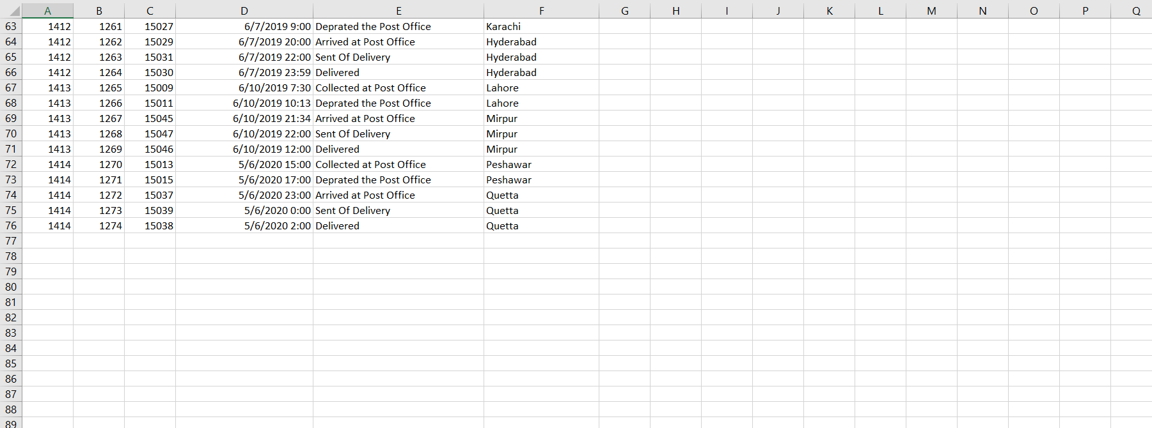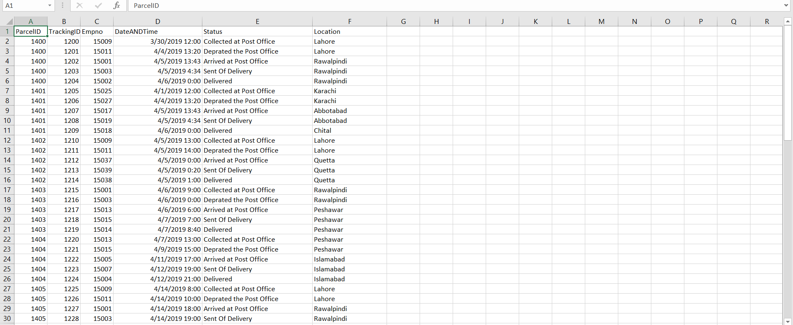

# Ticket Payment:

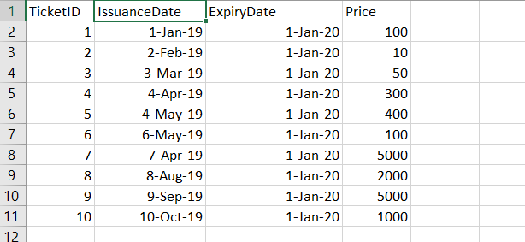

# Stamp:

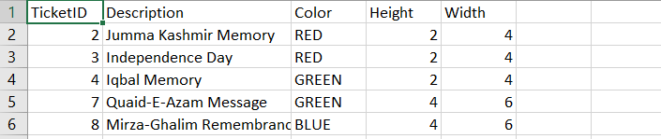

# Service:

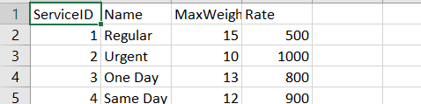

# Recipient:

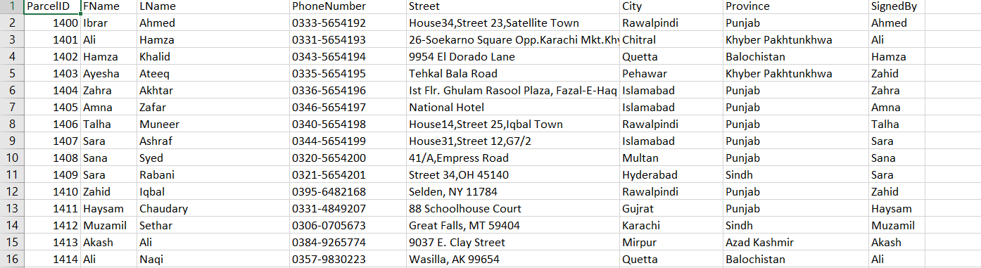

# Post Office:

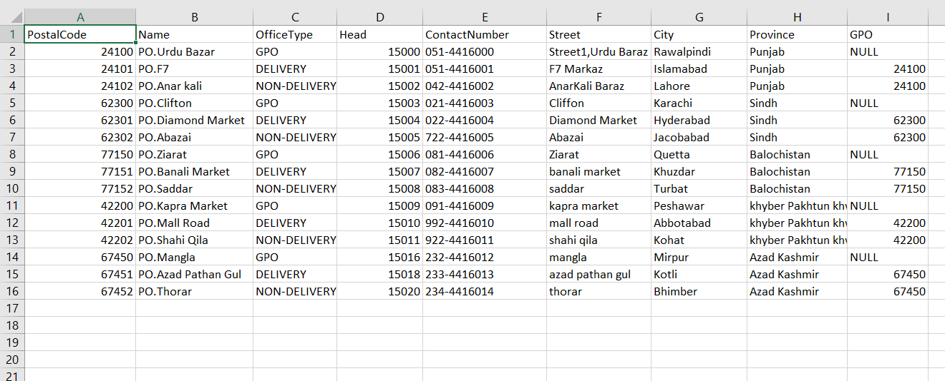

# Payment:

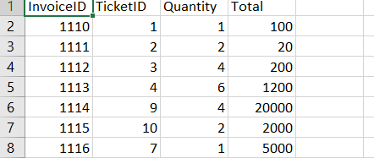

# Parcel:

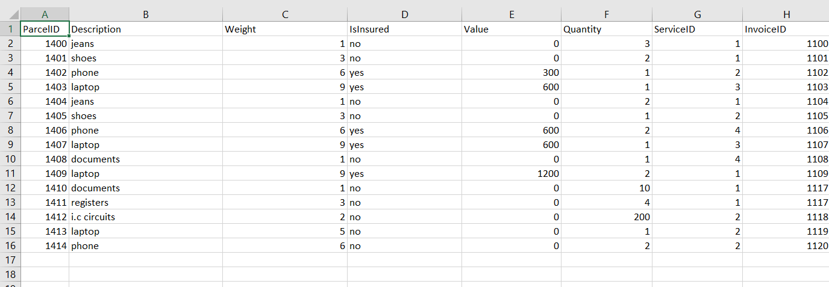

# Invoice:

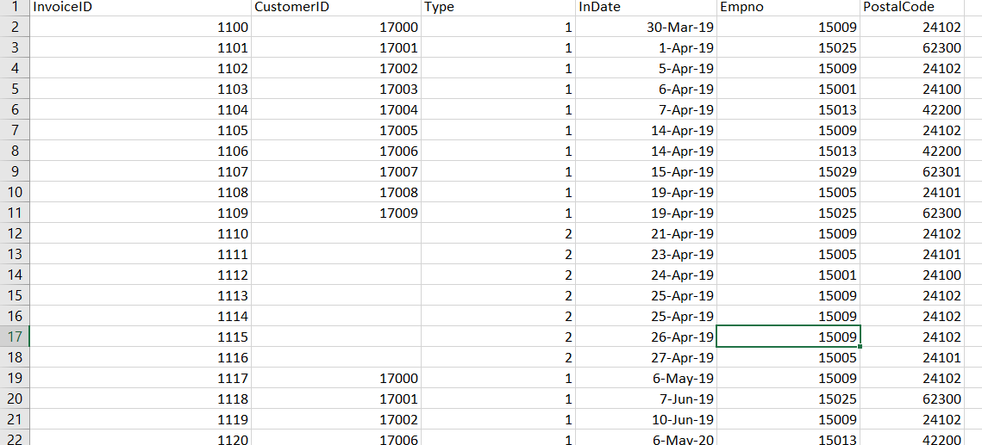

# Employee:

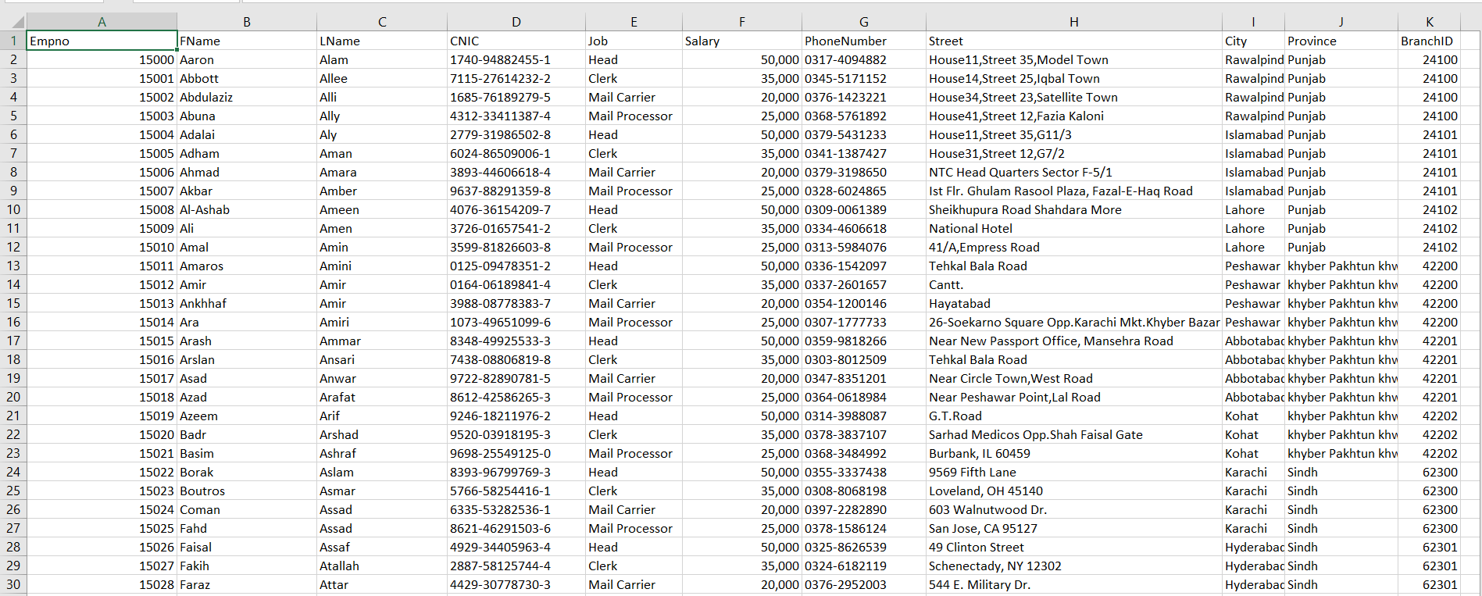

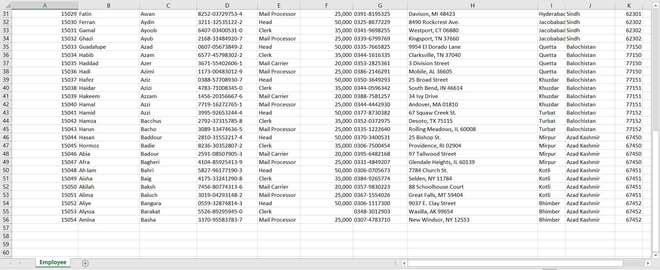

# Draft:

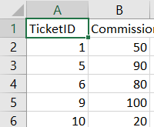



# HTML:

# C:\Users\Sheikh Ibrar\Desktop\PCS\Screenshot (91).pngFront Page:

# TrackOrder:

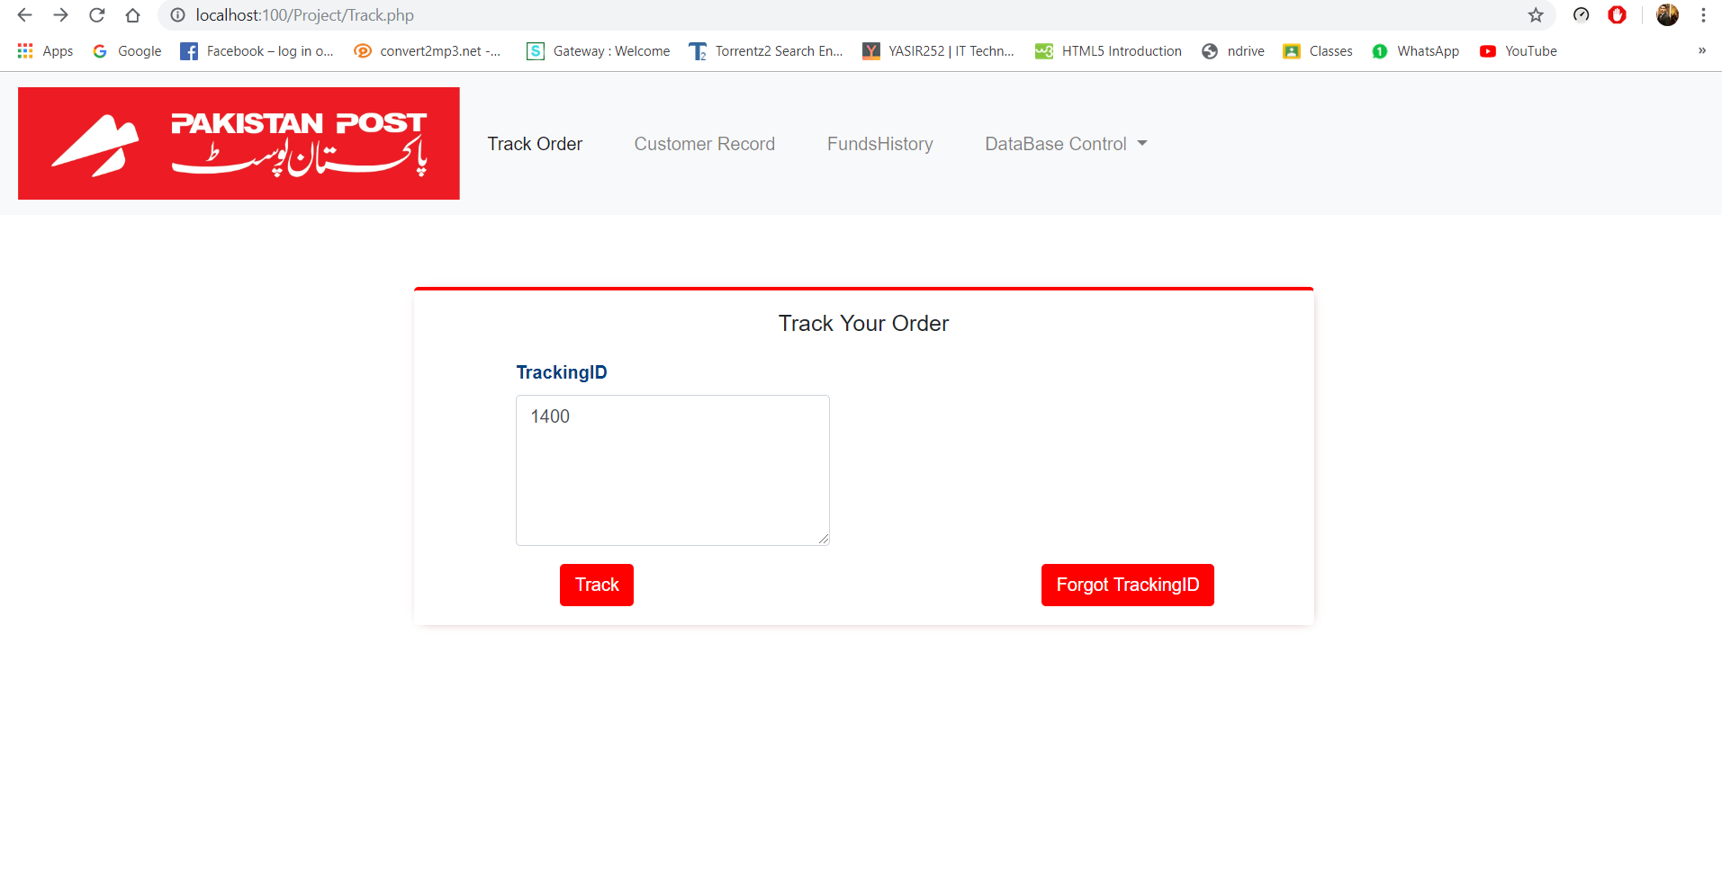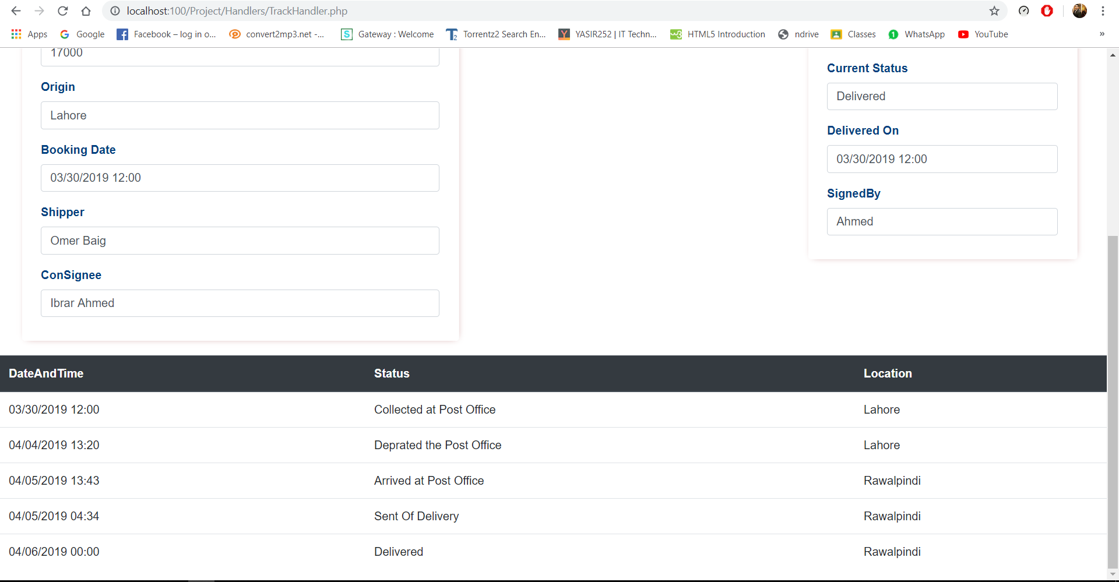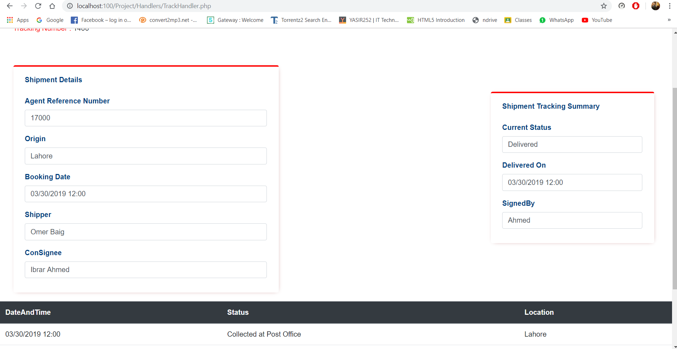

# Customer Record:C:\Users\Sheikh Ibrar\Desktop\PCS\Screenshot (96).png

# C:\Users\Sheikh Ibrar\Desktop\PCS\Screenshot (95).png Funds History:

