National University of Computer & Emerging Sciences, FAST, Islamabad

Computer Science Department

HOME WORK - ASSIGNMENT COVER SHEET

COURSE TITLE DATABASE SYSTEMS COURSE CODE CS203

INSTRUCTOR Dr. EJAZ AHMED TYPE √ (Please tick)
Indiv. Group
ASSIGNMENT NO 1

ASSIGNMENT Lab Project –PAK Post Services

HAND OUT DATE 08-APR-2019 DUE DATE 25-APR-2019

ESTIMATE TIME 28 Hours

ASSESSMENT CRITERIA (or attached) | % Mark
Instructions to Candidates:
Grade Distribution is Attached

Submission: Print & online slate followed by Demo/ presentation

Tools: Oracle Database & PHP
Group of max 4 students is allowed, individual work is discouraged with 10% deduction

TO BE COMPLETED BY STUDENT GROUP MEMBERS ID
ID Sec#

ID Sec#

ID Sec#

ID Sec#

NAME

ID NO

Time Taken

DECLARATION: I/We declare that this Coursework is my/our group’s own work

SIGNATURES (All members)

GRADE/ MARK AWARDED COMMENTS

INSTRUCTOR’S SIGNATURE DATE

Lab Project: Database Development

Objective:
Enable the student to design and develop a database. In this project, the students are required to show their abilities of:
- Analyzing the System Requirement
- Represent the requirement into logical design using Entity Relationship (ER) or/and Enhanced Entity Relationship (EER) model
- Mapping the designed model into relational schemas
- Transform the relational schemas into normalized tables (Normalization)
- Writing DDL SQL statements to creates the tables including all applied integrity constraints
- Writing SQL statements to populate the initial records of each table (DataSets)
- Front End Development of Forms/ Reports using PHP & Oracle database

Case Brief

Pakistan Post Courier Service

1. Introduction

The PPost wishes to develop a database system. The PPost is organized in the following way.

There are number of post offices and collection centers each of which processes documents/ parcels to deliver such as letters, packets etc. Mail has various services such as same day, one day, urgent and regular. Invoice will be issued for every parcel. Tickets/ stamps will be solved without invoice but one invoice will be issued for all stamps sold in a day. Reports can show various categories of various parcels and tickets.

Staff is working who is managing all types of mail services. Head of each PPost will finalize financial collections each day and submit to local GPO of each city. PPost handles returned and bounced mails as well. Insurance Policy can be managed for safe mail of parcels as an option for customer.

Customer (Senders) can track his/ her mail on internet with all confirmations and expected duration. Senders and recipient address will also store in the database system for future purpose. Search can be managed with some choices to extract data of Customers along with financial collections.

At present the PPost has a manual record system but this needs rationalization. It is hoped that the new computerized system will remove data redundancy.

Scope of this project can be determined with the help of below reports and forms.

2. The following records are kept:

Customer can search and track his/ her parcel with the following details

Form: Tracking Parcel

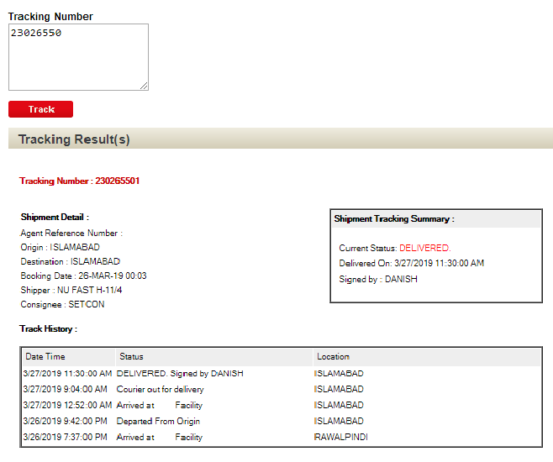

In case if tracking number is not available, then new system can facilitate customer to find out an actual tracking record.

Form & Report:
PPost Customer Transactions

Customer Name: CustID:

Address: City:

Mobile#: CNIC:

-----------------------------------------------------------------------

Parcel Information

Tracking/ Description Qty RecipientName RecAddress City Status Date
Parcel No
--------- ------------ ---- ------------- ---------- ---- ------ ------

Report
PPost Branch Yearly Funds Collections

Year: 2018

Branch#: Name:

Manager Name:

No of Collections Month AmountCollected AmountReturned NetAmount
----------------------- ------ ------------------------ ----------------------- --------------------

Total of each column is also required

Grade distribution:

Items | %
10 most suitable Questions for relationships | 10
ER and/or EER diagram | 20
Relational Schemas/ Mapping | 10
Datasets with all possible scenarios | 10
DDL & Constraints | 10
Forms & Reports | 20
Presentation (DEMO) | 20
T O T A L | 100

Note: Only give forms & reports must be developed using php. Other forms & reports are likely to be required but those will not be graded. All learning concepts need to be applied as you have studied in this course.

