“CPExpress”

A Buy and Sell

Posting Web Application

Object Oriented Programming

Database Management System

Mark Paulo A. Cube  
Benito S. Mascariñas

**I. Introduction**

Computer Engineering students deal with lots of materials and equipment necessary for the creation of projects and prototypes for academic or personal purposes. These materials could be costly if bought brand-new which would result to more expensive overall cost of the project.

The developers had an idea to develop a web application system that allows users to post their secondhand or brand-new items for sale which specializes but not limited to computer engineering products like microcontroller, electronic devices, integrated circuits, etc.

**II. Scope and Limitation**

The system displays the items available for sale from all the authenticated users. Each item has a name, product description, price, category, and follows the profile and contact information of the seller.

All transactions are made outside the scope of the application. Interested buyers must contact the seller through their preferred method.

**III. System Overview**

**System Requirements**

* **NodeJS** - is a JavaScript runtime built on Chrome's V8 JavaScript engine. It uses an event-driven, non-blocking I/O model that makes it lightweight and efficient. Node.js' package ecosystem, npm, is the largest ecosystem of open source libraries in the world.
  + **Express** - is a minimal and flexible Node.js web application framework that provides a robust set of features for web and mobile applications. It is the one responsible for routing.
  + **Passport -** is authentication middleware for Node.js. Extremely flexible and modular, Passport can be unobtrusively dropped in to any Express-based web application. A comprehensive set of strategies support authentication using a username and password, Facebook, Twitter, and more.
  + **Mongoose** - provides a straight-forward, schema-based solution to model your application data. It includes built-in type casting, validation, query building, business logic hooks and more, out of the box.
* **MongoDB -** is a free and open-source cross-platform document-oriented database program. Classified as a NoSQL database program, MongoDB uses JSON-like documents with schemas.

**Block Diagram**

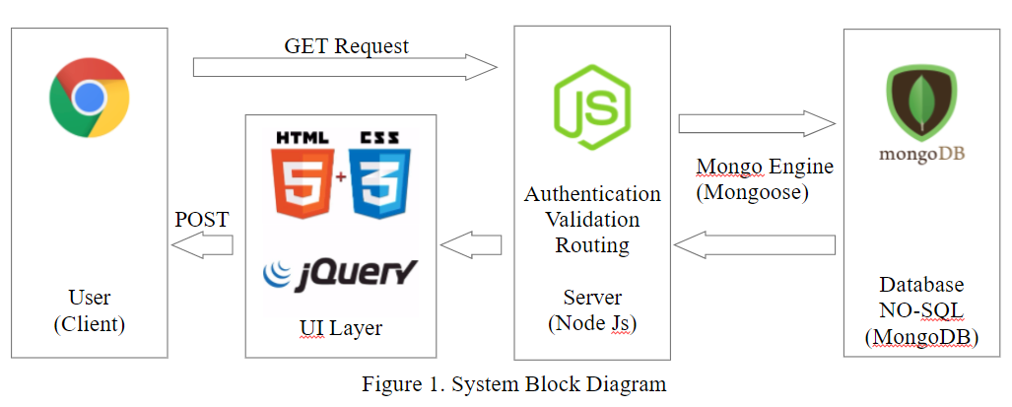

**IV. Database Model System**

NoSQL Database 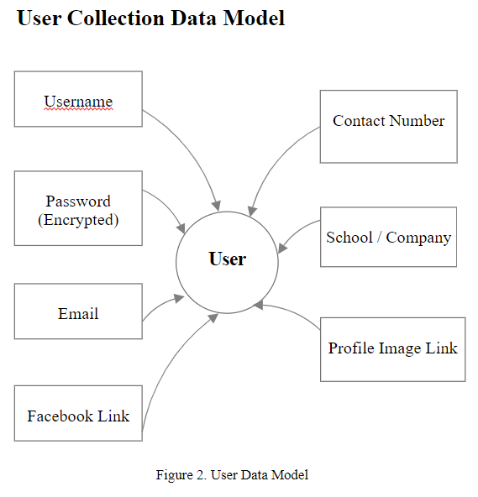- MongoDB

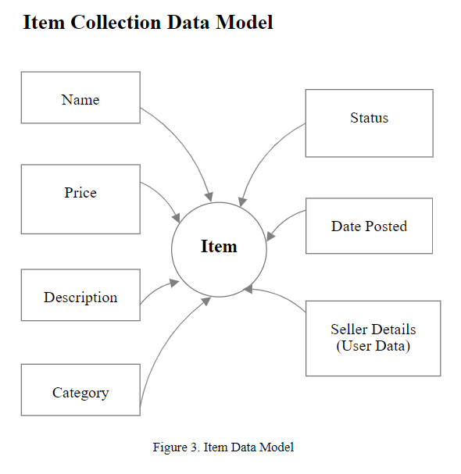

**V. Developer Profile**

Mark Paulo A. Cube  
2012-00978-MN-0  
  
0002 Galanto Compound, Cleofer St.,   
Sta. Quiteria, Caloocan City 1402

Role: Front-End and Back-End Developer

Benito S. Mascañas  
 2012-XXXXX-MN-0  
  
 Insert address here.   
  
  
 Role: Front-end Developer