**Project 1**

***Image Processing***

**Name:** Yildirim Kocoglu

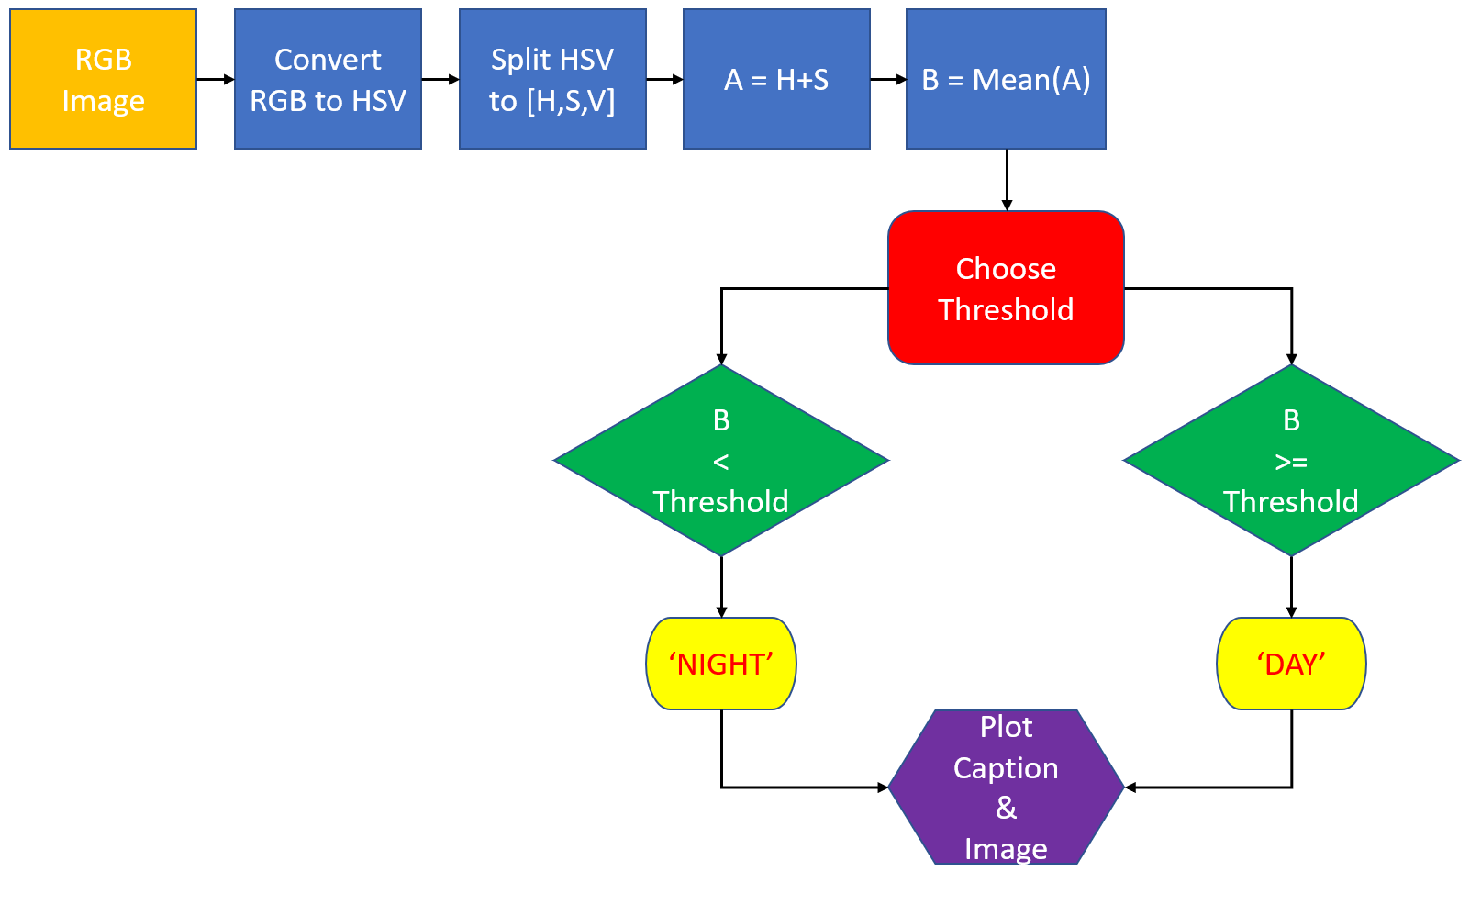

**Figure 1**: Process of Image Captioning for Project 1.