**Name:** Yildirim Kocoglu

Image Processing

**Project 2**

**FLOWCHART**

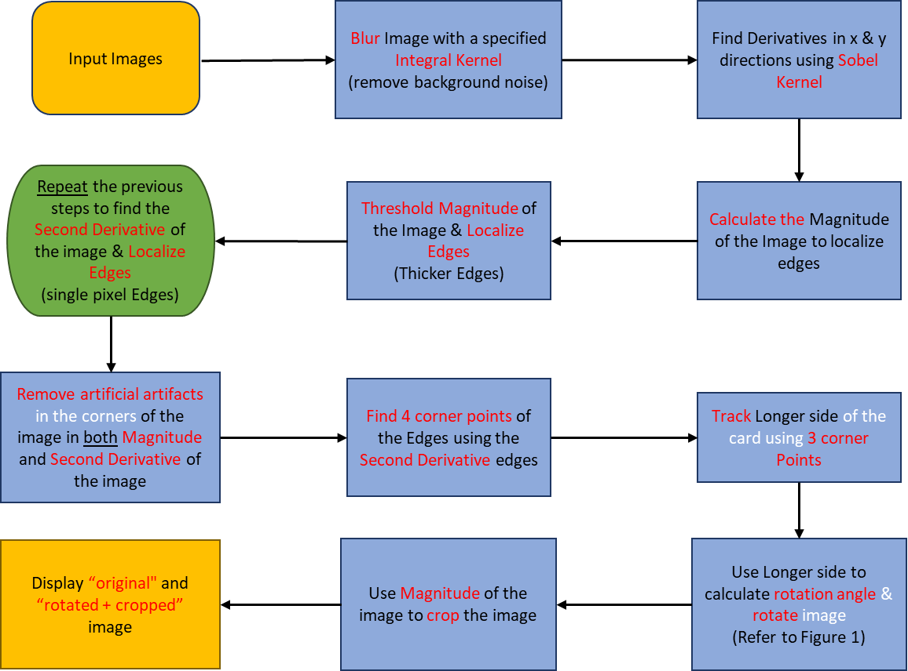



Rotation angle

**Figure 1:** Figure showing an example of 4 Corner Points and tracking of longer side of the card using the edges found with Second Derivative and calculating the rotation angle