**Group members**

Yildirim Kocoglu

Farshad Balouri

**Image Processing**

**Project 3**

**Table of Contents**

**List of Assumptions** 2

**Algorithm Pipeline** 2

**Subset of Results** 3

***Single card classification*** 3

***Multi card classification*** 5

***Misclassification*** 6

**Contributions** 8

***Yildirim Kocoglu’s contributions*** 8

***Farshad Bolouri’s contributions*** 8

**References** 8

# **List of Assumptions**

* Webcam acquired input image size = 960X1280
* A uniform & dark background for image acquisition
* Uniform illumination with no partial shadows or glare on the playing card or background
* Sharp input images with no blur (No out of focus images)
* Sufficient space between playing cards (no overlap or edge touching) during multi-image acquisition
* Orientation of the playing card does not matter.

# **Algorithm Pipeline**

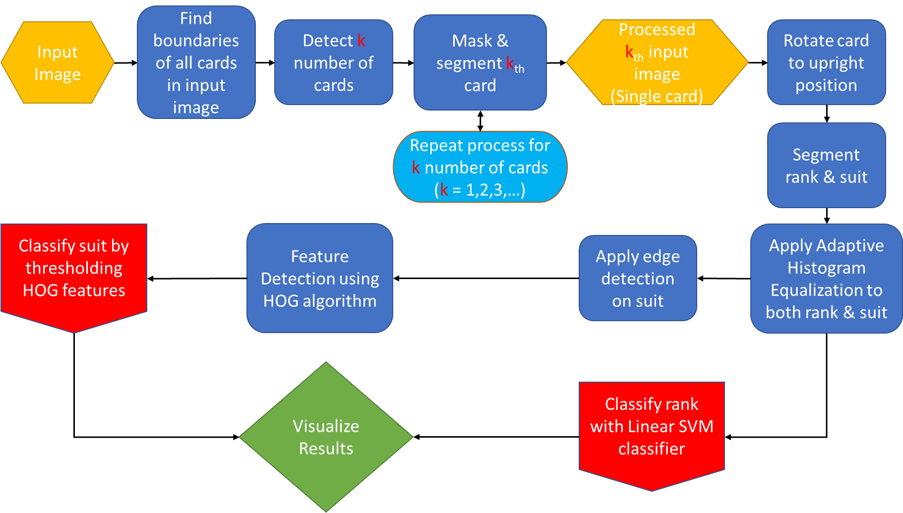

# **Subset of Results**

## ***Single card classification***

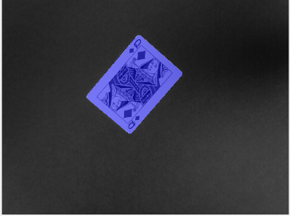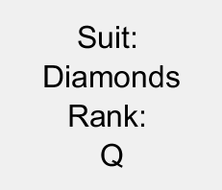

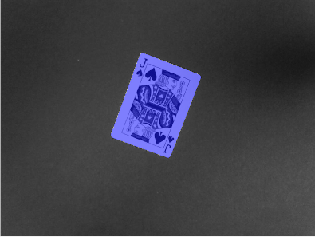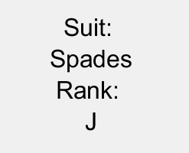

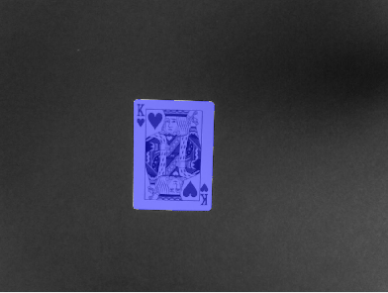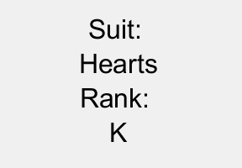

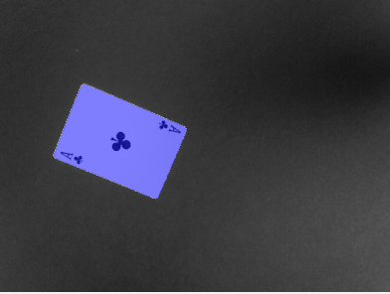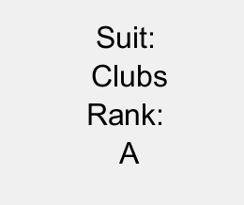

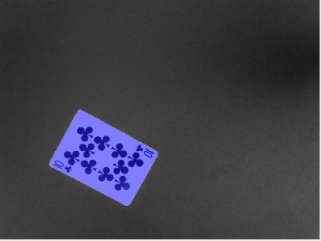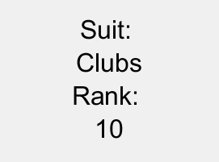

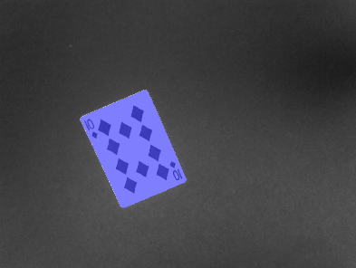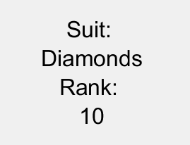

## ***Multi card classification***

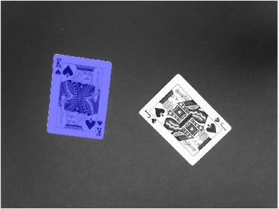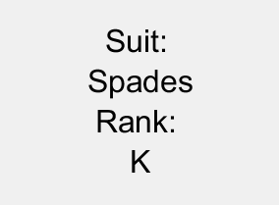

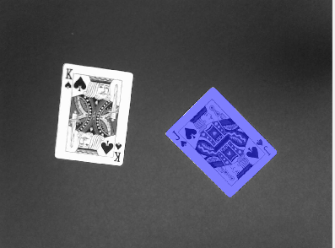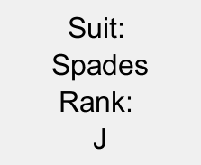

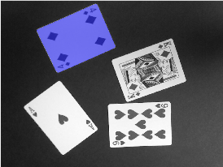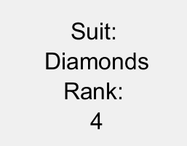

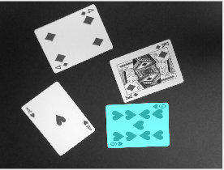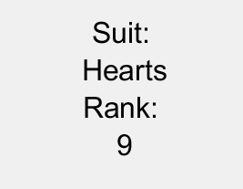

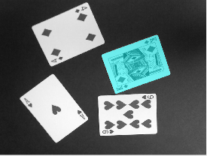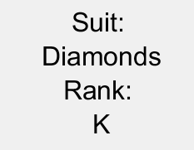

## ***Misclassification***

**Here is an example of a failed classification below**.

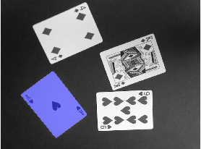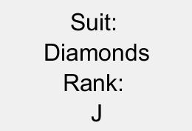

**Explanation**: When the card is out of focus (image is blurry) as seen below on the **left image**, it can sometimes become an issue for the segmentation & classification process. Specifically, detecting the rank and the suit and segmenting them out properly can be nearly impossible on a blurry image. In this specific case, the segmentation process failed and the previous rank from the previously segmented rank image “J” could not be overwritten and the suit has the same issue due to image being blurry. Even if the rank and suit are segmented out correctly, the blurriness can still create challenges for the classifier. Another image from a different card that was correctly classified can be seen for comparison on the **right image**. These issues are more prevalent when looking at the zoomed in version of the image and may not be apparent on the original image.

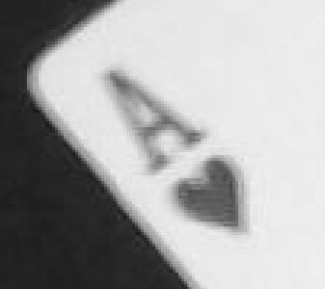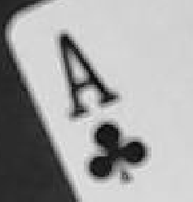

Below is the classification for the image on the **right**.

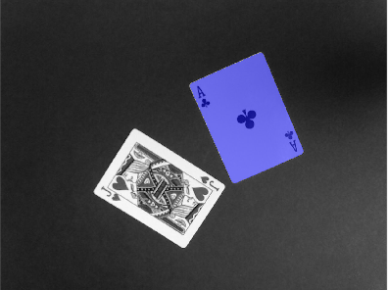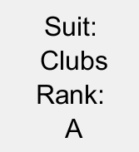

# **Contributions**

## ***Yildirim Kocoglu’s contributions***

Applied the rotation algorithm, applied multi card masking for segmentation of multiple cards sequentially in a single scene, contributed to the application of histogram of gradients for suit classification, created dataset for classifiers.

## ***Farshad Bolouri’s contributions***

Segmented the suits and ranks, trained a linear SVM classifier for rank classification, applied histogram of gradients algorithm and setup required thresholds for suit classification, setup the visualization of results for multi card classification, created dataset for classifiers.

# **References**

<https://www.mathworks.com/help/images/boundary-tracing-in-images.html>

<https://www.mathworks.com/help/images/ref/poly2mask.html>

<https://www.mathworks.com/help/images/ref/regionprops.html>