**Extra Credit Assignment**

**Pattern Recognition**

**Name: Yildirim Kocoglu**

***Note:*** *If the figures given in this report are not clear enough, please run the MATLAB script provided along with this report.*

The task of this assignment was to create a nonlinear decision boundary using Gaussian Kernel and Soft Margin SVM with quadprog in MATLAB or an equivalent function in Python such as CVXOPT. For this assignment, quadprog in MATLAB was used to solve the unknowns in Soft Margin SVM. The only difference between drawing a linear decision boundary or nonlinear decision boundary using Soft Margin SVM is that the nonlinear decision boundary requires the use of Kernels and in this case, it was the Gaussian Kernel that was used to draw the nonlinear decision boundary.

The formula for the Gaussian Kernel is given below:



**Figure-1** shows the nonlinear decision boundary (solid black line) and the 2 margins (red and blue dotted lines) for the given value of **C=10** with sigma = 1.75. The number of **misclassified classes are 7** (3 class 1 (red) + 4 class 2 (green)) for this case. The **number of Support vectors are 22** (8 on margin support vectors) and the rest are either inside margin and/or misclassified.

**Figure-2** shows the nonlinear decision boundary (solid black line) and the 2 margins (red and blue dotted lines) for the given value of **C=100** with sigma = 1.75. The **number of** **misclassified classes are 5** (1 class 1 (red) + 4 class 2 (green)) for this case. The **number of Support vectors are 21** (11 on margin support vectors) and the rest are either inside margin and/or misclassified.

**References**

https://en.wikipedia.org/wiki/Radial_basis_function_kernel

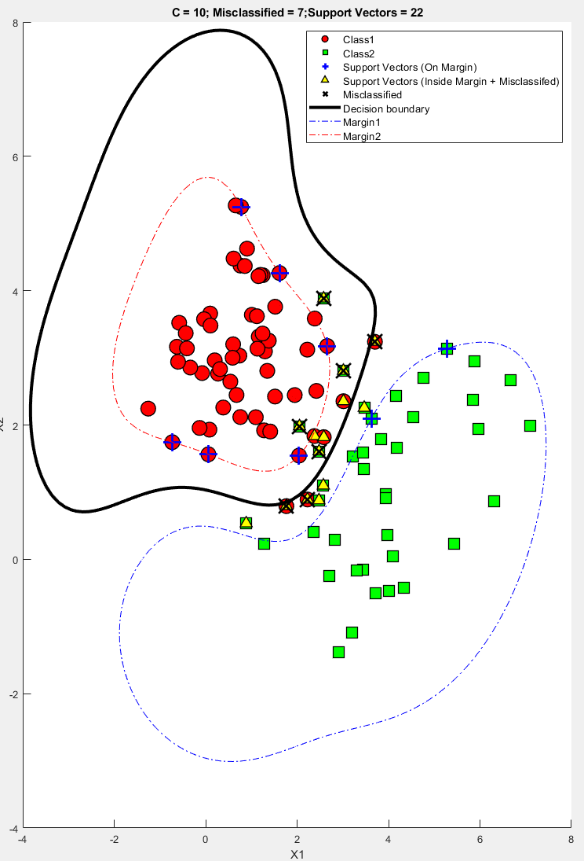

**Figure-1:** Nonlinear decision boundary using Gaussian Kernel with Soft Margin SVM (**C = 10**)

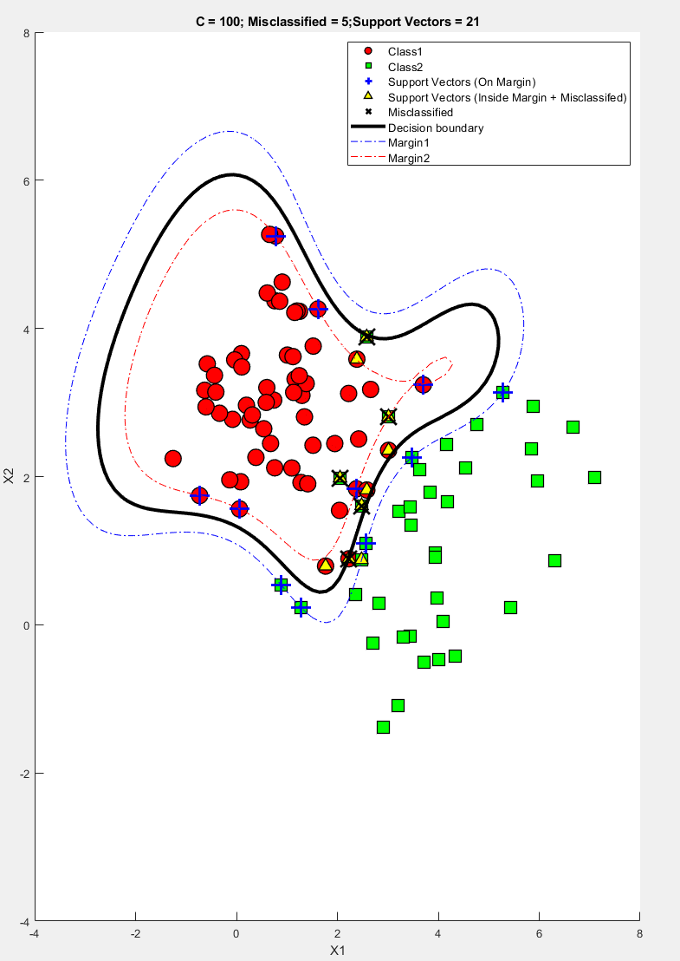

**Figure-2:** Nonlinear decision boundary using Gaussian Kernel with Soft Margin SVM (**C = 100**)