**Assignment 3**

**Pattern Recognition**

**Name: Yildirim Kocoglu**

In this Assignment, data was generated using MATLAB with the given mean (m), covariance matrix (S), and prior probability (P). 2 different training data was generated with N=100 and N=1000 by using rng(0) and 1 test data was generated with N=10000 by using rng(100).

**Due to the repetitive nature of the assignment, multiple functions were written:**

1. **generate_gauss_classes** – Generates Training data and labels given the parameters
2. **Bayes_classifier** – Predicts labels using Bayes classifier
3. **Naive_Bayes_classifier** – Predicts labels using Naive Bayes classifier
4. **ML_estimate_naive** – ML estimate for parameters for Naïve Bayes classifier
5. **ML_estimate** – ML estimate for parameters for Bayes classifier
6. **Calculate_Accuracy_error** -Calculates Accuracy & Error given the predictions & labels

**The task in this assignment was to apply:**

1. Naive Bayes classifier
2. Bayes classifier with MLE for parameter estimation
3. Bayes classifier with true parameters

**Table-1** shows the Test Accuracy and Test Errors for each classifier. It can be seen from the Test Accuracy that Naive Bayes classifier outperforms the Bayes classifier when parameters are estimated using the training data with N=100 but, when parameters are estimated using the training data with N=1000, Bayes classifier outperforms Naive Bayes classifier. Also, there is not much difference in the accuracy of Naive Bayes classifier with N=100 and N=1000 ( < 0.5%) but, there is a significant difference in the accuracy of Bayes classifier with MLE with N=100 and N=1000 ( > 2%). Bayes classifier with MLE with N=1000 comes closest to the accuracy of Bayes classifier with true parameters. Bayes classifier with the true parameters has the highest Test Accuracy since the parameters used are the true parameters.

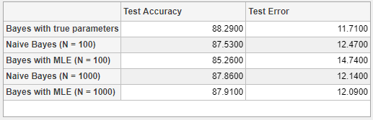

**Table-1:** Test Accuracy and Test Error for each classifier