  - Analytical Report

Licensing Developmental-Support Software in India: An April 2026 Case Study Assessed Against CDSCO’s July 2026 Guidance
Koti Reddy Saripalli
Bharath Healthcare Laboratories Private Limited (Pinnacle Blooms Network®), Plot No. 50/A, Raghavendra Nagar Colony, Jeedimetla, Suchitra, Hyderabad 500055, Telangana, India.
Correspondence: Koti Reddy Saripalli; kotii@bhclpl.org; ORCID: 0009-0007-7866-0737
Manuscript BHCL-PUB-2026-09-01 | Version 3.0 | 15 September 2026
Abstract 208 words | Main text 2505 words
Revised manuscript. Not peer reviewed.

Abstract
Developmental-support software can influence assessment and intervention without making a diagnosis. Its regulation therefore requires a precise intended purpose, proportionate evidence, and control of software changes. This analytical report examines the April 2026 Indian licensing of PinnacleAI GPT-OS v1.0.0 and retrospectively assesses the case against CDSCO’s medical-device-software guidance released in July 2026. Electronic copies of the issued manufacturing licence, its accompanying letter, and quality-system certificates were examined alongside the manufacturer’s case account and public regulatory sources. Digital signatures and current registry status were not independently validated. The MD-5 licence and matching covering letter establish the documented Class B scope, an application dated 16 April, and a grant dated 21 April 2026. The manufacturer separately reports a classification decision on 13 April and a notified-body audit on 18 April. The comparison identifies continuity with the July guidance while distinguishing a software release record from a test licence, a management-system licence from product-performance certification, and risk classification from clinical validity. A claim–evidence matrix shows how licensing, technical verification, clinical evaluation, and outcome studies answer different questions. The case contributes a reusable documentary framework for developmental-support software regulation. Its findings concern a documented regulatory pathway and evidence architecture; they do not establish comparative effectiveness, international authorisation, or a general licensing timetable.
Keywords: software as a medical device; developmental support; India; regulatory science; quality management; clinical evaluation

Introduction
Software that measures developmental abilities, tracks readiness, or supports intervention planning can affect decisions about a child’s care even when it does not diagnose a condition. A non-diagnostic label identifies an important boundary, but does not resolve the consequences of an incorrect measurement, misleading forecast, or inappropriate recommendation. Regulatory analysis must therefore connect the stated purpose to the people using the output, the decisions it informs, and the controls governing its development and use.
India’s Medical Devices Rules, 2017 provide the statutory framework for classification and licensing.[1] CDSCO subsequently published its Guidance Document on Medical Device Software, CDSCO/MD/GD/MDSW/01/2026, on 21 July 2026.[2] The present case concerns an April 2026 decision, following the October 2025 draft guidance.[3] This chronology creates an opportunity to distinguish the documented application pathway from its later assessment against published software-specific guidance.
The objective is to analyse the manufacturer-documented licensing of PinnacleAI GPT-OS v1.0.0 and derive a transferable method for connecting regulatory instruments, software controls, and permissible evidence claims. The contribution is a regulatory case analysis: it does not depend on treating the licence as proof of therapeutic benefit.

Materials and methods
A retrospective documentary case analysis covered classification work reported in 2025 through 15 September 2026. The manufacturer’s 28-page regulatory case account, version 2.0, supplied the chronology, dossier structure, and operational-control descriptions.[4] Electronic copies of the issued Form MD-5 and its annexure, the matching State Licensing Authority covering letter, and ISO 13485 and ISO/IEC 27001 certificates were directly examined.[5,6,7] Public legislation, guidance, and institutional standards information supplied the external interpretive framework. The case was selected because it concerned a named developmental-support device and an identifiable licensing sequence.
Extraction recorded each document’s issuer, identifier, date, function, and permissible inference. The licence and certificate text was checked against rendered pages. Directly inspected instruments were distinguished from decisions, audits, and processes described only in the manufacturer’s account. The classification letter, original notified-body audit report, and BIS licence were not among the instruments directly examined. Inspection established what the supplied documents state; it did not validate digital-signature trust chains, confirm current registry status, or constitute an independent compliance audit. A matching licence and covering letter were used for the licensing result; another supplied covering-letter copy contained a different licence number and was not treated as equivalent.
The comparison examined intended purpose, classification, manufacturing documentation, software release, change control, and post-market evidence. July guidance was used as a retrospective analytical framework, not as the legal basis of the earlier April decision. No regulator interviews, patient records, executable software, source code, or underlying clinical datasets were examined. The analysis did not estimate treatment effects, reproduce psychometric results, or rank regulatory systems. Supplementary Table S1 records the sources and their availability.

Results

Device identity and intended purpose
The inspected MD-5 annexure identifies the generic device as Developmental Support Software (Non-Diagnostic), the brand as PinnacleAI GPT-OS, and the model as v1.0.0: cloud-based SaMD with web and mobile access through Android/iOS. Its intended users are parents, therapists, educators, and caregivers; the population is children aged 0–12 years. The annexure specifies four functions: developmental ability measurement, readiness tracking, progress forecasting, and adaptive therapy-plan support.[5] These are the recorded intended functions of the licensed device; the annexure does not supply study-level performance estimates.
The non-diagnostic designation in the licence establishes an important scope boundary.[5] The manufacturer additionally describes professional oversight.[4] The licensed boundary should be maintained consistently in instructions, interfaces, study objectives, and public communication. A forecast of readiness should, for example, identify its time horizon and intended decision; an ability score should identify what it measures and the conditions under which it can be interpreted. Those specifications make the purpose testable without converting it into a diagnostic claim.

Classification and manufacturing licence
The manufacturer’s account records an initial Class A position and a Central Licensing Authority determination of Class B on 13 April 2026 under file MD/classification/2025/150.[4,8] The inspected MD-5 licence records Class B and licence MFG/MD/2026/000248, dated 21 April 2026. Its matching covering letter, Lr. Rc. MFG/MD/2026/189231, identifies the application date as 16 April and directs compliance with the Fifth Schedule and Rules 22 and 26.[5] A notified-body audit on 18 April is reported in the manufacturer’s account.[4] Table 1 distinguishes directly documented events from those reported in the account; Figure 1 separates the April sequence from subsequent guidance and certification.
The statutory distinction is material: MD-3 is the application and MD-5 is the manufacturing licence for the relevant Class A or B route.[1] The reported Class B determination is the case result; it is not an independently reconstructed classification rationale. Nor is an increase in risk class evidence that a developmental measure is valid. The five calendar days between the reported application and grant describe one administrative interval. Because classification and quality preparation began earlier, that interval cannot establish total development time, routine processing time, or comparative regulatory efficiency.

Quality systems and the software dossier
The manufacturer describes a plant master file addressing the development and cloud environment, a device master file, risk management, verification and validation, a clinical evaluation report, and post-market arrangements.[4] The inspected ISO 13485:2016 certificate covers software design, development, deployment, maintenance, and support. The ISO/IEC 27001:2022 certificate covers information security for SaMD-related development, cloud operations, cybersecurity, data protection, and support.[6,7] The manufacturer also reports a subsequent BIS licence under IS 23485:2019.[9] BIS describes that standard as combining medical-device quality-management requirements with essential principles of safety and performance.[10] The reported BIS instrument is a management-system licence, not a product mark or certification of clinical efficacy.
Document inspection also revealed a terminology difference: the November 2025 ISO 13485 certificate includes “diagnostic mapping (AbilityScore)” within its stated scope, whereas the April 2026 MD-5 names the device non-diagnostic.[5,6] The certificate’s wording does not expand the licensed medical purpose. This illustrates why a publication should identify each instrument’s function and date instead of combining all certificate descriptions into one device claim.
The regulatory architecture also requires precise documentary labels. The Fourth Schedule addresses manufacturing-licence documentation and the Fifth Schedule quality-system requirements. The Third Schedule concerns notified bodies, rather than serving as the essential-principles checklist.[1] CDSCO separately provides essential-principles guidance.[11] Form MD-11 is the audit/inspection book, and should not be substituted for the title or identifier of a notified-body audit report.[1] These distinctions allow a reviewer to trace what was submitted, inspected, licensed, or certified without treating every document as an interchangeable approval.
The case’s practical contribution is the description of software manufacture as a controlled sequence of design, implementation, testing, release, deployment, and surveillance.[4] In this model, the relevant product boundary includes the deployed version and its operating environment. A traceable release package can connect requirements, risk controls, test outcomes, unresolved anomalies, approval, and deployment records. This structure makes the manufacturing concept useful for a cloud service: the dossier is an account of how a reproducible software configuration is produced and maintained, rather than merely a description of an office or server location.

Assessment against the July 2026 guidance
The July guidance addresses intended use, classification, standards, quality systems, licensing routes, dossier content, and post-market activity; it also supplies software checklists and discusses an algorithm change protocol where applicable.[2] It describes current regulatory practice, with statutory provisions prevailing. Table 2 maps the manufacturer’s account to selected topics. The comparison identifies documentary continuity and questions for lifecycle governance, rather than issuing a retrospective compliance verdict.

Release records, test licences, and applicability
A software release record documents the version authorised for deployment within a quality system. The July checklist recognises software version release documentation, while its test-licence section separately describes the MD-12 application and MD-13 licence.[2] The case account’s release-certificate description therefore cannot establish a general rule that release documentation replaces test licensing. Whether a test licence applied to a particular activity requires the activity and applicable provisions to be examined; this report makes no adverse finding about the historical case from the absence of that analysis.
The account includes non-applicability rationales for physical-device requirements, including sterilisation and biocompatibility.[4] Such reasoning can be appropriate for a defined software configuration, but must remain requirement-specific. The absence of a sterile patient-contact component does not remove cybersecurity, usability, data-integrity, or clinical-performance questions. Similarly, software may not physically deteriorate, yet its fitness can change when operating systems, dependencies, deployment environments, populations, or workflows change. Software maintenance and surveillance therefore remain substantive lifecycle controls.

Controlled change and post-market learning
The manufacturer describes version-controlled releases, no in-field model retraining, multidisciplinary review, verification before deployment, rollback capability, and enhanced monitoring after release.[4] These practices offer a useful starting structure for change governance. The critical analytical step is to connect each change to the claim it might alter: a revised interface may change use error; a revised scoring function may affect comparability over time; a revised forecast may require fresh validation in its intended population.
CDSCO’s discussion of an algorithm change protocol supplies a current Indian point of reference.[2] Internationally, FDA’s August 2025 guidance describes a predetermined change control plan encompassing planned modifications, the methodology for their development, validation and implementation, and an impact assessment.[12] FDA reviews such a plan within a marketing submission. An internal change policy should consequently not be presented as an authorised US plan, or as automatic permission to modify a device in any jurisdiction. The transferable lesson is the need for explicit evidence and decision rules before changes reach users.

Decision records and evidence continuity
A useful extension of the case is a decision record for every significant release. Such a record would identify the change, affected function and population, foreseeable hazards, tests performed, acceptance criteria, approving role, and the reason for any additional regulatory action or its absence. This is an analytical recommendation, not a claim that every field was present in the historical dossier. It would make the relationship between routine software maintenance and changes to the medical purpose visible to technical, clinical, and regulatory reviewers.
Version traceability is particularly consequential for longitudinal developmental measurement. If a scoring rule changes between two assessments, an apparent difference may reflect the instrument as well as the child. A release policy should therefore state whether earlier and later scores remain comparable, whether recalculation is appropriate, and how changes are communicated. Similar reasoning applies to forecasts: altered inputs or target definitions may change the meaning of the predicted result even if the interface remains familiar. A clinically usable record should retain the version and relevant context needed to interpret each output.
Surveillance should then connect errors to these same records. A complaint about an implausible score, a recommendation overridden by a therapist, or a failure to display uncertainty can generate a reviewable signal. The value of such signals depends on ascertainment, investigation, and response, not simply their number. A low complaint count cannot be interpreted as a low failure rate without knowing who used the function, whether errors were recognised, and how reporting occurred. These considerations explain why the deployment denominator should be specific to the device and version.

Discussion
The case is most informative when regulatory legitimacy and scientific performance are related without being conflated. The inspected licence anchors the named device, model, purpose, and manufacturing authorisation; the certificates anchor stated management-system scopes. Table 3 distinguishes the questions answered by classification, licensing, quality systems, technical verification, clinical evaluation, and outcome studies. Figure 2 illustrates these as connected evidence domains. Confidence in a development process supports dependable evidence generation, while a clinical study addresses an empirical question that the existence of a certificate cannot answer.
IMDRF’s clinical-evaluation framework distinguishes valid clinical association, analytical validation, and clinical validation.[13] Applied here, a developmental score needs a justified relationship to the construct it represents; its calculation needs verification; and its performance needs evaluation in the intended users, population, and setting. An improvement in an internal score does not by itself establish an improvement in daily participation, school readiness, or independence. These outcomes require their own definitions, measurement methods, and study designs.
The case account identifies an AbilityScore methodology preprint and a separate validation-study protocol.[14,15] Their roles should be preserved: a methods publication explains a measure, and a protocol states planned procedures. Neither label establishes that a new study has completed recruitment or produced results. This report does not reproduce the account’s numerical psychometric or network-wide improvement claims because the underlying datasets and study-level analyses were outside its scope. It also does not infer exposure to the licensed software version from the historical scale of the wider clinical network.

Implications for international development
A reusable dossier should make the unit of evidence explicit: named function, software version, user group, population, workflow, and decision consequence. For a parent-facing score, this includes what parents are expected to do with the result and when professional review is required. For an adaptive plan, it includes who accepts or overrides recommendations. These details permit meaningful discussion with regulators across jurisdictions without assuming that one country’s licence determines another country’s classification or route.
Child-data governance also belongs within this evidence architecture. Appropriate access controls, consent processes, data minimisation, and auditability should be described in relation to actual data flows. Legal status must be dated: India’s November 2025 commencement notification places sections 7–10 of the Digital Personal Data Protection Act, including section 9, in an eighteen-month commencement tranche.[16] It would therefore be inaccurate, as of this report’s September 2026 cutoff, to describe section 9 as already operative on that basis.
The generalisable contribution is not a proposed foreign risk class. IMDRF’s categorisation framework considers the significance of software information and the healthcare situation or condition.[17] A transferable case report should accordingly expose its intended-purpose reasoning and evidence boundaries so that another jurisdiction can assess them under its own rules. Publishing the documentary pathway alongside subsequent validation and outcome studies creates a cumulative programme in which each paper answers a distinct question.
For developers, this suggests preparing a core evidence package with jurisdiction-specific decision records. The core can contain the device description, version history, risk file, technical evidence, and clinical-evaluation questions. The jurisdiction-specific layer should record the applicable route, authorised scope, conditions, and change obligations. For investigators, the same architecture helps select the next study: measurement validation for a score, forecast evaluation for a prediction, usability work for a parent interface, or comparative outcomes research for an intervention pathway. These are proposed applications of the case framework, rather than claims that one completed study or licence already covers every function.

Limitations
This is one manufacturer-authored case with a disclosed commercial interest. Electronic copies of the MD-5, its annexure and matching covering letter, and two quality-system certificates were examined, but their digital-signature trust chains and current registry status were not independently validated. The separate classification letter, notified-body audit report, and BIS licence remained source-reported. The analysis cannot establish why every regulatory decision was made, whether every control operated effectively, or whether the pathway is representative. It cannot demonstrate clinical validity or effectiveness without underlying studies. The July comparison is retrospective, and requirements may change after the stated cutoff.

Conclusion
The April 2026 licence and accompanying documents provide a concrete account of developmental-support software within India’s manufacturing-licensing framework. Assessment against the July guidance clarifies the importance of precise intended purpose, traceable software documentation, controlled change, and disciplined interpretation of licences and certificates. The international contribution is a transparent claim–evidence framework that connects regulatory authorisation to subsequent clinical research without presenting quality-system or regulatory instruments as substitutes for that research.

Declarations

Author contributions
Koti Reddy Saripalli: conceptualisation, case documentation, regulatory analysis, and manuscript preparation.

Funding
The work was supported by Bharath Healthcare Laboratories Private Limited. No external research funding was received for this analysis.

Competing interests
Koti Reddy Saripalli is the founder and chairman of Bharath Healthcare Laboratories Private Limited, an equity holder, the chief architect of PinnacleAI GPT-OS, and an inventor on related patent applications. The manufacturer has a commercial interest in the device and associated services. This is a manufacturer-authored regulatory case analysis.

Ethics and consent
This documentary analysis did not recruit participants, access patient-level records, or perform a clinical intervention. It contains no identifiable participant information or participant images. No new human-participant research is reported.

Data and materials availability
Public regulatory sources are linked in the references. Supplementary Table S1 identifies the directly inspected electronic instruments and records available only through the manufacturer’s case account. Documentary access requests may be addressed to the corresponding author. No patient dataset or software source code forms part of this analysis.

Use of artificial intelligence
Generative AI tools assisted with drafting, language revision, reference checking, and preparation of publication materials. AI tools are not authors. Responsibility for the case documentation, interpretations, and final submitted text rests with the named author.

Manuscript status
Revised manuscript, version 3.0, dated 15 September 2026. This version has not been submitted to or accepted by a journal.

References
1. Ministry of Health and Family Welfare, Government of India. Medical Devices Rules, 2017. G.S.R. 78(E), 31 January 2017, as amended. CDSCO consolidated rules and amendment index. Accessed 15 September 2026. https://cdsco.gov.in/opencms/opencms/en/Acts-and-rules/Medical-Devices-Rules/
2. Central Drugs Standard Control Organization. Guidance Document on Medical Device Software under the Medical Devices Rules, 2017. CDSCO/MD/GD/MDSW/01/2026. Released 21 July 2026. Accessed 15 September 2026. Available online
3. Central Drugs Standard Control Organization. Draft guidance document on medical device software. F. No. MED-16028/2/2024-eoffice. 21 October 2025. Historical draft; subsequent published guidance is reference 2. Available online
4. Saripalli KR. Measuring Child Development as a Medical Device: Classification and Licensing of PinnacleAI GPT-OS under India’s Medical Devices Rules, 2017. Manufacturer regulatory case account, BHCL-PUB-2026-09-01, version 2.0. Bharath Healthcare Laboratories Private Limited; 15 September 2026. 28 p. Source document supplied for this analysis; documentary access requests may be addressed to the corresponding author.
5. Drugs Control Administration, Telangana State Licensing Authority. Form MD-5: Licence to Manufacture for Sale or for Distribution of Class A or Class B medical device. Licence MFG/MD/2026/000248, with annexure for PinnacleAI GPT-OS v1.0.0; 21 April 2026. Accompanying letter Lr. Rc. MFG/MD/2026/189231, same date. Electronic copies directly inspected. Documentary access route: corresponding author.
6. QRO Certification LLP. Certificate of Registration: ISO 13485:2016, Quality Management System for Medical Devices. Bharath Healthcare Laboratories Private Limited; certificate 3050251115129MD. 25 November 2025. Electronic certificate copy directly inspected in the supplied regulatory-document compilation, page 11. Documentary access route: corresponding author.
7. QRO Certification LLP. Certificate of Registration: ISO/IEC 27001:2022, Information Security Management System. Bharath Healthcare Laboratories Private Limited; certificate 305025120207IS. 2 December 2025. Electronic certificate copy directly inspected. Documentary access route: corresponding author.
8. Central Licensing Authority, Central Drugs Standard Control Organization. Classification decision for PinnacleAI GPT-OS: Class B. File MD/classification/2025/150; 13 April 2026. Non-public instrument identified in the manufacturer’s case account [4]; original instrument not independently authenticated for this report. Access route: corresponding author.
9. Bureau of Indian Standards. Management-system licence MD/L-2026029599 under IS 23485:2019, Form III, Scheme III, for Bharath Healthcare Laboratories Private Limited. 3 September 2026. Instrument identified in the manufacturer’s case account [4]; original scope and present status not independently authenticated. Access route: corresponding author.
10. Bureau of Indian Standards. BIS publishes IS 23485—Medical Devices: Quality Management System Requirements and Essential Principles of Safety & Performance for Medical Devices. Accessed 15 September 2026. Available online
11. Central Drugs Standard Control Organization. Guidance document: essential principles for safety and performance of medical devices. Accessed 15 September 2026. Available online
12. US Food and Drug Administration. Marketing Submission Recommendations for a Predetermined Change Control Plan for Artificial Intelligence-Enabled Device Software Functions: Guidance for Industry and Food and Drug Administration Staff. August 2025. Accessed 15 September 2026. Available online
13. International Medical Device Regulators Forum. Software as a Medical Device (SaMD): Clinical Evaluation. IMDRF/SaMD WG/N41FINAL:2017. 21 September 2017. https://www.imdrf.org/documents/software-medical-device-samd-clinical-evaluation
14. Saripalli KR, Ramtenki R, Boini SY. AbilityScore: Development and Preliminary Psychometric Characterization of a Standardized Composite Index for Quantifying Child Developmental Readiness. Preprint. Zenodo; 9 April 2026. doi:10.5281/zenodo.19482123. https://doi.org/10.5281/zenodo.19482123
15. Saripalli KR, Ramtenki R, Boini SY. Concurrent Validity, Test-Retest Reliability, and Preliminary Minimal Clinically Important Difference of PinnacleAI AbilityScore: A Cross-Sectional Psychometric Validation Study Protocol. Version 2.1. Protocol preprint. Zenodo; 9 April 2026. doi:10.5281/zenodo.19482476. https://doi.org/10.5281/zenodo.19482476
16. Ministry of Electronics and Information Technology, Government of India. Notification G.S.R. 843(E): commencement of provisions of the Digital Personal Data Protection Act, 2023. Gazette of India, Extraordinary, Part II, Section 3(i). 13 November 2025. https://www.meity.gov.in/static/uploads/2025/11/c56ceae6c383460ca69577428d36828b.pdf
17. International Medical Device Regulators Forum. Software as a Medical Device: Possible Framework for Risk Categorization and Corresponding Considerations. IMDRF/SaMD WG/N12FINAL:2014. 18 September 2014. Available online

Table 1. Chronology of the documented regulatory case
Date | Event and identifier | Documentary basis and interpretation
2025 | Classification correspondence opened: MD/classification/  2025/150 | Manufacturer-reported preparation; not a marketing licence.[4,8]
25 November 2025 | ISO 13485:2016 certificate 3050251115129MD; QRO Certification LLP | Certificate copy directly inspected; software development, deployment, maintenance, and support are within the stated QMS scope.[6]
2 December 2025 | ISO/IEC 27001:2022 certificate 305025120207IS; QRO Certification LLP | Certificate copy directly inspected; information-security scope includes SaMD development, cloud operations, data protection, and support.[7]
13 April 2026 | Class B determination; MD/classification/  2025/150 | Central Licensing Authority decision reported by the manufacturer.[4,8]
16 April 2026 | Form MD-3 application to Telangana State Licensing Authority | Application date stated in the inspected State Licensing Authority covering letter.[5]
18 April 2026 | Notified-body audit: DI Quality Certification Services Pvt Ltd | Audit event and positive recommendation reported; the report itself was not independently reviewed.[4]
21 April 2026 | Form MD-5 MFG/MD/2026/000248 | Issued MD-5 and annexure directly inspected; matching covering letter also examined.[5]
21 July 2026 | CDSCO guidance CDSCO/MD/GD/MDSW/01/2026 released | Public external guidance; subsequent to the licensing decision.[2]
3 September 2026 | BIS management-system licence MD/L-2026029599; IS 23485:2019 | Subsequent licence identified in the case account; not part of the April grant.[4,9]
Direct inspection of supplied electronic documents is distinguished from events described in the manufacturer’s account. Inspection does not constitute cryptographic signature validation or confirmation of current licence or certification status.

Table 2. Retrospective software-governance crosswalk
Topic | Case account | Analytical conclusion
Intended purpose and classification | Four developmental-support functions, non-diagnostic designation, and Class B appear in the inspected MD-5; the earlier classification decision is separately reported.[4,5,8] | Retain the precise intended users, population, functions, and decision context. The decision establishes the reported classification, not an independently verified clinical-performance threshold.
Development and release documentation | Master files, risk management, verification and validation, and software release records.[4] | Trace each version from requirements to test evidence and deployment. A release record is not a substitute for a legally applicable test licence.
Applicability of physical-device tests | Device-specific non-applicability statements for selected physical-device requirements.[4] | Preserve the rationale for each exclusion and identify the software risks that remain; avoid a universal exemption for software.
Changes and monitoring | Controlled releases, no in-field retraining, pre-release review, rollback, and surveillance.[4] | A documented change policy is a useful control. It does not establish authorisation of every future model or functionality change.
Clinical evidence | Clinical evaluation report, developmental-measure publications, and internal evaluations described.[4] | Separate a dossier component from independently appraised clinical results; match evidence to the purpose, population, and software version.
Topics are informed by CDSCO’s July 2026 guidance.[2] The right-hand column contains the analysis of this report. It does not assert that the July text governed the April application or that a regulator independently endorsed these interpretations.

Table 3. Claim–evidence matrix for developmental-support software
Evidence domain | Question it can address | Inference that requires separate evidence
Risk classification | Which risk category and regulatory route apply to the defined device? | Accuracy, reliability, clinical benefit, or superiority.
Manufacturing licence | What manufacturer, device, site, and scope are recorded in the licence and its conditions? | Foreign authorisation, expanded intended purposes, or guaranteed child outcomes.
Quality or information-security management-system certificate | What processes and scope are covered by the identified certification instrument? | Validation of every output, immunity from incidents, or product-level efficacy certification.
Technical verification and validation | Does the defined software meet specified requirements under the evaluated conditions? | Benefit in routine care across unevaluated populations, workflows, and versions.
Clinical evaluation and measurement validation | Is the output clinically meaningful and does it perform as intended in the evaluated context? | Causal treatment benefit, universal generalisability, or an unevaluated use.
Prospective outcome and comparative studies | Do specified clinical or participation outcomes improve under a defined intervention and comparison? | Benefits beyond the studied population, intervention, follow-up, and uncertainty.
Post-market surveillance | What errors, incidents, drift, and use patterns occur during deployment? | Absence of harm when ascertainment is incomplete, or causal benefit without an appropriate design.
This matrix is an analytical framework. Interpretation depends on the actual instrument, study design, dataset, and scope. The separation of clinical association, analytical validation, and clinical validation follows IMDRF.[13]

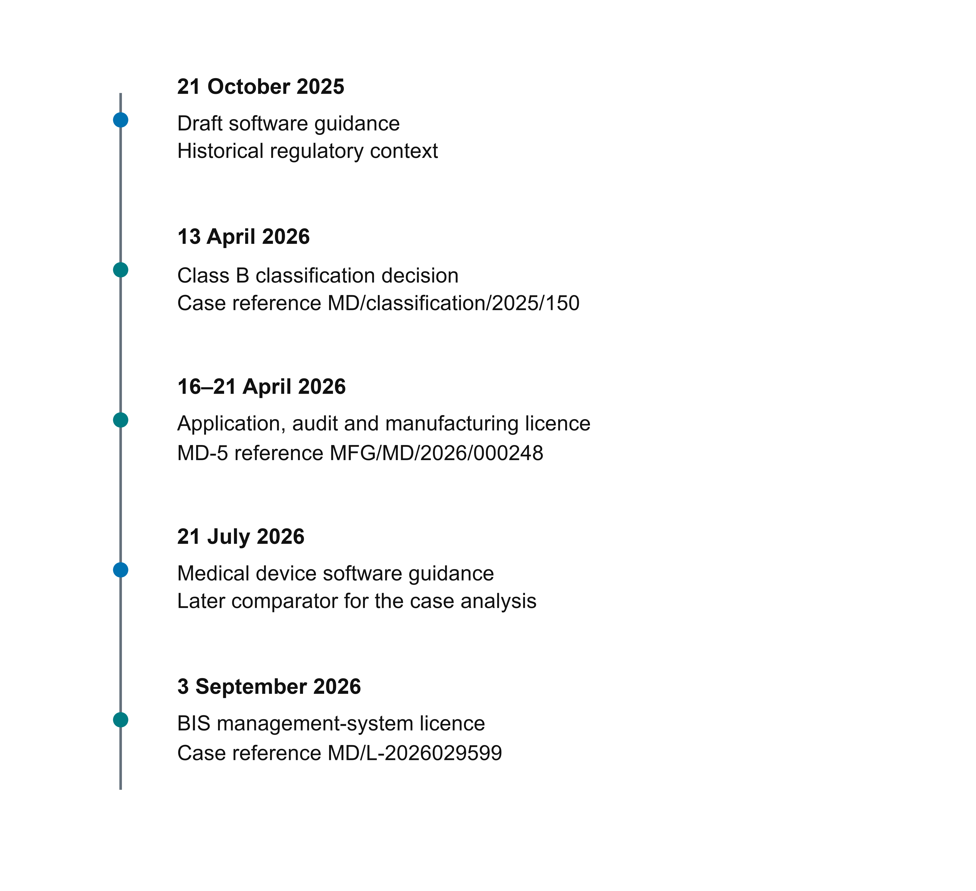
Figure 1. The case and the changing guidance context. Timeline of the April 2026 classification and licensing sequence, followed by public CDSCO software guidance in July and the manufacturer-reported BIS management-system licence in September. The application and licence dates are supported by directly inspected documents; the classification and audit dates are reported in the case account. July guidance is an analytical comparator, not the asserted basis of the April decision. Source details are in Table 1.

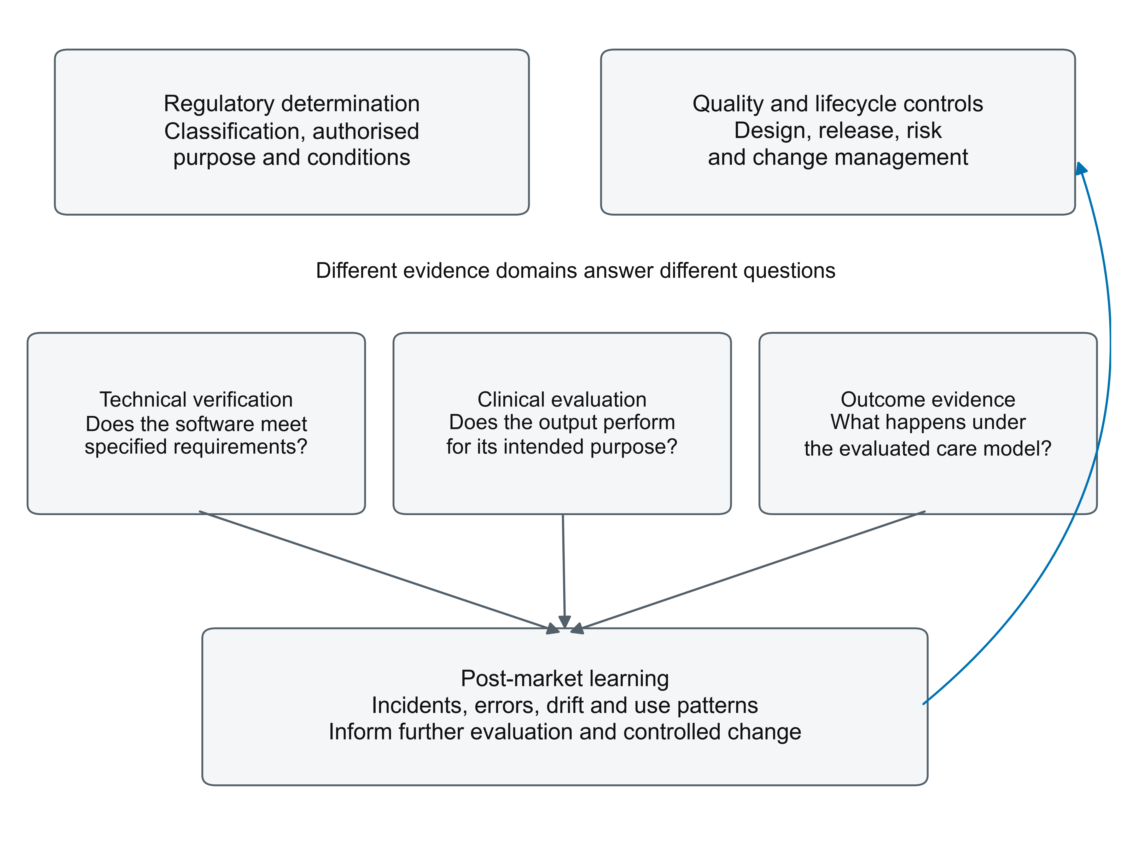
Figure 2. Connected evidence domains with distinct claims. Regulatory authorisation, quality-system controls, technical verification, clinical evaluation, and outcome evidence are connected but answer different questions. Post-market findings feed back into risk management, change control, and further evaluation. No arrow represents equivalence between a licence or certificate and demonstrated clinical benefit. The claim boundaries are specified in Table 3.

Supplementary material
Companion material to BHCL-PUB-2026-09-01 | 3.0

Supplement 1. Documentary source register
This register distinguishes directly inspected electronic instruments from public interpretive sources, manufacturer-reported instruments, and internal descriptions. Direct inspection establishes the content of a supplied document; it does not imply digital-signature validation or confirmation of present status. Documentary requests may be directed to the corresponding author.
Table S1. Document register and verification status
Document or record | Source and reported identifier | Role in this analysis | Availability and verification status
MDR 2017 and amendments | Ministry of Health and Family Welfare; G.S.R. 78(E).[1] | Statutory forms, schedules, and regulatory route | Public official source; used as interpretive authority.
2025 draft and July 2026 software guidance | CDSCO; references 2 and 3 | Historical context and retrospective comparison | Public official sources; July release distinguished from the earlier draft.
Manufacturer case account | BHCL-PUB-2026-09-01, version 2.0, 28 pages.[4] | Case facts, chronology, dossier and process descriptions | Supplied source text reviewed in full; manufacturer-authored, without independent documentary adjudication.
Classification decision | MD/classification/  2025/150; 13 April 2026.[8] | Reported Class B determination | Identifier and date taken from the case account; original not independently authenticated.
MD-3 application and notified-body audit | Application dated 16 April, as stated in covering letter [5]; audit on 18 April 2026 reported in [4] | Application and assessment sequence | Covering letter directly inspected; audit report itself not inspected.
MD-5 licence, annexure, and covering letter | MFG/MD/2026/000248 and Lr. Rc. MFG/MD/2026/189231; 21 April 2026.[5] | Named manufacturer, version, intended purpose, Class B, and licensing event | Electronic issued documents directly inspected; matching licence and covering letter agree. An alternate supplied covering letter refers to 000150 and was not treated as equivalent.
Quality and information-security certificates | QRO 3050251115129MD and 305025120207IS.[6,7] | Certification dates and stated scopes | Certificate copies directly inspected; certifier registry/accreditation and present status not independently checked.
BIS management-system licence | MD/L-2026029599; 3 September 2026.[9] | Reported subsequent IS 23485:2019 licence | Case-account description; original full scope and present status not independently authenticated.
Software development, release, and surveillance records | Dossier and process descriptions in reference 4 | Qualitative account of lifecycle controls | No source-code review, test execution, production audit, or surveillance-dataset analysis performed.
AbilityScore methodology and validation protocol | Zenodo DOIs in references 14 and 15 | Context for the distinction between methods, planned validation, and results | Cited as preprint and protocol; no new analysis of clinical data is reported.
The reference register distinguishes supplied documentary instruments from publicly accessible sources. Reference 5 identifies the actual MD-5 and its matching covering letter. The older case account remains the source for the uninspected classification letter, audit event, BIS instrument, and internal processes.

