Matrix Quiz : structure, technology and algorithms
A document describing the structure, technology and sizing algorithms in the main web-page of the Matrices questionnaire.

Contents
- A pictorial representation of the <div>s in the page, accompanied by a brief description of the purpose of each.
- Image dimensions
- A description of the algorithm used to determine the scaling of the image elements
- Worked numeric examples for various screen resolutions
- Included libraries

Layout
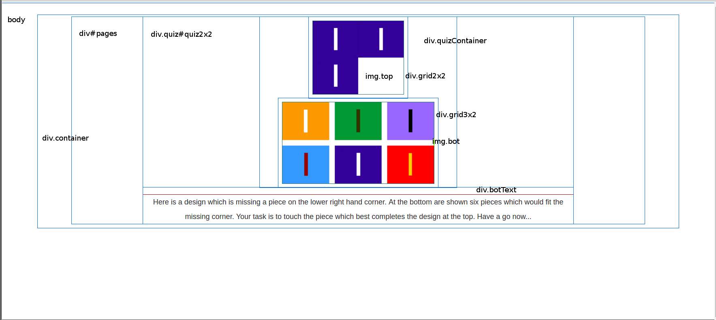
body HTML <body> tag
div.container Used to add margins around the content
div#pages A container for the pages, one of which is shown at a time
div#quiz2x2.quiz A page div, the 2x2 quiz is shown in this example
div.gridContainer Used to keep grids together and scaled relative to each other, and to centre using left and right margins
.grid2x2 Contains the top grid image
.grid3x2 Contains the bottom grid image, and padding to distance it from the top grid
img.top The top grid image, which is changed by main.js
img.bot The bottom grid image, which is changed by main.js
div.botText Holds the explanatory text when required

Natural image sizes
2x2, 3x2
img.top natural: 420 x 340
img.bot natural: 680 x 365

3x3, 4x2
img.top natural: 510 x 405
img.bot natural: 755 x 295

Width (symmetrical about y axis)
html -
body -
div.container 10px
div#pages -
div#quiz2x2.quiz -
div.gridContainer margins set by calc
div.grid3x2 margin: auto, width: 81% e.g. 65.1px
img.bot (natural) 680px (quiz2x2) | 755px (quiz3x3)
div.grid3x2 margin: auto, width: 81% e.g. 65.1px
div.gridContainer margins set by calc
div#quiz2x2.quiz -
div#pages -
div.container 10px
body -
html -
notes:
- div.container padding: 15px 10px 20px 10px; (N, E, S, W)
- div#pages has margin: auto but always fills div.container
- hard-code natural image sizes - see "Can we get the native/natural height of images?"

Height
html -
body -
#devBar hidden
div.container padding-top: 15px
div#pages -
div#quiz2x2.quiz -
div.gridContainer -
img.top (natural) 340px (quiz2x2) | 405px (quiz3x3)
div.grid3x2 padding-top: 5% e.g. 34px
img.bot (natural) 365px (quiz2x2) | 295px (quiz3x3)
div.gridContainer -
div.botText 72px minimum (if not wrapped) (if visible)
div#quiz2x2.quiz -
div#pages -
div#abandon-div 34px (if visible)
div.container padding-bottom: 20px
body -
html -

Details of image sizes

2x2 Puzzle
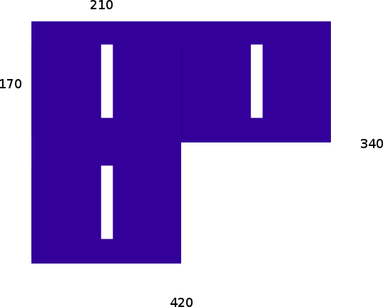
- The top image is 420px x 340px, 2 tiles wide by 2 tiles high
- Each tile is 210px x 170px, with no space between them
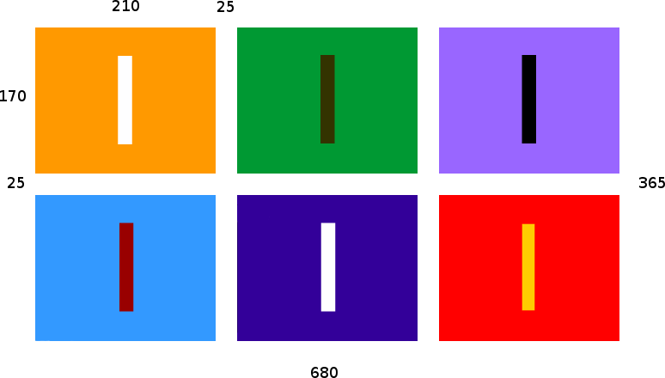
- The bottom image is 680px x 365px, 3 tiles wide x 2 tiles high
- Each tile is 210px x 170px and there is a gap of 25px between each tile, horizontally and vertically.

3x3 Puzzle
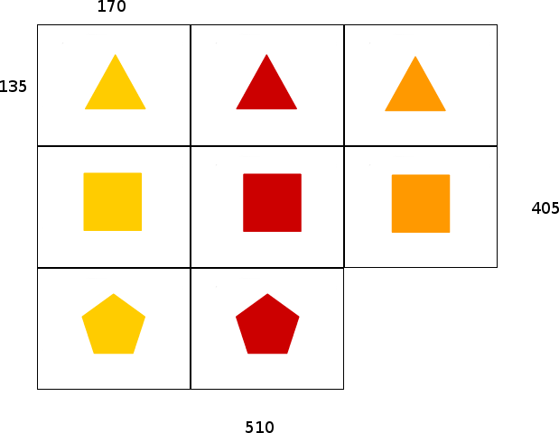
- The top image is 510px x 405px, 3 tiles wide by 3 tiles high
- Each tile is 170px x 135px, with no space between them
- The bottom image is 755px x 295px, 4 tiles wide x 2 tiles high
- Each tile is 170px x 135px and there is a gap of 25px between each tile, horizontally and vertically.
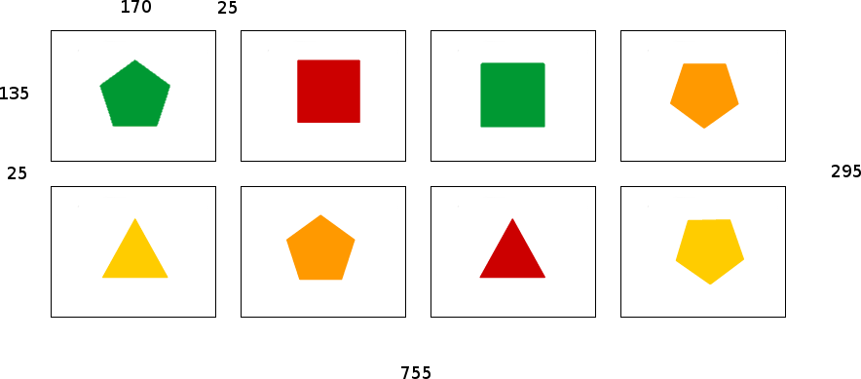

Description Of Scaling Algorithms

scaleImagesCBsimple()

Pseudo-code
setMargins = (window.width - (window.height() - heightExtra) - widthExtra) / 2;
- Tries to keep the div.gridContainer element square by setting the margins of .gridContainer
- The abandon button scrolls off the bottom at extreme width and short height.

JavaScript code
var widthExtra =
($('.container').outerWidth(true) - $('.container').width()) +
($('#pages').outerWidth(true) - $('#pages').width());

var heightExtra = // required height of .gridContainer
($('#abandon-div').is(':visible') ? $('#abandon-div').height() : 0) +
($('.botText').is(':visible') ? $('.botText').height() : 0);

var setMargins = ($(window).width() - ($(window).height() - heightExtra) - widthExtra) / 2;

if (setMargins > 0) {
$('.gridContainer').css('margin-left', setMargins);
$('.gridContainer').css('margin-right', setMargins);
} else { // content should shrink width-wise if needed
$('.gridContainer').css('margin-left', 0);
$('.gridContainer').css('margin-right', 0);
}

New Scaling Algorithm

Pseudo-code
get natural width/height (naturalFullWidth/Height)
get window width/height ($(window).width()/height)

# allow 200px for text at bottom
# window - 200px height needs to fit natural width/height

vertical shrink = (window height - 200px) / naturalFullHeight
horizontal shrink = window width / naturalFullWidth

scale = vShrink < hShrink ? vShrink : hShrink

targetHeight = naturalFullHeight * scale
targetWidth = naturalFullWidth * scale

targetMiddleHeight = targetHeight - heightExtras

# need h/w ratio of .gridContainer
# Typical dimensions: 162 x 144
# 162 / 144 == 1.125
middleHWRatio = 1.125

# what innerWidth of .gridContainer would create targetMiddleHeight?
targetMiddleWidth = targetMiddleHeight * middleHWRatio

# set margins on .gridContainer to achieve targetWidth and targetHeight
margins = (window.width - widthExtra) / 2

JavaScript code
var topWidth, topHeight, botWidth, botHeight;
if (currentPage().templateId == 'quiz2x2') {
topWidth = 420;
topHeight = 340;
botWidth = 680;
botHeight = 365;
} else if (page.templateId == 'quiz3x3') {
topWidth = 510;
topHeight = 405;
botWidth = 755;
botHeight = 295;
}

var widthExtra =
($('.container').outerWidth(true) - $('.container').width()) +
($('#pages').outerWidth(true) - $('#pages').width());

var heightExtra =
($('#abandon-div').is(':visible') ? $('#abandon-div').height() : 0) +
($('.botText').is(':visible') ? $('.botText').height() : 0);

var naturalFullWidth = widthExtra + botWidth; // bottom image widest
var naturalFullHeight = heightExtra + topHeight + botHeight;

var scaleV = ($(window).height() - 200) / naturalFullHeight;
var scaleH = $(window).width() / naturalFullWidth;
var scale = scaleV <= scaleH ? scaleV : scaleH;

var targetWidth = naturalFullWidth * scale;
var targetHeight = naturalFullHeight * scale;
var targetMiddleHeight = targetHeight - heightExtras;

var middleHWRatio = 1.125
var targetMiddleWidth = targetMiddleHeight * middleHWRatio;

setMargin = ($(window).width - widthExtra) / 2
$('.gridContainer').css('margin-left', setMargin);
$('.gridContainer').css('margin-right', setMargin);

Can we get the native/natural height of images in JavaScript?
In order to work out the natural, unscaled dimensions of the content, in order to scale them to fit the viewport, we need to know the original dimensions of the images. Could we do this programmatically?
This is slighty tricky: there are native javascript attributes: .naturalWidth / .naturalHeight but for IE, in IE9+
var width = $(this).get(0).naturalWidth; var height = $(this).get(0).naturalHeight; // current element
var width = $("selector").get(0).naturalWidth; var height = $("selector").get(0).naturalHeight; // selected element
There is a plugin that adds .naturalHeight() and .naturalWidth() to jQuery. Workaround for IE6-IE8: create a new Image() element, and get the width and height of that. As we know the image dimensions and they are not going to change, we might as well hard-code them.

Worked examples
Worked numeric examples for screen resolutions of (HxV) 1280x1024, 640x480, 320x480, 750x1334 and 1242x2208.
1308 x 598
botHeight = 365 botWidth = 680 topHeight = 340 topWidth = 420 widthExtra = 20 heightExtra = 72 middleHWRatio = 1.125 naturalFullHeight = 777 naturalFullWidth = 700
scaleH = 1.8685714285714285 scaleV = 0.5122265122265123 scale = 0.5122265122265123 targetWidth = 358.56 targetHeight = 398 targetMiddleWidth = 366.75 targetMiddleHeight = 326 setMargins = 460.63
1280x1024
botHeight = 365 botWidth = 680 heightExtra = 72 topHeight = 340 topWidth = 420 widthExtra = 20 middleHWRatio = 1.125 naturalFullHeight = 777 naturalFullWidth = 700
scaleH = 1.8285714285714285 scaleV = 1.0604890604890604 scale = 1.0604890604890604 targetWidth = 742.34 targetHeight = 824 targetMiddleHeight = 752 targetMiddleWidth = 846 setMargins = 207
640x480
botWidth = 680 botHeight = 365 topWidth = 420 topHeight = 340 widthExtra = 20 heightExtra = 60 middleHWRatio = 1.125 naturalFullWidth = 700 naturalFullHeight = 765
scaleH = 0.9142857142857143 scaleV = 0.3660130718954248 scale = 0.3660130718954248 targetWidth = 256.21 targetHeight = 280 targetMiddleWidth = 247.5 targetMiddleHeight = 220 setMargins = 186.25
320x480
botWidth = 680 botHeight = 365 topWidth = 420 topHeight = 340 widthExtra = 20 heightExtra = 120 middleHWRatio = 1.125 naturalFullWidth = 700 naturalFullHeight = 825
scaleH = 0.45714285714285713 scaleV = 0.3393939393939394 scale = 0.3393939393939394 targetWidth = 237.58 targetHeight = 280 targetMiddleWidth = 180 targetMiddleHeight = 160 setMargins = 60
750x1334
botWidth = 680 botHeight = 365 topWidth = 420 topHeight = 340 widthExtra = 20 heightExtra = 60 middleHWRatio = 1.125 naturalFullWidth = 700 naturalFullHeight = 765
scaleH = 1.072857142857143 scaleV = 1.4823529411764707 scale = 1.072857142857143 targetWidth = 751 targetHeight = 820.73 targetMiddleWidth = 855.83 targetMiddleHeight = 760.74 setMargins = -62.41
1242x2208
botWidth = 680 botHeight = 365 topWidth = 420 topHeight = 340 widthExtra = 20 heightExtra = 72 middleHWRatio = 1.125 naturalFullWidth = 700 naturalFullHeight = 777
scaleH = 1.7757142857142858 scaleV = 2.584298584298584 scale = 1.7757142857142858 targetWidth = 1243 targetHeight = 1379.73 targetMiddleWidth = 1471.19625 targetMiddleHeight = 1307.73 setMargins = -124.09812499999998

List of included libraries
jquery.js
jquery-ui.css
modernizr.js
browser-sync.js
bootstrap.css
bootstrap-sass
imageMapResizer.js
The build system was created by yeoman running on node.js via npm. It uses the gulp task runner to perform SASS compilation, testing, linting, synchronised browsing, minification, and front-end package management via bower.
The CSS framework is Bootstrap, though I have overridden a lot of it to make things simpler. The code in main.js uses jQuery.
http://yeoman.io/
https://nodejs.org/
https://www.npmjs.com
http://gulpjs.com
http://sass-lang.com/
https://bower.io/
http://getbootstrap.com/
https://github.com/davidjbradshaw/image-map-resizer
https://jquery.com/

