

Graphics Logo
Conversion Guide

To display a color graphics logo during POST

Information in this document is subject to change without notice and does not represent a commitment on the part of Intel Corporation. No part of this program or publication may be reproduced, transmitted, transcribed, stored in a retrieval system, or translated into any language or computer language, in any form or by any means, electronic, mechanical, magnetic, optical, chemical, manual, or otherwise, without the prior written permission of Intel Corporation. Any unauthorized duplication is a violation of U.S. copyright and other laws which may result in severe monetary and criminal damages.
Copyright ©1996, Intel Corporation. All rights reserved.
Intel Corporation
5200 NE Elam Young Parkway
Hillsboro, OR 97124-6497
Printed in U.S.A.

Introduction
This document describes the requirements, preparation, conversion, and installation of an OEM logo into Intel Storm-based BIOS. This allows a color graphics logo of up to 640 pixels by 480 pixels by 16 colors to be displayed during POST (Power-On Self Test).
The logo is converted from a .BMP file to a .USR file and is then flashed into the BIOS user data area.

Limitations and Requirements
The basic requirements are a Microsoft BMP file format using RBG encoding and standard 16 EGA colors. The image complexity should not exceed that which allows the converted file size to be flashed into the USR file image area of the BIOS (generally 4 KB or 8 KB, depending on the platform’s capability).
- The BMP file must be a 16-color image using the standard EGA color palette. Custom colors are not supported since they would require changing the color or palette registers during BIOS POST. CLRlogo will re-map any non-standard colors in the original .BMP file into the standard EGA color which is the closest match.
- The BMP file must use standard RGB file encoding. This precludes the use of four-bit Run Length Encoded compression (RLE) and all OS/2 BMP file formats.
- Although the .BMP file can contain a full-screen image (640 pixels in width and 480 pixels in height), the image would be overwritten by the standard BIOS POST display messages. To prevent this, the logo should not exceed an image width of 240 pixels and an image height of 171 pixels, and should be placed in the upper right-hand corner of the screen (see figure).
- The image width must be a integral multiple of eight pixels, since it will be displayed on a eight-pixel horizontal boundary. The height is not restricted. If the specified width is not a multiple of eight, the image will be truncated.
- The combination of image width and starting column should not exceed 640; otherwise, the image will “wrap” to the left side of the screen.
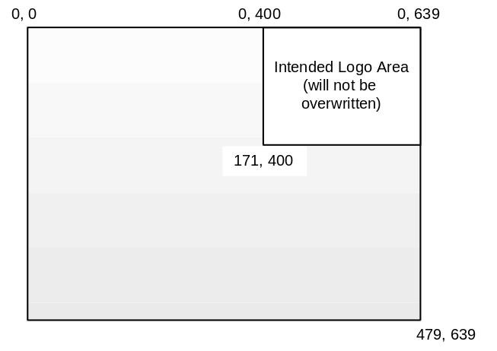

Recommended Command Line
- CLRLOGO /c400 /display logo.bmp (Assumes a standard logo size and
position.)
This command converts the bitmap file logo.bmp to a .USR file logodata.usr (default name) and displays the result as it would appear on the POST screen, with the upper left corner of the image starting at coordinates 0, 400. This would put the appropriate-sized image in the reserved space shown in the figure.
Test the logo display by using FMUP to flash the file logodata.usr into the BIOS.

Option Switches
The following switches may be specified in any order, separated by spaces. Note that there is no space between the switch and its parameter.
- /fu<file> Specify filename of .USR file. Used to override the default filename of the .USR file. If this switch is not specified, the default filename is logodata.usr.
- /r<num> Row number (0 .. 479). Starting row for top of image assuming upper line of screen is row 0 (see figure). Default row is 0.
- /c<num> Column number (0 .. 639). Starting column for left edge of image assuming left edge of screen is column 0 (see figure). Default is column 0. This number should be an integral multiple of 8; if it is not, the largest column number which is an integral multiple of 8 will be used.
- To position logo in the standard position which will not overwritten by Post messages, we recommend setting the starting column to 400 (/c400).
- Note that the sum of the starting column and image width should be less than 640 to prevent the picture from wrapping to the left side of the screen.
- /s<num> The size of the .USR file desired in kilobytes. The .USR file image data (excluding the .USR header) space in the BIOS will be padded to the specified size. Default is 4 KB.
- /t<string> Title string for .usr file. The internal title string for the .USR file which is displayed by FMUP and SHOWHEADER utilities.
- /nologo Suppress Intel copyright message during conversion. This standard option prevents program title display.
- /display Display the graphics logo; allows you to see the image as it would appear during POST. The video mode will change to Mode 12 (640x480 with 16 colors) and the logo will be displayed using row and column parameters specified (or defaults). The image will be displayed until the user hits any key. Then the video will return to Mode 3.
- /v Verbose. Informative messages will be displayed at various stages during program execution.
- /? or /h Help. Displays this list of switches on screen with a brief description of each.

