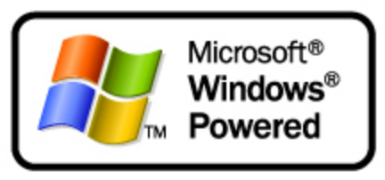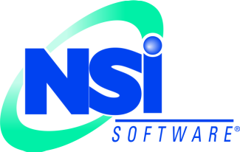
Improving Business Continuity using Windows Powered NAS Devices
White Paper
Published: April 2003

Table of Contents
Introduction 1
Deciding What to Protect 1
Metrics for Business Continuity Planning 1
How Double-Take Replication Works 1
How Replication Improves Business Continuity 1
High Availability 1
Disaster Recovery 1
Enhanced and Centralized Backups 1
Planned Maintenance and Migration Projects 1
A Typical Customer Scenario 1
Summary 1
For More Information 1

Improving Business Continuity with Windows Powered NAS Devices
White Paper

Published: April 2003
For the latest information, please see http://www.microsoft.com/storage/ or http://www.nsisoftware.com/nas/

Introduction
Businesses and organizations of all sizes increasingly depend on computerized data systems for their operations. Ensuring that these systems, and their stored data, keep operating is a critical part of business planning. Business continuance is the process of ensuring that critical data and systems remain available even if hardware, software, or environmental problems interrupt the primary servers’ normal operation. This paper describes some technologies and approaches for achieving business continuity within the Windows environment; specifically, by combining replication software and Windows Powered network-attached storage (NAS) devices, businesses can reliably safeguard their data while realizing cost and efficiency improvements in their storage management and provisioning.

Deciding What to Protect
The simplest approach to business continuance is to treat all data as equal, and equally important to business operations. However, this approach leads to unnecessary cost and complexity; many areas of the Windows infrastructure already have fault resilience. For example, Active Directory’s multiple-master replication model means that loss of one or more domain controllers is survivable as long as at least one DC remains. Likewise, DNS, WINS, and most other infrastructure servers can handle the loss of one or more participants. Furthermore, the design of these services is such that a failed server can often be quickly replaced and rebuilt, with its data restored via replication from its remaining peers. However, line-of-business applications and their associated data generally don’t enjoy this same level of protection. Messaging, database, resource planning, and other critical systems carry the data without which a business cannot operate, so it’s critical to ensure that those data are protected. Figure 1 illustrates the systems that are commonly protected versus those that often are not.
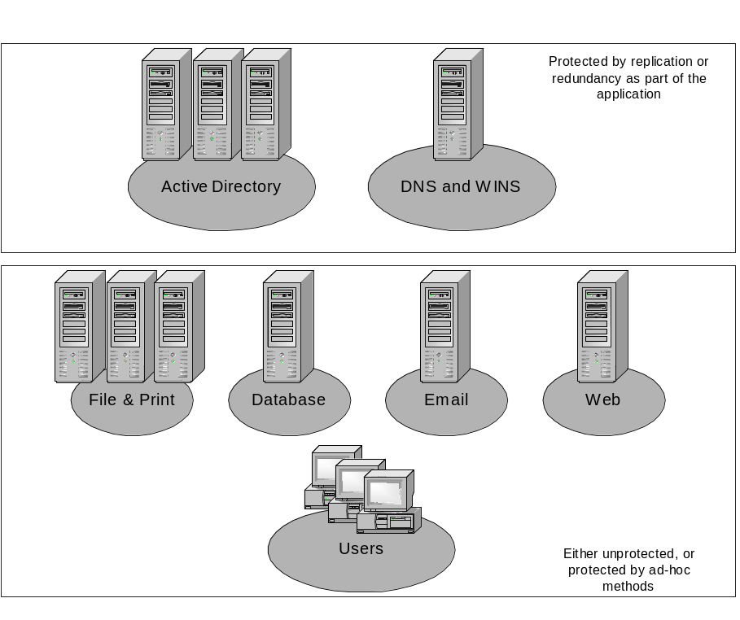
Figure 1: Infrastructure and line-of-business systems often have different degrees of protection
Business continuity planning is a complicated process that involves every aspect of business operations, from mundane concerns about office space and furniture to complex issues around automatic failover and transaction replay. The key point to remember is this: until critical line-of-business data can be restored, most other business resumption efforts cannot even begin.

Metrics for Business Continuity Planning
The decision as to what systems are worth protecting must be made based on business requirements and costs, particularly the cost of interrupted operations. Unplanned downtime costs money; it’s not uncommon for post-failure analysis to show direct costs of tens of thousands of dollars per hour for major outages. Those costs, of course, increase for businesses that are highly dependent on their data systems. Downtime costs can be precisely calculated and used to determine what level of investment in business continuity makes sense; however, the mechanics of doing so are outside the scope of this paper. (See the “For More Information” section for some useful references.)
When considering any business continuity technology, establishing some baseline expectations is important. It’s important to examine possible solutions in terms of two goals: data protection and data availability. These goals can be measured using two quantitative measures:
- Recovery Time Objective (RTO) represents the amount of time between the start of an outage and the resumption of normal business operations. The RTO for an outage that can be resolved by reloading from a tape backup includes the time necessary to locate and mount the tape, the time required to restore the data from the tape, and any time necessary to post-process the restored data before restarting the downed applications. Replicated storage systems using Windows Powered NAS devices offer an RTO close to zero...
- Recovery Point Objective (RPO) represent the point to which business data can be restored. This can be thought of as the latency between a production data set and its redundant or replicated copy. This latency may be expressed as a number of changes or a time interval; it measures how out-of-date the replicated copy will be compared to the original. For example, a nightly backup means that the RPO will be the time between when data was written to the tape and when the failure occurs: a failure any time on Tuesday has an RPO of Monday night. With replicated storage on Windows Powered NAS devices, the RPO is near zero.
Data availability requirements are usually expressed in terms of RTO, because the key factor that drives availability needs is the requirement to have access to critical data within a certain interval. By contrast, data protection requirements are usually expressed in terms of RPO. These requirements revolve around the need not to lose any important data. Data protection efforts often focus more on preserving access to the data under dire circumstances than on the amount of time required to regain access to the data if those circumstances occur.
Most businesses face a conundrum: tape backup systems are inexpensive and fairly reliable, but they offer poor RPO and RTO. Mirrored disk systems (like those found in SAN hardware from various vendors) offer excellent RPO and RTO, but they are expensive to buy and manage. An ideal solution would offer acceptable RTO and RPO without excessive acquisition or management cost. Combining NSI Software’s Double-Take® with Windows Powered NAS devices provides this ideal solution.

How Double-Take Replication Works
NSI Software’s replication solutions work by copying file changes from Windows servers and NAS devices (the replication source) to one or more replication target platforms). Software on the source systems captures changes to files on the source volumes, then queues the changes for network transmission to a target. Since this software operates as part of the operating system’s kernel, it captures all changes written to the source volumes; this approach is application-independent, and it doesn’t care whether the source is an application server or a Windows Powered NAS device. In addition, the replication software only copies the bytes changed for each write request; if a user makes a 250-byte change to a file, only 250 bytes of data is copied, not the 32-128KB actually used as the chunk size on the underlying RAID storage system. The replication software is able to distinguish between file reads and file writes, so it only replicates write operations to the remote targets.
Figure 2 shows a logical view of replication software in use on a Windows Powered NAS device. The application reads and writes data by making calls to the operating system. Double-Take intercepts write requests and copies them over the network to the replication target; afterwards, it allows the original request to be passed normally to the filesystem and on to the physical storage hardware. The replicated write request is accepted by the replication target and passed down through the operating system and filesystem layers as though it had been locally originated.
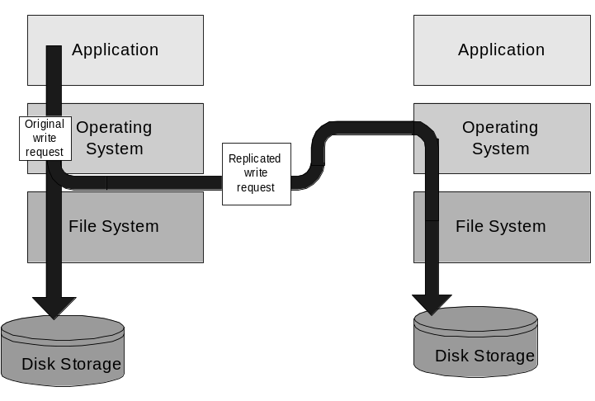
Figure 2: How the replication process works

How Replication Improves Business Continuity
The approach of replicating data in real time offers a potential escape from the cost-versus-recoverability dilemma. Instead of having to choose between operational cost and quick recovery, by choosing the right technology combination, businesses can have both: quick RPO/RTO and low acquisition, maintenance, and operating cost. The key is to use replication to copy necessary data, but it’s important to understand exactly how replication strengthens business continuity before making a deployment decision.
The phrase “business continuity” covers a broad spectrum of technologies, processes, and planning approaches; evaluating the usefulness of replication for particular conditions requires us to examine four separate scenarios in which replication might lead to better business continuity:
- Loss of a single resource. In this scenario, a single important server fails or is interrupted. For example, losing the web front end that customers use for product ordering would cripple any business that depends on orders from the web; likewise, many organizations would be seriously affected by the loss of one of their primary mailbox servers. For these cases, some companies will investigate fault-tolerant architectures, but few will invest in fault-tolerance technology for file and print servers—even though the failure of a single file server may simultaneously prevent several departments’ employees from accessing their stored data.
- Loss of an entire facility. In this scenario, an entire facility, and all of its resources, is unavailable. This can happen as the result of natural disasters, extended power outages, failure of the facility’s environmental conditioning systems, persistent loss of communications, or terrorist action. For most organizations, the normal response to loss of use for a facility is to initiate a disaster recovery to resume normal operations at another physical site.
- Loss of user data files. This unfortunately common scenario involves the accidental or intentional loss of important data files; the most common mitigation is to restore the lost data from a backup, but this normally involves going back to the previous RPO—often with data loss.
- Planned outages for maintenance or migration. The goal of planned maintenance or migrations is almost always to restore or repair service in a way that’s transparent to the end users.

High Availability
One of the most common approaches to continuous business operations is that of "failover". The goal for these high availability (HA) solutions is to keep the users productive even when outages affect their servers. HA is often thought of in terms of implementations of highly redundant hardware and Windows clustering; however, in many environments file and print servers are perceived as not worth the expense and complexity of a true HA solution. Double-Take’s ability to copy needed data from multiple sources to a single target provides a scalable and cost-effective way to enhance the resilience of file servers.
Windows Powered NAS is an optimized Windows fileserver itself. The combination of high hardware scalability, low operation and maintenance costs, and ease of integration with existing systems means that Windows Powered NAS devices running Double-Take provide a cost-effective redundant target server for groups of generic Windows file servers. In the same way, production NAS file servers can also be replication sources copied to a different Windows Powered NAS target. Three key benefits from the combination of Double-Take and Windows Powered NAS are:
- Windows servers running Windows NT 4.0, Windows 2000, and Windows 2003 and Windows Powered NAS appliances can be protected equally, either to the same target or to multiple, geographically distributed targets. This allows quick deployment of a single target for immediate protection, followed with later addition of more targets to improve resilience.
- Windows Powered NAS devices are easy to manage with familiar tools. They integrate seamlessly into the existing domain infrastructure. User rights and permissions are easily maintained in the target data sets.
- A single Double-Take target can handle failover for multiple source servers simultaneously. If a source server fails, its workload can be transparently redirected to the target; if other sources fail later, their work can also be directed to the target. The high scalability of Windows Powered NAS solutions means that a single device can handle failover of multiple servers without additional administrative overhead.
Figure 3 illustrates a production network of file servers replicated to a single Windows Powered NAS device; in the illustration, three file servers have failed and been retargeted to the NAS device.
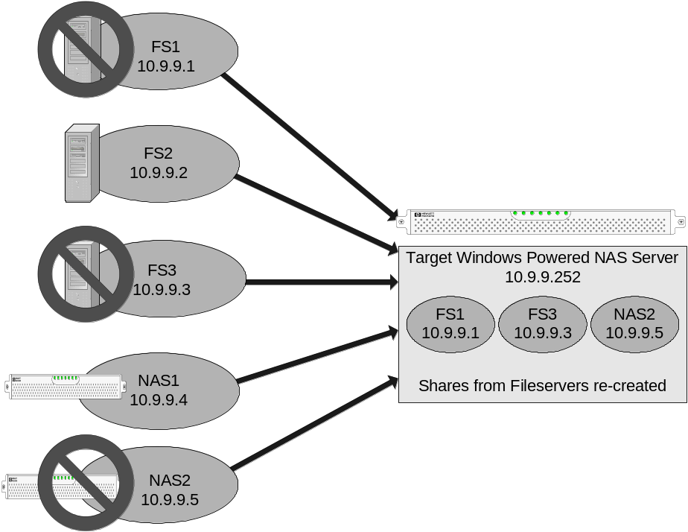
Figure 3: Replication provides high availability

Disaster Recovery
Disaster recovery is often taken to be synonymous with business continuity. However, true disaster recovery is the ability to restore needed business data after a disaster; it’s a part of, not the whole, of business continuity. Many administrators and planners think of disaster recovery as the ability to quickly resume operations at a separate physical site; that’s an overbroad, and very expensive, capability that’s mostly relegated to very large organizations whose businesses are able to justify the cost and logistical complexity. Windows Powered NAS devices and Double-Take together give you large-enterprise disaster recovery abilities at a fraction of the cost of large, dedicated “hot site” recovery operations. The ease of administration and high scalability of Windows Powered NAS solutions means that disaster recovery is more affordable, easier to deploy, and simpler to operate than other DR solutions.
Most disaster recovery plans define a successful disaster recovery as one that protects the data; this highlights the difference between disaster recovery’s focus on data protection and high availability’s focus on data availability. Because disaster recovery plans don’t usually include a failover component, disaster recovery represents another ideal situation for a Windows Powered NAS as the disaster recovery target platform. Regardless of the chosen solution for implementing high availability and failover solution, NSI’s Double-Take can replicate the data from the production Windows server location to a disaster recovery site. Combining Double-Take and Windows Powered NAS offers significant advantages:
- Because Double-Take can use dissimilar sources and targets, any vendor’s Windows Powered NAS appliance can protect the Windows servers from any other vendor.
- Asynchronous replication using the Internet Protocol (IP) allows the target to be any distance away from the source, using any network topology or transport, without significantly hindering the production server. The only considerations are latency of data and queue size.
- Because Windows Powered NAS platforms are optimized for speed of deployment and file handling, it’s easy to set up disaster recovery target sites.
- Because Windows Powered NAS servers participate in Windows domains, they retain all user permissions from the production servers-- the target is simply another Windows platform in the domain.
Figure 4 shows a sample configuration using Windows Powered NAS devices as replication targets for disaster recovery.
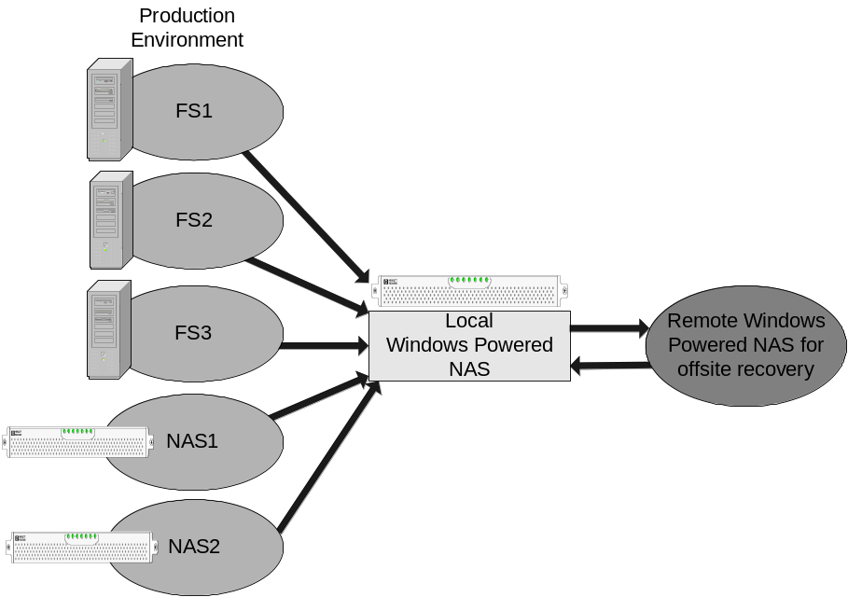
Figure 4: Disaster recovery configurations depend on quick setup and access to replicated data

Enhanced and Centralized Backups
Disaster recoveries are seldom necessary; unplanned failovers are more common, but still rare. However, most IT departments have to frequently restore data from tape backups. Replication doesn’t eliminate the need for tape backups, but it does open the door for higher-fidelity backups that take less time and effort to capture and restore. Figure 5 shows a sample replication environment; live data from production servers is replicated to the backup host, from which it is backed up to tape. This approach offers a number of benefits:
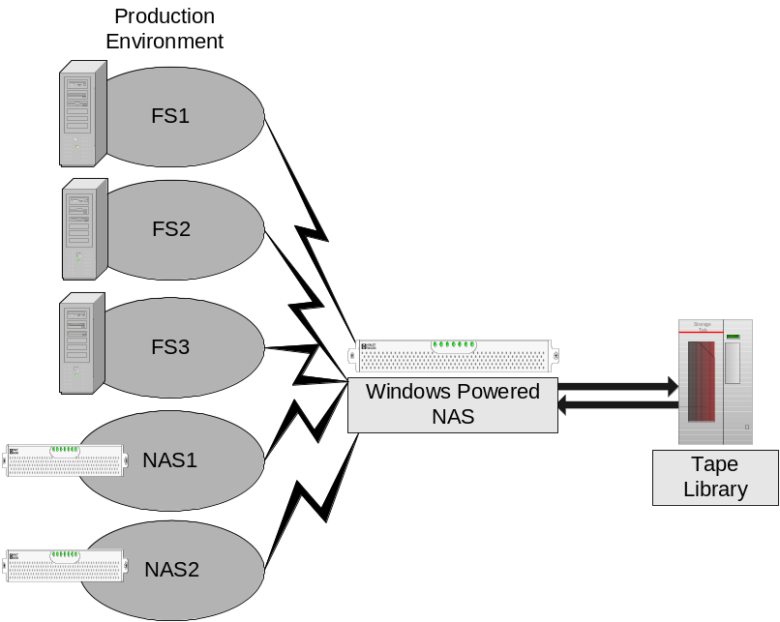
Figure 5: The file servers are replicated to the Windows Powered NAS device, thence to a tape library
- No open files, regardless of whether the files being backed up are user or application files. User directories can be replicated without special agents, and the backup software can protect them without the need for “open file agents”, which add significant complexity and expense to backup solutions.
- No spikes in CPU or I/O load on the production server. Since data is replicated as it’s written, the production server doesn’t have the sudden load spikes common during backup operations.
- No spikes in network I/O for distributed backups. It’s common to have a small number of high-speed or high-capacity tape drives that any host can use over the network. However, this approach leads to high network utilization during backup windows. Replication consolidates the data to the backup servers, thus allowing backups to take place at any time of day without impact to the production server.
Because the applications that are typically responsible for locking files (e.g. email, databases, and file sharing) are not running on the target server, the redundant data sets are in a dormant state. This means that one can use whatever tape backup software and hardware that has already been purchased on the target.
As an additional benefit, distributed branch office servers can replicate their small changes to a corporate target server. In many environments, this eliminates the need for tape hardware (and rotations and cleaning cartridges) in the field offices. Instead, corporate IT personnel can handle all backups from the data center.
As a file handling platform, a Windows Powered NAS is obviously well-suited as the replication target and tape backup server. This is especially true when considering centralized backup of branch offices, since a Windows Powered NAS scales better with larger amounts of storage. As the storage requirements grow even larger, a Windows Powered NAS can scale to handle many terabytes of data.

Planned Maintenance and Migration Projects
An important reality is that many service outages are planned. As an example, migrations are typically a planned weekend event—but during the migration, the server is still unavailable to the users. This, by definition, means that the business is not continuous; this problem is particularly acute for organizations that must offer round-the-clock access to data. Data migrations usually involve extended outages—and thus consume weekends or holidays—for two reasons: the files must typically be left dormant long enough to move them without users updating them in mid-move, and a "point of no return" must be defined so that if the migration is unsuccessful, it can be rolled back so that production resources are available for the next business day.
Replicating and migrating from stand-alone servers to Windows Powered NAS appliances offer some attractive benefits:
- Replication and mirroring can start during the workweek. By using the replication software’s scheduling and throttling features, replication can be tuned to have minimum impact on the production server. This allows the data to be moved to the new platform without consuming the IT administrators’ weekend; even while the initial mirror is being built on the target, changes to the source data are replicated to the target in real time.
- As soon as the initial mirroring completes, test users can be pointed at the new resource. If all goes well, the remaining users can be redirected sooner than originally planned—still without weekend work. If problems occur, the production server is still online and available. In this scenario, there is no “point of no return".
- Instead of disabling user access at 6 PM on Friday and working all weekend, the new target can be brought online on Monday morning, and users can be migrated during the workday
Because replication allows the data to be moved while preserving user access, many migration and consolidation projects no longer require weekend efforts.

A Typical Customer Scenario
A sample customer configuration helps illustrate the process of protecting file server data with Windows Powered NAS devices and Double-Take. Talespin Toys is a small toy company with multiple servers at each of their three plants: one SQL Server computer, one Exchange server, and three file/print/web servers (Figure 6 shows a single site’s configuration). Talespin’s technical requirements are threefold: they wanted to add local failover capability for their critical applications, then add disaster recovery and improve their backup capabilities. In addition, Talespin wanted to accomplish these requirements with as little capital expenditure as possible.
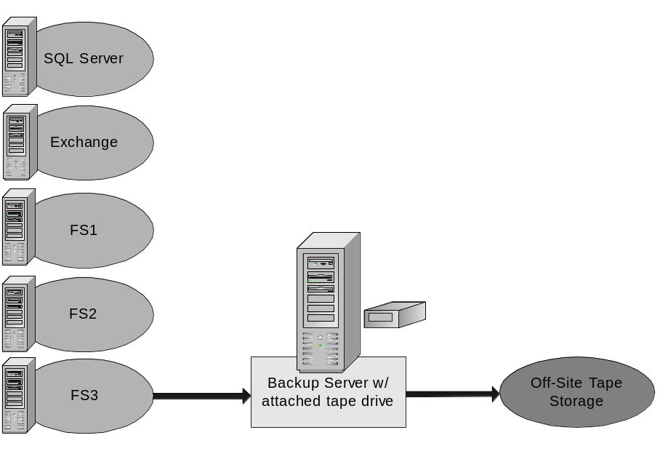
Figure 6: Talespin Toys environment before migration
The customer's first priority was providing local failover, in order to ensure productivity by their users. To achieve this, they chose to deploy Double-Take as an application failover solution, tying together their production and backup for Exchange and SQL Servers. Most administrators might have assumed that the three file servers could not be cost-effectively protected; however, Talespin chose to protect these valuable systems by deploying a Windows Powered NAS target at each site. By leveraging Double-Take’s ability to protect and provide failover for multiple sources, Tailspin was able to provide enhanced availability for all of the critical resources at each plant, as shown in Figure 7
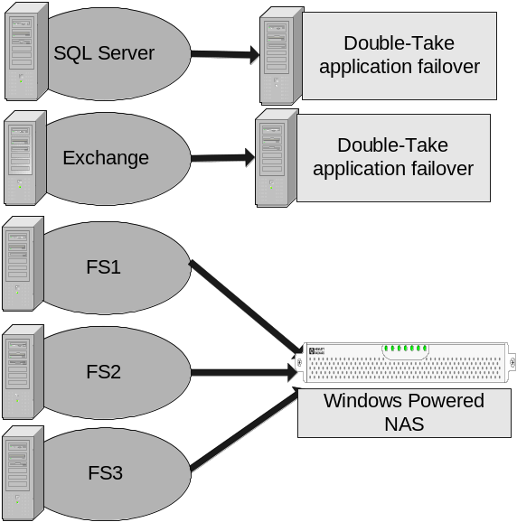
Figure 7: Talespin’s enhanced-availability configuration
Next, Talespin configured replication from site to site, using the Windows Powered NAS devices as sources and targets at alternate locations. Because Double-Take performs byte-level replication, the customer was able to utilize their existing WAN infrastructure between sites. The design philosophy was to have application failover within the clusters, with file servers failing over to the Windows Powered NAS devices, with alternate sites available for disaster recovery. A portion of this architecture is shown in Figure 8.
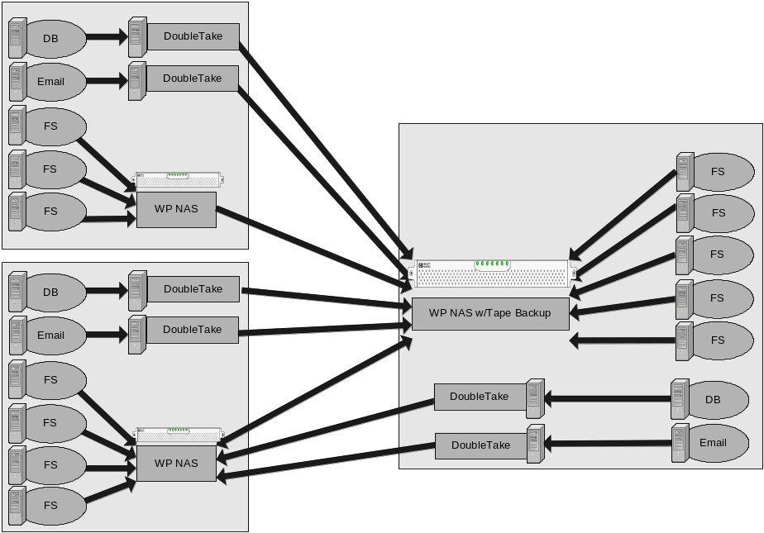
Figure 8: Enhancing availability with alternate sites
In total, three business sites were protected. All servers in each site had a local failover capability and the data was then replicated to a different geographic location. In addition, all tape backup operations are now performed at the one location that has IT personnel. Talespin’s solution used the high price/performance ratio of Windows Powered NAS devices to deliver these benefits for less than the cost of deploying high availability storage or backup systems alone.

Summary
As businesses come to increasingly depend on continuous access to their data (including systems formerly misunderstood as non-critical), ensuring that their data is available on demand is of paramount importance. The inability to access critical data on demand is a business-killer. To fight this problem, businesses can deploy expensive high-availability measures, but they’re often not cost-effective for the file and print servers that actually hold the bulk of day-to-day operational data. Combining the highly scalable and easily managed Windows Powered NAS architecture with NSI Software’s Double-Take replication agent provides a solution that protects important data by copying it in real time, without the hassles or time gaps inherent in traditional backup systems. This combination provides sound protection and better business continuity for a fraction of the cost of hardware replication or clustering technologies.

For More Information
- Microsoft Windows Powered NAS home page: http://www.microsoft.com/storage/
- NSI Software’s Double-Take home page: http://www.nsisoftware.com/nas/



The information contained in this document represents the current view of Microsoft Corporation on the issues discussed as of the date of publication. Because Microsoft must respond to changing market conditions, it should not be interpreted to be a commitment on the part of Microsoft, and Microsoft cannot guarantee the accuracy of any information presented after the date of publication.

This White Paper is for informational purposes only. MICROSOFT MAKES NO WARRANTIES, EXPRESS, IMPLIED OR STATUTORY, AS TO THE INFORMATION IN THIS DOCUMENT.

Complying with all applicable copyright laws is the responsibility of the user. Without limiting the rights under copyright, no part of this document may be reproduced, stored in or introduced into a retrieval system, or transmitted in any form or by any means (electronic, mechanical, photocopying, recording, or otherwise), or for any purpose, without the express written permission of Microsoft Corporation.

Microsoft may have patents, patent applications, trademarks, copyrights, or other intellectual property rights covering subject matter in this document. Except as expressly provided in any written license agreement from Microsoft, the furnishing of this document does not give you any license to these patents, trademarks, copyrights, or other intellectual property.

Unless otherwise noted, the example companies, organizations, products, domain names, e-mail addresses, logos, people, places and events depicted herein are fictitious, and no association with any real company, organization, product, domain name, email address, logo, person, place or event is intended or should be inferred.

© 2003 Microsoft Corporation. All rights reserved.

Microsoft, Windows Powered, Windows, Exchange, and SQL Server, are either registered trademarks or trademarks of Microsoft Corporation in the United States and/or other countries.

NSI and Double-Take are registered trademarks of Network Specialists Inc. and are used with permission of the trademark owner.

The names of actual companies and products mentioned herein may be the trademarks of their respective owners.

