Javascript Window Shake
Assumed Knowledge:
- Javascripting
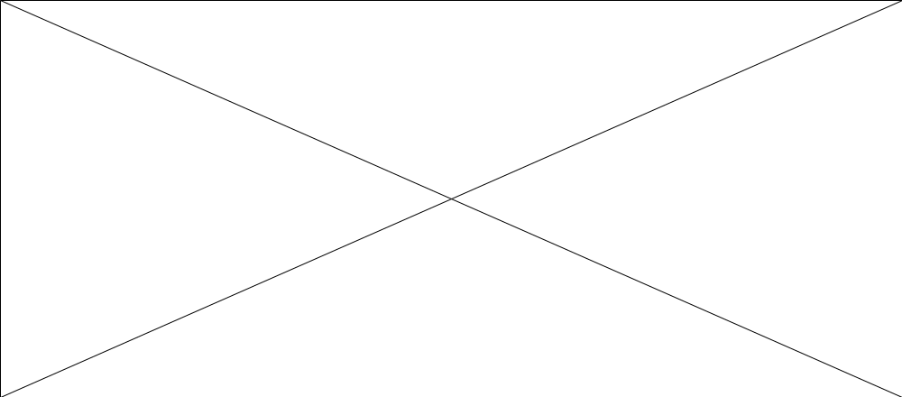To shake your browser window (browsers v4 and above) CLick the Start button in the movie above! This is a very cool effect based on a free script from the Javascript Source. In a version 4 browser it causes the window to shake! There are three javascript functions here, of which you can put one or all into your html page which holds your flash movie. The three functions are:
- shake_xy(n) : Shakes the screen in x and y directions, n is a size number, bigger means more shaking!
- shake_x(n) : Shakes the screen in the x direction!
- shake_y(n) : Shakes the screen in the y direction!
Insert the following code into your HTML page
<SCRIPT LANGUAGE="JavaScript1.2">
<!-- This script and many more are available free online at -->
<!-- The JavaScript Source!! http://javascript.internet.com -->
<!-- Modified by Flash kit http://www.flashkit.com -->

function shake_xy(n) {
if (self.moveBy) {
for (i = 10; i > 0; i--) {
for (j = n; j > 0; j--) {
self.moveBy(0,i);
self.moveBy(i,0);
self.moveBy(0,-i);
self.moveBy(-i,0);
}
}
}
}

function shake_x(n) {
if (self.moveBy) {
for (i = 10; i > 0; i--) {
for (j = n; j > 0; j--) {
self.moveBy(i,0);
self.moveBy(-i,0);
}
}
}
}

function shake_y(n) {
if (self.moveBy) {
for (i = 10; i > 0; i--) {
for (j = n; j > 0; j--) {
self.moveBy(0,i);
self.moveBy(0,-i);
}
}
}
}

//-->
</SCRIPT>
To call from HTML use call the javascript shake functions described above, either using an
<A HREF = "javascript:shake_xy(3)">Shake XY</A>
within a normal link, or as a javascript event in a button
<INPUT TYPE=BUTTON value="Shake x" onClick="shake_x(4)">
The above code would generate the links below....

Top of Form
Shake XY or
Bottom of Form

To access the same effect from within a flash movie, use the Get URL method on either a frame or a button and call a function as in the example below.
javascript:shake_xy(n)
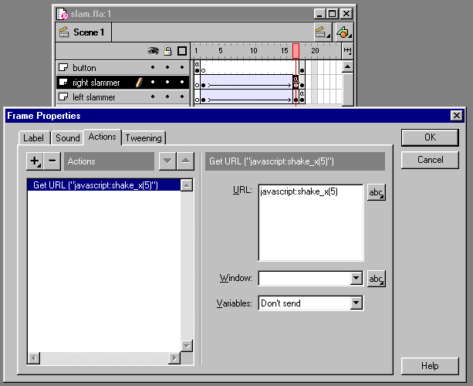
Download my Example (27k)  For conversion and unzipping tools  for PC and Mac Click Here! | Your Feedback!  Please rate this tutorial, 10 is the top rating  Top of Form |   Bottom of Form



