Homework 5

Drumea Matei

In the code that I wrote, I began by defining the functions for the, well, functions. I took one that was convex and its derivative, and one that was *not* convex and its derivative:

After which, I defined the function for the gradient descent method as such:

Defined the function to use for creating the graphs:

Created a menu in which to create the graphs in order:

And in said menu, created the graphs with appropriate values

As for the examples, this is the graph resulted from a small learning rate:

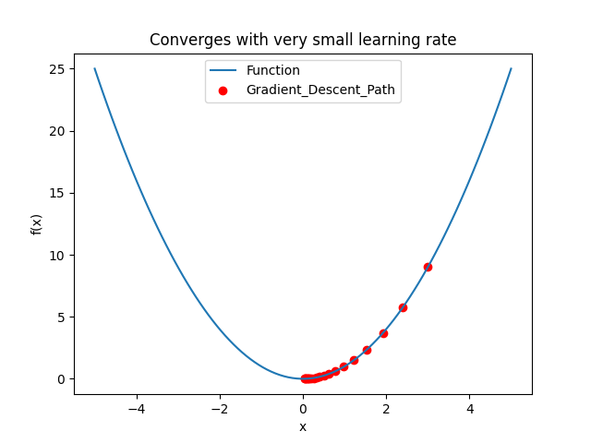

This is the graph for which the learning rate is a bit bigger:

This is the graph for which the learning rate is too large (in this case the function that creates the graph bugged out and I had to take a smaller starting x and a smaller number of iterations):

And lastly, the case in which f is a non-convex function, the values get stuck in a local minimum:

The github link for the repository: <https://github.com/drmatei/Analysis>

The files are: Homework5.py and Homework_5.docx