BLINDSPOT
A Second-Order Cybernetics Sketching Tool
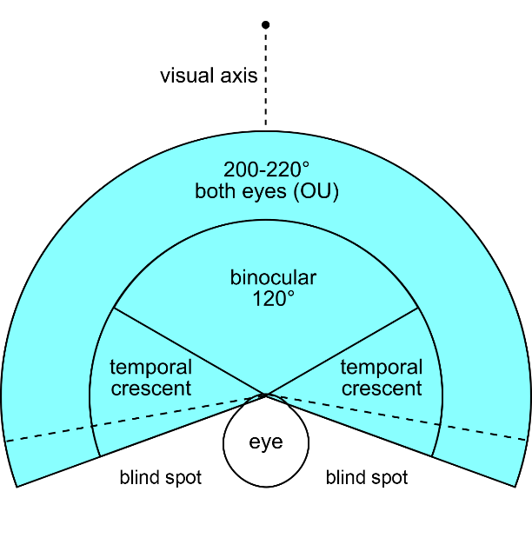

01 CONCEPT

Geometry in Blindspot is contingent — it persists only as long as it is observed. The viewport window acts as a gate: elements outside the current viewport are subject to mutation.

The observer is part of the system: observation itself alters what is observed.

02 PRACTICAL USAGE

Drawings in Blindspot are a live negotiation between the designer's intentions and the system's reinterpretation of them. What is watched stays fixed. What is unwatched mutates.
This prevents designers from anchoring too heavily to first drafts. The tool encourages continuous decisions about what is worth keeping and what is worth releasing.

03 LOGIC

The drawing surface is a digital whiteboard. Users draw freehand strokes with variable line weight and color, intended for early, preliminary sketching. Internally, strokes are represented as polylines — a graph of vertices as endpoints and intersections, edges as segments. This structure is what the mutation system operates on.
RULE 1 — VIEWPORT BOUNDARY
Mutation fires at the moment geometry crosses the viewport edge — either leaving or re-entering the visible frame. Elements entirely within the viewport are protected. Elements entirely outside are subject to mutation.

RULE 2 — TIME DECAY
The longer an element has been outside the viewport, the greater the degree of mutation applied when it re-enters. Brief panning produces subtle shifts; prolonged absence produces significant reorganization. Mutation magnitude scales continuously with unobserved duration.

ZOOM AS AMPLIFIER
Zooming into a detail is an intentional consequence of these rules: the majority of the drawing immediately becomes unobserved and subject to mutation. Zooming in commits the designer to a detail while the broader plan reorganizes itself.

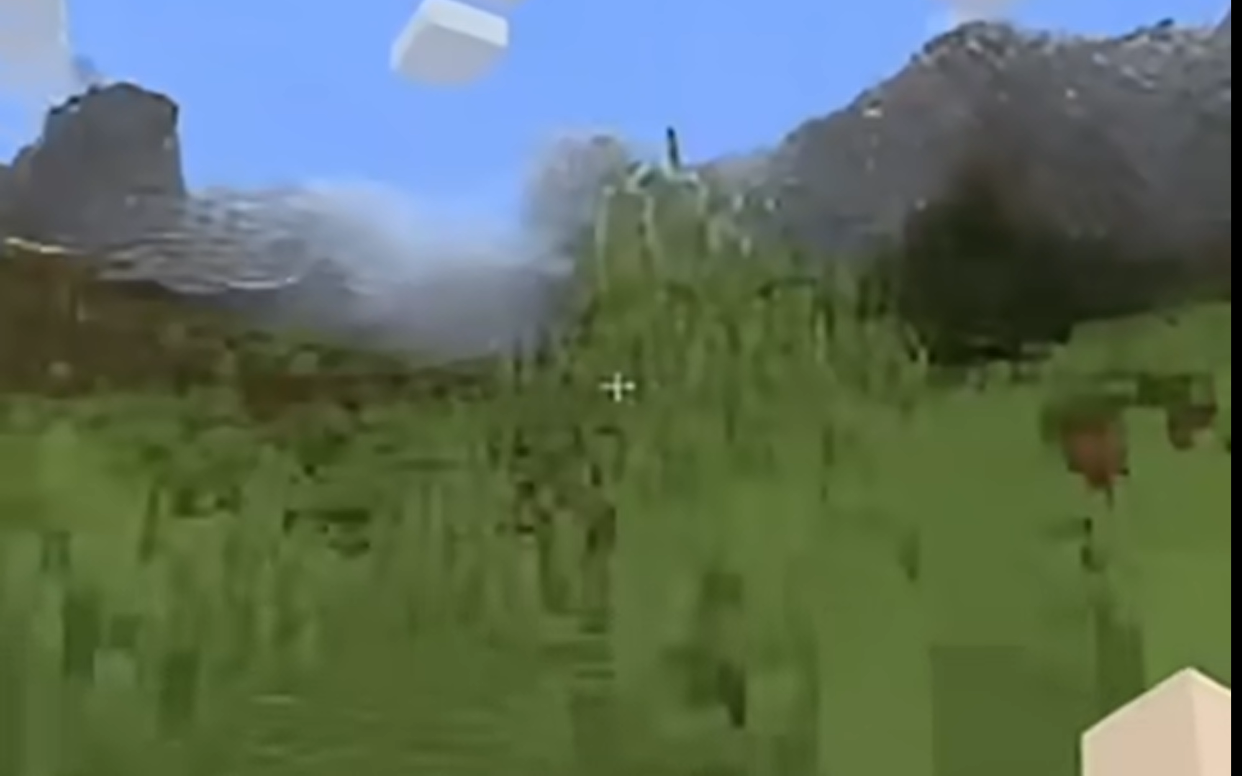

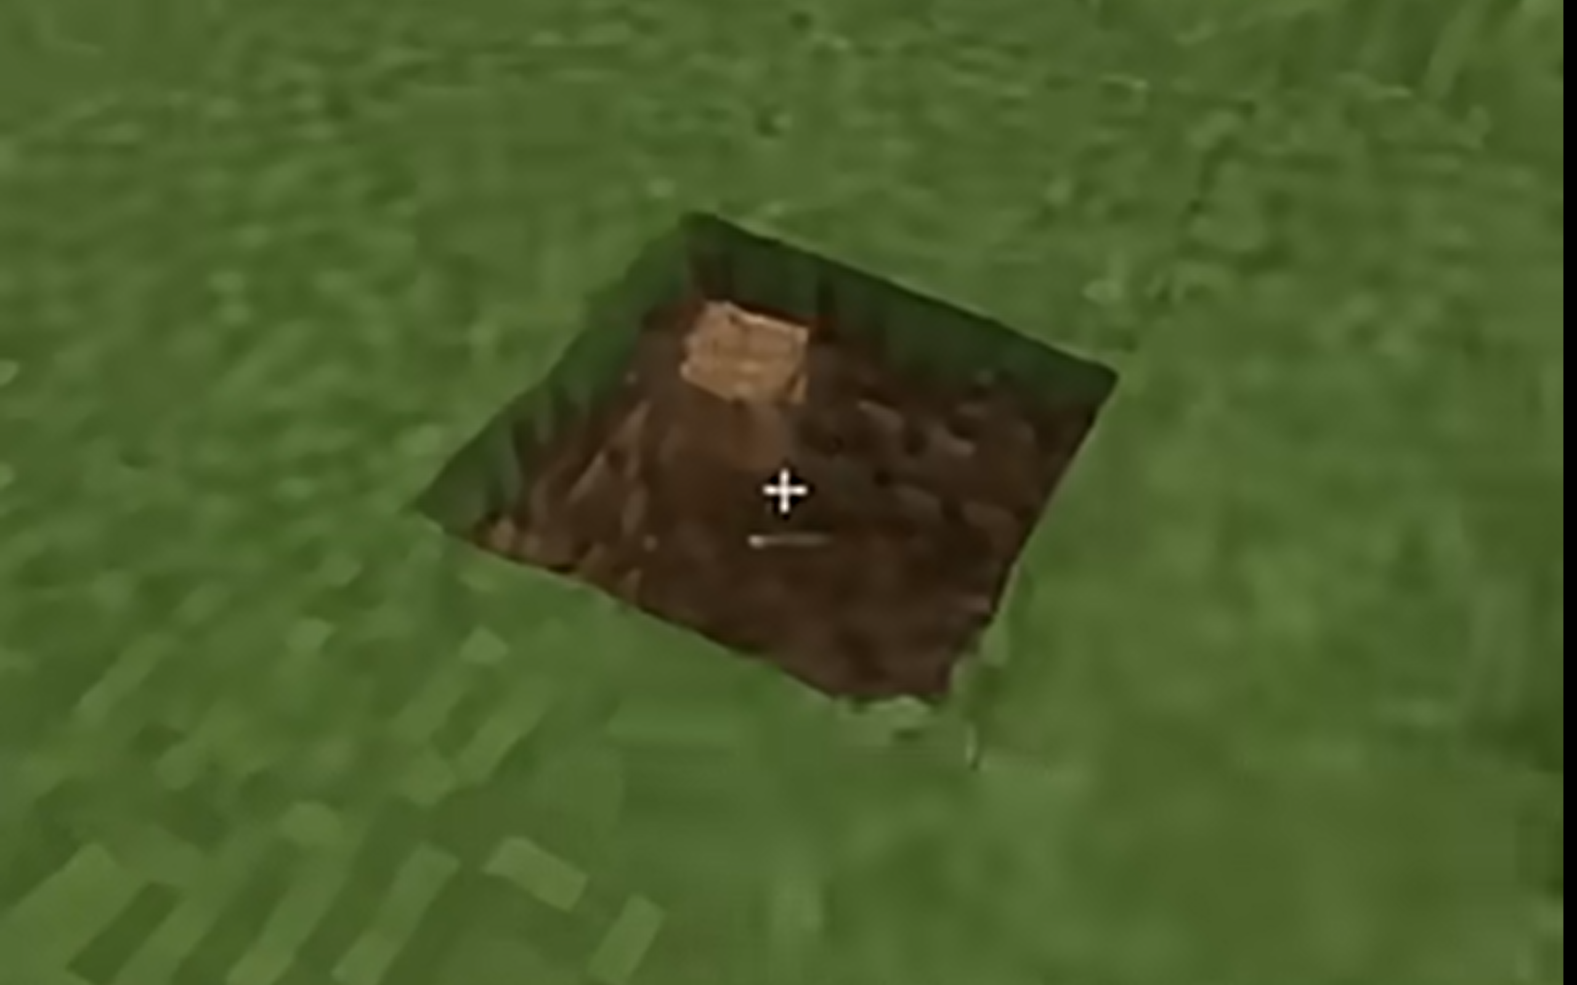

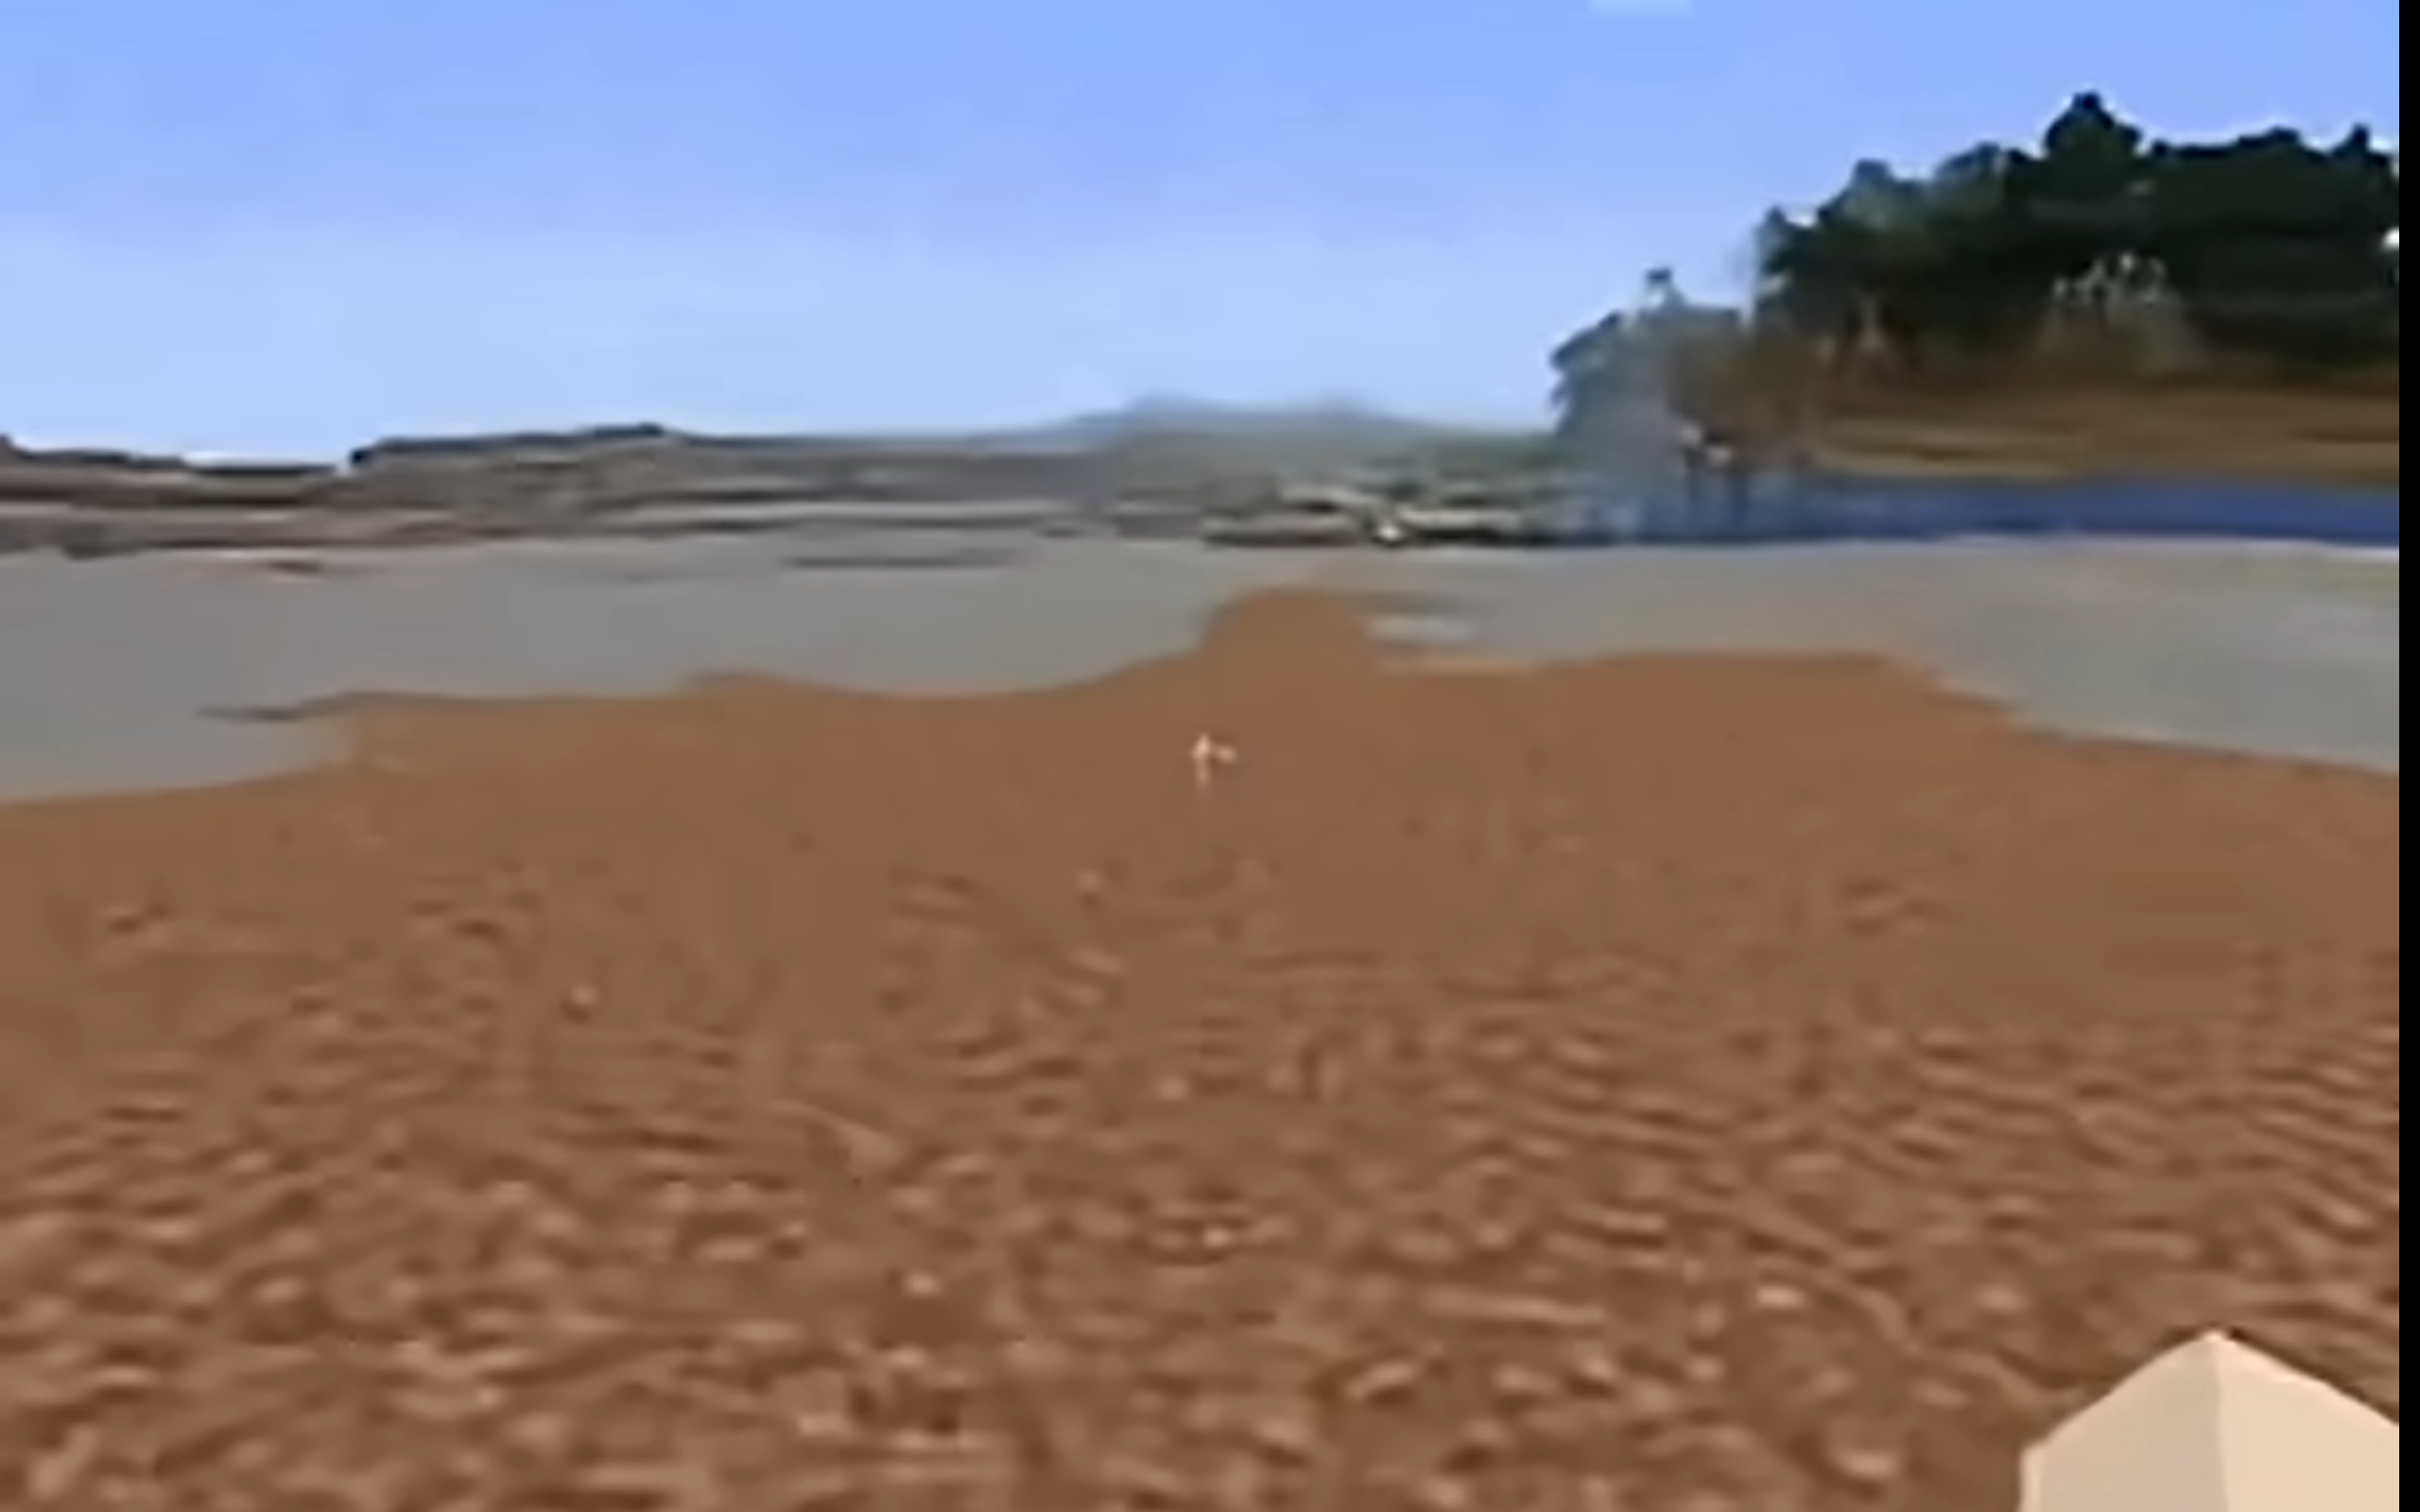

The ai lacks object/scene permanence and hallucinates Minecraft’s
environment when user repositions view. Click for video.

04 THREE MUTATION MODES

Three distinct mutation modes can be selected before or during a drawing session. Each implies a different ideological stance the tool takes toward the designer's geometry.
01  NORMALIZATION  PROCEDURAL  LOCAL · CORRECTIVE | 02  RATIONALISM  PROCEDURAL  GLOBAL · COMPOSITIONAL | 03  HALLUCINATION  LLM  MULTI-MODAL · GENERATIVE
The tool reads intent from near-misses and either fulfills or exaggerates them. Almost-parallel walls snap to parallel. Normalization operates element by element — it has no opinion about the whole composition, only about the coherence of individual relationships.  Approach Constraint relaxation toward preferred angular and rectilinear relationships. | Where Normalization is local, Rationalism is global. Elements migrate toward grid alignment, proportional harmony, or pure geometric forms. The tool favors the Cartesian, the modular, the classically resolved.  Approach Constraint fields seeded by existing elements, resolving outward through clusters that prioritize rationalism. | New geometry appears. Implied enclosures become explicit walls. Short segments extend toward adjacencies. Partial rooms are completed according to the model's interpretation of spatial logic.  Approach Geometry serialized as JSON or SVG, sent to a language model with a spatial completion prompt. Returned geometry is parsed and animated into the canvas.

05 THE LOCKING MECHANISM

Giving agency to the designer to declare what is fixed while leaving everything else negotiable.
Pins as Metaballs
Locks are placed as visible pins on the canvas. Each pin radiates a zone of influence modeled on the metaball principle: a smooth, continuous field rather than a hard boundary. Within the core radius, geometry is entirely frozen. Approaching the edge of the radius, the influence falls off gradually, preventing hard discontinuities between locked and unlocked regions.
Multiple overlapping pins merge their zones, creating larger protected areas. The designer builds up certainty incrementally: sketch everything loose, pin what works, let the rest evolve.

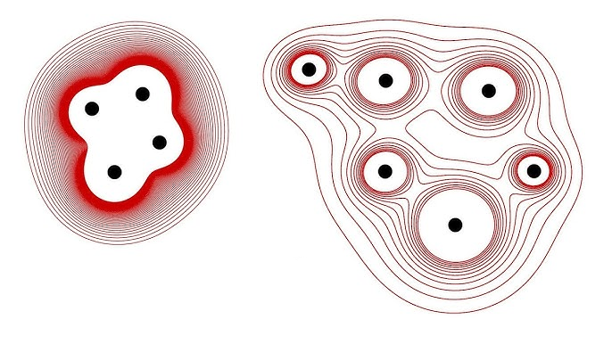

06 EVOLUTIONARY LINEAGE

Every mutation event is saved as a discrete state in the background, invisible to the designer during the session. When satisfied, the designer can choose to reveal the full mutation history.
The reveal renders all saved states simultaneously as overlapping layers — analogous to sheets of trace paper stacked on a light table. The earliest state is rendered lightest; the most recent is darkest. The full trajectory of the drawing's evolution becomes visible at once: not as an animation, but as a composite record of every negotiation the tool made on the designer's behalf.

The final artifact is not the drawing. It is the history of the drawing becoming itself.

07 IMPLEMENTATION OVERVIEW *draft

Canvas & Input | HTML5 Canvas or SVG surface with freehand stroke capture. Wacom tablet API for pressure sensitivity. Stroke simplification (Ramer-Douglas-Peucker) applied on completion.
Geometry Graph | Strokes stored as a planar graph of vertices and edges. Mutation algorithms operate on this structure: merging nearby nodes, extending dangling edges, applying vertex drift via Perlin noise fields.
Viewport Observer | Pan/zoom event listeners track which graph edges are inside or outside the viewport at all times. A per-element timer accumulates unobserved duration and drives mutation magnitude.
Locking Field | Pin positions define influence fields computed per-vertex using a smooth falloff function (inverse square with clamped radius). Mutation magnitude for each vertex is scaled by 1 minus its total lock influence.
State History | On each mutation event, a snapshot of the current geometry graph is pushed to a hidden history array. On Evolution Reveal, all snapshots are rendered with linearly interpolated opacity.
Hallucination API | On mode activation, current geometry is serialized to a JSON segment list and sent to the Anthropic API with a spatial completion prompt. The returned geometry is parsed and animated into the canvas over 1–2 seconds.

