**How to install Phonopy in ubuntu plateform**

**A short tutorial by Dr Mohan L Verma**

**-------------------------------------------------------------------------------------------------------**

**Step 1: Instalation of miniconda**

To install Miniconda on Ubuntu 20.04 from command line, it only takes 3 steps excluding creating and activating a conda environment.

* Download the latest shell script

**wget** **https://repo.anaconda.com/miniconda/Miniconda3-latest-Linux-x86_64.sh**

* Make the miniconda installation script executable

**chmod +x Miniconda3-latest-Linux-x86_64.sh**

* Run miniconda installation script

**./Miniconda3-latest-Linux-x86_64.sh**

* Create and activate an conda environment

To create a conda environment, run **conda create -n newenv**  
  
You can also create the environment from a file like environment.yml, you can use use the conda env create -f command: conda env create -f environment.yml. The environment name will be the directory name.

**Step-2 : Installation of Phonopy**

Reference : <https://phonopy.github.io/phonopy/install.html>

### **[Installing required packages by conda](https://phonopy.github.io/phonopy/install.html" \l "id6)**

The python libraries can be installed using conda. Conda packages are distributed in binary. Minimum setup of conda envrironment is done by miniconda, which is downloaded at <https://conda.io/miniconda.html>. It is strongly recommended to create conda’s virtual environment by conda create -n <venvname> as written above. The installation of necessary libraries is done as follows:

**% conda install -c conda-forge numpy scipy h5py pyyaml matplotlib-base spglib**

A libblas library installed can be chosen among [openblas, mkl, blis, netlib]. If specific one is expected, it is installed by (e.g. openblas)

**% conda install -c conda-forge "libblas=*=*openblas"**

If you need a compiler, for usual 64-bit linux system:

**% conda install -c conda-forge gcc_linux-64**

### **[Building using setup.py](https://phonopy.github.io/phonopy/install.html" \l "id7)**

If package installation is not possible or you want to compile with special compiler or special options, phonopy is built using setup.py. In this case, manual modification of setup.py may be needed.

1. Get the source code from github

% **git clone https://github.com/phonopy/phonopy.git**

% **cd phonopy**

% **git checkout master**

1. Run setup.py script

% **python setup.py build**

% **pip install -e .**

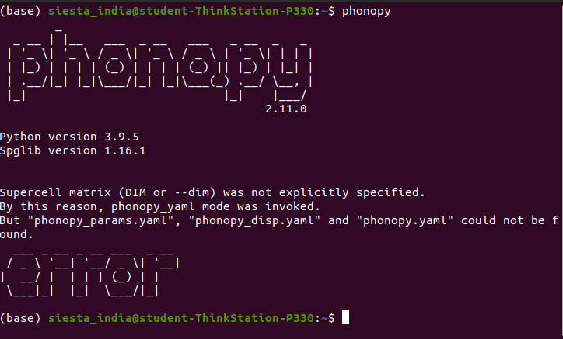

Enjoy phonopy.

All The best.

------------------------------------------------------------------------------------------------------------------------