Neural Networks (deep Learning)

**EE 5410, Sec - 01, T-Th: 9.35 Am – 10.50 AM, ENG: 5022**

**Assignment 2, Points: 40, Due Date: 02/26/2018 by 4:00 PM**

Consider a problem of pattern classification composed of three input features x1, x2, and x3 ϵ R into two classes using the Perceptron network. The training and test patterns are provided in the excel files “TrainingPatterns.csv” and “TestPatterns.csv”.

Note: The files are saved in “Comma Separated Values” format.

* Determine an appropriate activation function for the single neuron that can be used in training the perceptron network based on the desired outputs representing the two class labels.
* Describe the cost function used in the perceptron training and the goal of the perceptron training with respect to the cost function.
* Using the provided python project, implement a perceptron neural network to train with the training patterns **(Note: Examine the given code in the Python project and read the comments before implementing your code).**
* Execute the five training processes for the perceptron neural network, initializing the weight vector W = {w1, w2, w3}t with random values between zero and one for each training processes.
* Generate the results shown in Table 1 of the training process:

**Table 1 Perceptron Training Results**

|  |  |  |  |  |  |  |  |  |  |
| --- | --- | --- | --- | --- | --- | --- | --- | --- | --- |
| **Training** | **Vector of Weights (Initial)** | | | | **Vector of Weights (Final)** | | | | **# of Epochs** |
| **w1** | **w2** | **w3** | **w0** | **w1** | **w2** | **w3** | **w0** |  |
| **T1** |  |  |  |  |  |  |  |  |  |
| **T2** |  |  |  |  |  |  |  |  |  |
| **T3** |  |  |  |  |  |  |  |  |  |
| **T4** |  |  |  |  |  |  |  |  |  |
| **T5** |  |  |  |  |  |  |  |  |  |

* Provide plots depicting the variation of the cost function with epochs and analyze the reduction of the cost. A sample variation of the cost function is shown in Figure 1.
* Evaluate the performance of the five networks (obtained from the five training process) using the test patterns and generate the results shown in Table 2.
* Explain why the number of training epochs for each training process varies.
* Determine the equation of the hypersurface discriminating the two classes for the five training processes.
* For the given training patterns, affirm that the classes are linearly separable using either a hypersurface equation or computing the centroid of each class and point distances from the centroid.
* Submit the completed Python project with the commented code.

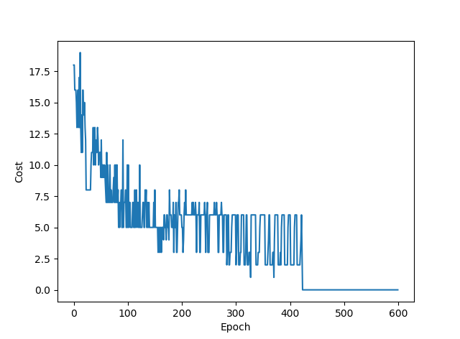

**Figure 1 Variation of Cost Function with Epoch Count**

|  |  |  |  |  |  |  |  |  |
| --- | --- | --- | --- | --- | --- | --- | --- | --- |
| Sample | x1 | x2 | x3 | YP (T1) | YP (T2) | YP (T3) | YP (T4) | YP (T5) |
| 1 |  |  |  |  |  |  |  |  |
| 2 |  |  |  |  |  |  |  |  |
| 3 |  |  |  |  |  |  |  |  |
| 4 |  |  |  |  |  |  |  |  |
| 5 |  |  |  |  |  |  |  |  |
| 6 |  |  |  |  |  |  |  |  |
| 7 |  |  |  |  |  |  |  |  |
| 8 |  |  |  |  |  |  |  |  |
| 9 |  |  |  |  |  |  |  |  |
| 10 |  |  |  |  |  |  |  |  |

**Submission Format:**

**A word file (pdf or latex files will not be graded) and the Python project on the class server.**