**David R Mohler**

**EE-5410: Neural Networks**

**Assignment #4**

**04-12-2018**

For this assignment I have implemented six unique neural networks for the purpose of classifying the data sets given that describe the success rate of two different wart treatments for patients in conjunction with other patient data. The two methods being classified are that of Immunotherapy and Cryotherapy, with the added information of age, time, number of warts, type, area, and in the case of immunotherapy, induration diameter. With each network I will show its ability to classify the data associated with its own data set as well as cross validation of the network against its counterpart data set. Each network is tested under a series of ten trials for testing under its own data and against the cross performance testing data.

* **Immunology Network #1:**

This is a basic implementation of the back propagation algorithm with only a single hidden layer consisting of six inputs, 36 neurons in the hidden layer, and a single output neuron. All of the networks are tested using a global learning rate of $η= 0.1$ in order to view the effect of different topologies and optimizations independently of the learning rate.

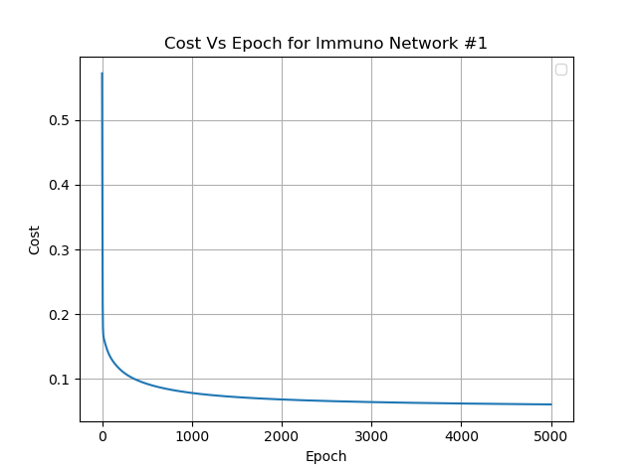

* **Immunology Network #2:**

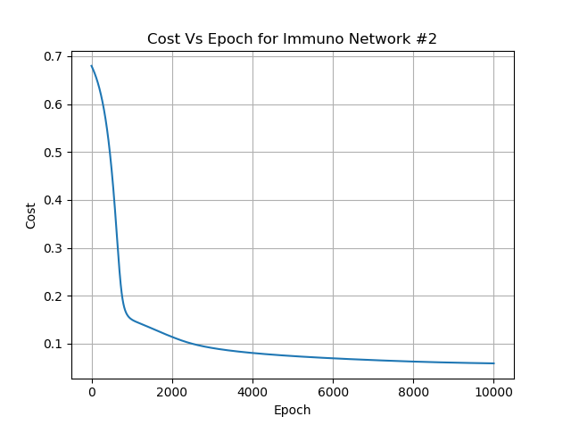

* **Immunology Network #3:**

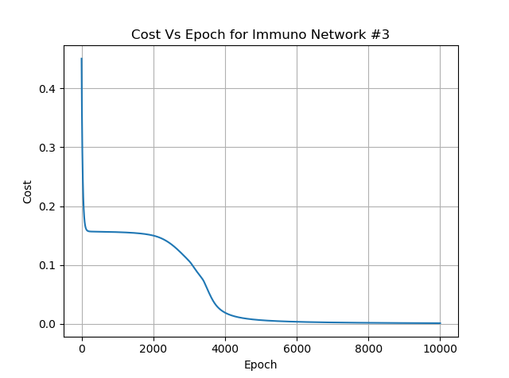

* **Cryotherapy Network #1:**

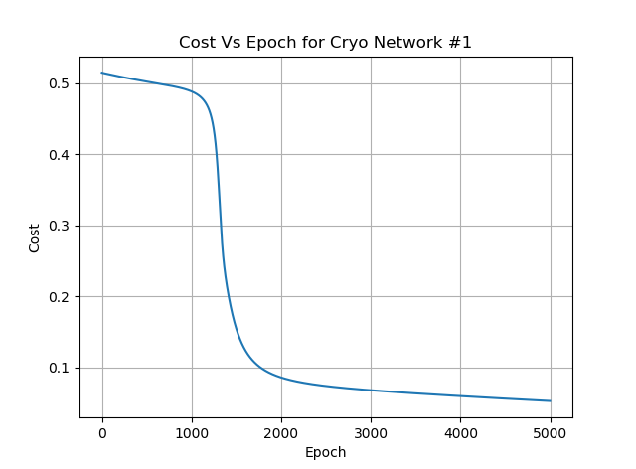

* **Cryotherapy Network #2:**

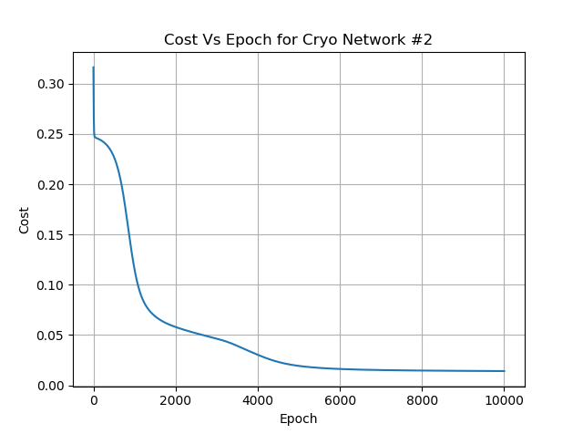

* **Cryotherapy Network #3**

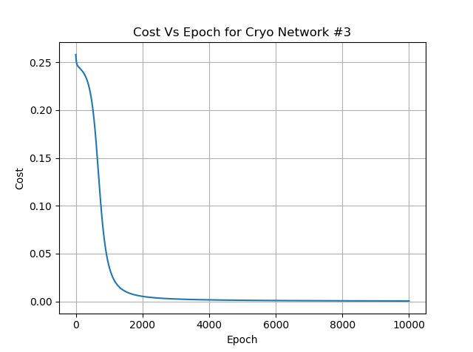

* **Results:**