3. Results
3.1 Participant characteristics
The final analysis comprised five participants with aortic stenosis (AS) and five healthy controls. Baseline demographic, clinical and CMR characteristics of the analysed participants are presented in Table 1.

Table 1. Baseline demographic, clinical and CMR characteristics of the analysed participants
Characteristic | AS (n=5) | Healthy controls (n=5)
Age, years | 71.2 ± 8.0 | [Pending]
Sex, n (%) | [Pending] | [Pending]
Height, cm | 170.0 ± 10.3 | [Pending]
Weight, kg | 86.6 ± 15.4 | [Pending]
BMI, kg/m² | 28.5 ± 4.1* | [Pending]
Heart rate, bpm | 67.4 ± 7.9 | [Pending]
Systolic BP, mmHg | 144.4 ± 20.5 | [Pending]
Diastolic BP, mmHg | 70.8 ± 7.3 | [Pending]
LV EDV, ml | 147.2 ± 48.5 | [Pending]
LV ESV, ml | 41.2 ± 28.2 | [Pending]
LV stroke volume, ml | 106.0 ± 25.0 | [Pending]
LVEF, % | 73.8 ± 9.5 | [Pending]
LV mass, g | 175.4 ± 45.8 | [Pending]
Atrial fibrillation, n (%) | 1 (20%) | [Pending]
COPD, n (%) | 0 (0%) | [Pending]

*BMI was available for four of the five AS participants.
Table note: Continuous variables are presented as mean ± SD and categorical variables as n (%). [Pending] indicates information awaited for the healthy-control group. AS, aortic stenosis; BMI, body mass index; BP, blood pressure; COPD, chronic obstructive pulmonary disease; EDV, end-diastolic volume; ESV, end-systolic volume; LV, left ventricular; LVEF, left ventricular ejection fraction; SD, standard deviation.

The AS group had a mean age of 71.2 ± 8.0 years. Mean heart rate was 67.4 ± 7.9 beats/min, while mean systolic and diastolic blood pressures were 144.4 ± 20.5 mmHg and 70.8 ± 7.3 mmHg, respectively. Mean LV EDV, ESV and stroke volume were 147.2 ± 48.5 ml, 41.2 ± 28.2 ml and 106.0 ± 25.0 ml, respectively. Mean LVEF was 73.8 ± 9.5%, and mean LV mass was 175.4 ± 45.8 g.
One participant with AS had atrial fibrillation (20%), while none of the AS participants had COPD. Corresponding baseline characteristics for the five healthy controls are [Pending].
Among the AS participants, mean peak aortic velocity was 3.94 ± 0.94 m/s, while the mean aortic pressure gradient was 35.5 ± 6.6 mmHg. Mean aortic valve area measured by the velocity-time integral method was 0.93 ± 0.25 cm². These AS-specific measurements were available for fewer than five participants and are therefore reported separately from the between-group baseline characteristics.

3.2 EDV-normalised LV kinetic energy
EDV-normalised LV kinetic energy was assessed across FullRR, systole, diastole, E-wave and A-wave intervals.

The complete between-group statistical comparisons are presented in Table 2.

Comparison of 4D-flow CMR-derived LV flow-energetic parameters between healthy controls and participants with AS
Domain | Cardiac interval | Healthy controls (n=5) | AS (n=5) | Statistical test | Test statistic | Mean difference, control − AS (95% CI) | p-value | Effect size
EDV-normalised kinetic energy | FullRR (µJ/ml) | 9.82 ± 3.27 | 14.15 ± 3.54 | Student's t-test | t(8) = −2.013 | −4.34 (−9.30 to 0.63) | 0.079 | Hedges' g = −1.149
 | Systole (µJ/ml) | 9.09 ± 2.94 | 13.47 ± 4.96 | Student's t-test | t(8) = −1.698 | −4.37 (−10.31 to 1.57) | 0.128 | Hedges' g = −0.969
 | Diastole (µJ/ml) | 8.23 (7.24) | 16.11 (6.58) | Mann–Whitney U | U = 5.00 | — | 0.151† | Rank-biserial r = 0.60
 | E-wave (µJ/ml) | 9.61 ± 3.22 | 14.60 ± 4.96 | Student's t-test | t(8) = −1.889 | −4.99 (−11.08 to 1.10) | 0.096 | Hedges' g = −1.078
 | A-wave (µJ/ml) | 9.27 (15.92) | 17.78 (6.16) | Mann–Whitney U | U = 5.00 | — | 0.151† | Rank-biserial r = 0.60
Vorticity | FullRR (s⁻¹) | 239.22 ± 27.01 | 315.10 ± 59.91 | Student's t-test | t(8) = −2.581 | −75.87 (−143.66 to −8.08) | 0.033 | Hedges' g = −1.474
 | Systole (s⁻¹) | 237.33 ± 34.49 | 308.67 ± 44.46 | Student's t-test | t(8) = −2.835 | −71.34 (−129.37 to −13.31) | 0.022 | Hedges' g = −1.619
 | Diastole (s⁻¹) | 245.56 ± 43.53 | 318.38 ± 75.88 | Student's t-test | t(8) = −1.861 | −72.82 (−163.05 to 17.41) | 0.100 | Hedges' g = −1.063
 | E-wave (s⁻¹) | 243.20 ± 17.91 | 317.53 ± 80.54 | Student's t-test | t(8) = −2.014 | −74.33 (−159.43 to 10.78) | 0.079 | Hedges' g = −1.150
 | A-wave (s⁻¹) | 249.14 ± 105.64 | 319.80 ± 73.30 | Student's t-test | t(8) = −1.229 | −70.65 (−203.22 to 61.92) | 0.254 | Hedges' g = −0.701
Energy loss | FullRR (µW) | 579.85 ± 267.13 | 1245.26 ± 729.98 | Student's t-test | t(8) = −1.914 | −665.41 (−1467.11 to 136.28) | 0.092 | Hedges' g = −1.093
 | Systole (µW) | 599.16 ± 388.59 | 1203.90 ± 699.58 | Student's t-test | t(8) = −1.690 | −604.75 (−1429.92 to 220.43) | 0.130 | Hedges' g = −0.965
 | Diastole (µW) | 593.60 ± 265.45 | 1260.32 ± 744.61 | Student's t-test | t(8) = −1.886 | −666.72 (−1481.92 to 148.48) | 0.096 | Hedges' g = −1.077
 | E-wave (µW) | 501.42 ± 92.53 | 1192.73 ± 796.44 | Student's t-test | t(8) = −1.928 | −691.31 (−1518.16 to 135.54) | 0.090 | Hedges' g = −1.101
 | A-wave (µW) | 769.47 ± 634.23 | 1388.06 ± 676.47 | Student's t-test | t(8) = −1.492 | −618.59 (−1574.67 to 337.49) | 0.174 | Hedges' g = −0.852

Table 2: Continuous variables are presented as mean ± SD for outcomes analysed using independent-samples Student's t-tests and as median (IQR) for outcomes analysed using the Mann–Whitney U test. Mean differences are expressed as control minus AS, with 95% confidence intervals. All p-values are two-tailed. Exact two-tailed p-values are reported for Mann–Whitney U analyses. Effect sizes for independent-samples t-tests are reported as Hedges' g. Rank-biserial correlation is reported for Mann–Whitney U comparisons. AS, aortic stenosis; CMR, cardiovascular magnetic resonance; EDV, end-diastolic volume; IQR, interquartile range; LV, left ventricular; SD, standard deviation.
† Exact two-tailed p = 0.151.

For FullRR, mean LV kinetic energy was 14.15 ± 3.54 µJ/ml in the AS group compared with 9.82 ± 3.27 µJ/ml in the healthy-control group. The between-group mean difference was −4.34 µJ/ml (95% CI −9.30 to 0.63), with p = 0.079 and a Hedges' g of −1.149.
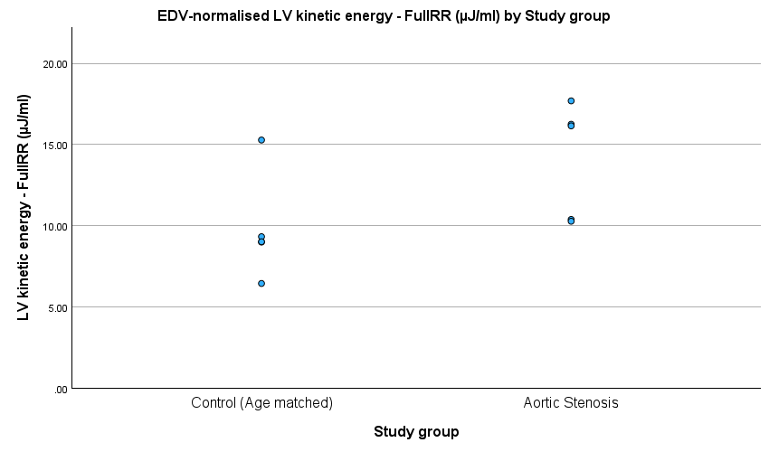
Figure 1. EDV-normalised LV kinetic energy during the full cardiac cycle (FullRR) in healthy controls and participants with aortic stenosis.

During systole, mean LV kinetic energy was 13.47 ± 4.96 µJ/ml in the AS group and 9.09 ± 2.94 µJ/ml in the healthy-control group. The between-group mean difference was −4.37 µJ/ml (95% CI −10.31 to 1.57), with p = 0.128 and a Hedges' g of −0.969.

For diastolic kinetic energy, the median (IQR) was 16.11 (6.58) µJ/ml in the AS group and 8.23 (7.24) µJ/ml in the healthy-control group. The Mann–Whitney U test showed no statistically significant between-group difference (U = 5.00, exact two-tailed p = 0.151), with a rank-biserial correlation of 0.60.
For E-wave kinetic energy, mean values were 14.60 ± 4.96 µJ/ml in the AS group and 9.61 ± 3.22 µJ/ml in the healthy-control group. The between-group mean difference was −4.99 µJ/ml (95% CI −11.08 to 1.10), with p = 0.096 and a Hedges' g of −1.078.

For A-wave kinetic energy, the median (IQR) was 17.78 (6.16) µJ/ml in the AS group and 9.27 (15.92) µJ/ml in the healthy-control group. The Mann–Whitney U test showed no statistically significant between-group difference (U = 5.00, exact two-tailed p = 0.151), with a rank-biserial correlation of 0.60.
None of the five kinetic-energy comparisons reached the prespecified significance threshold of p < 0.05.

3.3 LV vorticity
LV vorticity was assessed across FullRR, systole, diastole, E-wave and A-wave intervals.
Mean FullRR LV vorticity was 315.10 ± 59.91 s⁻¹ in the AS group compared with 239.22 ± 27.01 s⁻¹ in the healthy-control group. The between-group mean difference was −75.87 s⁻¹ (95% CI −143.66 to −8.08), with p = 0.033 and a Hedges' g of −1.474.

During systole, mean LV vorticity was 308.67 ± 44.46 s⁻¹ in the AS group and 237.33 ± 34.49 s⁻¹ in the healthy-control group. The between-group mean difference was −71.34 s⁻¹ (95% CI −129.37 to −13.31), with p = 0.022 and a Hedges' g of −1.619.

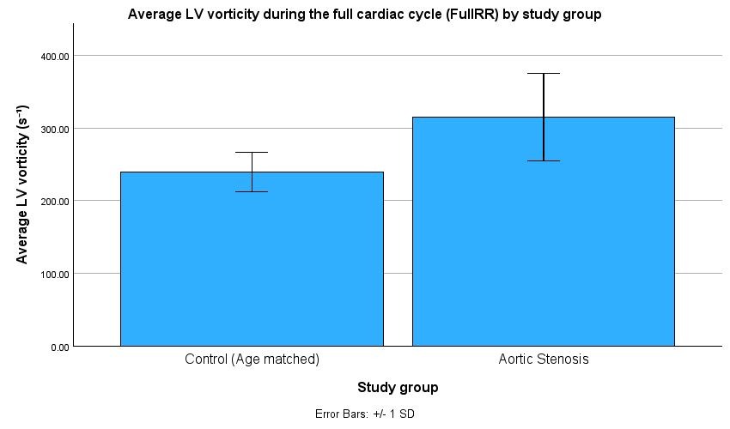
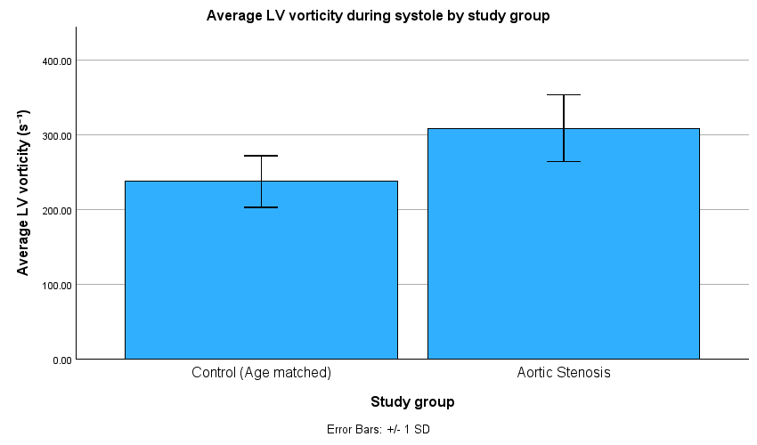
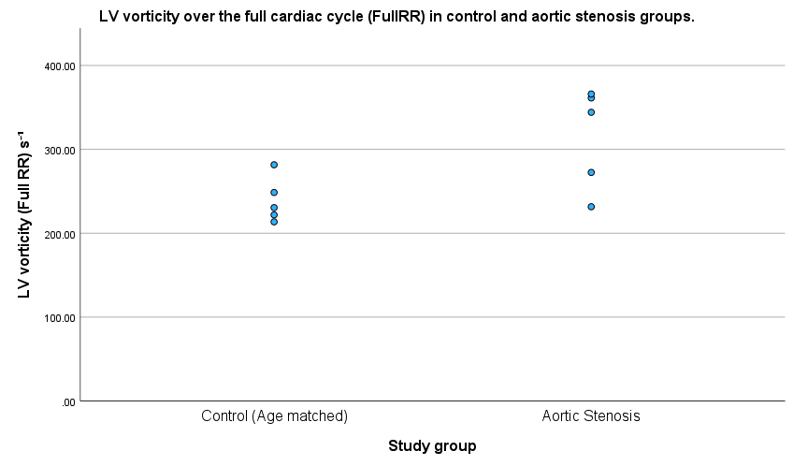
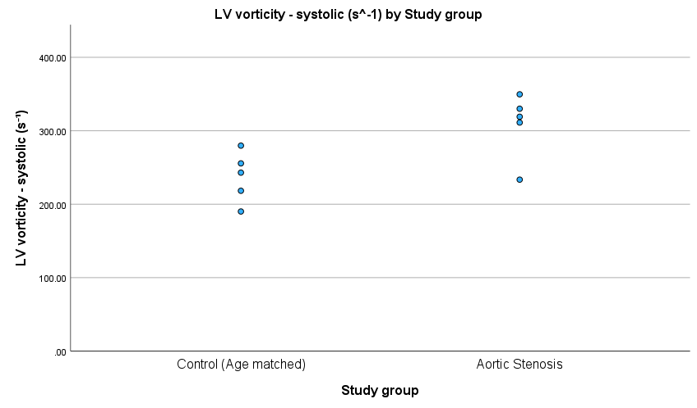
Figure 2. LV vorticity during the full cardiac cycle (FullRR) and systole in healthy controls and participants with aortic stenosis. (A) FullRR LV vorticity and (B) systolic LV vorticity. Bars represent mean values and error bars represent ±1 SD. (C) individual FullRR LV vorticity observations (D) individual systolic LV vorticity observations.
(A)
(B)
(C)
(D)

For diastolic LV vorticity, mean values were 318.38 ± 75.88 s⁻¹ in the AS group and 245.56 ± 43.53 s⁻¹ in the healthy-control group. The difference was not statistically significant (p = 0.100; Hedges' g = −1.063).
During the E-wave interval, mean LV vorticity was 317.53 ± 80.54 s⁻¹ in the AS group compared with 243.20 ± 17.91 s⁻¹ in the healthy-control group. The difference was not statistically significant (p = 0.079; Hedges' g = −1.150).

During the A-wave interval, mean LV vorticity was 319.80 ± 73.30 s⁻¹ in the AS group and 249.14 ± 105.64 s⁻¹ in the healthy-control group. The difference was not statistically significant (p = 0.254; Hedges' g = −0.701).

Thus, two of the five vorticity comparisons reached the prespecified significance threshold, involving FullRR and systolic vorticity. These two measurements represent related components of the same cardiac cycle and were therefore not considered independent confirmations of separate effects.
[Insert vorticity figure here]
Figure X. Time-resolved LV vorticity across the cardiac cycle in the analysed AS and healthy-control datasets.

3.4 LV energy loss
LV energy loss was assessed across FullRR, systole, diastole, E-wave and A-wave intervals.
Mean FullRR energy loss was 1245.26 ± 729.98 µW in the AS group compared with 579.85 ± 267.13 µW in the healthy-control group. The between-group mean difference was −665.41 µW (95% CI −1467.11 to 136.28), with p = 0.092 and a Hedges' g of −1.093.
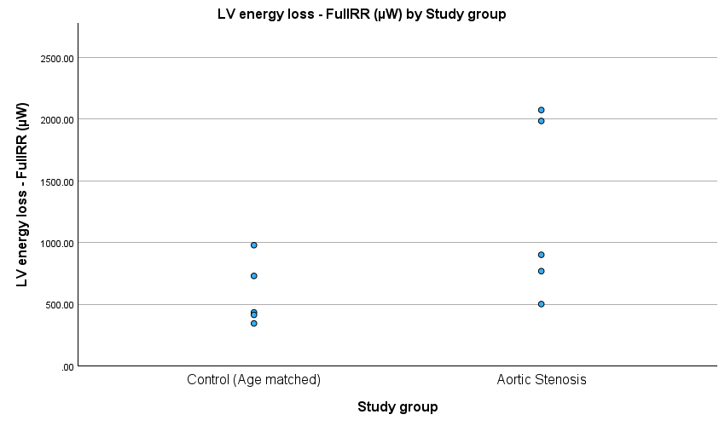
Figure 3. LV energy loss during the full cardiac cycle (FullRR) in healthy controls and participants with aortic stenosis.

During systole, mean energy loss was 1203.90 ± 699.58 µW in the AS group and 599.16 ± 388.59 µW in the healthy-control group. The between-group mean difference was −604.75 µW (95% CI −1429.92 to 220.43), with p = 0.130 and a Hedges' g of −0.965.

During diastole, mean energy loss was 1260.32 ± 744.61 µW in the AS group compared with 593.60 ± 265.45 µW in the healthy-control group. The between-group mean difference was −666.72 µW (95% CI −1481.92 to 148.48), with p = 0.096 and a Hedges' g of −1.077.
During the E-wave interval, mean energy loss was 1192.73 ± 796.44 µW in the AS group and 501.42 ± 92.53 µW in the healthy-control group. The between-group mean difference was −691.31 µW (95% CI −1518.16 to 135.54), with p = 0.090 and a Hedges' g of −1.101.

During the A-wave interval, mean energy loss was 1388.06 ± 676.47 µW in the AS group compared with 769.47 ± 634.23 µW in the healthy-control group. The between-group mean difference was −618.59 µW (95% CI −1574.67 to 337.49), with p = 0.174 and a Hedges' g of −0.852.
None of the five energy-loss comparisons reached the prespecified significance threshold of p < 0.05.

3.5 Overall flow-energetic findings
Across the three 4D-flow CMR-derived parameters, the only statistically significant between-group comparisons involved LV vorticity during FullRR and systole. Mean vorticity was higher in the AS group for both intervals, with Hedges' g values of −1.474 and −1.619, respectively.

None of the five EDV-normalised kinetic-energy comparisons reached the prespecified significance threshold. The largest standardised effect sizes within this domain were observed for FullRR, systolic and E-wave kinetic energy, with Hedges' g values of −1.149, −0.969 and −1.078, respectively.

Similarly, none of the five energy-loss comparisons reached the prespecified significance threshold. The largest standardised effect sizes were observed for E-wave, FullRR and diastolic energy loss, with Hedges' g values of −1.101, −1.093 and −1.077, respectively.

The Welch unequal-variance sensitivity analysis produced the same significance classification as the primary analysis, with no comparison changing statistical significance status.
Given the small sample size of five participants per group, the findings were considered exploratory. The related FullRR and systolic measurements were not interpreted as independent confirmations of separate effects.

